

K.L.E. SOCIETY’S CHIDANAND B. KORE POLYTECHNIC,
CHIKODI-591201
District : Belagavi

DEPARTMENT OF COMPUTER SCIENCE AND ENGINEERING
2024-2025

Internship Report On
“OJT 1 – ONLINE BLOOD BANK MANAGEMENT”
“OJT 2 – JOB PORTAL(HIRRD)”
In partial fulfilment for the award of the diploma of

DIPLOMA IN COMPUTER SCIENCE AND ENGINEERING

SUBMITTED BY

Mr. ADITYA MANE DTE REG : 339CS22005

Under the guidance of

Mr. Anoop Desai
Designation - Full Stack Developer, Pranaksh Technologies LLP, Belagavi



K.L.E. SOCIETY’S CHIDANAND B. KORE POLYTECHNIC,
CHIKODI-591201
District : Belagavi

DEPARTMENT OF COMPUTER SCIENCE AND ENGINEERING
2024-2025

A Internship Report On
“OJT 1 – ONLINE BLOOD BANK MANAGEMENT”
“OJT 2 – JOB PORTAL(HIRRD)”
In partial fulfilment for the award of the diploma of

DIPLOMA IN COMPUTER SCIENCE AND ENGINEERING

SUBMITTED BY

Mr. ADITYA MANE DTE REG : 339CS22005

Under the guidance of

Mr. Anoop Desai
Designation - Full Stack Developer, Pranaksh Technologies LLP, Belagavi

Internship Guide | Cohort Owner | Head of Department | Principal
Mr. Anoop Desai | Prof. S.S Khot | Prof. S.K Tavadare | Prof. D.D Billur



K.L.E. SOCIETY’S CHIDANAND B. KORE POLYTECHNIC,
CHIKODI-591201
District : Belagavi

DEPARTMENT OF COMPUTER SCIENCE AND ENGINEERING
2024-2025

CERTIFICATE

This is to certify that the Internship report entitled “ONLINE BLOOD BANK MANAGEMENT & JOB PORTAL(HIRRD)” was carried out by Mr. ADITYA MANE of 6th Semester Diploma in Computer Science and Engineering, K.L.E. Society’s C. B. Kore Polytechnic, Chikodi. In practical fulfillment of the Diploma in Computer Science and Engineering award requirement during 2024 – 2025. This work has been carried out under the guidance of Mr. Anoop Desai, Designation - Full Stack Developer, Pranaksh Technologies LLP, Belagavi. The Internship work prescribed for the said Diploma.

It is further understood that by this certificate the undersigned does not endorse or approve any statement made, opinion expressed, or conclusion purpose for which it is submitted.

Internship Guide | Cohort Owner | Head of Department | Principal
Mr. Anoop Desai | Prof. S.S Khot | Prof. S.K Tavadare | Prof. D.D Billur



K.L.E. SOCIETY’S CHIDANAND B. KORE POLYTECHNIC,
CHIKODI-591201
District : Belagavi

DEPARTMENT OF COMPUTER SCIENCE AND ENGINEERING
2024-2025

STUDENT DECLARATION

We, Mr. ADITYA MANE A Sixth-Semester Diploma in Computer Science and Engineering students of K.L.E Society’s Chidanand B. Kore Polytechnic, Chikodi. Hereby declare that the work entitled “Online Blood Bank Management & Job Portal (Hirrd)” has been carried out independently by us under the guidance Mr. Anoop Desai, Designation - Full Stack Developer, Pranaksh Technologies LLP, Belagavi. we further declare that the work reported in this Internship has not been submitted and will be submitted in part or full for the award of any after diploma or degree in this institute or any other institute or university.

Mr. Aditya Mane (339CS22005)

Date :
Place : Chikodi

INTERNSHIP CERTIFICATE ISSUED BY THE ORGANIZATION
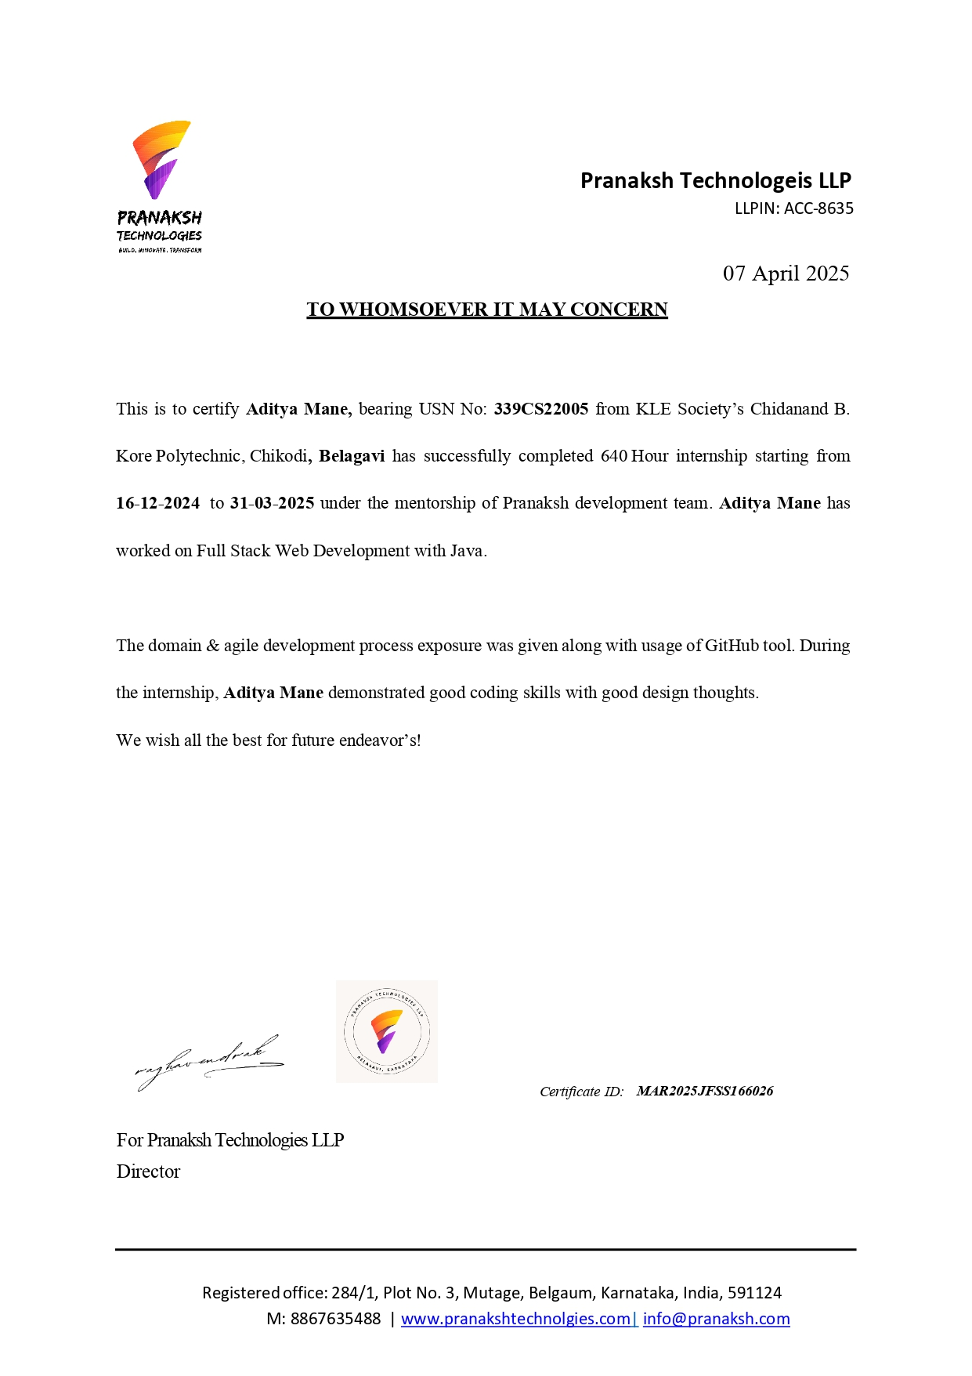

ACKNOWLEDGEMENTS
I would like to express my sincere gratitude to all those who have supported and guided me throughout the successful completion of this Internship.

First and foremost, I would like to thank Prof. DARSHANKUMAR D. BILLUR, Principal of K.L.E. SOCIETY’S C.B. KORE POLYTECHNIC CHIKODI-591201, for providing the necessary facilities and a motivating environment to carry out this work.

I express my deep sense of gratitude to Prof. SANTOSH K TAVADARE, Head of the Department of COMPUTER SCIENCE AND ENGNEERING, for their constant encouragement and valuable support during the course of this Internship.

I am especially thankful to my Internship guide, Mr. ANOOP DESAI, Designation - Full stack Developer for their consistent guidance, suggestions, and valuable feedback that helped shape this Internship into its final form.

I would also like to thank all the faculty members and staff of the PRANAKSH TECHNOLOGIES LLP, BELAGAVI. for their help and cooperation throughout the duration of this Internship.

I extend my heartfelt thanks to all the Staff Members of the Department of COMPUTER SCIENCE AND ENGNEERING for their continuous support and assistance throughout my academic journey.

Last but not the least, I am deeply thankful to my family and friends for their unwavering support, patience, and encouragement during every stage of this journey.

EXECUTIVE SUMMARY

On Job Training1: Online Blood Bank Management
The Blood Bank Management System is a web-based platform designed to manage donor registrations, search for blood availability, and connect donors with recipients efficiently. It offers real-time donor search, automated notifications, and secure data handling to streamline the donation process.
The motivation behind this project is to simplify and digitize the traditional blood donation system by leveraging technology to reduce delays, improve accessibility, and save lives during emergencies.
The development process involved identifying challenges in existing systems, conducting a literature review, gathering requirements, designing the user interface, developing the backend, testing core functionalities, and refining features based on feedback.
Key results include a working donor search feature, successful user registration and login module, efficient profile and donation status management, and real-time notification alerts. The system demonstrates strong potential for practical use in hospitals, clinics, and public health organizations.

On Job Training 2: Job Portal (Hirrd)

Job Portal (Hirrd) is a full-stack web-based job portal designed to streamline the interaction between job seekers (candidates) and employers (recruiters). It offers user-friendly features such as job posting, filtering, resume uploading, and application tracking.

The motivation behind this project is to create a modern, easy-to-use employment platform that simplifies the recruitment process and helps job seekers find relevant opportunities efficiently.

The development process involved literature review, system requirement analysis, database design using Supabase, UI/UX planning, modular coding, and multiple rounds of testing to ensure functionality and usability.

Key results include a fully functional platform with candidate and recruiter modules, effective job filtering and application features, and smooth integration of resume handling. The system demonstrates strong potential for use in real-world recruitment scenarios.

CONTENTS
[OJT – 1 Online Blood Bank Management]

SL No | Contents | Page No
1 | Abstract | 1-1
2 | Introduction | 2-2
3 | Existing System and Literature Survey  - Existing System  - Literature Survey | 3-4
4 | Problem Statement and Objectives  - Problem Definition  - Challenges  - Limitations  - Applications | 5-6
5 | Requirements  - Hardware Requirements  - Software Requirements  - Functional Requirements  - Non-Functional Requirements | 7-8
6 | System Design and Methodology  - Methodology  - Software Architecture  - Database Design  - UI Design  - Module Design  - ERD Diagram | 9-13
7 | Pseudocode | 14-15
8 | Experiments and Results | 16-21
9 | Test Cases | 22-26
10 | Future Scope | 27-27
11 | Conclusion | 28-28
12 | References | 29-29

CONTENTS
[OJT -2 JOB PORTAL (HIRRD)]
SL No | Contents | Page No
1 | Abstract | 1-1
2 | Introduction | 2-2
3 | Existing System and Literature Survey  - Existing System  - Literature Survey | 3-5
4 | Problem Statement and Objectives  - Problem Definition  - Challenges  - Limitations  - Applications | 6-6
5 | Requirements  - Hardware Requirements  - Software Requirements  - Functional Requirements  - Non-Functional Requirements | 7-8
6 | System Design and Methodology  - Methodology  - Software Architecture  - Database Design  - UI Design  - Module Design  - ERD Diagram | 9-13
7 | Pseudocode | 14-15
8 | Experiments and Results | 16-21
9 | Test Cases | 22-27
9 | Project Core Features | 28-28
10 | Future Scope | 29-29
11 | Conclusion | 30-30
12 | References | 31-31

LIST OF FIGURES

Figure No. | Title of the Figure | Page No.
2.1 | ERD Diagram | 13
2.2 | Screenshot of User Registration & Login | 16
2.3 | Screenshot of Donors | 17
2.4 | Screenshot of Search Donors | 18
2.5 | Screenshot of Update Account | 18
2.6 | Screenshot of Delete Account | 19
2.7 | Screenshot of Donated User | 21
3.1 | ERD Diagram (Level 1) | 13
3.2 | Screenshot of User Registration & Login | 16
3.3 | Screenshot of Post Job | 17
3.4 | Screenshot of Search Jobs | 18
3.5 | Screenshot of Applied For Job | 19
3.6 | Screenshot of Job Status (Open / Closed) | 20
3.7 | Screenshot of Delete Jobs | 20
3.8 | Screenshot of Saved Jobs | 21
3.9 | Screenshot of User Profile | 21

LIST OF TABLES

Table No. | Title of the Table | Page No.
2.1 | Literature Survey | 4

ABBREVIATIONS / NOTATIONS / NOMENCLATURE

Abbreviation / Symbol | Full Form / Description
IoT | Internet of Things
API | Application Programming Interface
GUI | Graphical User Interface
CPU | Central Processing Unit
RAM | Random Access Memory
HTML | Hyper Text Markup Language
DFD | Data Flow Diagram
UML | Unified Modeling Language
DBMS | Database Management System
SQL | Structured Query Language
HTTP | Hyper Text Transfer Protocol
IP | Internet Protocol
JSON | JavaScript Object Notation
Mbps | Megabits per second

CHAPTER 1

COMPANY PROFILE

Pranaksh Technologies, established in 2023, is a dynamic company specializing in technology solutions, digital marketing, and academic training. Initially focused on educational technology services for IT companies, the firm has expanded its expertise to include software development, artificial intelligence, embedded systems, cybersecurity, and the Internet of Things (IoT).

Vision and Mission
Pranaksh Technologies aims to be a trusted leader in delivering high-quality services that bridge the gap between academia and the corporate world. Their mission is to provide exceptional solutions and training that connect academic learning with corporate success, empowering individuals and organizations with cutting-edge skills and knowledge.

Services Offered
- Corporate Solutions: Offering smart strategies and tools to boost efficiency, tackle challenges, and drive growth, ensuring success in today's competitive market.
- Academic Training: Providing hands-on expertise in fields like AI and Data Science, equipping individuals with the skills needed to stay competitive in a rapidly evolving landscape.

Technology Focus
- Internet of Things (IoT)
- Data Science
- Artificial Intelligence & Machine Learning
- Web Development

Milestones
Since its inception, Pranaksh Technologies has achieved significant milestones:

- 50+ Happy Clients
- 100+ Students Trained
- 150+ Projects Completed
- 10,000+ Training Hours Delivered

These accomplishments reflect the company's dedication to excellence and client satisfaction.

Why Choose Pranaksh Technologies

The company's value-driven approach ensures cost-effective services without compromising quality. They emphasize innovative partnerships, working closely with clients to deliver creative solutions. With a focus on trust and tangible results, Pranaksh Technologies prepares individuals with corporate-ready skills through programs that mirror real-world expectations.

Contact Information

Pranaksh Technologies is located in Belagavi, Karnataka. For inquiries:

- Email: info@pranakshtechnologies.com
- Phone: +91-8867635488

For more detailed information, please visit their official website: https://pranakshtech nologies.com

CHAPTER 2

ON JOB TRAINING – 1 “ONLINE BLOOD BANK MANAGEMENT”

ABSTRACT

The Blood Bank Management System is a web-based application designed to automate and improve the process of blood donation by connecting donors with recipients efficiently and reliably. Traditional blood donation processes often involve manual record-keeping, delayed communication, and difficulties in finding suitable donors during emergencies. This system addresses these issues by providing a centralized platform where users can register, log in securely, and maintain their donor profiles with relevant personal and medical details.

Users can search for blood donors based on specific criteria such as blood group and geographic location, making the search faster and more targeted. The system also includes features for updating profile information, tracking donation history, and managing user activity. Automated notifications remind eligible donors about their next donation date, encouraging regular and timely contributions.

With secure authentication, real-time data access, and a user-friendly interface, the Blood Bank Management System reduces the burden on hospitals and simplifies the coordination between donors and recipients. This project demonstrates how digital technology can be used to enhance healthcare services and support life-saving efforts by ensuring timely blood availability in critical situations.

INTRODUCTION
An online blood bank management system is a web-based platform designed to streamline and automate the process of blood donation and donor-recipient matching. It serves as a centralized system where users can register as blood donors, search for donors based on blood group and location, and manage their donation history efficiently.
By digitizing donor records and automating the search process, this system eliminates the inefficiencies of manual blood donation management, ensuring faster response times, accurate donor information, and improved accessibility. With features like real-time donor availability tracking, automated notifications, and secure profile management, this system enhances the overall blood donation experience.
By reducing manual effort and improving data accuracy, the online blood bank management system helps patients find compatible donors quickly, encourages voluntary blood donation, and ensures a more organized approach to blood donation management. This system plays a vital role in bridging the gap between blood donors and recipients, ultimately saving more lives through efficient and accessible blood donation services.

EXISTING SYSTEM AND LITERATURE SURVEY

Existing System
The current blood donation process is largely manual and inefficient, making it difficult to find suitable donors quickly during emergencies. Hospitals and blood banks maintain donor records in separate databases, leading to delays and limited accessibility for those in urgent need.
In the existing system, patients or their families must manually search for donors through hospitals, blood banks, or social media appeals, which is time-consuming and unreliable. There is no centralized platform where users can easily find available donors based on blood group and location. Additionally, donor information is often outdated, and there is no automated tracking of donor eligibility, making it challenging to ensure timely blood availability.
Manual record-keeping in hospitals and blood banks also increases the chances of errors, data loss, and difficulty in updating donor information. Furthermore, there is no proper communication system between donors and recipients, causing delays in the donation process. Due to the lack of real-time donor availability tracking, patients often struggle to find a matching donor when they need it the most.
The inefficiencies in the existing system highlight the need for an online blood bank management system that can automate and streamline the entire blood donation process, ensuring faster and more reliable donor-recipient connections.
Literature Survey

Sl. No. | Title & Authors | Year | Key Contributions & Findings
1 | Online Blood Bank Management Systems: Challenges and Opportunities  Sharma V., Patel A. | 2020 | - Discusses modernization of blood donation through technology.  - Centralized systems reduce manual work and errors.  - Real-time donor search, availability tracking, and reminders.  - Emphasizes security (authentication, encryption).  - Highlights challenges like low awareness and rural gaps.
2 | Cloud-Based Blood Bank Management System  Das K., Iyer P. | 2019 | - Proposes scalable cloud setup for multiple hospitals.  - Enables real-time sync across blood banks.  - Uses platforms like Firebase, AWS Lambda.  - Concerns about vendor lock-in and data security.
3 | Smart Blood Bank Using IoT and Web Technologies  Naidu A., Rao V. | 2020 | - IoT-based tracking of temperature, expiry, volume.  - Real-time alerts through web portals.  - Built using Raspberry Pi, PHP, JavaScript, MySQL.  - High cost and need for technical skills are barriers.
4 | A Review on Blood Donation Management Systems  Kumar S., Yadav N. | 2018 | - Compares global systems on features and usage.  - Encourages open-source tools (Open Blood Bank, Bahmni).  - Suggests awareness and government involvement.  - Highlights need for interoperability and education.

Table 2.1 Literature Survey

PROBLEM STATEMENT AND OBJECTIVES

Problem Definition/Aim of the Project
The process of finding blood donors in emergencies is often slow and inefficient due to the lack of a centralized system. Traditional methods rely on hospital databases, manual donor lists, and word-of-mouth referrals, making it difficult to locate suitable donors quickly. Additionally, donor information is often outdated, and there is no automated system to track donor availability or notify them about upcoming eligibility.
The aim of this project is to develop an online blood donation system that allows users to register as donors, search for donors based on blood group and state, manage their profiles, and receive notifications about urgent blood requests. The system ensures that only eligible donors are displayed, reducing delays in finding a match. By providing a user-friendly interface, real-time donor availability tracking, and secure data management, this project aims to bridge the gap between blood donors and recipients, promote voluntary blood donation, and make the entire donation process more efficient and accessible.

Challenges

    - Real-time donor availability tracking – Keeping donor information updated and ensuring that only eligible donors are displayed in search results.
    - Data security and privacy – Protecting sensitive donor and recipient information from unauthorized access and data breaches.
    - User engagement and participation – Encouraging donors to register, update their availability, and participate actively in blood donation.
    - Ensuring accurate donor information – Preventing fake or incorrect registrations by implementing verification methods.

Limitations

    - No guarantee of immediate donor availability – Even if a donor is listed, they may not respond immediately or may be unavailable at the required time.
    - User participation dependency – The system relies on users actively registering, updating their availability, and responding to donation requests.
    - Lack of physical blood storage – Unlike traditional blood banks, the system only facilitates donor-recipient connections and does not store blood for immediate transfusion.
    - Verification of donor information – Ensuring that registered donors provide accurate and legitimate details can be challenging without a strict verification process.

Applications

- Real-time donor search – Enables users to search for donors by filtering results based on blood type and state.
- Donor registration and management – Allows individuals to register as donors, update their availability status, and manage their profiles.
- Community support and engagement – Helps create a strong network of blood donors who can contribute regularly to save lives.

REQUIREMENTS

Hardware Requirements
      - Processor: Intel Core i5 or equivalent
      - RAM: 8 GB
      - Storage: 512 GB HDD or SSD
      - Internet: Reliable internet connection for real-time donor searches and updates

Software Requirements
- Operating System: Windows 10 or higher, macOS, or Linux
- Programming Languages: HTML, CSS, JavaScript, and PHP
- Database: MySQL for storing donor and recipient information
- Web Server: Apache or Nginx for hosting the application
- Frameworks: Bootstrap for responsive design and jQuery for interactive elements

Functional Requirements

- User Registration and Authentication:
- Donor and recipient registration with secure login credentials.
- Profile management (update, modify, or delete information).
- Blood Donor Management:
- Stores donor details including blood group, state, and contact information.
- Allows donors to update availability status.
- Blood Search and Filtering:
- Search donors by blood group and state.
- Display only eligible donors based on last donation date
- Notifications:
- Reminders for donors when they become eligible to donate again.

- Security and Authentication:
- Secure user authentication with encrypted password storage.
- Prevent unauthorized access to donor and recipient data.

Non-Functional Requirements

- Performance Requirements:
  - The system should be able to handle at least 500 simultaneous donor searches without affecting performance.
  - Response time for searching a donor should be less than 3 seconds.
- Scalability:
  - The system should support an increasing number of registered donors and recipients as the platform grows.
- Usability:
  - The interface should be simple, intuitive, and user-friendly for users of all backgrounds.
- Security Requirements:
  - User authentication should be implemented with secure login and session management.
  - All donor and recipient information should be encrypted to prevent unauthorized access.

SYSTEM DESIGN AND METHODOLOGY

Methodology
The development of an online blood donation system follows a systematic approach to ensure efficiency, reliability, and accessibility. The methodology is based on the Software Development Life Cycle (SDLC), implemented using a modular design to streamline donor registration, search functionalities, and user profile management. The process begins with requirement analysis, where key system functionalities are identified, such as donor registration, user authentication, and real-time donor search. This ensures a well-defined system that meets the needs of both donors and recipients.
Following this, the system design phase involves defining the architecture, designing the database schema, and developing UI/UX prototypes for an intuitive and user-friendly experience. The frontend is built using HTML, CSS, and JavaScript, while the backend is developed using PHP and MySQL for secure data management. Once development is complete, the testing phase ensures that all modules function correctly, verifying real-time donor search, profile management, and security features. The system is then deployed on a web server, making it accessible to users. Regular maintenance and updates are performed to enhance security, improve performance, and ensure a smooth user experience. This structured approach ensures an effective and reliable online blood donation system.

Software Architecture

The online blood donation system follows a three-tier architecture, ensuring scalability, security, and efficiency. It consists of the Presentation Layer (Frontend), Application Layer (Backend), and Database Layer (Data Storage). This structure facilitates smooth communication between users, system processes, and stored data.

The Presentation Layer is responsible for user interaction and is developed using HTML, CSS, JavaScript, and Bootstrap. It provides an intuitive interface where users can register as donors, search for blood donors, update their profiles, and receive notifications. The frontend communicates with the backend via HTTP requests to retrieve and update data.

The Application Layer (Backend) handles core functionalities such as user authentication, donor registration, real-time donor search, and notifications. It is developed using PHP, ensuring secure data processing and smooth communication between the frontend and database. This layer ensures that only eligible donors are displayed, and automated notifications are sent to donors when they become eligible for donation again.
The Database Layer manages all data storage and retrieval processes using MySQL. It stores user profiles, donor details, last donation dates, and search queries. The database ensures data consistency, security, and quick retrieval to facilitate real-time donor availability tracking.

Database Design

Donor Table

Stores details of registered blood donors.
- Name
- Gender
- Email
- City
- Date of Birth
- Contact Number
- Blood Group
- Password
- Save Life Date
After this process is complete, the donor will have access to update their profile, search for other donors, and manage their donation history.

UI Design

The UI design of the online blood donation system focuses on simplicity, responsiveness, and user-friendliness, ensuring a smooth experience for donors and recipients. The system includes multiple pages, each designed for a specific function.

Home Page
- Displays an introduction to the platform and its purpose.
- Provides buttons for "Register," "Login," and "Search Donors."

Registration Page (Donate page)
- Users enter details such as name, email, phone number, blood group, city, and password.
- A simple form layout ensures easy registration.

Login Page
- Users log in using their email and password.
- A password visibility toggle helps users check their input.

Donor Search Page
- Recipients can search for donors by blood group and state.
- Displays matching donor profiles with contact details.

Profile Page
- Allows users to update personal details, change password, or delete their account.
- Displays eligibility for next donation.

Contact Page
- Provides an option for users to send inquiries or feedback about the system.

Module Design
The online blood donation system is divided into different modules to ensure smooth functionality, scalability, and maintainability. Each module handles a specific feature of the system.
- User Registration & Authentication Module
  - Allows users to register, log in, and log out securely.
  - Stores user credentials and ensures authentication.
- Donor Management Module
  - Enables users to register as blood donors by providing personal details, blood group, and location.
  - Allows donors to update, modify, or delete their profiles.
- Blood Donor Search Module
  - Enables recipients to search for donors based on blood group and state.
  - Displays a list of matching donors with contact details (if allowed).
- Profile Management Module
  - Allows users to edit personal details, change availability status, or delete their accounts.
  - Ensures only active and eligible donors are displayed.
- Notification Module
  - Reminds donors when they are eligible to donate again (after 3 months).
- Security & Data Management Module
  - Ensures secure data storage and privacy protection for donor and recipient details.
  - Prevents unauthorized access through authentication mechanisms.

ER Diagram

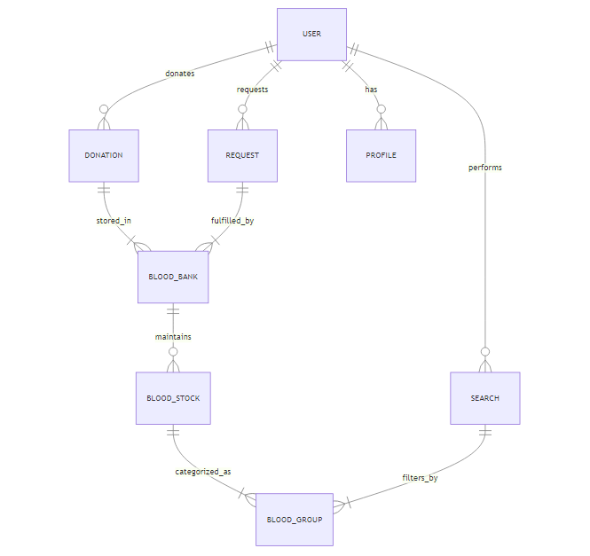

Figure 2.1 ER Diagram

PSUEDOCODE

BEGIN Online_Blood_Bank_Management_System

// User Authentication Module
FUNCTION Login(email, password)
IF Validate_Credentials(email, password) THEN
RETURN "Login Successful"
ELSE
RETURN "Invalid Credentials"
ENDIF
END FUNCTION

FUNCTION Register_User(name, email, password, phone, blood_group, city)
SAVE user details in database
RETURN "User Registered Successfully"
END FUNCTION

// Donor Management Module
FUNCTION Add_Donor(donor_details)
SAVE donor_details in database
RETURN "Donor Added Successfully"
END FUNCTION

FUNCTION Update_Donor_Profile(donor_id, updated_details)
UPDATE donor profile in database
RETURN "Profile Updated Successfully"
END FUNCTION

FUNCTION Delete_Donor_Profile(donor_id)
DELETE donor profile from database
RETURN "Profile Deleted Successfully"
END FUNCTION

// Blood Donor Search Module
FUNCTION Search_Donor(blood_group, state)
FETCH donors WHERE blood_group AND state MATCH database
IF donors found THEN
RETURN list of donors
ELSE
RETURN "No Donors Available"
ENDIF
END FUNCTION

// Notifications Module
FUNCTION Send_Notification(user_id, message)
FETCH user contact details
SEND message via Email/SMS
RETURN "Notification Sent"
END FUNCTION

FUNCTION Donation_Reminder()
FETCH donors eligible for donation (after 3 months)
FOR EACH eligible donor DO
Send_Notification(donor_id, "You are eligible to donate again!")
ENDFOR
END FUNCTION

END Online_Blood_Bank_Management_System

EXPERIMENTS AND RESULTS
- User Registration & Authentication
- Verified that users can sign up by entering their details.
- Checked if users can log in securely using their credentials.
- Ensured authentication prevents unauthorized access.
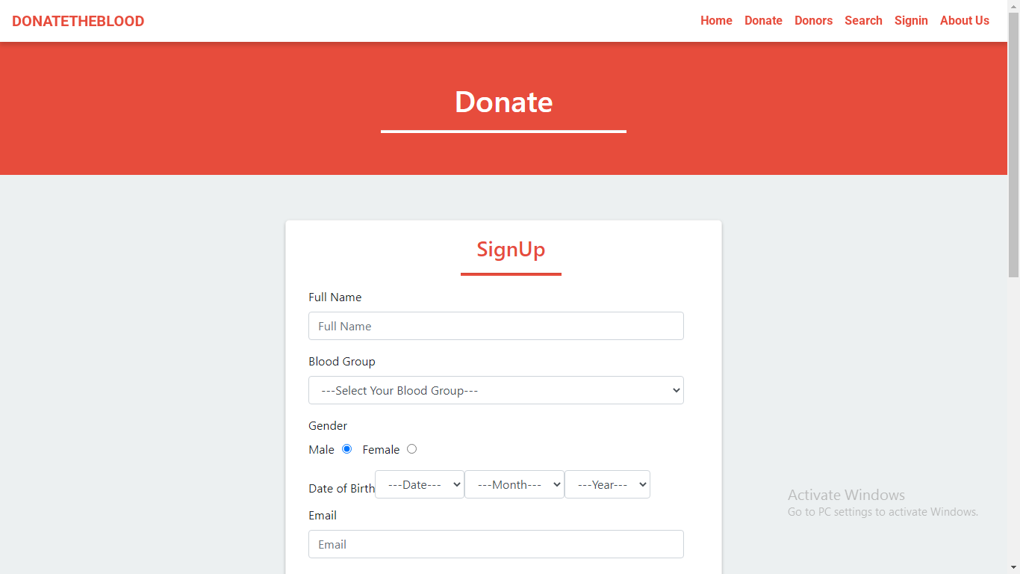

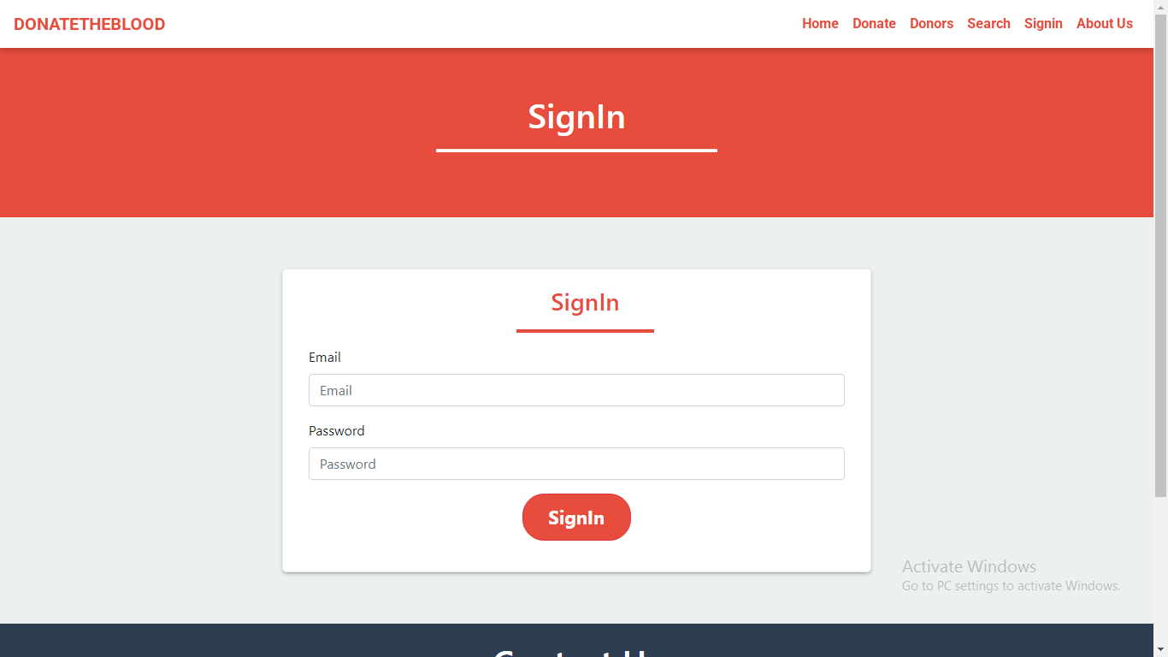
Figure 2.2 User Registration & Login Page

- Donor Management
- Tested profile creation, updating, and deletion.
- Checked if donors can search for blood groups and filter results by location.
- Verified that donation status is updated correctly.
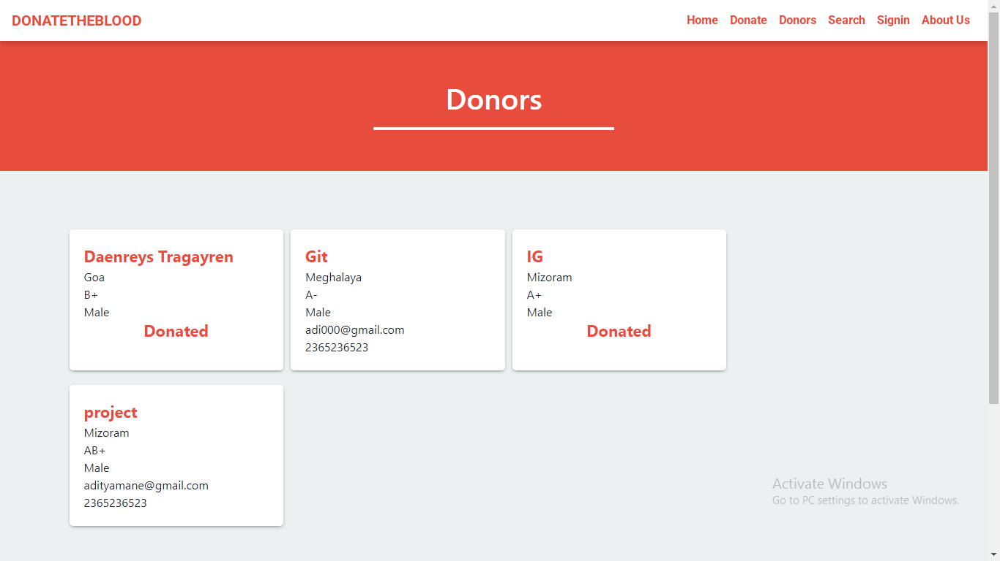

Figure 2.3 Donors

- Blood Donor Search
- Ensured users can search for donors based on blood group and state.
- Checked that results display accurate donor information.
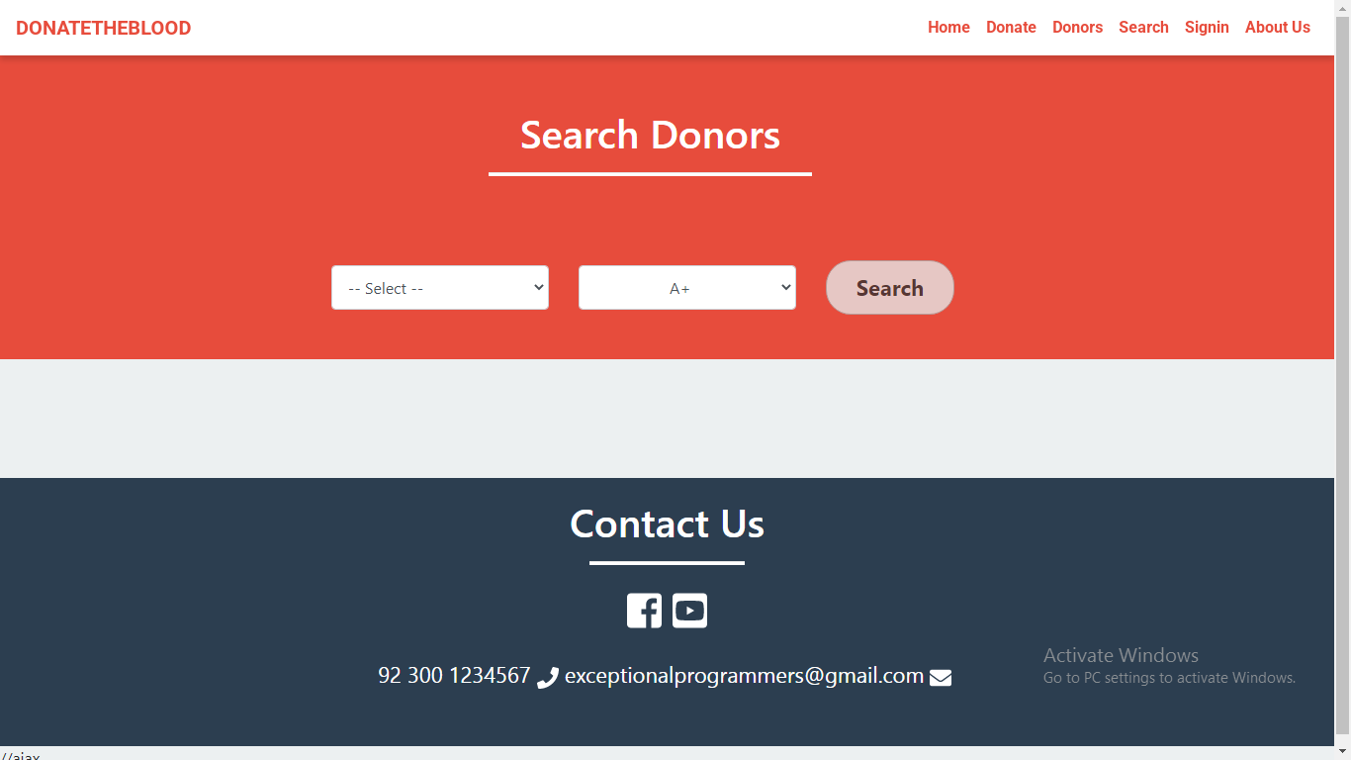

Result:
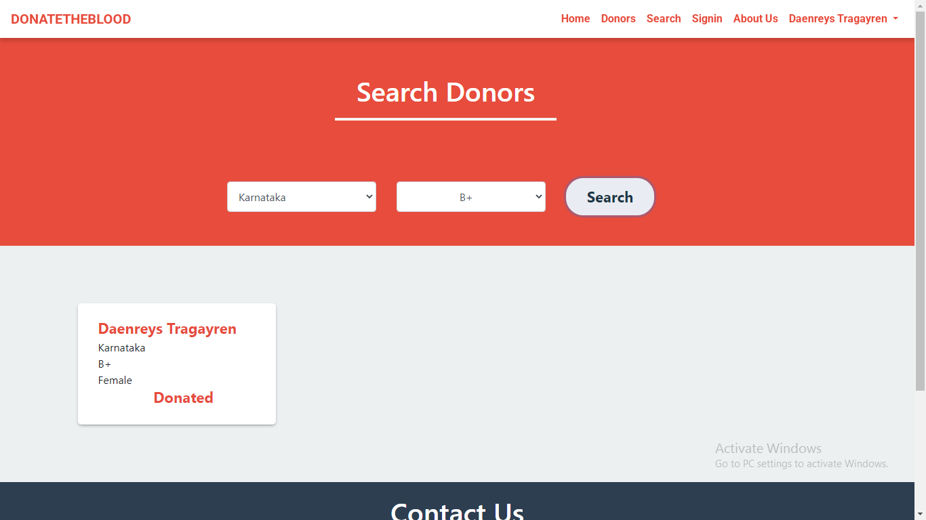
Figure 2.4 Search Donors

- Profile Management
- Users can update their personal information (name, email, blood group, location, etc.).
- Users have the option to delete their account permanently.
- All profile updates are saved instantly in the system.

Update Account:
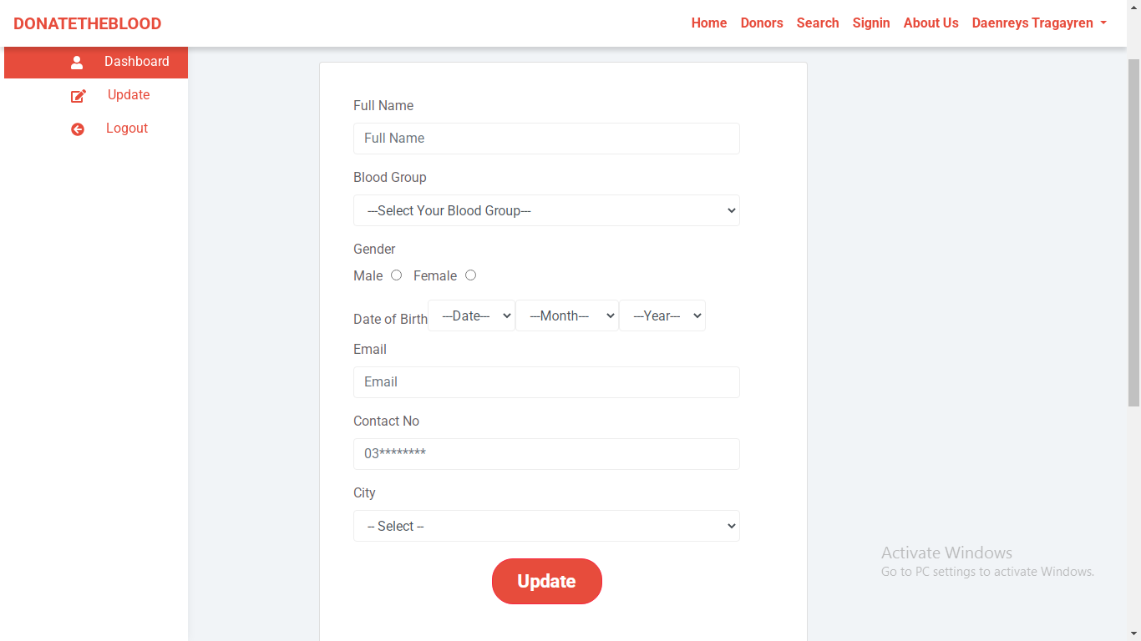
Figure 2.5 Update Account

Delete Account:
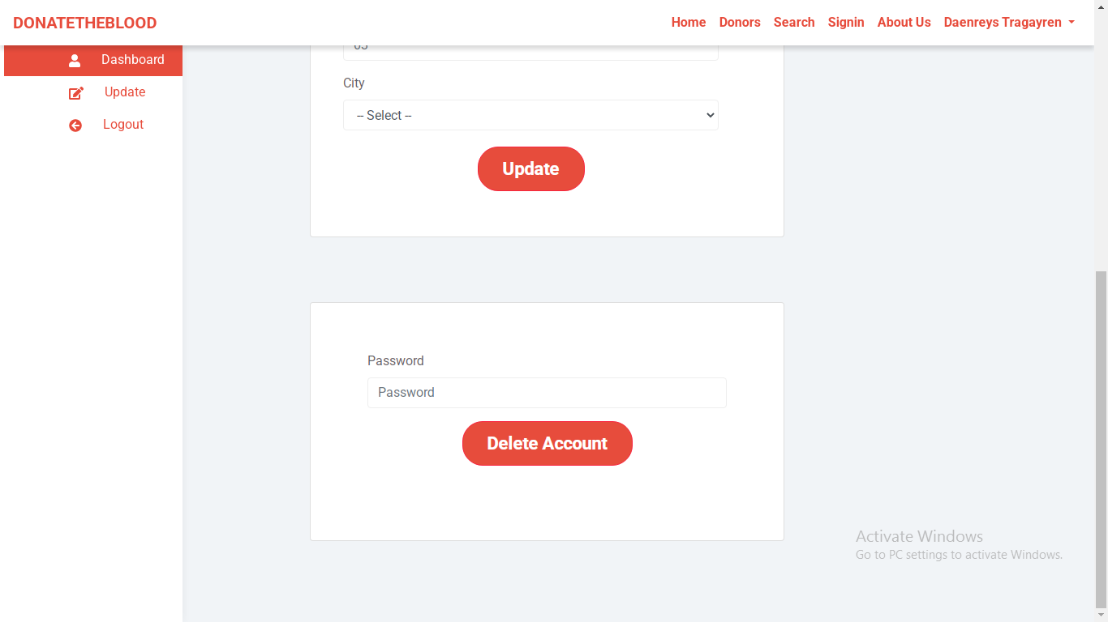

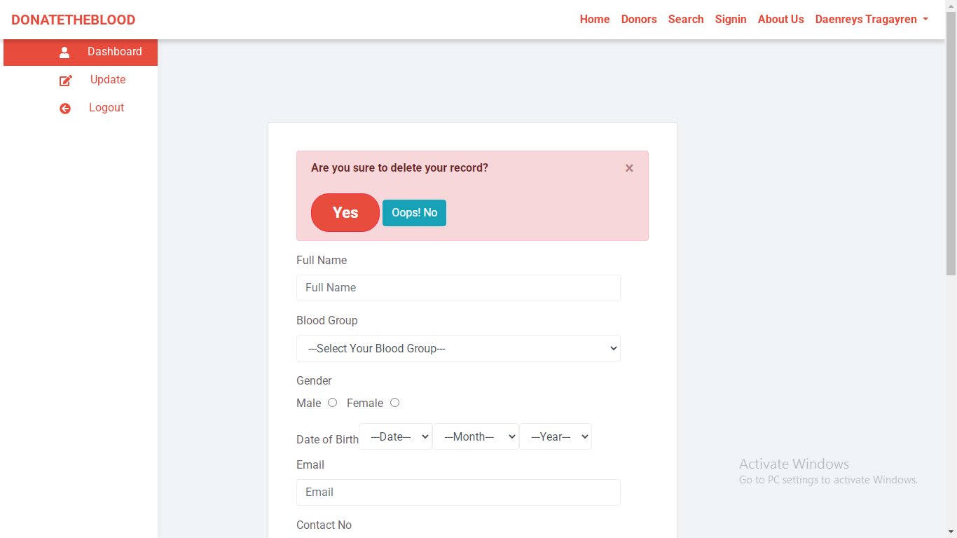

Figure 2.6 Delete Account

Notification Module
- Verified that donors receive reminders when they are eligible to donate again.
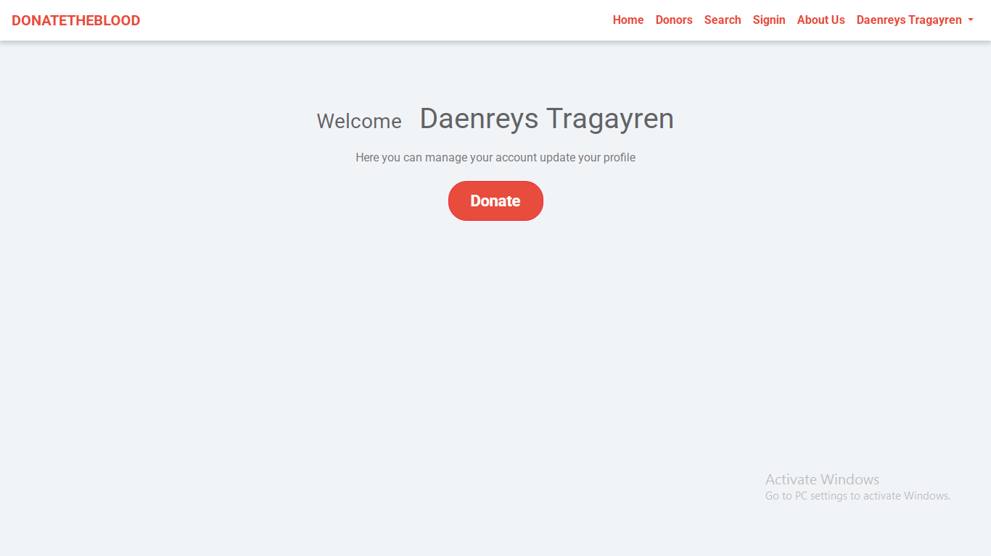

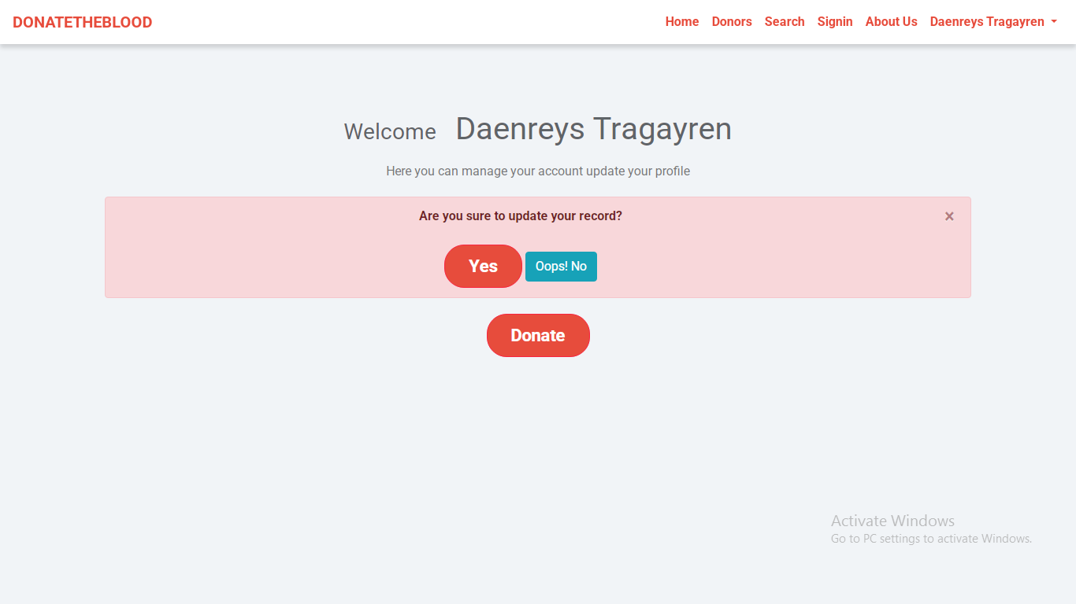

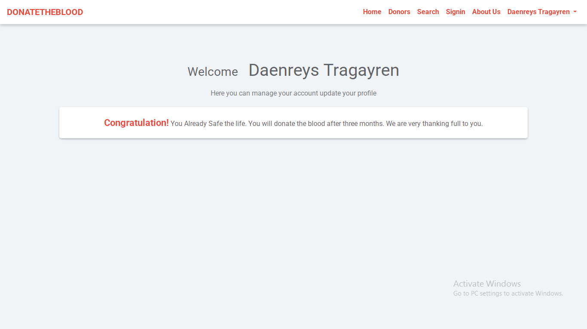
Figure 2.7 Donated User

TEST-CASES

- User Registration & Authentication Module
Test Case ID: 001
Description: Verify that clicking the "Login" button redirects the user to the login page.
Preconditions:
[1] User is on the homepage.
[2] "Login" button is visible.
Steps:
[1] Click the "Login" button.
Expected Result:
[1] User is redirected to the login page.
Actual Result:
[1] To be filled after execution.

Test Case ID: 002
Description: Verify that new users can register with valid details.
Preconditions:
[1] User is on the registration page.
Steps:
[1] Fill in Name, Email, Gender, DOB, City, Blood Group, and Password.
[2] Click "Register".
Expected Result:
[1] Account created successfully and redirected to login.
Actual Result:
[1] To be filled after execution.

- Patient Management Module
Test Case ID: 003
Description: Verify successful patient data storage upon registration.
Preconditions:
[1] User fills the registration form.
Steps:
[1] Submit valid patient details.
[2] Check patient is listed in the database.
Expected Result:
[1] Patient data saved successfully.
Actual Result:
[1] To be filled after execution.

- Blood Donor Search Module
Test Case ID: 004
Description: Verify that a user can search for donors by blood group and state.
Preconditions:
[1] User is logged in.
[2] On "Search Donor" page.
Steps:
[1] Select blood group and state.
[2] Click "Search".
Expected Result:
[1] List of matching donors is displayed.
Actual Result:
[1] To be filled after execution.

- Profile Management Module
Test Case ID: 005
Description: Verify that a user can update their profile information.
Preconditions:
[1] User is logged in.
[2] On "Profile" page.
Steps:
[1] Modify fields like phone number or city.
[2] Click "Update".
Expected Result:
[1] Profile updated successfully.
Actual Result:
[1] To be filled after execution.

Test Case ID: 006
Description: Verify that a user can delete their account.
Preconditions:
[1] User is logged in.
Steps:
[1] Click on "Delete Account".
[2] Confirm deletion.
Expected Result:
[1] Account is permanently deleted.
Actual Result:
[1] To be filled after execution.

- Notification Module
Test Case ID: 007
Description: Verify that the user receives donation eligibility reminder after 3 months.
Preconditions:
[1] User has donated blood at least once.
Steps:
[1] Wait for 3 months to pass after last donation.
[2] Check if notification is triggered.
Expected Result:
[1] Notification alert is shown or sent to the user.
Actual Result:
[1] To be filled after execution.

FUTURE SCOPE
- Mobile Application Development – Expanding the system into a mobile app for easier donor registration and real-time notifications.
- AI-Based Donor Matching – Implementing smart algorithms to suggest the nearest and most suitable donors based on availability and past donation history.
- Real-Time Blood Availability Tracking – Integrating with hospitals and blood banks to provide live updates on available blood units.
- Automated Donation Reminders – Enhancing the notification system to automatically remind donors when they become eligible again.
- Multi-Language Support – Adding regional language options to make the system more accessible to a larger audience.
- Integration with Healthcare Systems – Connecting with hospital databases to ensure faster and more accurate donor-recipient matching.
- Emergency Request Feature – Implementing an urgent request button to notify nearby donors instantly in case of emergencies.

CONCLUSION
The Blood Bank Management System provides an effective solution for managing blood donor information and connecting recipients with available donors. By allowing users to register, search for donors, update profiles, and receive donation reminders, the system ensures a quick and reliable process for blood donation.
Through secure authentication, real-time donor search, and automated notifications, the platform enhances efficiency, accessibility, and user engagement. Future improvements such as mobile app integration, AI-based donor matching, and hospital collaborations can further enhance the system, making blood donation more accessible and organized. This system plays a vital role in saving lives by ensuring timely blood availability.

REFERENCES

Books & Journals
- Jacob, S., & Kumar, R. (2018). Blood Bank Management Systems: Concepts and Implementation. Springer.
- Singh, A., & Mehta, P. (2021). Healthcare Information Systems and Blood Donation Management. CRC Press.

Research Papers
- Sharma, V., & Patel, A. (2020). Optimizing Blood Bank Management Systems Using Digital Technology. International Journal of Healthcare Technology.
- Ramesh, B., & Gupta, M. (2019). Challenges and Advancements in Online Blood Donation Systems. Journal of Medical Informatics.

Web Resources
- World Health Organization (WHO) – www.who.int
- National Blood Transfusion Council (NBTC), India – www.naco.gov.in/nbtc
- American Red Cross Blood Donation – www.redcrossblood.org
- ResearchGate – www.researchgate.net

CHAPTER 3
ON JOB TRAINING – 2 “JOB PORTAL (HIRRD)”
ABSTRACT

The Job Portal System is a web-based platform designed to bridge the gap between job seekers and recruiters by providing a seamless and interactive recruitment experience. The system offers two types of user roles: candidates and recruiters. Candidates can sign up, create profiles, search and filter job listings, apply for jobs by uploading resumes, and track their application status. Recruiters, on the other hand, can register their companies, post new job vacancies, view and manage applications, and download candidate resumes.

Developed using modern web technologies and powered by Supabase as the backend database, the platform ensures real-time data handling and secure authentication. The user interface is intuitive and responsive, allowing smooth navigation and efficient interaction. Key features include profile management, job filtering by company or location, real-time job posting and application tracking, and secure data operations.

The primary goal of the system is to streamline the hiring process, reduce manual efforts, and enhance the job-seeking experience. By providing a centralized portal for employment-related activities, the Job Portal helps improve the visibility of job opportunities and simplifies talent acquisition for organizations.

INTRODUCTION
A job portal is an online platform designed to connect job seekers with potential employers. It serves as a bridge where candidates can explore job opportunities, apply for positions, and manage their professional profiles, while recruiters can post job openings, search for suitable candidates, and manage their hiring processes.
In today’s digital age, job portals simplify the recruitment process by offering an efficient, centralized system where users can easily access relevant job listings or talent pools. Job seekers can filter jobs based on location, industry, or job type, while employers can access resumes, review applications, and communicate directly with candidates. This system reduces the time and effort involved in traditional job searches and recruitment, ultimately providing a more streamlined, effective hiring experience for both parties.
The job portal is an essential tool for job seekers looking for new opportunities and companies seeking the right talent to fill their vacancies, making the entire hiring process faster, easier, and more accessible.

EXISTING SYSTEM AND LITERATURE SURVEY

Existing System
The current job portal systems are often fragmented and lack integration, making it difficult for both job seekers and employers to efficiently connect with each other. Many existing platforms require candidates to manually search for jobs based on limited filters, which can be time-consuming and lead to missed opportunities. Similarly, recruiters face challenges when trying to manage applications across multiple platforms, often dealing with inconsistent data and outdated resumes.
In the existing system, candidates have to individually apply to each job posting, upload resumes, and sometimes even manually track their applications, leading to a lack of visibility and progress updates. Recruiters, on the other hand, often struggle to access a diverse pool of candidates due to the limitations in search filters and the absence of automated matching systems, which can result in a slower recruitment process. Additionally, job seekers may not have the ability to filter job listings effectively by location, company, or other preferences, reducing the overall efficiency of the system.
Moreover, some job portals fail to provide advanced features such as personalized job recommendations, automated interview scheduling, or candidate messaging, which further delays the hiring process. The lack of integration between job seekers' profiles and employers' job postings also limits the seamless exchange of information, leading to inefficiencies for both parties.
These challenges highlight the need for an efficient and integrated job portal system. Such a system would streamline the recruitment process by offering better matching of candidates and jobs, real-time application tracking, advanced search filters, and automated communication tools, ultimately enhancing the overall user experience for both job seekers and recruiters.

Literature Survey

An Efficient Job Portal Recommendation System Using Machine Learning Techniques

Authors: D. Suganthi, M. Sharmila, S. Banu Priya (2021)

In the paper "An Efficient Job Portal Recommendation System Using Machine Learning Techniques," the authors propose an intelligent job recommendation system to enhance job matching between candidates and employers. The study emphasizes the role of machine learning algorithms in improving the accuracy and relevance of job recommendations. Key points discussed include:

Datasets: The paper utilizes real-time job listings and user profiles for training and testing the model. The authors highlight the importance of structured and labeled datasets that include candidate skills, location preferences, and job history to improve model performance.

Techniques: Several machine learning algorithms were explored, including decision trees, Naive Bayes, and support vecto machines. The system also employs content-based filtering and collaborative filtering methods to provide personalized job suggestions.

Performance: The models were evaluated using metrics like precision, recall, and accuracy. The authors found that hybrid recommendation techniques performed better compared to single method approaches in terms of user satisfaction and engagement.

Challenges: The study identifies challenges such as handling large volumes of data, dealing with incomplete or noisy profiles, and ensuring real-time performance. The paper also points out the difficulty of aligning candidate expectations with job descriptions due to inconsistent data.

A Survey on E-Recruitment System and Its Benefits

Authors: Smita Chavan, Sushma Bhutada (2019)

In the paper "A Survey on E-Recruitment System and Its Benefits," the authors discuss the growing adoption of e-recruitment platforms and how they transform traditional hiring processes. The paper explores the structure and advantages of online recruitment systems used by companies to streamline hiring. Key aspects include:

Scope:
The study reviews the use of web-based portals and mobile apps for recruitment, highlighting how digital platforms help in reaching a wider pool of applicants.

Features:
It focuses on the integration of features such as resume parsing, job alerts, application tracking, and automated interview scheduling. These features increase recruiter efficiency and enhance the applicant experience.

Benefits:
The paper emphasizes benefits like cost reduction, improved hiring speed, and better candidate quality. Employers can sort applications quickly, while job seekers can apply for multiple jobs with ease.

Challenges:
The authors mention data privacy concerns, system integration with internal HR tools, and lack of personalization as key challenges faced by many portals.

PROBLEM STATEMENT AND OBJECTIVES

Problem Definition/Aim of the Project
The job market is vast and often difficult to navigate for both job seekers and employers. Candidates face challenges in finding suitable jobs that match their skills and preferences, while recruiters struggle to reach the right talent in a timely manner. There is a need for an efficient system that streamlines the job application process for candidates and job posting process for recruiters.
The project aims to:

Challenges
- Secure User Authentication – Ensuring candidates and recruiters can log in safely without unauthorized access.
- Profile Data Accuracy – Maintaining up-to-date and accurate profiles for both candidates and recruiters.
Limitations
- Limited Verification of Job Listings – Difficult to completely prevent fake job postings or fraudulent recruiters.
- Dependency on User Activity – The portal's effectiveness depends on active job postings and applications.
Application
- Job Searching & Recruitment – Helps candidates find job opportunities and recruiters hire suitable candidates.
- Resume & Profile Management – Allows candidates to create, update, and manage their resumes and profiles.
- Job Posting & Company Branding – Enables recruiters to post job openings and promote their companies.

REQUIREMENTS

Hardware Requirements
- Processor: Intel Core i3 or equivalent
- RAM : 4GB
- Storage : 100GB SDD
- Display:1366x768 resolution
Software Requirements
- Operating System : Windows 10/11, macOS, Linux (Ubuntu preferred)
- Frontend Technologies : HTML, CSS, JavaScript, React.js
- Backend Technologies : Node.js with Express.js
- Database : Supa base
- Version Control : Git, GitHub/GitLab/Bitbucket
- Package Manager : npm
- IDE/Code Editor : VS Code, Sublime Text, or IntelliJ IDEA
- Browser : Google Chrome, Firefox, or Edge

Functional Requirements
- User Authentication & Management
- Sign-up and login for candidates and recruiters.
- Secure password management and account recovery options.
- Candidate Features
- Create and update profile with personal details, skills, and experience.
- Upload, edit, and manage resumes.
- Search and filter jobs based on location, company, salary, experience, and job type.
- Apply for jobs with a resume and cover letter.
- Track application status and receive notifications.
- Recruiter Features
- Create and update company profile.
- Post job vacancies with details like job role, salary, and requirements.
- Edit or delete job postings.
- View and manage candidate applications.
- Download candidate resumes and shortlist applicants.
- Job Search & Filtering
- Search jobs using keywords, categories, and filters.
- Display job details with description, requirements, and application process.
- Application Tracking System
- Allow candidates to track application status (Applied, Interviewing, Hired, Rejected).
- Enable recruiters to update and manage application progress.
- Mobile Responsiveness
- Ensure the platform works smoothly on mobile devices.
- Support mobile-friendly job search and application submission.

Non-Functional Requirements

Performance
- The system should load job listings and user profiles within 2 seconds.
- It should handle high traffic without performance issues.
- Scalability
- The portal should support thousands of users simultaneously.
- It should be able to scale horizontally by adding more servers if needed.
- Security
- User data (passwords, resumes) should be encrypted to prevent data breaches.
- Secure authentication mechanisms (e.g., OAuth, JWT tokens) should be used.
- Availability
- The system should have 99.9% uptime, ensuring it's available 24/7.
- A backup mechanism should be in place to restore data in case of failures.

SYSTEM DESIGN AND METHODOLOGY

Methodology
The development of the job portal follows a systematic approach to ensure efficiency, security, and scalability. It begins with requirement analysis, where user needs are gathered and functional and non-functional requirements are defined. Next, in the system design phase, UI/UX mock-ups are created, and the database schema is structured to manage user profiles, job postings, and applications effectively. The technology selection phase identifies the appropriate stack, including React.js for the frontend, Node.js with Express.js for the backend, Supa base for the database. The development phase involves implementing core functionalities such as authentication, job search, job posting, application submission, and recruiter dashboards. Once development is complete, the testing phase ensures the portal functions correctly through unit, integration, and user acceptance testing. After successful testing, the deployment phase hosts the system on cloud platforms like AWS, Firebase, or Heroku, ensuring security measures such as HTTPS encryption. Lastly, the maintenance and updates phase includes monitoring performance, fixing bugs, and rolling out new features based on user feedback. This structured methodology ensures a robust, user-friendly, and scalable job portal.

Software Architecture
The job portal follows a three-tier architecture consisting of the frontend, backend, and database layers.
The frontend is built using React.js, providing an interactive and responsive user interface. It handles user interactions such as job searches, profile management, and applications. The frontend communicates with the backend through RESTful APIs for seamless data exchange.
The backend is developed using Node.js and Express.js, responsible for handling authentication, job postings, application tracking, and other business logic. It ensures secure communication between the frontend and the database, processing requests efficiently.
The database layer utilizes Supabase (PostgreSQL) for storing user profiles, job listings, and applications. Supabase offers real-time updates, authentication, and secure data management, ensuring data consistency and reliability.

Database Design
- Companies Table
Stores details of companies registered by recruiters.
- ID
- Name
- Logo URL
- Created At
- Jobs Table
Stores job postings by recruiters.
- ID
- Title
- Description
- Location
- Requirements
- Company ID
- Recruiter ID
- Is Open (Boolean – Open/Closed)
- Created At
- Applications Table
Stores job applications submitted by candidates.
- ID
- Job ID
- Candidate ID
- Status (/Rejected)
- Resume (File URL)
- Skills
- Experience
- Education
- Candidate Name
- Created At
- Saved Jobs Table
Stores jobs saved by candidates for later application.
- ID
- User ID
- Job ID
- Created At

UI Design
The job portal’s UI design focuses on simplicity, responsiveness, and ease of use. The interface is structured to ensure seamless navigation for both candidates and recruiters. Below are the key UI components:
- Home Page
- Displays a search bar for quick job searches.
- Shows featured job postings and trending companies.
- Login/Sign-up buttons for candidates and recruiters.
- Sign-up & Login Page
- Separate login options for candidates and recruiters.
- Simple form with email, password, and authentication options.
- "Forgot Password" option for account recovery.
- Job Search Page (For Candidates)
- A search bar to enter job titles or keywords.
- Filters for location, company, job type, and salary range.
- Job listings displayed in a scrollable card format with key details.
- Clicking on a job opens the Job Details Page with an "Apply" button.
- Job Details Page
- Displays job title, company details, location, salary, and job description.
- Shows required qualifications and skills.
- "Apply Now" button with a resume upload option.
- Apply Job Page (For Candidates)
- Allows users to upload resumes and add a cover letter.
- Shows application status (Pending, Shortlisted, Rejected).
- Post Job Page (For Recruiters)
- Form to enter job title, description, qualifications, location, and salary range.
- Option to add company details and upload a company logo.
- "Post Job" button to make the job listing live.
- Applications Page (For Recruiters)
- Lists candidates who applied for a job.
- Shows each candidate’s resume, skills, and experience.
- Options to shortlist, reject, or download resumes.
- Profile Page
- Candidate Profile: Update personal details, upload resumes, and track applications.
- Recruiter Profile: Manage company information, view posted jobs, and access applicants.

Module Design
- User Module
The User Module manages user registration, authentication, and profile management, including sign-up for candidates and recruiters, login and logout, profile editing, and account deletion.
- Company Module
The Company Module handles company-related operations for recruiters, including adding a company, updating company details, and viewing company information.
- Job Management Module
The Job Module enables recruiters to manage job postings, including posting new jobs, editing job details, deleting jobs, and viewing posted jobs.
- Job Search & Filtering Module
The Job Search Module allows candidates to find and filter jobs based on various criteria, including searching by keywords, filtering by location and company, and viewing job details.
- Job Application Module
The Application Module manages job applications submitted by candidates, including applying for jobs with a resume upload, checking application status, and withdrawing applications.
- Saved Jobs Module
The Saved Jobs Module enables candidates to manage saved jobs, including saving jobs for later, removing saved jobs, and viewing the list of saved jobs.
- Recruiter Dashboard Module
The Application Management Module allows recruiters to manage applications for their job postings, including viewing applied candidates, downloading candidate resumes, and shortlisting or rejecting candidates.

ER DIAGRAM

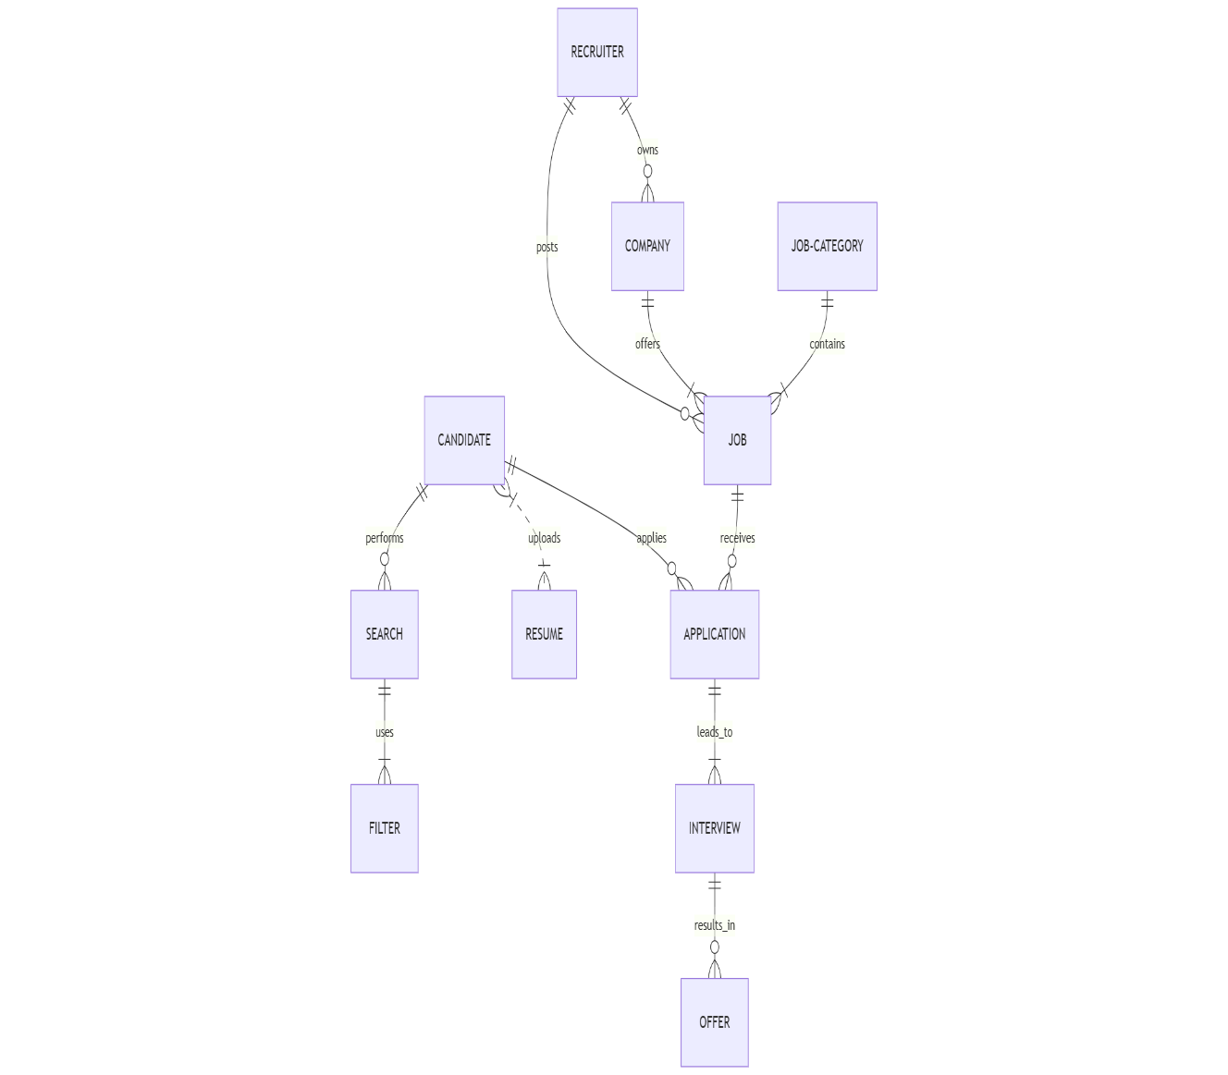

Figure 3.1 ER Diagram

PSUEDOCODE

// User Authentication

Function signUp(userDetails):
if userDetails are valid:
save userDetails in database
send confirmation email
return "Sign-up successful"
else:
return "Invalid details, please try again"

Function login(email, password):
if user exists in database and password matches:
create session for user
return "Login successful"
else:
return "Invalid credentials, please try again"

Function logout(userID):
end session for user
return "Logout successful"

// Candidate Profile Management

Function createProfile(candidateDetails):
if candidateDetails are valid:
save profile in database
return "Profile created successfully"
else:
return "Invalid profile details"

Function editProfile(candidateID, updatedDetails):
find candidate by candidateID
if candidate found:
update profile with updatedDetails
return "Profile updated successfully"
else:
return "Candidate not found"

// Job Posting (Recruiter)

Function postJob(recruiterID, jobDetails):
if recruiter is logged in:
save jobDetails in job database
return "Job posted successfully"
else:
return "Recruiter not logged in"

// Job Search (Candidate)

Function searchJobs(searchCriteria):
filter jobs in database based on searchCriteria
if jobs found:
return list of filtered jobs
else:
return "No jobs found.”

// Apply for a Job (Candidate)

Function applyForJob(candidateID, jobID, resume):
if resume is valid:
save application in database with candidateID, jobID, and resume
return "Application submitted successfully"
else:
return "Invalid resume"

// View Applications (Recruiter)

Function viewApplications(recruiterID, jobID):
if recruiter is logged in:
fetch applications for jobID
return list of candidates who applied
else:
return "Recruiter not logged in"

// Real-Time Application Tracking (Recruiter)
Function trackApplications(jobID):
fetch all applications for jobID
return list of applications with current status (pending, reviewed, etc.)

// Delete Job Posting (Recruiter)
Function deleteJob(recruiterID, jobID):
if recruiterID owns the job:
delete job posting from database
return "Job posting deleted successfully"
else:
return "Permission denied"

EXPERIMENTS AND RESULTS

User Registration & Login:

Candidates and recruiters registered successfully with unique emails.

Login was tested with valid and invalid credentials

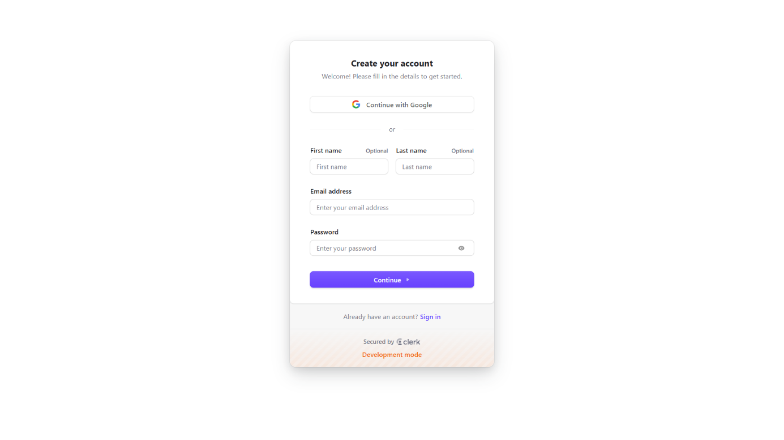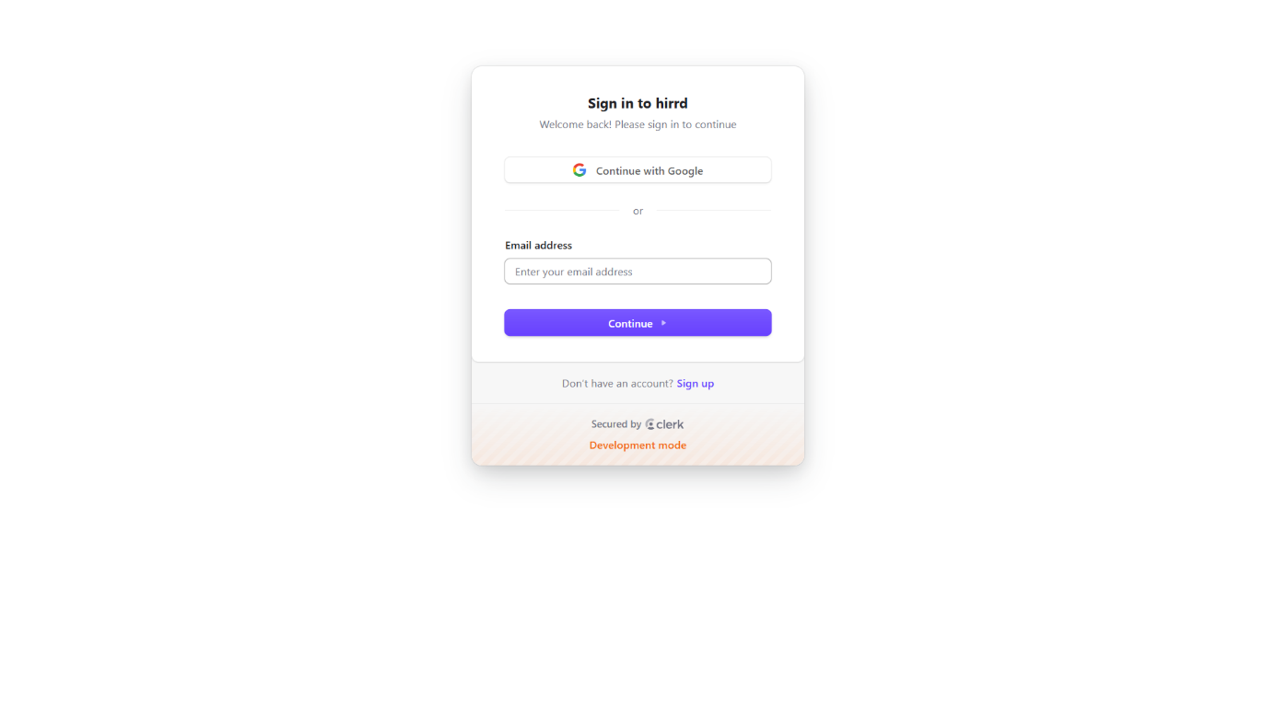

Figure 3.2 User Registration & Login Page

- Job Posting & Management:
- Recruiters successfully posted and deleted job listings.

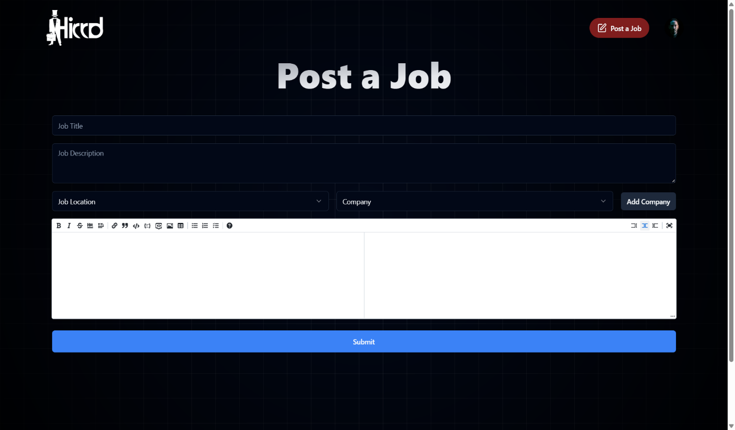

Figure 3.3 Post Job

- Job Search & Filtering:
- Candidates were able to search for jobs using keywords.
- Filtering jobs by location and company worked correctly.

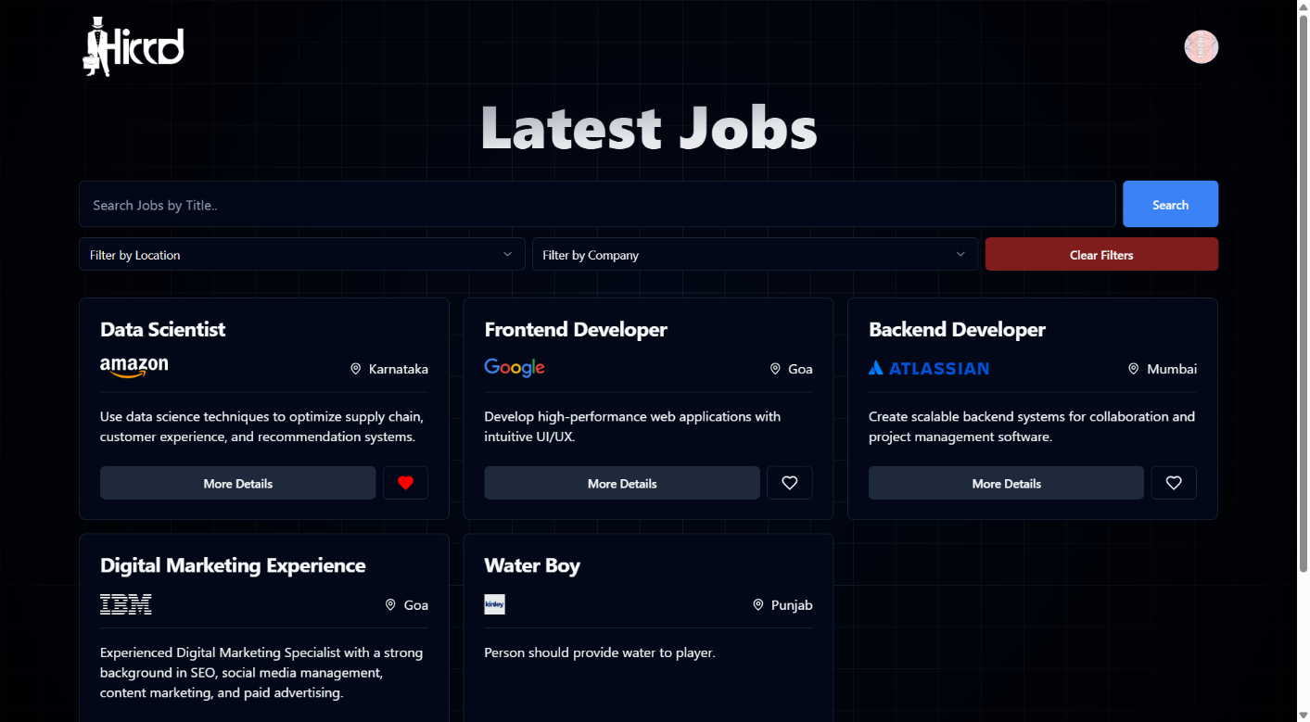

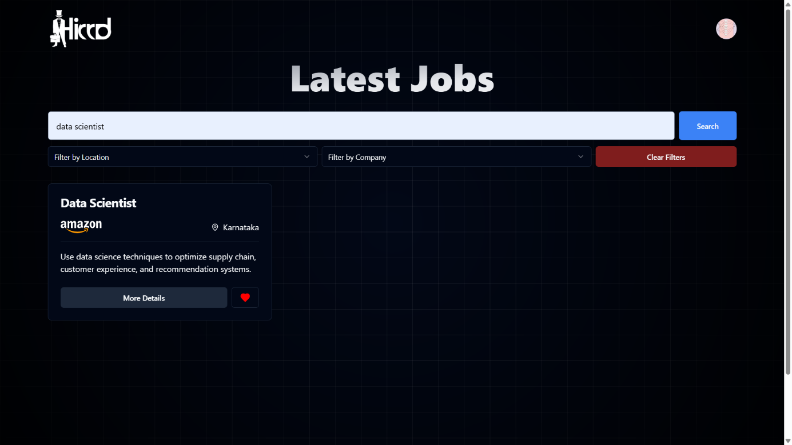

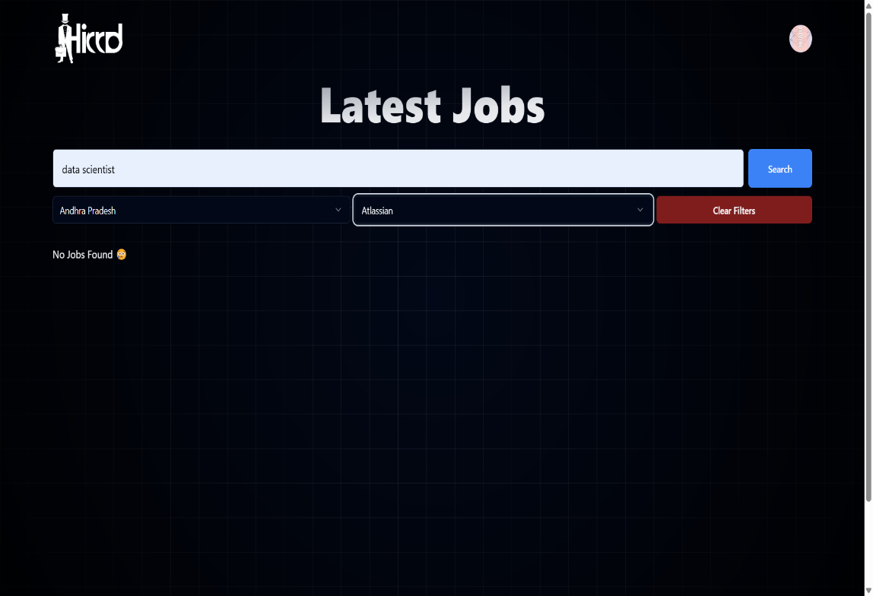

Figure 3.4 Search Jobs

- Job Applications:
- Candidates applied for jobs with resume uploads.
- Recruiters accessed applied candidates' resumes.

Candidates: -

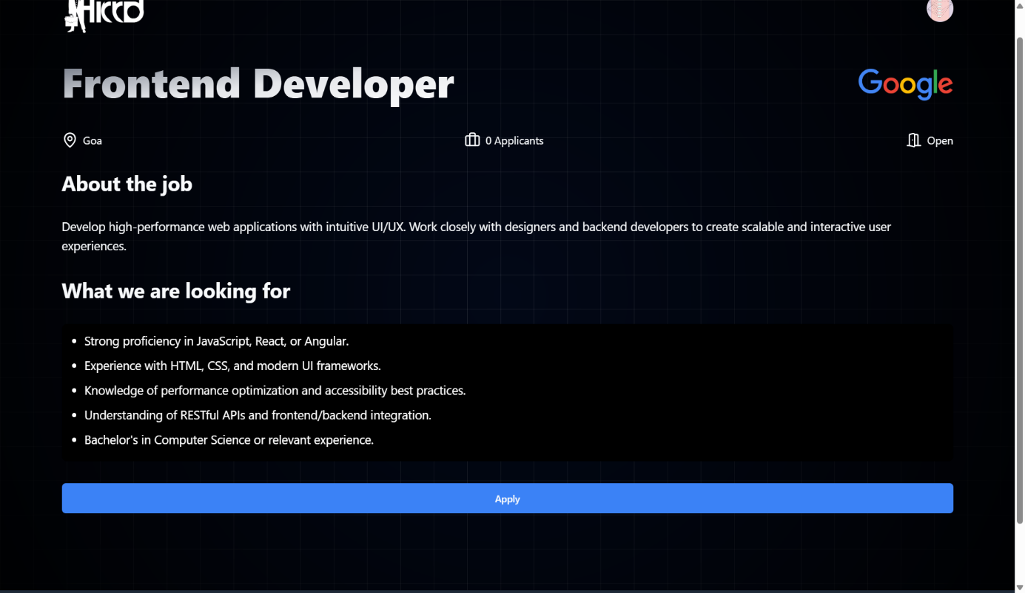

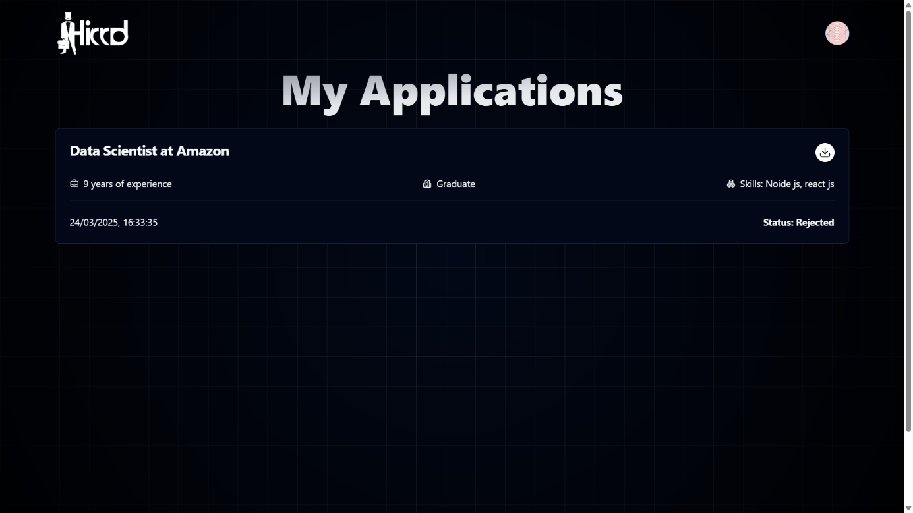

Figure 3.5 Applied For Job

Recruiter: -

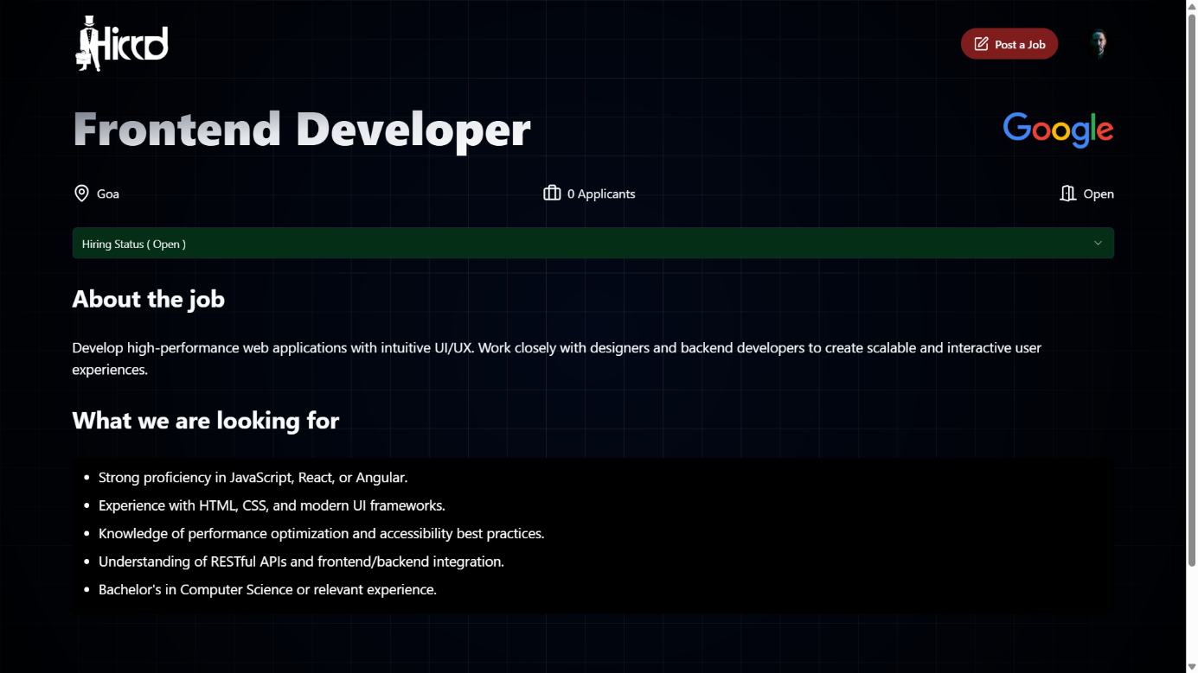

Figure 3.6 Job Status (Open / Closed)

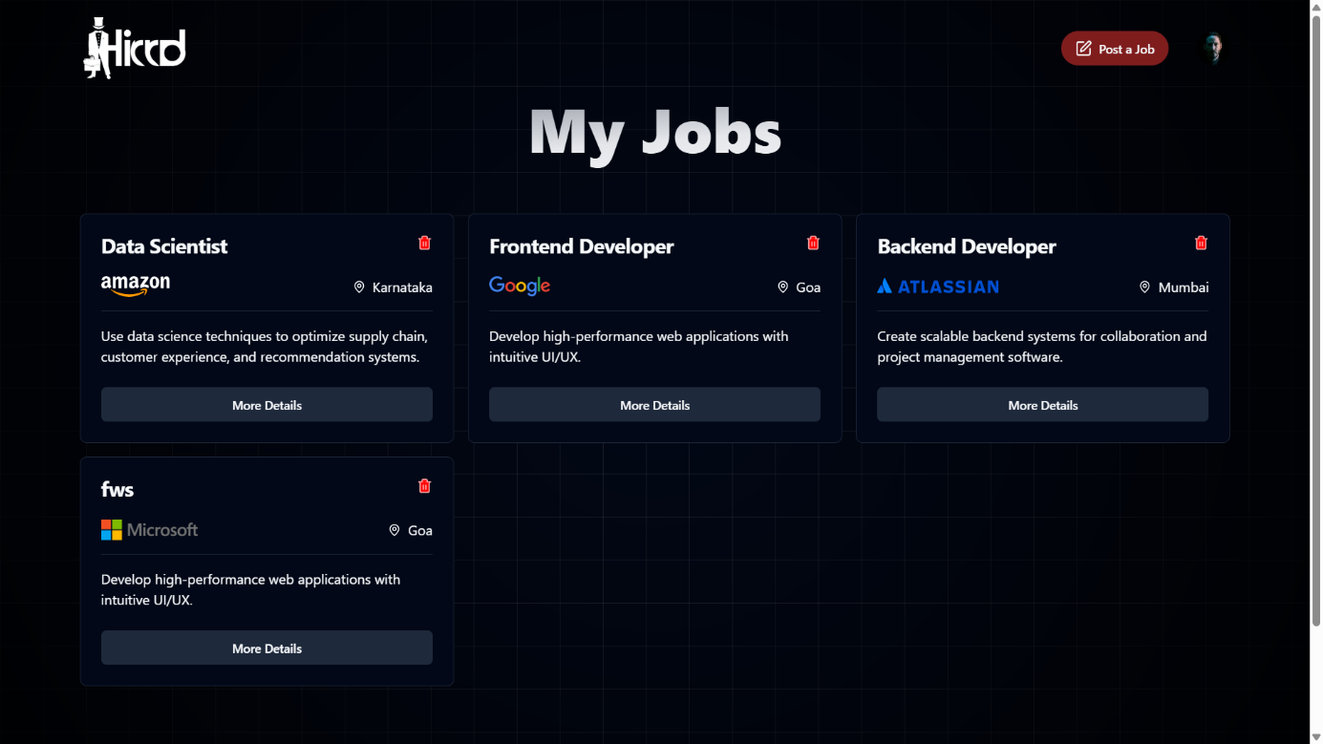

Figure 3.7 Delete Jobs

- Saved Jobs:
- Candidates successfully saved jobs and removed them from the saved list.

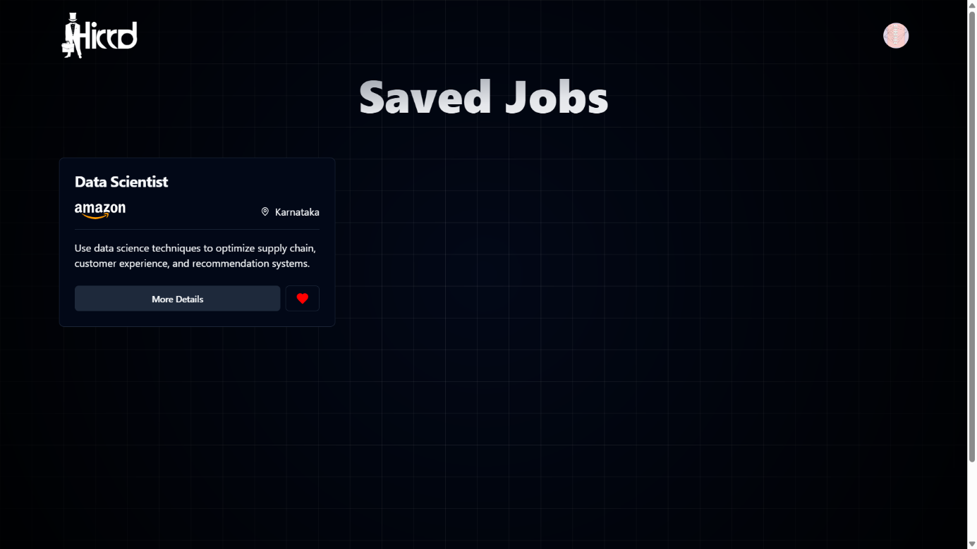

Figure 3.8 Saved Jobs

- Profile & Account Management:
- Users edited their profiles and deleted their accounts.

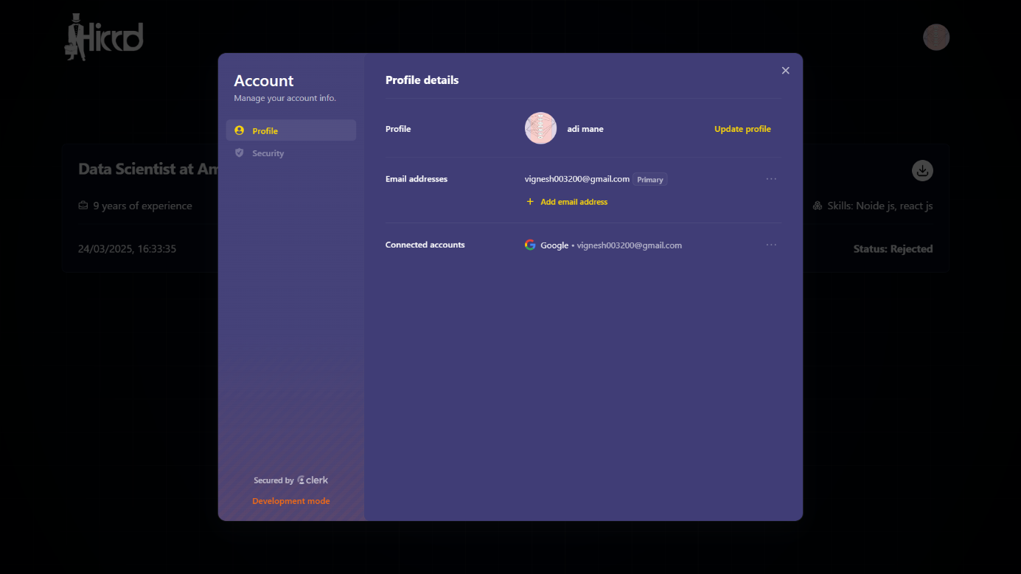

Figure 3.9 User Profile

TEST-CASES
User Authentication
Test Case ID: TC-01
Description: Register a new candidate with valid details.
Preconditions:
[1] User is on the registration page.
[2] All input fields (name, email, password) are visible and active.
Steps:
[1] Enter a valid name, email, and password.
[2] Click on the register/sign-up button.
Expected Result:
[1] User account should be created successfully.
Actual Result:
[1] To be filled after executing the test.
Status: Pass/Fail

Test Case ID: TC-02
Description: Register with an existing email.
Preconditions:
[1] User is on the registration page.
[2] The email is already present in the system.
Steps:
[1] Enter an existing email address.
[2] Fill in other fields and submit the form.
Expected Result:
[1] Error message should appear: "Email already exists".
Actual Result:
[1] To be filled after executing the test.
Status: Pass/Fail

Job Search & Filtering (Candidate)

Test Case ID: TC-03
Description: Search for a job using a keyword or job title.
Preconditions:
[1] User is logged in as a candidate.
[2] The search bar is visible and enabled.
Steps:
[1] Enter a job title or keyword in the search bar.
[2] Click on the search icon or press Enter.
Expected Result:
[1] A list of relevant job listings should appear based on the entered keyword.
Actual Result:
[1] To be filled after executing the test.
Status: Pass/Fail

Test Case ID: TC-04
Description: Filter jobs by both location and company.
Preconditions:
[1] Jobs are posted with associated location and company information.
[2] Location and company filters are visible and enabled.

Steps:
[1] Select a specific location from the location filter.
[2] Select a specific company from the company filter.
[3] Apply the filters.

Expected Result:
[1] Jobs matching both the selected location and company should be displayed.

Actual Result:
[1] To be filled after executing the test.

Status: Pass/Fail

Job Application (Candidate)

Test Case ID: TC-06
Description: Apply for a job with a resume uploaded.
Preconditions:
[1] Candidate is logged in.
[2] Resume is uploaded.
Steps:
[1] Select a job.
[2] Click “Apply” and attach the resume.
Expected Result:
[1] Application is submitted successfully.
Actual Result:
[1] To be filled after executing the test.
Status: Pass/Fail

Test Case ID: TC-07
Description: Check application status.
Preconditions:
[1] Candidate has applied for jobs.
Steps:
[1] Go to “My Applications” section.
Expected Result:
[1] Application status is shown (e.g., Applied, Interviewing, Hired, Rejected).
Actual Result:
[1] To be filled after executing the test.
Status: Pass/Fail

Job Posting (Recruiter)

Test Case ID: TC-08
Description: Post a new job.
Preconditions:
[1] Recruiter is logged in.
Steps:
[1] Fill job title, description, requirements, location.
[2] Click “Post Job”.
Expected Result:
[1] Job posted successfully and appears on listings.
Actual Result:
[1] To be filled after executing the test.
Status: Pass/Fail

Test Case ID: TC-09
Description: Delete a posted job.
Preconditions:
[1] Job is already posted by the recruiter.
Steps:
[1] Click on delete icon next to the job.
[2] Confirm deletion.
Expected Result:
[1] Job is removed from listings.
Actual Result:
[1] To be filled after executing the test.
Status: Pass/Fail

Candidate Management (Recruiter)

Test Case ID: TC-10
Description: View applied candidates.
Preconditions:
[1] Candidates have applied for jobs posted by recruiter.
Steps:
[1] Go to applications tab.
Expected Result:
[1] List of applied candidates and their resumes are visible.
Actual Result:
[1] To be filled after executing the test.
Status: Pass/Fail

Test Case ID: TC-11
Description: Download a candidate’s resume.
Preconditions:
[1] Resumes are available in applications.
Steps:
[1] Click the download button.
Expected Result:
[1] Resume is downloaded in PDF or DOCX format.
Actual Result:
[1] To be filled after executing the test.
Status: Pass/Fail

Profile Management

Test Case ID: TC-12
Description: Update candidate / recruiter profile.
Preconditions:
[1] Candidate is logged in.
Steps:
[1] Navigate to profile section, update details, and click save.
Expected Result:
[1] Profile is updated successfully.
Actual Result:
[1] To be filled after executing the test.
Status: Pass/Fail

Project Core Features

The Job Portal project is designed to streamline the recruitment process for both candidates and recruiters through a user-friendly web interface. The platform provides essential features such as user registration, job search, job posting, and candidate management. Users are required to sign up to apply for jobs and manage their profiles, while browsing and searching for jobs can be done without logging in. The sign-up and sign-in modules include a secure registration form, login panel, and a "Forgot Password" option to reset user credentials if needed.
Once a candidate logs in, they are directed to a candidate dashboard, where they can view and manage their job applications, saved jobs, and update their profile. The account settings feature allows candidates to modify personal information, change passwords, and upload resumes. The dashboard also includes application tracking to monitor the status of each job they have applied for, such as “Applied,” “Interviewing,” “Hired,” or “Rejected.”
The job search functionality lets users search for jobs using keywords, job titles, or company names. Advanced search filters help users refine their search by location or company, ensuring that relevant job listings are displayed. Additionally, jobs can be explored by category, making it easier for users to navigate based on their domain of interest.
Candidates can apply for jobs directly through the job details page by submitting a resume. The system ensures that no application is submitted without a resume, providing relevant error messages when required. A confirmation message is shown once the application is successfully submitted.
For recruiters, logging in leads to a recruiter dashboard where they can manage all aspects of recruitment. This includes posting new jobs with details such as title, description, location, and required qualifications. Recruiters can also edit or delete job listings at any time. The platform also supports company management, allowing recruiters to create and update company profiles, including the company name and logo, which are visible on job listings.
Candidate management is another crucial feature for recruiters. It allows them to view the list of applicants for each job post, download resumes, and shortlist candidates based on their qualifications. Recruiters can update application statuses to reflect progress in the hiring process, providing transparency and organization.

FUTURE SCOPE
- AI-Powered Job Matching
Implementing machine learning algorithms to match candidates with jobs based on their skills, experience, and preferences.
- Advanced Filtering and Search
Integrating natural language processing (NLP) to allow for more flexible and intuitive search queries.
- Real-Time Notifications & Alerts
Adding SMS or email alerts for candidates when jobs matching their profile are posted.
- Video Interviews & Integration
Offering recorded video interviews as part of the application process for candidates to present themselves better.
- Advanced Analytics & Reporting for Recruiters
Enabling recruiters to track the success of job ads and optimize recruitment strategies.
- Social Media Integration
Allowing users to sign up or log in via social media platforms like LinkedIn.
- Employer Branding Tools
Helping employers attract candidates by highlighting the benefits of working for their organization.
- Integration with Job Marketplaces
Partnering with other job marketplaces or job boards to increase job listing visibility.

CONCLUSION
The development of a job portal presents several challenges that need to be carefully addressed to create a seamless and efficient platform for both job seekers (candidates) and employers (recruiters). Key challenges include user authentication, profile management, job search functionality, resume handling, and ensuring secure, real-time application tracking. Additionally, managing user roles and ensuring scalability and performance will be critical for the platform's long-term success.
By overcoming these challenges, the job portal will be able to deliver a user-friendly experience, helping candidates find suitable jobs and recruiters discover qualified talent quickly and efficiently. The ultimate goal is to provide an intuitive, secure, and scalable platform that enhances the job-seeking and recruitment processes for both parties, contributing to a more effective and streamlined job market.

REFERENCES

Research Papers
- Han, L., Yang, K., & Zhang, Z. (2022). A Survey on Legal Judgment Prediction: Datasets, Metrics, Models, and Challenges. arXiv preprint arXiv:2204.12544.
- Suganthi, D., Sharmila, M., & Priya, S. B. (2021). An Efficient Job Portal Recommendation System Using Machine Learning Techniques. In 2021 International Conference on Intelligent Computing and Control Systems (ICICCS). IEEE.

Books
- Ian Goodfellow, Yoshua Bengio, and Aaron Courville. (2016). Deep Learning. MIT Press.
- E. Balagurusamy. (2019). Programming with Java. McGraw Hill Education.
- Jeffrey D. Ullman, & Jennifer Widom. (2008). A First Course in Database Systems. Pearson.
Web Sources
- Supabase Docs. (2025). The Open Source Firebase Alternative. Available at: https://supabase.com/docs
- W3Schools. (2025). HTML, CSS, JavaScript Tutorials. Available at: https://www.w3schools.com
- Mozilla Developer Network (MDN). (2025). Web Docs for JavaScript and Web APIs. Available at: https://developer.mozilla.org

CHAPTER 4

USE-CASES

Use Case 1: User Login
Actors: User
Preconditions:
- The user is on the homepage of the website or application.
- The "Login" button is visible on the navigation bar or a designated section.
Steps:
- The user navigates to the homepage.
- The user clicks the "Login" button.
- The system redirects the user to the login page.
- The user enters their email and password.
- The user clicks the "Submit" button.
Postconditions:
- The system validates the credentials.
- If valid, the user is redirected to their dashboard.
- If invalid, an error message is displayed.

Use Case 2: User Registration (Sign Up)
Actors: New User
Preconditions:
- The user is on the homepage of the website or application.
- The "Sign Up" button is visible on the navigation bar or a designated section.
Steps:
- The user navigates to the homepage.
- The user clicks on the "Sign Up" button.
- The system displays the sign-up form with fields for Name, Email, Password, Blood Group, and State.
- The user enters valid details in all fields.
- The user clicks the "Submit" button.
Postconditions:
- The system validates the inputs and creates a new account.
- The user is redirected to a confirmation page or their dashboard.

Use Case 3: Blood Donation Request
Actors: Logged-in User
Preconditions:
- The user is logged into the website or application.
- The "Donate Blood" button is visible and enabled.
Steps:
- The user navigates to the "Donate Blood" button.
- The user clicks the "Donate Blood" button.
- The system displays a form asking for blood donation details (availability, location, and preferred date).
- The user fills in the required details and clicks "Submit."
Postconditions:
- The system stores the donation details in the database.
- The user receives a confirmation message.

Use Case 4: Search for Donors
Actors: Any User
Preconditions:
- The user is on the homepage or logged into the application.
- The "Search Donors" feature is visible and enabled.
Steps:
- The user clicks on the "Search Donors" option.
- The system displays a search form with filters for Blood Group and State.
- The user selects the required Blood Group and State.
- The user clicks the "Search" button.
Postconditions:
- The system fetches and displays a list of matching donors.
- The user can view donor profiles and contact details.
Use Case 5: View Donor List
Actors: Logged-in User
Preconditions:
- The user is logged into the website or application.
- The "View Donors" button is visible and enabled.
Steps:
- The user navigates to the "View Donors" button.
- The user clicks the "View Donors" button.
Postconditions:
- The system displays a list of all available donors.
- The user can filter the list based on Blood Group and State.

STUDENT PROFILE/RESUME
NAME: - ADARSH GAJANAN KOKANE E-MAIL: kokaneadarsh@gmail.com

DIPLOMA BRANCH: - Computer Science CONTACT NO: - 9740637067 COLLEGE:- K.L.E SOCIETY’S C. B. KORE POLYTECHNIC, CHIKODI
ADDRESS: - Chikodi - 591201

AGGREGATE: - 67.80

Career Objectives: -

To secure a challenging position in a reputable organization where I can utilize my skills, contribute to the company's success, and grow both professionally and personally

Educational Qualification: -

a) Diploma in Computer Science and Engineering:-

SEM | INSTITUTE/BOARD | YEAR OF PASSING | CLASS OBATAINED | PERCENTAGE%/SGPA
6TH | 339 – [ K L E SOCIETY’S C B KORE POLYTECHNIC  CHIKODI]
5TH | 339 – [ K L E SOCIETY’S C B KORE POLYTECHNIC  CHIKODI] | Nov/Dec-2024 | First Class | 7.00
4TH | 339 – [ K L E SOCIETY’S C B  KORE POLYTECHNIC CHIKODI] | Apr/May-2024 | Distinction | 8.00
3RD | 339 – [ K L E SOCIETY’S C B KORE POLYTECHNIC  CHIKODI] | Nov/Dec-2023 | Distinction | 8.08
2ND | 339 – [ K L E SOCIETY’S C B  KORE POLYTECHNIC CHIKODI] | Apr/May-2023 | Distinction | 7.82
1ST | 339 – [ K L E SOCIETY’S C B KORE POLYTECHNIC  CHIKODI] | Nov/Dec-2022 | First Class | 6.44

Software efficiency: -

Language | JAVA, CSS, JS
Packages | CAD

Project profile: -
Title: Purpose of Jobs
Abstract: Jobs play a vital role in shaping both individual lives and society as a whole. They offer a platform for people to utilize their talents, grow professionally, and become financially independent. Employment not only ensures economic stability but also drives creativity and innovation. This project highlights the importance of jobs in empowering individuals and contributing to the progress of communities.
Personal profile: -

Name : Adarsh kokane

Father name : Gajanan

Mother name : Lata

Nationality : Indian

DOB : 02/05/2006

Hobbies : Driving, Framing, Travelling

Language known : Kannada, English, Hindi, Marathi

Marital status : Single

Alternate contact no :9740637067

Declaration:-

I hereby informed that above mentioned details are true the best of my knowledge.

Place: -Yadurwadi Adarsh Gajanan kokane
(student name)

STUDENT PROFILE/RESUME
NAME: - ADITYA TIPPANNA MANE E-MAIL: adityamane0320@gmail.com

DIPLOMA BRANCH: - Computer Science CONTACT NO: - 9482743546 COLLEGE:- K.L.E SOCIETY’S C. B. KORE POLYTECHNIC, CHIKODI
ADDRESS: - Chikodi - 591201

AGGREGATE: - 90.40

Career Objectives: -

To secure a challenging position in a reputable organization where I can utilize my skills, contribute to the company's success, and grow both professionally and personally

Educational Qualification: -

a) Diploma in Computer Science And Engineering:-

SEM | INSTITUTE/BOARD | YEAR OF PASSING | CLASS OBATAINED | PERCENTAGE%/SGPA
6TH | 339 – [ K L E SOCIETY’S C B KORE POLYTECHNIC  CHIKODI]
5TH | 339 – [ K L E SOCIETY’S C B KORE POLYTECHNIC  CHIKODI] | Nov/Dec-2024 | Distinction | 10.00
4TH | 339 – [ K L E SOCIETY’S C B  KORE POLYTECHNIC CHIKODI] | Apr/May-2024 | Distinction | 9.92
3RD | 339 – [ K L E SOCIETY’S C B KORE POLYTECHNIC  CHIKODI] | Nov/Dec-2023 | Distinction | 9.85
2ND | 339 – [ K L E SOCIETY’S C B  KORE POLYTECHNIC CHIKODI] | Apr/May-2023 | Distinction | 9.45
1ST | 339 – [ K L E SOCIETY’S C B KORE POLYTECHNIC  CHIKODI] | Nov/Dec-2022 | Distinction | 9.67

Software efficiency: -

Language | JAVA, CSS, JS
Packages | CAD

Project profile: -
Title: Purpose of Jobs
Abstract: Jobs play a vital role in shaping both individual lives and society as a whole. They offer a platform for people to utilize their talents, grow professionally, and become financially independent. Employment not only ensures economic stability but also drives creativity and innovation. This project highlights the importance of jobs in empowering individuals and contributing to the progress of communities.
Personal profile: -

Name : Aditya Mane

Father name : Tippanna

Mother name : Pratibha

Nationality : Indian

DOB : 05/06/2006

Hobbies : E-sports, Watching Movies

Language known : Kannada, English, Hindi, Marathi

Marital status : Single

Alternate contact no :9482743546

Declaration:-

I hereby informed that above mentioned details are true the best of my knowledge.

Place: -Nipani Aditya Tippanna Mane
(student name)

STUDENT PROFILE/RESUME
NAME: - PRATHAMESH DEVARKAR E-MAIL: prathameshdevarkar05@gmail.com

DIPLOMA BRANCH: - Computer Science CONTACT NO: -8424993647 COLLEGE:- K.L.E SOCIETY’S C. B. KORE POLYTECHNIC, CHIKODI
ADDRESS: - Chikodi - 591201

AGGREGATE: - 75.30%

Career Objectives: -

To secure a challenging position in a reputable organization where I can utilize my skills, contribute to the company's success, and grow both professionally and personally

Educational Qualification: -

a) Diploma in Computer Science and Engineering:-

SEM | INSTITUTE/BOARD | YEAR OF PASSING | CLASS OBATAINED | PERCENTAGE%/SGPA
6TH | 339 – [ K L E SOCIETY’S C B KORE POLYTECHNIC  CHIKODI]
5TH | 339 – [ K L E SOCIETY’S C B KORE POLYTECHNIC  CHIKODI] | Nov/Dec-2024 | Distinction | 7.00
4TH | 339 – [ K L E SOCIETY’S C B  KORE POLYTECHNIC CHIKODI] | Apr/May-2024 | Distinction | 8.54
3RD | 339 – [ K L E SOCIETY’S C B KORE POLYTECHNIC  CHIKODI] | Nov/Dec-2023 | Distinction | 8.85
2ND | 339 – [ K L E SOCIETY’S C B  KORE POLYTECHNIC CHIKODI] | Apr/May-2023 | Distinction | 8.73
1ST | 339 – [ K L E SOCIETY’S C B KORE POLYTECHNIC  CHIKODI] | Nov/Dec-2022 | Distinction | 8.22

Software efficiency: -

Language | HTML, CSS, JS
Packages | CAD

Project profile: -
Title: Purpose of Jobs
Abstract: Jobs play a vital role in shaping both individual lives and society as a whole. They offer a platform for people to utilize their talents, grow professionally, and become financially independent. Employment not only ensures economic stability but also drives creativity and innovation. This project highlights the importance of jobs in empowering individuals and contributing to the progress of communities.
Personal profile: -

Name : Prathamesh Devarkar

Father name : Sudhakar

Mother name : Savita

Nationality : Indian

DOB : 30/05/2005

Hobbies : Cricket, Swimming, Travelling.

Language known : Kannada, English, Hindi, Marathi

Marital status : Single

Alternate contact no : 8424993647

Declaration:-

I hereby informed that above mentioned details are true the best of my knowledge.

Place: -Nipani Prathamesh Sudhakar Devarkar
(student name)

STUDENT PROFILE/RESUME
NAME: - SOHAM SUNIL MORE E-MAIL: sohammore3754@gmail.com

DIPLOMA BRANCH: - Computer Science CONTACT NO: 9035303754
COLLEGE:- K.L.E SOCIETY’S C. B. KORE POLYTECHNIC, CHIKODI
ADDRESS: - Chikodi - 591201

AGGREGATE: -

Career Objectives: -

To secure a challenging position in a reputable organization where I can utilize my skills, contribute to the company's success, and grow both professionally and personally

Educational Qualification: -

a) Diploma in Computer Science And Engineering:-

SEM | INSTITUTE/BOARD | YEAR OF PASSING | CLASS OBATAINED | PERCENTAGE%/SGPA
6TH | 339 – [ K L E SOCIETY’S C B KORE POLYTECHNIC  CHIKODI]
5TH | 339 – [ K L E SOCIETY’S C B KORE POLYTECHNIC  CHIKODI]
4TH | 339 – [ K L E SOCIETY’S C B  KORE POLYTECHNIC CHIKODI] | Apr/May-2024 | First Class | 7.46
3RD | 339 – [ K L E SOCIETY’S C B KORE POLYTECHNIC  CHIKODI] | Nov/Dec-2023 | First Class | 7.23
2ND | 339 – [ K L E SOCIETY’S C B  KORE POLYTECHNIC CHIKODI]
1ST | 339 – [ K L E SOCIETY’S C B KORE POLYTECHNIC  CHIKODI]

Software efficiency: -

Language | HTML
Packages | CAD

Project profile: -
Title: Purpose of Jobs
Abstract: Jobs play a vital role in shaping both individual lives and society as a whole. They offer a platform for people to utilize their talents, grow professionally, and become financially independent. Employment not only ensures economic stability but also drives creativity and innovation. This project highlights the importance of jobs in empowering individuals and contributing to the progress of communities.
Personal profile: -

Name : Soham More

Father name : Sunil

Mother name : Vidya

Nationality : Indian

DOB : 05/06/2005

Hobbies : DJ operating, Driving

Language known : Kannada, English, Hindi, Marathi

Marital status : Single

Alternate contact no : 9035303754

Declaration:-

I hereby informed that above mentioned details are true the best of my knowledge.

Place: -Nainglaj Soham Sunil More
(student name)

PHOTO GALLERY



APPENDICES
Appendix No. | Title | Description
Appendix A | Source Code | Contains the complete source code used in the project.
Appendix B | Project Screenshots | Screenshots of various modules and interfaces developed.
Appendix C | Survey/Questionnaire (if any) | Blank and filled survey forms used for data collection.
Appendix D | User Manual / Installation Guide | Step-by-step instructions for installation and usage of the application.
Appendix E | Additional Charts / Graphs | Extra data visualizations or performance results.

