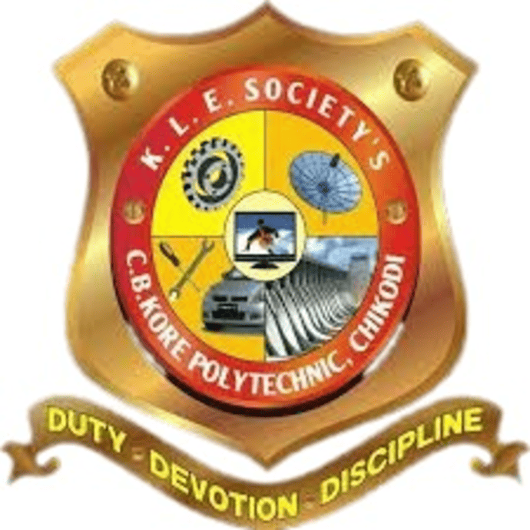

K.L.E. SOCIETY’S
CHIDANAND B. KORE POLYTECHNIC,
CHIKODI-591201
District : Belagavi

DEPARTMENT OF COMPUTER SCIENCE AND ENGINEERING
2024-2025

Internship Report On
“OJT 1 – ONLINE BLOOD BANK MANAGEMENT “
“OJT 2 – JOB PORTAL (HIRRD)”
In partial fulfilment for the award of the diploma of
DIPLOMA IN COMPUTER SCIENCE AND ENGINEERING

SUBMITTED BY

Mr. ADARSH KOKANE DTE REG : 339CS22002
Mr. ADITYA MANE DTE REG : 339CS22005
Mr. PRATHAMESH DEVARKAR DTE REG : 339CS22001
Mr. SOHAM MORE DTE REG : 339CS23705

Under the guidance of

Mr. Anoop Desai
Designation - Full Stack Developer, Pranaksh Technologies LLP, Belagavi


K.L.E. SOCIETY’S
CHIDANAND B. KORE POLYTECHNIC,
CHIKODI-591201
District : Belagavi

DEPARTMENT OF COMPUTER SCIENCE AND ENGINEERING
2024-2025
A Internship Report On
“OJT 1 – ONLINE BLOOD BANK MANAGEMENT “
“OJT 2 – JOB PORTAL (HIRRD)”
In partial fulfilment for the award of the diploma of
DIPLOMA IN COMPUTER SCIENCE AND ENGINEERING
SUBMITTED BY

Mr. ADARSH KOKANE DTE REG : 339CS22002
Mr. ADITYA MANE DTE REG : 339CS22005
Mr. PRATHAMESH DEVARKAR DTE REG : 339CS22001
Mr. SOHAM MORE DTE REG : 339CS23705

UNDER GUIDANCE OF

Mr. Anoop Desai

Internship Guide | Cohort Owner | Head of Department | Principal
Mr. Anoop Desai | Prof. S.S Khot | Prof. S.K Tavadare | Prof. D.DBillur


K.L.E. SOCIETY’S
CHIDANAND B. KORE POLYTECHNIC,
CHIKODI-591201
District : Belagavi

DEPARTMENT OF COMPUTER SCIENCE AND ENGINEERING
2024-2025

CERTIFICATE
This is to certify that the Internship report entitled “ONLINE BLOOD BANK MANAGEMENT & JOB PORTAL(HIRRD)” was carried out by Mr. ADARSH KOKANE ,Mr. ADITYA MANE, Mr. PRATHAMESH DEVARKAR, Mr. SOHAM MORE of 6th Semester Diploma in Computer Science and Engineering, K.L.E. Society’s C. B. Kore Polytechnic, Chikodi. In practical fulfillment of the Diploma in Computer Science and Engineering award requirement during 2024 – 2025. This work has been carried out under the guidance of Mr. Anoop Desai, Designation - Full Stack Developer, Pranaksh Technologies LLP, Belagavi. The Internship work prescribed for the said Diploma.
It is further understood that by this certificate the undersigned does not endorse or approve any statement made, opinion expressed, or conclusion purpose for which it is submitted.

Internship Guide | Cohort Owner | Head of Department | Principal
Mr. Anoop Desai | Prof. S.S Khot | Prof. S.K Tavadare | Prof. D.D Billur

Name and Signature of Examiners: -
1._________________________________
2._________________________________

