

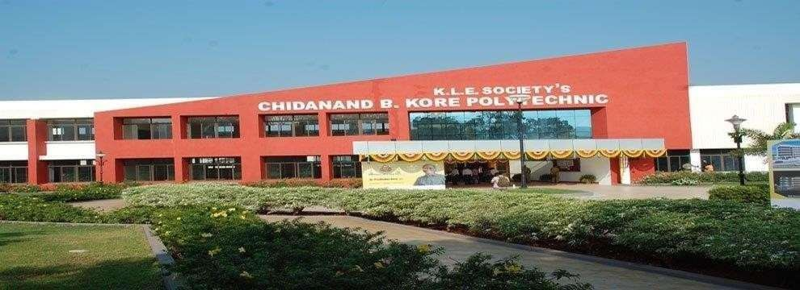

K.L.E. Society' s
C.B. KORE POLYTECHNIC CHIKODI-591201

DEPARTMENT OF COMPUTER SCIENCE AND ENGNEERING

INTERNSHIP REPORT ON
OVERVIEW OF THE ORGNAIZATION

SUBMITTED BY

SOHAM MORE 339CS23705

COHORT OWNER H.O.D PRINCIPAL

INDEX

Sl. No | Particulars | Page Number
1. | Overview of the Organization | 2
2. | Vision, Mission | 3
3. | Company Approach | 4
4. | Roles and Responsibility | 5
5. | Product Performance | 6
6. | Market Performance | 7
7. | Organization Structure | 8
8. | Services | 9
9. | Features | 10
10. | Advantages | 11
11. | Full stack Development Overview | 12
12. | Conclusion | 13

K.L.E’S C.B.KORE POLYTECHNIC, CHIKODI

OVERVIEW OF THE ORGNIZATION

Here's an overview of Pranaksh Technologies based on the information from their website: Pranaksh Technologies, located in Belagavi, Karnataka, is focused on providing high- quality services in technology, digital marketing, and academic training. They aim to connect academia with the corporate world, promoting excellence and innovation.

Key highlights:
- Services: They specialize in corporate, academic, and digital marketing services, offering personalized support and customized solutions.
- Technology Focus: Their technology expertise includes Internet of Things (IoT),Data Science, Artificial Intelligence & Machine Learning (AI & ML), and Web Development.
- Achievements: They have trained over 150 students and delivered over 10,000 training hours.

VISION

Pranaksh Technologies aims to be a trusted leader in delivering top-level quality in technology, digital marketing, and academic training. They want to bridge the gap between academia and the corporate world, fostering a future where their expertise drives excellence and innovation. By empowering individuals and organizations with cutting-edge skills and knowledge, ¹ they strive to set the standard for success in an ever-evolving landscape.

MISSION
Pranaksh Technologies' mission is to deliver exceptional services in technology, digital marketing, and academic training, connecting academic learning with corporate success. They are dedicated to providing top-quality solutions and training, enabling their clients to achieve their goals and stay competitive. Through their expertise, they aim to empower individuals with the skills needed for excellence and innovation in today's dynamic world.

COMPANY APPROACH

Pranaksh Technologies positions itself as a versatile service provider with a strong Focus on bridging the gap between academic knowledge and practical corporate application.Their approach seems to be built on the following key pillars:

- Integrated Service Offering: They uniquely combine technology solutions, digital marketing expertise, and academic training. This suggests they aim to provide holistic support for both individuals and organizations,
- Customization and Personalization: They emphasize "personalized support" and "customized solutions," indicating that they don't offer one-size-fits-all packages.
- Focus on Practical Application: Their vision explicitly mentions bridging the academia- corporate gap. This implies their training programs are designed to be relevant and immediately applicable in a professional setting,
- Data-Driven Digital Marketing: In their digital marketing services, they Highlight "tailored strategies in SEO, content, and social media" to "captivate your audience and drive impressive results."
- Efficiency and Growth for Businesses: Their corporate solutions aim to provide "smart strategies and tools to boost efficiency, tackle challenges, and drive impressive growth.

K.L.E’S C.B.KORE POLYTECHNIC, CHIKODI

ROLES AND RISPONSIBILIIES

Pranaksh Technologies operates with teams focused on their core service areas:

  - Technology Team: Includes Technology Consultants who understand client needs and implement solutions, and Project Managers who oversee technology projects from start to finish.
  - Digital Marketing Team: Consists of Strategists who develop marketing plans, SEO Specialists for online visibility, Content Specialists for creating engaging material, Social Media Managers for platform engagement ,and Paid Advertising Specialists for managing online ads.
  - Academic Training Team: Features Trainers/Instructors who deliver courses, Curriculum Developers who design training content, and Training Coordinators who manage the logistics of programs.
  - Business Development/Sales Team: Includes Business Development Managers focused on acquiring new clients and Account Managers dedicated to maintaining client relationships.
  - Management/Leadership Team: Provides strategic direction and oversees the operations of all departments.

K.L.E’S C.B.KORE POLYTECHNIC, CHIKODI

PRODUCT PERFORMANCE

Pranaksh Technologies emphasizes quality and client success, but their website doesn't offer specific data or detailed examples to definitively assess their product performance. The high number of stated partners suggests a positive track record, but concrete performance metrics and client testimonials would provide a more comprehensive evaluation.

To get a clearer understanding of their product performance, you might need to:
  - Explore other sections of their website beyond the homepage.
  - Look for external reviews or mentions of the company.
  - If you are a potential client, directly request case studies or performance data relevant to your specific needs.Sources and related content

K.L.E’S C.B.KORE POLYTECHNIC, CHIKODI

MARKET PERFORMANCE

Pranaksh Technologies' market performance in fewer sentences and points:

  - Operates in growing tech, marketing, and training markets.
  - Focuses on in-demand skills like AI.
  - Claims a large partner network (10K+).
  - Listed legal entity appears relatively new (incorporated Sept 2023).
  - Public financial data and market share are unavailable.
  - Competitive standing and client satisfaction are unclear publicly.

K.L.E’S C.B.KORE POLYTECHNIC, CHIKODI

ORGNIAZTION STRUCTURE

Their mission is to bridge the gap between academia and the corporate world by offering digital transformation and competency development services tailored for the IT sector.

Organizational Structure:
Designated Partners:
- Dr. Raghavendra Katagall | Co-Founder and CEO
- Mr. Krishnappa Katagall | CFO

Team Members:
- Mr. Anoop Desai - Head of Technology
- Miss. Sakshi Yadav – Web Developer
- Miss. Mansi Patil – Java Developer

The company operates with a focus on delivering value-driven solutions, fostering innovative partnerships, and ensuring corporate-ready skills among its clients. Their R&D and incubation centres are strategically located within academic institutions, promoting innovation and bridging the gap between academia and industry.

K.L.E’S C.B.KORE POLYTECHNIC, CHIKODI

SERVICES

Pranaksh Technologies' website, their main services fall into three key categories:
- Technology Solutions:
  - This likely encompasses services such as software development, IT consulting, web development, and potentially emerging technologies like IoT, AI, and Data Science (as mentioned in their "Technology Focus").
  - They aim to provide innovative technology to transform businesses and drive growth.

Digital Marketing:
  - This includes strategies and services to enhance a brand's online presence and reach.
*They offer tailored strategies in SEO, content marketing, and social media to engage audiences and deliver results.

Academic Training:
  - This focuses on providing individuals with cutting-edge skills to achieve their career goals.
  - They offer training in fields like AI and Data Science, aiming to bridge the gap between academia and corporate needs.

K.L.E’S C.B.KORE POLYTECHNIC, CHIKODI

FEATURES

- Integrated & Quality Services: Offers top-quality technology solutions, digital marketing, and academic training under one roof.
- Personalized & Strategic Approach: Provides customized solutions and data-driven strategies in areas like digital marketing.
- Bridging Academia & Industry with Innovative Training: Focuses on delivering practical, cutting-edge skills in relevant fields like AI.
- Experienced & Trusted Partner: Claims a large network of over 10,000 corporate and academic partners, indicating trust and experience.
- Client-Centric with a Focus on Excellence: Aims to empower clients, drive their success, and set high standards in their services.

K.L.E’S C.B.KORE POLYTECHNIC, CHIKODI

ADVANTAGES

- Integrated Solutions: Offers a single point of contact for technology, marketing, and training needs.
- Practical Training Focus: Aims to provide skills directly applicable to the corporate world.
- Synergistic Potential: Allows for better alignment between technology and marketing efforts.
- Access to Future Skills: Provides training in high-demand areas like AI.
- Established Presence (Implied): Suggests reliability through a large network of partners.

K.L.E’S C.B.KORE POLYTECHNIC, CHIKODI

OVERVIEW OF FULLSTACK DEVLOPMENT

A Full-Stack Developer is a software engineer capable of handling all stages of web application development, encompassing both the user-facing front-end and the server-side back-end. Their broad skillset allows them to build complete and functional applications. Key Areas:
- Front-End Development: Focuses on the user interface (UI) and user experience (UX). Core technologies include HTML (structure), CSS (styling), and JavaScript (interactivity). Front-end frameworks/libraries like React, Angular, and Vue.js aid in efficient development.
- Back-End Development: Deals with server-side logic, database management, application functionality. Popular server-side languages include Node.js, Python, Java, and PHP. Databases can be relational (SQL-based like MySQL) or non-relational (NoSQL like MongoDB).
- Databases and Storage: Involves designing, implementing, and interacting with databases to store and retrieve application data effectively.
- Version Control: Proficiency in Git is crucial for managing code changes and facilitating team collaboration.
- API Development: Understanding how to create and consume Application Programming Interfaces (APIs) for seamless communication between different application layers.

K.L.E’S C.B.KORE POLYTECHNIC, CHIKODI

CONCLUSION

Based on the information available, Pranaksh Technologies appears to offer Full-Stack Development as part of its services. They aim to bridge the gap between academia and the corporate world, providing training in cutting-edge skills. Their approach like emphasizes practical, hands-on expertise to equip individuals with the necessary skills for a career in full-stack development.While the specific details of their full-stack curriculum aren't fully detailed, they aim to empower individuals with skills for excellence and innovation. They also offer corporate solutions and digital marketing services.

K.L.E’S C.B.KORE POLYTECHNIC, CHIKODI

