**2. Project Profile:-**

**2.1 Project Definition**

Guftagu

**2.2 Project Description**

Chatting is a method of using technology to bring people and ideas together despite of the geographical barriers. The technology has been available for years but the acceptance was quite recent. Our project is an example of a chat server. It is made up of two applications - the client application, which runs on the user’s web browser and server application, runs on any hosting servers on the network. To start chatting client should get connected to server where they can do private and group chat. Security measures were taken during the last one.

Today Developers around the world are making efforts to enhance user experience of using application as well as to enhance the developer’s workflow of designing applications to deliver projects and rollout change requests under strict timeline. Stacks can be used to build web applications in the shortest span of time. The stacks used in web development are basically the response of software engineers to current demands. They have essentially adopted pre-existing frameworks (including JavaScript) to make their lives easier.

While there are many, MEAN and MERN are just two of the popular stacks that have evolved out of JavaScript. Both stacks are made up of open source components and offer an end-to-end framework for building comprehensive web apps that enable browsers to connect with databases. The common theme between the two is JavaScript and this is also the key benefit of using either stack. One can basically avoid any syntax errors or any confusion by just coding in one programming language, JavaScript. Another advantage of building web projects with MERN is the fact that one can benefit from its enhanced flexibility. In order to understand MERN stack, we need to understand the four components that make up the MERN stack namely – MongoDB, Express.js, React and Node.js.

**2.3 Existing System / Work Environment**

In the existing system, you will not be able to keep the chat persistant this issues has been solved in this application. You will be able to create groups and initiate chats with them.

In the existing system, you cannot differentiate the chat on any basis, but in this application you will be able to differentiate the chat on many parameters.

**2.4 Problem Statements**

* This project is to create a chat application with a server and users to enable the users to chat with each other’s.
* To develop an instant messaging solution to enable users to seamlessly communicate with each other.
* The project should be very easy to use enabling even a novice person to use it.
* This project can play an important role in organizational field where employees can connect through LAN.
* The main purpose of this project is to provide multi chatting functionality through network.

**2.5 Need for New System**

The Old manual system was suffering from a series of drawbacks. Since whole of the system was to be maintained with handle hands the process of keeping, maintaining and retrieving the information was very tedious and lengthy. The records were never used to be in a systematic order. There used to be lots of difficulties in associating any particular transaction with a particular context. If any information was to be found it was required to go through the different registers, documents there would never exist anything like report generation. There would always be unnecessary consumption of time while entering records and retrieving records. One more problem was that it was very difficult to find errors while entering the records. Once the records were entered it was very difficult to update these records.

The reason behind it is that there is a lot of information to be maintained and have to be kept in mind while running the business. For this reason we have provided features present is partially automated, actually existing system is quite laborious as one has to enter same information at three different places.

**Following Points should be well considered:-**

Documents and reports that must be provided by the new system: there can also be few reports, which can help management in decision-making and cost controlling, but since these reports do not get required attention, such kind of reports and information were also identified and given required attention.

Details of the information needed for each document and report.

The required frequency and distribution for each document.

With the implementation of computerized system, the task of keeping records in an organized manner will be solved. The greatest of all is the retrieval of information which will be at the click of the mouse. So the processed system helps in saving the time in different operations and making information flow easy giving valuable reports.

**2.6 Proposed System & Features**

### Modules

### User

### Features and Functionalities

### User able to register

### User able to Login

### User able to initiate chat with any other users

### User able to create group

### User able to add members into the group

### Admin able to manage all the users and chat

### User able to differentiate the chat the chats.

**2.7 Scope**

It may help collecting perfect management in details. In very short time, the collection will be obvious, simple and sensible. It will help a person to know the management of passed year perfectly and vividly. It also helps in current all works relative to Online Chat Application. It will be also reduced the cost of collecting the management & collection procedure will go on smoothly.

Our project aims at buisness process automation, i.e. we have tried to computerize various processes of Online Chat Application.

* In computer system the person has to fill the various forms & number of copies of the forms can be easily generated at a time.
* In computer system, it is not necessary to create the manifest but we can directly print it, which saves our times.
* To assist the staff in capturing the effort spent on their respective working areas.
* To utilize resources in an efficient manner by increasing their productivity through automation.
* The system generates types of information that can be used for various purposes.
* It satisfy user requirement.
* Be easy to understand by the user and operator.
* Be easy to operate
* Have a good user interface
* Be expandable
* Delivered on schedule within the budget
  1. **Outcomes**
* User will get an overall smooth experience after using this app.
* User will be able to track down the history of his chat with a certain user.
* User will be able to create group and add user in them.
* User can differentiate the other user on the basis of the relationship he/she posses with that particular user.

**2.9 Tools & Technology use**

**Front End:**

* HTML:-Page layout has been designed in HTML.
* CSS:-CSS has been used for all the designing part.
* Chakra UI:-Chakra UI is a more widely used framework that uses CSS and JavaScript.
* Java Script:-All the validation task and animations has been developed by JavaScript.
* Recat JS : A Java Script library that is used to make attractive UI.

**Back End:**

* Node JS
* Express JS
* Scoket.io
* Axios

**Database:**

* MongoDB

**2.10 Project Plan**

|  |  |  |
| --- | --- | --- |
| Serial No. | Date | Tasks |
| 1 | 13/07/2022 | Search all details about Project Profile and make PPT and Word file for it. |
| 2 | 15/07/2022 | Submit document about Project Profile. |
| 3 | 16/07/2022 | Start to study more about our system, identify roles, rights and responsibilities of each user in our system and study module of the system. |
| 4 | 17/07/2022 | Try to study and select suitable development strategy for the system. |
| 5 | 18/07/2022 | Identify hardware and software requirements, use cases and make use case diagram. Make documentation for our requirement analysis. |
| 6 | 20/07/2022 | Submit document. |
| 7 | 23/07/2022 | Prepare Use Case Scenarios and necessary diagrams. |
| 8 | 27/07/2022 | Start making form layouts. |
| 9 | 21/08/2022 | Start making report layouts and creating business logic. |
| 10 | 30/08/2022 | Prepare documentation and submit it. |
| 11 | 2/09/2022 | Start to prepare Test Strategy and Test Cases. |
| 12 | 10/09/2022 | Complete final documentation. |
| 13 | 13/09/2022 | Submit hard copy. |

**3. Feasibility of the study**

The software requirement specification is produced at the culmination of the analysis All projects are feasible given unlimited and resource and infinite time. Unfortunately, the development of computer-based system is more likely to be plagued by scarcity of resources and difficult delivery dates.

Feasibility study is a system proposal according to its workability, impact on the organization, ability to meet user needs and efficient use of resources. Feasibility study identifiers, describes, and evaluates the candidate system and select the best system for the job. An important outcome of the preliminary investigation is determining whether the system requested is feasible or not. After the proposed system was found to be social and technically acceptable, it was tested for economic feasibility.

**TECHNICAL FEASIBILITY**

There may be a number of technical issues, which are generally raised during the feasibility stage of the investigation. Programming languages, other hardware and software specifications are easily available for this system development. Hence the proposed system is technically feasible. The considerations that are normally associated technical feasibility include.

- Development Risk.  
- Resource Availability.  
- Technology.

**ECONOMIC FEASIBILITY**

The proposed system insures very low cost for the development and implementation. The system can work on systems with a configuration and connectivity which causes no excessive cost for implementation or usage. Data charge is the only cost that incurred once the software is installed on the system. The study is carried out to check the economic impact that the system will have on the organization. The amount of fund that the company can pour into the research and development is limited. The expenditure must be justified. Thus the developed system as well within the budget and this was achieved because most of the technologies used are freely available. Only the customized products had to be purchased. All you really need to do is install the software on your system and activate it.

**BEHAVIOURAL FEASIBILITY**

It centers on the reaction of the users, since the system is not so complicated it is easily understandable by anyone. User training is also very easy. The user must not feel threatened by the system, instead must accept it as a necessity. The user also does not need to have any concept of the software used for developing the system.

**OPERATIONAL FEASIBILITY**

This is necessary to know whether the system is operationally feasible. It checks whether the system is flexible for the user to use and whether all the operations are working correctly and effectively. The newly developed chat application management system satisfies all the operational conditions.

The system does not require enormous amount of money to be developed. The cost of project depends upon the number of man hours required. Proposed system can support all type of users, who has limited knowledge in computing why because the system provides a user interactive GUI created by using simple language. This is just a thing to install the software on the system, and then it’s a matter of going through each area of the software that you want to control.

**3.2 USERS OF THE SYSTEM:**

Chat App User:

Role:

* Register
* Login
* Initiate Chat
* Create and Manage Group
* Categorize the users

Right:

* Manage the Chat
* Manage the User
* Manage their own Profile

Responsibilities:

* Delete the chat that is of no use
* Delete the user if not wanted

**3.3 MODULES OF THE SYSTEM**

* Registration
* Login
* Chat
* Grouping
* Differntiating into category

##### 3.4 Process Model

The Software process model chosen for the project is the “Agile Model”.

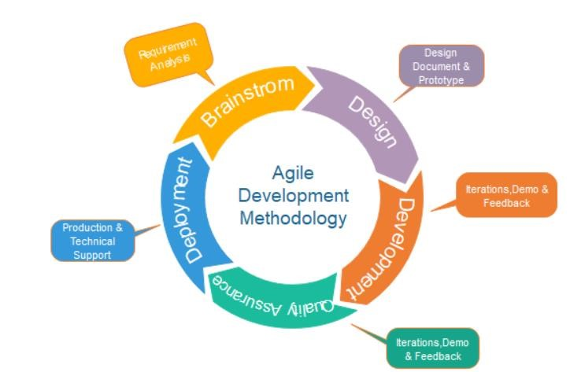

Figure 1. Process Model

**Requirements gathering:**

In this phase, Business requirements and system requirements are being gathered from the client.

**Design the requirements:** UI will be prepared first and then implemented.

**Construction/ iteration:** According to User requirements it will be prepare **Testing:** UI Testing done for design checking in the Smart devices.

**Feedback:** Feedback from the tester, users and rectors.

**Advantages of Agile Model**

* Frequent Delivery
* Face-to-Face Communication with clients.
* Efficient design and fulfils the business requirement.
* Anytime changes are acceptable.
* It reduces total development time.

**Disadvantages Of Agile Model**

* The shortage of formal documents, creates confusion and crucial decisions taken throughout various phases can be misinterpreted at any time by different team members.
* Due to the lack of proper documentation, once the project completes and the developers allotted to another project, maintenance of the finished project can become difficult.

**3.5 Hardware and Software requirement:**

**Front End:**

* HTML:-Page layout has been designed in HTML.
* CSS:-CSS has been used for all the designing part.
* Bootstrap:-Bootstrap is a more widely used framework that uses CSS and JavaScript.
* Java Script:-All the validation task and animations has been developed by JavaScript.
* Recat JS : A Java Script library that is used to make attractive UI.

**Back End:**

* Node JS
* Express JS
* Scoket.io
* Axios

**Database:**

* MongoDB

**3.6 USE CASE**

This use Case Diagram is a Graphic depiction of the interactions among the elements of chat application. It represents the methodology used in system analysis to identify, clarify, and organize system requirement of chat application.

Use Case Diagram:

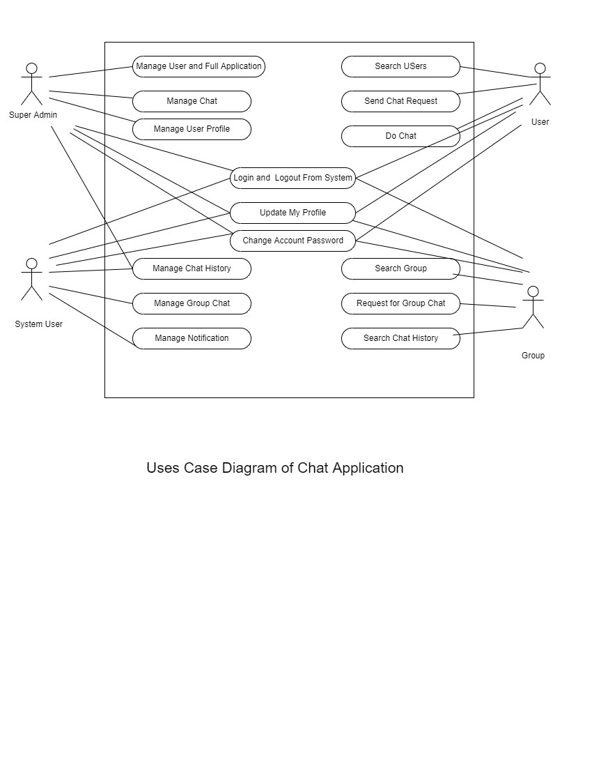

**Entity – Relationship Diagram:**

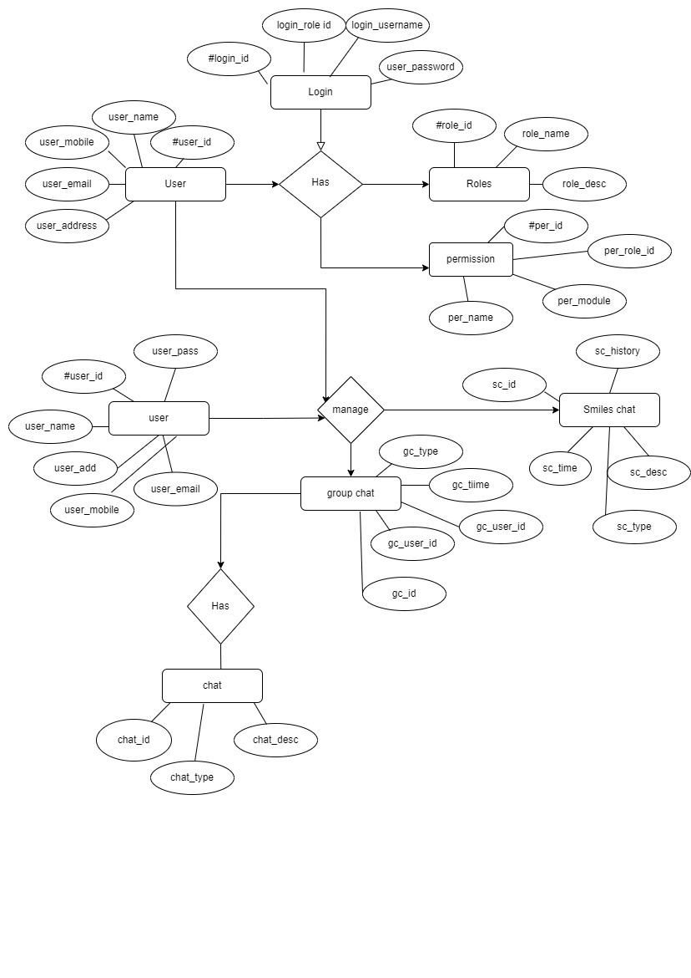

**Data-Flow Diagram:**

**Level-0:**

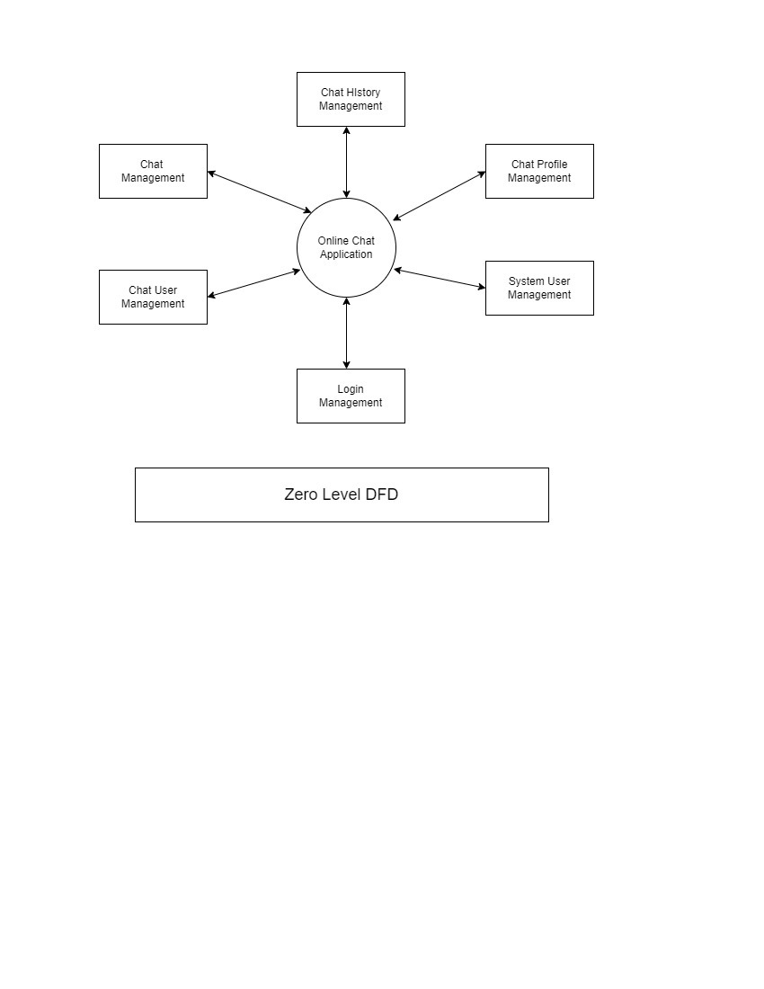

**Level-1:**

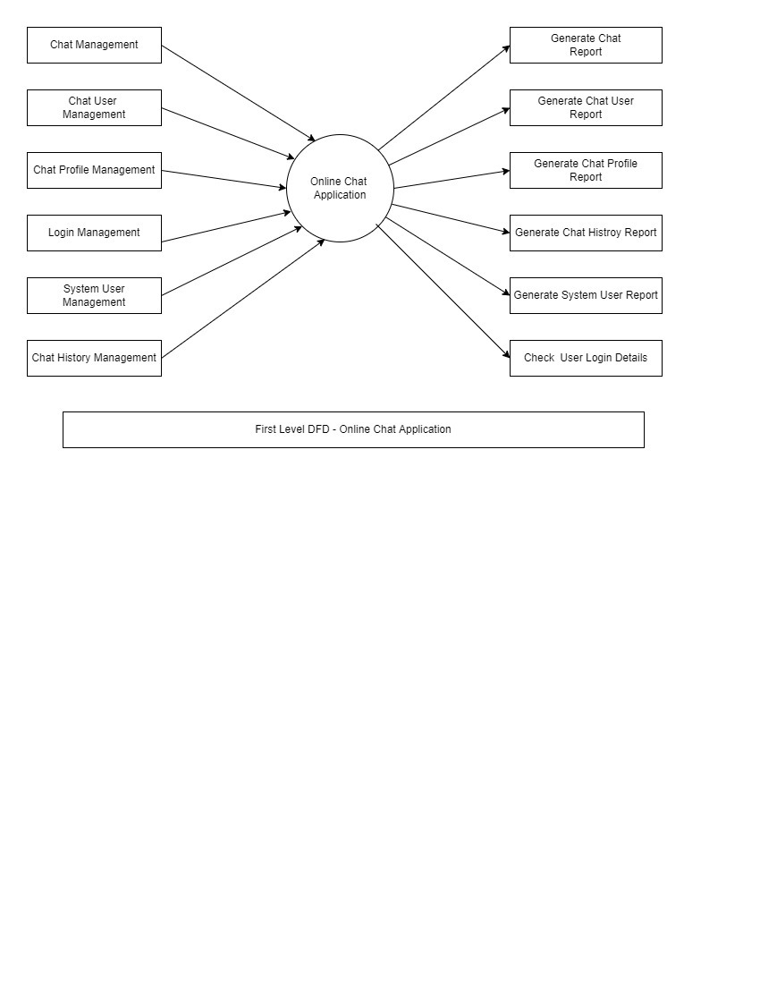

**Level-2:**

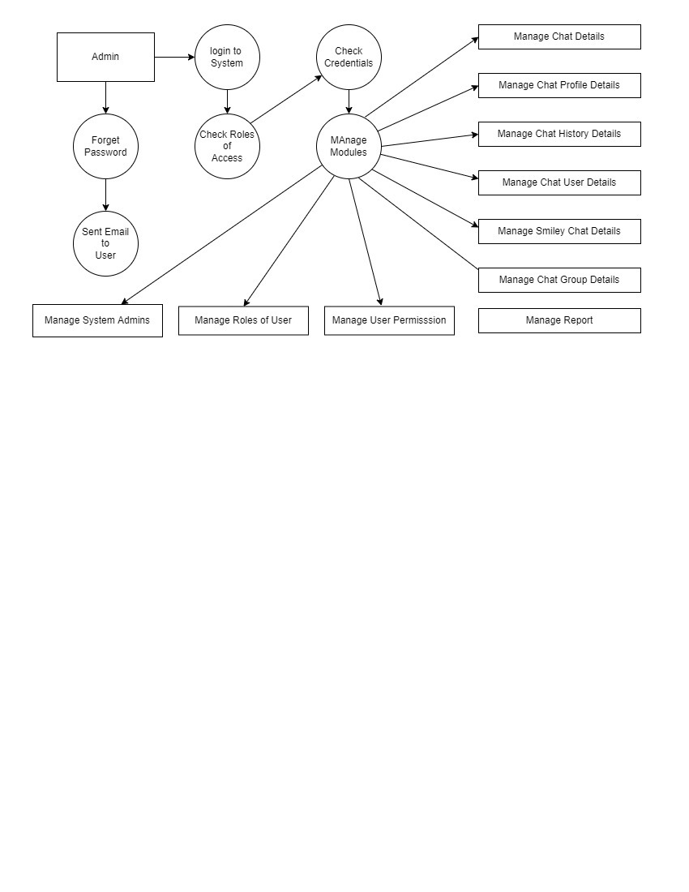

**Component – Diagram :**

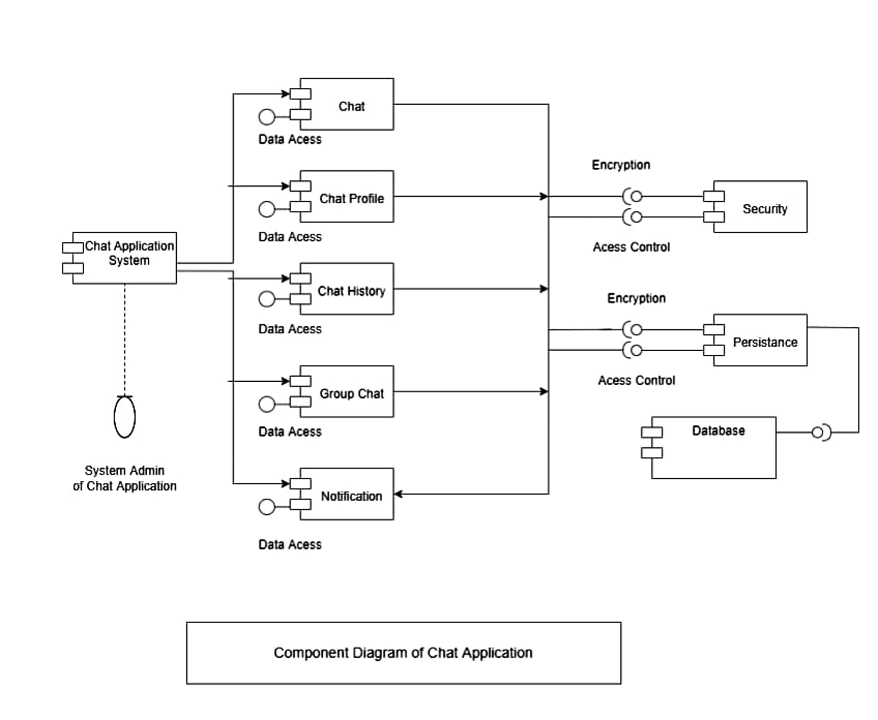

**Class-Diagram:**

