**Design Document FOR HMI**

**Client Name: Global Techno Solution**

**Project Tittle: SF6 Gas Analyzer**

**Process: Gas Detection & Measuring Unit**

**Project #: GSN-15102024**

Table of Contents

1. INTRODUCTION 3

2. HMI SYSTEM 3

3. USER INTERFACE 3

1. LOGIN Details and Access Levels: 3

2. MAIN SCREEN: 5

3. TEST 6

4. PUMPBACK 7

5. PURGING 8

6. SETTINGS 9

4. ALARM: 10

5. USER MANAGEMENT: 11

6. APPENDICES 12

1. ABBREVIATION LIST 12

2. TROUBLESHOOTING 12

# **1. INTRODUCTION**

This manual provides instructions for Designing and Development of the Human Machine Interface (HMI) device. The HMI is designed to interact with a Programmable Logic Controller (PLC) to monitor and control processes in various industrial applications.

**Purpose:** This operator document outlines the processes of SF6 & other Gas measuring modes of the machine. Ensuring proper and safe operations is essential for maintaining a high level of product quality and production efficiency.

# **2. HMI SYSTEM**

**Hardware and Software used for HMI system of base mixing plant process is as follow:**

* **HMI Hardware: 7” Wecon With Ethernet**

# **3. USER INTERFACE**

**The user interface (UI) is the point of human-computer interaction and communication in a device. This can include display screens, keyboards, a mouse and the appearance of a desktop. It is also how a user interacts with an application or a website, using visual and audio elements, such as type fonts, icons, buttons, animations and sounds.**

**Here in HMI, display screens are as HOME, MAIN, Sampling, Pumpback, Purging, Calibration, ALARMS and USER MANAGEMENT.**

**On system power up system displays Home screen, which maintains for 10 sec and switch to Main Page.**

## **1. Home:**

In figure 1 Home Screen with Logo, Title, Model, Serial Number. Date Of Calibration

## **2. MAIN SCREEN:**

**MAIN**: This is overview screen. Screen displays all the parameters measured by the system. The levels of measured parameters will be indicated on the scale of minimum to maximum of the parameters with represented colour fill.

Screen provides information about following:

1. Battery #1 & #2: Battery Level Indication
2. Date & Time: Real time Parameters
3. Measured Parameters as follows:
   1. SF6: Measured Value with Unit (with a purple bar)
   2. H2O: Measured Value with 4 Units (with a grey bar)
   3. SO2: Measured Value with Unit (with a red bar)
   4. HF: Measured Value with Unit (with a orange bar)
   5. Inlet Gas Pressure: Measured Value with Unit (with a blue bar)
   6. Bag Full: Measured Value with Unit (with a yellow bar)

* It contains following navigation keys to provide access as follows:
  + 1. Home: Home Screen
    2. Test: Test Screen
    3. Pumpbk: Pump back Screen
    4. Line Purge: Line Purging Screen
    5. Settings: Setting Screen

## **3. Test**

**TEST**: This is overview screen of the process which indicates status of various components in the operation. Screen displays all the components with their operation status colour during operation of the sampling mode of the system.

Screen provides information about following:

1. Battery #1 & #2: Battery Level Indication
2. Date & Time: Real time Parameters
3. Provides access to operation as follows:
   * Start: Start Sampling Operation(Indicates green highlight on active state)
   * **Stop**: Stop Sampling Operation(Indicates green highlight on active state)
   * **Pause**: Pause Sampling Operation(Indicates green highlight on active state)

* It contains following navigation keys to provide access as follows:
  + 1. **Home**: Home Screen
    2. **Main**: Main Screen
    3. **Pumpbk**: Pump back Screen
    4. **Purging**: Air Purging Screen
    5. **Settings**: Setting Screen

## **4. PUMPBACK**

**PUMPBACK**: This is overview screen of the process which indicates status of various components in the operation. Screen displays all the components with their operation status colour during operation of the pumpback mode of the system.

Screen provides information about following:

1. Battery #1 & #2: Battery Level Indication
2. Date & Time: Real time Parameters
3. Provides access to operation as follows:
   * Start: Start Pumpback Operation(Indicates green highlight on active state)
   * **Stop**: Stop Pumpback Operation(Indicates green highlight on active state)
   * **Pause**: Pause Pumpback Operation(Indicates green highlight on active state)

* It contains following navigation keys to provide access as follows:
  + 1. **Home**: Home Screen
    2. **Main**: Main Screen
    3. **TEST**: TEST Screen
    4. **Purging**: Air Purging Screen
    5. **Settings**: Setting Screen

## **5. PURGING**

**PURGING**: This is overview screen of the process which indicates status of various components in the operation. Screen displays all the components with their operation status colour during operation of the purging mode of the system.

Screen provides information about following:

1. Battery #1 & #2: Battery Level Indication
2. Date & Time: Real time Parameters
3. Provides access to operation as follows:
   * Start: Start Purging Operation(Indicates green highlight on active state)
   * **Stop**: Stop Purging Operation(Indicates green highlight on active state)
   * **Pause**: Pause Purging Operation(Indicates green highlight on active state)

* It contains following navigation keys to provide access as follows:
  + 1. **Home**: Home Screen
    2. **Main**: Main Screen
    3. **TEST**: TEST Screen
    4. **Pumpbk**: Pumpback Screen
    5. **Settings**: Setting Screen

## **6. SETTINGS**

**Setting**: This is screen for the settings of various parameters of the system.

Screen provides access to define setting of following:

1. Battery #1 & #2: Battery Level Indication
2. Date & Time: Real time Parameters
3. Provides access to operation as follows:
   * Calibrn: Calibration Screen
   * **Alarms**: Alarms Screen
   * **Access**: Access Level Screen

* It contains following navigation keys to provide access as follows:
  + 1. **Home**: Home Screen
    2. **Main**: Main Screen
    3. **TEST**: TEST Screen
    4. **Pumpbk**: Pumpback Screen
    5. **Purge**: Purge Screen

# **4. ALARM:**

Alarm Screen shows list of all alarms.

Here is the List of alarms.

|  |  |  |
| --- | --- | --- |
| **Sr. no** | **Description** | **Alarm** |
| 1 | Pressure High Alarm | Inlet Pressure Hi |
| 2 | Battery #1 Low | Battery #1 Low |
| 3 | Battery #2 Low | Battery #2 Low |
| 4 | PLC Communication | Communication Failed Alarm |
| 5 | HMI Communication | Communication Failed Alarm |
| 6 | Connection Hose Not Connected | Please Check Connection |
| 7 | TEST Bag Full | TEST Bag Full |
| 8 |  |  |
| 9 |  |  |
| 10 |  |  |

# **5. USER MANAGEMENT:**

User management is a system that handles activities related to individuals' access to devices, software, and services. It focuses on managing permissions for access and actions, as well as monitoring usage.

Key elements of user management include:

* **User Authentication:** Verifying the identity of users through methods such as passwords, biometrics, or two-factor authentication.
* **User Authorization:** Determining what actions a user is allowed to perform within a system based on their role and permissions.
* **Access Control:** Defining and managing user access to specific resources and data within a system

In the HMI Operator Manual, the user management access levels are detailed as follows:

1. Administrator(Level1): Has full access to all functions and can add users.
2. Viewer (Level 3): Can only view the system status, detailed screens and events.

Login: This button will enable login window for the user to login the system

Logout: This button will logout existing used from the system

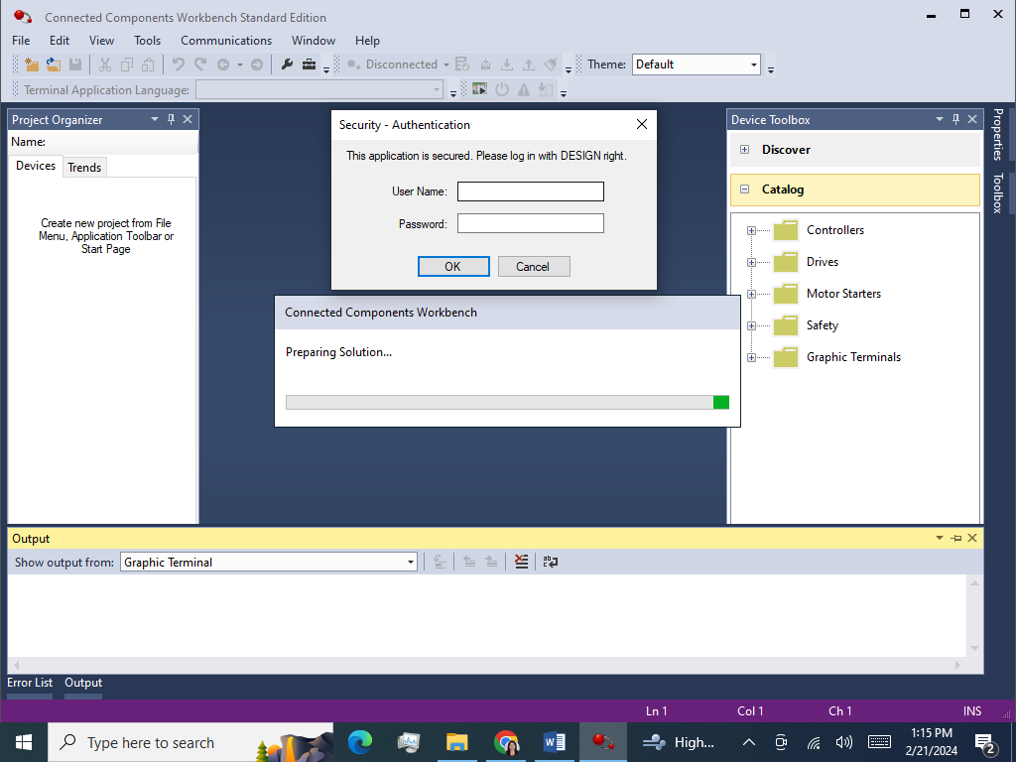

By entering User Name and Password in this window customer will login to the system.

Here for Operator and Administrator, User Name and Password will be different.

for Operator and Administrator access level is shown as below:

|  |  |  |
| --- | --- | --- |
| Access Topic | Operator | Administrator |
| Operate Plant in Manual | YES | YES |
| Operate Plant in Auto | YES | YES |
| RECIPE EDIT | NO | YES |
| Username |  | - |
| Password |  | - |