**Student Management API Application**

**INTRODUCTION**

The Student Management API is a web-based application designed for the process of managing student records within an educational institution. Developed in the Go programming language and utilizing the gofr web framework, this API offers a simple and efficient solution for performing essential CRUD operations on student data.

**Features:**

**Create - Add Student:**

Easily add new students to the system by providing their name, age, and enrollment information through a user-friendly API endpoint (POST /add).

**Read - View Students:**

Retrieve a comprehensive list of all registered students along with their details, facilitating easy access to information about the student body (GET /view).

**Update - Update Student Details:**

Modify and update the information of existing students using the dedicated API endpoint (PUT /update/:id), allowing for real-time adjustments to student records.

**Delete - Remove Student:**

Effortlessly remove students from the system based on their unique identifier (GET /d/:id). This feature ensures accurate and up-to-date student records.

**SEQUENCE DIAGRAM FOR THE APPLICATION**

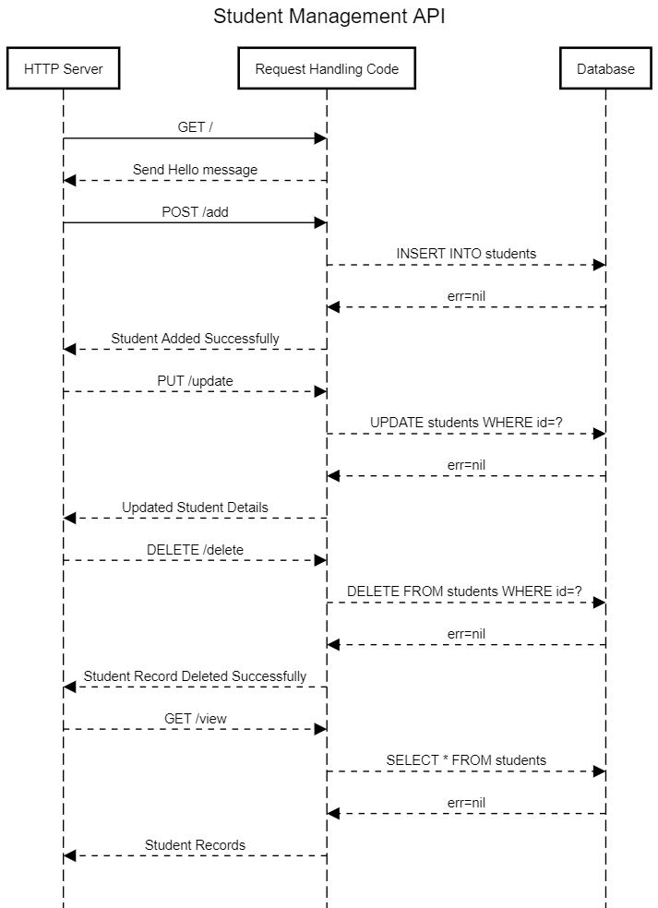

**Student Management API UML Diagram**

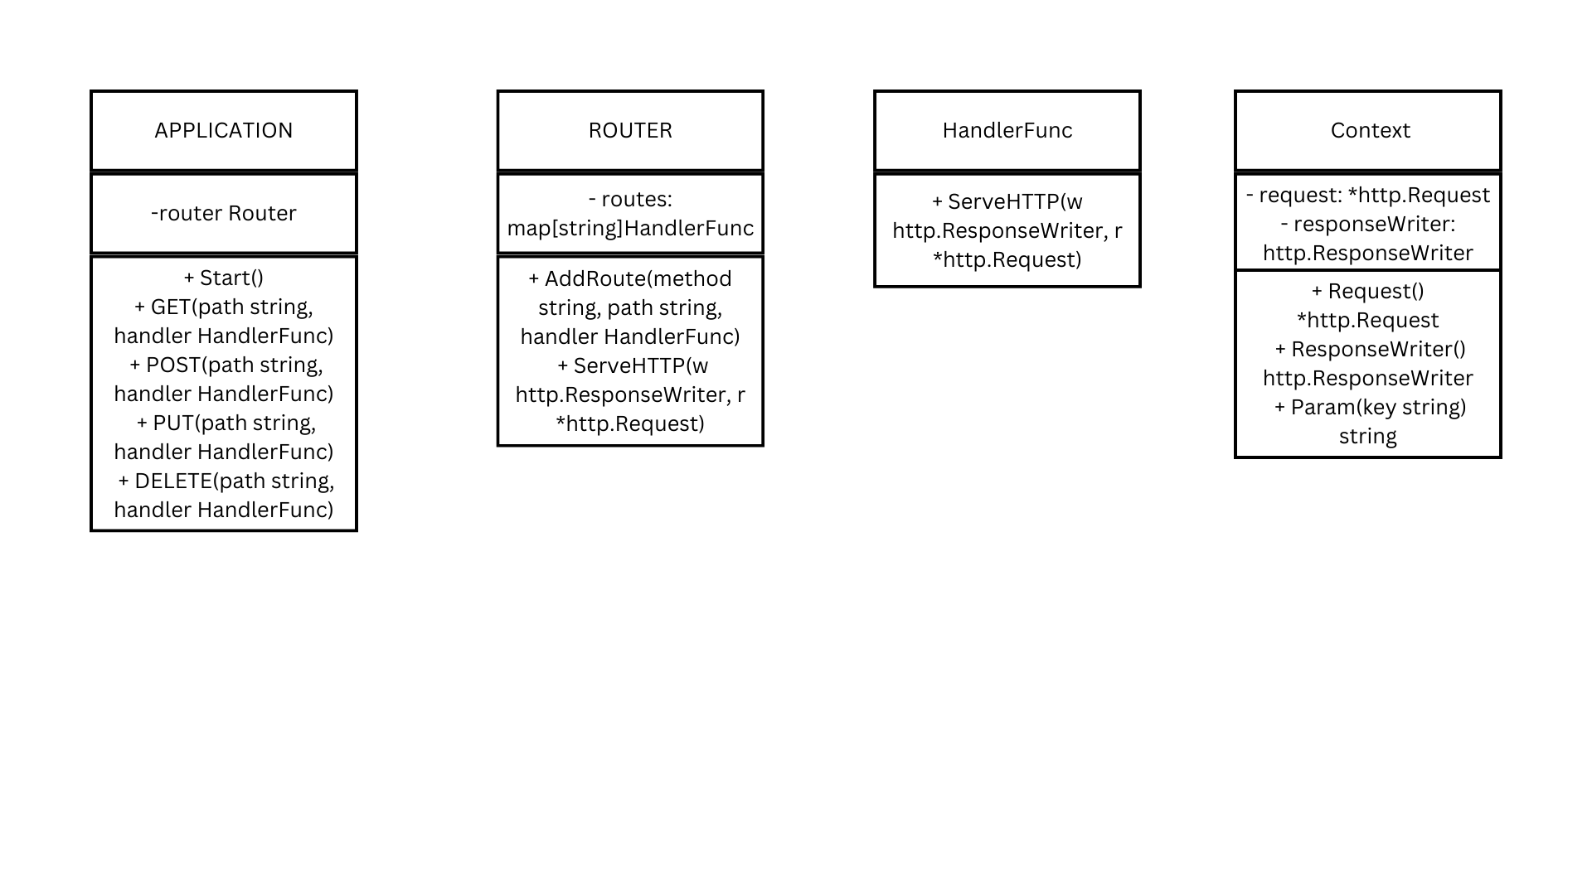

**Database Integration:**

The API seamlessly integrates with an SQLite database (students.db), providing a robust and scalable solution for storing student information. The database employs a straightforward structure with columns for student ID, name, age, and enrollment information.

**Web Framework - gofr:**

The API leverages the gofr web framework, simplifying the process of handling HTTP requests and responses. This lightweight framework enhances the development experience, allowing for rapid implementation of RESTful API endpoints.

**Usage:**

**Clone the Repository:**

git clone https://github.com/Adityamishra1352/studentManagementGoFr.git

cd studentManagementGoFr

**Install Go:**

Ensure that you have Go installed on your machine. Follow the official Go installation guide if needed.

**Install Dependencies:**

go get -u gofr.dev/pkg/gofr

**Build the Project:**

Build the Go project to generate the executable file. This assumes your main package is in the root directory.

go build

**Run the Application:**

go run main.go

**Access the API Endpoints:**

Once the application is running, users can access the API endpoints through a tool like cURL, Postman, or a web browser.

**Conclusion:**

The Student Management API provides a straightforward and accessible solution for educational institutions seeking an efficient way to manage and maintain student records. Whether adding new students, updating existing details, or retrieving information, this API offers a user-friendly interface to facilitate seamless interactions with student data. As an open-source project, developers can further extend and customize the API to meet specific requirements, making it a versatile tool for educational institutions of varying scales.