**Name : Aditya Kumar Pandey**

**Reg No : 12018602**

**Course code : INT-353**

**My Data set : Sample superstore**

**My GitHub link :**

<https://github.com/rakeshgem/Sample_super_store/blob/main/Sample_super_store.ipynb>

**My dataset link :**

https://www.kaggle.com/datasets/bravehart101/sample-supermarket-dataset

# **Project introduction**: -

I have chosen a data set from Kaggle it is about a superstore in the United States, it contains 13 columns namely ship mode, segment, country, city, state, postal code, region, categories of Office supplies, furniture, and technology, sub category`s like Binder’s paper, phones, art, furnishings, envelopes, bookcases, chairs, phones, storage, labels, accessories, fasteners, tables, supplies, machines, appliances, sales column, quantity, discount and finally profit.

I mainly chose this data set to analyze how a store work under different situations and how they tackle profit or loss, while they are in profit how they got profit and how to increase it further, and if they are in loss how they tend to increase the sales and background works like how they analyze to make profit and improvement in sales. Not only for one store huge number of stores near 10,000

# **Domain**: -

Superstore, a large retail store operated on a self-service basis, selling groceries, fresh produce, bakery, and dairy products, and sometimes an assortment of non-food goods.

# **About my data set**: -

It is all about sample superstores in the United States, it contains 13 columns are as follows: -

* Ship mode contains the class of shipping modes: standard, second, and first.
* Segment contains segment categories: consumer, corporate, and home office.
* Country contains the country of the super store in this data set all the super stores are taken from the United States only.
* City it contains the city of the superstore.
* State it contains the state of the superstore.
* Postal code.
* Region, it contains the region that is from west or east or central or south or north.
* Category contains the type of products, in its three categories, are there office supplies, furniture, and technology?
* Sub-category contains different products depending on the category of the superstore.
* Sales contains the number of times sold depending on the sub-category.
* Quantity contains the number of products sold at a time depending on the sub-category.
* Discount contains how much discount got on an average of sales, and quantity.
* Profit.

# **Analysis I will do**: -

* I will analyze the sales of certain products and the profit and discount that the superstore provides.
* I will analyze categories and sub-categories depending on sales and profit so that I will get the relation between sales and profit, and in which categories the sales are more and profit also more, or sales less and profit more, or sales less and profit also less.
* I will analyze the profit or loss by giving discounts.
* I will analyze sub-categories that which products are more in the sale and which products getting more profits, and how the super stores give the discount depending on the product and category.
* I will analyze profit and sales depending on shipping mode.
* I will analyze the segment that is in which segment category and how the sales and profits going on.
* I will analyze which region is attractive by seeing sales and in which region the profits are more.

**Top 5 rows in my data set**:

|  |  |  |  |  |  |  |  |  |  |  |  |  |  |
| --- | --- | --- | --- | --- | --- | --- | --- | --- | --- | --- | --- | --- | --- |
|  | Ship Mode | Segment | Country | City | State | Postal Code | Region | Category | Sub-Category | Sales | Quantity | Discount | Profit |
| 0 | Second Class | Consumer | United States | Henderson | Kentucky | 42420 | South | Furniture | Bookcases | 261.9600 | 2 | 0.00 | 41.9136 |
| 1 | Second Class | Consumer | United States | Henderson | Kentucky | 42420 | South | Furniture | Chairs | 731.9400 | 3 | 0.00 | 219.5820 |
| 2 | Second Class | Corporate | United States | Los Angeles | California | 90036 | West | Office Supplies | Labels | 14.6200 | 2 | 0.00 | 6.8714 |
| 3 | Standard Class | Consumer | United States | Fort Lauderdale | Florida | 33311 | South | Furniture | Tables | 957.5775 | 5 | 0.45 | -383.0310 |
| 4 | Standard Class | Consumer | United States | Fort Lauderdale | Florida | 33311 | South | Office Supplies | Storage | 22.3680 | 2 | 0.20 | 2.5164 |

**Data cleaning:**

**Checking information:**

<class 'pandas.core.frame.DataFrame'>

RangeIndex: 9994 entries, 0 to 9993

Data columns (total 13 columns):

# Column Non-Null Count Dtype

--- ------ -------------- -----

0 Ship Mode 9994 non-null object

1 Segment 9994 non-null object

2 Country 9994 non-null object

3 City 9994 non-null object

4 State 9994 non-null object

5 Postal Code 9994 non-null int64

6 Region 9994 non-null object

7 Category 9994 non-null object

8 Sub-Category 9994 non-null object

9 Sales 9994 non-null float64

10 Quantity 9994 non-null int64

11 Discount 9994 non-null float64

12 Profit 9994 non-null float64

dtypes: float64(3), int64(2), object(8)

memory usage: 1015.1+ KB

No missing values and all data types are okay

From the information of my data set 8 categorical and 5 numerical columns are there and no null values are there. If null values are there then two ways to handle them:

1. Deleting the missing values:

With this method, we delete the row if some random null values are there whether a column contains more than 30% null values we can drop the column but the main problem with this method we are deleting the data but it also cost some money to gather the data.

1. Imputing null values:

There are different ways of replacing the missing values:

* 1. **Replacing With Arbitrary Value**
  2. **Replacing with mean**
  3. **Replacing with mode**
  4. Replacing with median etc.

**Checking for duplicate values**:

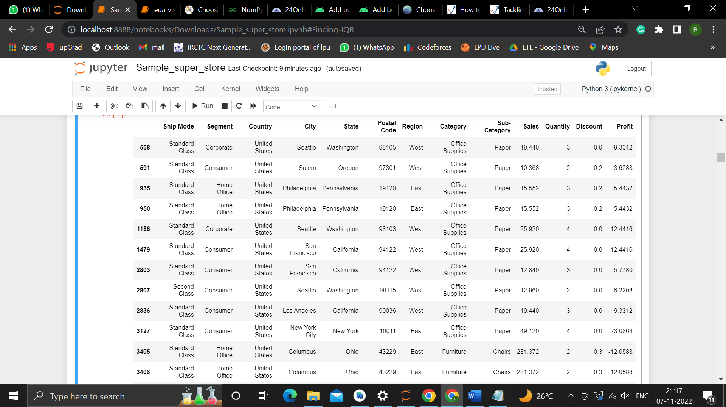

etc

By checking my data set some duplicate values are there so I will remove those.

**Finding outliers:**

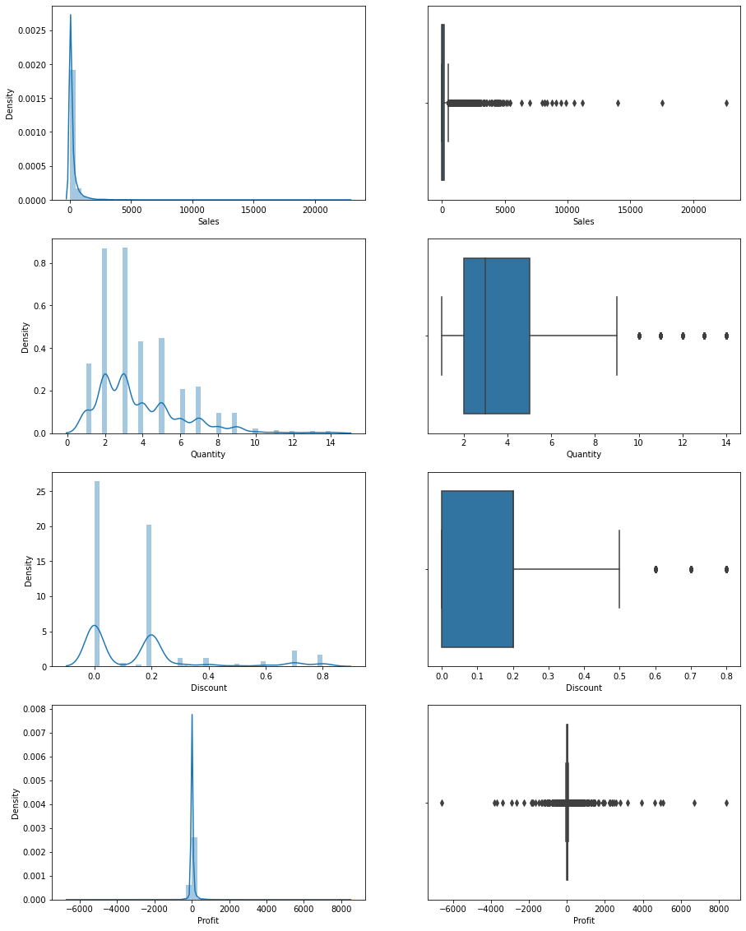



**For Normal distributions**: we need to use empirical relations of Normal distribution.

– The data points which fall below mean-3*(sigma) or above mean+3*(sigma) are outliers.

where mean and sigma are a particular column's average value and standard deviation.

**For Skewed distributions**: Use Inter-Quartile Range (IQR) proximity rule.

– The data points which fall below Q1 – 1.5 IQR or above Q3 + 1.5 IQR are outliers.

where Q1 and Q3 are the 25th and 75th percentile of the dataset respectively, and IQR represents the inter-quartile range and is given by Q3 – Q1.

By using these distributions I removed the outliers.

## **Exploratory Data Analysis:**

First, I will plot a heat map to find any correlation is there between the columns:

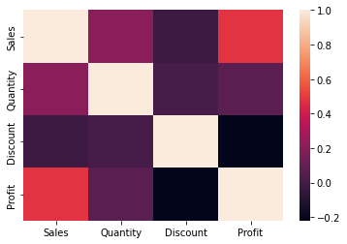

By the heat map, we notice there's a correlation between (profit, discount) and (profit, sales) and (quantity, sales)

**Univariant analysis:**

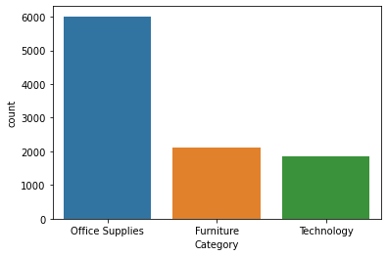

* Office Supplies has the highest number

**Bivariate analysis:**

**Categorical to numerical:**

I will check profit, sales, and discounts based on the categorical columns:

**For each region:**

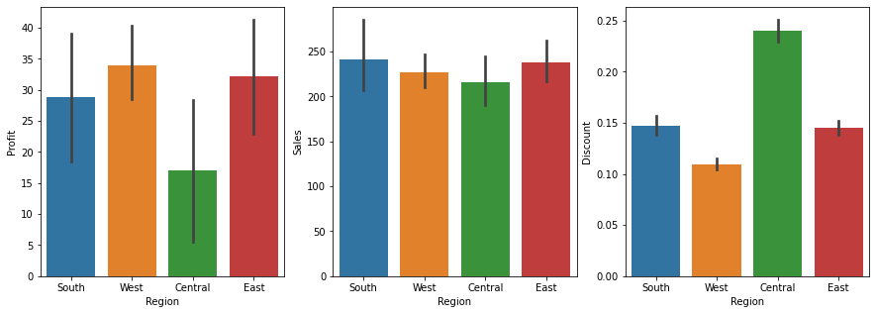

* West region has the highest profit and finds the same region has the lowest discount
* South has the highest sales
* Central has the lowest profit and the highest discount, maybe that is why.

### **For each category:**

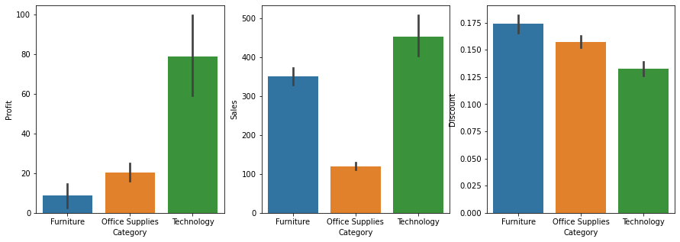

* Furniture sales are high but have very low profit maybe a high discount is the reason.

**For each Segment:**

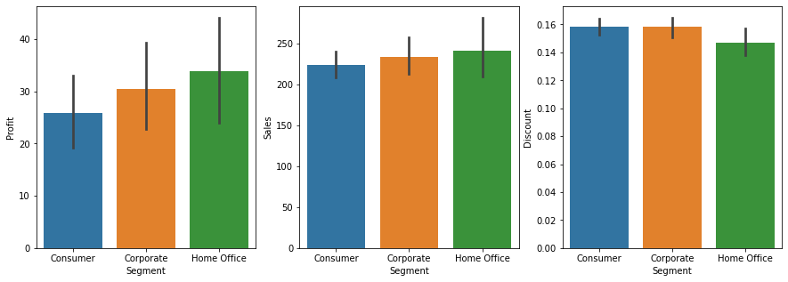

* Home Office has the lowest discount but has also the highest profit as sales

### **For each ship mode**:

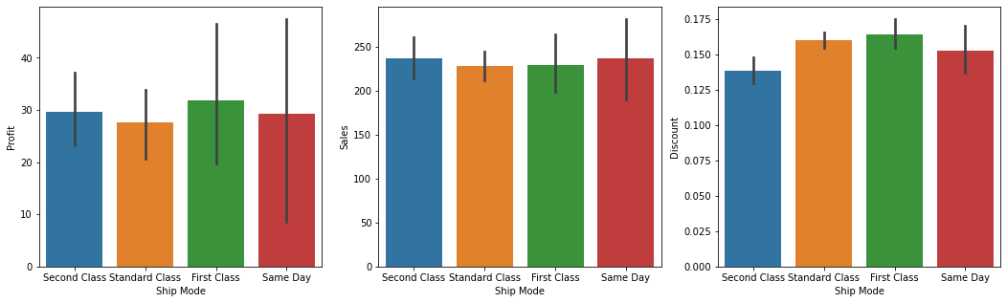

* Same-day shipping has the highest sales
* First class has the highest discount but also the highest profit

**Numerical to numerical:**

### **For quantity**:

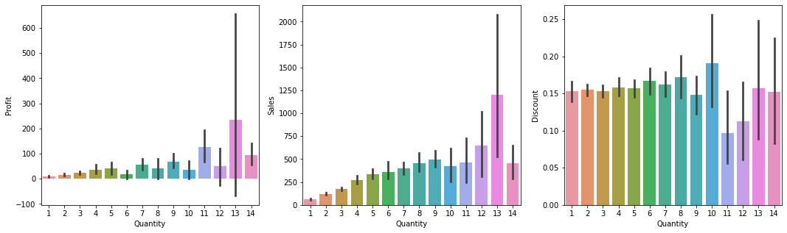

* quantity 13 is the highest in sales and profit but number 10 is the highest in discount and gains lower profit
* we need to balance between quantity and discount

**For Discount:**

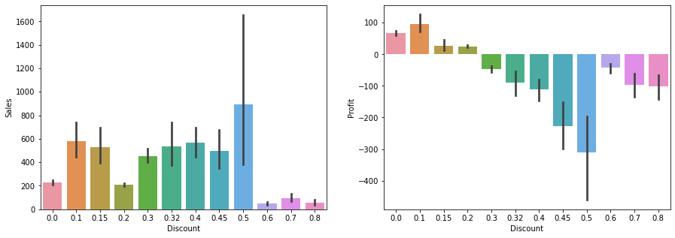

* We note that when the discount is high, the profit is negative

### **check the number of each sub-category:**

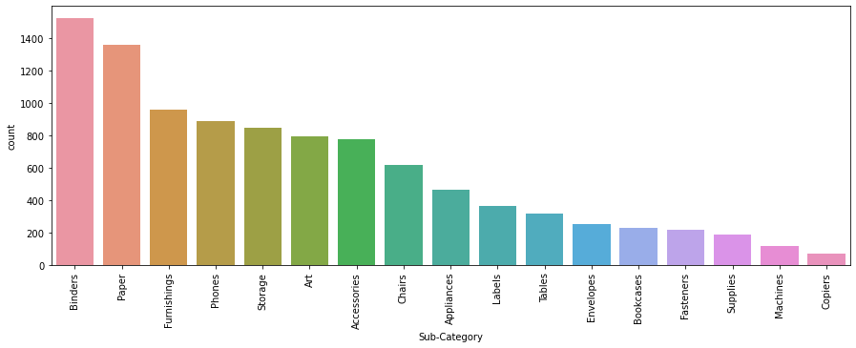

* Sales of Binders as Paper are the highest.

### **check Sub-category with profit:**

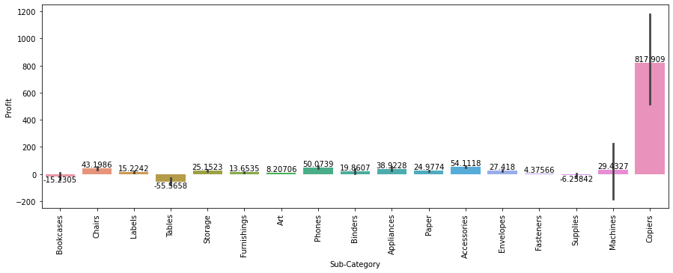

* Tables Supplies and Bookcases have negative profit

### **check sales:**

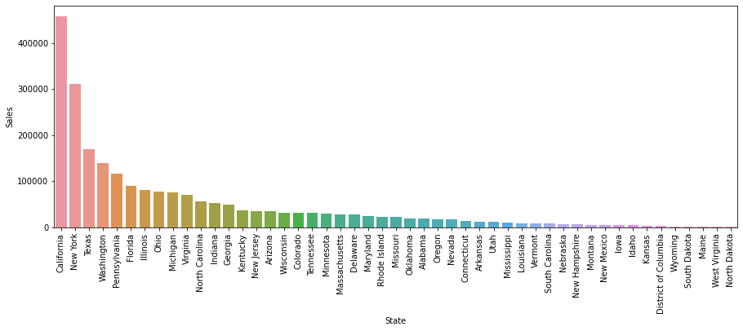

* California and New York have the maximum sales
* Many states have lower sales

### **Check Quantity:**

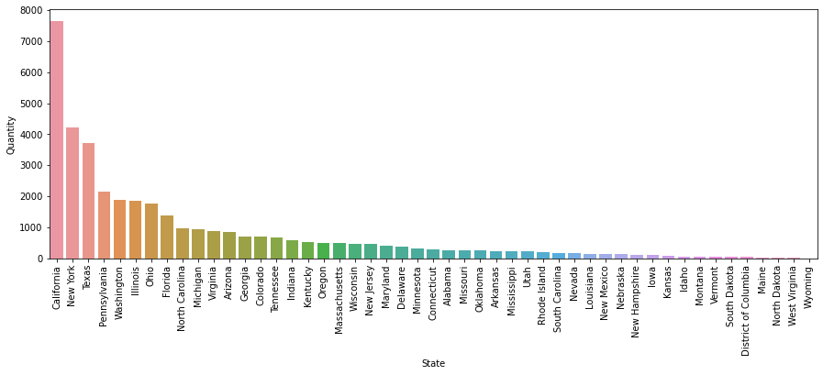

* In California and New York people like to take more quantity of products at a time.

### **check Profit:**

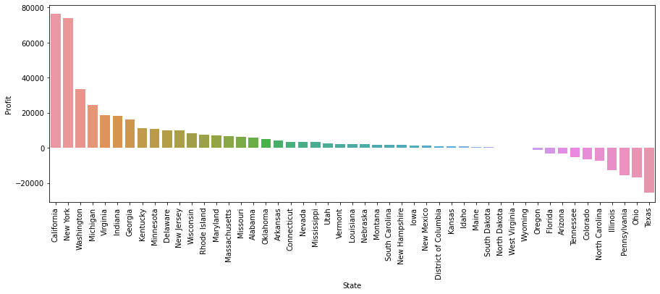

* California and New York have the highest profit
* Some states have good sales but profits in negative

## **Check Discount for the state:**

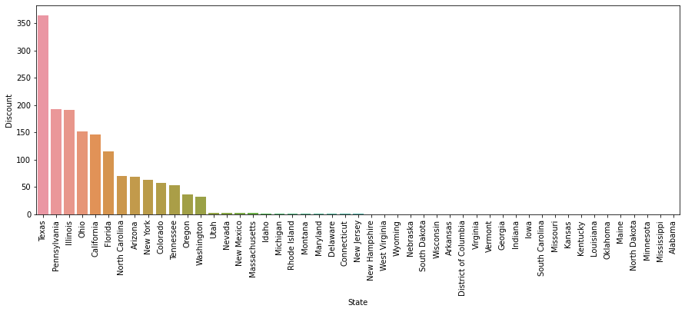

* high discounts sometimes cause to loss profit and we can see that

**Category to category:**

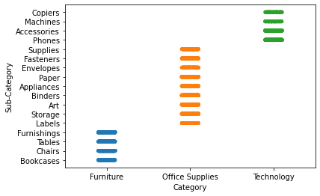

* From this graph we can understand that different sub-category of categories

**Multivariant analysis:**

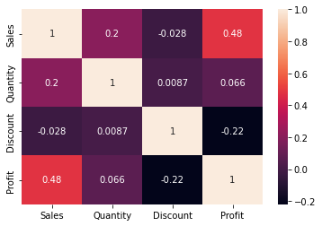

* From this heat map profit and sales have more correlation and then sales and quantity have a good correlation.

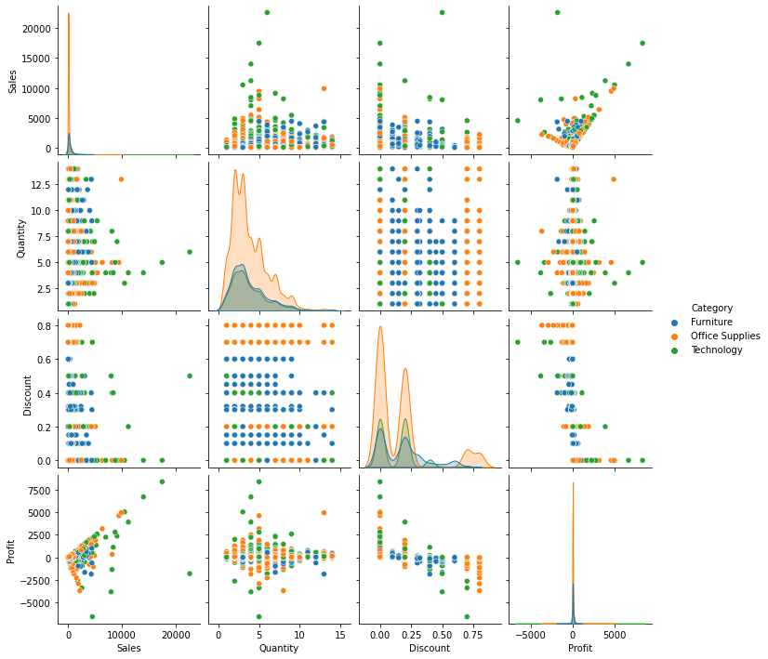

* The Technology category is high in sales, low in discounts, and high in profit.
* The Furniture category is low in profit, high in discount, and compared to office supplies high in sales.
* The Office supplies category is low in sales, compared to furniture high in profit, and compared to technology high discount.

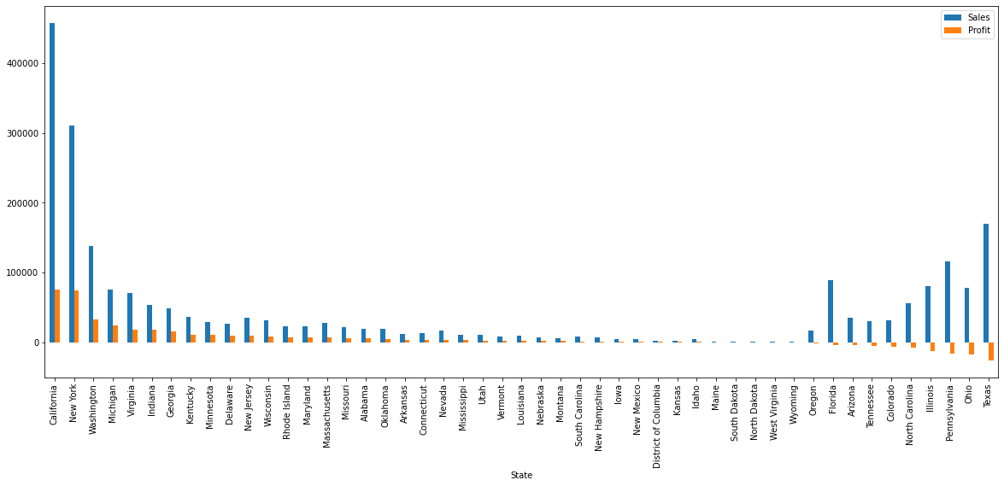

* Not all good sales make a good profit

### **Conclusion:**

* For each region:
* West region has the highest profit and finds the same region has the lowest discount
* South has the highest sales
* Central has the lowest profit and the highest discount, maybe that is why.
* For each category:
* Furniture sales are high but have very low profit maybe a high discount is the reason.
* For each segment:
* Home Office has the lowest discount but has also the highest profit as sales
* For each ship mode:
* Same-day shipping has the highest sales
* First class has the highest discount but also the highest profit
* Sales and Profit are not linear for most States
* Central region needs more attention
* Furniture and Office Supplies have high loss profit with high discount
* Office Supplies has maximum loss at 80% and 0% discount
* Furniture and Technology have a maximum loss between 30% to 50%
* Technology also has maximum loss profit at 70%
* Tables and Supplies and bookcases in the sub-category have negative profit

**Overall analysis and predictions:**

* Technology earns more profit compared to furniture
* Same-day shipping earns high sales
* West region has the highest profit
* Vermont state has a good profit with low sales
* Discount with 50% and less gain more profit
* Need to give more discounts on Furniture to attract customers
* In segment need to give more discounts in Consumer and in Home-Office promote more for higher the profit