🛒 E-Commerce Order & Customer Analytics
Using MySQL & Power BI



DEVI ADITYA PRASAD METLA
Data Analyst
2026

1. Business Problem
An e-commerce company wants to answer the following business questions:
- How are customers behaving over time?
- Which products and categories generate the most revenue?
- How are orders performing (delivery, cancellation, returns)?
- Which payment methods are preferred?
- Who are the most valuable customers?
- How much revenue comes from repeat customers?
The goal is to use data to improve revenue, retention, and operational efficiency.

2. Project Scope
This project covers:
- Customer analytics
- Order analytics
- Revenue and performance analysis
- Product and category analysis
- Payment method analysis

3. Dataset Description
The project uses a custom-designed e-commerce dataset consisting of the following tables:
Tables Used:
- customers – stores customer details (name, city, signup date)
- products – stores product details (name, category, price)
- orders – stores order information (order date, status, customer)
- order_items – stores order-product mapping and quantity
- payments – stores payment details (method, status, amount)
Key Columns:
- Customer ID, Customer Name, City
- Product ID, Category, Price
- Order ID, Order Date, Order Status
- Quantity, Payment Method, Payment Status, Amount

4. Database Design
The database was designed using a relational model with proper primary keys and foreign keys:
- customers.customer_id → orders.customer_id
- orders.order_id → order_items.order_id
- products.product_id → order_items.product_id
- orders.order_id → payments.order_id
This structure ensures:
- Data integrity
- No duplication
- Easy joining of tables for analysis

5. Data Analysis Using SQL
More than 30 analytical SQL queries were written to answer real business questions, including:
Customer Analysis:
- Total customers
- New customers per month
- Returning vs new customers
- Customers with no orders
- Average orders per customer
- Top customers by number of orders

Order Analysis:
- Total orders
- Monthly order trend
- Order status distribution
- Cancelled order percentage
- Orders with more than 3 items
- Orders without successful payment

Revenue Analysis:
- Total revenue
- Average Order Value (AOV)
- Monthly revenue trend
- Revenue by customer
- Revenue from repeat vs new customers

Product & Category Analysis:
- Top-selling products
- Category-wise revenue
- Unsold products
- Highest revenue generating product

Payment Analysis:
- Most used payment methods
- Average payment per method
- Revenue contribution by each payment method

6. Exporting SQL Results
Each important SQL query result was:
- Exported from MySQL Workbench as CSV
- Loaded into Power BI
- Used for building visuals and KPIs
This reflects a real-world data analyst workflow:
MySQL → SQL Queries → CSV → Power BI → Dashboard → Insights

7. Power BI Dashboard Design
The Power BI dashboard was designed with a professional, business-focused layout and includes multiple pages:
Page 1: Executive Overview
- KPI Cards:
  - Total Customers
  - Total Orders
  - Total Revenue
  - AOV
  - Cancelled % / Repeat Rate
- Revenue trend line chart
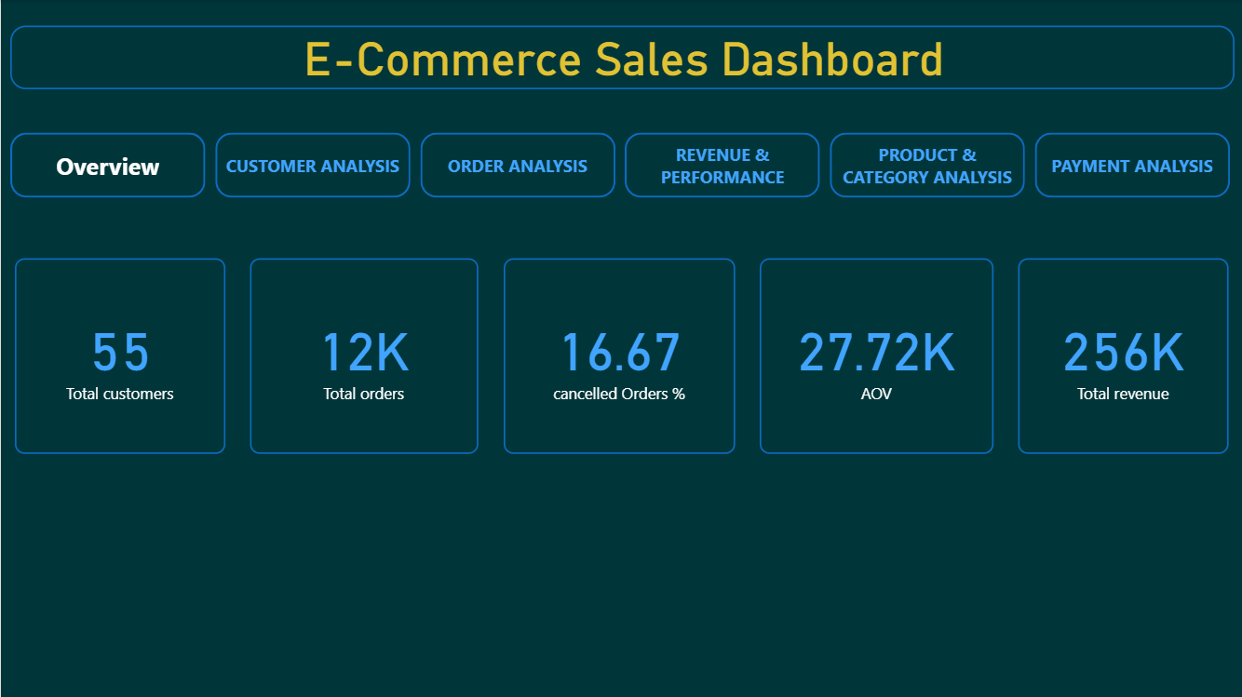
Fig 1: KPI Cards

Page 2: Customer Analysis
- New customers trend
- City-wise customer distribution
- Returning vs new customers
- Top customers by orders

Fig 2: This chart shows the monthly new customer acquisition trend, indicating growth patterns over time.
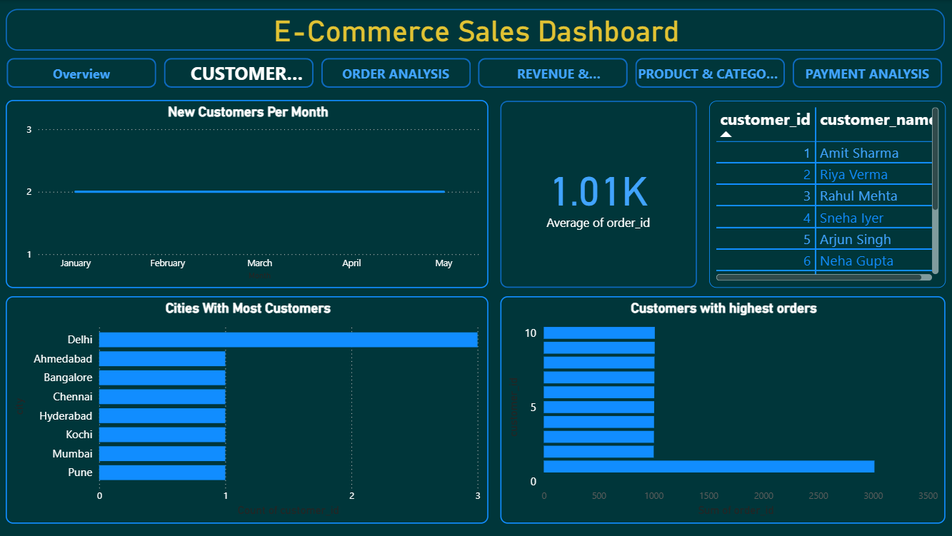

Page 3: Order Analysis
- Monthly orders trend
- Order status distribution
- High item orders
- Average items per order

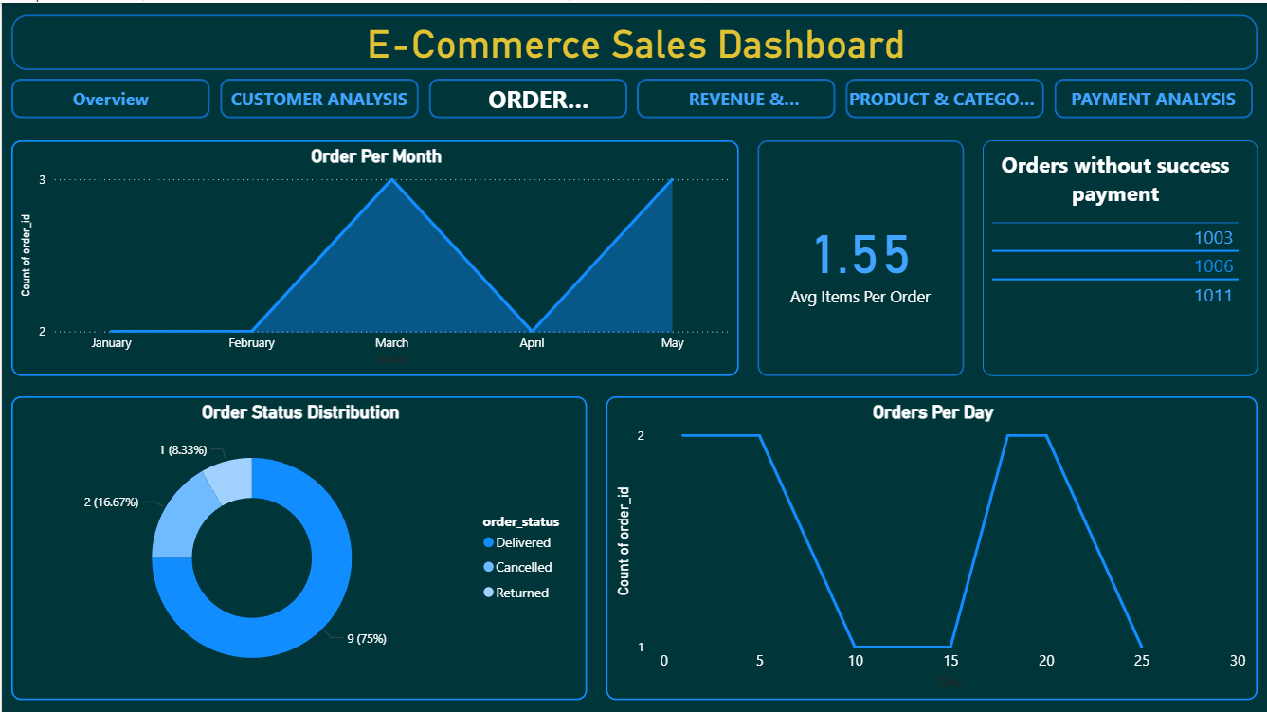
Fig 3: This Chart shows that Order Per monthly and day-wise, and status of orders.

Page 4: Revenue & Performance
- Monthly revenue trend
- Top customers by revenue
- Repeat vs new customer revenue

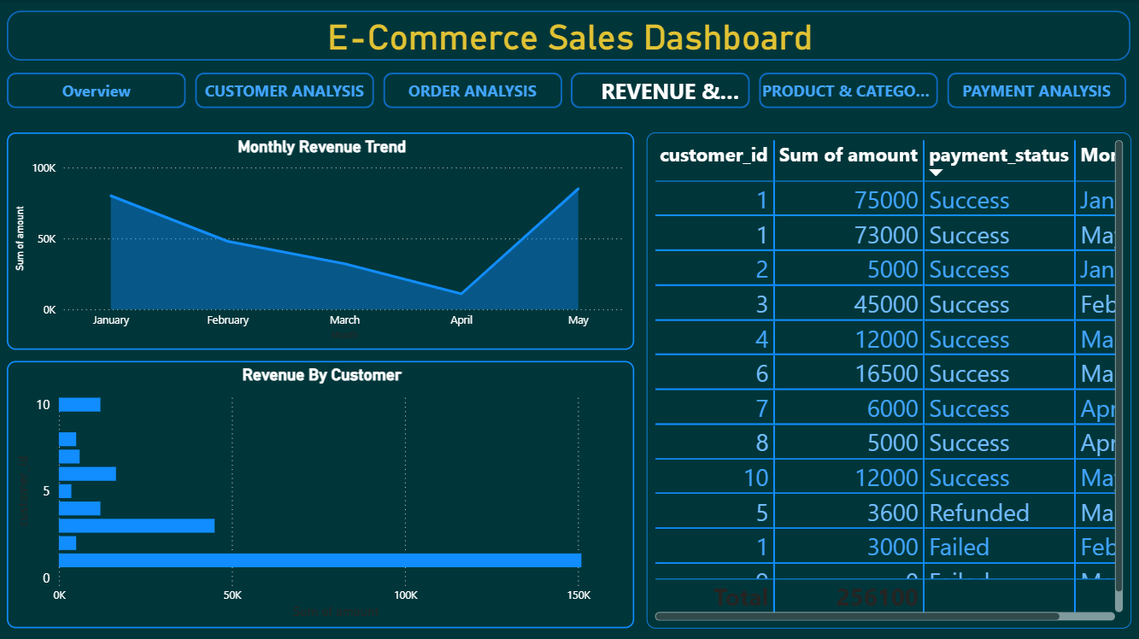
Fig 4: This line chart represents monthly revenue trend and highlights peak sales periods.

Page 5: Product & Category Analysis
- Top-selling products
- Category-wise revenue
- Unsold products

Fig 5 : This chart shows that Category-wise Revenue, Top selling products.
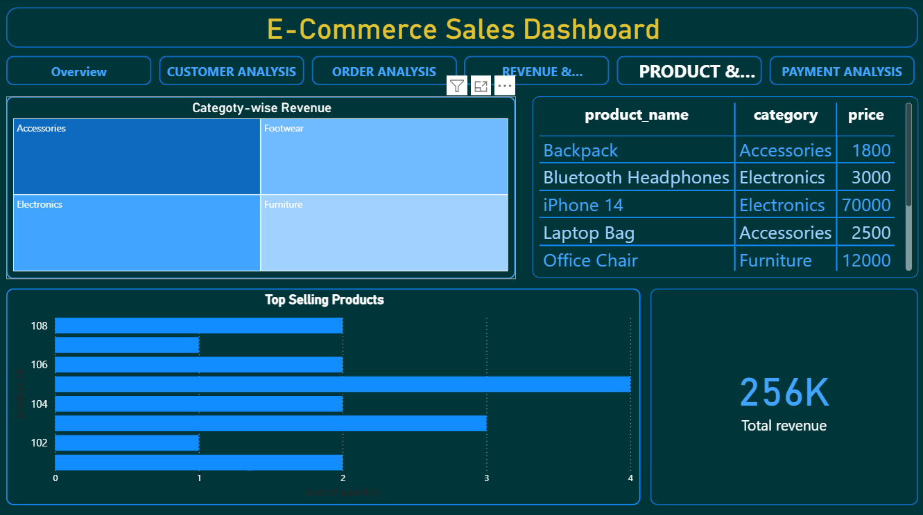

Page 6: Payment Analysis
- Payment method usage
- Revenue share by payment method
- Average payment amount by method

Fig 6: This donut chart shows the distribution of payment methods used by customers.
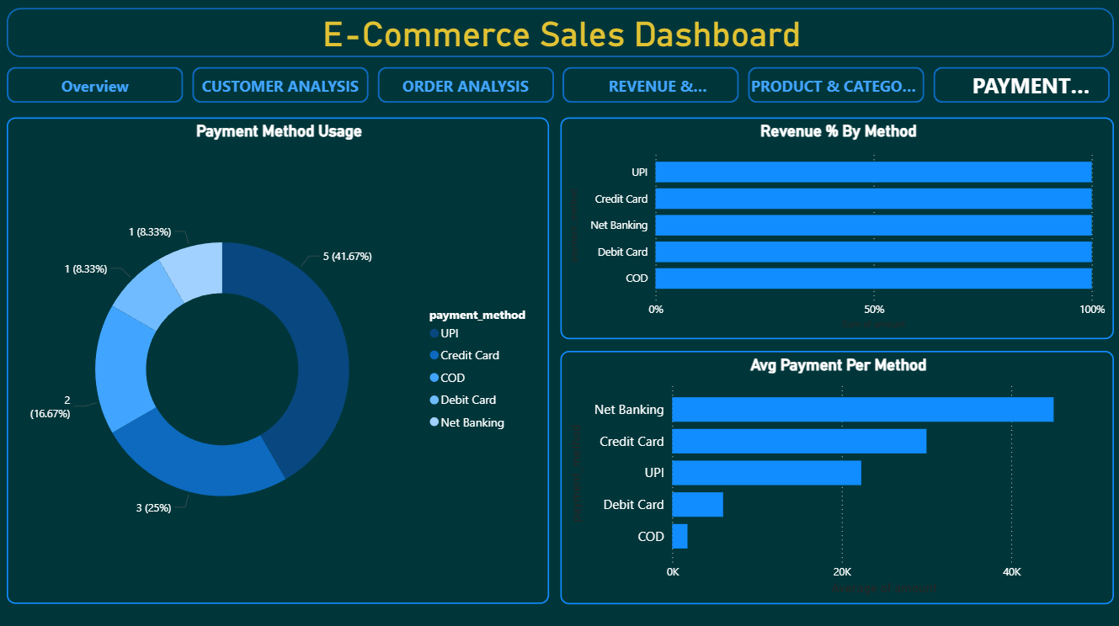

8. Key KPIs Used
- Total Revenue
- Total Orders
- Total Customers
- Average Order Value (AOV)
- Customer Lifetime Value (CLV)
- Repeat Purchase Rate
- Cancelled Order Percentage

9. Key Business Insights
Some important insights derived from the analysis:
- A small group of repeat customers contributes a large portion of total revenue
- Electronics category generates the highest revenue
- UPI and Credit Card are the most preferred payment methods
- Order cancellations, although limited, impact monthly growth
- Average Order Value is stable but can be increased using cross-selling strategies
- Top 5 customers contribute a significant share of total revenue

10. Tools & Technologies Used
- MySQL – Database design and SQL analysis
- MySQL Workbench – Query execution and data export
- Power BI – Dashboard creation and visualization
- Excel / CSV – Intermediate data storage

11. Conclusion
This project successfully demonstrates an end-to-end data analytics pipeline:
- Database design
- SQL-based business analysis
- Data export and transformation
- Dashboard development
- Insight generation
The project shows strong skills in:
- SQL querying
- Data analysis
- Business thinking
- Dashboard design
- Storytelling with data
This makes it a portfolio-ready and interview-ready project for Data Analyst roles.

12. Future Enhancements
- Add larger real-world dataset
- Add customer segmentation
- Add profit analysis
- Connect Power BI directly to MySQL
- Automate report refresh

