RESTAURANT DATA ANALYSIS REPORT

Challenge

DEVI ADITYA PRASAD METLA
18-11-2025
COGNIFYZ TECHNOLOGIES – DATA ANALYST INTERN

INTRODUCTION 2
DATA EXPLORATION 3

METHODS 4
MODELLING AND RESULTS 5
CONCLUSION 6
REFERENCES 7

INTRODUCTION
Exploratory Data Analysis (EDA) uncovers patterns, anomalies and relationships in raw data before applying models. EDA helps stakeholders understand market trends, customer behaviour and operational gaps. For restaurant analytics, EDA informs decisions about menu strategy, location planning, pricing, and service offerings.
What I did
Performed EDA using Python (Pandas), visualized results with Matplotlib and Folium, and created interactive dashboards in Power BI. Cleaned and normalized the dataset to ensure correct aggregations.

Dataset Description

Understanding data schema and field semantics prevents misinterpretation. Key fields (IDs, coordinates, ratings, votes, service flags) enable cross-sectional and geospatial analysis.

What I did

Examined columns for missing values and data types.

Standardized columns (e.g., Has Online delivery to Yes/No, Cuisines trimmed and exploded).

De-duplicated by Restaurant ID to ensure unique restaurant-level metrics.

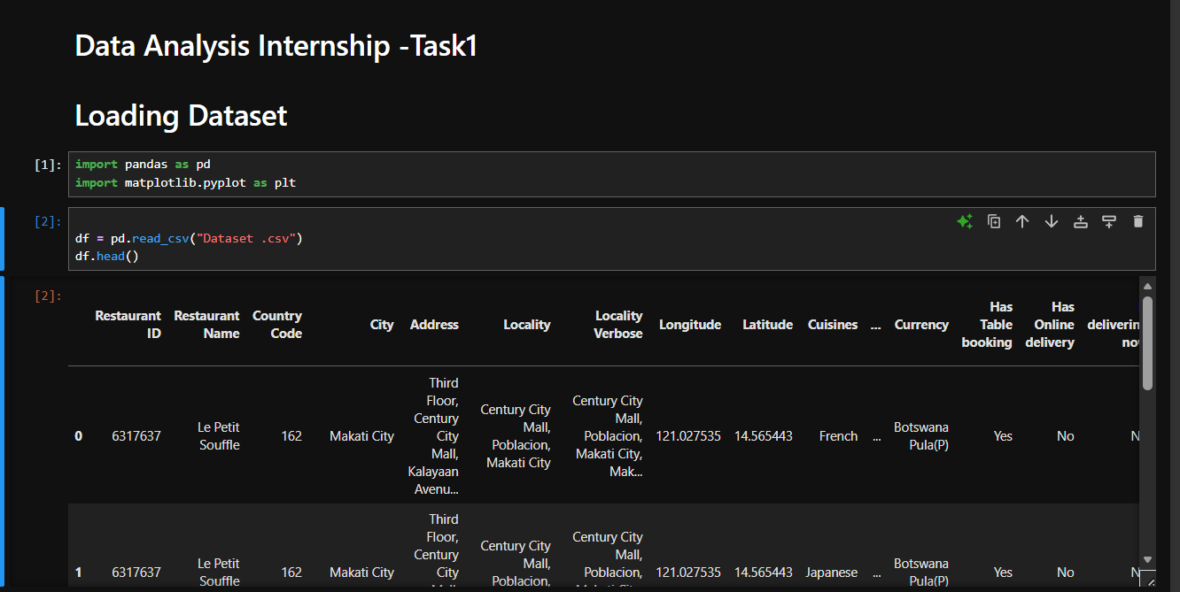
Fig 1: Loading the Dataset in Pandas Dataframe

Outcome

A clean dataframe ready for aggregation, with numeric fields converted and textual flags standardized.

Screenshots of Pandas-Profiling Reports

Methodology
A reproducible pipeline: cleaning → transformation → aggregation → visualization → interpretation. Each step reduces bias and preserves data integrity.
What I did (high level)
- Data cleaning: trim strings, drop exact duplicates, convert numeric columns.
- Transformation: split multi-cuisine cells into separate rows for per-cuisine analysis.
- Aggregation: groupby operations to compute counts, averages and percentages.
- Text analysis: tokenization and stopword removal for keyword extraction.
- Geospatial: plotted lat-long on interactive maps to reveal clusters.
- Validation: cross-checked Python results with Excel pivot tables.

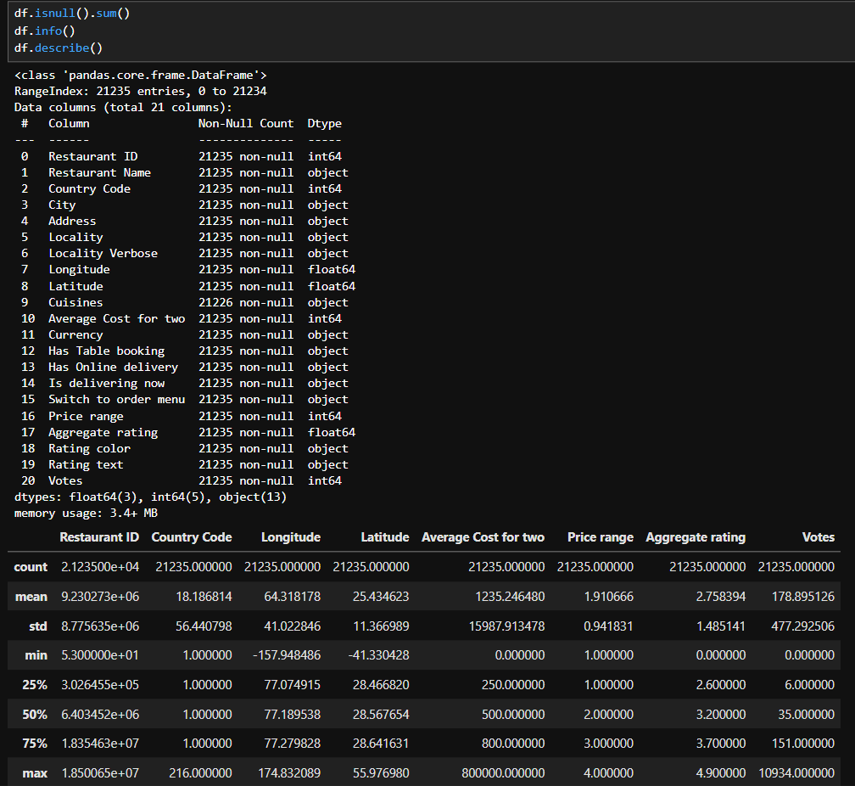

4.1 Top Cuisines
Cuisine frequency indicates market preference; % coverage = number of restaurants offering a cuisine / total restaurant. Use explodes to handle multi-cuisine entries.
What I did / Output
- Cleaned and exploded cuisines, removed duplicate restaurant–cuisine pairs.
- Calculated counts and % coverage.
- Top cuisines (example): Indian ~46%, North Indian ~43%, Chinese ~30%.
Chart placeholder: Bar chart showing top cuisines with % labels.
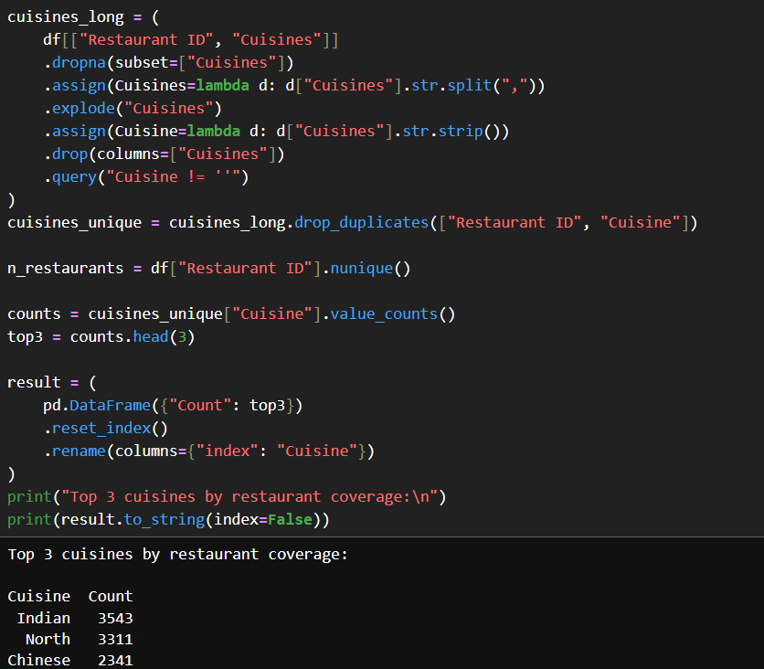
Plot Showing Total Confirmed Cases by Continents

4.2 City Analysis (highest restaurant count & avg rating)
City concentration shows market opportunity; average rating reveals customer satisfaction regionally.
What I did / Output
- Computed unique restaurants per city to identify the busiest cities.
- Calculated mean aggregate rating per city.
Chart placeholder: Top 10 cities by restaurant count + horizontal bar of average rating.

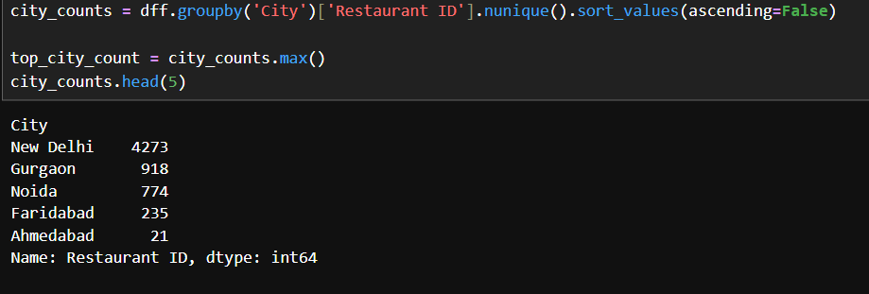

4.3 Price Range Distribution
Price segmentation helps position products and target customer groups.
What I did / Output
- Used unique restaurants to compute percentages by price band (1–4).
Chart placeholder: Histogram / bar chart of % restaurants per price range.
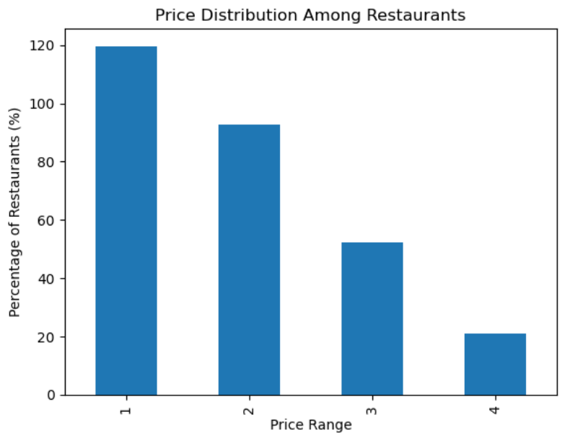

4.4 Online Delivery vs Rating
Service availability (delivery) can correlate with ratings due to convenience and reach.
What I did / Output
- Cleaned flag and calculated average rating for Yes and No.
- Observed that restaurants offering online delivery had higher average ratings.
Chart placeholder: Side-by-side bar chart of avg rating for delivery vs no delivery.
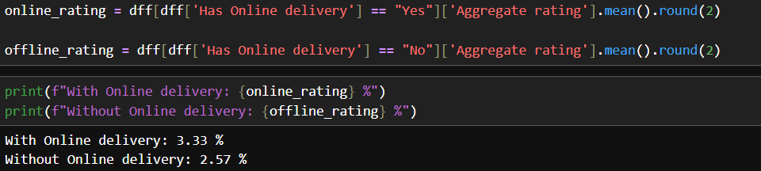

5.1 Review Text Analysis — Positive & Negative Keywords
Extracting frequent sentiment words identifies strengths and pain points. Use stopword removal and simple lexicons or sentiment libraries for more advanced work.
What I did / Output
- Extracted and counted lexicon matches.
- Positive examples: good, tasty, excellent; Negative: slow, average, poor.
Chart placeholder: Two bar charts (top positive words / top negative words) or word clouds.

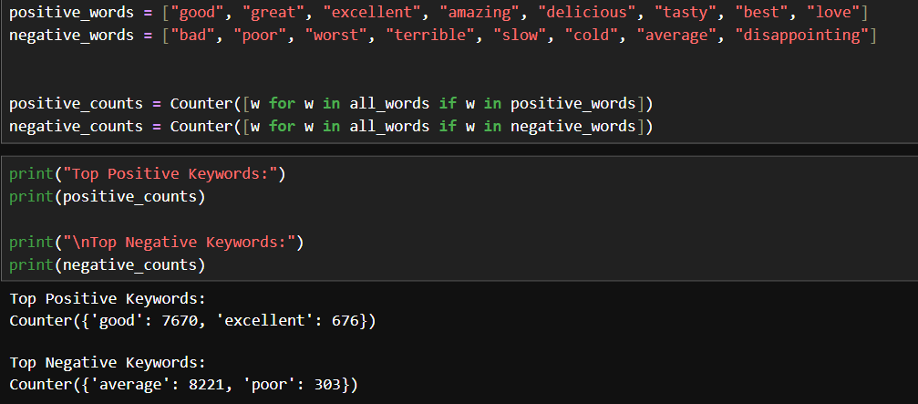

5.2 Review Length vs Rating
Review length (words) can reflect engagement; longer positive reviews often indicate detailed satisfaction.
What I did / Output
- Computed average review length per rating; trend shows increasing length with higher ratings.
Chart placeholder: Line chart or bar chart Rating vs Avg Review Length.
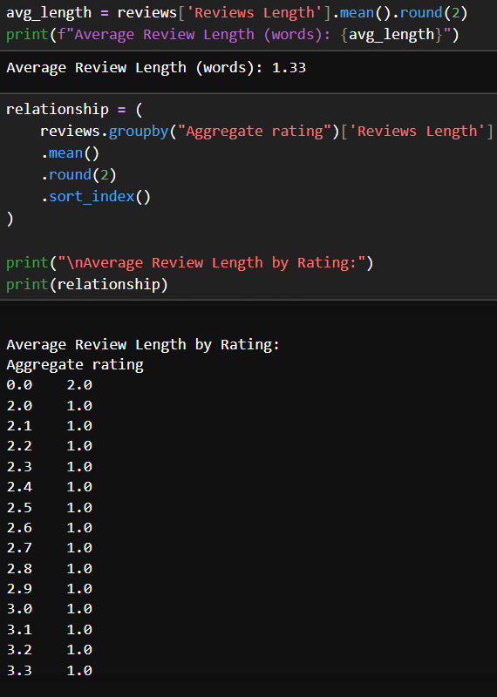

5.3 Geospatial Mapping & Clusters
Mapping latitude/longitude reveals density hotspots and catchment areas for business decisions.
What I did / Output
- Created interactive Power BI map with clustered markers.
- Observed dense clusters in major cities.
Chart placeholder: Screenshot of the interactive map.

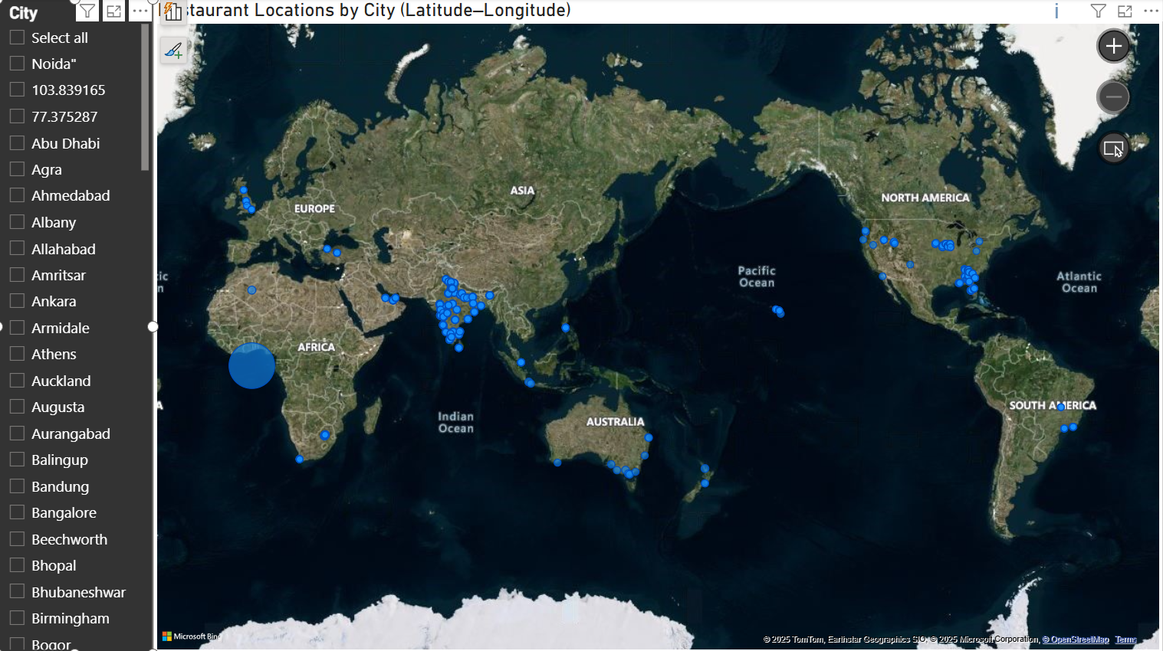

5.4 Restaurant Chain Detection
Chain detection via name frequency identifies brand presence and franchise reach.
What I did / Output
- Listed restaurant names appearing multiple times; counted outlets per chain.
- Cross-referenced chain outlets by city for distribution mapping.
Chart placeholder: Table of top chains + map markers showing chain spread.

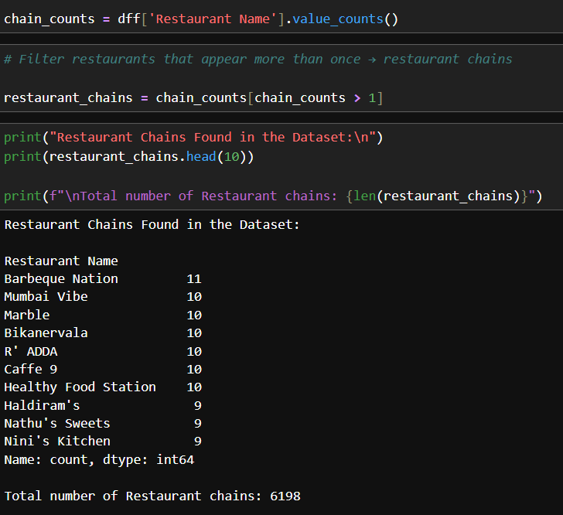

6.1 Highest & Lowest Votes
Votes approximate engagement; high votes indicate popularity/visibility.
What I did / Output
- Extracted top and bottom restaurants by votes.
Chart placeholder: Two small tables or bar charts showing top 10 and bottom 10 by votes.
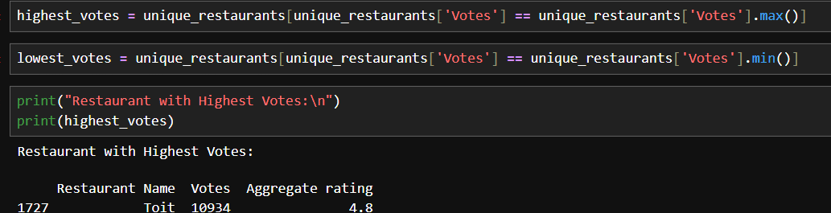

6.2 Votes vs Rating Correlation
Correlation quantifies linear association; Pearson’s r indicates strength/direction.
What I did / Output
- Computed correlation (example: r ≈ 0.4) showing positive relationship: higher-rated restaurants tend to have more votes.
Chart placeholder: Scatter plot Votes vs Aggregate rating with a regression line.

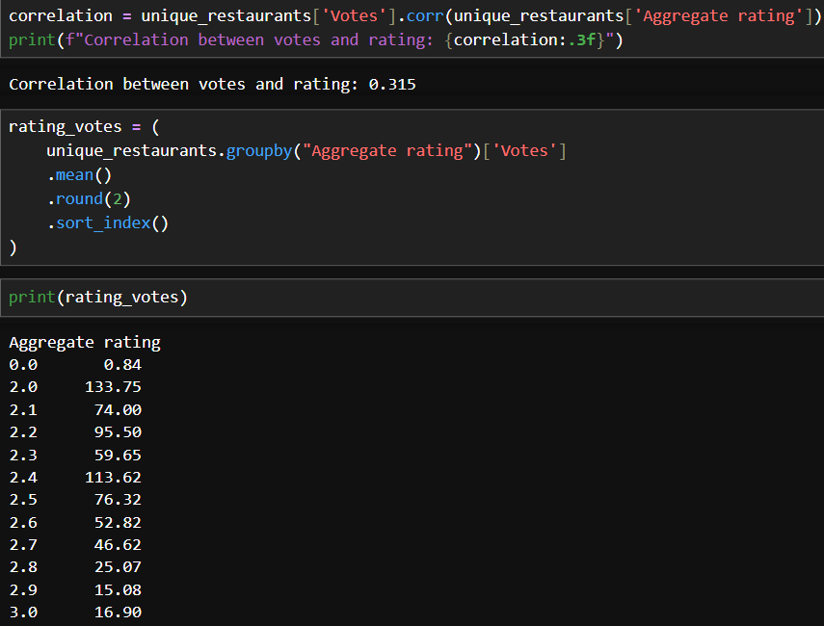

6.3 Price Range vs Service Availability (Delivery & Table Booking)
Service provisioning is often correlated with price level and target market.
What I did / Output
- Calculated % of restaurants offering services in each price band.
- Concluded higher-price ranges show higher % for both services.
Chart placeholder: Stacked bar or grouped bar chart of % Yes by price range.
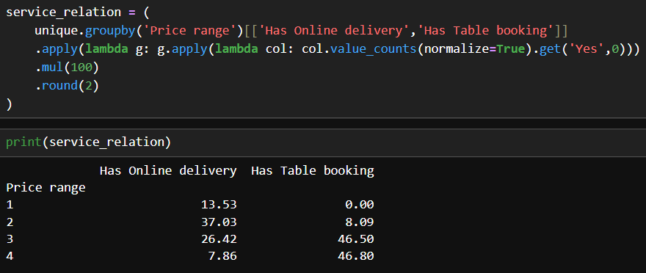

7. Key Insights & Recommendations
Theory (why actionable insights matter)
Combining data-driven analysis with business context generates recommendations that can be used in strategy, marketing, and operations.
Findings
- Market dominated by Indian & North Indian cuisines → focus menu strategy accordingly.
- Urban clusters = prime expansion points.
- Higher-priced restaurants provide more services → mid-range restaurants can increase revenues by enabling delivery/table booking.
- Positive sentiment keywords highlight strengths; negative keywords indicate operational areas for improvement.
- Encouraging detailed reviews increases visibility and aids reputation building.
Recommendations
- Prioritize delivery infrastructure for mid-range restaurants.
- Target expansion in identified cluster zones.
- Leverage top-rated cuisine combinations in new outlets.
- Implement measures to convert short negative reviews into service improvements.

Business Requirements (Bullet Points)
- Identify the top cuisines and their popularity among restaurants.
- Determine city-level restaurant distribution and performance.
- Analyze price range distribution to understand affordability trends.
- Compare ratings between restaurants with and without online delivery.
- Calculate the average rating for restaurants across cities.

CONCLUSION
- The analysis revealed strong trends in cuisine popularity, pricing, and customer preferences across cities.
- Online delivery and table booking services showed a clear impact on customer satisfaction and ratings.
- Geospatial mapping highlighted major restaurant clusters in metropolitan regions.
- Sentiment and review analysis provided valuable insights into customer experiences.
- Overall, the project offers actionable insights to improve restaurant performance and decision-making.

