# **MATLAB Modelling of PCM-Integrated Building Envelopes**

Numerical modelling seeks to determine the ideal location of a PCM layer within the wall assembly that reduces the peak interior air temperature relative to a conventional wall, and to examine the effect of PCM concentration on thermal performance while respecting structural restrictions. A two-dimensional transient heat-transfer model was constructed in MATLAB utilizing an enthalpy-based formulation to incorporate phase change effects. Simulations were performed for MS0, MS1, and MS2, and results were confirmed against experimental observations. One of the objectives of this modelling is to identify the most effective position for the PCM layer within the wall assembly to achieve maximum thermal comfort and energy efficiency. A comprehensive numerical simulation is performed using MATLAB, employing a two-dimensional transient heat conduction model integrated with the enthalpy method to account for phase change effects. Based on Fourier’s law of heat conduction and energy conservation principles, the governing heat transfer equations are solved under dynamic boundary conditions using actual climatic data for solar radiation and ambient temperature. Thermal properties such as density, thermal conductivity, specific heat, and latent heat of the composite PCM are integrated into the model

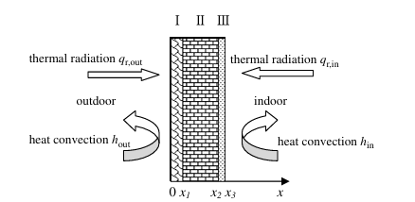

Governing Equation  **(a)**

Where,

K= Thermal conductivity [W/m·K]

= Density [kg/m³]

*C*p​= Specific heat [J/kg.K]

Now the above equation for PCM layer can be written as for nodes:

**(b)**

**(c)**

1. Finite Difference method

Where is the density, *H* is enthalpy, is the time, is thermal conductivity, is the temperature, *i* represent the PCM position in inner wall, *j* represent the brick and mortar.

The ambient temperature and solar radiation data for continuous three day has been taken for the location (25.3176° N, 82.9739° E) and use to solve the above mathematical model using MATLAB.

Boundary condition

PCMIW

For x = 0,

+

For x = ,

For x = ,

For x =,

Roof of PCMIW

For y = 0,

+

For y = ,

For y = ,

+

The simulation evaluates three possible configurations for PCM placement within the wall structure as brief in details.

* 1. **Outer Layer Placement**

In this configuration, the PCM layer is applied directly on the outer surface of the wall, where it is exposed to direct solar radiation. This arrangement lets the PCM absorb incoming solar heat at the earliest point, potentially reducing heat transfer to the inner wall layers.

When the PCM was integrated at the outer surface of the wall, the temperature variation inside the wall remained relatively stable throughout the two-day cycle. At t = 12:00 pm, which corresponds to the maximum outside ambient temperature, the PCM absorbed a significant portion of the incident solar heat due to its latent heat storage capacity. This resulted in a dampening of the temperature fluctuations inside the wall, thereby reducing the thermal load on the inner surface. By t = 6:00 pm, when the external solar input decreased, the PCM had already stored a large fraction of the heat, causing the outer surface to cool down faster than the inner surface. However, because of direct exposure to ambient, the PCM released stored heat relatively quickly during the evening, which may affect nighttime cooling benefits.

* 1. **Middle Layer Placement**

Here, the PCM layer is embedded between the outer and inner plaster layers at the mid-section of the wall. This position allows the PCM to act as a thermal buffer, absorbing heat as it penetrates the wall and delaying its transmission to the interior space, thereby enhancing time lag and reducing peak indoor temperature. When the PCM was placed at the centre of the wall, the results showed a different dynamic behaviour. At t = 12:00 pm, the outer surface of the wall was heated significantly, while the PCM layer acted as a thermal buffer zone, reducing the heat penetration towards the inner wall surface. Consequently, the inner surface temperature remained lower compared to the outer surface, demonstrating the effectiveness of PCM in delaying and attenuating heat transfer. At t = 6:00 pm, the thermal gradient across the wall reversed. The outer surface became cooler due to reduced solar input, whereas the inner surface temperature increased gradually, indicating a time-lag effect created by the PCM layer. This time-shifted heat release is particularly beneficial for reducing indoor thermal discomfort during peak hours.

* 1. **Inner Layer Placement**

In this scenario, the PCM layer is placed on the inner surface of the wall, in direct contact with the indoor air. This configuration prioritizes the stabilization of indoor temperatures by absorbing heat just before it enters the room, reducing immediate heat gain and improving occupant comfort. When the PCM was placed at the inner surface of the wall, the results showed the most significant improvement in thermal comfort for indoor spaces. At t = 12:00 pm, despite the rise in outside temperature, the inner surface remained much cooler compared to both the outer and mid-plane cases. This was attributed to the direct interaction of the PCM with the indoor-facing side, allowing it to absorb heat just before it enters the occupied zone. At t = 6:00 pm, the inner surface still remained cooler than the mid-plane and outer surface setups. The PCM at the inner side delayed the heat release and maintained a cooler indoor environment for a longer period, which is advantageous in hot climates such as Varanasi.

From the above simulations, it is evident that the location of the PCM layer within the wall significantly influences the thermal response of the building envelope. When the PCM is positioned at the outer surface, it provides immediate thermal buffering during peak solar hours by absorbing a considerable amount of heat; however, it also tends to release the stored energy quickly after sunset, limiting its effectiveness during nighttime. In contrast, the placement of PCM at the mid-plane of the wall acts as a thermal resistor, delaying the inward flow of heat and introducing a noticeable time lag, which helps reduce heat gains during the late afternoon and early evening. The most effective configuration was observed when the PCM was placed at the inner surface of the wall, as it directly regulates the heat entering the indoor environment, thereby maintaining cooler inner surface temperatures and enhancing thermal comfort. Additionally, at 6:00 pm, the outer surface was consistently cooler than the inner surface across all cases, which corresponds to the reversal of heat flux after solar radiation declines. The extent of this reversal, however, was strongly influenced by the PCM location, with the inner-surface configuration delivering the most favourable results for building applications in hot climatic conditions.

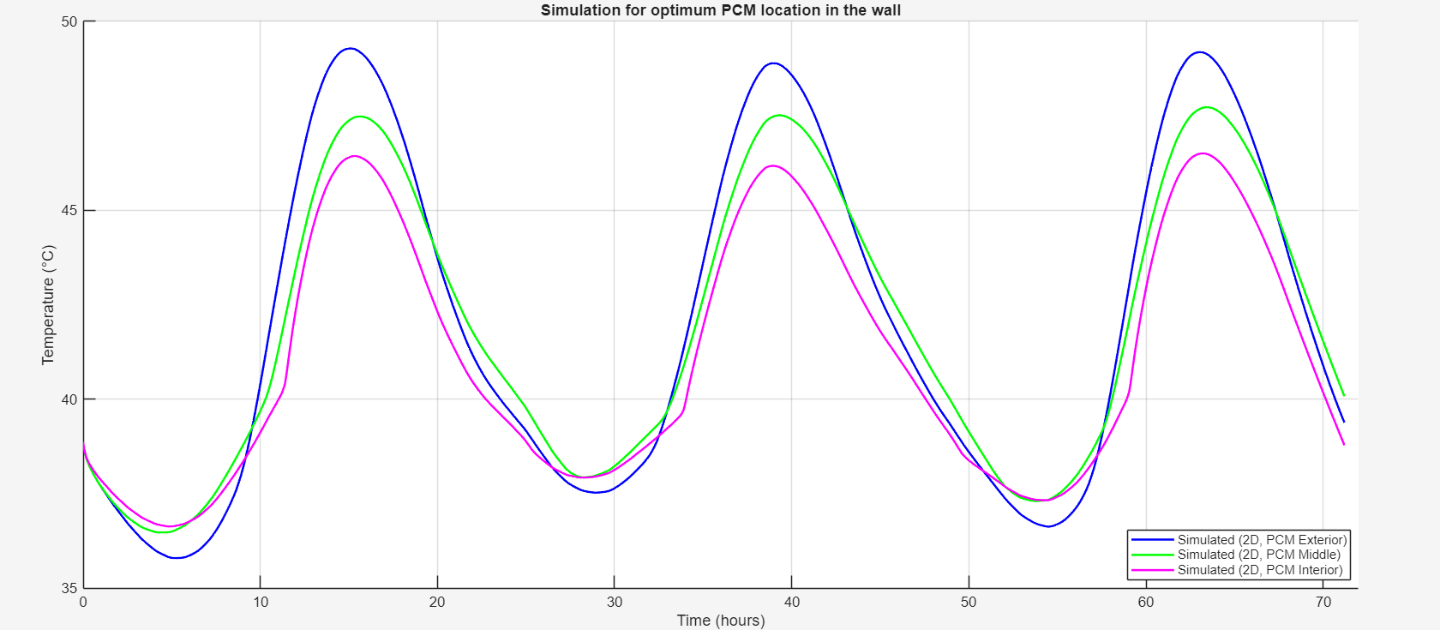

From the above plot we can say that the best position of pcm layer for getting lower room temperature is on **Inner wall**.{ Citation need }

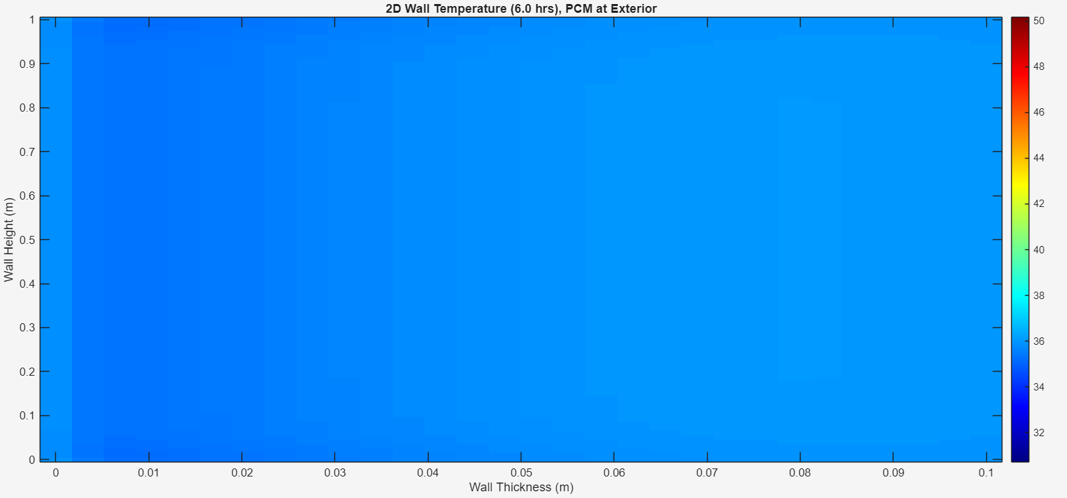 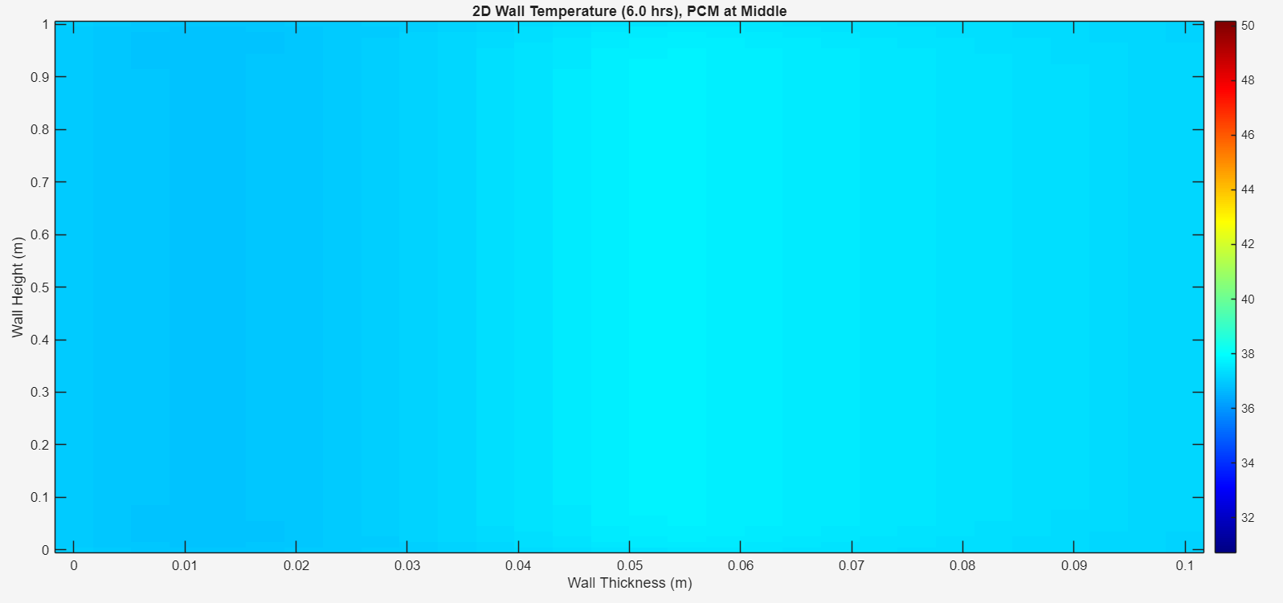 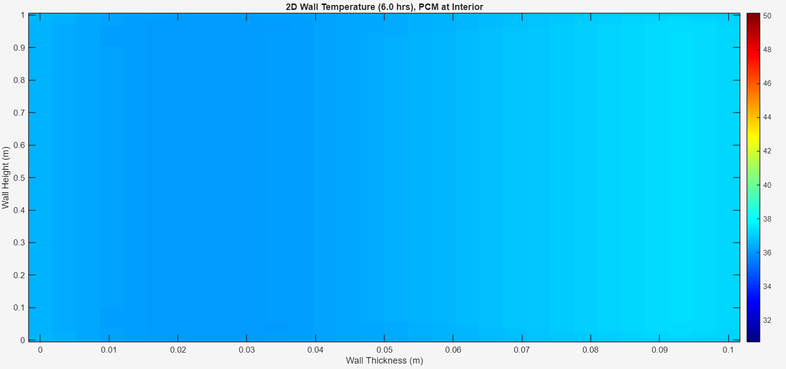

**(a) (b) (c)**

Figure 3(a) When PCM is at outer layer (b) PCM at middle (c) PCM at inner most layer at t = 6 am.

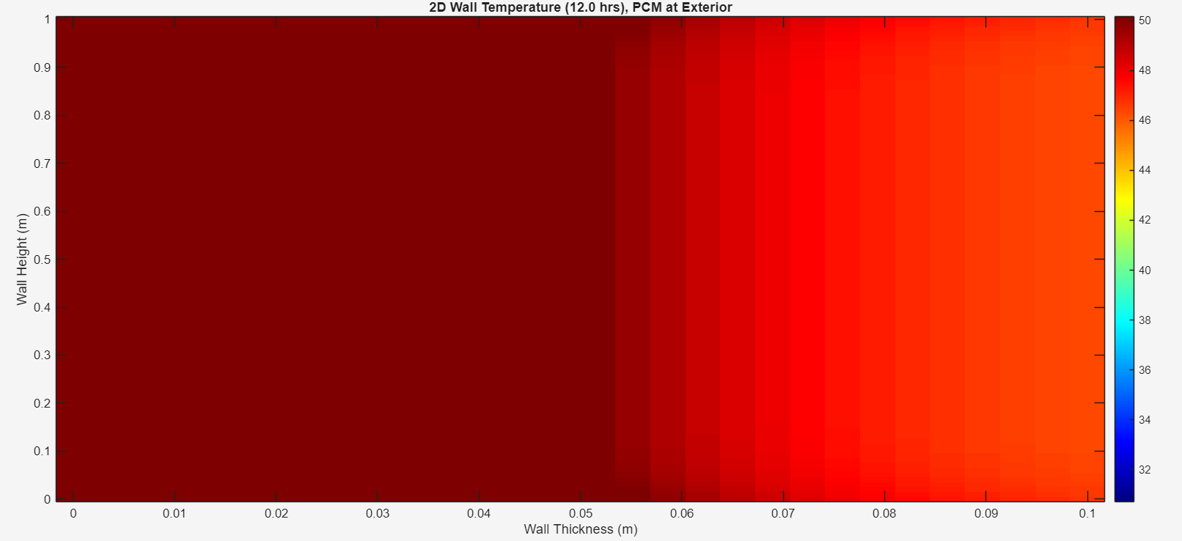 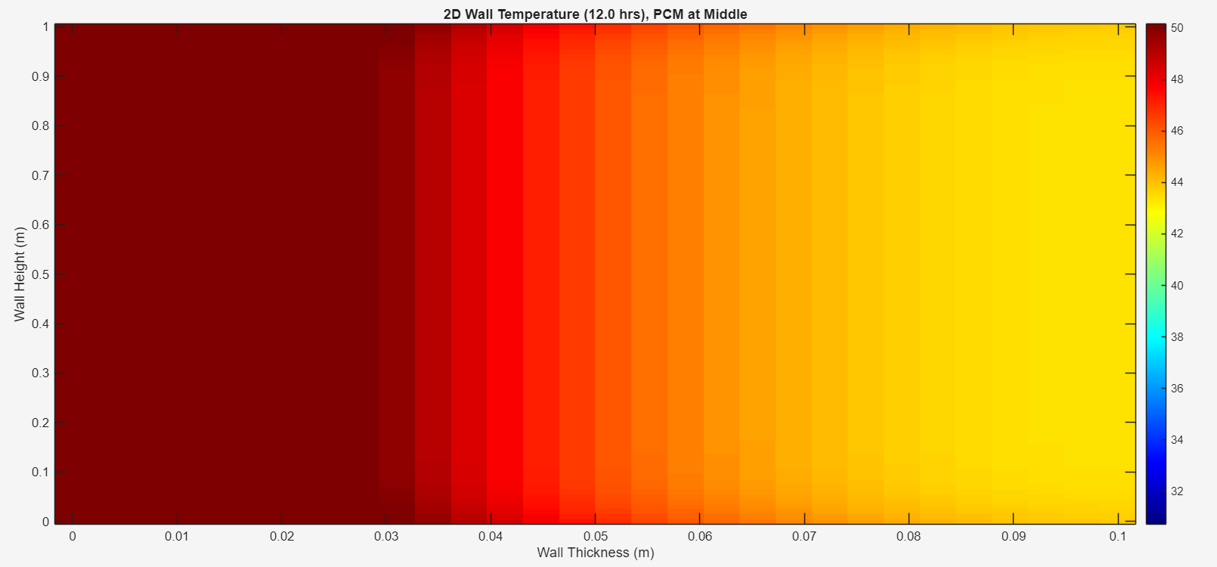 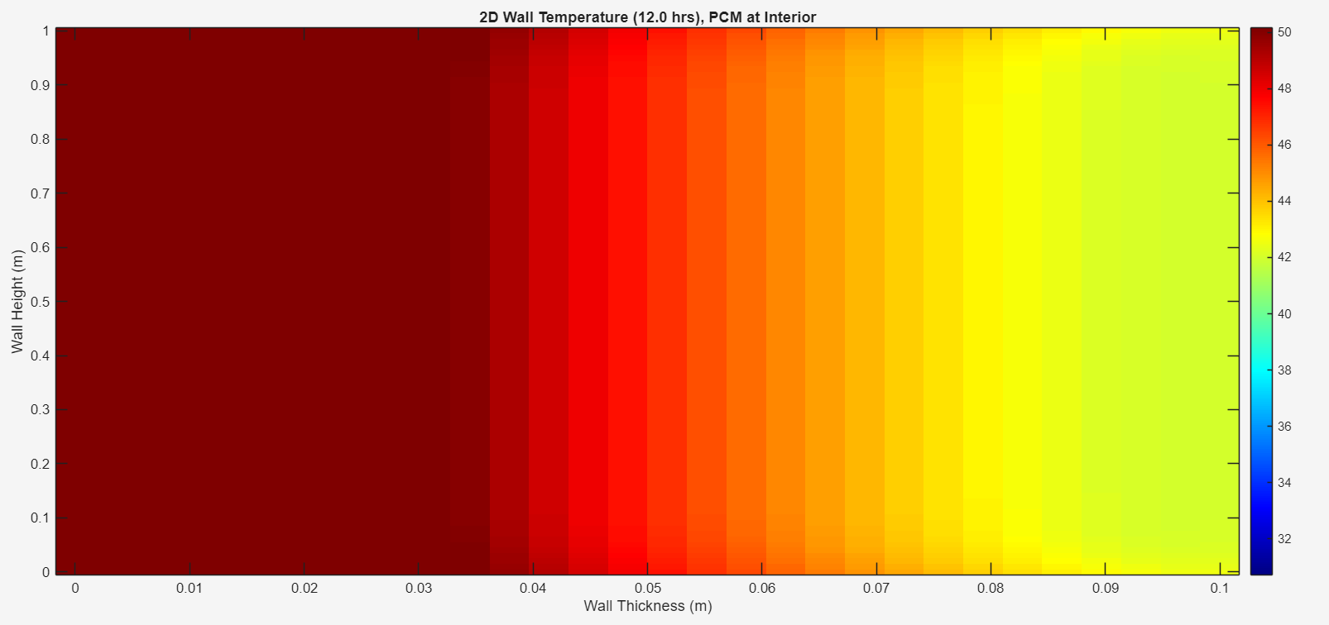

**(a) (b) (c)**

Figure 4(a) When PCM is at outer layer (b) PCM at middle (c) PCM at inner most layer at t = 12 pm.

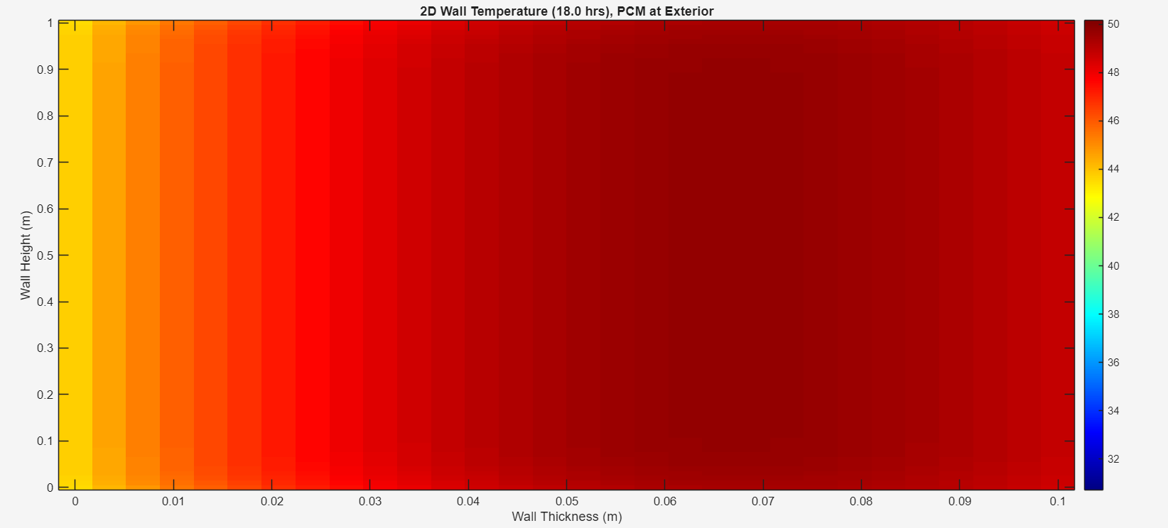 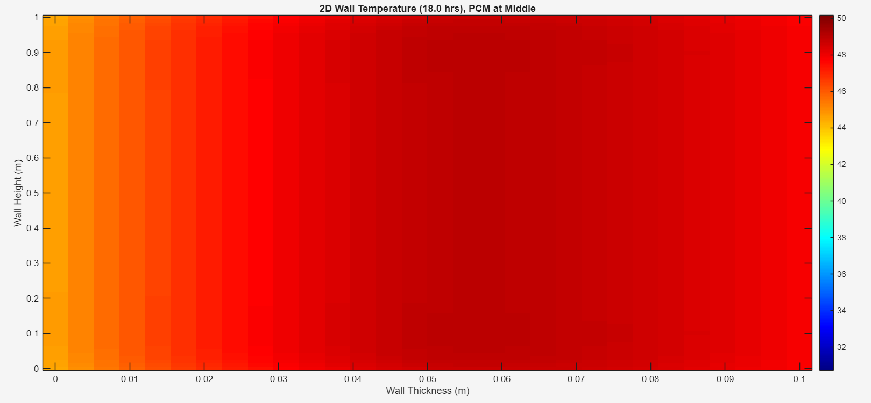 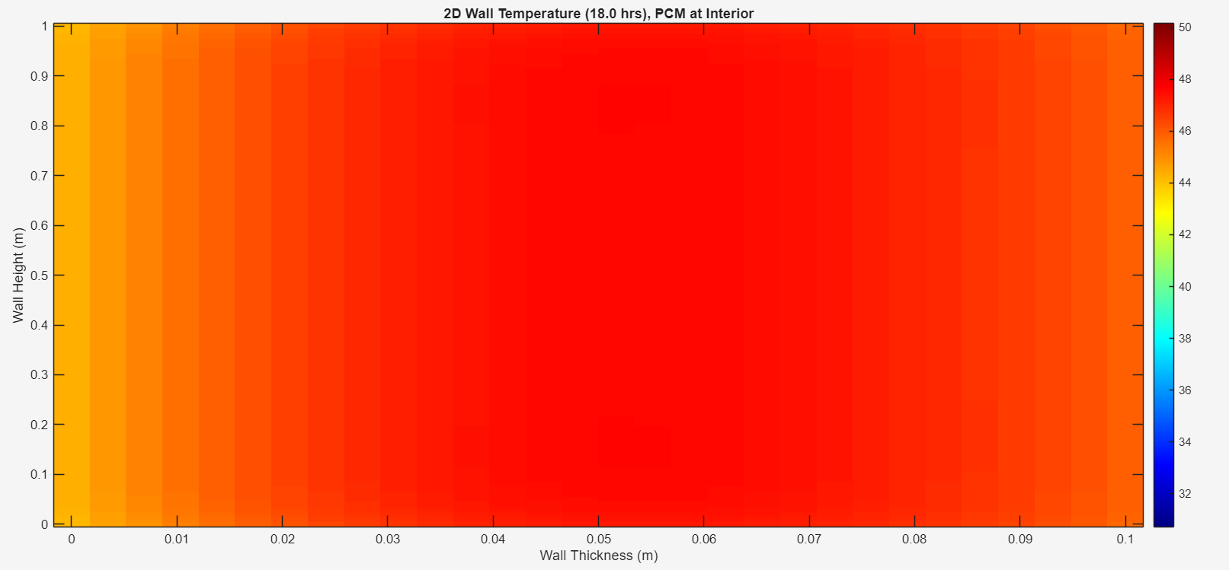

**(a) (b) (c)**

Figure 5(a) When PCM is at outer layer (b) PCM at middle (c) PCM at inner most layer at t = 6 pm.

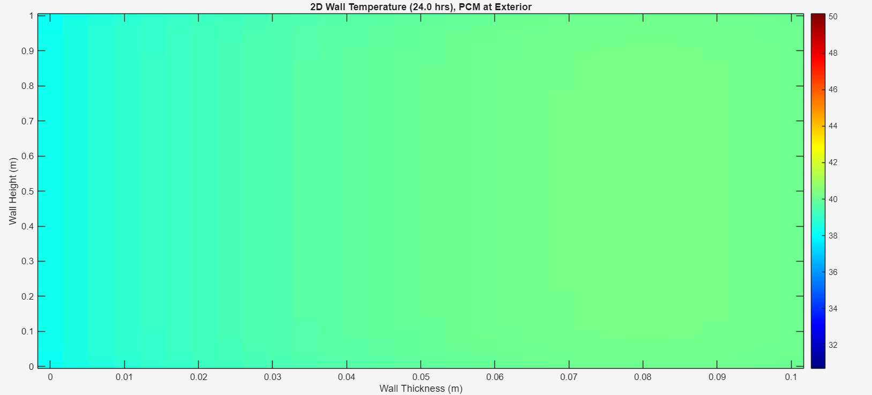 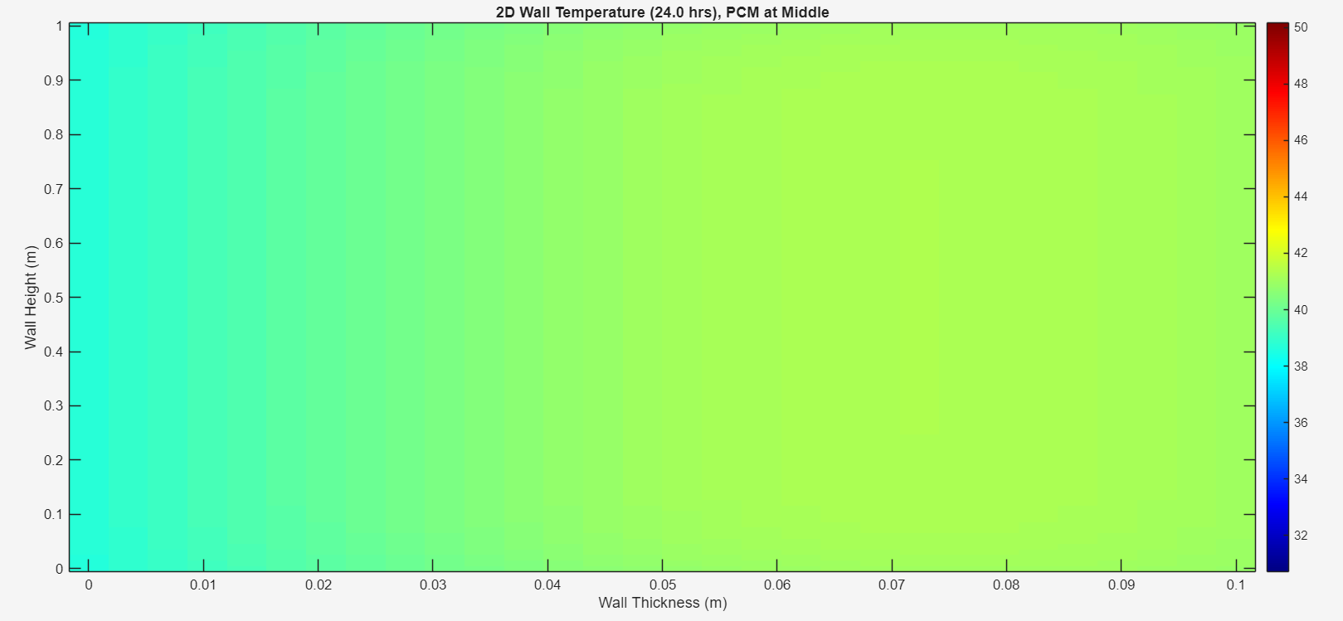 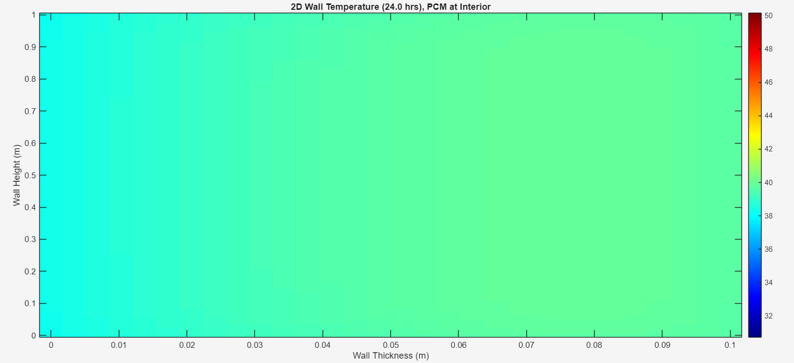

**(a) (b) (c)**

Figure 6 (a) When PCM is at outer layer (b) PCM at middle (c) PCM at inner most layer at t = 12 am.

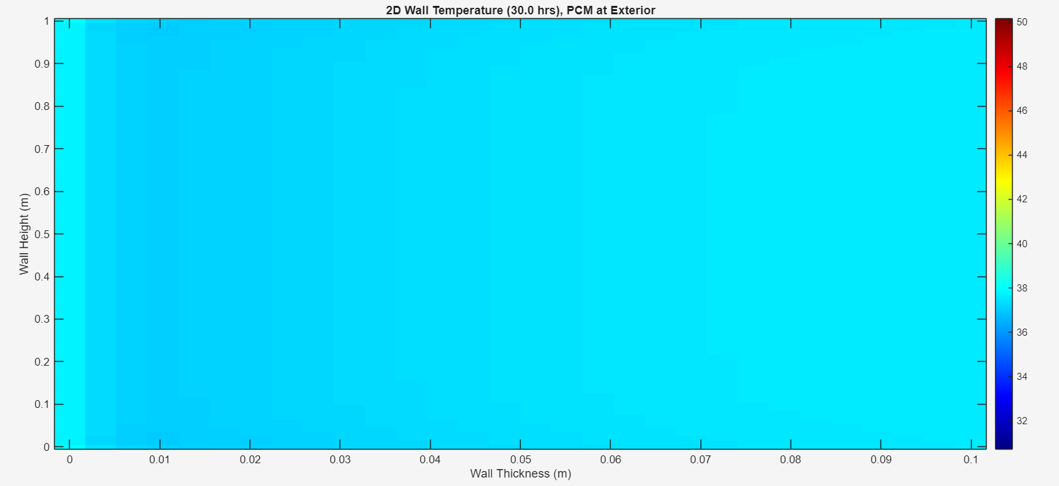 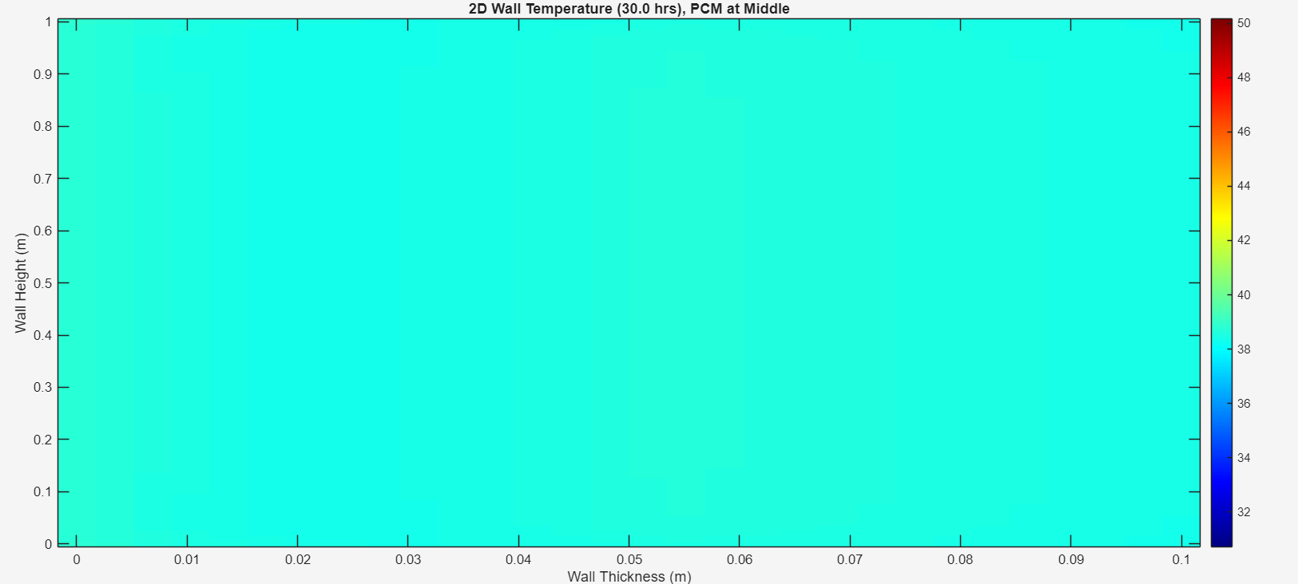 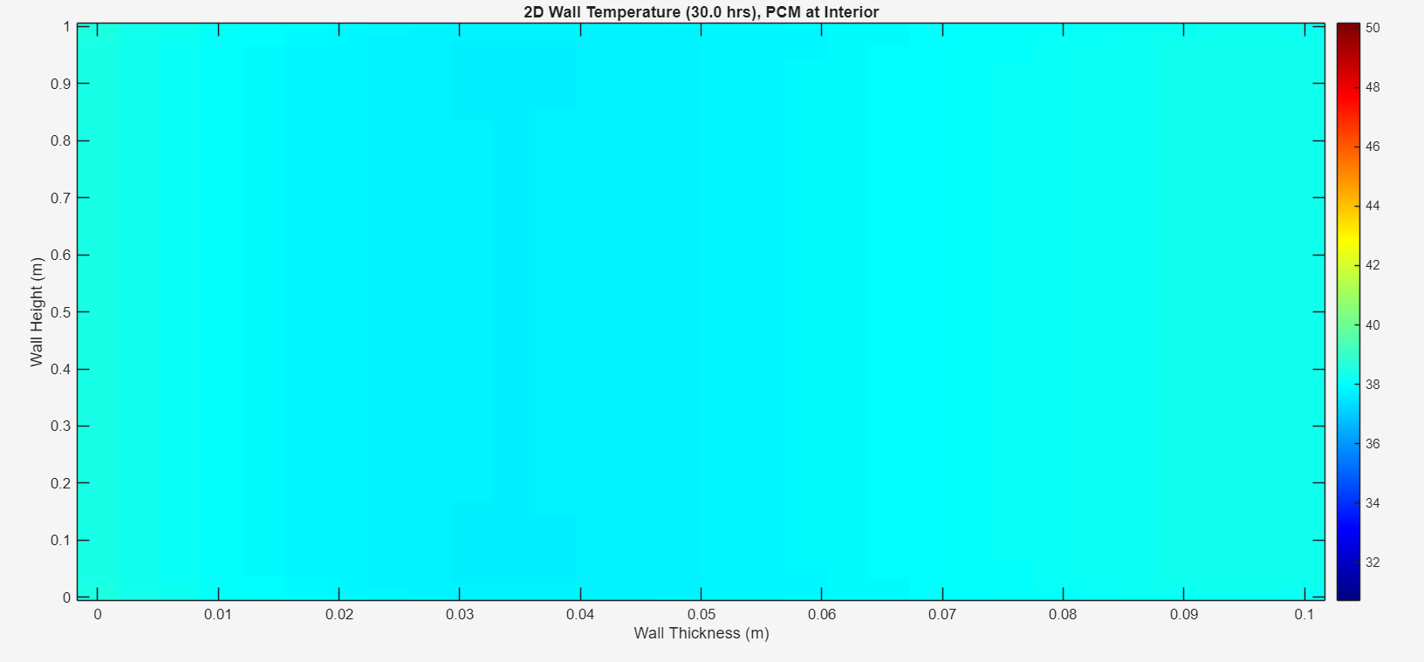

**(a) (b) (c)**

Figure 7 (a) When PCM is at outer layer (b) PCM at middle (c) PCM at inner most layer at t = 6 am on 2nd day.

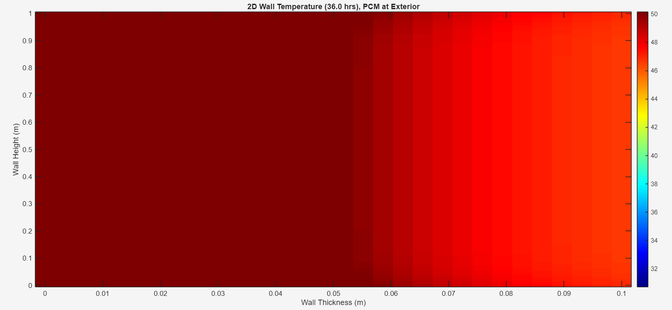 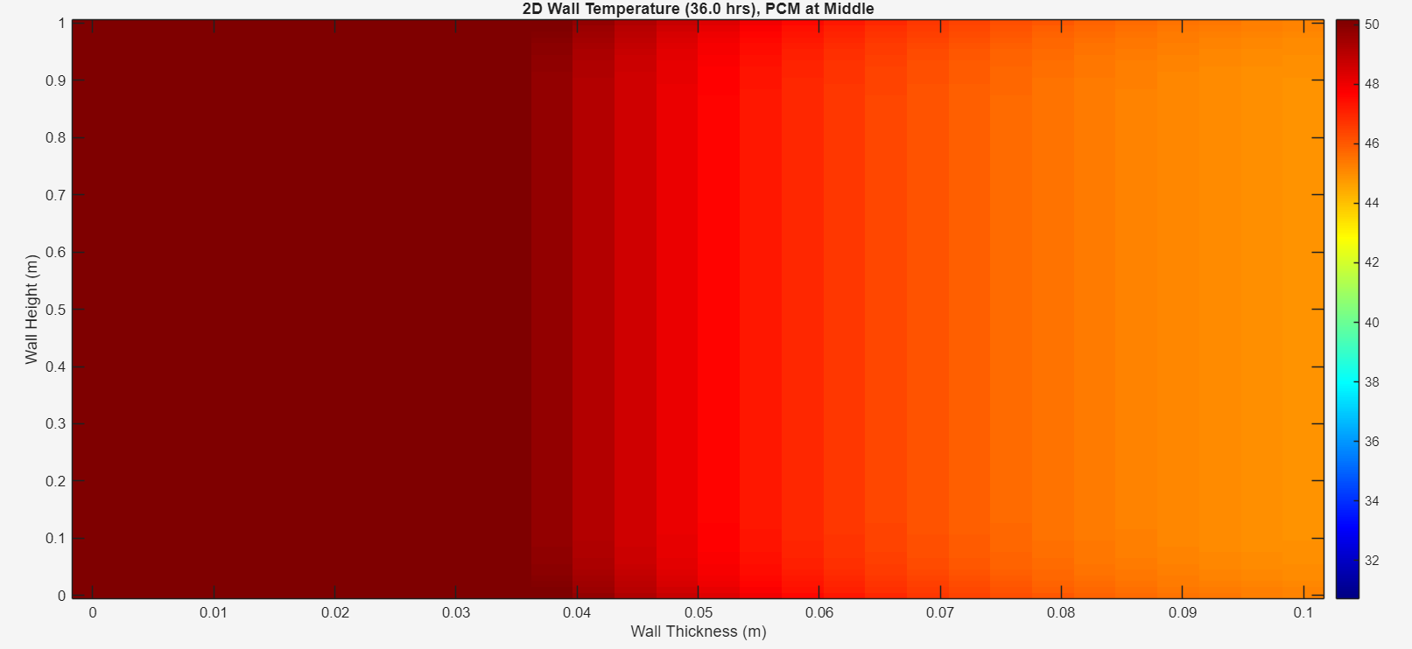 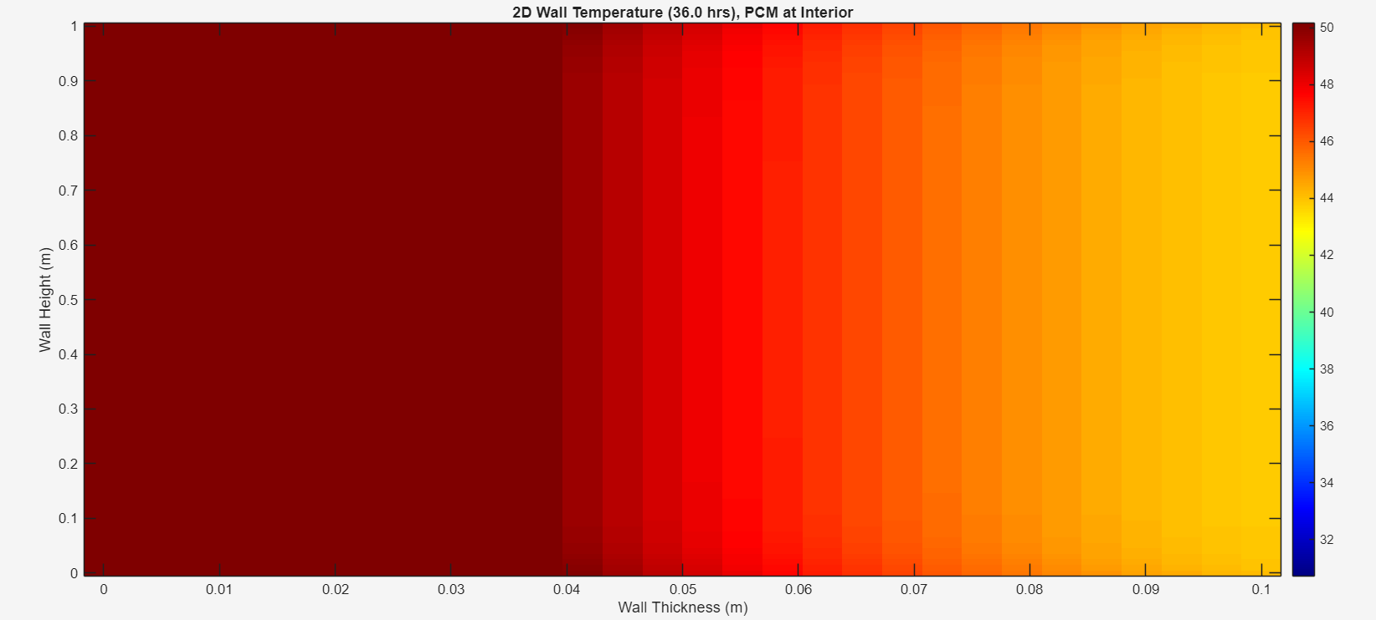

**(a) (b) (c)**

Figure 8 (a) When PCM is at outer layer (b) PCM at middle (c) PCM at inner most layer at t = 12 pm on 2nd day.

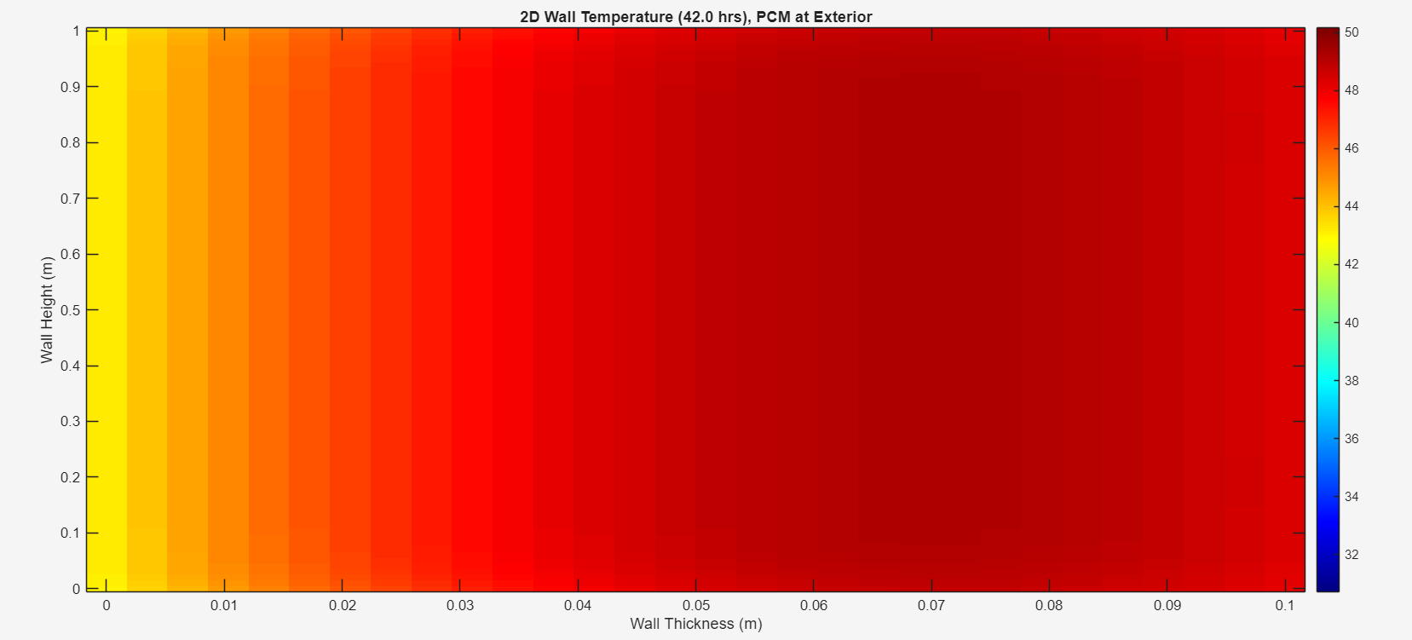 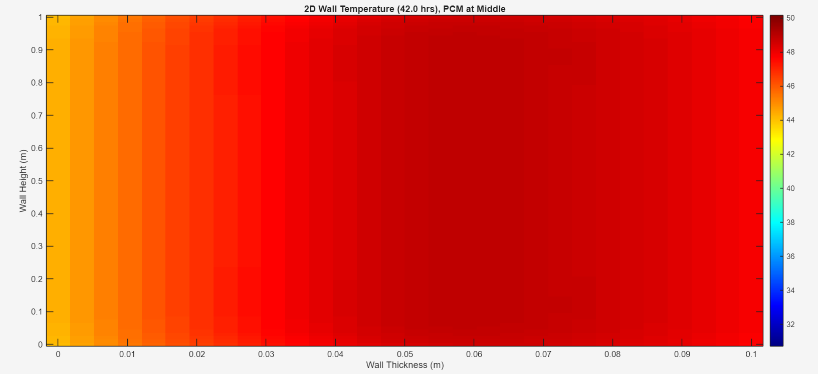 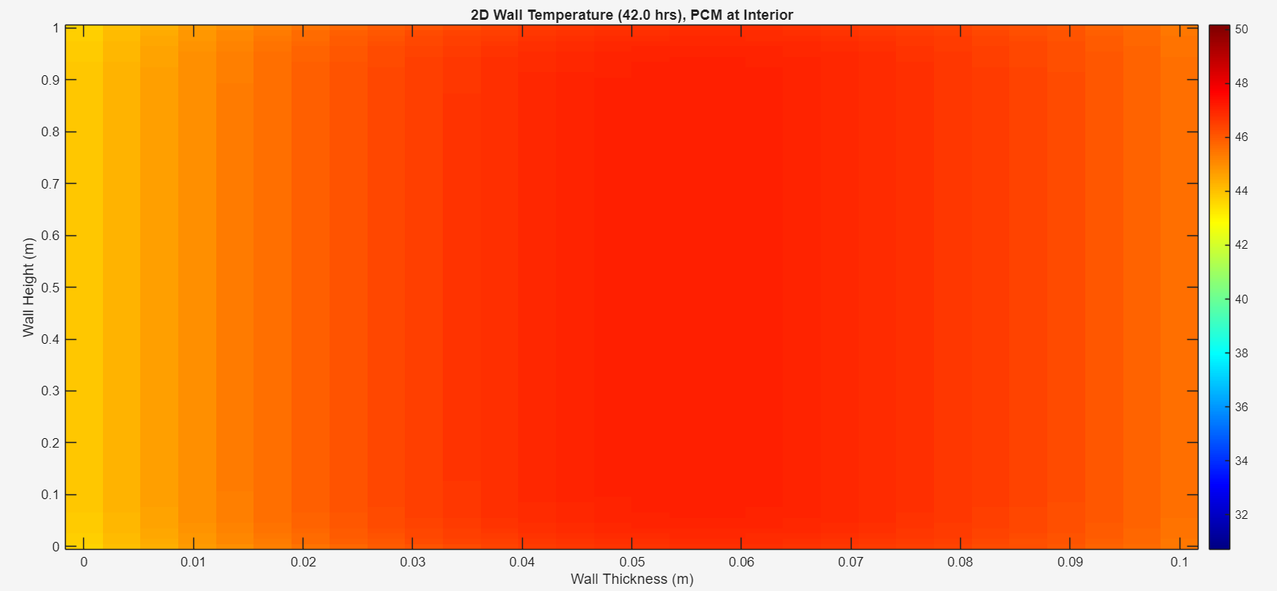

**(a) (b) (c)**

Figure 9 (a) When PCM is at outer layer (b) PCM at middle (c) PCM at inner most layer at t = 6 pm on 2nd day.

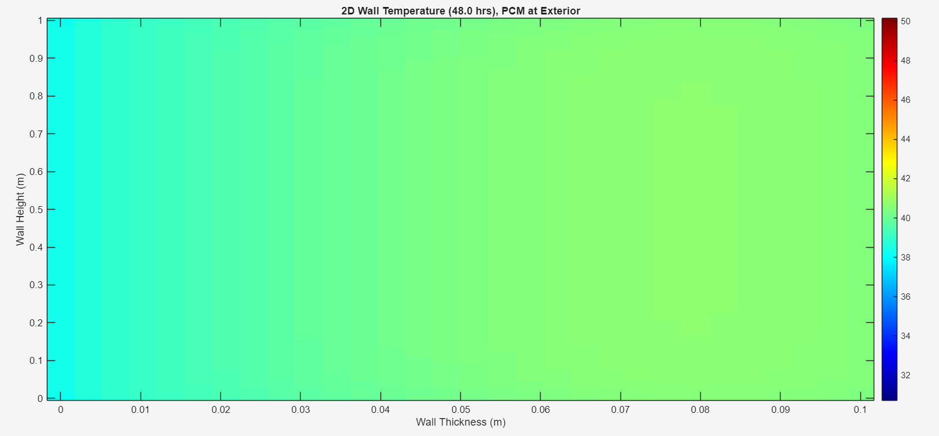 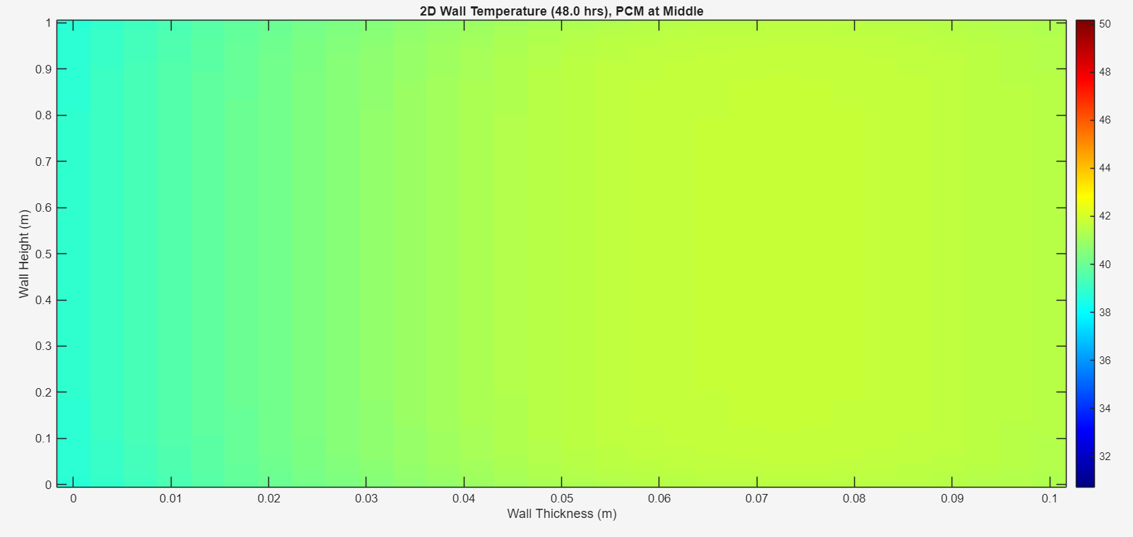 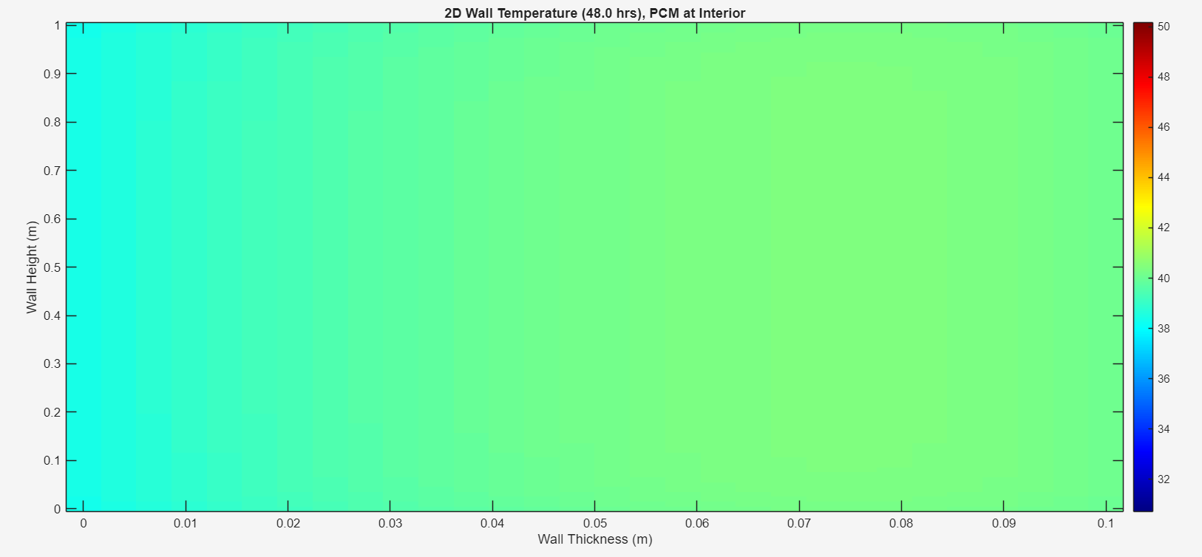

**(a) (b) (c)**

Figure 10 (a) When PCM is at outer layer (b) PCM at middle (c) PCM at inner most layer at t = 12 am on 3rd day.

The correctness of the constructed two-dimensional transient heat transfer model was assessed by comparing simulated indoor air temperature profiles with the experimental data obtained from the three test chambers (MS0, MS1, and MS2) under real-time outdoor conditions in Varanasi. Figure 17 (a), (b), and (c) shows the temporal variation of measured and expected indoor temperatures over the monitoring period for each setup respectively. The simulated results strongly agree with the experimental data, reflecting the magnitude and pattern of diurnal temperature changes across all scenarios. The error analysis was carried out utilizing statistical indicators, including Relative Mean Error (RME%), Relative Absolute Error (RAE%), Bias (D), Maximum Absolute Difference (D_Max), Standard Deviation (SD), and Limits of Agreement (LoA). These metrics quantify the degree of variance between the simulated and observed values and provide insight into model resilience. As indicated in Table 2, the reference chamber (MS0) exhibited an SD of 2.23°C, while PCM-modified chambers MS1 and MS2 recorded SD values of 2.25°C and 2.14°C, respectively. Similarly, the RAE values varied from 4.0% to 4.36%, showing a modest percentage variation between predicted and experimental outcomes. The bias values for all configurations were near zero, showing that the model does not systematically overestimate or underestimate the temperature readings. The Limits of Agreement (LoA) further indicate that the anticipated and experimental data differences stay within acceptable bounds, with upper and lower limits well within ±5 °C. The substantially reduced in maximum difference between experimental and simulated data (D_Max) for MS1 and MS2 compared to MS0 show that the model performs more properly when accounting for latent heat storage effects induced by PCM integration. This discovery emphasizes the capability of the enthalpy-basedss modeling approach to capture phase transition dynamics accurately. This model is validated with the corresponding experimental data of inner room temperature.

Table 2Summary of error analyssis of different PCM concentration

|  |  |  |  |  |  |  |  |
| --- | --- | --- | --- | --- | --- | --- | --- |
| **Model** | **RME**  **(%)** | **RAE**  **(%)** | **D_Max (°C)** | **Bias**  **(°C)** | **SD**  **(°C)** | **LoA Lower** | **LoA Upper** |
| **MS0** | 11.25 | 4.00 | 5.09 | 0.36 | 2.23 | 4.73 | 4.01 |
| **MS1** | 11.56 | 4.36 | 5.07 | 0.69 | 2.25 | 5.11 | 3.72 |
| **MS2** | 12.06 | 4.22 | 5.05 | 0.56 | 2.14 | 4.76 | 3.64 |

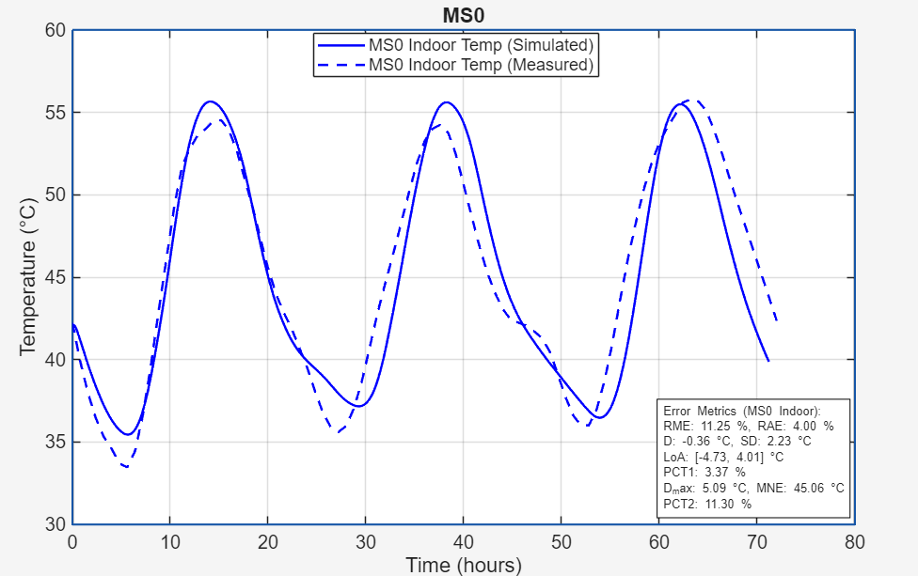

(a)

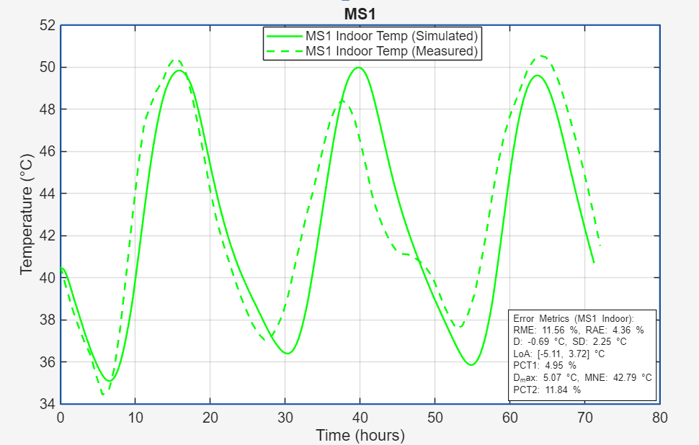

(b)

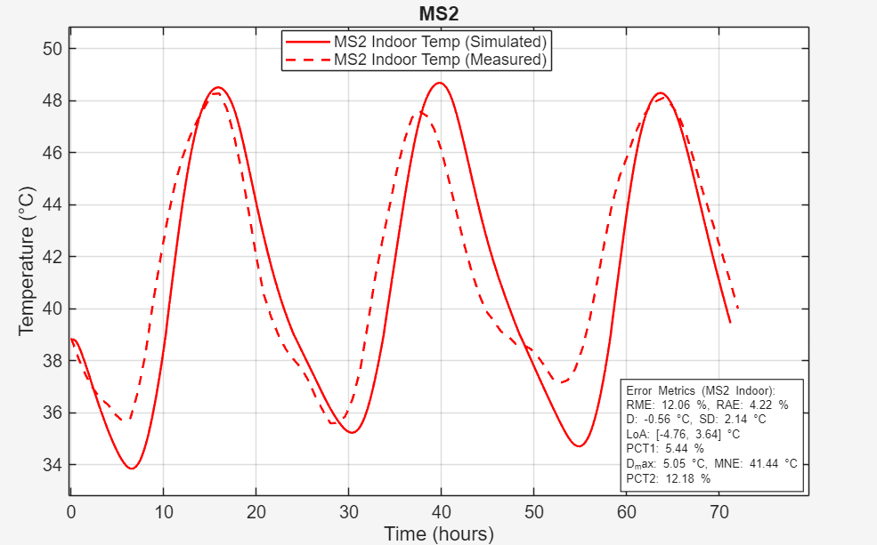

(c)

Figure 17 Comparison between simulated and measured temperature variation inside the, (a) MS0 coated chamber (b) MS1 coated chamber (c) MS2 coated chamber