**Indian Institute of Information Technology,**

**Design and Manufacturing, Kurnool**



# Academic Year 2024-25 Semester: 6th Department: Mechanical Engineering Project : Solar Panel Cleaning Robot

**NAME :** Aditya Kumar Rai

**ROLL NUMBER :** 122ME0028

**SUBJECT :** Product Design

**PROFESSOR SIGN :**

# PROJECT APPROVAL CERTIFICATE

This is to certify that the project titled **“Bluetooth-Controlled Solar Panel Cleaning Robot”** submitted by **Aditya Kumar Rai,** partial fulfilment of the requirements for **Product Design Practice** at **Indian Institute of Information and Technology Design and Manufacturing, Kurnool** has been approved and accepted.

**Supervisor: Dr. Aktar Khan (HOD) & Dr. Vipin Das**

# ACKNOWLEDGEMENT

I would like to express my sincere gratitude to my project guide, **Dr. Vipin Das Sir and Dr. Aktar Khan Sir**, for their invaluable support, guidance, and encouragement throughout the course of this project. I extend my appreciation to **Indian Institute Of Information Technology Design and Manufacturing , Kurnool** for providing the necessary facilities and resources for the successful completion of this work. Special thanks to my friends and family for their continuous support and motivation.

# ABSTRACT

The efficiency of solar panels decreases due to dust and debris accumulation, necessitating regular cleaning. This project presents a **Bluetooth-controlled solar panel cleaning robot**, designed for automated and efficient cleaning of solar panels. The system includes a motorized brush and water pump mechanism, controlled via a mobile application through a Bluetooth module. The Arduino Nano acts as the central controller, managing the L298N motor driver for movement and brush control. This cost-effective and adaptable solution enhances solar panel efficiency, reduces maintenance efforts, and conserves water. Future enhancements could include AI-based dirt detection and obstacle avoidance.

# TABLE OF CONTENTS

|  |  |  |
| --- | --- | --- |
| **S.no. Title** | | **Page No.** |
| **1.** | Introduction | 6 |
| **2.** | Objective | 7 |
| **4.** | Literature Review | 8 |
| **6.** | Block Diagram | 9 |
| **7.** | Circuit Diagram | 10 |
| **8.** | Component List | 11-23 |
| **9.** | Working Principle | 24-25 |
| **10.** | Working Mechanism | 26-27 |
| **11.** | Advantages of the System | 28-29 |
| **12.** | Conclusion | 30 |
| **13.** | Project Code | 31-34 |

# Introduction

Solar panels accumulate dust, dirt, and debris over time, reducing their efficiency and energy output. Regular cleaning is essential to maintain optimal performance, but manual cleaning can be labour-intensive and time-consuming. To address this challenge, we propose a **Bluetooth-controlled solar panel cleaning robot** equipped with an inbuilt cleaning mechanism.

This robot features a **motorized brush system** to remove dust and dirt efficiently. It is designed for remote operation via **Bluetooth**, allowing users to control its movement and cleaning process using a mobile app or remote controller. The robot ensures effective and automated cleaning, reducing maintenance efforts while maximizing the energy efficiency of solar panels.

This innovative solution is ideal for residential, commercial, and industrial solar power installations, providing a cost-effective and time-saving approach to solar panel maintenance.

# Objective

The primary objective of this project is to design and develop a **Bluetooth controlled solar panel cleaning robot** that enhances the efficiency and longevity of solar panels by removing dust and debris. The key goals of this project include:

1. **Efficient Cleaning Mechanism** – Implement a motorized brush system to effectively clean the surface of solar panels without causing damage.
2. **Wireless Control** – Enable remote operation through **Bluetooth connectivity**, allowing users to control the robot via a mobile app or remote device.
3. **Automation & Ease of Use** – Develop a user-friendly system that simplifies the cleaning process and reduces manual labour.
4. **Energy Optimization** – Ensure the robot operates efficiently, minimizing power consumption while maximizing solar panel performance.
5. **Durability & Adaptability** – Design a robust robot capable of functioning in different environmental conditions, ensuring reliability and long-term use.

# Literature Review

The efficiency of solar panels is significantly affected by dust, dirt, and environmental pollutants. Studies indicate that accumulated dust can reduce solar panel efficiency by 20-30%, depending on geographical location and climate conditions. Regular cleaning is necessary to maintain optimal performance, but traditional manual cleaning methods are often impractical for large-scale installations.

Several automated cleaning solutions have been explored in research and industry, including:

1. **Water-Based Cleaning Systems** – These systems use water jets or sprinklers to wash away dirt, but they increase water consumption, making them unsuitable for water-scarce regions.
2. **Electrostatic and Self-Cleaning Coatings** – Some studies suggest the use of hydrophobic or electrostatic coatings that repel dust, but these solutions are expensive and require periodic re-application.
3. **Robotic Cleaning Systems** – Various robotic solutions have been developed, such as rail-mounted, autonomous, and semi-automated cleaning robots. These systems enhance efficiency but may have high installation costs and limited adaptability.

# Block Diagram

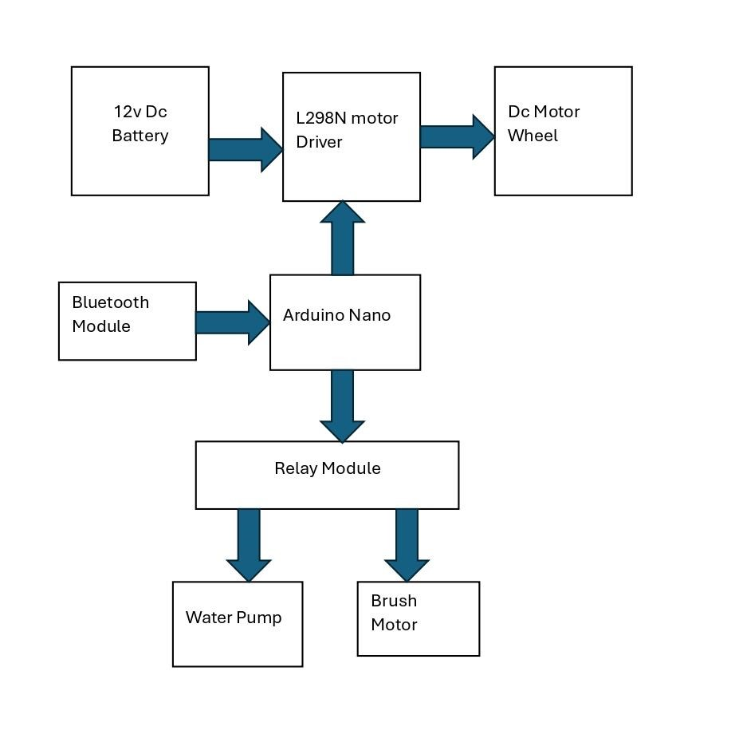

# Circuit Diagram

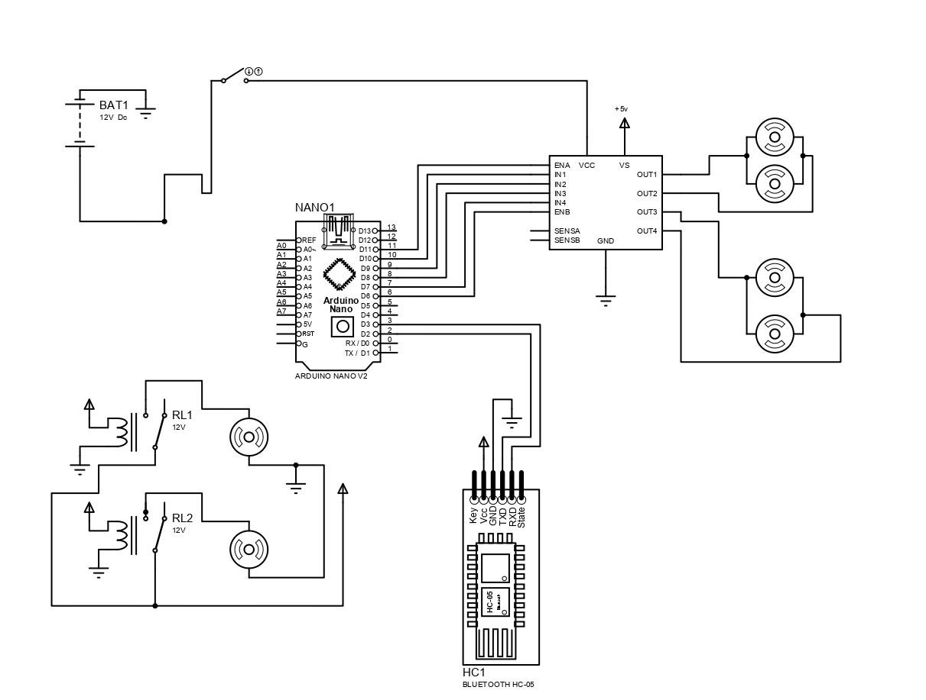

# Components for Solar Panel Cleaning Robot

## 1. Arduino Nano

The **Arduino Nano** is another popular Arduino development board very much similar to the [Arduino UNO.](https://components101.com/microcontrollers/arduino-uno) They use the same Processor (Atmega328p) and hence they both can share the same program.

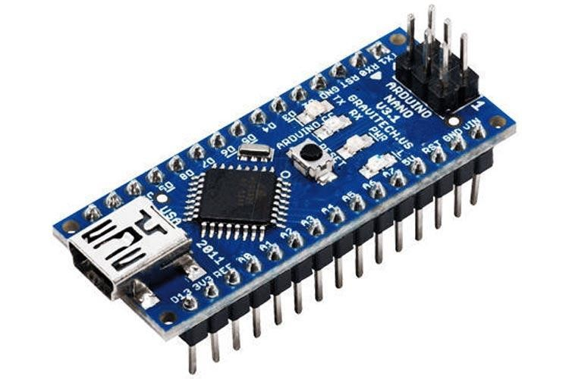

**Arduino Nano Pinout Configuration**

|  |  |  |
| --- | --- | --- |
| **Pin Category** | **Pin Name** | **Details** |
| Power | **Vin, 3.3V,**  **5V,** **GND** | **Vin:** Input voltage to Arduino when using an external power source (612V).  **5V:** Regulated power supply used to power microcontroller and other components on the board.  **3.3V:** 3.3V supply generated by onboard voltage regulator. Maximum current draw is 50mA.  **GND:** Ground pins. |
| Reset | **Reset** | Resets the microcontroller. |
| Analog Pins | **A0 – A7** | Used to measure analog voltage in the range of 0-5V |
| Input/Output  Pins | **Digital Pins D0 -**  **D13** | Can be used as input or output pins. 0V  (low) and 5V (high) |
| Serial | Rx, **Tx** | Used to receive and transmit TTL serial data. |
| External  Interrupts | 2, 3 | To trigger an interrupt. |
| PWM | 3, 5, 6, 9, 11 | Provides 8-bit PWM output. |
| SPI | 10 (SS), 11  (MOSI), 12 (MISO) and 13 (SCK) | Used for SPI communication. |
| Inbuilt LED | **13** | To turn on the inbuilt LED. |
| IIC | A4 (SDA), A5  (SCA) | Used for TWI communication. |
| AREF | **AREF** | To provide a reference voltage for input voltage. |

## 2. HC-05 - Bluetooth Module

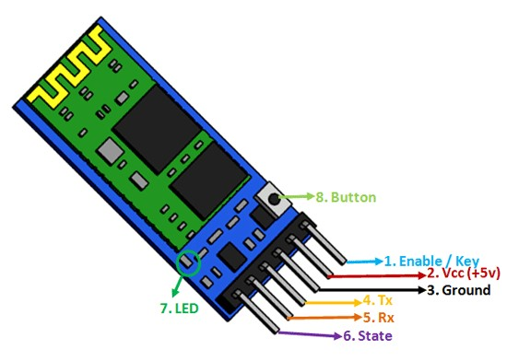

**HC-05 Bluetooth Module Pinout**

The **HC-05** is a popular bluetooth module which can add two-way (full-duplex) wireless functionality to your projects.

**HC-05 Pinout Configuration**

|  |  |  |
| --- | --- | --- |
| **Pin**  **Number** | **Pin Name** | **Description** |
| 1 | Enable / Key | This pin is used to toggle between Data Mode (set low) and AT command mode (set high). By default it is in Data mode |
| 2 | VCC | Powers the module. Connect to +5V Supply voltage |
| 3 | Ground | Ground pin of module, connect to system ground. |
| 4 | TX –  Transmitter | Transmits Serial Data. Everything received via Bluetooth will be given out by this pin as serial data. |
| 5 | RX –  Receiver | Receive Serial Data. Every serial data given to this pin will be broadcasted via Bluetooth |
| 6 | State | The state pin is connected to on board LED, it can be used as a feedback to check if Bluetooth is working properly. |
| 7 | LED | Indicates the status of Module   * Blink once in 2 sec: Module has entered Command Mode * Repeated Blinking: Waiting for connection in Data Mode • Blink twice in 1 sec: Connection successful in Data Mode |
| 8 | Button | Used to control the Key/Enable pin to toggle between Data and command Mode |

**HC-05 Default Settings**

Default Bluetooth Name: “HC-05”

Default Password: 1234 or 0000

Default Communication: Slave

Default Mode: Data Mode

Data Mode Baud Rate: 9600, 8, N, 1

Command Mode Baud Rate: 38400, 8, N, 1

Default firmware: LINVOR

**HC-05 Technical Specifications**

* Serial Bluetooth module for [Arduino](https://components101.com/microcontrollers/arduino-uno) and other microcontrollers
* Operating Voltage: 4V to 6V (Typically +5V)
* Operating Current: 30mA
* Range: <100m
* Works with Serial communication (USART) and TTL compatible
* Follows IEEE 802.15.1 standardized protocol
* Uses Frequency-Hopping Spread spectrum (FHSS)
* Can operate in Master, Slave or Master/Slave mode
* Can be easily interfaced with Laptop or Mobile phones with Bluetooth
* Supported baud rate: 9600,19200,38400,57600,115200,230400,460800.

## 3. L298N Motor Driver Module

This **L298N Motor Driver Module** is a high power motor driver module for driving DC and Stepper Motors. This module consists of an L298 motor driver IC and a 78M05 5V regulator. **L298N Module** can control up to 4 DC motors, or 2 DC motors with directional and speed control.

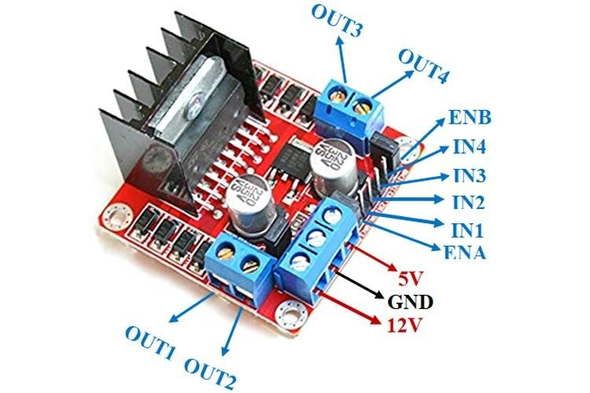

**L298N Module Pinout Configuration**

|  |  |
| --- | --- |
| **Pin Name** | **Description** |
| IN1 & IN2 | Motor A input pins. Used to control the spinning direction of Motor A |
| IN3 & IN4 | Motor B input pins. Used to control the spinning direction of Motor B |
| ENA | Enables PWM signal for Motor A |
| ENB | Enables PWM signal for Motor B |
| OUT1 &  OUT2 | Output pins of Motor A |
| OUT3 &  OUT4 | Output pins of Motor B |
| 12V | 12V input from DC power Source |
| 5V | Supplies power for the switching logic circuitry inside L298N IC |
| GND | Ground pin |

**Features & Specifications**

* Driver Model: L298N 2A
* Driver Chip: Double H Bridge L298N
* Motor Supply Voltage (Maximum): 46V
* Motor Supply Current (Maximum): 2A
* Logic Voltage: 5V
* Driver Voltage: 5-35V
* Driver Current:2A
* Logical Current:0-36mA
* Maximum Power (W): 25W
* Current Sense for each motor
* Heatsink for better performance
* Power-On LED indicator

**Alternate Driver Modules:**[TMC2209,](https://components101.com/index.php/modules/tmc2209-stepper-motor-driver-module) [DRV8825,](https://components101.com/index.php/modules/drv8825-stepper-motor-driver-module) [A4988,](https://components101.com/modules/a4988-stepper-motor-driver-module) L9110S, DRV8711

**Related Components:** LM298 Motor Driver IC, 78M05 Voltage Regulator, [Capacitors,](https://components101.com/index.php/capacitors) [Resistors,](https://components101.com/index.php/resistors) [Heat Sink](https://components101.com/articles/selecting-the-right-heatsink-for-your-design-and-steps-for-heatsink-calculation-and-selection)

**Note:** Complete technical details can be found in the **L298N Datasheet** linked at the bottom of this page.

**Brief about L298N Module**

The L298N Motor Driver module consists of an L298 Motor Driver IC, 78M05 Voltage Regulator, resistors, capacitor, Power LED, 5V jumper in an integrated circuit.

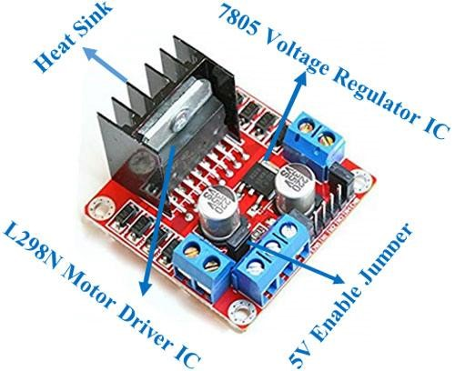

78M05 Voltage regulator will be enabled only when the jumper is placed.

When the power supply is less than or equal to 12V, then the internal circuitry will be powered by the voltage regulator and the 5V pin can be used as an output pin to power the microcontroller. The jumper should not be placed when the power supply is greater than 12V and separate 5V should be given through 5V terminal to power the internal circuitry.

ENA & ENB pins are speed control pins for Motor A and Motor B while IN1& IN2 and IN3 & IN4 are direction control pins for Motor A and Motor B.

Internal circuit diagram of L298N Motor Driver module is given below:

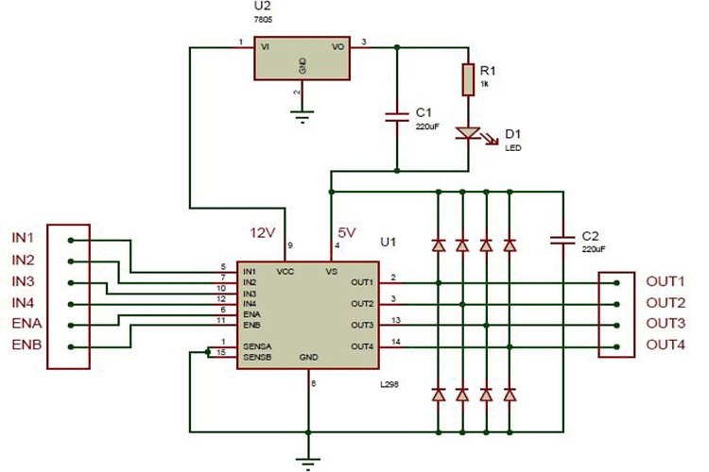

**Applications**

* Drive DC motors.
* Drive stepping motors
* In Robotics

**4. DC Gear Motor Robot Motor.**

60 RPM 12V Center Shaft DC Geared Motor specifically designed for robotic applications offer a wide variety of options. Key features easy to use and mount, standard size for all RPMs, a huge variety of RPMs available, long durability and very affordable considering the features. These motors open a wide choice for you in terms of Wheels and chassis.

Also, you don’t have to spend a lot of money to control motors with an Arduino or compatible board. The most popular L298N H-bridge module with onboard voltage regulator motor driver can be used with this motor that has a voltage of between 5 and 35V DC or you can choose the most precise motor diver module from the wide range available in our Motor divers category as per your specific requirements.

Center Shaft Geared motors specifically designed for robotic applications offer a wide variety of options. Key features – easy to use and mount, standard size for all RPM’s, a huge variety of RPM’s available, long durability and very affordable considering the features. These motors open a wide choice for you in terms of Wheels and chassis.

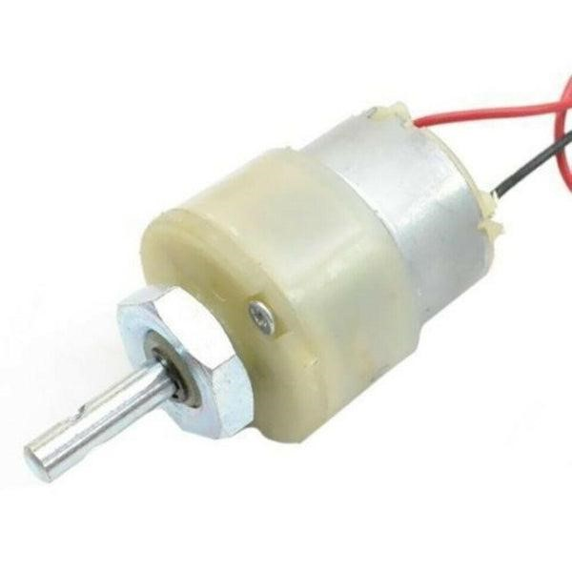

We offer a great and unmatched pricing on these motors !

Features:

* It comes with Good Quality Gears.
* The metal gears have better wear and tear properties.
* Gearbox is sealed and lubricated with lithium grease and requires no maintenance.
* Although motor gives 60 RPM at 12V, motor runs smoothly from 4V to 12V and gives the wide range of RPM, and torque.
* The shaft has a hole for better coupling.

Specifications –

* RPM – 60
* Shaft Diameter – 6mm (with internal hole)
* Weight - 125gms
* Torque – 6kgcm
* Voltage – 6 to 24 (Nominal Voltage – 12v)
* No-load current = 60 mA(Max), Load current = 300 mA(Max)

## 5. Horizontal Mute Sounds Mini Submersible Pump DC 3V-9V

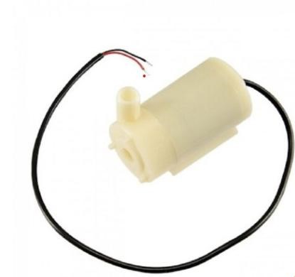

1. **DC voltage: 2.5-6V**
2. **Maximum lift: 40-110cm/15.75″-43.4″**
3. **Flow rate: 80-120L/H**
4. **Outer diameter of effluent: 7.5mm/0.3″**

Submersible Pumps are efficient for pumping out septic tanks. Fluid is transferred into hoses to storage tanks and taken to a treatment facility. Submersible pumps are often used to pump excess water from work sites or flooded basements on construction sites. They can also be used to pump slurries Submersible pumps are centrifugal pumps whose hydraulic components (pump casing, impeller, diffuser element) are flooded by the fluid handled. Usually, this type of pump is not fitted with a suction line. A submersible pump whose motor is arranged above the floor is referred to as a vertical shaft submersible pump Using attention:

1. The pump does not have a power supply, it is a DC pump. It cannot be used directly with AC 220V voltage.
2. Land use need to allow water to flow into the pump (nonself priming pump), the installation of water level higher than the pump.
3. To keep the water clean, so as not to block the pump rotor. the pump should be cleaned regularly to keep the pump clean.

Features:

100% brand new, high quality

Type: Horizontal Mute Sounds Mini Submersible Pump

Material: engineering plastic

Drive mode: DC brushless design, magnetic drive

500 urs of continuous working life

## 6. Dc Gear motor Brush motor

60 RPM 12V Center Shaft DC Geared Motor specifically designed for robotic applications offer a wide variety of options. Key features easy to use and

mount, standard size for all RPMs, a huge variety of RPMs available, long

durability and very affordable considering the features. These motors open a wide choice for you in terms of Wheels and chassis.



Also, you don’t have to spend a lot of money to control motors with an Arduino or compatible board. The most popular L298N H-bridge module with onboard voltage regulator motor driver can be used with this motor that has a voltage of between 5 and 35V DC or you can choose the most precise motor diver module from the wide range available in our Motor divers category as per your specific requirements.

Centre Shaft Geared motors specifically designed for robotic applications offer a wide variety of options. Key features – easy to use and mount, standard size for all RPM’s, a huge variety of RPM’s available, long durability and very affordable considering the features. These motors open a wide choice for you in terms of Wheels and chassis.

We offer a great and unmatched pricing on these motors !

Features:

* It comes with Good Quality Gears.
* The metal gears have better wear and tear properties.
* Gearbox is sealed and lubricated with lithium grease and requires no maintenance.
* Although motor gives 10 RPM at 12V, motor runs smoothly from 4V to 12V and gives the wide range of RPM, and torque.
* The shaft has a hole for better coupling.

Specifications –

* RPM – 10
* Shaft Diameter – 6mm (with internal hole)
* Weight - 125gms
* Torque – 6kgcm
* Voltage – 6 to 24 (Nominal Voltage – 12v)
* No-load current = 60 mA(Max), Load current = 300 mA(Max)

# Working Principle

Solar energy is one of the most efficient and sustainable sources of power. However, the efficiency of solar panels decreases significantly when dust, dirt, and other contaminants accumulate on their surface. To address this issue, a **Bluetooth-controlled solar panel cleaning robot** is designed, which automates the cleaning process using a brush and water spray mechanism. The robot is remotely controlled using a smartphone application via a Bluetooth module.

The system incorporates an **Arduino Nano** as the primary controller, an **L298N motor driver** to operate the movement of the robot, **two DC motors** (one for movement and one for the brush), and a **water pump** for spraying water. This combination ensures an effective, efficient, and controlled cleaning process, enhancing the overall efficiency of solar panels.

The system consists of various electronic and mechanical components that work together to execute the cleaning process effectively. Below is a detailed breakdown of each component and its role:

## 1. Arduino Nano

The Arduino Nano is the core microcontroller of the system. It processes signals received from the Bluetooth module and controls the motor driver to perform specific cleaning operations. It also manages the activation of the brush motor and water pump based on user commands.

## 2. L298N Motor Driver

The L298N motor driver is responsible for controlling the **two DC motors** that drive the robot's movement and the brush mechanism. It receives PWM (Pulse Width Modulation) signals from the Arduino Nano to regulate the speed and direction of the motors.

## 3. HC-05 Bluetooth Module

The HC-05 Bluetooth module enables wireless communication between the robot and the user’s smartphone. Commands such as start, stop, move forward, move backward, activate brush, and activate water spray are sent via a mobile app and processed by the Arduino Nano.

## 4. 60 RPM Gear Motor

This motor is used to move the robot over the surface of the solar panel. Its slow speed and high torque allow smooth movement, ensuring stability and precision during the cleaning process.

## 5. 10 RPM Brush Motor

The brush motor rotates a cylindrical cleaning brush, which scrubs away dirt and dust from the surface of the solar panel. The motor operates at low speed to avoid any damage to the panel while ensuring effective cleaning.

## 6. 12V Water Pump

The water pump is used to spray water onto the solar panel to loosen and remove stubborn dirt particles. The water supply is controlled through the Arduino Nano, allowing users to turn it on and off as needed.

## 7. 12.6V Battery

A 12.6V rechargeable battery powers the entire system, ensuring portability and independent operation without the need for an external power source.

# Working Mechanism

The working of the Bluetooth-controlled solar panel cleaning robot involves several steps, which are outlined below:

## 1. Initialization and System Start-Up

1. The **Arduino Nano** initializes and powers up the system when the 12.6V battery is connected.
2. The **HC-05 Bluetooth module** enters pairing mode and waits for connection with a smartphone.
3. The user opens the mobile app and connects to the HC-05 module via Bluetooth.
4. Once connected, the user interface allows various commands to be sent to the robot.

## 2. Robot Movement and Navigation

1. When the user selects the **forward movement** command, the **L298N motor driver** activates both **60 RPM gear motors**, moving the robot forward.
2. The **left and right turn** commands rotate the respective motors in opposite directions, allowing the robot to steer.
3. The **backward movement** command reverses the polarity of the motors, making the robot move in the opposite direction.
4. The movement of the robot is controlled in real-time via the mobile application, ensuring precise control over navigation.

## 3. Cleaning Process

The cleaning process involves two major components: **the brush mechanism** and **the water pump system**.

1. Brush Cleaning Mechanism
   1. Upon receiving the **brush activation** command, the **Arduino Nano** sends a signal to the **L298N motor driver** to activate the **10 RPM brush motor**.
   2. The brush motor rotates the cylindrical brush, which scrubs the dust and dirt accumulated on the solar panel surface.
   3. The cleaning brush ensures even coverage, preventing streaks or missed spots.
2. Water Pump Mechanism
   1. When the user selects the **water spray** command, the **Arduino Nano** activates the **12V water pump**.
   2. The water pump sprays a controlled amount of water onto the solar panel.
   3. The combination of water and brush movement effectively removes stubborn dirt, mud, or bird droppings.
   4. The user can control when and how much water is sprayed to optimize water usage and prevent waste

# Advantages of the System

The **Bluetooth-controlled solar panel cleaning robot** is designed to minimize human intervention while ensuring a **consistent and efficient cleaning process**. Unlike manual cleaning, which is labour-intensive and time-consuming, this automated system ensures that **solar panels remain free of dust and debris** with minimal effort.

**Key Benefits of Automated Cleaning:**

1. **Consistent Performance:**

o The robot follows a programmed cleaning pattern, ensuring that every panel is cleaned uniformly. o Unlike manual cleaning, which can be inconsistent due to human fatigue or oversight, the robot maintains optimal cleaning efficiency.

1. **Time and Cost Savings:**
   * + Manual cleaning requires trained personnel, leading to higher operational costs.
     + Automation significantly **reduces labour costs and cleaning time**, making it an economical long-term solution.
2. **Optimized Solar Panel Efficiency:**
   * + Dust and dirt accumulation reduce solar panel output. The automated robot cleans the panels **regularly and efficiently**, maintaining high energy conversion rates.
     + As seen in the test data, **cleaned panels showed an increase in power output**, proving the effectiveness of the automated cleaning mechanism.

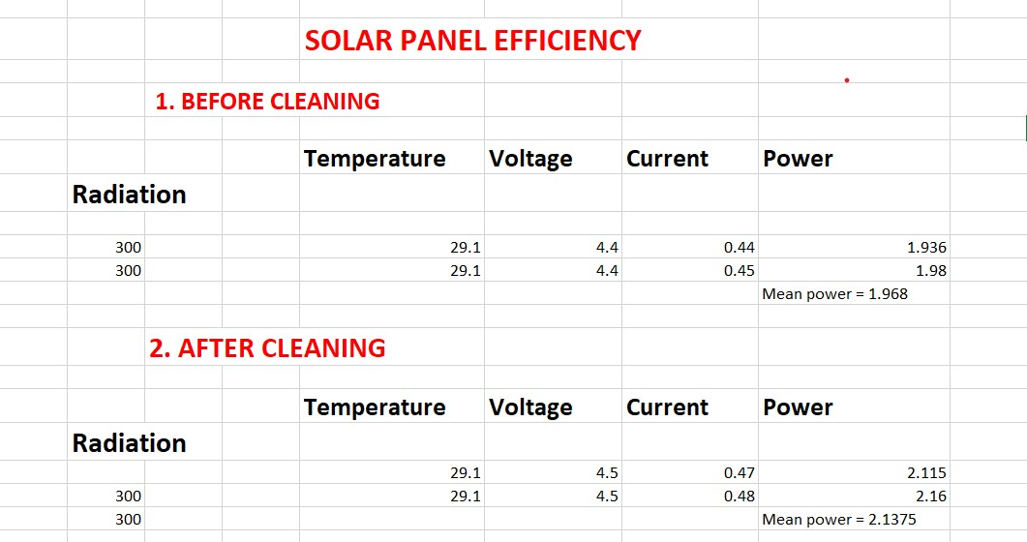

1. **Adaptability and Remote Operation:**
   * The robot can be controlled via **Bluetooth**, allowing users to operate it remotely using a smartphone.
   * This feature makes it ideal for **hard-to-reach solar installations**, such as rooftops and large solar farms.
2. **Water Conservation & Cleaning Efficiency:**
   * Depending on the cleaning method used (**dry cleaning with a brush or wet cleaning with a water spray**), the robot can adapt to different environments.
   * Dry cleaning **saves water**, while wet cleaning ensures **thorough removal of stubborn dirt**.
3. **Reduction in Maintenance Needs:**
   * Regular automated cleaning reduces the risk of long-term **panel degradation** due to accumulated dirt, improving **durability and lifespan**.
   * It prevents the need for frequent manual inspections and repairs.
4. **Eco-Friendly and Sustainable:**
   * By maintaining **optimal energy production**, the cleaning robot enhances the overall efficiency of renewable energy sources.
   * Using automated cleaning methods minimizes **chemical cleaning agents** that could be harmful to the environment.

# Conclusion

The **Bluetooth-controlled solar panel cleaning robot** provides an effective and convenient solution for maintaining solar panels, ensuring that they operate at peak efficiency. By integrating **wireless control, a brush mechanism, and a water pump system**, this robot reduces maintenance efforts while maximizing energy generation. The project offers a scalable and cost-effective alternative to manual cleaning, making it suitable for both residential and commercial solar panel installations.

In the future, additional features such as **automated scheduling, obstacle detection, and AI-based dirt detection** can be integrated to further enhance its functionality.

# Project Code

#include <SoftwareSerial.h>

#include <Servo.h>

// Define motor driver pins

#define IN1 5 #define IN2 6 #define IN3 9

#define IN4 10

// Define brush and water pump pins

#define BRUSH_MOTOR 7

#define WATER_PUMP 8

// Bluetooth module RX & TX pins

SoftwareSerial Bluetooth(2, 3);

void setup() { pinMode(IN1, OUTPUT); pinMode(IN2, OUTPUT); pinMode(IN3, OUTPUT); pinMode(IN4, OUTPUT); pinMode(BRUSH_MOTOR, OUTPUT); pinMode(WATER_PUMP, OUTPUT);

Bluetooth.begin(9600);

Serial.begin(9600);

}

void loop() { if (Bluetooth.available()) { char command = Bluetooth.read();

Serial.println(command);

switch (command) { case 'F': // Move Forward moveForward(); break;

case 'B': // Move Backward moveBackward(); break; case 'L': // Turn Left turnLeft(); break; case 'R': // Turn Right turnRight(); break; case 'S': // Stop stopMotors(); break;

case 'W': // Activate Water Pump digitalWrite(WATER_PUMP, HIGH);

break;

case 'w': // Deactivate Water Pump digitalWrite(WATER_PUMP, LOW);

break;

case 'B': // Activate Brush Motor digitalWrite(BRUSH_MOTOR, HIGH);

break;

case 'b': // Deactivate Brush Motor digitalWrite(BRUSH_MOTOR, LOW);

break; default: stopMotors(); break;

}

}

}

void moveForward() { digitalWrite(IN1, HIGH); digitalWrite(IN2, LOW); digitalWrite(IN3, HIGH); digitalWrite(IN4, LOW);

}

void moveBackward() { digitalWrite(IN1, LOW); digitalWrite(IN2, HIGH); digitalWrite(IN3, LOW); digitalWrite(IN4, HIGH);

}

void turnLeft() { digitalWrite(IN1, LOW); digitalWrite(IN2, HIGH); digitalWrite(IN3, HIGH); digitalWrite(IN4, LOW);

}

void turnRight() { digitalWrite(IN1, HIGH); digitalWrite(IN2, LOW); digitalWrite(IN3, LOW); digitalWrite(IN4, HIGH);

}

void stopMotors() { digitalWrite(IN1, LOW); digitalWrite(IN2, LOW); digitalWrite(IN3, LOW); digitalWrite(IN4, LOW);

}