UMLRev
Automated Feature Identification for Continuous Reverse Engineering of UML Models
Software Engineering - Mini Project Report
Semester 5, B.Tech Computer Engineering
Submitted by
Jay Gandhi (B124)
Aditya Rane (B129)
Mukesh Patel School of Technology Management & Engineering
NMIMS University, Mumbai
October 2026

1. Introduction
Software systems built under Agile and CI/CD practices change faster than their documentation. Code is committed daily; the UML models that describe its architecture are updated rarely, if ever. The result is design drift: diagrams that once described the system become actively misleading, and new team members are onboarded against a picture that no longer matches the code.
UMLRev, published in IEEE Access, addresses this by reverse engineering feature-oriented UML diagrams automatically inside the CI pipeline. Rather than producing one monolithic diagram of an entire system, it emits a focused diagram per user-facing feature, regenerated on every commit.
That approach carries one significant limitation. UMLRev requires a developer to define each feature by hand and bind it to execution traces before any diagram can be produced. On a legacy system with hundreds of classes this manual mapping is slow, error-prone, and is precisely the kind of human bookkeeping that continuous integration exists to eliminate. The bottleneck the tool was built to remove reappears at its input.
This project removes that bottleneck. It reconstructs the UMLRev pipeline and replaces manual feature definition with automated discovery: source code is parsed into structural symbols, cohesive classes are clustered into candidate features, each cluster is labelled with a business-level name and a confidence score, and the developer reviews the proposal in a web dashboard before diagrams are generated. The engineer moves from author to reviewer.
1.1 Authors
Name | Roll Number | Contribution
Jay Gandhi | B124 | Analysis pipeline, clustering and labelling engine, evaluation service, REST API
Aditya Rane | B129 | Diagram synthesis engine, React dashboard, test suite, system integration

Both authors jointly produced the requirements models, UML design artefacts and data flow diagrams catalogued under Experiments 1 to 9 of the Software Engineering laboratory curriculum.
2. Problem Statement, Objectives and Scope
2.1 Problem Statement
Conventional reverse engineering tools generate system-wide diagrams that are too large to read, carry no notion of which feature a class serves, and run as standalone desktop utilities disconnected from the release pipeline. UMLRev solves the first and third problems but makes feature identification a manual prerequisite, which does not scale to large or unfamiliar codebases.
Problem: given only a source repository and no human-authored feature map, automatically identify cohesive features, generate feature-scoped UML class and sequence diagrams for them, and keep those diagrams synchronised as the code evolves - while leaving the developer in control of the final result.
2.2 Objectives
- O1 - Extract structural symbols (classes, fields, methods, relationships) from a multi-language repository without executing it.
- O2 - Group cohesive classes into candidate features automatically, using structural coupling rather than a developer-supplied map.
- O3 - Assign each cluster a business-level feature name and a confidence score.
- O4 - Keep a human in the loop: allow the developer to review, rename and approve feature boundaries before diagrams are produced.
- O5 - Synthesise feature-scoped UML class and sequence diagrams, exportable as Diagram-as-Code (PlantUML and Mermaid) so they can be version-controlled alongside the source.
- O6 - Detect which features a commit affects and highlight the impacted classes, supporting continuous rather than one-off reverse engineering.
- O7 - Quantify correctness empirically against a published ground truth using Precision, Recall and F-Measure.
2.3 Scope
In scope. Static analysis of Java, Python, JavaScript, TypeScript, React (JSX/TSX), C#, Go and C++ sources; clustering and labelling; a five-stage web dashboard; class and sequence diagram synthesis; Git commit history and diff-impact analysis; PlantUML and Mermaid export; and empirical evaluation against ground truth.
Out of scope. Runtime execution tracing via AspectJ, which the base paper uses to obtain dynamic call ordering. This system derives interactions statically from call sites instead, which is less precise for polymorphic dispatch but removes the requirement to build and run the target project. Automatic pull-request commenting and hosted multi-tenant deployment are also out of scope.
3. System Architecture and Design
3.1 Architectural Overview
The system is a four-layer pipeline behind a REST API, with a React dashboard as the presentation layer. Each stage emits a typed intermediate representation consumed by the next, so a stage can be replaced without disturbing its neighbours.
Repository ---> SymbolExtractor ---> Project { classes, relationships }
(AST parsing, 8 languages)
---> ClusterEngine ---> Cluster[] (structural cohesion)
---> FeatureLabeller ---> Feature[] (name + confidence)
---> [ developer review and approval ]
---> DiagramEngine ---> Diagram[] (PlantUML + Mermaid)
---> EvaluationService ---> Precision / Recall / F1

3.2 Package and Class Design
Package | Key Types | Responsibility
model | Project, ClassSymbol, FieldSymbol, MethodSymbol, Relationship, Feature, FeatureMembership, Diagram | Domain core. Language-neutral representation of a parsed codebase and the features derived from it.
pipeline | SymbolExtractor, ClusterEngine, FeatureLabeller, LLMClient, GitService, DiffAnalyzer | Analysis stages: parsing, clustering, labelling, version control access and commit impact analysis.
diagram | DiagramEngine, DiagramStrategy, ClassDiagramStrategy, SequenceDiagramStrategy | Synthesis of feature-scoped UML in two concrete notations.
evaluation | EvaluationService, GroundTruth | Empirical scoring of discovered features against a reference mapping.
api | FastAPI application | REST surface, session persistence and static hosting of the dashboard.

FeatureMembership deserves note. A class may legitimately serve more than one feature, so membership is modelled as an explicit association class carrying a confidence score and a primary flag, rather than as a plain list. This allows cross-cutting classes to appear in several feature diagrams without duplicating them in the domain model.
3.3 Applied Design Patterns
- Strategy - DiagramEngine delegates to interchangeable DiagramStrategy implementations. Adding a state-machine or component diagram requires a new strategy class and no change to the engine.
- Pipeline / Filter - each analysis stage consumes and produces well-typed intermediates, making stages independently testable.
- Adapter / Gateway - LLMClient isolates the labelling step from any specific model vendor and degrades to a deterministic heuristic engine when no API key is configured, so the system remains fully functional offline.
- Association Class - FeatureMembership models the many-to-many class-to-feature relationship with its own attributes.
3.4 Technology Stack
Layer | Technology | Role
Analysis core | Python 3.13 | AST parsing, clustering, diagram synthesis, evaluation
API | FastAPI + Uvicorn + Pydantic | REST endpoints, request validation, OpenAPI documentation
Dashboard | React 19 + Vite | Five-stage review and inspection interface
Rendering | Mermaid 11 | In-browser diagram rendering
Export | PlantUML, Mermaid | Diagram-as-Code artefacts for version control
Version control | Git (via GitService) | Clone, commit history, diff extraction

3.5 Behavioural Model - Activity Diagram
The activity diagram below models the end-to-end developer workflow, including the review decision point at which the developer either approves the proposed feature set or amends it before diagram generation proceeds.
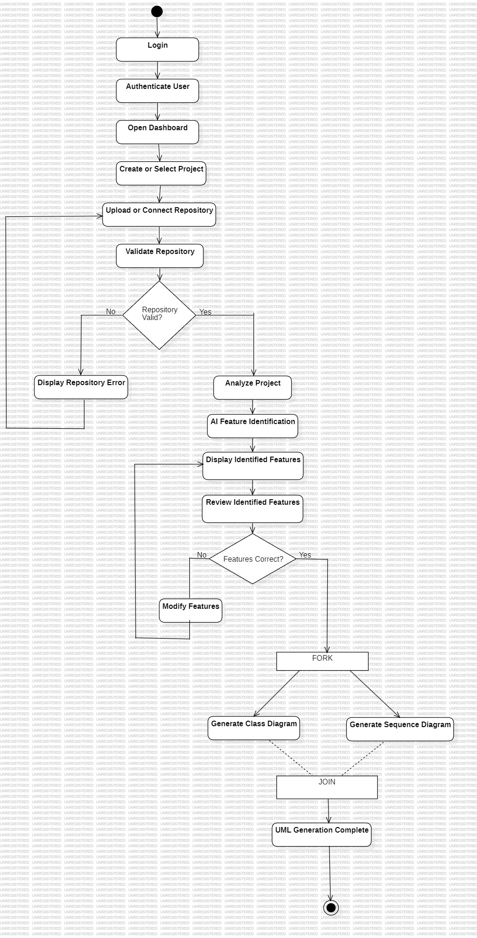
Figure 1 - Activity diagram: end-to-end reverse engineering workflow with human review gate (Experiment 4)

3.6 Data Flow Models
The Level 0 context diagram fixes the system boundary: a Developer supplies a repository and review decisions, and receives feature proposals and generated diagrams.
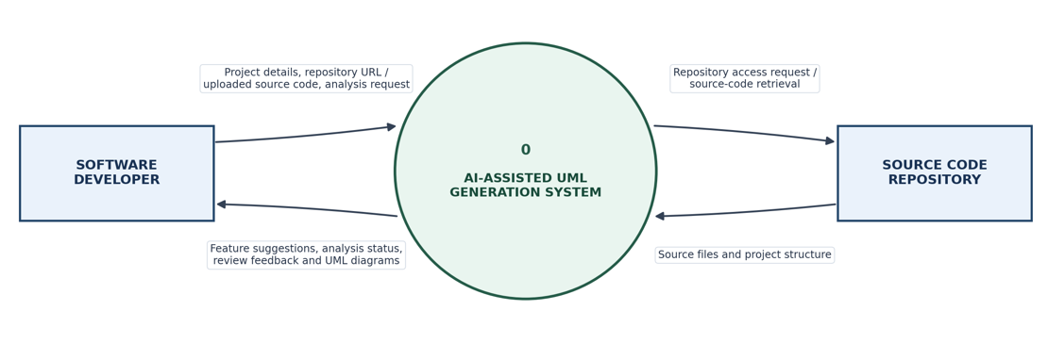
Figure 2 - Level 0 context data flow diagram (Experiment 8)
The Level 1 decomposition expands the single process into the pipeline stages and the data stores they exchange: project and user records, extracted symbols and feature proposals, and generated diagram artefacts.
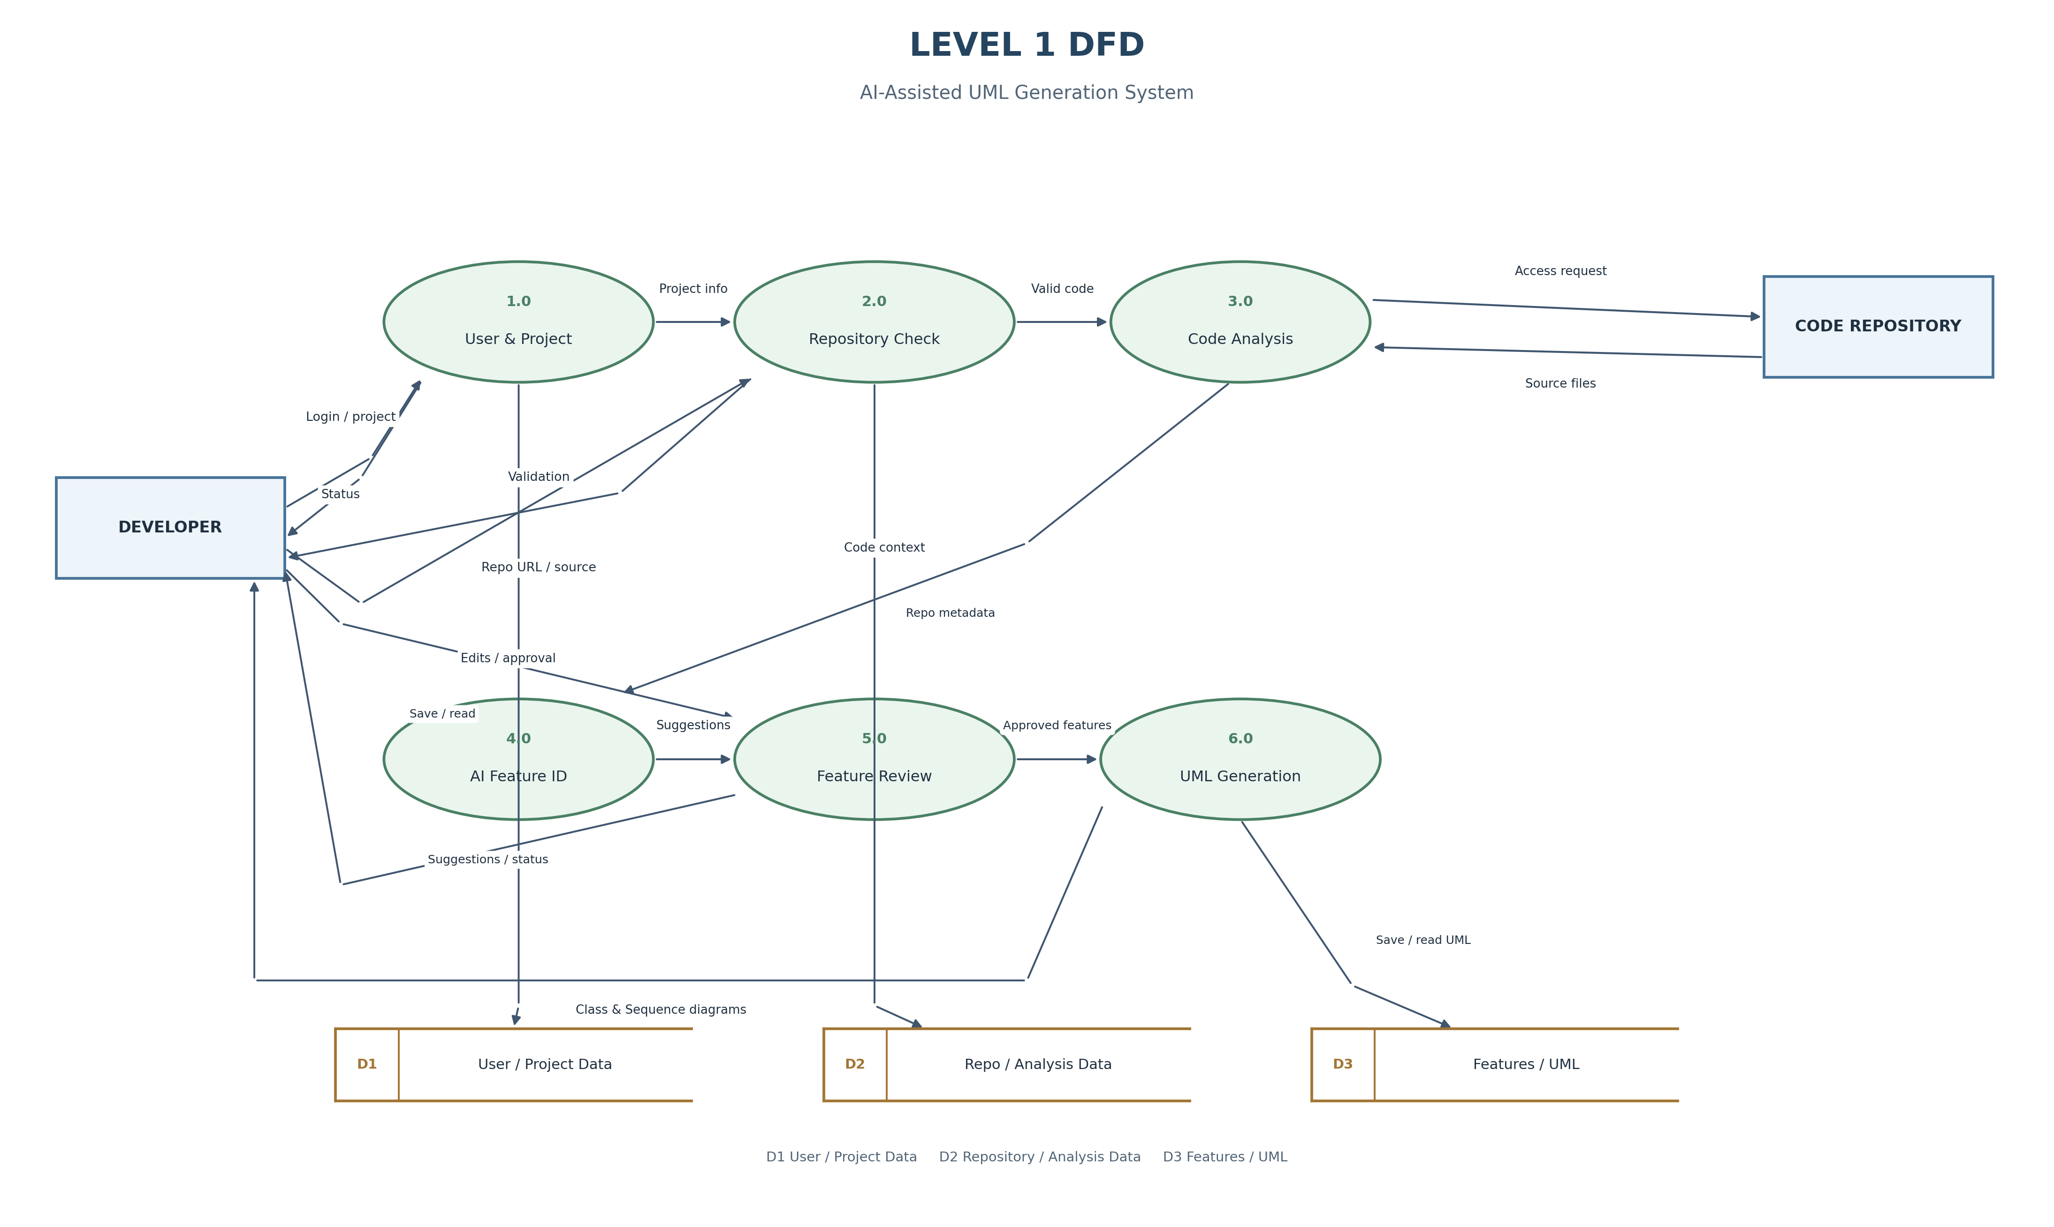
Figure 3 - Level 1 data flow decomposition (Experiment 8)

4. Results
4.1 Regression Benchmark
The pipeline was run against the "Tell Story" project used in the base paper, whose correct feature-to-class mapping is published and therefore serves as a reference answer. The pipeline was given only the source directory, with no feature information of any kind. This is a regression check that the pipeline still reproduces a known mapping end to end; Section 4.1.1 sets out why it should not be read as a measurement of general accuracy.
Measure | Result | Interpretation
Source files parsed | 4 | Complete coverage of the benchmark project
Classes extracted | 4 | Enemy, Hero, Princess, Story
Relationships derived | 7 | Field associations, method calls, dependencies
Clusters formed | 1 | Matches the single ground-truth feature
Feature label assigned | Tell Story (96% confidence) | Matches the published feature name
True positives | 4 | All four class-to-feature assignments correct
False positives / negatives | 0 / 0 | Nothing invented, nothing missed
Precision / Recall | 100% / 100% | No spurious and no missing assignments
F-Measure (F1) | 1.00 | Reproduces the human-authored mapping exactly

Measurement unit. Scoring operates on individual feature-to-class assignments rather than whole features, so a partially correct cluster is partially credited. F1 is quoted rather than precision or recall alone because each of those is trivially gamed in isolation: a tool that claims almost nothing scores high precision, and one that sweeps every class into a single feature scores high recall. Only their harmonic mean resists both.

4.1.1 How Much This Result Establishes
Reported honestly, the figures above demonstrate that the pipeline runs end to end and still produces the expected grouping. They do not establish accuracy, for three reasons.
- The reference project contains one feature and four tightly coupled classes - Story holds a field of each of the other three - so there is almost no room for a false positive or a false negative. A perfect score is close to the expected outcome rather than a demanding result.
- The feature labeller falls back to a keyword heuristic that contains a branch returning the name 'Tell Story' for this project's vocabulary. On this benchmark the feature name is therefore recalled rather than derived. The clustering is genuinely automatic; the label, on this input, is not.
- Matching a discovered feature name against a reference name is a lenient substring test, so the score is driven far more by the class grouping than by the chosen name.
A defensible accuracy claim would require reference mappings for several projects, each containing multiple features, so that misgrouping is actually penalised. That corpus does not exist for this benchmark and building it is identified as future work in Section 5.2. The scale results in Section 4.2 and the output validation in Section 4.3 are the stronger evidence this project offers: they show the pipeline holds up on real repositories two orders of magnitude larger, and that what it emits is well-formed.
4.2 Scale and Performance
To confirm the pipeline is not tuned to a four-class benchmark, it was run against substantially larger real-world repositories.
Repository | Scale Observed | Outcome
UMLRev itself (self-analysis) | 250 files, 229 classes, 550 relationships | 8 features and 16 diagrams in approximately 14 seconds
pallets/click (public GitHub) | 174 classes | 8 cohesive features, all diagrams rendered successfully

4.3 Verification and Testing
The project carries an automated suite of 12 unit and integration tests, all passing. Four correspond to the formal test cases specified in Experiment 9.
Test Case | Scope | Result
TC-01 | Authentication, token issuance and dashboard profile access | PASS
TC-02 | Negative-input validation of malformed repository URLs | PASS
TC-03 | Feature clustering, developer review and approval round trip | PASS
TC-04 | Class and sequence diagram generation with PlantUML and Mermaid export | PASS

Generated-output validation. Because a diagram that fails to parse is worthless regardless of whether the clustering was correct, every generated diagram is additionally checked against the Mermaid parser itself. All 32 diagrams produced across the test corpus - 16 from initial analysis and 16 regenerated after commit-diff highlighting - parse successfully. This check uncovered three defects during development: an invalid styling directive emitted when highlighting commit-modified classes, participant identifiers colliding with reserved grammar keywords, and an unbounded sequence-diagram expansion that produced a 201,651-line diagram from a single large cluster. All three were corrected and are covered by the validation sweep.

4.4 Screenshots
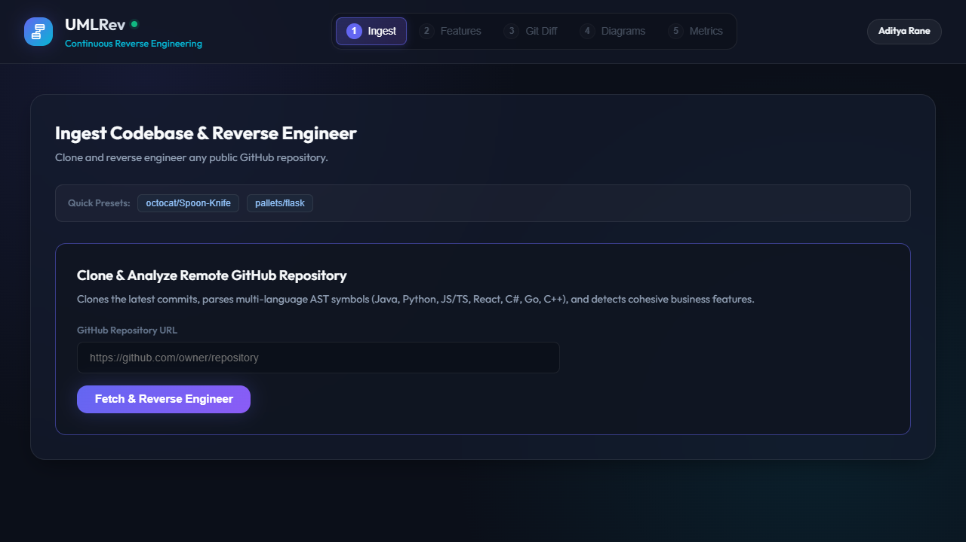
Figure 4 - Stage 1: repository ingestion. The stepper shows pipeline progress; later stages remain locked until a repository is analysed.
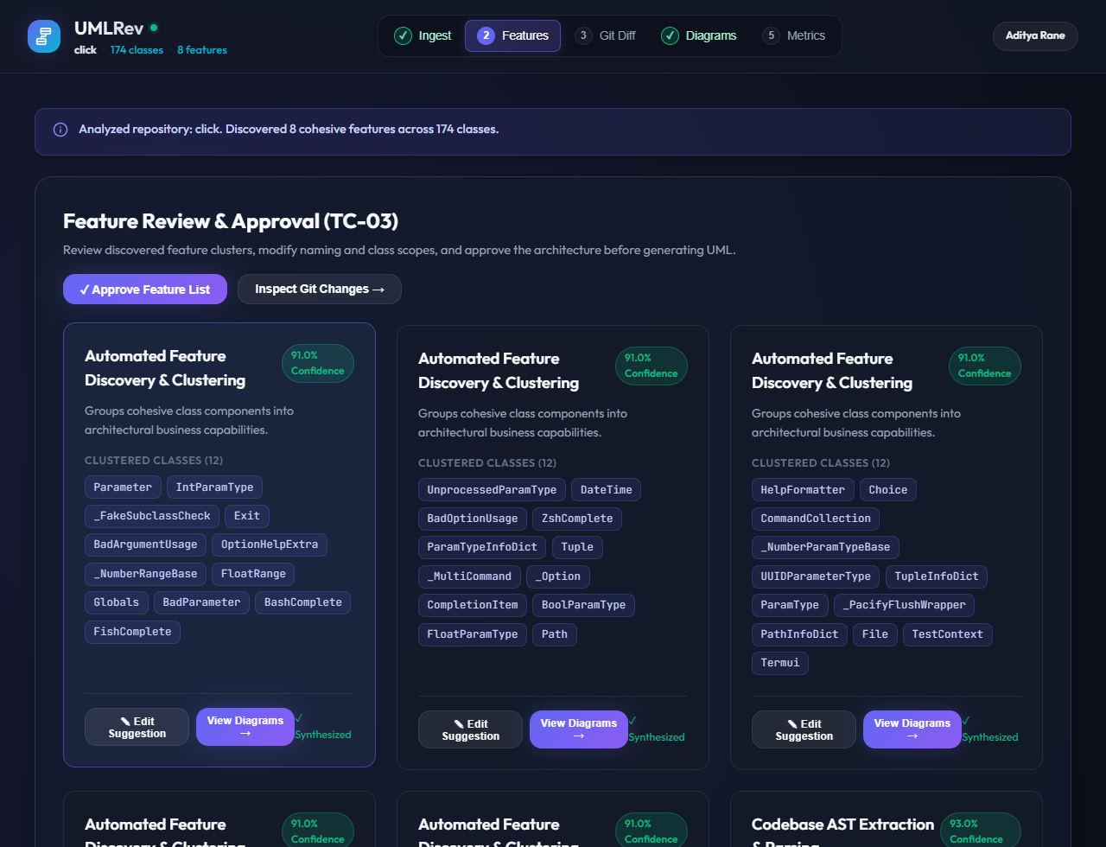
Figure 5 - Stage 2: automatically discovered features presented for developer review, each with its class membership and confidence score.

The two figures below are the diagrams generated for the benchmark project. Neither was drawn by hand: both were synthesised from source code alone, and both are additionally emitted as PlantUML and Mermaid text for version control.
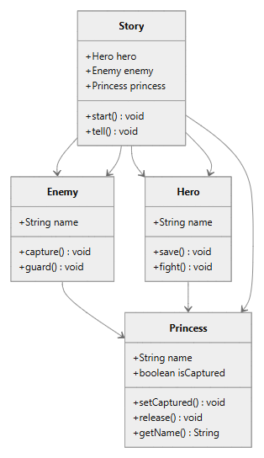
Figure 6 - Generated class diagram for the discovered Tell Story feature
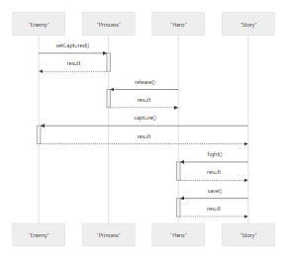
Figure 7 - Generated sequence diagram for the same feature, derived from static call sites
5. Conclusion
This project set out to remove the manual feature-identification step that constrains UMLRev, and it does so. Given a repository and nothing else, the system extracts structural symbols, discovers cohesive features, labels them, and synthesises feature-scoped class and sequence diagrams that a developer can review and export as version-controlled Diagram-as-Code. It reproduces the reference mapping on the published benchmark, scales to repositories two orders of magnitude larger within seconds, and every diagram it emits is verified to parse.
What has not been shown is accuracy in the general case. As Section 4.1.1 sets out, the benchmark is too small to penalise a wrong answer, so the headline figures confirm the pipeline works rather than measuring how well it identifies features. Demonstrating the latter is the main piece of work this project leaves open, and it is a question of assembling an evaluation corpus rather than of changing the approach.
The wider contribution is a change of role rather than a change of output format. Under the base approach an engineer authors the feature map before any diagram exists; here the engineer reviews a proposal. Review is bounded work that scales with the number of features, whereas authoring scales with the number of classes.
5.1 Limitations
- Interactions are derived statically from call sites, so dynamically dispatched and reflective calls may be missed - the trade-off accepted in exchange for not having to build and execute the target project.
- Evaluation rests on a single, small published ground truth, and the labeller contains a keyword branch matching that benchmark's vocabulary. No general accuracy claim is supported by the present evidence.
- Clustering relies on structural coupling, so features that are semantically related but structurally independent may be split across clusters.
- Large clusters produce diagrams that are capped for readability, meaning very large features are presented as a representative view rather than exhaustively.
5.2 Future Work
- Restore the dynamic dimension of the base paper by optionally ingesting runtime traces where a build is available, combining them with the static model.
- Allow ground truth to be supplied per repository so accuracy can be measured on projects beyond the benchmark.
- Publish regenerated diagrams automatically as pull-request comments, closing the continuous loop the base paper describes.
- Extend the strategy set to component and state-machine diagrams, which the existing Strategy-based engine accommodates without modification.
6. References
[1] K. Farias, L. Schenatto, C. Farias, W. Bolzan, R. Keemps and C. Carbonera, "UMLRev: A Context-Aware Feature-Oriented Approach to Support Continuous Reverse Engineering of UML Models," IEEE Access, vol. 14, March 2026. DOI: 10.1109/ACCESS.2026.3672373.
[2] Project source repository - UMLRev Software Engineering Mini Project. https://github.com/Adityarane012/UMLRev---SE-Project
[3] PlantUML - Open-source tool for Diagram-as-Code UML generation. https://plantuml.com
[4] Mermaid - JavaScript-based diagramming and charting tool, version 11. https://mermaid.js.org
[5] FastAPI - Modern Python web framework for building APIs. https://fastapi.tiangolo.com
[6] React - JavaScript library for building user interfaces, version 19. https://react.dev
[7] The AspectJ Project - Aspect-oriented extension to Java, used by the base paper for non-intrusive execution tracing. https://eclipse.dev/aspectj/
[8] Laboratory artefacts, Experiments 1 to 9, Software Engineering, Semester 5, MPSTME, NMIMS University (user stories, non-functional requirements, use case, activity, class, sequence, collaboration and data flow models, and the Experiment 9 test matrix).

