**Step 1**:To install Terraform, visit the official Terraform website mentioned below, go to the Downloads section, select Windows, and download the 64-bit version for your system.

website:https://www.terraform.io/downloads.html  
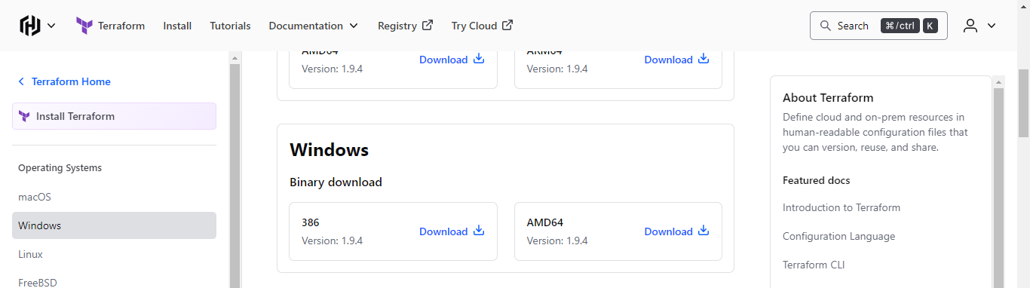

**Step 2**: Extract the downloaded `Terraform.exe` file to the `C:\Terraform` directory on your system.  
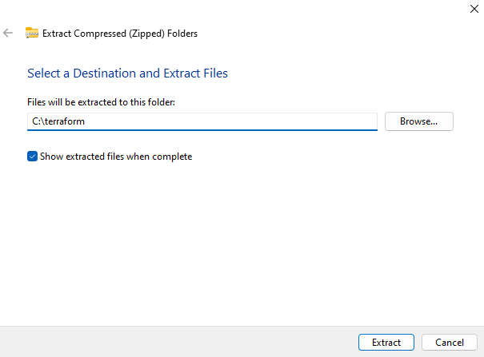

**Step 3**: Set the System path for Terraform in Environment Variables  
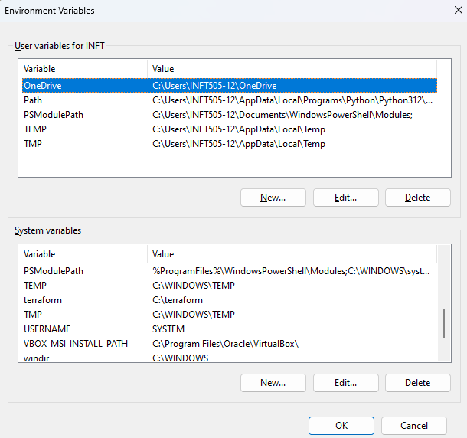

**Step 4**: Run the windows powershell as administrator.

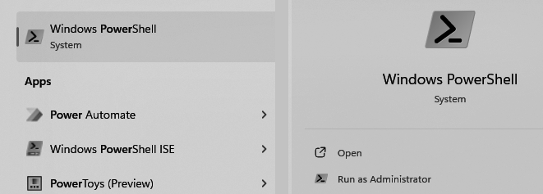

**Step 5**: Run terraform to verify its functionality. If you encounter any errors, double-check or update the Terraform path in your environment variables.

