GOVERNMENT COLLEGE OF ENGINEERING,
CHHATRAPATI SAMBHAJI NAGAR
(An Autonomous Institute of Government of Maharashtra)

MINI PROJECT REPORT
ON
CIVICLENS AI

Submitted by
BT24S05F006 - Pathan Huzaifkhan
BT24S05F009 - Shivam Atram

Under the guidance of
Prof. Shubham Madane Sir
In partial fulfilment of the award of Bachelor of Technology in Computer Science and Engineering
Chhatrapati Sambhajinagar (Aurangabad)
Academic Year 2026-27

GOVERNMENT COLLEGE OF ENGINEERING,
CHHATRAPATI SAMBHAJI NAGAR
(An Autonomous Institute of Government of Maharashtra)
CERTIFICATE
This is to certify that the Mini Project report entitled CivicLens AI, submitted by Pathan Huzaifkhan (BT24S05F006) and Shivam Atram (BT24S05F009), is being submitted for the award of Bachelor of Technology in Computer Science and Engineering at Government College of Engineering, Chhatrapati Sambhajinagar, affiliated to Dr. Babasaheb Ambedkar Marathwada University, Chhatrapati Sambhajinagar.
The work presented in this report has been carried out by the students under the guidance of Prof. Shubham Madane Sir during the academic year 2026-27 and represents their original academic project work.
Place: Chhatrapati Sambhajinagar (Aurangabad)
Date: 14/10/2026
The above project report is submitted by:
Roll No. | Name
BT24S05F006 | Pathan Huzaifkhan
BT24S05F009 | Shivam Atram

Prof. Shubham Madane sir Prof. Vikul Pawar Sir
Guide Head of CSE Department

ACKNOWLEDGEMENT
We would like to express our sincere gratitude and appreciation to all those who helped us in the successful completion of the CivicLens AI project.
Firstly, we are deeply thankful to our project guide, Prof. Vikul Pawar Sir, for his guidance, encouragement, and continuous support throughout the project journey. We also acknowledge the teaching and non-teaching staff of the Computer Science and Engineering Department, together with the laboratory and library staff, for providing the facilities and resources required for this work.
We are grateful to Government College of Engineering, Chhatrapati Sambhaji Nagar, for giving us the opportunity to work on a practical project involving web development, artificial intelligence, information retrieval, document processing, and OCR. Finally, we thank our families and friends for their motivation and support.
Signed by the Students,
Pathan Huzaifkhan
Shivam Atram

ABSTRACT
CivicLens AI is a web-based civic information assistant designed to help students and citizens understand government schemes, educational scholarships, MahaDBT listings, eligibility-related information, and required documents. The application combines a React and Vite frontend with a Python Flask backend and a retrieval-based information layer.
The system provides a searchable scheme explorer, profile-based scheme recommendations, a conversational assistant, and a Chat with PDF module. The PDF module extracts text using PyMuPDF and applies Tesseract OCR to scanned or image-only PDFs. Users can upload EWS, hostel, income, caste, domicile, and similar certificates, view document overviews, ask questions, and receive page-specific evidence.
CivicLens AI uses TF-IDF and cosine similarity for lightweight retrieval and supports an optional OpenAI-compatible language model provider. When no external API key is available, the system produces an evidence-only response from the uploaded document. Responsible-use warnings make it clear that the system does not make official eligibility, authenticity, validity, or approval decisions.

INDEX
TITLE | PAGE NO.
Certificate | i
Acknowledgement | ii
Abstract | iii
1. INTRODUCTION | 1
1.1 Motivation | 1
1.2 Problem Statement | 1-2
1.3 Objectives | 2
1.4 Scope and Limitations | 2-3
1.5 Organization and Project Plan | 3
2. IMPLEMENTATION | 4
2.1 Proposed System | 4
2.2 Algorithms, Techniques and Procedures Used | 4-6
2.3 Program Code and API Flow | 6-8
2.4 Implementation Details and Screenshots | 8-15
3. CONCLUSION | 16
3.1 Conclusion | 16
3.2 Future Scope | 17
REFERENCES | 18

1. INTRODUCTION
Government schemes and scholarships provide important support for education, accommodation, fees, and social welfare. However, students often face difficulty finding the correct scheme, understanding eligibility conditions, identifying required documents, and interpreting official certificates. Information is distributed across government portals, notifications, and PDF documents, which makes the process time-consuming and confusing.
CivicLens AI addresses this problem by providing one simple web interface for scheme discovery and document understanding. The application includes a catalog of Maharashtra MahaDBT scheme names, a guided recommendation form, an AI assistant, and a PDF question-answering workflow with OCR support.
This report describes the motivation, problem statement, objectives, scope, implementation, algorithms, testing, limitations, and future scope of CivicLens AI.
1.1 Motivation
The motivation for developing CivicLens AI is to make public information easier to understand for students and citizens. A user should not need advanced technical knowledge to search for scholarships or understand whether a certificate may be relevant to an application. By combining an accessible interface with retrieval and OCR, the project demonstrates how artificial intelligence can be applied to a practical civic problem.
1.2 Problem Statement
Students may know that scholarships or welfare schemes exist but may not know which scheme matches their course, category, income, residence, or educational level. They may also possess certificates such as EWS, hostel, income, or caste certificates without understanding their general purpose. Existing portals can contain many listings and long notifications, while scanned documents may not contain selectable text. The project therefore addresses the need for an understandable, searchable, and evidence-oriented civic information assistant.
1.3 Objectives
The primary objectives of the CivicLens AI project are:
- Develop a responsive web application for searching government schemes and educational scholarships.
- Include MahaDBT catalog entries covering education, agriculture, welfare, assistance, labour, and skill-related listings.
- Provide guided profile-based recommendations without claiming official eligibility.
- Allow users to upload text-based and scanned PDFs and ask questions about their contents.
- Use OCR to extract text from image-only certificates and preserve page-specific evidence.
- Provide safe, source-aware answers with clear limitations and verification guidance.
- Create a project suitable for demonstration, academic evaluation, and future expansion.
1.4 Scope and Limitations
Scope:
- Scheme search, category filtering, scheme details, and profile-based discovery.
- Educational and welfare scheme catalog with official source links where available.
- PDF text extraction, Tesseract OCR, document topic detection, and page-aware question answering.
- English, Hindi, and Marathi interface options.
- Optional external LLM integration with an evidence-only local fallback.
Limitations:
- Recommendations are potential matches and are not official eligibility decisions.
- MahaDBT catalog names marked UNVERIFIED must be checked against current official notifications.
- OCR can misread names, dates, numbers, stamps, and signatures.
- The system cannot confirm document authenticity, validity, or acceptance by an authority.
- The application is a prototype and does not submit applications to government portals.
1.5 Organization and Project Plan
The project was organized into the following phases:
- Research and Planning: Studying student needs, public scheme portals, PDF processing, and responsible AI.
- Design and Development: Building the React frontend, Flask backend, scheme dataset, retrieval layer, and PDF workflow.
- Integration: Connecting scheme APIs, recommendation logic, OCR, document overview, and optional LLM support.
- Testing and Debugging: Running backend tests, frontend builds, API checks, and browser smoke tests.
- Documentation and Demonstration: Preparing the report, viva guide, feature explanations, and project demonstration.

2. IMPLEMENTATION
This section discusses the implementation of CivicLens AI, including the proposed system, algorithms, techniques, procedures, program structure, and user-facing functionality. The system is implemented as a client-server web application with separate frontend and backend responsibilities.
2.1 Proposed System
The proposed system is a web-based civic information assistant. The React frontend provides navigation, forms, scheme cards, assistant chat, and PDF interaction. The Flask backend validates requests, loads scheme data, performs retrieval, extracts PDF text, runs OCR for scanned pages, and returns structured JSON responses.
The main components of the system are:
- Frontend: React, Vite, React Router, responsive CSS, and Lucide icons.
- Backend: Python Flask APIs for health, schemes, recommendations, chat, PDF upload, PDF questions, and session cleanup.
- Scheme Knowledge Base: Curated records and MahaDBT catalog names with categories, descriptions, links, and verification status.
- Retrieval Layer: TF-IDF vectorization and cosine similarity for ranking relevant passages.
- PDF and OCR Layer: PyMuPDF for text extraction, page rendering for scanned documents, and Tesseract OCR for image-only pages.
- Provider Layer: Optional OpenAI-compatible API and local evidence-only fallback when no API key is configured.
2.2 Algorithms, Techniques and Procedures Used
The following algorithms and techniques are used in the system:
- TF-IDF Retrieval: Scheme descriptions and PDF passages are converted into term-frequency/inverse-document-frequency vectors.
- Cosine Similarity: The user question is compared with knowledge-base passages and the highest scoring passages are selected.
- Evidence-Grounded Prompting: Retrieved passages are placed into a structured prompt that instructs the provider not to invent facts.
- OCR Processing: Pages with no selectable text are rendered as images and passed to Tesseract OCR.
- Keyword-Based Document Overview: Terms such as EWS, hostel, income, caste, disability, scholarship, and validity are detected as cautious hints.
- Profile-Based Recommendation: User preferences are compared with scheme categories, beneficiaries, descriptions, and eligibility summaries.
- Session-Based Temporary Storage: Uploaded PDFs are associated with a temporary session ID and can be cleared after use.
- Error Handling and Safety: Invalid files, missing sessions, unavailable providers, OCR errors, and unsupported claims are communicated explicitly.
2.3 Program Code and API Flow
The project is divided into modular source files. The PDF upload procedure validates the file, saves it to a temporary session path, extracts selectable text using PyMuPDF, renders image-only pages, runs Tesseract OCR, stores page passages, builds a document overview, and returns structured data to the frontend.
The PDF question procedure receives a session ID, question, and language; loads the associated passages; ranks them using TF-IDF and cosine similarity; uses the optional language model when configured; otherwise creates a local evidence-only explanation; and returns the answer with page-specific source passages.
Representative API routes include GET /api/health, GET /api/schemes, POST /api/schemes/recommend, POST /api/chat, POST /api/pdf/upload, POST /api/pdf/ask, and DELETE /api/pdf/session.
Layer | Technology / Responsibility
Presentation | React, Vite, React Router, responsive CSS
Application API | Flask, Flask-CORS, JSON endpoints
Retrieval | scikit-learn TF-IDF and cosine similarity
Documents | PyMuPDF page extraction and temporary sessions
OCR | Tesseract OCR through pytesseract and Pillow
Testing | Pytest, frontend production build, browser smoke testing

2.4 Implementation Details and Screenshots
The following screenshots document the implemented application interface and demonstrate the major user-facing features.
This screen demonstrates the corresponding user workflow and confirms that the feature is integrated into the responsive frontend.
This screen demonstrates the corresponding user workflow and confirms that the feature is integrated into the responsive frontend.
This screen demonstrates the corresponding user workflow and confirms that the feature is integrated into the responsive frontend.
The Scheme Explorer displays searchable scheme cards and contains a guided discovery form. The form accepts education level, social category, goal, occupation, and state preferences and returns potential matches with reasons and verification status.
The Chat with PDF page accepts PDF files through a browser upload control. After upload, it displays extracted text, document topics, possible uses, limitations, and suggested questions. For scanned certificates, the backend uses Tesseract OCR. The answer view presents an explanation followed by relevant source passages identified by page number.
Testing results: The backend test suite completed successfully with 15 passing tests. The tests cover health checks, scheme listing and search, recommendations, provider behavior, PDF validation, text extraction, OCR extraction, PDF question answering, and temporary file cleanup. The frontend production build also completed successfully using Vite.

APPLICATION SCREENSHOTS
The following screenshots show the implemented CivicLens AI interface, including the home page, scheme explorer, AI assistant, multilingual support, responsible-use information, and OCR-enabled PDF workflow.
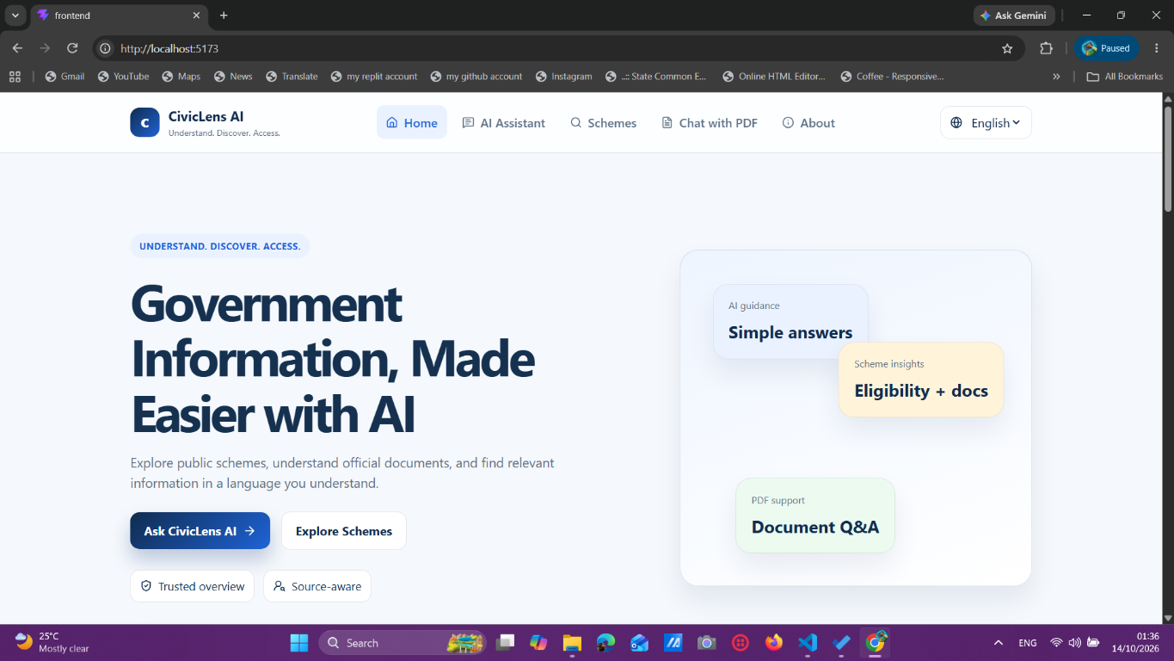
Figure 1307: CivicLens AI home page with navigation and primary actions.
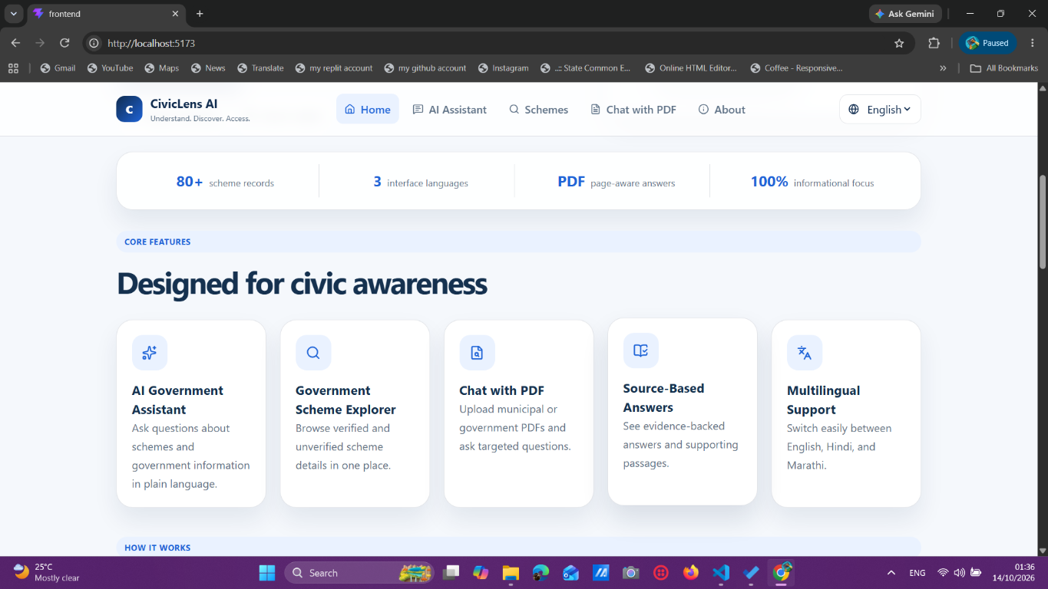
Figure 1308: Home page statistics and core feature cards.
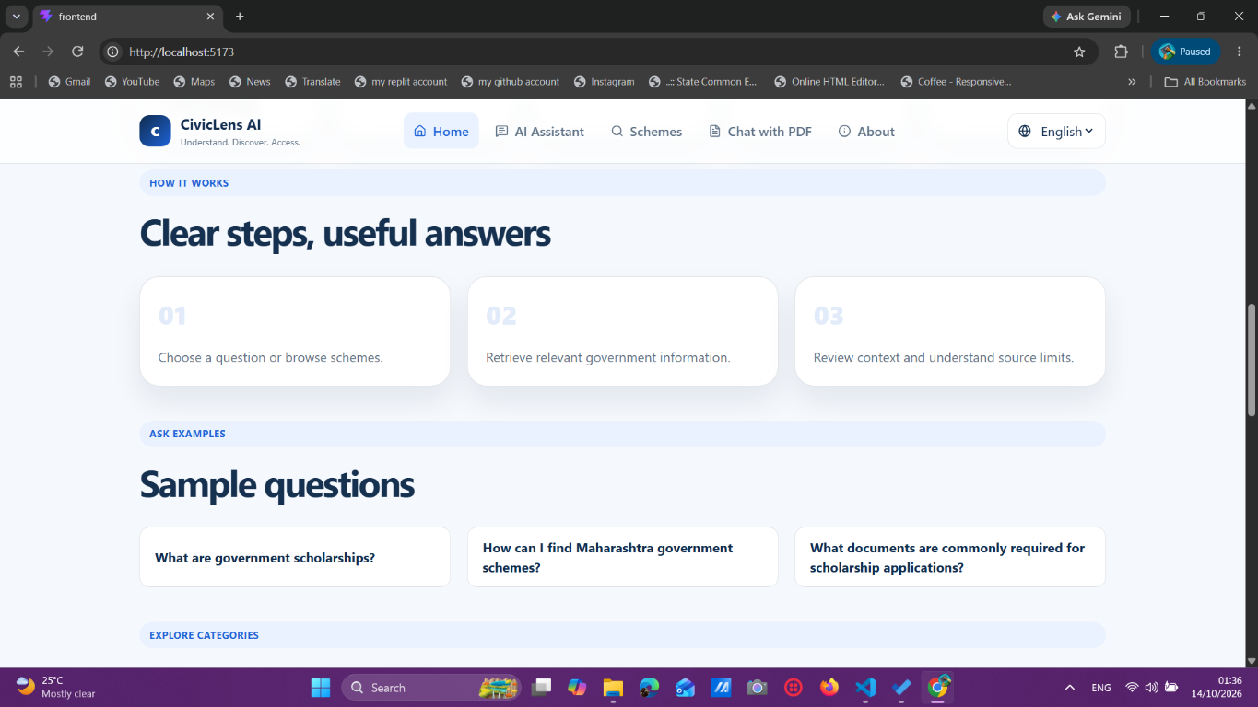
Figure 1309: Home page workflow and sample questions.
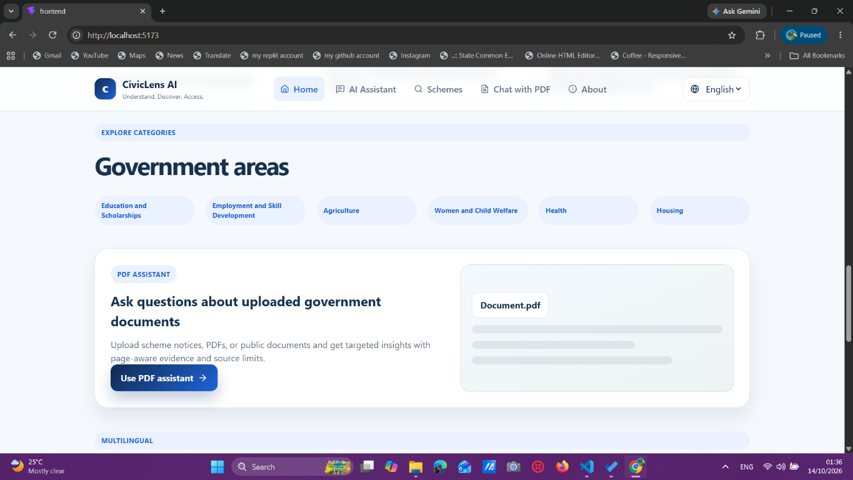
Figure 1310: Government areas, PDF assistant entry point, and scheme categories.
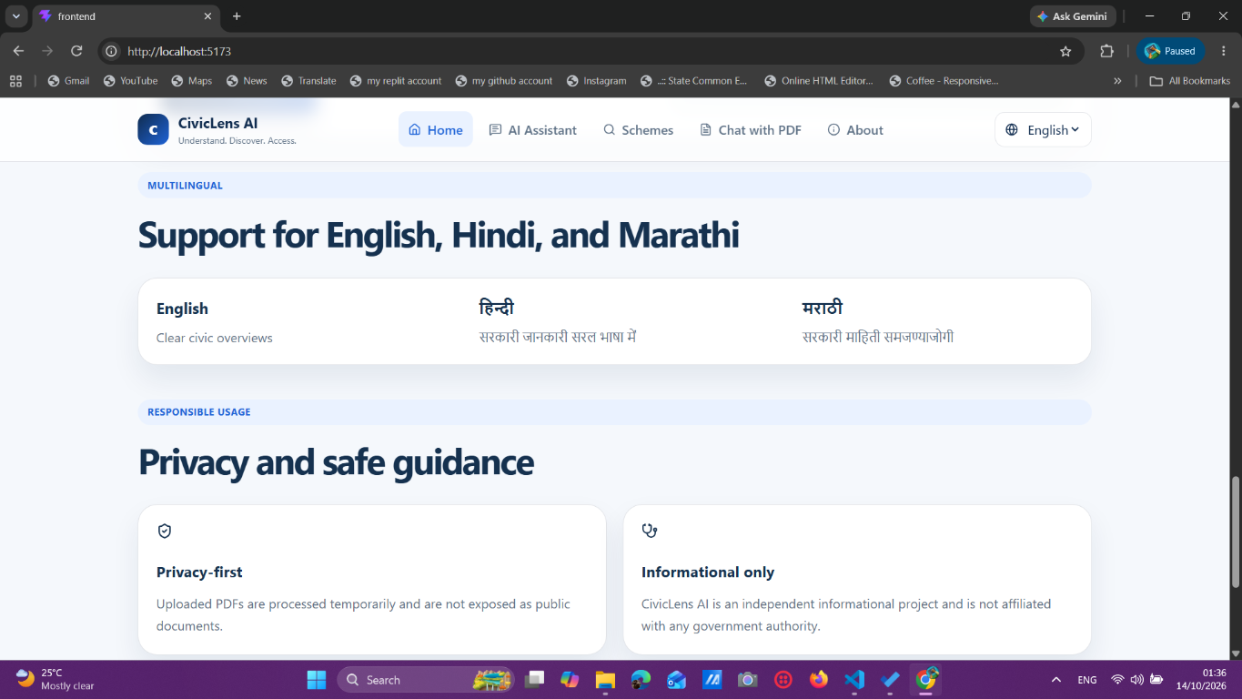
Figure 1311: Multilingual support and responsible-use information.
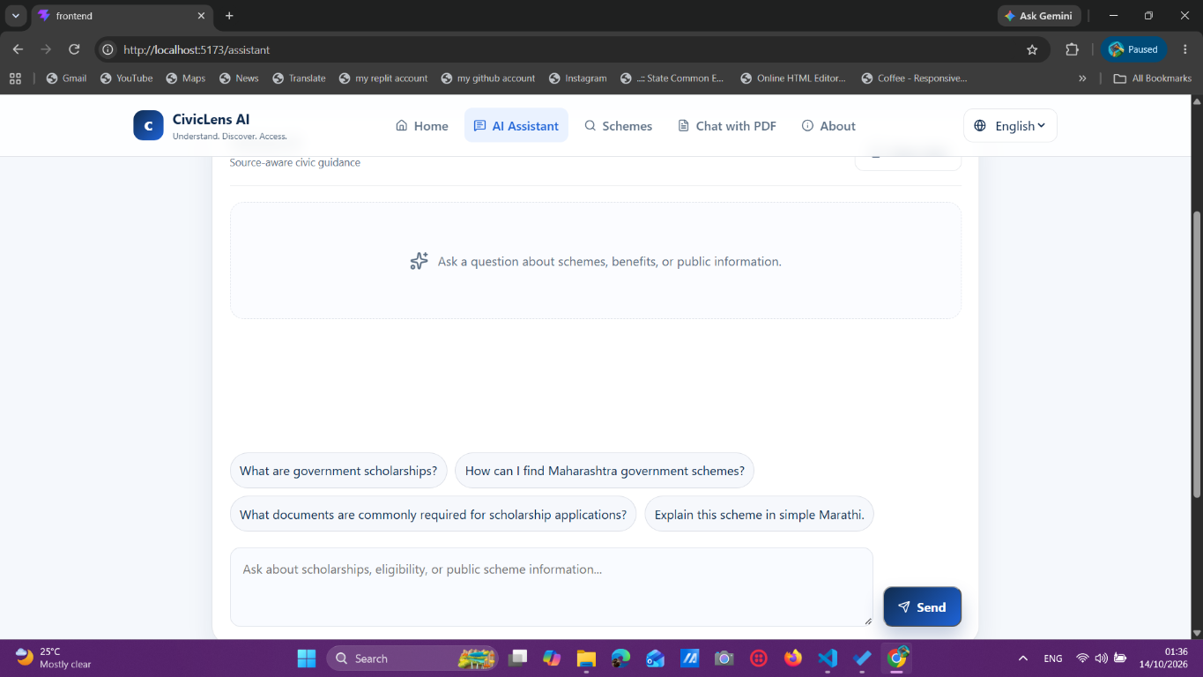
Figure 1312: AI Assistant page with example prompts and question input.
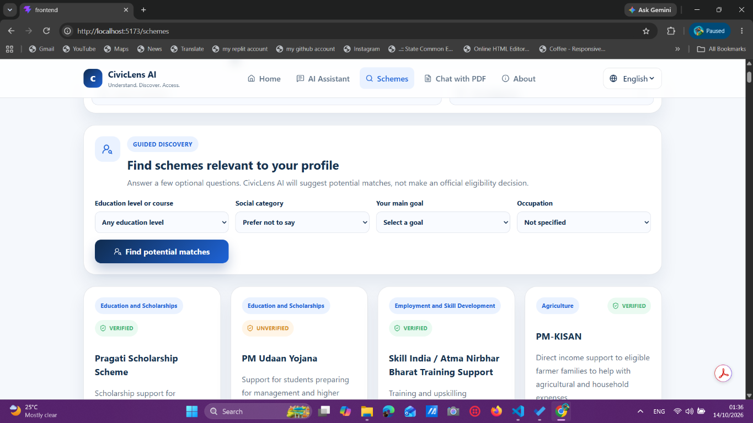
Figure 1313: Scheme Explorer guided discovery form and scheme cards.
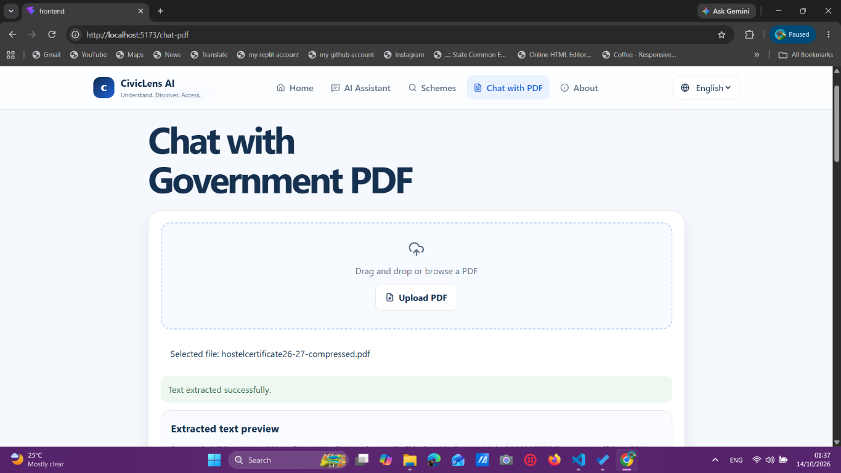
Figure 1314: Chat with PDF upload interface and extracted document status.
3. CONCLUSION
3.1 Conclusion
CivicLens AI successfully demonstrates a practical civic-information assistant for students and citizens. It combines scheme discovery, MahaDBT catalog coverage, guided recommendations, retrieval-based answering, PDF extraction, OCR, and page-specific evidence in a single responsive web application. The project focuses on clarity and responsible use by distinguishing potential matches from official decisions and by reminding users to verify current rules with official authorities.
The completed system is suitable for academic demonstration and shows how web development, information retrieval, artificial intelligence, document processing, and OCR can be integrated to solve a meaningful real-world problem.
3.2 Future Scope
- Add Marathi and Hindi OCR language packs and multilingual OCR answers.
- Use verified scheme notifications and automatic expiry checks for deadlines.
- Add document authenticity checks using official verification portals where permitted.
- Improve OCR post-processing for names, dates, tables, stamps, and handwritten fields.
- Add user accounts, saved schemes, document history, and exportable application checklists.
- Deploy the application using a production WSGI server and secure cloud storage policies.
- Add evaluation datasets for retrieval quality, OCR accuracy, and answer faithfulness.
- Integrate voice input, accessibility improvements, and mobile application support.

REFERENCES
Government of Maharashtra MahaDBT Portal: https://mahadbt.maharashtra.gov.in/
Aaple Sarkar Portal: https://aaplesarkar.mahaonline.gov.in/
Python Documentation: https://docs.python.org/3/
Flask Documentation: https://flask.palletsprojects.com/
React Documentation: https://react.dev/
Vite Documentation: https://vite.dev/
PyMuPDF Documentation: https://pymupdf.readthedocs.io/
scikit-learn Documentation: https://scikit-learn.org/
Tesseract OCR Documentation: https://tesseract-ocr.github.io/
OpenAI-compatible provider documentation used for optional language-model integration.
CivicLens AI source code, test suite, and project documentation.

