Freight Rate Prediction: Approach & Validation
Goal: predict posted_rate for 12,000 loads dated Nov-Dec 2025 using 48,000 labelled loads dated Jan-Oct 2025. The final model is a LightGBM regressor on log(rate) using load-level features, combined with two linear time terms (a long-run trend and a quarter-end ramp) that extrapolate into the unseen months.
Out-of-time backtest (mean of three 2-month folds): MAPE 2.13% / MAE $52 on clean loads, versus 2.81% / $61 for a robust log-linear baseline. Including corrupted labels, MAPE is 4.49% and median APE 1.67%.

1. Key findings from the data
- The split is by time: train_test covers 2025-01-01 to 2025-10-31; validation covers 2025-11-01 to 2025-12-31. Validation is a forecast of the next two months, so random K-fold splits would leak future market conditions and overstate accuracy.
- Distance explains most of the variance (rate per mile falls with distance). Reefer costs ~12% and Flatbed ~8% more than Dry Van; heavier loads cost slightly more (~3% per 10,000 lb).
- market_index is almost a per-day series: its spread within a day (std 0.025) is far smaller than its spread between days (0.17). A 10% rise in the index adds ~1.5% to the rate.
- Rates ramp up roughly linearly over the last ~3 weeks of every quarter (about +3.5% by quarter end in March, June and September) and drop back on the first day of the next quarter. December 31 is a quarter end, so this matters for the December forecast.
- There is an upward drift of about 7% per year that market_index does not explain.
- quote_signal is a weak signal. It adds a little through non-linear effects.
- Coordinates are synthetic/jittered (e.g. New York to Allentown is 0.9 miles apart), and distance has a 70-mile floor, so posted distance, not haversine, is the authoritative length. Rates line up with posted distance even where it disagrees with the coordinates.

2. Data-quality issues and how they were handled
Issue | Extent | Handling
Corrupted labels: posted_rate at ~0.2-0.5x or ~2-6x the expected rate | ~1.4% of rows (677 flagged) | Fit a robust Huber log-linear model and drop rows with |log residual| > 0.25 (clean residual std is ~0.04, so this cut is above 6 sigma). The filter is fitted only on each training fold.
Negative weights | 292 train / 145 validation rows | Treated as sign errors and replaced with |weight|, which falls in the normal range.
Missing weight | 300 train / 165 validation | Equipment median, plus a missing-value flag.
Missing market_index | 374 train / 249 validation | Filled with the same day's mean index, since the index is effectively a daily series.
Cities unseen in training | 8 cities (Chicago, Charlotte, Laredo, ...) in validation | City identities are not used as features. Location enters through lat/lon, which generalise to new cities.
Distance vs coordinates mismatch | ~200 rows with ratio > 1.5 (up to 78x) | Investigated and kept: rates follow posted distance, and the mismatches come from the 70-mile floor and jittered coordinates.

3. Train/test split and validation approach
The validation set is the two months after the training data ends, so the backtest mimics that exactly. It uses expanding-window, out-of-time folds: each fold trains on all data before a cutoff and tests on the following two months. Folds F1 and F3 both contain a quarter end, which tests whether the quarter-end ramp carries over.
Fold | Train window | Test window
F1 | Jan-Apr 2025 | May-Jun 2025
F2 | Jan-Jun 2025 | Jul-Aug 2025
F3 | Jan-Aug 2025 | Sep-Oct 2025
Metrics are reported on all test loads and on 'clean' test loads. Clean loads exclude corrupted labels, flagged by the filter fitted on the training fold. No model can predict a 5x label error, so the clean metrics compare model quality fairly, while the all-rows metrics show what to expect against the raw labels. All preprocessing is fitted inside each fold. Daily market means use only same-day feature values, never labels.
Backtest results (mean over F1-F3):
Model | Clean MAE $ | Clean MAPE | All MAE $ | All MAPE | All MdAPE
Hybrid: LightGBM (load features) + linear trend & quarter-end terms [chosen] | 51.8 | 2.13% | 105.5 | 4.49% | 1.67%
Hybrid, trained without label-outlier filter | 52.6 | 2.17% | 106.3 | 4.54% | 1.72%
LightGBM with calendar features, linear detrend | 52.7 | 2.21% | 106.4 | 4.58% | 1.75%
Robust (Huber) log-linear baseline | 60.7 | 2.81% | 114.5 | 5.17% | 2.40%
LightGBM with calendar features, no trend handling | 62.2 | 2.73% | 115.9 | 5.02% | 2.22%

Chosen model by fold | Clean MAE $ | Clean MAPE | All MAPE
F1 | 46.1 | 1.81% | 4.09%
F2 | 71.6 | 2.91% | 5.21%
F3 | 37.7 | 1.66% | 4.18%
F2 (Jul-Aug) is the hardest fold. Rates dipped about 1% below what the market index and trend imply, a market-wide move that no feature in the data anticipates.
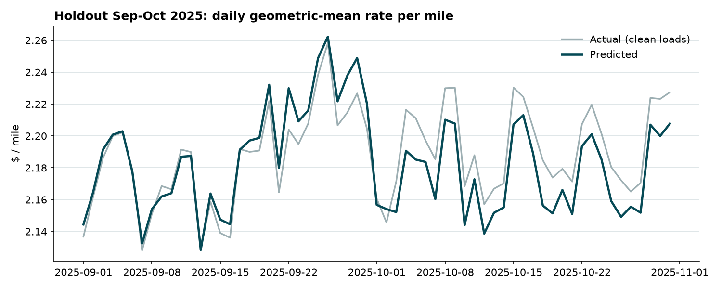

4. Model choice
- The target is log(rate). Errors are multiplicative, and exponentiating a log prediction gives a median-style estimate that is robust for MAE/MAPE.
- A plain GBM given calendar features (day of quarter, daily market mean) memorises individual training days. It cannot extrapolate time, so its F3 error was nearly double.
- The hybrid keeps the GBM for what it does well: non-linear distance curves, equipment x distance interactions and regional (lat/lon) effects. Calendar effects that must carry into Nov-Dec (trend, quarter-end ramp) are linear terms. The two parts are fitted by backfitting with a robust Huber loss.
- Final time terms: trend 6.8% per year, quarter-end ramp +3.5% at quarter end. LightGBM uses a Huber objective, learning rate 0.03, 2,500 trees and 31 leaves.
- Removing corrupted labels before training lowered error slightly in every fold.
- Feature importance (gain share): log_distance 80.6%, pickup_lon 6.8%, delivery_lon 5.3%, log_quote_signal 2.2%, equipment_code 1.9%, pickup_lat 1.1%.

5. December 2025 fixed-lane chart
The chart is produced by the provided score.py. The December input rows have no market_index or quote_signal, so each date uses the daily mean of the validation loads on that date (the only market information for those days). The curve shows the market index's weekly cycle and the quarter-end ramp lifting rates through late December.
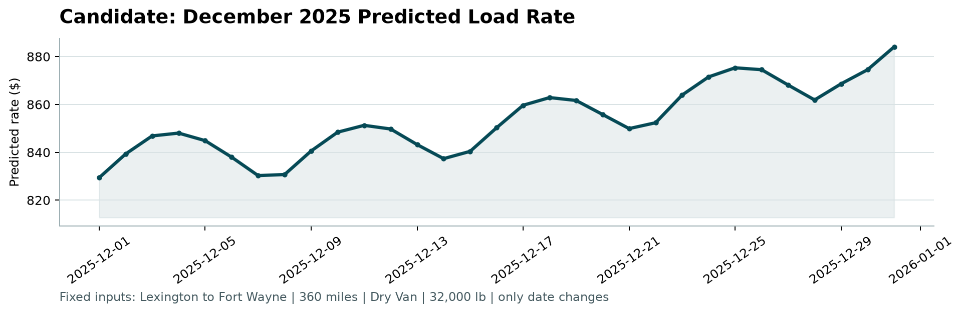

6. Limitations and next steps
- Two-month-ahead market moves not reflected in market_index (as in Jul-Aug) remain the largest error source. A leading market indicator would help most.
- Nov-Dec holidays (Thanksgiving, Christmas) do not appear in the training months, so their effect cannot be learned from this data.
- The trend is linear and estimated from ten months. It should be re-estimated as new data arrives.

