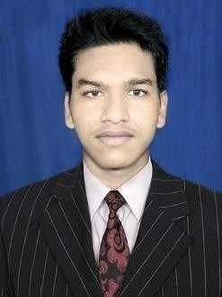
ADITYA NARAYAN SAHOO
Full Stack Developer (.NET + Angular)
Address: Jagatsinghpur, Odisha
Mobile: +917787936260
Email: sahooaditya2003@gmail.com
LinkedIn: AdityaNarayanSahoo

Professional Summary
- Full Stack Developer with 2 years of experience specializing in ASP.NET Core, Angular, SQL Server, Entity Framework Core, REST API development, and Azure cloud services. Skilled in building secure, scalable, and high-performance applications with clean architecture and best coding practices.

Technical Skills
- Backend: ASP.NET Core 6/7, C#, Web API, ADO.NET, Entity Framework Core
- Frontend: Angular
- Database: SQL Server
- Cloud: Azure App Service, Azure SQL, Azure Storage, Application Insights, Key Vault
- Tools: GitHub, Postman, Swagger, Visual Studio, VS Code

Experience
Software Engineer | ApMoSys Technologies (Jan 2024 – Present)
- Developed and maintained enterprise web applications using ASP.NET Core 6, .NET Web API, and SQL Server, ensuring high performance and security
- Designed and implemented RESTful APIs for seamless communication between Angular frontend and backend modules.
- Contributed to ARPA – ApMoSys Robotic Process Automation Portal, a centralized platform for automating key banking workflows.
- Built interactive and user-friendly UI screens using Angular for dashboards, task automation, and real-time data visualization.
- Engineered robust backend architecture with ASP.NET Core & Web API, improving scalability and maintainability.
- Utilized SQL Server for efficient data processing, indexing, and optimized queries.
- Improved workflow efficiency by automating critical banking operations, reducing manual efforts.
- Implemented secure user authentication & role-based authorization using JWT, ensuring restricted access control across the ARPA portal
- Collaborated using Git, Agile Scrum, and Azure DevOps for deployment and task tracking.

Soft Skills
- Good communication skills, Quick learner, Problem-solving, Teamwork

Academic Profile
•B.Tech in Computer Science Engineering – Trident Academy of Technology
• Intermediate (CHSE) – Biju Patnaik College 2020
• 10th (BSE Odisha) – 2018

Personal Information
Date of birth: 28/11/2002
Languages Known: English, Hindi & Odia

