# EVIDENCE FOR PORTFOLIO

Table of Contents

EVIDENCE FOR PORTFOLIO 1

LA SHOP 1

FURNITURE SNOWFLAKE SCHEMA 4

FURNITURE STAR SCHEME 5

SS TASK1 6

## LA SHOP

**LA-SHOP Scenario**

LA-SHOP is a big department store across the countries i.e. Europe, North America and Australasia regions with a computer system working across the world Most likely this scenario is one centrally located database system, all sites looked through it.

OBJECTIVES OF LA-SHOP

1. Provide quality of Services to Customers.
2. Improve customer satisfaction.
3. Provide a better experience
4. Become well-known brand
5. Increase their market share
6. Family oriented and time oriented.
7. Increase in profit.
8. identify necessary actions,
9. Gets customers feedback.

**REPORT OF LA-SHOP SCHEME**

1)Total numbers of customers orders per each shop

2)Total profit made over the year in compare to previous year.

3) Total loss made over the year in compare to previous year.

4) Total numbers of complaints received this year compare to last year.

5) Total numbers of share market in different countries.

**Suggestions for LA-SHOP**

1. Open new shops.
2. Reduce no of complaints.
3. Reduce the number of complaints a specific shop or over the Company.
4. Reduce the number of staff at a specific shop or over the Company.
5. Close shops.

**To Support LA-SHOP WITH BUSINESS IDEAS**

1. View Profit per month per shop
2. View Profit for this year and last year too.
3. View gain profit per month per shop for shops with hairdressing.
4. View gain profit per month per shop for shops with inner design Services.
5. View gain profit per month per shop for shops with store café.
6. No of new customers per month.
7. No of new staffs per month .

**STAR SCHEME OF LA-SHOP**



FACT table in the middle in the above star scheme erd **‘FACT’s in bold** and also themeasure is in the fact table like total_loss,total_profit.

**1)Dim_time**

* Time-id,

* Months

* Years

**2) Dim_country**

* country_id,

*country _name

3)**dim_customers**

* customers-id

* customers-name

**Data Analysis Exercise**

Consider the data for the tables below:

|  |  |  |
| --- | --- | --- |
| Booking(booking_id, *Customer_id*, *nursery_id,* date_booked, booking_start_time, Booking_end_time, booked_by, no_in_party, special_notes) | | |
| Customer(Customer_id, customer_name, customer_address, customer_type)  What are the problems, anomalies, issues with the data above ?  Make a suggestion as to how to address each case.  Problems of the above data   1. Null in the start time 2. Customers doesn’t know the end time. 3. Booking -id is not in the order form. 4. End time is written in the word form whereas others in num forms. 5. Customers are not in the order forms.   SUGGESTIONS FOR THE ABOVE DATA  1 Start time must not be in null  2) During the booking customers have to know the end time  3) Booking id must be in the order.  4) End time must be in the num format  5) Customers id must be in the order format  . |  |  |

## FURNITURE SNOWFLAKE SCHEMA



Snowflake schema design model to support furniture wholesale company.

## FURNITURE STAR SCHEME



Star schema design model to support furniture wholesale company.

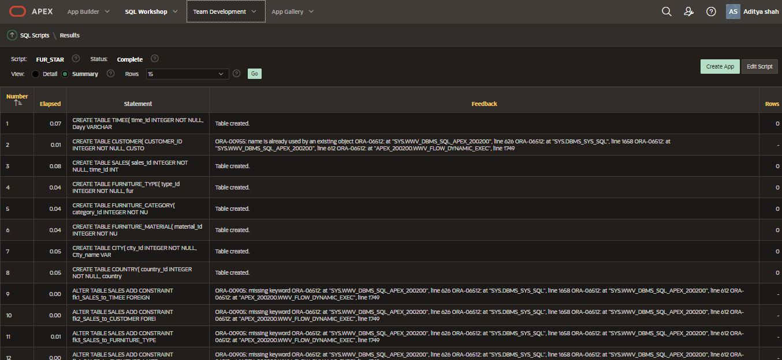

## SS TASK1



Star scheme model design to support SSTask1 requirement.

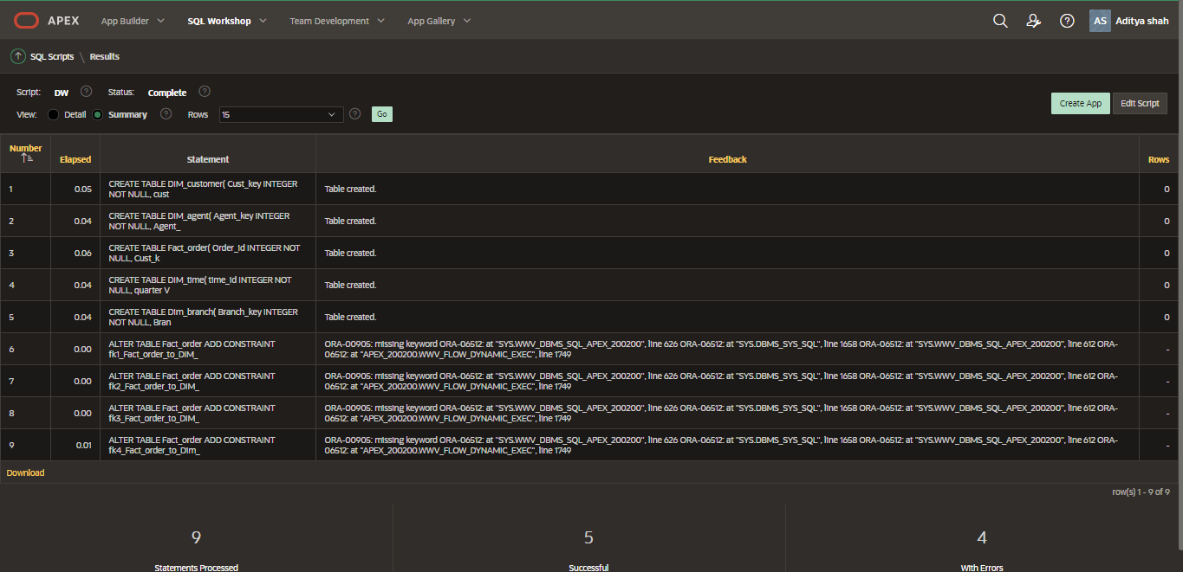

Creating table in oracle running sql script generated from QSEE.