KJSCE/IT/LY-B.Tech/SEM-VII/ML/2022-23

**Experiment No. 7**

**Title: Develop a Multiple linear regression model using Microsoft Azure Machine Learning Studio**

KJSCE/IT/LY-B.Tech/SEM-VII/ML/2022-23

**Batch: B1** **Roll No. 1914122 Experiment no.: 7**

**Title:** Develop a Multiple linear regression model using Microsoft Azure Machine Learning Studio

**Describe the following points with respect to the business under consideration,**

1. **Problem faced by the business**

The system is designed such that it helps to estimate the price of a Car based upon the different features present, so it helps the business to give the correct amount of pricing to their Car Models, so that the customers are attracted and also are satisfied with price range assigned based upon it’s features. So, assigning Price range accordingly is challenging without the use of ML algorithms.

1. **Approach/ Methodology followed by the business**

The methodology which we followed was that we took the dataset of Automobile Price Data. Then we split the dataset into train and test. Then we used Linear Regression and trained the machine learning model with that dataset and in the end we tested that model.

1. **Skillsets , infrastructure and other impact on the business during**

**implementation Skillset:** Cloud computing

**Infrastructure:** Microsoft Azure Cloud services

There were no as such impacts on the business, as any of the business service lines were not being used.

1. **Similar approaches followed by other businesses**

**Step 1.** Sign-in using Microsoft account on studio.azureml.net **Step 2.** Creating workspace for our Machine Learning project.

**Step 3.** Select New option on bottom right:

**Step 4.** Click on Blank experiment and write name and summary of experiment **Step 5.** Select From Saved Datasets-> Samples-> dataset of your choice

**Step 6.** Now, search ‘Select columns in dataset’ from items and drag it

**Step 7.** Now, click on launch column selector-> with rules->exclude column normalized-losses as that column contains many rows/records with empty values.

**Step 8.** Search and select ‘Clean Missing Data’ from items list

**Step 9.** Now, select cleaning mode -> Remove entire row as it will remove the entire row wherever missing value is found

**Step 10.** Again choose ‘select columns in dataset’

**Step 11.** Now, launch column selector and include all the columns based on which prediction is to be done: make, body-style, wheel-base, engine-size, horsepower, peak-rpm, highway-mpg, price

KJSCE/IT/LY-B.Tech/SEM-VII/ML/2022-23

**Step 12.** Now, select ‘split data’ from list and drag it

**Step 13.** For Split data, enter the fraction of data which is needed for training while rest will be used for testing

**Step 14.** Now, Select ‘Linear Regression’ as the algorithm to be used and ‘Train Model’ from list

**Step 15.** For training model, click on launch column selector, include price column as Price is what is to be predicted

**Step 16.** Add Score Model from list drag it and make connections **Step 17.** Now, Add Evaluate Model from list and make connections **Step 18.** Now, Click on Run

**Step 19.** To check prediction results, right click on Score Model, select visualize

**Step 20.** To check Evaluation results, right click on Evaluation Model, select visualize

1. **Problem faced by the business:**

The prices of new cars in the industry is fixed by the manufacturer with some additional costs incurred by the Government in the form of taxes. So, customers buying a new car can be assured of the money they invest to be worthy. But due to the increased price of new cars and the incapability of customers to buy new cars due to the lack of funds, used cars sales are on a global increase. There is a need for a used car price prediction system to effectively determine the worthiness of the car using a variety of features. Even though there are websites that offers this service, their prediction method may not be the best. Besides, different models and systems may contribute on predicting power for a used car’s actual market value. It is important to know their actual market value while both buying and selling.

1. **Approach followed by the business**

Generally, Car Manufacturers vary the product for the price of cars with the available independent variables. That should help the management to understand how exactly the prices vary with the independent variables. They can accordingly manipulate the design of the cars, the business strategy etc. to meet certain price levels. As the car is made to meet multiple requirements, the prediction is taken under the consideration of multiple facilities and services provided by the Car Manufacturer. Majority of the car manufacturers use machine learning models to predict the car price using multiple features as inputs with the current trends in the society.

1. **Skillsets, infrastructure and other impact on the business during implementation**

The Skillset required is the understanding of the machine learning models, individual parts and overall functioning of each and every part of the automobile. Thorough understanding of the automobile industry and independent parts of the automobile.

The infrastructure required is the Storage, Computational power and the data to implement these models to predict the pricing.

1. **Similar approaches followed by other businesses**

Majority Businesses follow a similar trend of prediction before date to improvise before-hand and produce good quality products. Another approach followed by similar businesses is to determine the brand pricing model of the Car Manufacturer and use it as its base to predict the sale. Current Trends, requirements and feature selection are also used by the car manufacturers and other businesses to predict the prices.

1. **Follow Machine learning studio for developing an application**

**Solution:**

Step1: Select the dataset and get the data

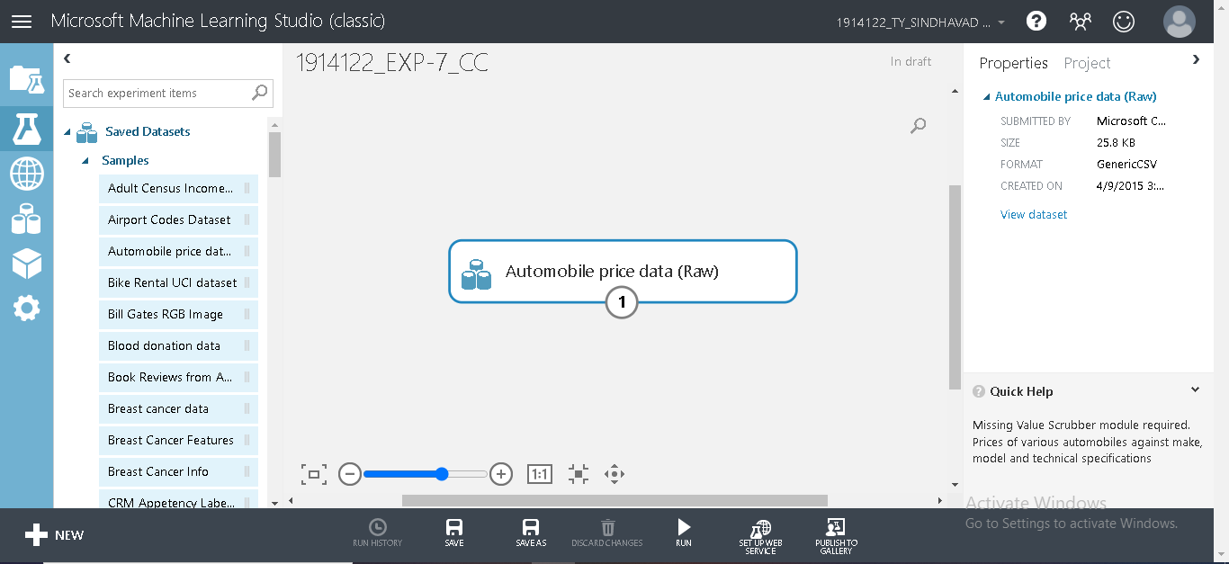

**Step2: Visualize the dataset**

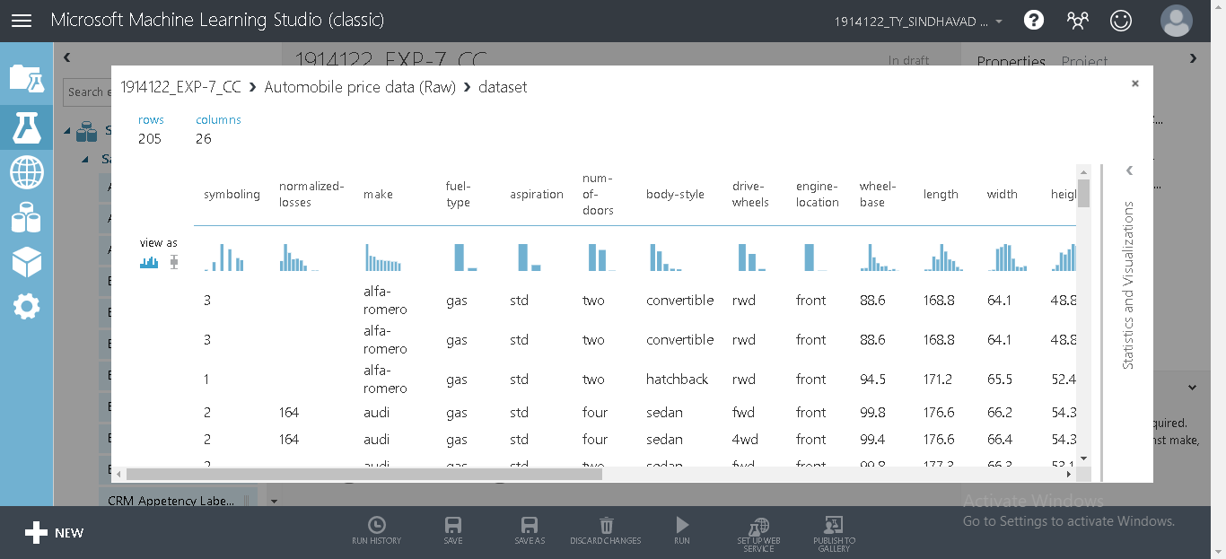

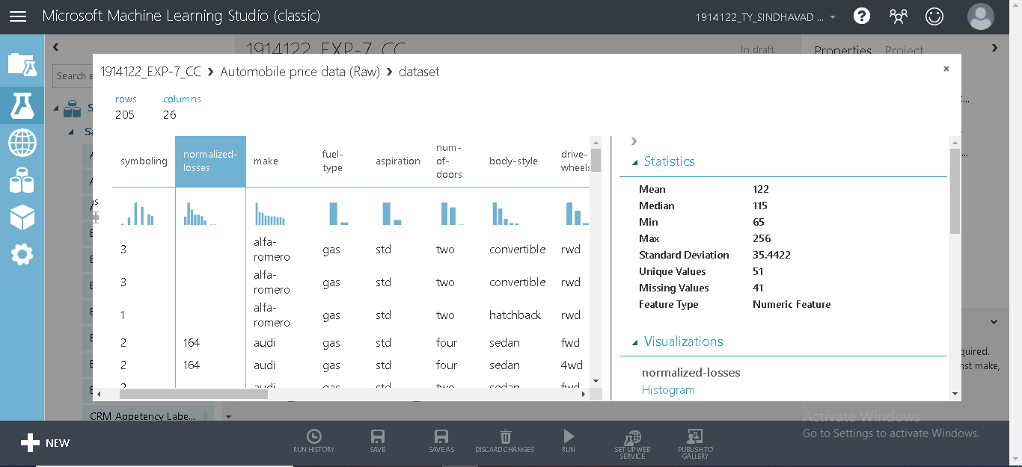

**Step 3: Preparing the data** (selecting columns from the dataset)

Click the Select Columns in Dataset module and click Launch column selector in the Properties pane.

* On the left, click With rules
* Under Begin With, click All columns. These rules direct Select Columns in Dataset to pass through all the columns (except those columns we're about to exclude).
* From the drop-downs, select Exclude and column names, and then click inside the text box. A list of columns is displayed. Select normalized-losses, and it's added to the text box.
* Click the check mark (OK) button to close the column selector (on the lower right).

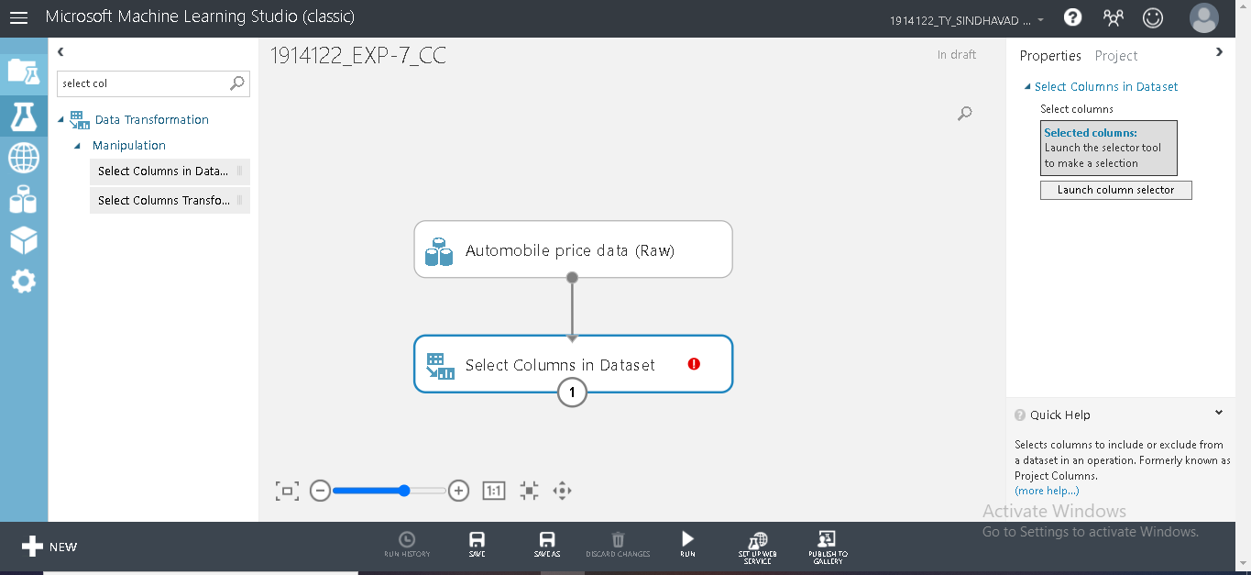

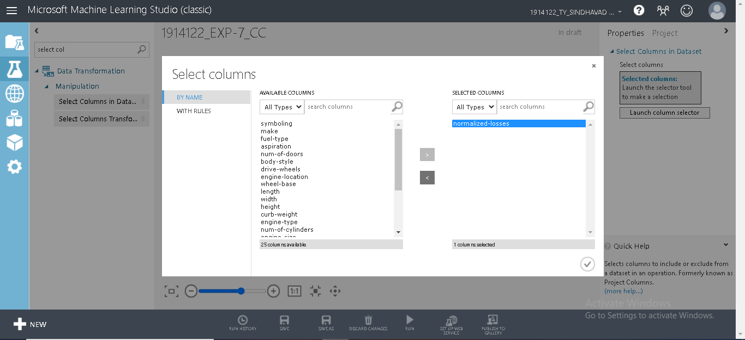

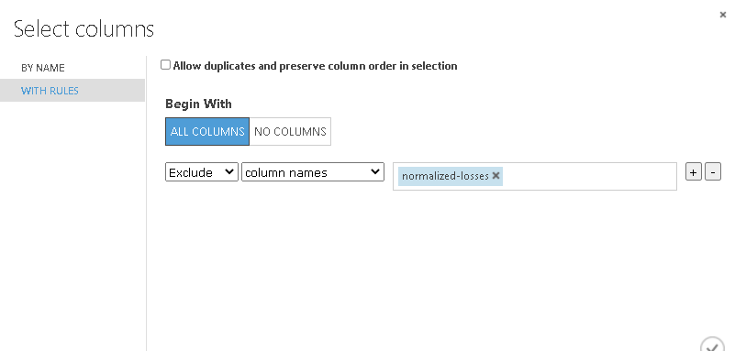

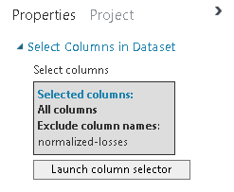

**Step 4: Preprocessing over the data**

Drag the Clean Missing Data module to the experiment canvas and connect it to the Select Columns in Dataset module. In the Properties pane, select Remove entire row under Cleaning mode.

These options direct Clean Missing Data to clean the data by removing rows that have any missing values. Double-click the module and type the comment "Remove missing value rows."

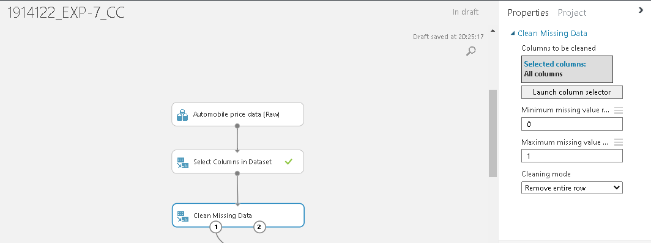

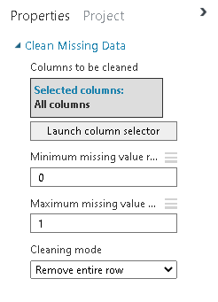

**Step 5: Define Features**

Drag another Select Columns in Dataset module to the experiment canvas. Connect the left output port of the Clean Missing Data module to the input of the Select Columns in Dataset module

Under Begin With, click No columns. In the filter row, select Include and column names and select our list of column names in the text box. This filter directs the module to not pass through any columns (features) except the ones that we specify.

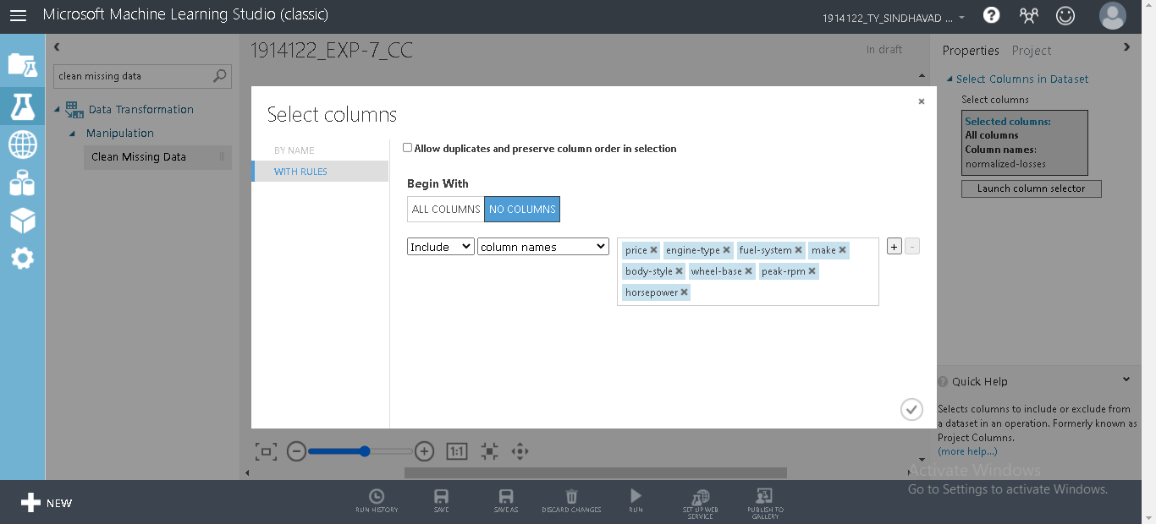

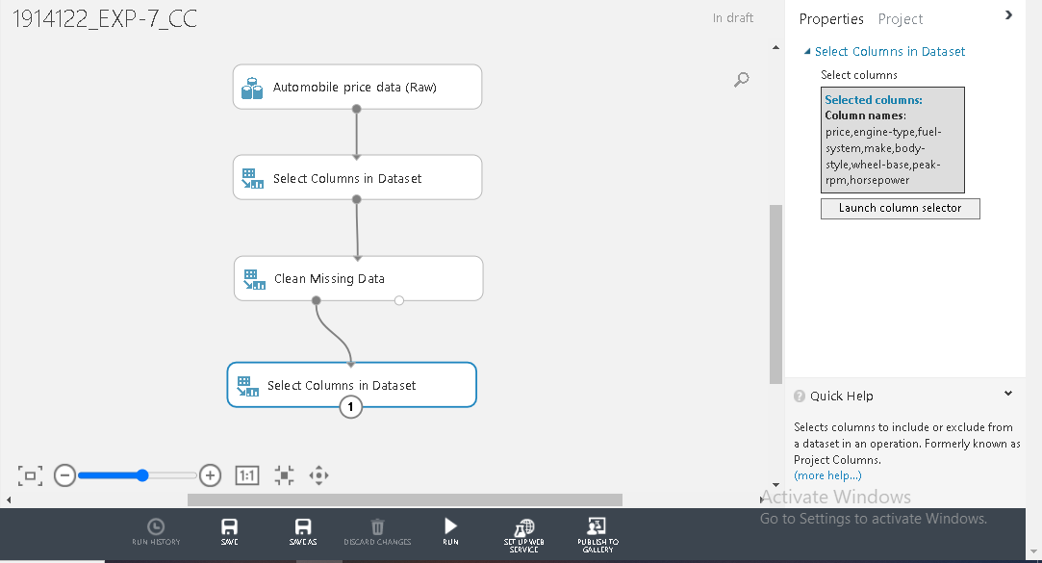

**Step 6: Split data**

Select and drag the Split Data module to the experiment canvas and connect it to the last Select Columns in Dataset module.

Click the Split Data module to select it. Find the Fraction of rows in the first output dataset (in the Properties pane to the right of the canvas) and set it to 0.75. This way, we'll use 75 percent of the data to train the model, and hold back 25 percent for testing. And then set Random seed to 250.

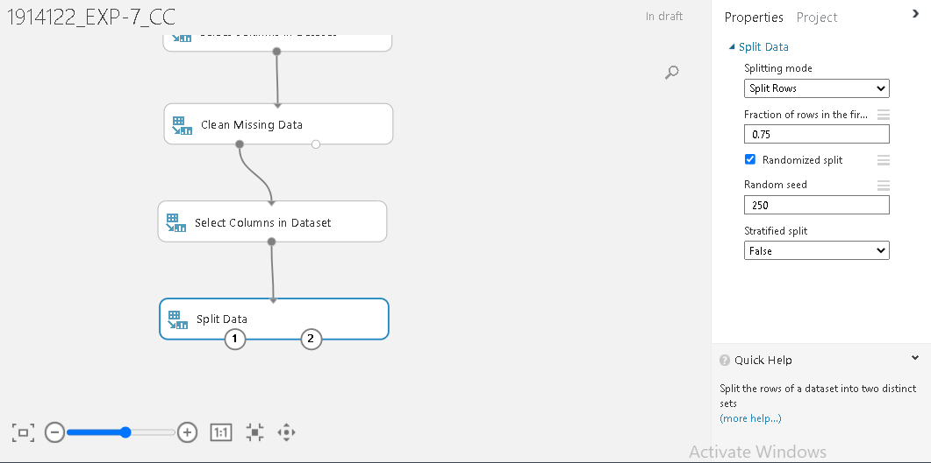

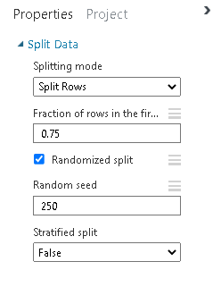

**Step 7: Choose an Algorithm**

Select the Linear Regression module under the Regression category, and drag it to the experiment canvas

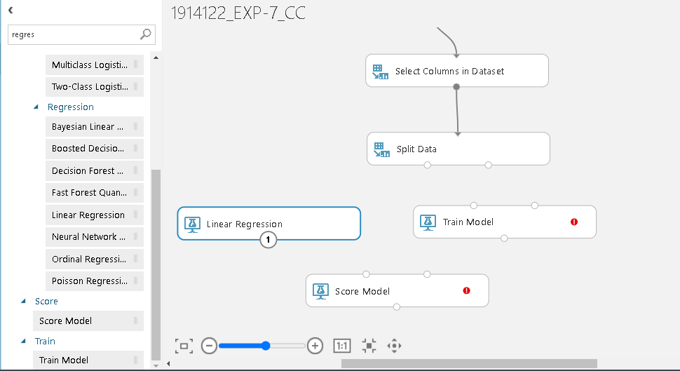

Find and drag the Train Model module to the experiment canvas. Connect the output of the Linear Regression module to the left input of the Train Model module, and connect the training data output (left port) of the Split Data module to the right input of the Train Model module.

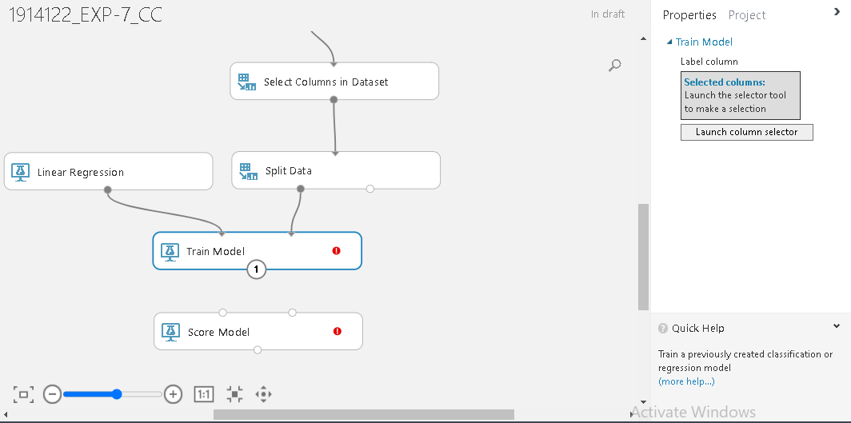

Click the Train Model module, click Launch column selector in the Properties pane, and then select the price column. ‘Price’ is the value that our model is going to predict.

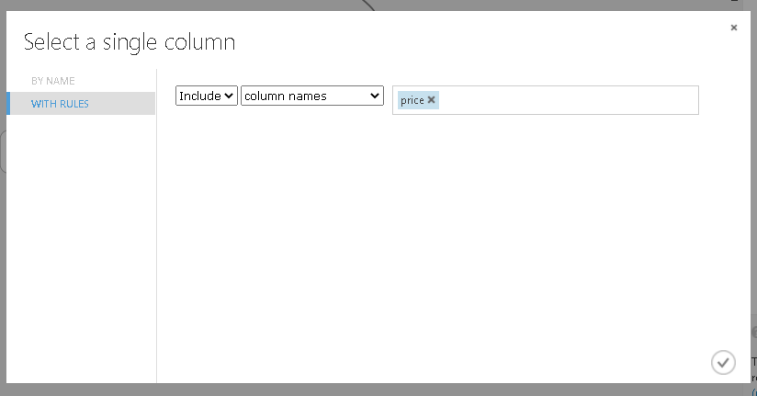

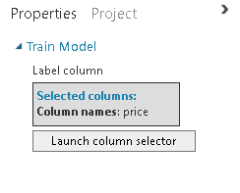

**Step 8: Predict new prices**

Find and drag the Score Model module to the experiment canvas. Connect the output of the Train Model module to the left input port of Score Model. Connect the test data output (right port) of the Split Data module to the right input port of Score Model.

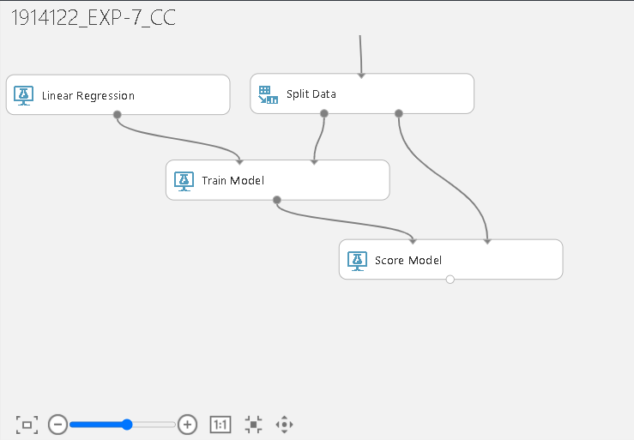

**Step 9: Run the model**

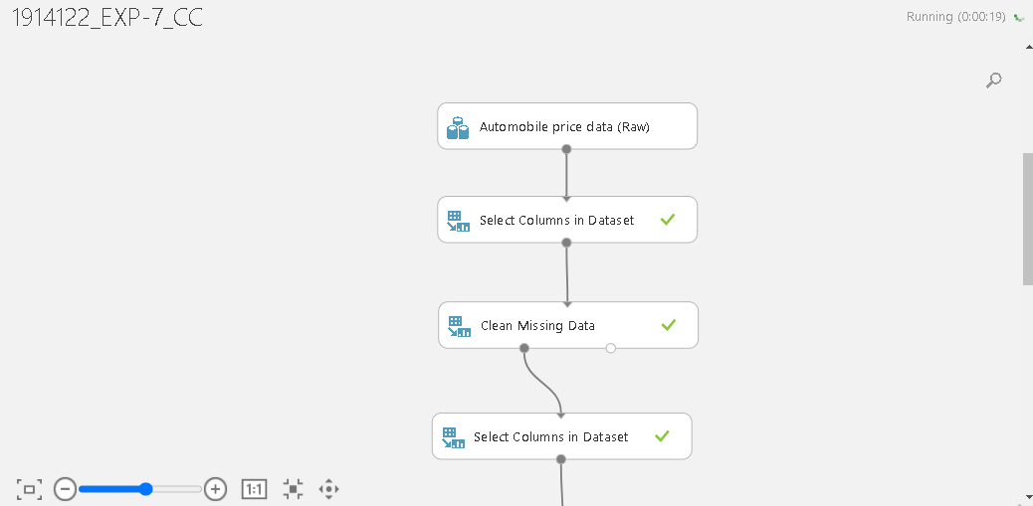

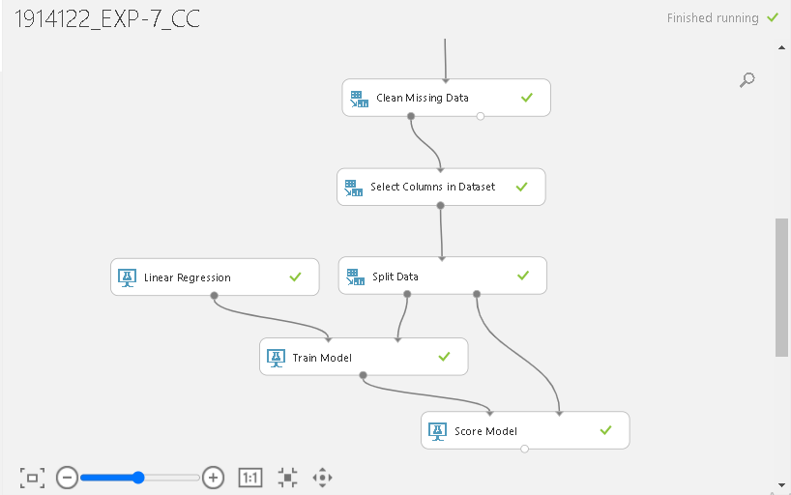

**Step 10: Visualize the score and the predicted score**

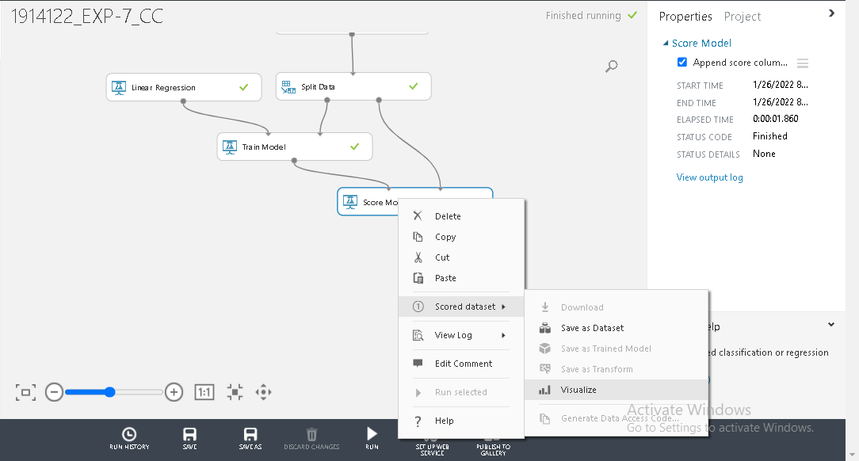

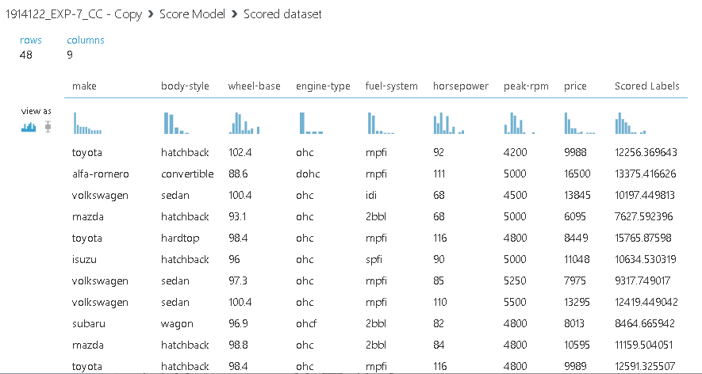

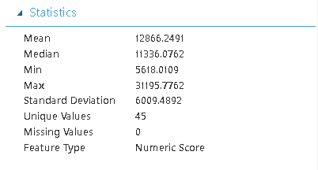

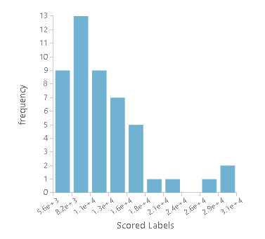

**Step 11: Evaluating the model and the quality of the result**

Finally, we test the quality of the results. Select and drag the Evaluate Model module to the experiment canvas, and connect the output of the Score Model module to the left input of Evaluate Model.

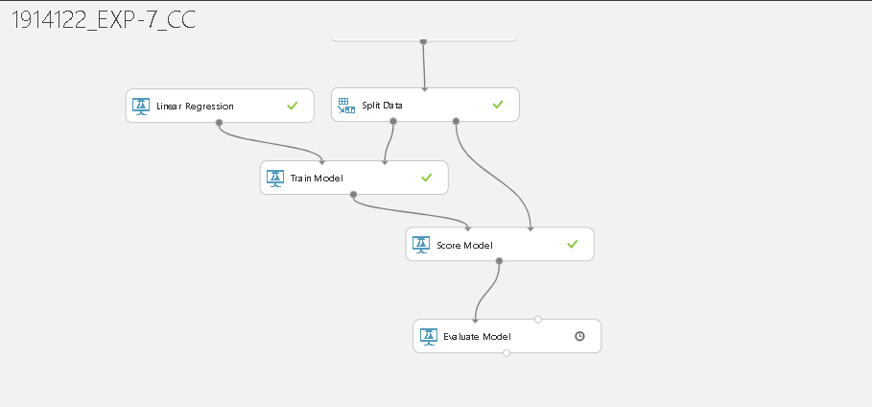

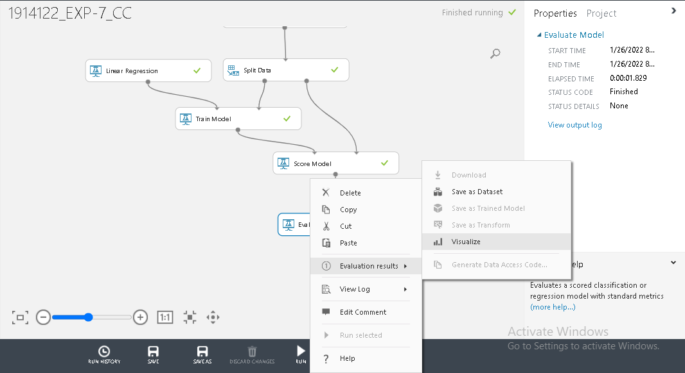

The following statistics are shown for our model:

* Mean Absolute Error (MAE): The average of absolute errors (an *error* is the difference between the predicted value and the actual value).
* Root Mean Squared Error (RMSE): The square root of the average of squared errors of predictions made on the test dataset.
* Relative Absolute Error: The average of absolute errors relative to the absolute difference between actual values and the average of all actual values.
* Relative Squared Error: The average of squared errors relative to the squared difference between the actual values and the average of all actual values.
* Coefficient of Determination: Also known as the R squared value, this is a statistical metric indicating how well a model fits the data.

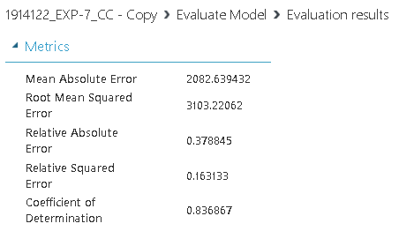

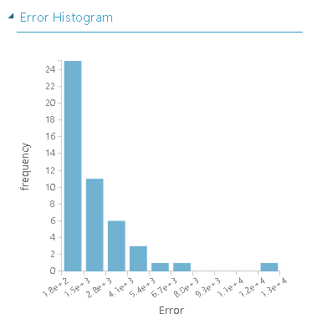

**Using the Custom Python Script**

We’ve used the custom python scipt to predict the Cost per horsepower as a regression model

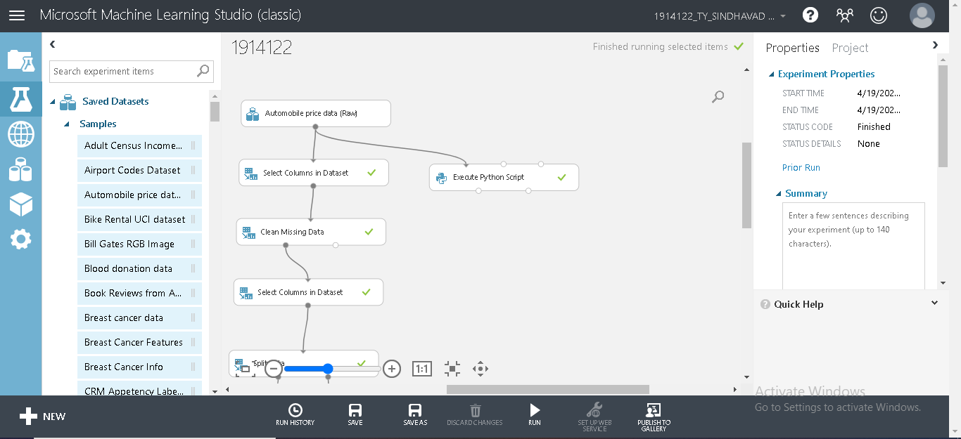

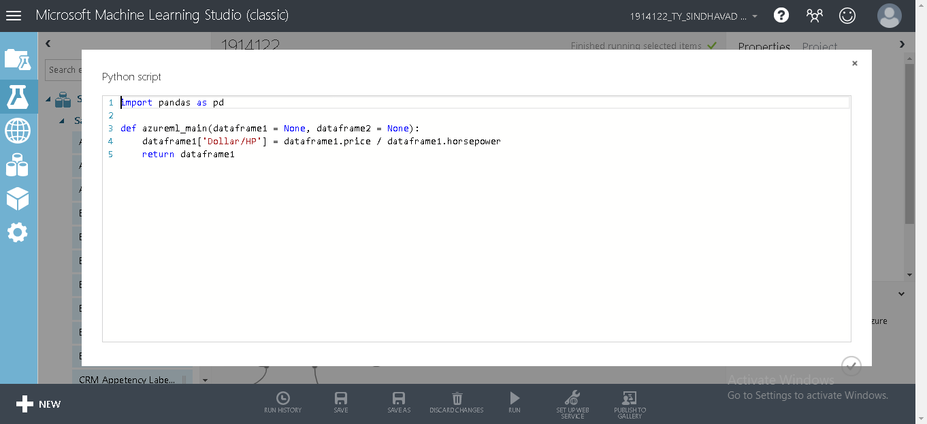

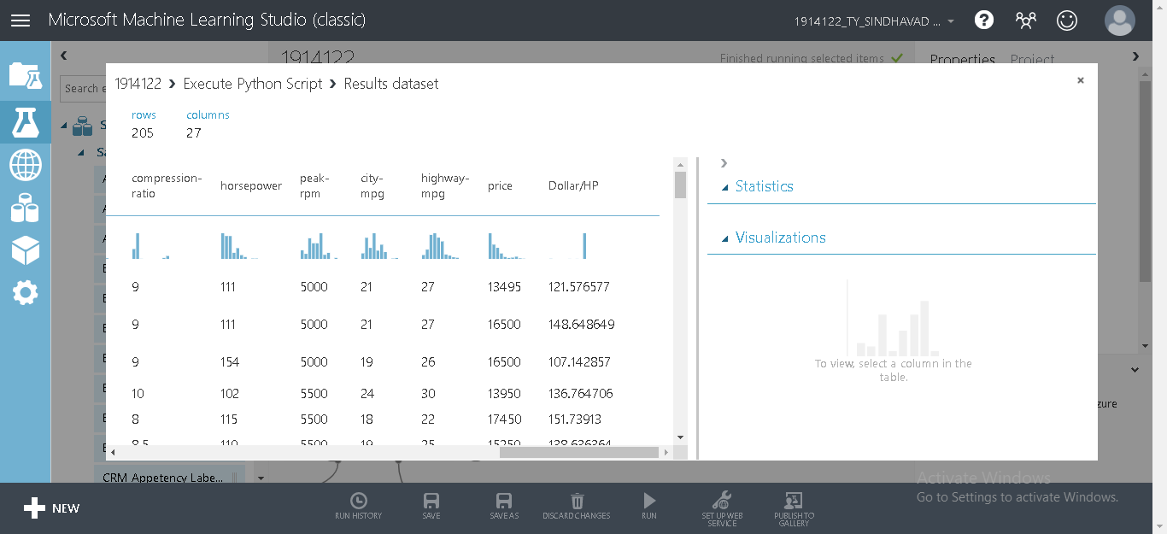

**Questions:**

1. **Differentiate between linear and nonlinear regression**

**Ans.**

**Linear regression:**

Linear regression always uses a linear equation, Y = a +bx, where x is the explanatory variable and Y is the dependent variable. In multiple linear regression, multiple equations are added together but the parameters are still linear.

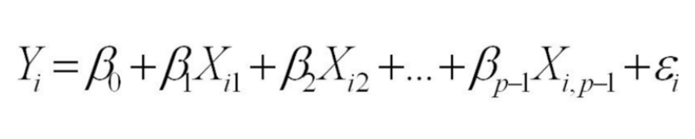

Following is the example of Linear Regression:

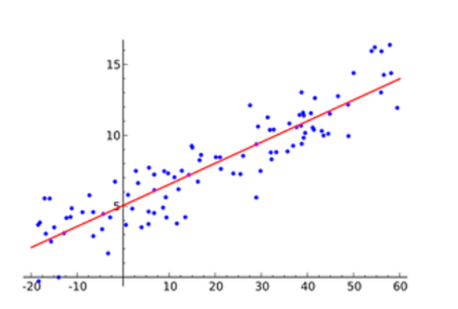

**Non Linear regression:**

If the model equation does not follow the Y = a +bx form then the relationship between the dependent and independent variables will not be linear. There are many different forms of non-linear models. A random forest regression is considered a non-linear model. Random forest models are ensemble learning methods for regression which grow a forest of regression trees and then average the outcomes. This cannot be expressed as an equation. In regression trees, the splitting decision is based on minimizing the Residual Sum of Squares (RSS). The variable which has the greatest possible reduction in RSS is chosen as the root node. The tree splitting takes a top-down greedy approach, meaning the algorithm makes the best split at the current step rather than saving a split for better results on future nodes.

Following is the example of Nonlinear regression:

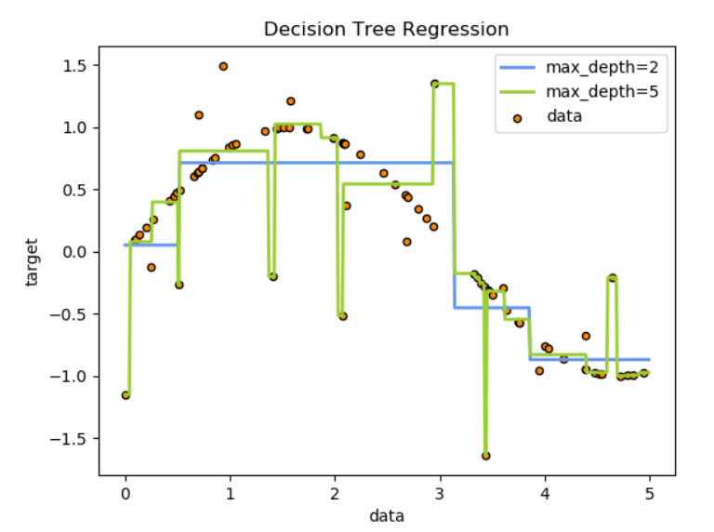

1. **Write a note on converting non-linear model into linear model.**

**Ans.**

Non-linear regression is a functional relationship that does not produce a straight-line in the scattered plot. Some non-linear curves can be transformed into linear regression. Following are the steps to convert a non-linear model to a linear model:

1. Firstly, you plot your data into scattered plot (XY type graph)
2. Examine if there is any non-linear relationship on the scattered plot
3. Guess the model that relate X and Y and transform the model into linear model
4. Compute the parameters and statistical fitness of the model
5. Transform back the parameter to non-linear model.
6. Generally, a logarithmic model is used to convert non linear model to a linear one.

**Outcomes:**

**CO2:** Apply concepts of different types of Learning and Neural Network

**Conclusion: (Conclusion to be based on the objectives and outcomes achieved)**

In this experiment we learnt about Azure ML Studio and how to create machine learning models using Multiple regression it. Azure ML Studio is a tool as it let us create complicated ML models without writing a single line of code. We implemented a Multiple linear regression model for automobile dataset which helped us predict price of the automobiles given a set of multiple features form which the price is derived.

**Github Link**: <https://github.com/Adityasindhavad>

**Github Link**: <https://github.com/Adityasindhavad/ML_Exp7.git>

**Grade: AA / AB / BB / BC / CC / CD /DD**

KJSCE/IT/LY-B.Tech/SEM-VII/ML/2022-23

**Signature of faculty in-charge with date**

**References:**

**Books/ Journals/ Websites:**

1. <https://blog.minitab.com/en/adventures-in-statistics-2/what-is-the-difference-between-linear-and-nonlinear-equations-in-regression-analysis>
2. <https://jenmckaig.medium.com/what-is-the-difference-between-linear-regression-and-non-linear-regression-e3b5981fcdc0>
3. <https://statisticsbyjim.com/regression/difference-between-linear-nonlinear-regression-models/>