***“Find My Scholarship”***

**A Project Report Submitted to**

**Rajiv Gandhi Proudyogiki Vishwavidyalaya**



**Towards Partial Fulfillment for the Award of**

**Bachelor of Engineering in *Computer Science & Engineering***

***Acropolis Institute of Technology & Research, Indore***

**Jan – June 2022**

***Submitted by:***

***Guided by:***

**Aanchal Patel (0827CS201002)**

**Aditi Rathore (0827CS201013)**

**Aditya K. Soni (0827CS201014)**

**Prof. Priyanka Jangde  
Prof. Nanrendra Pal Singh Associate Professor  
Computer Science & Engineering**

**I**

EXAMINER APPROVAL

The Project entitled ***“Find My Scholarship”***submitted by **Aanchal Patel (0827CS201002), Aditi Rathore (0827CS201013),Aditya K. Soni (0827CS201014)** has been examined and is hereby approved towards partial fulfillment for the award of Bachelor of Engineering degree in Computer Science & Engineeringdiscipline, for which it has beensubmitted. It understood that by this approval the undersigned do not necessarily endorse or approve any statement made, opinion expressed or conclusion drawn therein, but approve the project only for the purpose for which it has been submitted.

**(Internal Examiner)** **(External Examiner)**

**Date:** **Date:**

**II**

GUIDE RECOMMENDATION

This is to certify that the work embodied in this project entitled **“*Find My Scholarship*”** submitted by **Aanchal Patel (0827CS201002), Aditi Rathore (0827CS201013),Aditya K. Soni (0827CS201014)**  is a satisfactory account of the bonafide work done under the supervision of **Prof. Priyanka Jangde and Prof. Narendra Pal Singh** are recommended towards partial fulfillment for the award of the Bachelor of Engineering (Computer Science & Engineering) degree by Rajiv Gandhi Proudyogiki Vishwavidhyalaya, Bhopal.

**(Project Guide)** **(Project Coordinator)**

**III**

STUDENTS UNDERTAKING

This is to certify that project entitled **“Find My Scholarship”** has been developed by us under the supervision of Prof. Priyanka Jangde and Prof. Narendra Pal Singh Rathore. The whole responsibility of work done in this project is ours. The sole intention of this work is only for practical learning and research.

We further declare that to the best of our knowledge, this report does not contain any part of any work which has been submitted for the award of any degree either in this University or in any other University / Deemed University without proper citation and if the same work is found then we are liable for explanation to this.

**Aanchal Patel (0827CS201002)**

**Aditi Rathore (0827CS201013)**

**Aditya K. Soni (0827CS201014)**

**IV**

Acknowledgement



We thank the almighty Lord for giving me the strength and courage to sail out through the tough and reach on shore safely.

There are a number of people without whom this projects work would not have been feasible. Their high academic standards and personal integrity provided me with continuous guidance and support.

We owe a debt of sincere gratitude, deep sense of reverence and respect to our guide and mentors **Prof. Priyanka Jangde and Prof. Narendra Pal Singh Rathore**, AssociateProfessor, AITR, for their motivation, sagacious guidance, constant encouragement, vigilant supervision and valuable critical appreciation throughout this project work, which helped us to successfully complete the project on time.

We express profound gratitude and heartfelt thanks to **Dr Kamal** **Kumar Sethi**, HOD CSE, AITR Indore for his support, suggestion andinspiration for carrying out this project. I am very much thankful to other faculty and staff members of CSE Dept, AITR Indore for providing me all support, help and advice during the project. We would be failing in our duty if we do not acknowledge the support and guidance received from **Dr S C** **Sharma**, Director, AITR, Indore whenever needed. We take the opportunity toconvey my regards to the management of Acropolis Institute, Indore for extending academic and administrative support and providing me all necessary facilities for the project to achieve our objectives.

We are grateful to **our parents** and **family members** who have always loved and supported us unconditionally. To all of them, we want to say, “Thank you”, for being the best family that one could ever have and without whom none of this would have been possible

**Aanchal Patel (0827CS201002), Aditi Rathore (0827CS201013),Aditya K. Soni (0827CS201014)**

**V**

Executive Summary



***FIND MY SCHOLARSHIP***

This project is submitted to Rajiv Gandhi Proudyogiki Vishwavidhyalaya, Bhopal(MP), India for partial fulfillment of Bachelor of Engineering in Computer Science & Engineering branch under the sagacious guidance and vigilant supervision of ***Prof. Priyanka Jangde and Prof. Narendra Pl Singh Rathore***.

This project is developed for scholarship awareness amongst the students. Though via media systems are very popular, the majority of students are not aware of various schemes of scholarships applicable to them. To have a general awareness it will be more convenient if each and every educational institution/site uses and enquiries this site by taking active participation in the implementation of various scholarships schemes under their supervision. Institutions once can very well sort out eligible students for various types of scholarships. It will be an inducement to improve the quality of study and thereby attain high standards.

**VI**

*“Scholarship can find*

*little to say*

*about the obvious” -*

*Mason Cooley*

**VII**

Table of Contents



| **Chapter 1** | **Introduction** | **1** |
| --- | --- | --- |
|  | 1.1 Overview | 1 |
|  | 1.2 Background and Motivation | 1 |
|  | 1.3 Problem Statement and Objective | 2 |
|  | 1.4 Scope Of the Project | 2 |
|  | 1.5 Team Organization | 3 |
|  | 1.6 Report Structure | 4 |
| **Chapter 2** | **Review Of Literature** | **5** |
|  | 2.1 Preliminary Investigation | 5 |
|  | 2.1.1 current System | 5 |
|  | 2.2 Limitation of Current System | 5 |
|  | 2.3 Requirement Identification and analysis for Project | 5 |
|  | 2.4 Conclusion | 9 |
| **Chapter 3** | **Proposed system** | **10** |
|  | 3.1 The proposal | 10 |
|  | 3.2 Benefits of the proposed system | 10 |
|  | 3.3 Feasibility study | 11 |
|  | 3.4 Entity relationship diagram | 12 |
|  | 3.5 Use Case diagram | 13 |
|  | 3.6 software Architecture | 14 |
| **Chapter 4** | **Implementation** | **15** |
|  | 4.1 Design Methodology  4.1.1 Input Design  4.1.2 Output Design  4.1.3 Code Design  4.1.4 Database Design | 15  15  16  17  17 |
|  | 4.2 Screenshots | 18 |
|  | 4.3 Testing | 20 |
|  | 4.4 Strategy used | 20 |
| **Chapter 5** | **Conclusion** | **21** |
|  | 5.1 Conclusion | 21 |
|  | 5.2 Suggestion and Recommendations for Future Work | 21 |
| **Bibliography** |  | **22** |
| **Source Code** |  | **22** |

|  |  |
| --- | --- |

**Chapter 1 .Introduction**

Introduction



This project is developed for scholarship departments of a group of colleges. Though via media systems are very popular, the majority of students are not aware of various schemes of scholarships applicable to them. To have a general awareness it will be more convenient if each and every educational institution takes active participation in the implementation of various scholarships schemes under their supervision. At the time of giving application the scholarship officer can add data with regards to the student's parent's income, caste, merit etc concerned with scholarships. Institutions once can very well sort out eligible students for various types of scholarships. The campus information system here developing will help to get up-to-date information of a student regarding his both academic and non-academic activities. It will be an inducement to improve the quality of study and thereby attain high standards.

**1.1 Overview**

The project “Find my scholarship” is a software package developed for maintaining scholarships for different categories , checking eligibility criteria for each scholarship. The software is very helpful to find the eligible candidates from different colleges.The project finds the eligible candidates from students list on the basis of marks, caste, sports and income

Further more on implementation and through updates , the site will index the scholarships on the basis of requirement of the particular id/user.

**1.2 Background and Motivation**

Scholarship Information has always been the need of the hour , be it students pursuing their primary studies, bachelor’s degree, master degree, or for further study . There are excessive & tons and tons of scholarships that are provided under various government

schemes , government aided schemes & private institutions for the welfare of the student body entirely. But the problem arises when the person in need lacks the knowledge of the same even if the individual is eligible or meritorious he/she would not be able to gain any benefit from the scheme. To address this problem we came up with the idea of a website which will index all the major schemes of each field which will -:

* Increase the knowledge about schemes.
* Provide a more crystal clear insight on eligibility.
* It will motivate the youth to be meritorious in his/her career.

**1.3 Problem Statement and Objectives**

Our project’s objective is to automate the scholarship departments by assigning scholarship officers to every college. Students can upload various scholarship related documents.

Thus, the system implemented has the following objectives :

* Through the system we can easily maintain the data without any loss or damage.
* By using this system time consumption will be reduced.
* By using this website students can easily know about the scholarship details.
* Admin monitors a group of colleges by assigning a scholarship officer to every college.
* Scholarship Officer maintains each and every scholarship detail.
* Scholarship Officer sends mail to eligible students about the scholarship

**1.4 Scope of the Project**

The scope of the project is that it can be used by any student , or by institution to automate the scholarship departments. Anyone having access to the internet can access the application and can perform the operations.

In our application we have three modules.

1. Scholarship Information

2. Scholarship Officer

3. Student

**Scholarship Information**

This module contains all the information related to the scholarship ,like criteria of the scholarship , document required , central government scheme/ state government scheme / private institute scholarship .

Furthermore it will contain the session of application , also upon future addition it may contain features like setting up reminders of scholarships, check status of scholarship , best suited scheme applicable on the individual with caste , religion , merit criteria.

**Student**

This page stores the information about all the students like caste, marks, father annual income, mail id and address etc. This page generates username and password for every student.

**Scholarship Officer**

This module stores all the types of scholarships, and the list of all the students who have applied for scholarship. Scholarships are applied by the college on behalf of the students, which are sanctioned by the Government and trusts. Each and every student scholarship details are monitored by a scholarship officer.

**1.5 Team Organization**

**Aanchal Patel:**

I collected all the necessary information about our project and the working of counting of objects in the project. I also did the front-end as the framework and design ,surveyed various research papers and posters.Documentation is also a part of the work done by me in this project.

**Aditi Rathore:**

Along with doing preliminary investigation and understanding of the current system, I studied the topic and its scope.research papers related to the scholarship and the technology that is to be used. I also worked to find various scholarships data and the working of counting of objects in the project.

**Aditya Kumar Soni:**

I investigated and found the right technology and studied it. For the implementation of the project , I collected the object data and trained the model for it. Implementation logic for the project objective and coding of internal functionalities is also done by me. Also, worked on Back end design for storing results in the database for maintaining logs.

**1.6 Report Structure**

The project ***Find My Scholarship*** is primarily concerned with the **Scholarship Information System** and the whole project report is categorized into five chapters.

Chapter 1: Introduction- Introduces the background of the problem followed by rationale for the project undertaken. The chapter describes the objectives, scope and applications of the project. Further, the chapter gives the details of team members and their contribution in development of the project which is then subsequently ended with a report outline.

Chapter 2: Review of Literature- Explores the work done in the area of Project undertaken and discusses the limitations of the existing system and highlights the issues and challenges of the project area. The chapter finally ends up with the requirement identification for present project work based on findings drawn from reviewed literature and end user interactions.

Chapter 3: Proposed System - Starts with the project proposal based on requirement identified, followed by benefits of the project. The chapter also illustrates the software engineering paradigm used along with different design representations. The chapter also includes a block diagram and details of major modules of the project. Chapter also gives insights of different types of feasibility study carried out for the project undertaken. Later it gives details of the different deployment requirements for the developed project.

Chapter 4: Implementation - Includes the details of different Technology/ Techniques/ Tools/ Programming Languages used in developing the Project. The chapter also includes the different user interfaces designed in the project along with their functionality. Further it discusses the experiment results along with testing of the project. The chapter ends with evaluation of the project on different parameters like accuracy and efficiency.

Chapter 5: Conclusion - Concludes with objective wise analysis of results and limitation of present work which is then followed by suggestions and recommendations for further improvement

**Chapter 2 .Review of Literature**

Review of Literature



A scholarship is a form of financial aid that is specifically geared towards students who are attending college. It is used as a way of financing their education, and it may pay a part of their education, or it may pay the entire cost of a student’s tuition. In the existing system the student needs to search hundreds of websites to find the relevant information.

**2.1 Preliminary Investigation**

**2.1.1 Current System**

In the existing system we follow a manual system in which students have to fill an application form. It lacks in many ways ,firstly the website doesn't contain the information for any international scholarship.Secondly, the NSP portal provides a weak user interface .The scholarships on NSP are presented in complex form.

**2.2 Limitations of Current System**

* Timeconsuming
* For abroad studies find difficulties
* weak user interface
* complex form.

**2.3 Requirement Identification and Analysis for Project**

Significant work has been done in the field of Find MY Scholarship ; however, it is not easy to achieve desired results. The review of literature leads to draw certain major findings which are as under :

System requirements give an idea about what are the necessary things that are needed for the proposed system, which plays a very important role in the development of any system. This chapter deals with what are hardware components that are needed for the system, application, software that is required for the development of the system and the functional requirement of the system Frontend tools helps to visualize the system, while backend helps in activities which are not visible to the end user.

MODULES

This project consists of 3 modules

1. Admin

2. Scholarship Officer

3. Student

**Admin module:**

Functionalities:

* Add a Scholarship Officer.
* Set the user name and password to the Scholarship Officer.
* Block Scholarship Officer.

**Scholarship Officer:**

Functionalities:

* Adding Student details.
* Block students
* Add Scholarship details and set the criteria for scholarship.
* View all students who are fulfilling the scholarship requirement.
* Send scholarship details or alerts to the eligible students.
* Accept or Reject scholarship for students. > View feedback and send response to the students
* Set the username and password to Student.
* Update Profile.

**Student Module:**

Functionalities:

* The student details are given under this modules
* View all scholarship details and eligibility criteria.
* View scholarship status.
* Update profile
* Send feedback
* View response for feedback

**Software Requirement**

OPERATING SYSTEM : Windows

ENVIRONMENT : Visual Studio

LANGUAGE : HTML,CSS,JAVASCRIPT

LIBRARIES: BOOTSTRAP,REACT JS, NODE JS

BACKEND : SQL ,PHP

**Hardware Requirement**

PROCESSOR : Intel Pentium

RAM : 1 GB or more

MONITOR : COLOUR 720p

HARD DISK : 128Gb

KEYBOARD : STANDARD 102

KEYS MOUSE : 3 BUTTONS

**FUNCTIONAL REQUIREMENTS**

Input/output:

First Admin adds a new scholarship officer into the organization, he also blocks scholarship officers. Scholarship officer can add scholarship details, edit scholarship details, block students, and he can view and reply to students' feedback. Students can view scholarship details, upload documents, send feedback to scholarship officers and view responses.

Storage Requirements:

All the details of Scholarship Officer, student, college details and scholarship details are stored in the database and the updating of the data can be done through database (internet).

**NON-FUNCTIONAL REQUIREMENTS**

Usability:

The system is designed with completely automated process. Hence there is no or less intervention.

Reliability and Security:

The system is more reliable because of the qualities that are inherited from the chosen platform Dot net. And it provides secure access of confidential data with unique id and password.

Supportability:

The system is designed to be the cross platform supportable .The system is supported on a wide range of hardware and software platform

**2.3 Conclusion**

This paper studied about student scholarship system among authentication methods that can replace text based authentication student, and describes Pass Positions. Which is a new concept of student scholarship system implementation colleges Verify the Positions generate the student registration by taking advantage of the scholarship positions of the selection points, making it easy for sports people who cannot

**Chapter 3 .Proposed System**

Proposed System



**3.1 The Proposal**

The main objective of the proposed system is to eliminate the limitations of the existing manual system. Most of the limitations of the existing system can be overcome by the proposed system. Speed and accuracy are the main advantages of proposed system. There is no redundancy of data. Since all the details are stored in computer searching time can be reduced. The information can be more secure because the computer systems are more secure. The proposed system eliminates the drawbacks of the existing system to a great extent and it provides security of data.

**3.2 Benefits of the Proposed System**

1. The system avoids redundancy by the use of several type of validation that is the system is enhanced

2. Quick access and processing is the main advantage that forces as to implement the proposed system.

3. The main alteration between the existing system and the new automated system lies in the specialty which reduces the time consumption in an appropriate manner.

4. The system will reduce the amount of paper work require.

**3.3 Feasibility Study**

A feasibility study is an analysis of how successfully a system can be implemented, accounting for factors that affect it such as economic, technical and operational factors to determine its potential positive and negative outcomes before investing a considerable amount of time and money into it.

**ECONOMICALLY FEASIBILITY**

Since the existing system is manual on the feasibility for wrong data entry is higher and consumes a lot of time and can occur errors. But the proposed system aims at processing of information's efficiently, thus saving the time. The new system need only a system therefore the cost is negligible. Proposed system use validation check so there is no errors. Even though an initial investment has to be made on the software and the hardware aspects, the proposed system aims at processing of information's efficiently. Thus the benefits acquired out of the system are sufficient enough for the project to be undertaken.

**TECHNICAL FEASIBILITY**

Technical feasibility deals with hardware as well as software requirements and to what extend it can support the proposed system. The hardware required is a printer and software is Visual Basic 6.0 and Microsoft SQL server. If the necessary requirements are made available with the system that is a system, then the proposed system is said to be technically feasible.

**OPERATIONAL FEASIBILITY**

The proposed system offers greater of user friendliness combined with greater processing speed. Since the processing speed is very high compared with manual system on that management can take timely actions depending on information's obtained. Since the workload is also reduced the college authority convenience that the project is operationally feasible.

**3.4 Entity Relationship Diagram**

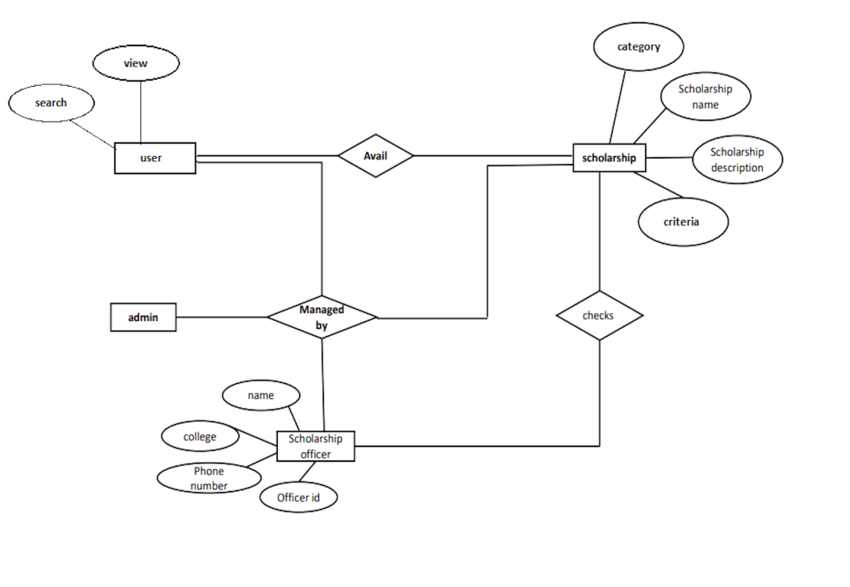

**3.5 Use Case Diagram**

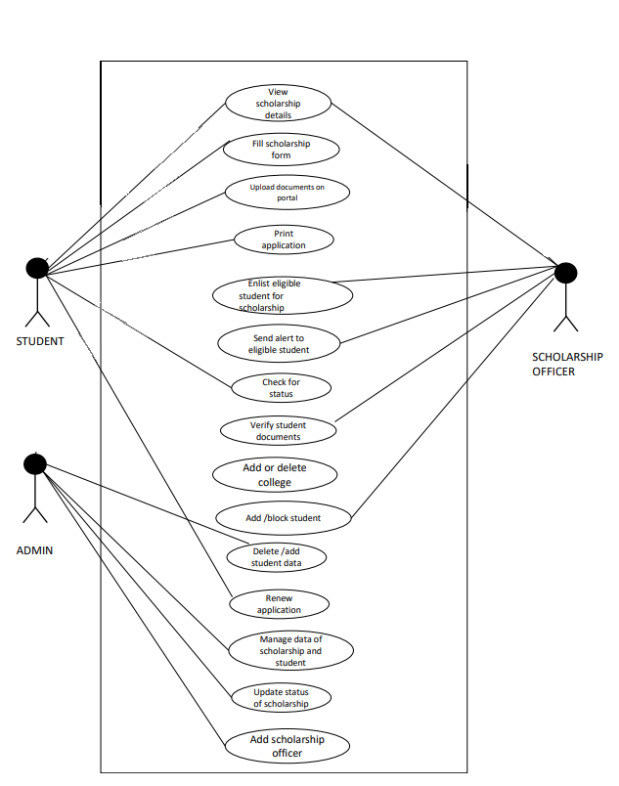

**3.8 Software Architecture**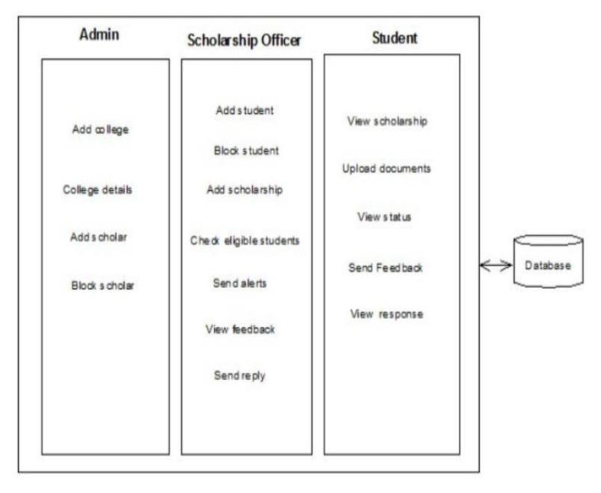

**Chapter 4 .Implementation**

Implementation



To provide flexibility to the users, the interfaces have been developed that are accessible through a browser. The GUI'S at the top level have been categorized as

1. Administrative user interface

2. The operational or generic user interface

The 'administrative user interface concentrates on the consistent information that is practically, part of the organizational activities and which needs proper authentication for the data collection. These interfaces help the administrators with all the transactional states like Data insertion, Data deletion and Data updating along with the extensive data search capabilities.

The 'operational or generic user interface helps the end users of the system in transactions through the existing data and required services. The operational user interface ako helps the ordinary users in managing their own information a customized manner as per the included flexibilities

**4.1 DESIGN METHODOLOGY**

**4.1.1 INPUT DESIGN**

In the input design, the user oriented inputs are converted into computer recognizable format. The collection of input data is the most expensive part of the system in terms of equipment used, time and number of users involved. Input design is the processes of converting user oriented inputs to a computer based format. The goal of designing input data is to make data entry as easy, logical and free from errors as possible.input design is the link between the information system and the users and the skip necessary to put transaction data in to a usable form for processing. Instructing the computer to read data from a written printed document can activate the activity of putting data into the computer for processing or it can occur by keying data directly into the system.

The design of input focusing on controlling the amount of input required, controlling the errors, avoid delay extra steps, and keeping the process simple. System analysis decides the following input design details:

* What data to input
* What medium is to use
* How the data is arranged and coded
* Data items and transaction needing validation to detect error occurs.
* Activities performed as part of input design are:
* Data recording
* Data verification
* Data conversion
* Data validation
* Data correction

**4.1.2 OUTPUT DESIGN**

Output design is a process that involves designing necessary outputs that have to be used by various users according to requirements. Designing computer should proceed in well thought out manner. The term output means any information produced by the information system whether printed or displayed. When analyst design computer output they identified the specific output that is needed to meet the requirement.

Computer is the most important source of information to the users. Efficient intelligent output design should improve the system relationship with the user and help in decision making. When designing the output, system analyst must accomplish the following:

* Determine the information to present
* Decide whether to display, print, speak the information and select the output medium
* Arrange the information acceptable format

The output design is the key to the success of any system. Output is the key between the user and the sensor. The output must be concerned to the system's working, as it should. Output design consists of displaying specification and procedures as data presentation. User is never left with the confusion as to what is happening without appropriate error and acknowledges message being received.

**4.1.3 CODE DESIGN**

The coding step is a process that transform design into programming language. It translates a detail design representation of software into a programming language realization. The code design should be done in such a way that the lines of code used in the software should be minimum for the specified design of the solution. The coding should be in modularized manner.

When code is placed in a module, one may hide it from view and give those executable statements a name (the name of the function or procedure). Information hiding is a good thing when it enhances the understanding of a program by letting it focus on a higher level of abstraction. Information hiding is a bad thing when it obscures one's understanding of a program. This usually happens when the name for the module is not chosen accurately.

In this software, the modularized approach is used. Different functions are created for different operations. The name of the module is chosen such a way that it describe what it does, ie the name gives the action performed by the module

**4.1.4 DATABASE DESIGN**

The details about the relevant data that came into lay in the system are identified according to the relationship the tables are designed by following the standard database design methods. The dative for each data in the table is defined. For optimum design of database to have better response time, to have data integrity, to avoid the redundancy and for security of the database tables created and analysed.

A database system can be defined as a representation of an information system in a computer. The general theme behind a database is to handle information as an integrated whole. A database is a collection of interrelated data stored with minimum redundancy to serve many users quickly and efficiently. The general objective is to make information access easy, quick, inexpensive and flexible for the user. In database design, several specific objectives are considered:

• Controlled redundancy

• Ease of learning and use

• Data independence

• More information at low cost

• Accuracy and integrity

• Recovery from failure

• Privacy and security • Performance

The scheme is the view that helps us the DBMS decide what data in storage it should act upon as requested by the application program. The subschema is concerned with a relatively small part of scheme. In database design, several views of data must be considered along with the persons who use them. The logical view is what the data look like, regardless of how they stored. The physical view is the way data exists in physical storage. It deals with how data are stored, accessed or related to other data in storage. The logical view are the users view the programmer's view and the overall logical view, called a schema.This project has used a main database having different tables, based on which the operations can perform well.

**4.2 Screenshot**

The Following are the screenshots of the result of the project :



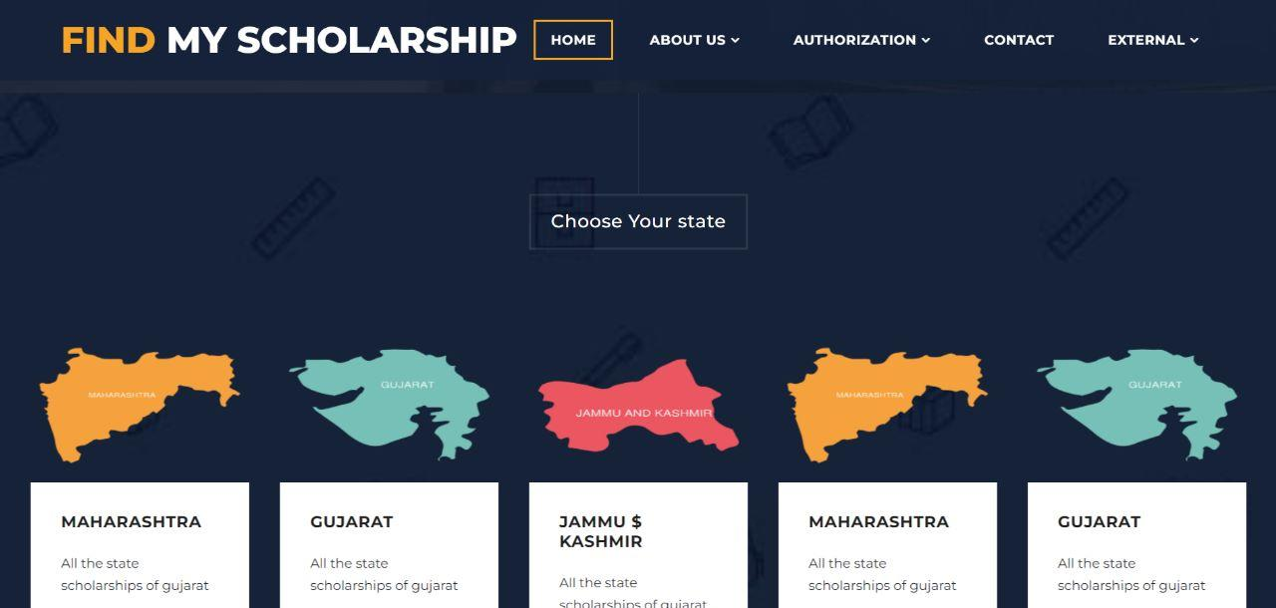

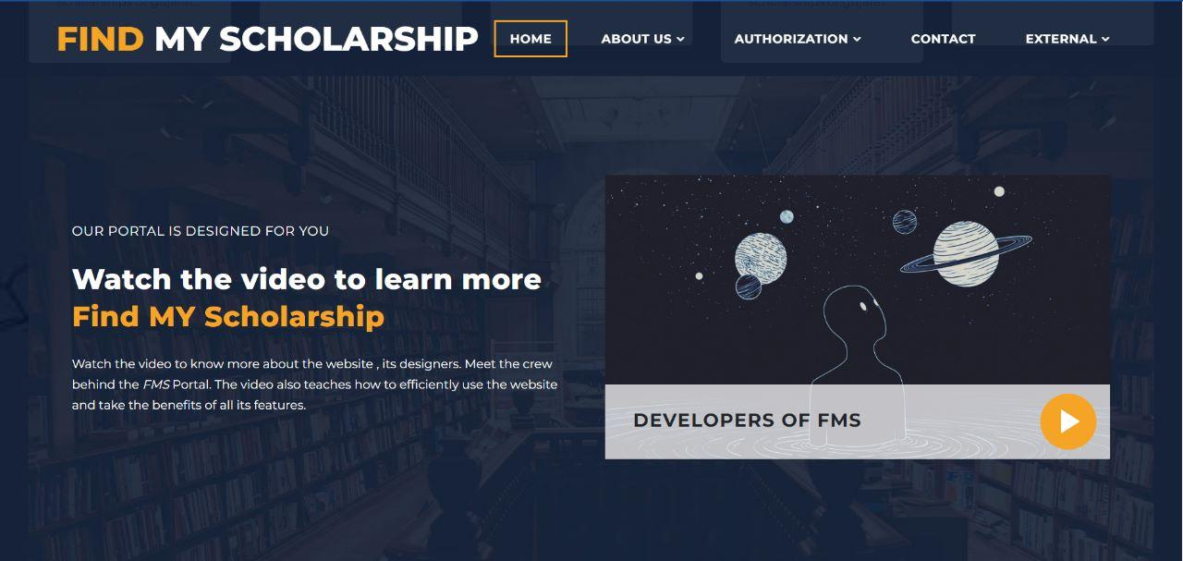

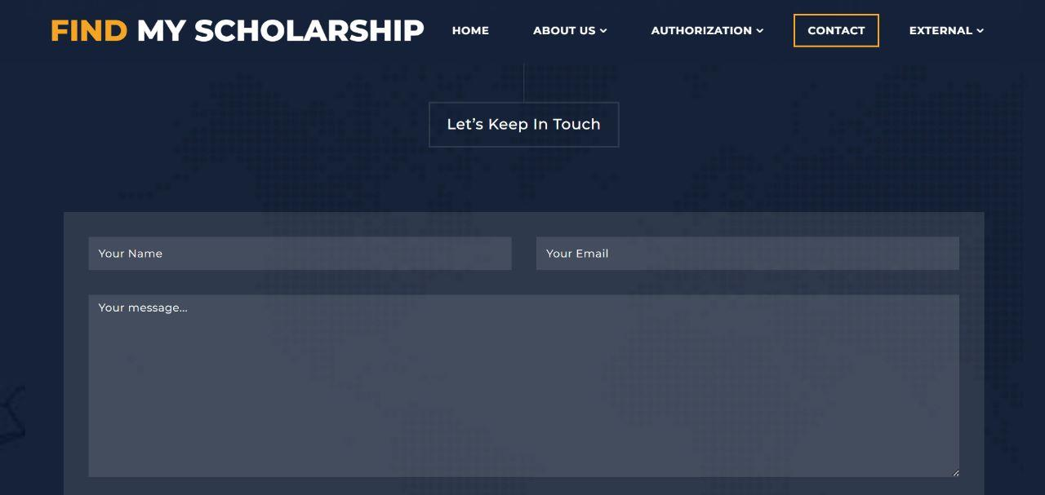

**4.3 Testing**

Software testing is a critical element of software quality assurance and represents the ultimate review of specification, design and coding. The increasing visibility of software as a system elen-ent and attendant costs associated with a software failure are motivating factors for we planned, through testing. Testing is the process of executing a program with the intent of finding an error. The design of tests for software and other engineered products can be as challenging as the initial design of the product itself.

There are basically two types of testing approaches.

One is *Black-Box testing* - the specified function that a product has been designed to perform, tests can be conducted that demon<;trate each function is fully operated.

The other is *White-Box testing* - knowing the internal workings of the product ,tests can be conducted to ensure that the internal operation of the product performs according to specifications and all internal components have been adequately exercise intermediate conditions. The test data was designed with a view to check for all the conditions and logical decisions. Error handling has been taken care of by the use of exception handlers.

**4.4 Strategy Used**

Tests can be conducted based on two approaches –

* Functionality testing
* Implementation testing

The texting method used here is Black Box Testing. It is carried out to test functionality of the program. It is also called ‘Behavioral’ testing. The tester in this case, has a set of input values and respective desired results. On providing input, if the output matches with the desired results, the program is tested ‘ok’, and problematic otherwise.

**Chapter 5.Conclusion**

Conclusion



**5.1 Conclusion**

Apart from the other facilities it also provides ease of data entry for the user. It has been found that the new system has overcome most of the limitations of the existing system and works according to the design specification given. The developed systems dispense the problems and the meets the need by providing reliable and comprehensive information. All the requirements projected by the user have been met by the system. The newly developed system consumes less processing time and all the details are updated and processed immediately. Since the screen provides real time help messages and is very user friendly, any user can get familiarized.

**5.2 Suggestion and Recommendations for Future Work**

Every application has its own merits and demerits. The project has covered almost all the requirements. Further requirements and improvements can easily be done since the coding is mainly structured or modular in nature. Changing the existing modules or adding new modules can append improvements. Further enhancements can be made to the application, so that the web site functions very attractive and useful manner than the present one.

**Bibliography**

Textbook References:

XML - XML complete reference by Aaron Skonnard & Martin Gudgin

HTML - Steven Holzner AJAX - JavaScript and Ajax for the web, Sixth

Edition(Visual Quick Start Guide)

Modern Web Design Using JavaScript and DOM by Stuart Landgridge

Websites:

www.google.com

www.asp.net

www.ajaxprojects.com

www.w3schools.com

www.programmingtutorials.com

www.youtube.com

**Source Code**

**Index**

<!DOCTYPE html>

<html lang="en">

  <head>

    <meta charset="utf-8">

    <meta name="viewport" content="width=device-width, initial-scale=1, shrink-to-fit=no">

    <meta name="description" content="">

    <meta name="author" content="">

    <link href="https://fonts.googleapis.com/css?family=Montserrat:100,200,300,400,500,600,700,800,900" rel="stylesheet">

    <title>FMS</title>

    <!-- Bootstrap core CSS -->

    <link href="vendor/bootstrap/css/bootstrap.min.css" rel="stylesheet">

    <!-- Additional CSS Files -->

    <link rel="stylesheet" href="assets/css/fontawesome.css">

    <link rel="stylesheet" href="assets/css/main.css">

    <link rel="stylesheet" href="assets/css/owl.css">

    <link rel="stylesheet" href="assets/css/lightbox.css">

  </head>

<body>

  <!--header-->

  <header class="main-header clearfix" role="header">

    <div class="logo">

      <a href="#"><em>FIND</em> MY SCHOLARSHIP</a>

    </div>

    <a href="#menu" class="menu-link"><i class="fa fa-bars"></i></a>

    <nav id="menu" class="main-nav" role="navigation">

      <ul class="main-menu">

        <li><a href="#section1">Home</a></li>

        <li class="has-submenu"><a href="#section2">About Us</a>

<ul class="sub-menu">

            <li><a href="#section2">Who we are?</a></li>

            <li><a href="#section3">What we do?</a></li>

            <li><a href="#section5">How it works?</a></li>

          </ul>

        </li>

        <li class="has-submenu"><a href="#">Authorization</a>

        <ul class="sub-menu">

          <li><a class="external" href="login/login.html">Login</a></li>

          <li><a class="external"href="signup/signup.html">Signup</a></li>

        </ul>

      </li>

        <li><a href="#section6">Contact</a></li>

        <li class="has-submenu"><a href="#section2">External</a>

          <ul class="sub-menu">

            <li><a class="external" href="https://scholarships.gov.in/">NSP</a></li>

            <li><a class="external" href="http://scholarshipportal.mp.nic.in/Index.aspx">M.P portal</a></li>

            <li><a class="external" href="https://postmatric-scholarship.cg.nic.in/">C.G portal</a></li>

          </ul>

        </li>

      </ul>

    </nav>

  </header>

  <!-- ***** Main Banner Area Start ***** -->

  <section class="section main-banner" id="top" data-section="section1">

      <video autoplay muted loop id="bg-video">

          <source src="assets/images/course-video.mp4" type="video/mp4" />

      </video>

      <div class="video-overlay header-text">

          <div class="caption">

              <h6>Find <em>MY</em> scholarship</h6>

              <h2><em>Your</em> one <em>stop</em> portal</h2>

              <div class="main-button">

                  <div class="scroll-to-section"><a href="#section2">Discover more</a></div>

              </div>

          </div>

      </div>

  </section>

  <!-- ***** Main Banner Area End ***** -->

  <section class="features">

    <div class="container">

      <div class="row">

        <div class="col-lg-4 col-12">

          <div class="features-post">

            <div class="features-content">

              <div class="content-show">

                <h4><i class="fa fa-pencil"></i>National & International</h4>

              </div>

              <div class="content-hide">

                <p>All types of scholarship for a undergraduate , graduate

                  and further more.

                  Regularly collected & updated data.

                </p>

                <div class="scroll-to-section"><a class="external" href="tables/national.php">More Info.</a></div>

            </div>

            </div>

          </div>

        </div>

        <div class="col-lg-4 col-12">

          <div class="features-post second-features">

            <div class="features-content">

              <div class="content-show">

                <h4><i class="fa fa-graduation-cap"></i>Central </h4>

              </div>

              <div class="content-hide">

                <p>Central and state goverment Schemes </p>

                <div class="scroll-to-section"><a class="external" href="tables/Central.php">Details</a></div>

            </div>

            </div>

          </div>

        </div>

        <div class="col-lg-4 col-12">

          <div class="features-post third-features">

            <div class="features-content">

              <div class="content-show">

                <h4><i class="fa fa-book"></i>state</h4>

              </div>

              <div class="content-hide">

                <p>international scholarship collections

                </p>

                <div class="scroll-to-section"><a class="external" href="tables/state.php">Read More</a></div>

            </div>

            </div>

          </div>

        </div>

      </div>

    </div>

  </section>

  <section class="section coming-soon" data-section="section3">

    <div class="container">

      <div class="row">

        <div class="col-md-7 col-xs-12">

          <div class="continer centerIt">

            <div>

              <h4>Register now and become<em> an FMS </em>member </h4>

            </div>

          </div>

        </div>

        <div class="col-md-12">

          <div class="right-content">

            <div class="top-content">

              <h6>Register your free account and <em>get immediate</em> access to benefits</h6>

            </div>

            <form id="contact" action="signup/signup.php" method="post">

              <div class="row">

                <div class="col-md-12">

                  <fieldset>

                    <input name="name" type="text" class="form-control" id="name" placeholder="Your Name" required="">

                  </fieldset>

                </div>

                <div class="col-md-12">

                  <fieldset>

                    <input name="user_name" type="text" class="form-control" id="email" placeholder="Your Email" required="">

                  </fieldset>

                </div>

                <div class="col-md-12">

                  <fieldset>

                    <input name="phone" type="text" class="form-control" id="phone-number" placeholder="Your Phone Number" required="">

                  </fieldset>

                </div>

                <div class="col-md-12">

                  <fieldset>

                    <input name="password" type="password" class="form-control" id="password" placeholder="Your Password" required="">

                  </fieldset>

                </div>

                <div class="col-md-12">

                  <fieldset>

                    <button type="submit" id="form-submit" value="submit" class="button">Get it now</button>

                  </fieldset>

                </div>

              </div>

            </form>

          </div>

        </div>

      </div>

    </div>

  </section>

  <section class="section courses" data-section="section4">

    <div class="container-fluid">

      <div class="row">

        <div class="col-md-12">

          <div class="section-heading">

            <h2>Choose Your state</h2>

          </div>

        </div>

        <div class="owl-carousel owl-theme">

          <!-- <div class="item">

            <img src="assets/images/mp.png" alt="Course #1">

            <div class="down-content">

              <h4>Madhya Pradesh</h4>

              <p>All the state scholarships of madhya pradesh</p>

            </div>

          </div> -->

          <div class="item">

            <img src="assets/images/gujarat.png" alt="Course #2">

            <div class="down-content">

              <h4>Gujarat</h4>

              <p>All the state scholarships of gujarat</p>

            </div>

          </div>

          <div class="item">

            <img src="assets/images/j&k.png"  alt="Course #3">

            <div class="down-content">

              <h4>Jammu $ Kashmir</h4>

              <p>All the state scholarships of gujarat.</p>

            </div>

          </div>

          <div class="item">

            <img src="assets/images/maharshtra.png" alt="Course #4">

            <div class="down-content">

              <h4>Maharashtra</h4>

              <p>All the state scholarships of gujarat</p>

              <div class="author-image">

              </div>

            </div>

          </div>

         </div>

         </div>

      </div>

  <section class="section video" data-section="section5">

    <div class="container">

      <div class="row">

        <div class="col-md-6 align-self-center">

          <div class="left-content">

            <span>Our portal is designed for you</span>

            <h4>Watch the video to learn more <em>Find MY Scholarship</em></h4>

            <p>Watch the video to know more about the website , its designers.

              Meet the crew behind the <em>FMS</em> Portal.

              The video also teaches how to efficiently use the website and take the benefits of all its features.

            </p>

          </div>

        </div>

        <div class="col-md-6">

          <article class="video-item">

            <div class="video-caption">

              <h4>Developers of FMS</h4>

            </div>

            <figure>

              <a href="https://www.youtube.com/watch?v=r9LtOG6pNUw" class="play"><img src="assets/images/main-thumb.jpg"></a>

            </figure>

          </article>

        </div>

      </div>

    </div>

  </section>

  <section class="section contact" data-section="section6">

    <div class="container">

      <div class="row">

        <div class="col-md-12">

          <div class="section-heading">

            <h2>Let’s Keep In Touch</h2>

          </div>

        </div>

        <div class="col-md-12"  >

          <form id="contact" action="queryform/form.php" method="post">

            <div class="row">

              <div class="col-md-6">

                  <fieldset>

                    <input name="name" type="text" class="form-control" id="name" placeholder="Your Name" required="">

                  </fieldset>

                </div>

                <div class="col-md-6">

                  <fieldset>

                    <input name="email" type="text" class="form-control" id="email" placeholder="Your Email" required="">

                  </fieldset>

                </div>

              <div class="col-md-12">

                <fieldset>

                  <textarea name="message" rows="6" class="form-control" id="message" placeholder="Your message..." required=""></textarea>

                </fieldset>

              </div>

              <div class="col-md-12">

                <fieldset>

                  <button type="submit" id="form-submit" class="button">Send Message Now</button>

                </fieldset>

              </div>

            </div>

          </form>

        </div>

      </div>

    </div>

  </section>

  <footer>

    <div class="container">

      <div class="row">

        <div class="col-md-12">

          <p><i class="fa fa-copyright"></i> Copyright 2022 by AKS </p>

        </div>

      </div>

    </div>

  </footer>

  <!-- Scripts -->

  <!-- Bootstrap core JavaScript -->

    <script src="vendor/jquery/jquery.min.js"></script>

    <script src="vendor/bootstrap/js/bootstrap.bundle.min.js"></script>

    <script src="assets/js/isotope.min.js"></script>

    <script src="assets/js/owl-carousel.js"></script>

    <script src="assets/js/lightbox.js"></script>

    <script src="assets/js/tabs.js"></script>

    <script src="assets/js/video.js"></script>

    <script src="assets/js/slick-slider.js"></script>

    <script src="assets/js/custom.js"></script>

    <script>

        //according to loftblog tut

**$**('.nav li:first').**addClass**('active');

        var **showSection** = function **showSection**(section, isAnimate) {

          var

          direction = section.**replace**(/#/, ''),

          reqSection = **$**('.section').**filter**('[data-section="' + direction + '"]'),

          reqSectionPos = reqSection.**offset**().top - 0;

          if (isAnimate) {

**$**('body, html').**animate**({

              scrollTop: reqSectionPos },

            800);

          } else {

**$**('body, html').**scrollTop**(reqSectionPos);

          }

        };

        var **checkSection** = function **checkSection**() {

**$**('.section').**each**(function () {

            var

            $this = **$**(this),

            topEdge = $this.**offset**().top - 80,

            bottomEdge = topEdge + $this.**height**(),

            wScroll = **$**(window).**scrollTop**();

            if (topEdge < wScroll && bottomEdge > wScroll) {

              var

              currentId = $this.**data**('section'),

              reqLink = **$**('a').**filter**('[href*=\\#' + currentId + ']');

              reqLink.**closest**('li').**addClass**('active').

**siblings**().**removeClass**('active');

            }

          });

        };

**$**('.main-menu, .scroll-to-section').**on**('click', 'a', function (e) {

          if(**$**(e.target).**hasClass**('external')) {

            return;

          }

          e.**preventDefault**();

**$**('#menu').**removeClass**('active');

**showSection**(**$**(this).**attr**('href'), true);

        });

**$**(window).**scroll**(function () {

**checkSection**();

        });

    </script>

</body>

</html>