1. The date command (Display the system date)
- date command(lowercase).
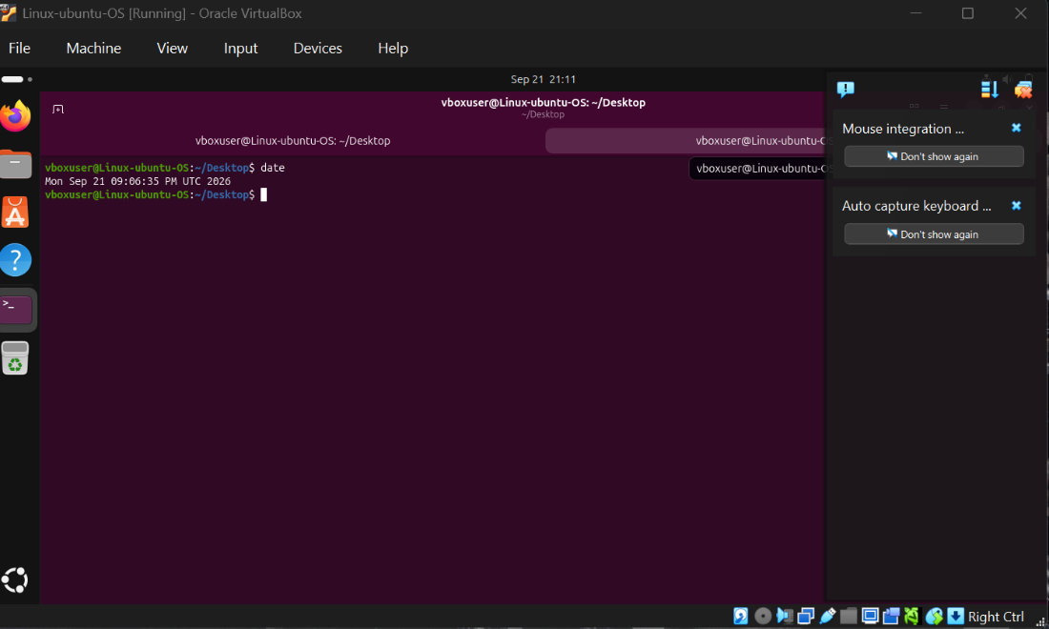
- It prints date on date command.

- Date command (with capital D).
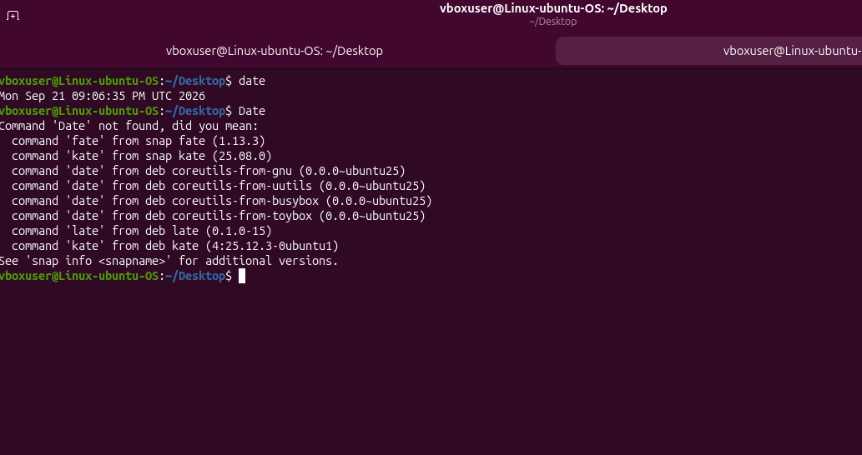
- Date command with a capital letter shows an error ‘Date not found’
- I think it is because it’s case sensitive and commands need to be lowercase.
2. The cal command (Display the system date)
- Type cal in the command line
and press Enter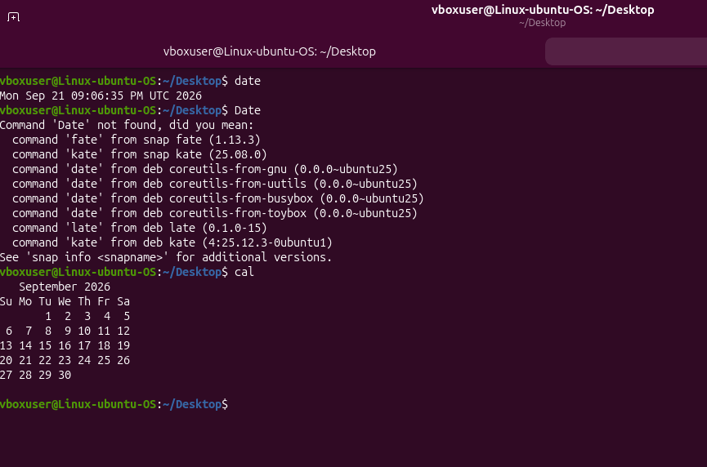
- Cal command output this months calendar.

- Type cal 7 1776
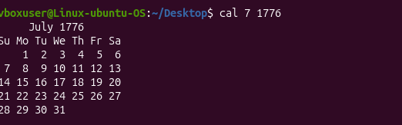
Outputs July month from 1776

- and cal -j 2009
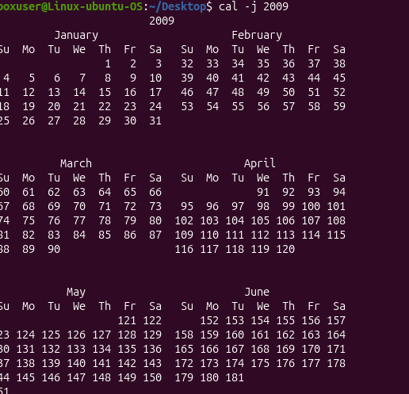
Outputs full calendar of 2009

- Try option(m,y,s)
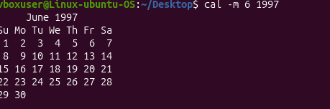
Option m prints the month.
3. The who command (Shows who is logged into the server)
- Type who in the command line and press Enter
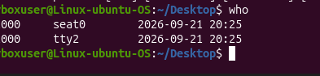
I did not understand the output given by command who.
- Options(H, u, s, q, b)
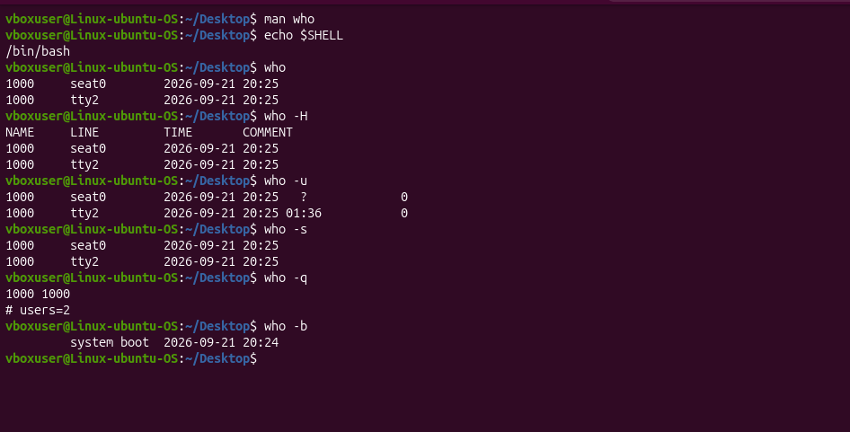
- Who am I and whoami and who are you
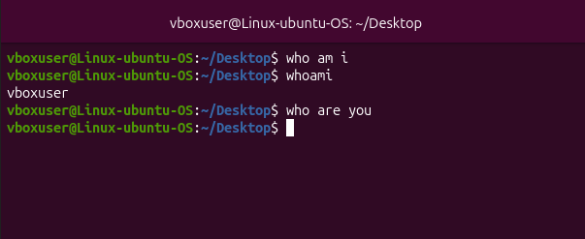
Who am I returns nothing while whoami returns the user logged in.
Did nor receive any return on who are you.

4. Clear command clears the terminal.
5. The what is command.
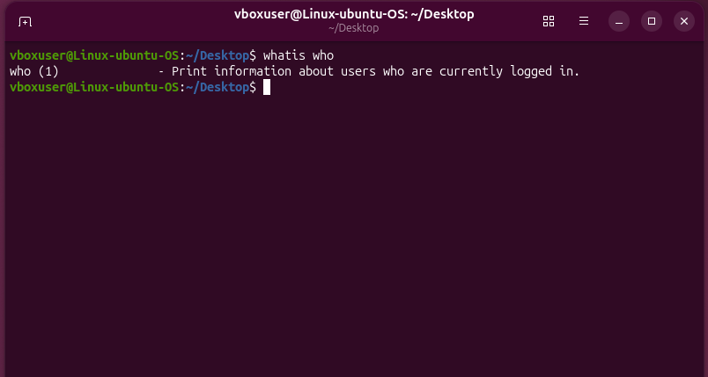
Print information about the users who are currently logged in.
6. the man command.
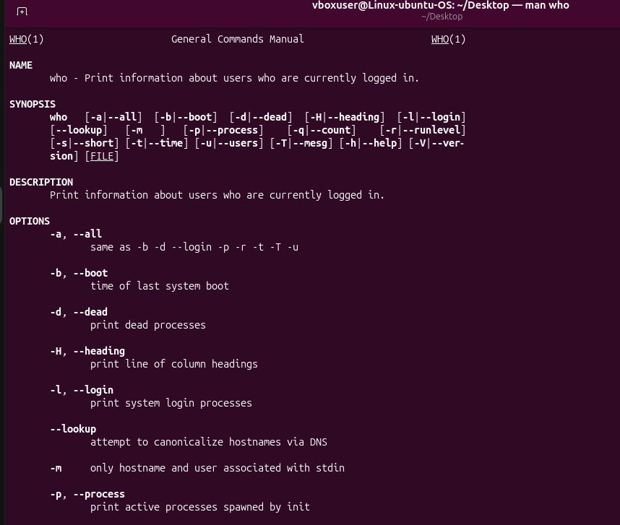
The man command prints information about the users logged in and privides a list of optional commands to choose from.
Pressing ENTER and SPACEBAR did not give any output at all.
Pressing Q cleared the terminal and exit out of the man command.
7. command echo $SHELL
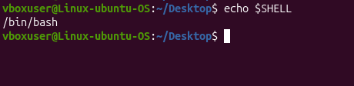
Gives /bin/bash output.
8. Execute multiple commands on one command line by using semicolon
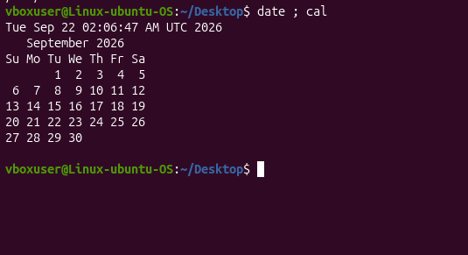
Command date ; cal executes date and calander at the same time using multiple commands in one line with the help of semicolons.
9. The EXIT command.
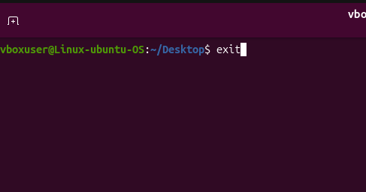
- EXIT command closes and logs out the terminal

