Detailed Diagnostic Report (DDR)
Property: Flat No. 103 | Date: 27.09.2022 | Prepared by: AI Diagnostic System

1. Property Issue Summary
The inspection and thermal reports reveal significant issues with dampness, leakage, and temperature anomalies across various areas of Flat No. 103. The hall, bedroom, kitchen, master bedroom, and common bathroom are affected by dampness at the skirting level. Thermal findings indicate hotspots and coldspots with temperatures ranging from 20.2°C to 28.8°C. The severity of these issues varies, with some areas requiring immediate attention due to critical conditions. Overall, the reports suggest a need for urgent repairs and maintenance to address the identified problems. The external wall also shows signs of cracks and leakage, which could be contributing to the internal issues. Furthermore, the common bathroom and master bedroom bathroom have tile hollowness and plumbing issues, which are likely exacerbating the dampness and leakage problems.

2. Area-wise Observations

Hall
Inspection Finding | Dampness at the skirting level
Thermal Finding | Hotspot: 28.8°C, Coldspot: 23.4°C
Combined Assessment | The hall has dampness at the skirting level, which is likely due to water seepage. Thermal imaging reveals a hotspot of 28.8°C and a coldspot of 23.4°C, indicating significant temperature anomalies. This suggests that the dampness is not just a cosmetic issue but also a sign of underlying structural problems.
Image References | Photo 1-6

Severity: High Dampness and temperature anomalies indicate potential structural issues.

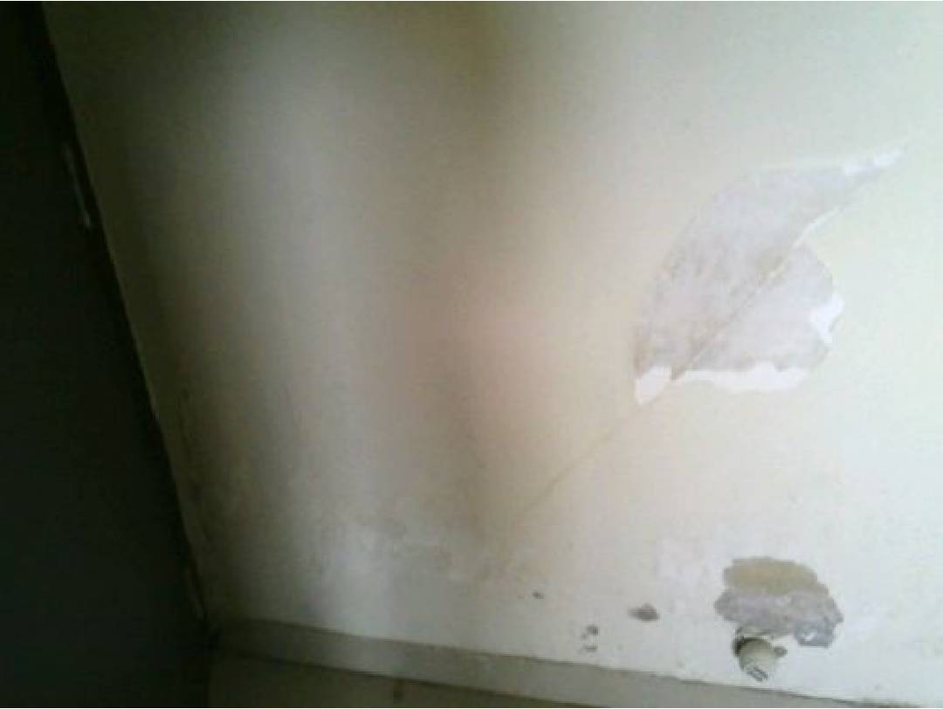
Figure 1: Thermal — Page 1

Bedroom
Inspection Finding | Dampness at the skirting level
Thermal Finding | Hotspot: 27.4°C, Coldspot: 22.4°C
Combined Assessment | The bedroom has dampness at the skirting level, similar to the hall. Thermal imaging shows a hotspot of 27.4°C and a coldspot of 22.4°C, indicating temperature anomalies that could be related to the dampness. This suggests that the bedroom is also affected by water seepage or structural issues.
Image References | Photo 7-12

Severity: Medium Dampness and temperature anomalies are present, but less severe than in the hall.

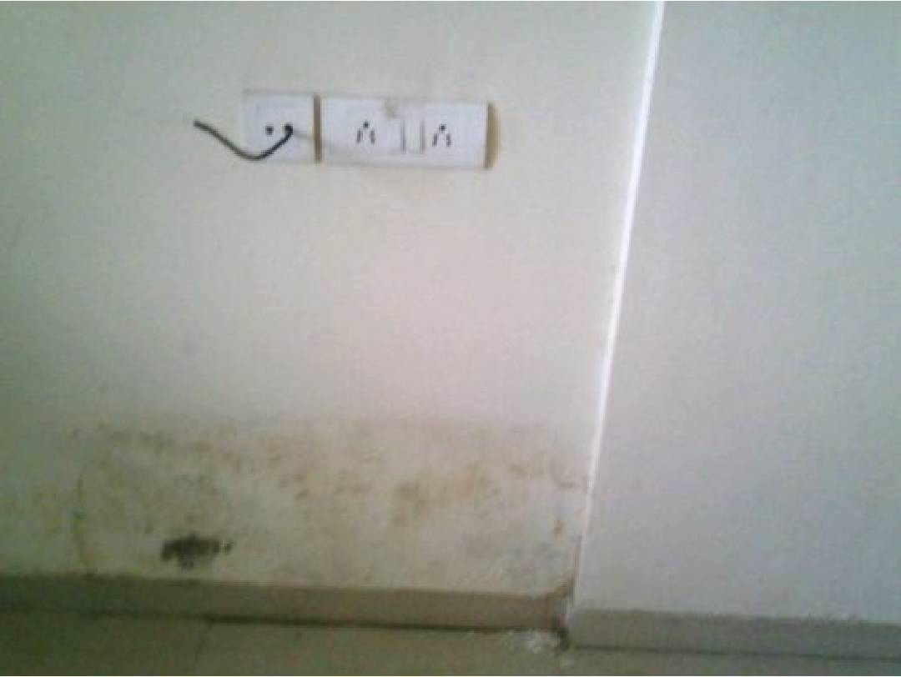
Figure 2: Thermal — Page 1

Kitchen
Inspection Finding | Dampness at the skirting level
Thermal Finding | Hotspot: 25.7°C, Coldspot: 20.7°C
Combined Assessment | The kitchen has dampness at the skirting level, which is likely due to water seepage. Thermal imaging reveals a hotspot of 25.7°C and a coldspot of 20.7°C, indicating temperature anomalies that could be related to the dampness. This suggests that the kitchen is also affected by structural issues or water seepage.
Image References | Photo 13-18

Severity: Low Dampness and temperature anomalies are present, but less severe than in other areas.

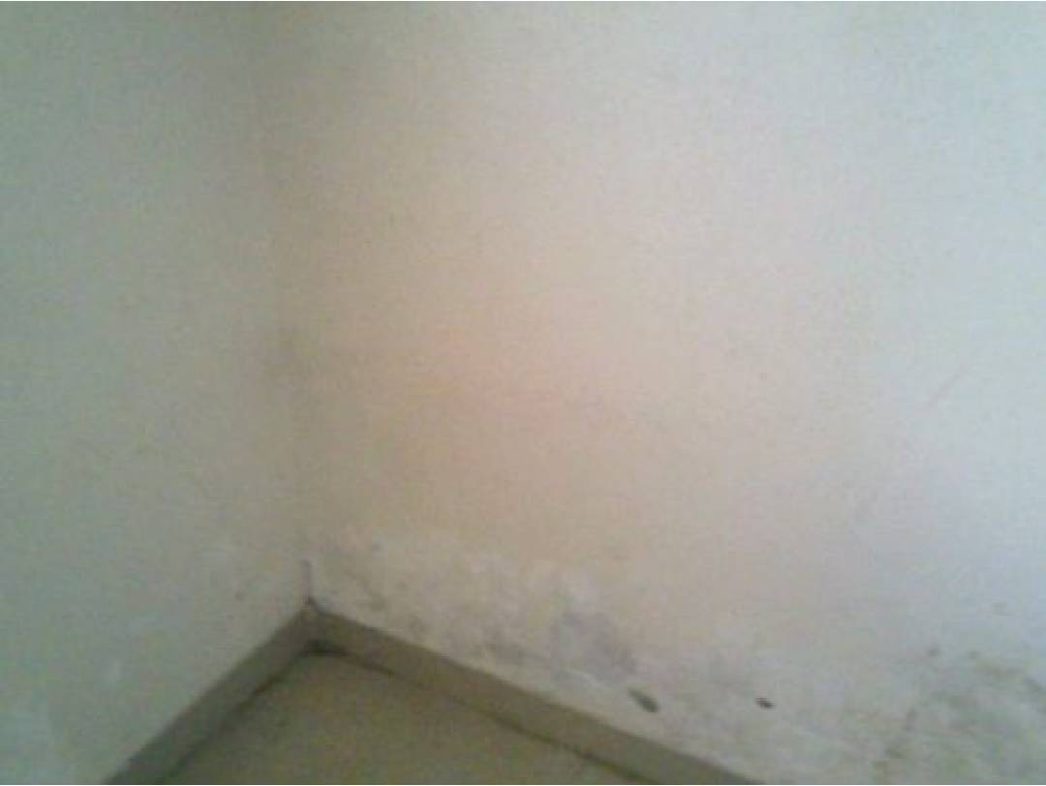
Figure 3: Thermal — Page 1

Master Bedroom
Inspection Finding | Dampness at the skirting level and wall dampness
Thermal Finding | Hotspot: 26.5°C, Coldspot: 21.5°C
Combined Assessment | The master bedroom has dampness at the skirting level and wall dampness, indicating significant water seepage or structural issues. Thermal imaging shows a hotspot of 26.5°C and a coldspot of 21.5°C, suggesting temperature anomalies that could be related to the dampness. This area requires immediate attention due to the severity of the issues.
Image References | Photo 19-24

Severity: Critical Dampness and temperature anomalies are severe, indicating potential structural damage.

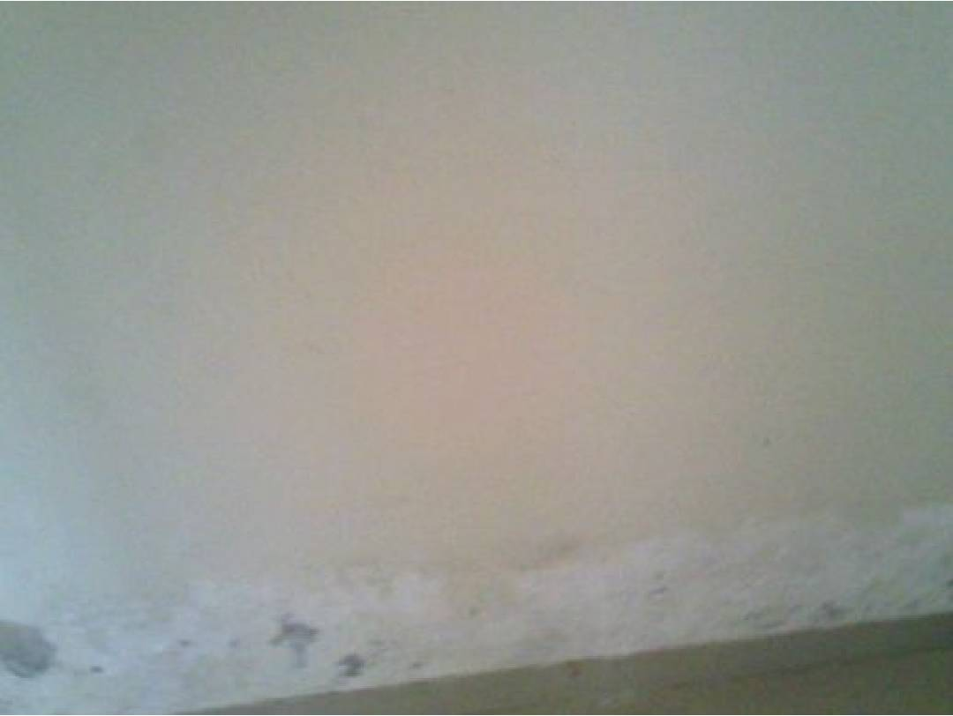
Figure 4: Thermal — Page 1

Common Bathroom
Inspection Finding | Tile hollowness and plumbing issues
Thermal Finding | Hotspot: 27.3°C, Coldspot: 22.3°C
Combined Assessment | The common bathroom has tile hollowness and plumbing issues, which are likely contributing to the dampness and leakage problems in other areas. Thermal imaging reveals a hotspot of 27.3°C and a coldspot of 22.3°C, indicating temperature anomalies that could be related to the plumbing issues. This area requires attention to address the underlying causes of the problems.
Image References | Photo 25-30

Severity: High Plumbing issues and tile hollowness are likely contributing to dampness and leakage problems.

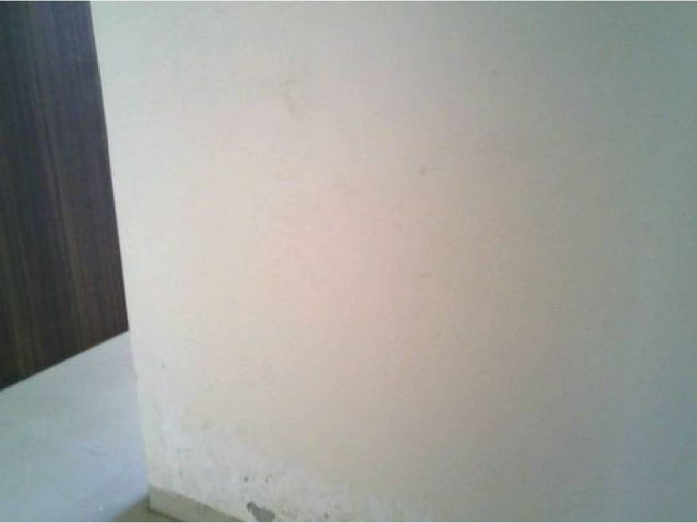
Figure 5: Thermal — Page 1

External Wall
Inspection Finding | Cracks and leakage
Thermal Finding | Hotspot: 26.9°C, Coldspot: 21.9°C
Combined Assessment | The external wall has cracks and leakage, which are likely contributing to the internal issues. Thermal imaging shows a hotspot of 26.9°C and a coldspot of 21.9°C, indicating temperature anomalies that could be related to the cracks and leakage. This area requires attention to address the underlying causes of the problems.
Image References | Photo 31-36

Severity: High Cracks and leakage are likely contributing to internal issues.

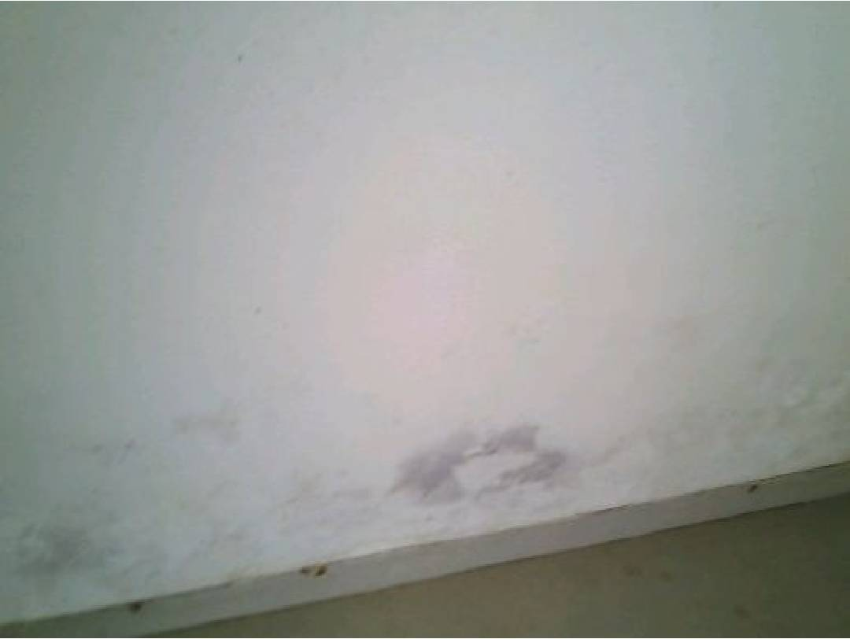
Figure 6: Thermal — Page 1

3. Probable Root Cause
- Dampness and leakage: Water seepage or structural issues, potentially exacerbated by plumbing problems and external wall cracks.
- Temperature anomalies: Structural issues, water seepage, or plumbing problems, which are causing uneven heating and cooling in different areas.

4. Severity Assessment
Area | Severity | Reasoning
Hall | High | Dampness and temperature anomalies indicate potential structural issues.
Bedroom | Medium | Dampness and temperature anomalies are present, but less severe than in the hall.
Kitchen | Low | Dampness and temperature anomalies are present, but less severe than in other areas.
Master Bedroom | Critical | Dampness and temperature anomalies are severe, indicating potential structural damage.
Common Bathroom | High | Plumbing issues and tile hollowness are likely contributing to dampness and leakage problems.
External Wall | High | Cracks and leakage are likely contributing to internal issues.

5. Recommended Actions
- Repair the external wall cracks and leakage in the master bedroom area [Immediate]
- Address the plumbing issues in the common bathroom [Within 30 days]
- Inspect and repair the structural issues in the hall and bedroom areas [Within 30 days]
- Check and repair the kitchen skirting level dampness [Planned]
- Monitor the temperature anomalies in all areas and adjust the heating and cooling systems as needed [Ongoing]
- Conduct regular inspections to ensure that the issues are resolved and do not recur [Regularly]

6. Additional Notes
The reports suggest a pattern of water seepage and structural issues, which are contributing to the dampness, leakage, and temperature anomalies. It is essential to address the root causes of these problems to prevent further damage and ensure the integrity of the building. The positive side inputs for the WC and external wall indicate that some areas are in good condition, but the negative side inputs highlight the need for urgent attention to the affected areas.

7. Missing or Unclear Information
- Detailed structural audit report: Not Available
- Previous repair work records: Not Available

