**INTRODUCTION**

The Internet of Things (IoT) industry protection system incorporating Arduino is a system created to guard against losses from incidents involving IoT.The system uses an Arduino to accomplish this. The system comprises of temperature, gas, and fire sensors interconnected to an Arduino and an LCD display. In order to capture readings and check for fire, gas leaks, or low/high temperatures, the sensor data is continuously scanned. This data is then provided online. In order to access the functions of internet, the Wi-Fi module is used. To attain the desired outcome, the IOT (internet of things) check server subsequently publishes this data online. By using GSM module if the authority persons are not available in online it will send a SMS of their mobile phone. So that they want to know about the accident. Here we have added the fault monitoring system where check & control the frequency, phase and voltage.

**Problem statement**

• Traditional methods of monitoring temperature, fire hazards and gas leaks in industrial environment are often manual and reactive, leading to delayed responses and increased risk of accidents and operational downtime.

• The absence of an automated fault detection system and lack of Real-time data analysis making it challenging to detect and diagnose faults promptly which can lead to sever safety and operational issues.

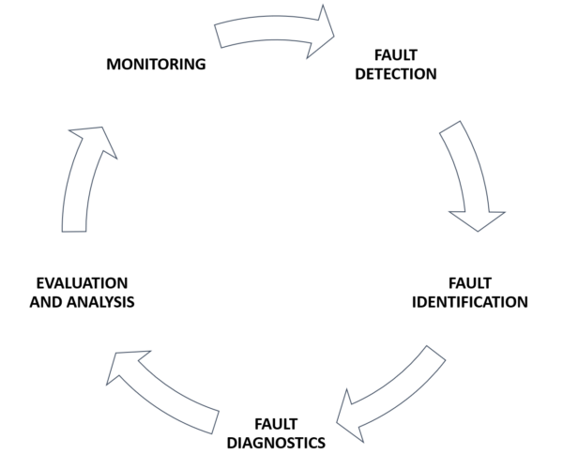

**METHODOLOGY**

The ultimate aim of our project is to give the risk-free environment of industry. In this project we will detect the Fire Gas and Temperature. Here we monitoring fault also where included phase failure, voltage up and down and frequency changing high or low. If any fault is detecting then it will give indicate by alarm and give information in online throw the server where all can know about the incident from anywhere in the world. In the mean-time the power will be shut down until recovering these problems.

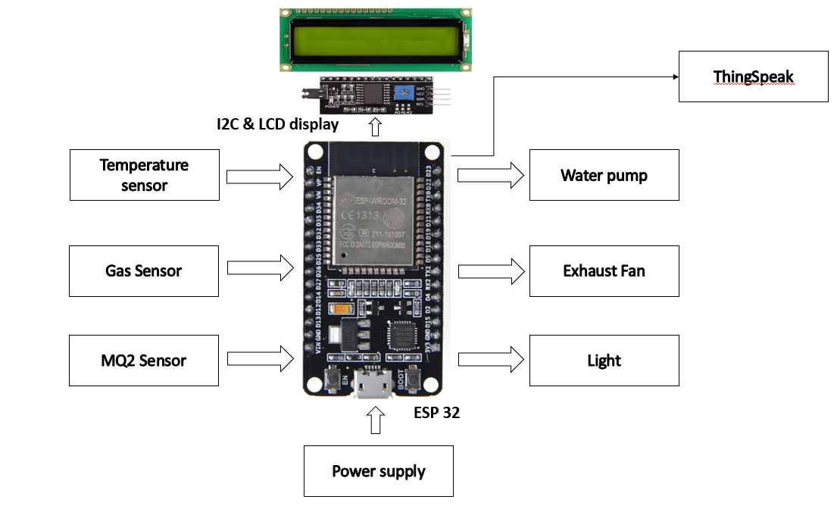

**RESULT**

**RESULT**

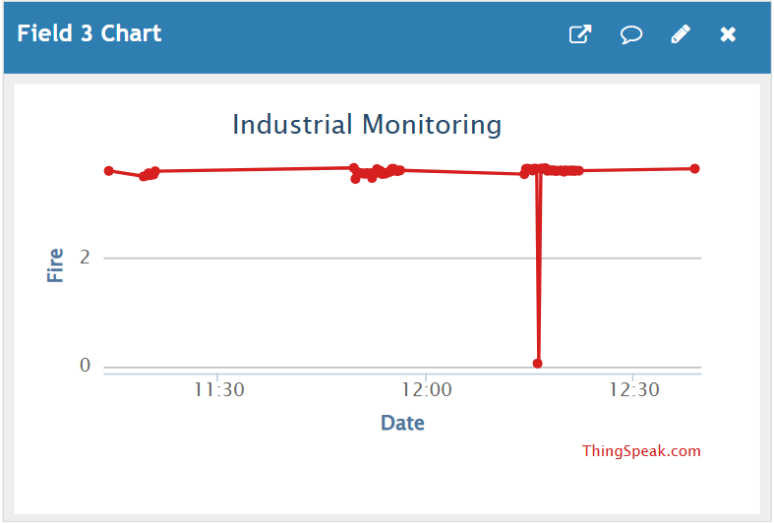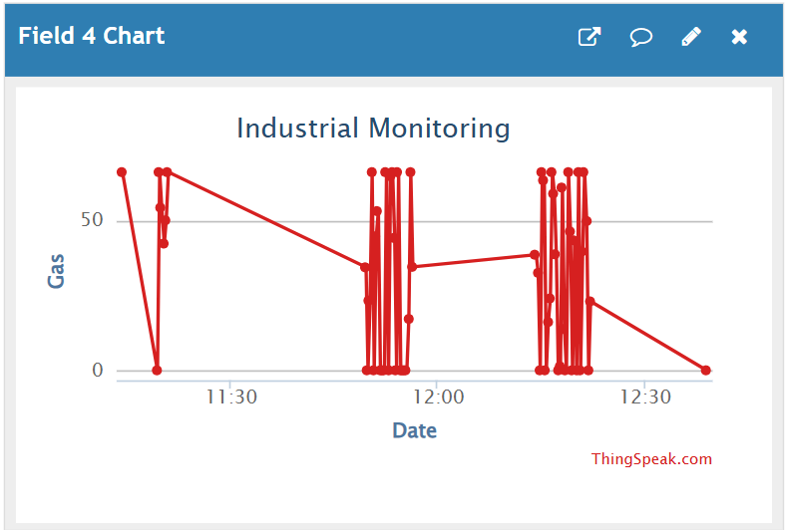

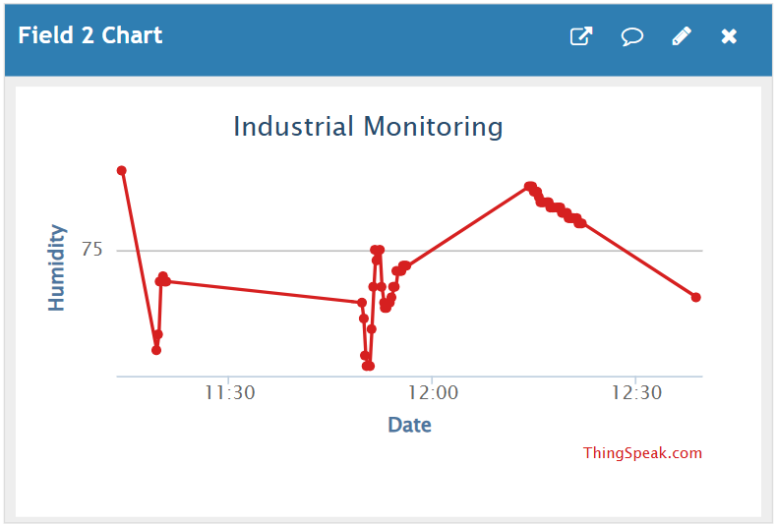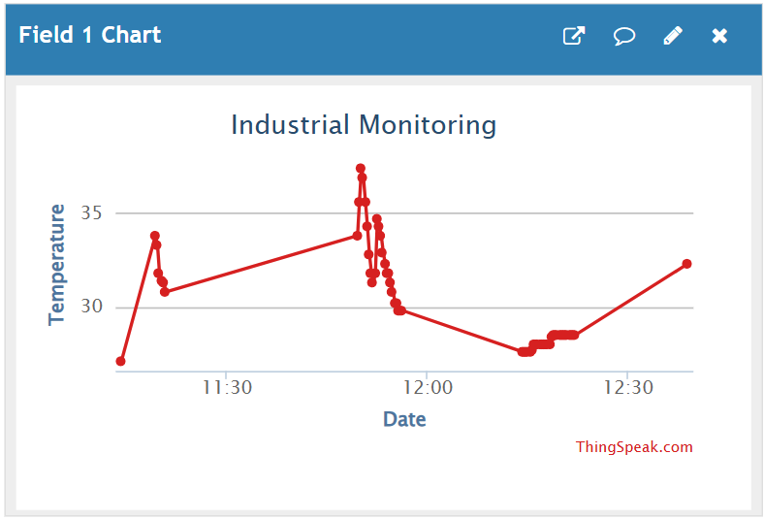

**Applications:**

* **Comprehensive Monitoring :** Develop a robust fault monitoring system that can detect and analyze a wide range of industrial equipment issues in real-time.
* **Predictive Maintenance:** Leverage IoT sensors and data analytics to enable predictive maintenance, reducing unplanned downtime and costly repairs.
* **Cost Savings:** Minimize operational expenses through early fault detection, reduced maintenance costs, and increased asset lifespan.
* **Improved Efficiency:** Optimize industrial processes and workflows by providing timely insights on equipment health and performance.

**CONCLUSION**

* Industry is the main earning source of a developing country.But if the industries are not safe and protected, peoples can’t getmore benefits from its. By using this protection system industry
* can be more secure. By using this system peoples can monitorprotection from anywhere in the world, and if occurs anyaccident they can take action immediately. More over the ownersof the industry can recheck the causes of occurs accident, whatare the false and how it was happened.

**REFERENCE**

1. Dr. ChalasaniSrinivas. TOXIC GAS DETECTION AND MONITORING UTILIZING INTERNET OF THINGS,International Journal of Civil Engineering and Technology, 12Dec2017
2. Mr.Neeraj P Sawant , Mr.Rohit P Sawant,15Feb2019,.nevonprojects.com/iot-industry-protection-systemarduino.
3. Kanchan D. Sase.03Mar2020. Arduino based Single Phase Fault Detection System using IoT.www.irjet.net/archives/V7/i3/IRJET-V7I3394.pdf
4. Li Da Zu, Nov2014, Internet of Things in Industries: A Survey, IEEE Transactions on Industrial Informatics, vol. 10, no. 4
5. Sadeque Reza Khan Professor Dr. M. S. Bhat,06July2014, “GUI Based Industrial Monitoring and Control System ``IEEE paper,
6. ShankerRoy,07Oct2018,MICROTRONICS TECHNOLOGIES,projectsof8051.com/iot-based-industrial-faultmonitoring-system-using-arduino/