EISMAS

A project for simulating traffic flow with java OOP features

Made by Adomas Bieliūnas in 2025

USAGE
To execute the program run Main.java in an IDE.

The program has an interactive text-based menu for managing the traffic:

1. Create vehicle
2. Start vehicle
3. Stop vehicle
4. Move vehicle cartesian
5. Move vehicle polar
6. Switch vehicle
7. Print vehicle info
8. Load data
9. Save data
10. Exit program

KEY CLASSES
Main.java
Main class that manages the program on a high level.
TrafficUser
Abstract base class that defines the fields child
classes will implement.
TrafficException
Base class for throwing exceptions.
TrafficUserFactory
Factory interface for creating objects.
DataManager
Helper class to save vehicle data.

UML STRUCTURE:
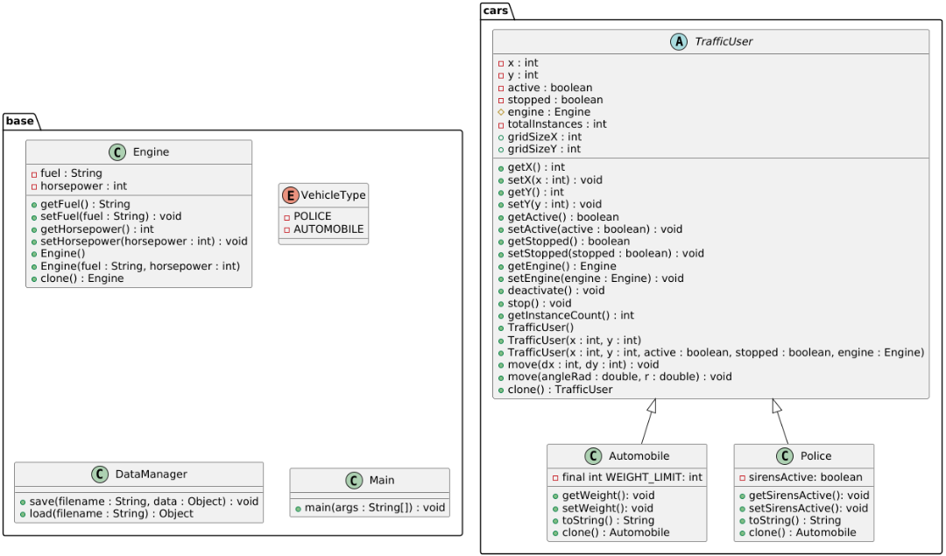
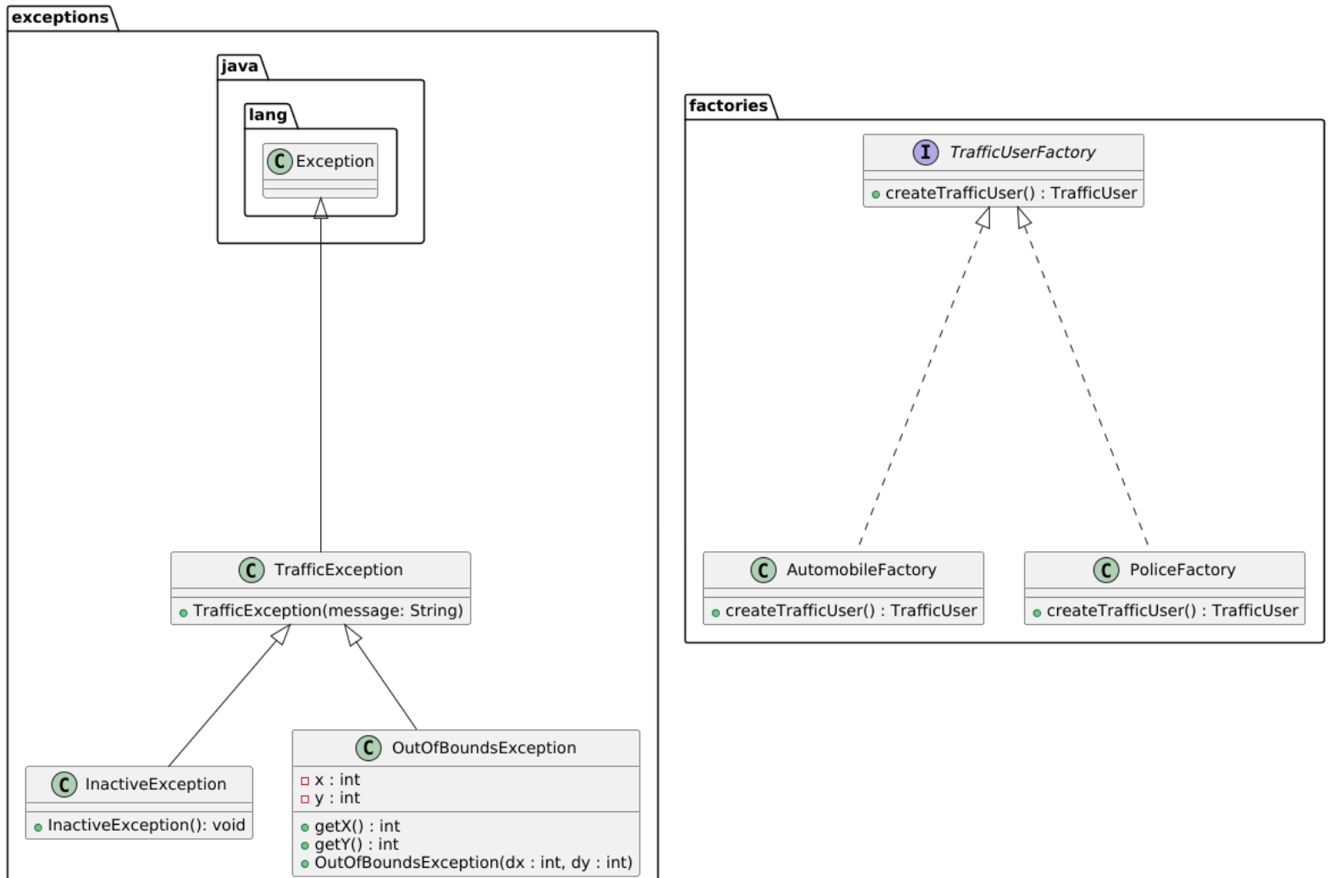

FUTURE CONSIDERATIONS
Considerations for future development: an implementation of a GUI, more vehicle types, traffic rules and automatic movement every update.

A specific OOP pattern used was a factory method.

