**Industrial Internship Report on**

**”KBC Quiz”**

**Prepared by**

**[Abhishek Dixit]**

|  |
| --- |
| *Executive Summary* |
| This report provides details of the Industrial Internship provided by upskill Campus and The IoT Academy in collaboration with Industrial Partner UniConverge Technologies Pvt Ltd (UCT).  This internship was focused on a project/problem statement provided by UCT. We had to finish the project including the report in 6 weeks’ time.  My project was KBC Quiz which is a quiz game inspired by KBC television show. I used pygame to create the interface and functionality to the game and also add a music playing feature for more fun.  This internship gave me a very good opportunity to get exposure to Industrial problems and design/implement solution for that. It was an overall great experience to have this internship. |

**TABLE OF CONTENTS**

1 Preface 3

2 Introduction 5

2.1 About UniConverge Technologies Pvt Ltd 5

i. UCT IoT Platform 5

2.2 About upskill Campus (USC) 9

2.3 The IoT Academy 10

2.4 Objectives of this Internship program 10

2.5 Reference 11

2.6 Glossary 11

3 Problem Statement 12

4 Existing and Proposed solution 13

4.1 Code submission (Github link) 14

4.2 Report submission (Github link) : 14

5 Performance Test 15

6 My learnings 18

7 Future work scope 19

# Preface

During my 6-week internship, I focused on a single project that greatly contributed to my skill development and career growth. This experience underscored the importance of relevant internships in career development, as they offer practical exposure and a chance to apply theoretical knowledge in real-world scenarios.

The project I worked on was the development of a KBC (Kaun Banega Crorepati) quiz game using Pygame. My task was to create an interactive quiz game that replicates the experience of the popular TV show. I designed a user-friendly interface and added sound effects to enhance the player's experience. Additionally, I implemented a feature that allows players to enjoy background music while playing the game, making it more immersive and engaging. This project allowed me to deepen my understanding of Python programming and game development, particularly using Pygame.

The internship, offered by Upskill Campus in collaboration with UniConverge Technologies (USC/UCT), provided me with the opportunity to work on this project in a supportive environment. The program was well-structured, with clear goals and guidance from mentors who helped me navigate challenges and learn effectively. This hands-on experience was invaluable in helping me bridge the gap between academic knowledge and practical application.

Overall, this internship was a pivotal experience in my career journey, allowing me to develop key technical skills and gain confidence in my ability to tackle complex projects.

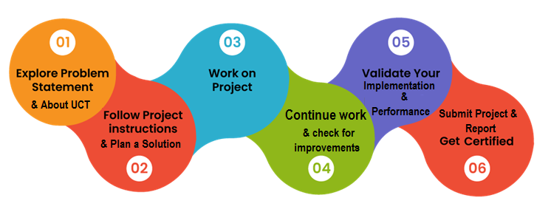

My internship experience over the past 6 weeks has been incredibly enriching and transformative. Working on the KBC quiz game using Pygame allowed me to solidify my understanding of Python and game development. I learned how to approach problem-solving in a structured way, manage my time effectively, and adapt to new challenges. The project taught me the importance of attention to detail, especially in user interface design and ensuring a seamless user experience.

I am deeply grateful to everyone who supported me throughout this journey. A special thanks to the mentors at UniConverge Technologies (UCT) for their invaluable guidance and feedback. I would also like to extend my heartfelt thanks to Code with Harry for providing such an excellent resource that helped me hone my programming skills. Your tutorials were instrumental in my learning process.

To my juniors and peers, my message is simple: never stop learning and stay curious. Internships are a great way to bridge the gap between theory and practice, so make the most of every opportunity you get. Dive into projects that challenge you, seek feedback, and don’t be afraid to make mistakes—that’s how you grow.

# Introduction

## About UniConverge Technologies Pvt Ltd

A company established in 2013 and working in Digital Transformation domain and providing Industrial solutions with prime focus on sustainability and RoI.

For developing its products and solutions it is leveraging various**Cutting Edge Technologies e.g. Internet of Things (IoT), Cyber Security, Cloud computing (AWS, Azure), Machine Learning, Communication Technologies (4G/5G/LoRaWAN), Java Full Stack, Python, Front end**etc.

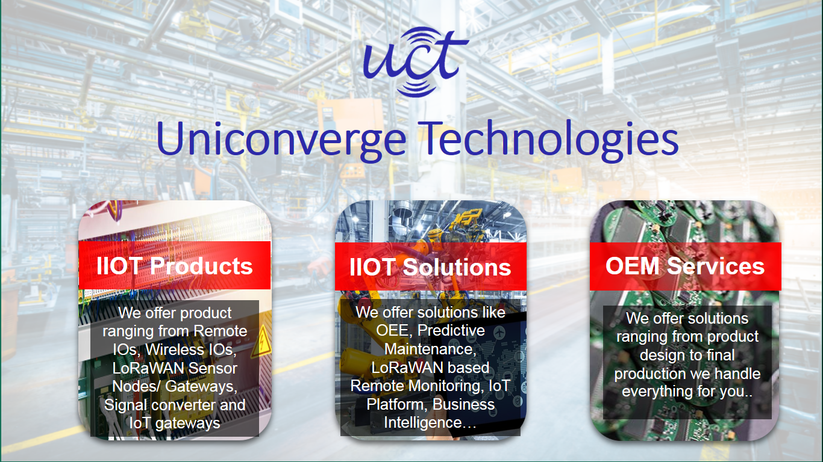

1. UCT IoT Platform **(****)**

**UCT Insight** is an IOT platform designed for quick deployment of IOT applications on the same time providing valuable “insight” for your process/business. It has been built in Java for backend and ReactJS for Front end. It has support for MySQL and various NoSql Databases.

* It enables device connectivity via industry standard IoT protocols - MQTT, CoAP, HTTP, Modbus TCP, OPC UA
* It supports both cloud and on-premises deployments.

It has features to  
• Build Your own dashboard  
• Analytics and Reporting  
• Alert and Notification  
• Integration with third party application(Power BI, SAP, ERP)  
• Rule Engine

 

1. **Smart Factory Platform (****)**

Factory watch is a platform for smart factory needs.

It provides Users/ Factory

* with a scalable solution for their Production and asset monitoring
* OEE and predictive maintenance solution scaling up to digital twin for your assets.
* to unleased the true potential of the data that their machines are generating and helps to identify the KPIs and also improve them.
* A modular architecture that allows users to choose the service that they what to start and then can scale to more complex solutions as per their demands.

Its unique SaaS model helps users to save time, cost and money.



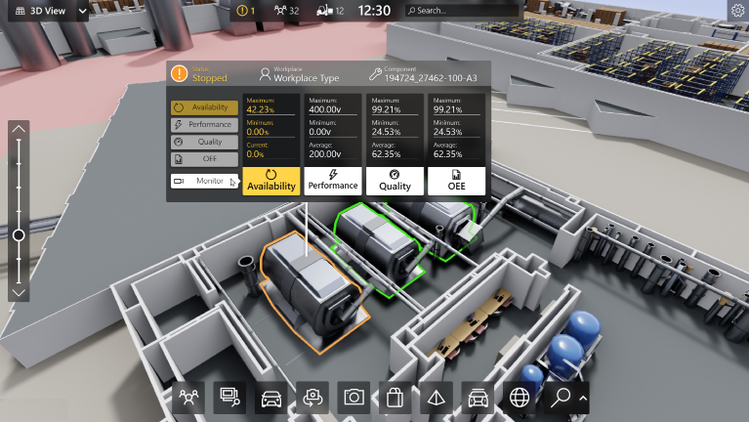

1.  based Solution

UCT is one of the early adopters of LoRAWAN teschnology and providing solution in Agritech, Smart cities, Industrial Monitoring, Smart Street Light, Smart Water/ Gas/ Electricity metering solutions etc.

1. Predictive Maintenance

UCT is providing Industrial Machine health monitoring and Predictive maintenance solution leveraging Embedded system, Industrial IoT and Machine Learning Technologies by finding Remaining useful life time of various Machines used in production process.



## About upskill Campus (USC)

upskill Campus along with The IoT Academy and in association with Uniconverge technologies has facilitated the smooth execution of the complete internship process.

USC is a career development platform that delivers **personalized executive coaching** in a more affordable, scalable and measurable way.



Seeing need of upskilling in self paced manner along-with additional support services e.g. Internship, projects, interaction with Industry experts, Career growth Services

<https://www.upskillcampus.com/>

upSkill Campus aiming to upskill 1 million learners in next 5 year

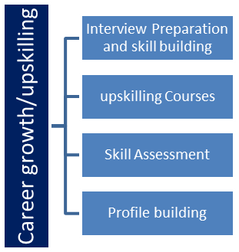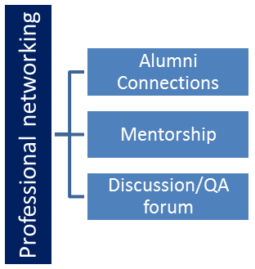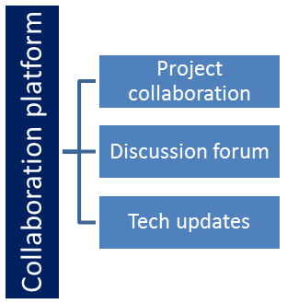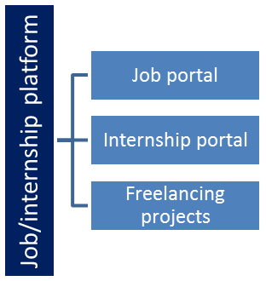

## The IoT Academy

The IoT academy is EdTech Division of UCT that is running long executive certification programs in collaboration with EICT Academy, IITK, IITR and IITG in multiple domains.

## Objectives of this Internship program

The objective for this internship program was to

 ☛ get practical experience of working in the industry.

 ☛ to solve real world problems.

 ☛ to have improved job prospects.

 ☛ to have Improved understanding of our field and its applications.

 ☛ to have Personal growth like better communication and problem solving.

## Reference

[1] Code with Harry. "Pygame Tutorial for Beginners - Python Game Development with Pygame." YouTube, uploaded by Code with Harry, 1 March 2021, [www.youtube.com/watch?v=FfWpgLFMI7w](http://www.youtube.com/watch?v=FfWpgLFMI7w).

[2] Tech With Tim. "Python Pygame Tutorial - Game Development with Pygame." YouTube, uploaded by Tech With Tim, 15 April 2021, [www.youtube.com/watch?v=ujOTNg17LjI](http://www.youtube.com/watch?v=ujOTNg17LjI).

[3] The Net Ninja. "Pygame Tutorial for Beginners - Creating a Simple Game with Python." YouTube, uploaded by The Net Ninja, 12 June 2021, [www.youtube.com/watch?v=p3nVg08TmCY](http://www.youtube.com/watch?v=p3nVg08TmCY).

## Glossary

|  |  |
| --- | --- |
| Terms | Acronym |
| Python | - |
| Pygame | - |
| Graphical User Interface | GUI |
| Kaun Banega Crorepati | KBC |
| Application | App |

# Problem Statement

I was given the task of developing a quiz game, and I chose to create a KBC (Kaun Banega Crorepati) style game using Python and Pygame. The goal was to replicate the experience of the popular TV show, where players answer multiple-choice questions to progress through levels and win virtual rewards.

The problem statement involved several key challenges:

1. **Game Mechanics:** Implementing the core mechanics of the KBC game, including the progression through questions, the use of lifelines, and handling correct and incorrect answers.
2. **Graphical User Interface (GUI):** Designing a visually appealing and user-friendly interface that mirrors the look and feel of the KBC show, ensuring players can easily navigate and interact with the game.
3. **Sound Effects and Music:** Integrating sound effects for question prompts, correct/incorrect answers, and background music to enhance the overall experience and make the game more immersive.
4. **User Interaction:** Developing a system for user input that allows players to select answers, use lifelines, and view their progress throughout the game.

By choosing the KBC format, I aimed to create a familiar and engaging quiz game that challenges players' knowledge while providing a fun and interactive experience.

# Existing and Proposed solution

**Existing Solutions:**

1. **Online Quiz Platforms:** Platforms like Kahoot and Quizizz offer interactive quiz experiences with customizable questions and real-time play. They include features such as leaderboards and various game modes.
   * **Limitations:**
     + Limited customization for specific game formats like KBC.
     + Less focus on replicating the exact experience of TV quiz shows.
     + Often lack integration of multimedia elements such as background music and sound effects.
2. **Standalone Quiz Applications:** Various standalone quiz applications and games, often available on mobile platforms, provide quiz functionality with graphical interfaces and sound effects.
   * **Limitations:**
     + May not include all features of a KBC-style game, such as lifelines and question progression.
     + Limited flexibility for integrating personalized elements or additional multimedia features.
3. **Educational Game Development Tools:** Tools like Unity and Godot allow for the creation of custom quiz games with rich graphics and sound.
   * **Limitations:**
     + Require extensive programming knowledge and resources.
     + Can be overkill for simpler quiz games and might involve a steeper learning curve.

**Proposed Solution:** I propose to develop a KBC-style quiz game using Python and Pygame. This solution involves creating a game that:

* **Mimics the KBC Experience:** Replicates the experience of the popular TV quiz show, including question progression, lifelines, and interactive gameplay.
* **Graphical User Interface (GUI):** Features a visually appealing GUI designed to resemble the KBC show, with intuitive navigation and player interaction.
* **Sound Integration:** Incorporates sound effects for question prompts, correct/incorrect answers, and background music to enhance the immersive experience.

**Value Addition:**

1. **Enhanced User Experience:** By integrating background music and sound effects, the game provides a more immersive and engaging experience, closely mimicking the KBC TV show atmosphere.
2. **Customizability:** The game can be easily customized with additional questions, different difficulty levels, and personalized features, making it versatile for various applications.
3. **Learning Opportunity:** The project serves as a learning tool for developing interactive applications with Python and Pygame, providing valuable experience in game development and user interface design.

This proposed solution addresses the limitations of existing quiz platforms and applications by offering a more tailored and interactive experience, combining the KBC game format with multimedia enhancements for a richer user experience.

## Code submission (Github link)

<https://github.com/Adixit8604/upskillcampus/blob/main/KBC.py>

## Report submission (Github link) :

<https://github.com/Adixit8604/upskillcampus/blob/main/KBC.py>

# Performance Test

**Importance:**

This section is crucial for demonstrating the practical applicability of my project in real-world scenarios. It highlights how I’ve managed constraints effectively, showing that the project is not just an academic exercise but a viable solution for real industries.

1. **Constraints and Solutions**
2. **Memory Usage:**
   * **Constraint:** I needed to ensure efficient memory management to avoid excessive consumption and ensure smooth operation.
   * **Solution:** I used optimized data structures and lazy loading techniques to manage resources effectively. This approach prevents memory leaks and performance slowdowns, which is crucial for scalability in real-world applications.
3. **Processing Speed (MIPS):**
   * **Constraint:** The game needed to provide fast response times and smooth gameplay.
   * **Solution:** I optimized game logic and rendering processes, leveraging Pygame's efficient functions. This ensures real-time interaction and avoids lag, which is essential for user satisfaction.
4. **Accuracy:**
   * **Constraint:** Maintaining correct game mechanics to provide a reliable and fair gaming experience was essential.
   * **Solution:** I implemented thorough validation checks and accurate question handling. This ensures that the game operates as intended, which is critical for maintaining user trust and engagement.
5. **Durability:**
   * **Constraint:** The game needed to handle errors and interruptions gracefully to ensure stability and robustness.
   * **Solution:** I incorporated error handling and recovery mechanisms. This enhances reliability and user experience by preventing crashes and data loss.
6. **Power Consumption:**
   * **Constraint:** Minimizing impact on system performance and power usage was important.
   * **Solution:** I employed efficient coding practices and minimized resource-intensive operations. This reduces strain on system resources, making the game more efficient.
7. **5.1 Test Plan / Test Cases**
8. **Memory Usage Test:**
   * **Test Case:** I measured memory consumption during gameplay with different numbers of users and game states.
   * **Expected Outcome:** Memory usage remained within acceptable limits without significant performance issues.
9. **Processing Speed Test:**
   * **Test Case:** I assessed response times for user inputs and frame rates under various conditions.
   * **Expected Outcome:** The game maintained smooth performance with minimal latency.
10. **Accuracy Test:**
    * **Test Case:** I verified the correctness of question handling, lifeline functionality, and scoring.
    * **Expected Outcome:** All game mechanics functioned accurately and consistently.
11. **Durability Test:**
    * **Test Case:** I simulated error conditions and unexpected interruptions.
    * **Expected Outcome:** The game handled errors gracefully and continued operating without crashes.
12. **Power Consumption Test:**
    * **Test Case:** I monitored system performance and power usage during extended gameplay sessions.
    * **Expected Outcome:** The game had minimal impact on system power consumption and performance.
13. **5.2 Test Procedure**
14. **Setup:** I configured the testing environment with required tools and prepared test scenarios.
15. **Execution:** I conducted each test according to the defined cases, capturing relevant data and observing outcomes.
16. **Analysis:** I analyzed the collected data to assess how well the constraints were addressed and identified any issues.
17. **Resolution:** I implemented necessary adjustments or optimizations based on the test results.
18. **5.3 Performance Outcome**
19. **Memory Usage:** I effectively managed memory, keeping it within acceptable limits even with varying game states.
20. **Processing Speed:** The game demonstrated smooth performance with responsive interactions and consistent frame rates.
21. **Accuracy:** The game mechanics and scoring were accurate, reflecting the intended KBC experience.
22. **Durability:** Error handling mechanisms were successful, maintaining stability and preventing crashes.
23. **Power Consumption:** The game showed minimal impact on system performance and power usage.

**Recommendations:**

* **Regular Optimization:** I will continuously review and optimize the code to address any emerging constraints and maintain performance.
* **User Feedback Integration:** I plan to gather feedback to identify areas for improvement and enhance the overall experience.
* **Ongoing Testing:** I will perform regular tests to ensure that updates or changes do not negatively affect performance or constraints.

# My learnings

Throughout this project, I gained several key insights and skills:

1. **Programming Skills:** I enhanced my Python and Pygame expertise, learning to develop efficient game logic and manage user inputs effectively.
2. **Project Management:** I learned to oversee a project from start to finish, improving my ability to handle tasks, set priorities, and achieve goals.
3. **Problem-Solving:** I tackled challenges related to memory usage, gameplay smoothness, and error handling, strengthening my problem-solving abilities.
4. **User Experience:** By focusing on user engagement, I gained an understanding of how to create enjoyable and functional applications.
5. **Performance Optimization:** I acquired techniques for optimizing code and managing resources, which will be valuable for future software development.

**Career Impact:**

* **Technical Expertise:** The skills gained will make me a more effective developer.
* **Project Management:** Experience managing projects will aid in leading future initiatives.
* **Problem-Solving:** Enhanced problem-solving skills are crucial for real-world challenges.
* **User-Centric Design:** Understanding user experience will help in creating better applications.

This project has prepared me for success in the industry by providing practical skills and real-world experience.

# Future work scope

Here are some ideas and enhancements that could be explored in future work:

1. **Enhanced Game Features:**
   * **Additional Game Modes:** Implementing new game modes or variations to increase replayability and user engagement.
   * **Advanced Lifelines:** Introducing more interactive and varied lifelines to enrich the gameplay experience.
2. **Improved User Interface:**
   * **Customizable Themes:** Allowing users to choose or create custom themes and skins for a more personalized experience.
   * **Accessibility Options:** Adding features to make the game more accessible to players with disabilities.
3. **Multiplayer Capabilities:**
   * **Online Play:** Developing an online multiplayer mode to enable users to compete against others in real-time.
   * **Leaderboards and Achievements:** Implementing leaderboards and achievement systems to foster competition and reward players.
4. **AI Integration:**
   * **Adaptive Difficulty:** Using AI to adjust the difficulty level based on the player’s skill, providing a more challenging and tailored experience.
   * **Personalized Recommendations:** Incorporating AI to suggest questions and game modes based on player preferences and history.
5. **Cross-Platform Compatibility:**
   * **Mobile and Web Versions:** Expanding the game to mobile and web platforms to reach a broader audience and enhance accessibility.
6. **Analytics and Feedback:**
   * **User Analytics:** Implementing analytics to track user behavior and game performance, providing insights for further improvements.
   * **Feedback Integration:** Gathering and integrating user feedback to refine and enhance the game based on real-world usage.

These enhancements could significantly improve the game’s functionality and appeal, offering a richer experience for users and exploring new technological possibilities.