**DOCUMENTATION**

**TECHNOLOGIES USED**

The technologies used in the project are Hyper Text Markup Language (HTML), Cascading Style Sheets (CSS), HyperText Preprocessor (PHP) and PhpMyAdmin in order to integrate the MariaDB database using Wamp Server.

Step 1:

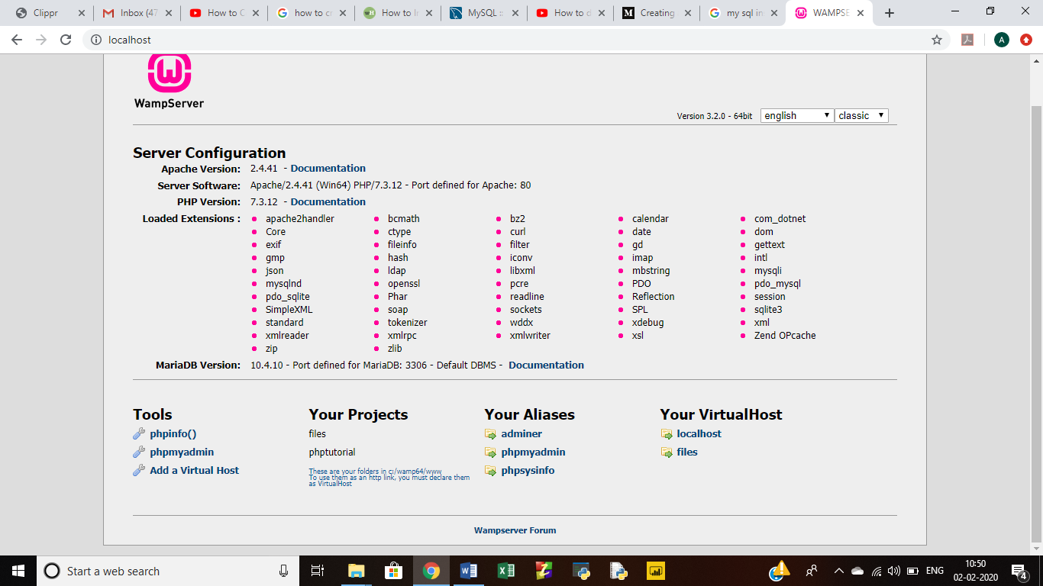

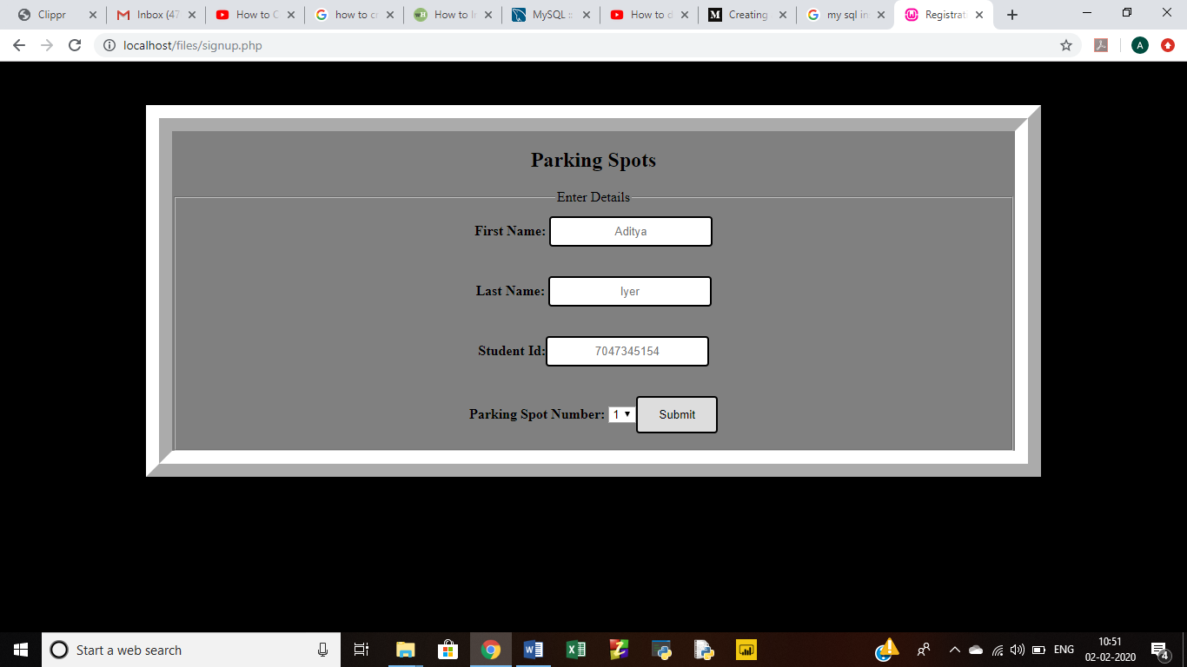Step 2:

Step 3:

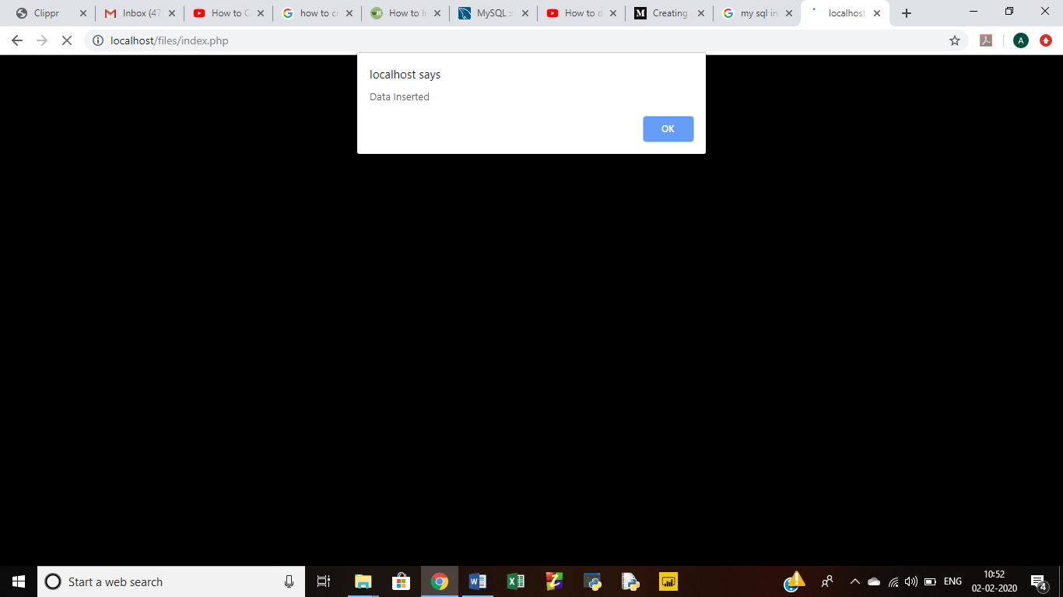

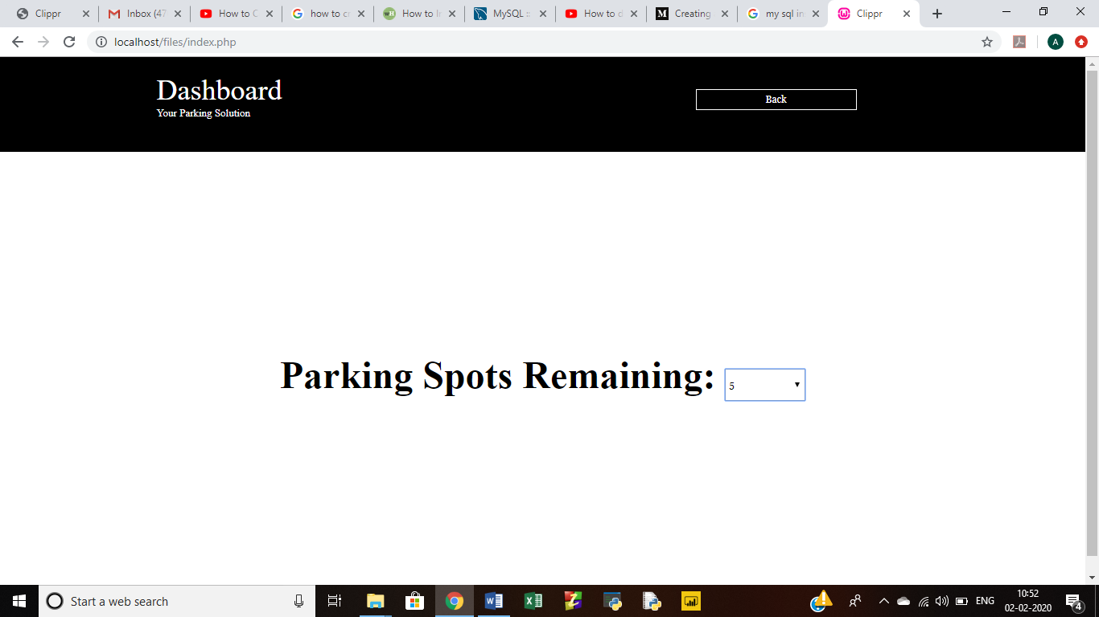Step 4: