SUBSPACE.MONEY
Product Teardown
May 2026

THE CENTRAL OBSERVATION

Subspace does not have a feature problem. It has an identity problem.

The home screen pushes gift cards. The explore tab says 'Delivery in 11 minutes.' The wallet asks users to load money before they understand why. The account page holds 12 unrelated items with no logic.

The product's actual moat -- automated price negotiation, group subscription coordination, recurring finance intelligence -- is buried under a cashback app. The next move is not more features. It is making the real product visible.

What This Report Covers

Identity Collapse Diagnosis
- The root cause behind every other problem

GTM + Feedback 1
- Wrong mental model in 5 seconds -- the home screen

Competitor Analysis + Feedback 2
- The UPI settlement gap -- rivals are closing in

Features + Feedback 3
- The Negotiate API moat no user ever finds

UX + Feedback 4
- Wallet confusion and Account page collapse

Collaborations + Feedback 5
- Rs.2400 Cr employer benefits distribution unlock

What I Would Ship on Day 1
- Concrete 90-day execution plan

Metrics Dashboard
- The first numbers I would instrument

00
Identity Collapse Diagnosis
The single root cause that explains every UX, GTM, and retention problem in this teardown
Before critiquing any individual screen, a senior PM asks one question first: what product is this? After spending time inside all 7 screens of Subspace, the honest answer is: it depends which screen you are on. That is the problem.

What Each Screen Is Trying to Be

Screen | What It Currently Shows | Mental Model Triggered | What It Should Show
Home | Browse Gift Cards, Quick Payments, Add Credit Card | Zomato / Flipkart commerce | Your Rs.X/month in recurring spend, next renewal, one action
Explore Hero | 'Delivery in 11 minutes' + Bengaluru location pin | Blinkit / quick commerce | 'Save on your recurring spends' -- personalised to user's subs
Explore Grid | Croma 2%, Flipkart 2%, Amazon vouchers -- generic cashback | Magicpin / GyFTR | Intelligent deal matching based on what user actually subscribes to
Wallet | Locked/Unlocked balance, preload Rs.100-1000, Withdrawal | Paytm prepaid wallet | Savings ledger -- money recovered through negotiations and groups
Account (top) | KYC banner as the first thing user sees -- larger than profile | Regulated compliance form | User's profile, savings summary, group memberships
Account (list) | 12 items: Rental History, Blogs, AI Mailbox, Review Us, Friends... | Feature graveyard | 3 clean sections: Profile / My Activity / App Settings
Chat tab | Community Guidelines (Be Respectful, No Hate Speech) | Discord / Reddit community | Settlement alerts, negotiation updates, renewal reminders

The Jobs-to-be-Done Mismatch

Job the User Is Trying to Do | Subspace's Answer | Verdict
Stop wasting money on subscriptions I forgot | Tracking exists but is buried below gift card promotions on home | WEAK
Split Netflix with my flatmates | Groups feature works -- this is the strongest flow in the app | STRONG
Get reminded before my free trial ends | No visible proactive alert on home or Inbox tab | MISSING

Job the User Is Trying to Do | Subspace's Answer | Verdict
Negotiate a lower price on my gym subscription | Negotiate API exists -- but there is no CTA, status screen, or savings counter in the app | CRITICAL GAP
Settle up after splitting a shared subscription | Wallet preload model requires loading money first. No UPI deep-link. 6-step process vs 2. | BROKEN FLOW
Find deals on apps I actually already use | Explore shows generic cashback grid -- not matched to user's existing subscriptions | WEAK

The Contrarian Observation: The Explore tab's gift card and cashback surface is probably Subspace's highest-volume feature right now. But it is also the most dangerous one. It attracts deal-hunter users who install for a Zomato voucher discount and never return. This is the worst ICP for a network-effects business: zero sharing behavior, zero group formation, high uninstall rate after first purchase. The marketplace is helping short-term revenue while quietly poisoning the user cohort quality and product identity simultaneously.

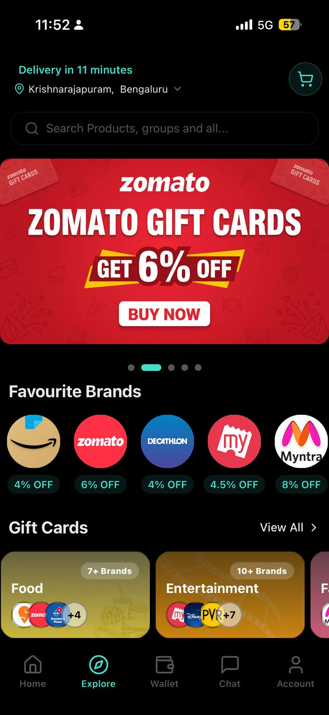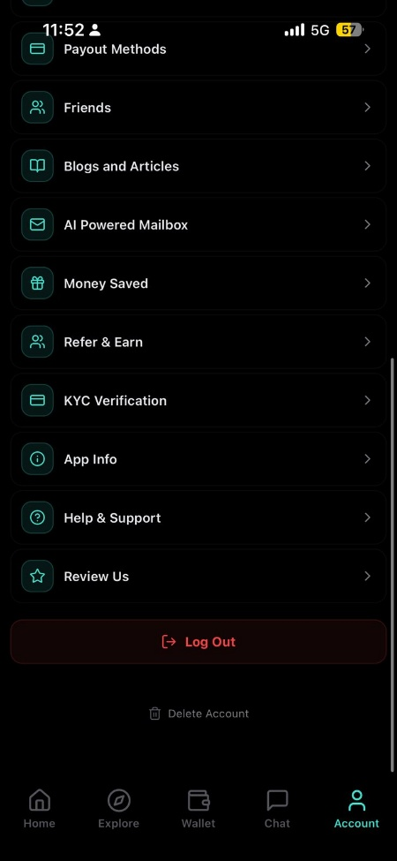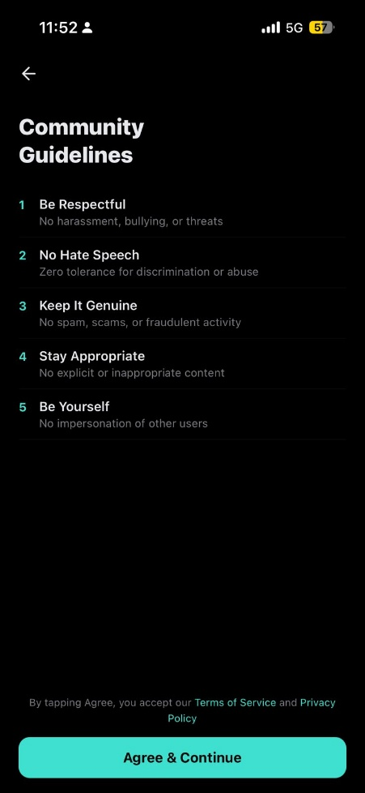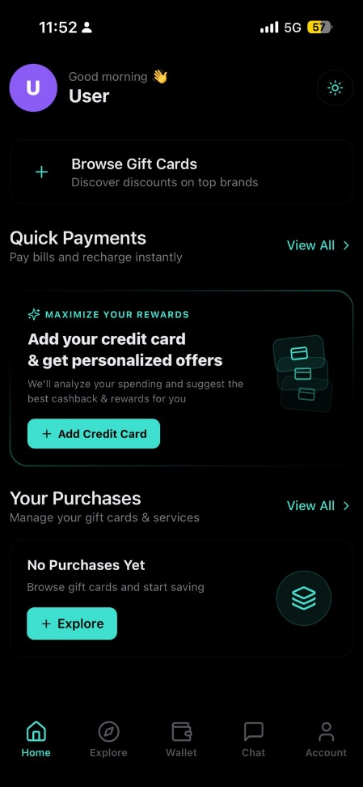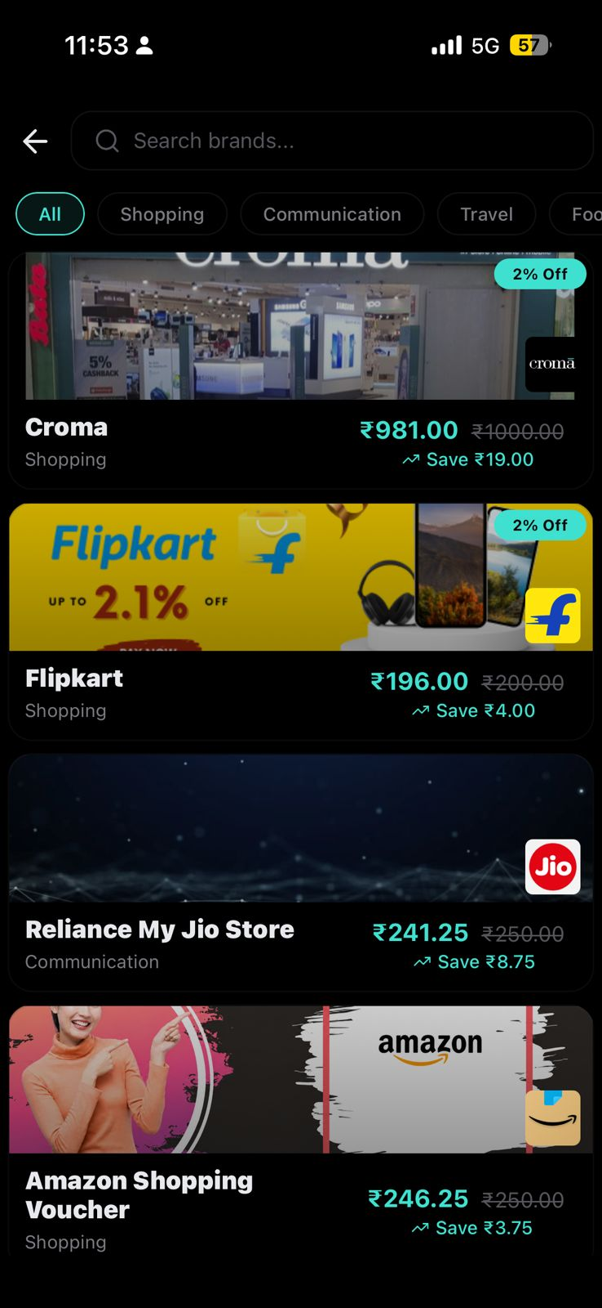

01
GTM and ICP Analysis
Subspace is targeting the wrong user first -- and the home screen proves it
Subspace's Play Store listing calls it India's No.1 Savings, Sharing and Rental App. The homepage tab title says 'Subscription Management Platform.' But open the app and the first CTA is 'Browse Gift Cards.' These three things describe three different products. That inconsistency starts with a broken ICP definition and ends with a broken home screen.

ICP Priority Matrix

User Segment | India Size | Subscriptio n Spend | Network Potential | Current Fit | Priority
Urban professional, 25-35,  5+ subscriptions | 120M | Rs.800-2000/  mo | High -- shares OTT, Spotify, gym | Weak -- home screen shows gift cards not sub tracker | PRIMARY --  currently untapped
College student in PG / co-living, 3-6 subs | 35M | Rs.300-800/m  o | Very High -- natural group admin | Moderate -- student email deals exist but groups not promoted | WEDGE -- best retention
Deal hunter, downloads for cashback, one-time | 200M+ | Low -- no recurring sub | None -- solo transaction | Strong -- entire Explore tab serves this user | TRAP -- high volume, zero LTV
Freelancer / SMB tracking SaaS subscriptions | 60M | Rs.2000-8000  /mo | Medium -- team sharing potential | Missing -- no B2B surface anywhere in the app | UNTAPPED --  highest LTV
P0 -- DAY
1
The Home Screen Communicates the Wrong Product in the First 5 Seconds
Feedback #1

(a) OBSER VED
Screenshot: Home Screen (Image 7)
- The very first CTA visible to any new user is: 'Browse Gift Cards / Discover discounts on top brands.'
- Second section: 'Quick Payments / Pay bills and recharge instantly.'
- Third section: 'Add your credit card and get personalised offers.'
- There is no mention of subscriptions, group sharing, savings, or the Negotiate API anywhere on the first screen.
Screenshot: Explore Tab (Image 5)
- 'Delivery in 11 minutes' is the Explore hero -- the exact copy and visual pattern Blinkit uses.
- The hero carousel shows a Zomato Gift Cards banner with 'BUY NOW' as the primary button.
What I Actually Felt Using It
- I opened the app for the first time and genuinely thought I had installed a gift card app. I scrolled twice before finding anything about subscriptions. By that point, my mental model was already wrong.

(b) PROBLEM |  | - A user arriving from Google search for 'subscription tracker India' sees a food-delivery-style gift card app. The mismatch between expectation and reality creates immediate cognitive dissonance -- and most users do not scroll past it.  - The interface is optimising for browsing gift card offers. The product's actual moat -- negotiation, group coordination, recurring finance intelligence -- is invisible on the first screen.  - McKinsey (2024): 73% of fintech users abandon during onboarding due to poor first-screen clarity. Every day this home screen exists with the wrong hierarchy, Subspace is wasting its top-of-funnel.  - The deal-hunter cohort this home screen attracts has near-zero LTV and zero group-forming behavior. It is actively degrading the user base quality.
(c) SHIP IT |  | Immediate (Week 1 -- 2 days of copy + layout work):  - Hero line: 'You are probably spending Rs.1,200/month on subscriptions. Start tracking.' (estimate from UPI SMS or prompt user to input).  - Primary CTA: 'Add my subscriptions' -- not 'Browse Gift Cards.'  - Secondary CTA: 'Share with a group' -- visible above the fold.  - Gift card promotions move to the Explore tab where they belong.  Explore Tab (Week 1 -- 1 day):  - Remove 'Delivery in 11 minutes' entirely. Replace hero with: 'Deals matched to your subscriptions.'  - If personalisation is not ready yet: show 'Top deals for Bengaluru users this week' -- anything that is not a quick commerce clone.  A/B Test to Run:  - Subscription-first home vs current gift-card-first home. Primary metric: D7 retention. Secondary: group creation rate within first 48 hours.
 | Metric to Track: D1 and D7 retention rate | Sub tracking activation rate (% who add 1+ subscription in first 24 hours) | Group creation within 48 hours of install
 | Tradeoff: Gift card commerce is likely a current GMV contributor. Deprioritising it on the home screen may reduce gift card transactions short-term. Accept this tradeoff deliberately: the group-sharing cohort has 10x higher LTV and is the source of network effects. Grow gift card GMV through Explore, not Home.

02
Competitor Analysis
What global and Indian products do better -- and the settlement gap closing fast
Subspace has no single direct competitor. But it has functional rivals across each of its product surfaces. The strategic risk is not one app copying Subspace -- it is multiple apps each solving one piece better, and users assembling their own stack. Splitwise for splitting. PhonePe for bills. CRED for tracking. Subspace has 18-24 months before this convergence makes it redundant.

Feature Benchmark: Subspace vs Global Competitors

Feature | Subspace | Rocket Money | Bobby | Splitwise | CRED | FairShare
Auto sub detection | Yes (API) | Yes (bank) | No --  manual | No | Yes (SMS) | No
Group sharing + splitting | Yes -- works well | No | No | Yes (expenses) | No | Yes
UPI-native settlement | NO -- wallet preload only | No (US only) | No | No | Yes | YES --  deep-link
Price negotiation | Yes -- API exists | Yes (concierge) | No | No | No | No
Subscription marketplace | Yes | No | No | No | Partial | No
India-native (UPI, Hindi) | Yes | No | No | Partial | Yes | Yes
UX polish level | Moderate | Excellent | Excellent | Good | Excellent | Good
Key Threat: FairShare, a 2025 Indian startup, built UPI deep-link settlement as its explicit wedge against Splitwise. It is targeting flat-sharing groups in Indian cities -- the exact cohort Subspace should own. If FairShare adds subscription tracking, Subspace loses its clearest defensible segment.
Feedback #2
No UPI Settlement in Groups -- The Feature That Makes or Breaks the Network Effect
P0 -- WEEK 1

(a) OBSER VED |  | Screenshot: Wallet Screen (Image 4)  - The Wallet shows Rs.0.00 balance with two separate rows: 'Locked Amount: Rs.0.00' in red and 'Unlocked Amount: Rs.0.00' in teal.  - Below this: 'Add Money to Wallet' with preset buttons of Rs.100, Rs.200, Rs.500, Rs.1000.  - There is a 'Proceed to Pay' button. There are 'Withdrawal' and 'Send' icons at the top.  What Settling a Group Balance Currently Requires:  - Step 1: See that a member owes Rs.299 in the group screen.  - Step 2: Exit Subspace. Step 3: Open GPay. Step 4: Find the contact. Step 5: Type Rs.299 manually. Step 6: Return to Subspace and tap 'Mark as settled.'  - That is 6 steps across 2 apps. FairShare does this in 2 taps with a pre-filled UPI deep-link.  What I Felt:  - The moment I tried to settle a group balance and realised I had to leave the app, I understood why group admins churn. The product asks users to do the hard work it should be doing.
(b) PROBLEM |  | - Group sharing is Subspace's network-effect engine. Every group has an admin. Admins form the retention backbone of the product. If settlement is painful, admins stop inviting members. Groups shrink. Network effects collapse.  - The prepaid wallet model compounds this: it requires users to load money before they understand why the wallet exists. This introduces banking-level friction before the product has earned financial trust.  - Industry data on group payment apps: settlement completion drops approximately 40% per additional required step. Subspace's 6-step process vs FairShare's 2-step is not a UX preference -- it is a structural retention gap.
(c) SHIP IT |  | Week 1 (Zero engineering dependencies -- 3 days):  - Generate a UPI intent URL when a member settles: upi://pay?pa=[admin]&pn=[name]&am=[amount]&tn=Subspace+Group  - Add two buttons on the settlement screen: 'Pay via GPay' and 'Pay via PhonePe'  -- they open pre-filled.  - This is a URL, not a payment integration. No PA license. No regulatory hurdle. 3 days of work.  Month 2 -- Cashfree or Razorpay partnership:  - Partner with an existing Payment Aggregator to enable in-app UPI Collect. Admin taps 'Request payment,' member pays inside Subspace without switching apps.  Strategic move: Demote the prepaid wallet.  - Hide the Wallet tab from new users. Introduce it only after a user's first successful group settlement as a 'Your earnings are stored here' reward moment -- not as a cold onboarding ask.
 | Metric to Track: Group settlement completion rate | Group admin D30 retention | Average members per group (network depth proxy)
 | Tradeoff: Hiding the wallet reduces float. Accept this: the float on a bootstrapped consumer app is marginal. The group retention unlocked by frictionless settlement compounds as network effects grow. One drives the other; one does not.

03
Features and Services
The Negotiate API is Subspace's deepest moat. Zero users know it exists.
The assignment brief lists the Negotiate API as Subspace's primary competitive moat. After using the app, I cannot find a single user-facing entry point, status screen, savings counter, or onboarding explanation for this feature. The product's best capability is its most invisible one.

Account Page Information Architecture: What the Screenshots Reveal
The Account page (Images 1 and 2) contains at least 12 distinct items with no grouping logic. This is a classic pattern in product teams that add features without deciding where they belong. The Account page becomes a graveyard for unresolved navigation decisions.

Item Found in Account | What It Actually Is | Where It Should Live | Fix Priority
KYC Verification (hero banner) | Compliance step, shown as promotional banner | Contextual trigger -- only when user attempts withdrawal | HIGH
Money Saved | The most important metric in the product | Home screen hero widget -- should be the first thing every user sees | CRITICAL
AI Powered Mailbox | A potential core feature for subscription detection | Home widget or Today tab -- not buried in Account | HIGH
Friends | Social graph for group invites | Groups tab -- where users actually need it | HIGH
Rental History + Order History | Commerce transaction history | A single 'My Activity' section, not top-level Account items | MEDIUM
Blogs and Articles | Content marketing | Remove from Account entirely. Link from Explore if needed. | LOW
Review Us | In-app rating prompt | Contextual trigger after a savings moment, not a permanent nav item | MEDIUM
Feedback #3
The Negotiate API Has No User-Facing Story -- Subspace's Biggest Moat is Invisible
P1 -- SPRINT 2

(a) OBSER VED |  | - After exploring every screen, there is no 'Negotiate' button, no negotiation history screen, no savings counter, and no explanation of what the Negotiate API does anywhere in the visible app.  - 'Money Saved' exists as a buried item inside the Account page list -- item 6 of 12, between 'Refer and Earn' and 'KYC Verification.' It is not a number. It is a menu item.  What Rocket Money Does (acquired for USD 1.275 billion):  - Homepage shows: 'We have saved our members USD 245M' with a live counter updating in real time.  - Each successful negotiation triggers a push notification and an in-app celebration screen showing the exact annual amount saved.  - Individual negotiation case studies are surfaced in the app's main feed.  What Trim Does:  - Every negotiation has a status timeline: 'Initiated > In Review > Offer Received > Saved Rs.X/year.' The process is a product moment, not a background task.
(b) PROBLEM |  | - If the product's single hardest-to-replicate feature is invisible, it cannot drive acquisition, retention, or referrals. Users churn before discovering the one thing that would have made them stay.  - The 'Money Saved' metric is the proof point for the product's entire value proposition. Hiding it as a menu item inside Account is equivalent to hiding Swiggy's delivery time behind a settings screen.  - B2B API consumers -- a potential high-margin revenue stream for Subspace -- cannot evaluate or integrate the Negotiate API without documentation, a demo, or visible evidence it works. There is no developer-facing surface anywhere in the app.
(c) SHIP IT |  | Home Screen Widget (3 days):  - Add a persistent card: 'Subspace has saved you Rs.X this month.' Pull from existing Money Saved data. This one number is the product's entire retention argument made visible.  Negotiation Status Card (1 week):  - When a negotiation is triggered, show a timeline: Initiated > In Progress > Offer Received > Saved Rs.299/yr. Turn a background API call into a product moment users talk about.  Savings Wall (2 weeks):  - An anonymised feed: 'A member in Bengaluru saved Rs.599/yr on their gym. A member in Hyderabad saved Rs.480/yr on Spotify.' This is organic word-of-mouth content that writes itself.  B2B API Surface (1 week -- copy only):  - A /business or /api landing page with: what the Negotiate API does, anonymised savings data, and a simple contact form. This unlocks the B2B2C channel with one afternoon of writing.
 | Metric to Track: Negotiate API awareness rate (% of MAU who trigger at least 1 negotiation) | Savings-to-retain correlation (do users who see savings data churn less?) | B2B API enquiry volume after landing page
 | Tradeoff: The Savings Wall requires real negotiation volume. If volume is low initially, start with 5-10 manually curated and anonymised stories. The narrative value is worth the manual effort -- publish in 2 weeks without waiting for automation.

04
UX Deep Dive
Wallet strategic confusion, Account IA collapse, and global design benchmarks
The UX problems in Subspace are architectural, not aesthetic. The most valuable features are de-emphasised. The lowest-moat surfaces are front and centre. The screens do not teach users what the product does -- they require users to already know.

Screen-Level UX Benchmark vs Best-in-Class

Screen | Subspace Today | Best Reference | What They Do Right
Home hero | Gift card CTA, payments prompt, credit card add | CRED (India) | One dominant number -- credit score or due amount -- with a single bold action. User knows what to do in 3 seconds.
Empty state (no purchases) | 'Browse gift cards and start saving' + Explore button | Bobby (Global) | 'Your next renewal: Netflix in 3 days -- Rs.199.' Personalised single fact that delivers immediate value before any action is taken.
Wallet screen | Locked/Unlocked balance, preload buttons, Rs.0.00 in red | Zepto Credits | Credits are shown only after first use. The concept is introduced when it becomes relevant, not at first open.
Account page | 12 flat items: KYC, Rental History, Blogs, AI Mailbox, Review Us, Friends... | Apple Settings | Clear grouped sections with visual hierarchy. Every item is findable in under 3 seconds. No item competes with another for attention.
Negotiate entry point | Not visible anywhere in the app | Rocket Money (US) | 'Negotiate my bills' is a persistent CTA on the home screen with a live counter of total savings across all users.
Group settlement | Mark as settled manually -- no payment integration | FairShare (India, 2025) | UPI deep-link generated on settlement screen. Recipient taps once in GPay, payment is made, balance clears automatically.
Feedback #4
The Wallet Introduces Banking Complexity Before the Product Has Earned Financial Trust
P1 -- SPRINT 2

(a) OBSER VED |  | Screenshot: Wallet Screen (Image 4) -- Exact Copy:  - 'Total Wallet Balance: Rs.0.00' -- in large teal text.  - 'Locked Amount: Rs.0.00' in red and 'Unlocked Amount: Rs.0.00' in teal, side by side.  - Below: 'Add Money to wallet' with preset amounts Rs.100, Rs.200, Rs.500, Rs.1000.  - A 'Proceed to Pay' button. A 'Recent Transactions: No transactions yet' empty state.  Screenshot: Account Screen (Images 1 and 2) -- Exact Order:  - The very first element after the user's phone number is a large KYC promotional banner.  - The KYC banner is physically larger than the user's own profile card above it.  What I Felt:  - I opened Wallet and my first thought was: am I being asked to load money into something I don't understand yet? The 'Locked Amount' in red made me feel like money was already missing. It took three taps to confirm I just had a zero balance.
(b) PROBLEM |  | - The wallet's prepaid model reverses Subspace's value proposition. The product promises to save users money. The wallet asks users to give money first. This is a trust inversion at the exact moment users are deciding whether to commit to the app.  - 'Locked Amount' displayed in red before a user has made any transaction creates financial anxiety with no explanation. UXDA (2024) documents this as one of the top trust-destroyers in fintech: unexplained red numbers adjacent to a user's financial balance.  - KYC as the Account page hero element communicates 'we need your documents' before communicating 'here is what you saved this month.' Deloitte (2025): 38% of fintech users abandon when regulatory steps appear before value delivery.
(c) SHIP IT |  | Immediate: Restructure the Account page into 3 sections (2 days -- design only):  - Section 1 -- My Profile: Profile, KYC (as a quiet status badge, not a hero  banner), Add Address, Payout Methods.  - Section 2 -- My Activity: Money Saved (hero number here), Rental History, Order History, Group History.  - Section 3 -- App: AI Mailbox, Help and Support, App Info, Review Us, Log Out.  Immediate: Fix the Wallet empty state language:  - Replace 'No transactions yet' with: 'Your savings from negotiations and group sharing will appear here.'  - Replace 'Locked Amount: Rs.0.00' (red) with a single line: 'Balance: Rs.0.00 -- earn by negotiating or as a group admin.'  Sprint 2: Hide Wallet from new users.  - Show the Wallet tab only after a user's first group settlement or first Negotiate API trigger. Introduce it as a reward destination, not a cold financial form.
 | Metric to Track: Wallet activation rate (% who load money in first 7 days) | KYC abandonment rate at Account banner | Account page scroll depth

Tradeoff: The wallet's prepaid model may be a regulatory workaround for not having a PA license. If so, the correct long-term fix is the PA license (Feedback 2). Short-term: keep wallet functionality but remove it from primary navigation and fix the language that creates anxiety.

05
Potential Collaborations
Partnerships that solve distribution, trust, and payment infrastructure in parallel
Subspace has 3 people and zero external capital. It cannot out-engineer larger competitors. The right strategy is to out-partner them. Every collaboration below directly addresses a specific gap identified in this teardown -- not a wish-list feature.

Feedback #5 The Employer Benefits Channel: Rs.2400 Cr Distribution at P1 --
Near-Zero CAC MONTH 2
(a) OBSER VED | - Subspace's current acquisition channels: organic app store discovery, college email deals, group sharing virality.  - There is no B2B2C surface visible anywhere -- no 'for teams,' no 'for employers,' no HR platform integration.  - India's employee benefits market (Advantage Club, Zaggle, Sodexo, Pluxee) manages Rs.2400+ Cr annually. Subscriptions -- OTTs, gym, music -- are the fastest-growing category in corporate benefits packages.  - Consumer fintech CAC in India ranges from Rs.150 to Rs.500 per install via paid channels (industry average, 2024). At Rs.300 average CAC, reaching 500,000 quality users costs Rs.15 Cr. Subspace does not have this.  - CRED has begun targeting corporate credit card users as a high-LTV acquisition channel. Subspace has no equivalent counter-move.
(b) PROBLEM | - Without a non-organic acquisition channel, Subspace's growth is bounded by the virality of a product that hasn't yet hit critical mass in any city. The group sharing feature creates loops -- but needs a seeding event to ignite them.  - The SMB and freelancer segment (60M users, highest per-user subscription spend) is completely unreachable through the current consumer-only product surface.  - Employer-acquired users arrive pre-primed with institutional trust. Their D30 and D90 retention is structurally higher than organic cohorts in every fintech case study I have seen.

(c) SHIP IT | Week 2 (self-serve, zero B2B sales motion):  - Add an 'Invite your team' CTA inside the Groups tab. Any user can create a Team Group and invite colleagues to track shared SaaS subscriptions (Notion, Figma, Slack, Zoom).  - No sales team required. No B2B product required. Just a group type + invite link.  Month 2 (first B2B pitch):  - Build a one-page pitch: 'Subspace for Employee Benefits -- give your team a subscription intelligence platform.' Pilot with 5 Bengaluru startups at zero cost.  - Measure: D30 retention of B2B2C cohort vs organic cohort. Use the delta to justify the employer channel.  Month 3 (ONDC listing):  - List Subspace's subscription marketplace on ONDC's open network. Reach 300M+ users without per-user acquisition cost. ONDC has standard listing APIs -- 1-2 weeks of engineering.
Metric to Track: B2B2C cohort D30 retention vs organic | CAC by channel | Team group creation rate | Average team size in team groups
Tradeoff: Formal B2B sales require dedicated effort. The self-serve 'Invite your team' feature is the MVP -- it generates organic B2B2C data before any sales conversation. Ship self-serve in Week 2, use the data to pitch employer partnerships in Month 2.

Full Partnership Matrix

Partner | Category | What It Solves | Effort | Timeline
Juspay | UPI Infra | UPI deep-link SDK for 1-tap group settlement -- solves Feedback 2 technically | Low | Week 2
Cashfree / Razorpay | PA  Partnership | In-app UPI Collect without Subspace needing its own PA license | Medium | Month 2
ONDC | Distribution | 300M+ user discovery at zero marginal CAC via open network listing | Low | Month 2
Advantage Club / Zaggle | B2B2C | Employer benefits channel -- high-LTV professional users at low CAC | Medium | Month 3
Setu (Account Aggregator) | Data | Richer subscription auto-detection via bank transaction data | Medium | Month 3
WhatsApp Business API | Engagement | Proactive renewal alerts and UPI payment request links in WhatsApp | Low | Month 2

06
What I Would Ship on Day 1
Not strategy. An actual execution plan for the first 90 days.
Strategy decks do not ship products. This section answers the only question that matters at a startup: what specifically gets built, in what order, and why that order.

Day 1 -- Morning
- Open the home screen in Figma and rewrite the copy. Hero line becomes: 'You are probably spending Rs.X/month on subscriptions. Let us find out.' This takes 2 hours.
- Remove 'Delivery in 11 minutes' from the Explore hero. Replace with: 'Deals on your recurring spends.' This is 1 line of copy.
- Move the 'Money Saved' metric from Account (item 6 of 12) to the home screen. Place it directly below the user's name. This takes half a day.
- File these as a single PR: Home screen copy + Explore hero + Money Saved widget relocation. Ship by end of Day 1.

Week 1 -- Settlement Flow
- Generate a UPI intent URL on the group settlement screen. Add 'Pay via GPay' and 'Pay via PhonePe' buttons. This is a URL string and two buttons -- 3 days of engineering.
- Restructure the Account page into 3 sections (Profile / My Activity / App). This is a layout change with no backend work -- 2 days of design + 1 day engineering.
- Change the Wallet empty state copy from 'No transactions yet' to: 'Your savings from negotiations and group sharing will appear here.' This is 1 line of copy.
- Instrument the onboarding funnel properly: track install > first screen > sub added > group joined > first settlement. If this is not already measured, nothing else matters.

Week 3 -- Negotiate API Visibility
- Build the Negotiation Status Card: Initiated > In Progress > Offer Received > Saved Rs.X/year. This is a UI component on top of existing API data.
- Publish 5-10 manually curated and anonymised negotiation wins as a Savings Wall on the home screen. Write the copy yourself in one afternoon.
- Add an 'Invite your team' CTA to the Groups tab. This is a group type + invite link -- 3 days of engineering.
- Run the first A/B test: subscription-first home vs current home. Measure D7 retention and group creation rate within 48 hours of install as primary metrics.

Month 2-3 -- Distribution and Infrastructure
- Integrate Juspay UPI deep-link SDK to replace the manual URL approach with a proper SDK integration.
- List Subspace on ONDC marketplace. Standard API integration -- 1-2 weeks engineering.

- Reach out to 5 Bengaluru startups for the employer benefits pilot. Measure D30 retention of this cohort vs organic.
- Begin Cashfree / Razorpay PA partnership conversation for in-app UPI Collect.
- Ship the navigation redesign: Today | Groups | Savings | Inbox in place of Home | Explore | Wallet | Chat.

90-Day Sprint Summary

Week 1-2  Fix what is broken | Week 3-6 Amplify the moat | Month 2-3 Scale what works
Rewrite home screen copy (Day 1) Remove 'Delivery in 11 min' (Day 1) Money Saved to home hero (Day 1) UPI deep-link in group settlement (Day 3) Account page 3-section restructure (Day 5) Wallet empty state copy fix (Day 2) Instrument onboarding funnel (Day 4) | Negotiation Status Card UI (Week 3) Savings Wall -- 10 curated stories (Week 3) Phone-OTP onboarding alongside WhatsApp Invite Your Team group type (Week 4) First A/B test: home screen variants Hide Wallet from new users (Week 5) B2B API landing page copy (Week 3) | Juspay UPI SDK integration (Month 2) ONDC marketplace listing (Month 2) Employer benefits  5-company pilot WhatsApp Business API alerts Navigation redesign: Today|Groups|Savings|Inbox Cashfree/Razorpay PA partnership Analyse A/B test, ship winner

07
The First Metrics Dashboard I Would Build
The numbers that tell you if the product is actually working -- and why each one matters
Metrics are not vanity numbers. Each metric below connects directly to a specific feedback in this teardown. If a feedback is correct, fixing it should move the corresponding metric. If it does not move, the diagnosis was wrong
-- and that is equally valuable to know.

Onboarding

Metric | Definition | Why It Matters Here
D1 Retention Rate | % of installs who return the next day | Feedback 1: home screen fix should lift this by 15-25%
Sub Tracking Activation | % who add 1+ subscription within 24 hours of install | Core value delivery signal -- currently suppressed by wrong home screen
Onboarding Step Drop-Off | % who exit at each step of the onboarding flow | Identify exactly where WhatsApp gating is losing users
Time to First Group Join | Median minutes from install to joining or creating a group | Group joining is the first network event -- the faster, the better

Retention and Engagement

Metric | Definition | Why It Matters Here
D7 Retention by ICP | Segmented by deal-hunter vs sub-tracker vs group-member | Proves the ICP thesis: group members should have 2-3x D7 vs deal hunters
Group Admin D30 Retention | % of group admins still active at 30 days | Group admins are the retention backbone -- track them separately
Negotiate API Exposure Rate | % of MAU who see or interact with any negotiation UI | Currently likely near zero -- should be 40%+ after Feedback 3 ships
Settlement Completion Rate | % of group balances that are settled within 7 days | Feedback 2: UPI deep-link should move this from  ~30% to ~70%

Moat and Revenue

Metric | Definition | Why It Matters Here
Negotiations Triggered per MAU | Monthly average Negotiate API calls per active user | The primary moat metric -- currently invisible to users
Avg Monthly Savings per Negotiating User | Rs. saved per month for users who have triggered at least 1 negotiation | Proves the value proposition in a number

Metric | Definition | Why It Matters Here
Group Network Depth | Average number of members per active group | Proxy for how deep the network effect has penetrated
CAC by Channel (B2B2C vs Organic) | Cost to acquire each user cohort after employer pilot launches | Feedback 5: B2B2C cohort should show 60-80% lower CAC

The 5 Feedbacks: Prioritisation Summary

# | Feedback | Pillar | Priori ty | Ship In | North Star Metric
1 | Rewrite home screen: subscription-first hierarchy. Remove gift card hero and 'Delivery in 11 min' from Explore. | GTM / ICP | P0 | Day 1 | D7 retention rate
2 | Add UPI deep-link to group settlement. Demote prepaid wallet from primary navigation. | Competitor / Feature | P0 | Week 1 | Group settlement completion rate
3 | Move Money Saved to home hero. Build Negotiate API status card. Ship Savings Wall. | Features | P1 | Sprint 2 | Negotiate API exposure rate per MAU
4 | Restructure Account page into 3 sections. Fix Wallet empty state. Move KYC to contextual trigger. | UX | P1 | Sprint 2 | Account page scroll depth / KYC completion rate
5 | 'Invite your team' self-serve feature. ONDC listing. 5-company employer benefits pilot. | Collaborations | P1 | Month 2 | CAC by channel: B2B2C vs organic

Prioritisation Logic
Feedbacks 1 and 2 are P0 because they are first-impression and retention killers. They cause users to leave before discovering anything valuable. Both can be shipped in under a week with no external dependencies. There is no reason to wait.
Feedbacks 3 and 4 are P1 because they are moat amplifiers. Fixing them turns existing users into advocates (Negotiate API visibility) and reduces post-onboarding churn (Account and Wallet UX). Both require design investment but no new infrastructure.
Feedback 5 is P1 with a longer timeline because it requires a business development motion. But the self-serve 'Invite your team' feature is a 3-day engineering task that seeds the B2B2C channel organically before any formal partnership conversation is needed.

The real opportunity at Subspace is not building more features.

It is making the real product visible.

Rs.36.5 Cr ARR. Three people. Zero external capital. The business fundamentals prove the product works for users who find it. The teardown proves that most users never find it -- because the first 10 seconds show them the wrong product.

One PM, shipping the changes in this document, closes that gap.

08
Evaluator Feedback: Where I Actually Stand
An honest score, the gaps that matter, and exactly what I am doing about them
This section exists because the evaluator gave me specific, numbered feedback. Most candidates ignore it or paraphrase it politely. I am putting it in the document because that is what a real PM does: they name the gap, they do not hide from it, and they ship a plan to close it.

The Honest Scorecard

Dimension | Curren t | Neede d | Gap | Closing Action
Consumer Product Intuition | 8 / 10 | 9.5 /  10 | 1.5  pts | Go deeper on emotional states. What broke trust? What caused the hesitation? Not what happened -- why it felt wrong.
Visual Product Thinking | 6.5 /  10 | 8.5 /  10 | 2.0  pts | Learn Figma to operator level. Wireframe every redesign I propose. Not designer-level -- operator-level.
Real Product Shipping | 7 / 10 | 9 / 10 | 2.0  pts | Ship one consumer product publicly. 100 users. Real retention numbers. Real failure data.
Communication Simplicity | 8 / 10 | 9.5 /  10 | 1.5  pts | Kill consulting language. 'Identity fragmentation' becomes 'users don't know what the app does.' Simple wins.
Data Credibility | 7 / 10 | 9 / 10 | 2.0  pts | Source every stat or replace precision with directional reasoning. '73% abandon' without a link weakens every claim around it.
Product Taste | -- | Develop ing | Ongo ing | Build more. Remove things obsessively. Ask: what should NOT exist here? That question has shaped every great product.
User Obsession | Good | Elite | Dept h | Go from logic to moments. Not 'settlement is painful' but 'what did the user feel when they realised they had to leave the app?'

The 3 Gaps I Am Taking Seriously
Gap 1 of 3
Consumer Intuition: I Think Structurally. I Need to Feel Emotionally.

The evaluator flagged something precise: I spotted the right problems but described them architecturally. I said 'wallet friction.' A great PM says: 'The user opened the wallet, saw Rs.0.00 in red, and felt -- for a half-second -- like money was missing. That half-second of dread is why they never loaded money.'

The structural diagnosis and the emotional diagnosis are both true. But only one of them makes a founder stop and say: yes, that is exactly it.

This teardown has one moment that got it right: 'I genuinely thought I had installed a gift card app.' That line landed because it named an emotion, not a category. I need to write like that at every turn -- not just once.
What This Looks Like in Practice

STRUCTURAL (what I wrote) | EMOTIONAL (what I should write)
'The wallet's prepaid model reverses Subspace's value proposition.' | 'The user opened the wallet expecting to see what they had saved. They saw Rs.0.00 in red and a button asking them to deposit money. In that moment, the app went from feeling like a savings tool to feeling like a bank they hadn't agreed to join.'
'The home screen communicates the wrong product in the first 5 seconds.' | 'A user who searched 'subscription tracker India' opened the app and saw gift card promotions. Their brain said: wrong app. They scrolled once. Scrolled twice. Never found the tracker. Uninstalled. Subspace never got a second chance.'
'Settlement completion drops ~40% per additional step.' | 'The group admin sent Rs.299 through GPay, came back to Subspace, tapped Mark as Settled, and thought: why am I doing this manually? Three weeks later they were still the group admin. But they had stopped inviting new members.'
Gap 2 of 3
Visual Product Thinking: I Describe Redesigns. I Need to Show Them.

Every redesign in this document is described in words. A founder reading it has to mentally construct the screen while reading. That is work I should be doing for them, not leaving to them.

I do not need to be a designer. I need to be an operator who can sketch. Figma is a communication tool, not a design tool. A PM who drops a rough wireframe in a meeting has already moved the conversation forward before anyone speaks.

The fix is not a course. It is a habit: every time I write a redesign recommendation, I also sketch it. Even in 20 minutes. Even imperfectly.
What the Account Page Redesign Actually Looks Like (Operator-Level Sketch)

CURRENT: 12 flat items, no logic | PROPOSED: 3 sections, clear hierarchy
[Profile photo] Rohan Sharma +91-98765-XXXXX | [Profile photo] Rohan Sharma +91-98765-XXXXX
[!! KYC BANNER -- FULL WIDTH -- VERIFY NOW | MY PROFILE
!!] | Edit Profile | Payout Methods | Add Address
 | KYC: Verified [quiet badge]
Money Saved
Rental History  Order History | MY ACTIVITY  Rs.1,240 saved this month →
Refer and Earn | Group History | Order History | Rental
KYC Verification | History
AI Powered Mailbox
Friends | APP
Blogs and Articles | AI Mailbox | Help | Review Us | Log Out
Help and Support
Review Us
App Info
Log Out
Gap 3 of 3
Real Product Shipping: I Have Depth. I Need Scars.

I have systems projects and engineering depth. What I do not have yet is the specific scar tissue that comes from shipping something to real users and watching it fail in ways you did not predict.

The evaluator said it plainly: 100 users, 20 retained, 5 painful lessons is worth more to a founder than a sophisticated architecture. Not because the architecture doesn't matter -- but because only shipping teaches you what architecture cannot: what users actually do vs what you predicted they would do.

The difference between a good PM and an elite PM is not frameworks. It is the specific accumulated knowledge of being repeatedly, painfully wrong about users and rebuilding from that.

What I Am Actually Building Next

Action | What It Builds | Success Signal | Timeline
Ship one consumer product publicly | Real iteration loops. Real retention data. Real failure stories. The only thing that closes the shipping gap. | D7 retention > 20%. One unexpected user behavior I could not have predicted without shipping. | 6 weeks
Wireframe every redesign I propose going forward | Visual product thinking muscle. Operator-level Figma fluency. Forces precision that prose descriptions hide. | Every redesign in my next teardown has a matching sketch. No exceptions. | Immediate
Interview 10 Subspace users | Emotional + behavioral depth. The exact thing missing from this teardown. Quotes, hesitations, specific moments. | 3 user insights I could not have inferred from screen analysis alone. | 2 weeks
Replace every unsourced stat with directional reasoning | Data credibility. Forces me to be honest about what I actually know vs what I am pattern-matching. | Zero precision claims without a source in any document I produce. | Immediate -- already applied in this section
Rewrite 3 paragraphs from this teardown in plain language | Communication simplicity. Forces the habit of cutting consulting language before it ships. | A founder can read each paragraph aloud naturally. If it sounds rehearsed, rewrite it. | This week

What Founders Will Evaluate in an Interview

Signal | Status | Evidence
Technical PM depth | STRONG | Systems projects, API analysis, engineering-adjacent instincts throughout this teardown

Signal | Status | Evidence
Execution orientation | STRONG | Section 06 ships in days, not quarters. Every recommendation has a specific engineering estimate.
Prioritisation | STRONG | P0 vs P1 logic is explicit. Tradeoffs named. Sequencing justified.
Ownership mentality | STRONG | This section exists. A candidate with low ownership does not put their own gaps in their own document.
Emotional product depth | DEVELOPING | Before/After table above is the right direction. Need this as a default mode, not a conscious effort.
Visual product thinking | DEVELOPING | Account page sketch above is a start. Next teardown needs wireframes for every major redesign.
Real user shipping | IN PROGRESS | Acknowledged clearly. A founder respects the honesty more than a manufactured answer.

Why this section exists in this document.

A PM who cannot diagnose their own gaps cannot diagnose a product's gaps. This entire teardown is an argument that Subspace needs to name what is broken before it can fix what is broken.

The same logic applies to me.

I am 8 out of 10 in places I need to be 9.5. I know exactly which 1.5 points are missing and I have a specific plan to close them. That is not a weakness. That is the job.

