Synthetic Biology Handout

1. Cell membrane
The cell membrane controls exchange between the cell and its environment.

1.1 Transport comparison
Process | Energy
Diffusion | No ATP
Active transport | Uses ATP
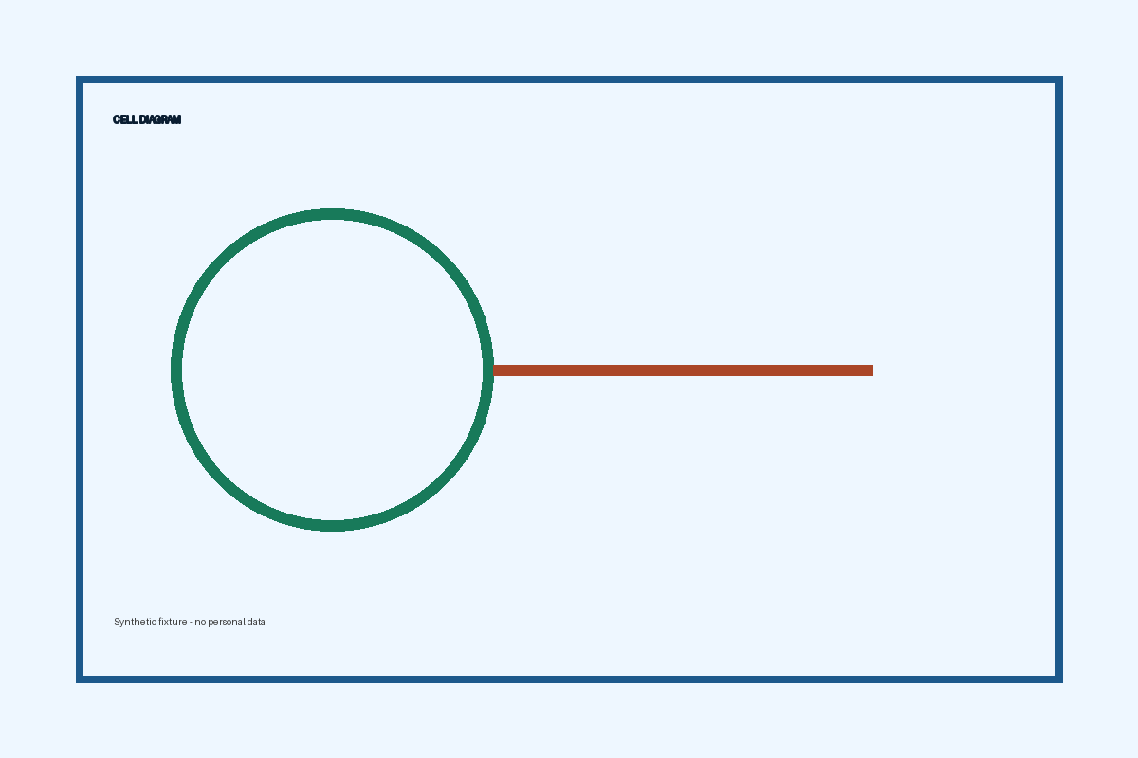
Figure 1. Synthetic cell diagram.

