JURISGUARD: SECURE LEGAL DOCUMENT EXTRACTION AND
ARCHIVING SYSTEM



Presented to the
Institute of Computing
Davao del Norte State College Panabo City, Davao del Norte

In Partial Fulfillment of the Requirements for the Degree
BACHELOR OF SCIENCE IN INFORMATION TECHNOLOGY

CHRISTIAN DAVE S. DURAN
KENT DIETHER B. GERALDO JOHN LYOLD C. LOZADA

MAY 2026
CHAPTER 1

INTRODUCTION

Background of Study
In the global landscape of digital transformation, secure Document Management Systems (DMS) have become essential for maintaining operational efficiency, preserving document integrity, and strengthening resilience against increasing cybersecurity risks [1]. Current international directions in document security emphasize Zero Trust Architecture, where access to protected resources is continuously verified rather than assumed, because organizations that handle sensitive records remain vulnerable to unauthorized access, ransomware incidents, and internal data tampering when controls are weak [2]. In this context, secure legal and administrative recordkeeping is no longer only a technical concern but also an institutional requirement for trustworthy and accountable information management.
This concern also connects with broader development priorities. Effective and secure management of sensitive records supports Sustainable Development Goal (SDG) 16, particularly the promotion of effective, accountable, and transparent institutions, because information systems shape how institutions protect data, maintain traceability, and deliver reliable public and legal services. In the same way, the study is naturally aligned with the DNSC Research, Development, and Extension (RDE) agenda by advancing an ICT-based solution that improves institutional processes, strengthens data protection practices, and promotes socially responsive digital innovation in service-oriented environments.
In the Philippines, records digitization initiatives in State Universities and Colleges show growing recognition that paper-based recordkeeping is inefficient and vulnerable to loss, damage, and retrieval delays [3]. However, the National Privacy Commission warns that spreadsheets remain a weak storage medium for personal data because they commonly lack sufficient security controls, accountability mechanisms, and access restrictions [4]. Despite ongoing digitization efforts, institutions continue to face cybersecurity and service-delivery challenges that weaken compliance and expose sensitive records to accidental deletion, unauthorized copying, and other cyber risks [5], [6].
There is also limited integration between intelligent document processing and security-centered archival design in existing systems. Recent studies show that OCR and legal information extraction can transform scanned documents into searchable and structured digital records [8], [9], [11], while secure document management studies emphasize stronger governance, encryption, and access control in repositories handling sensitive information [1], [2], [12]. However, these approaches are often treated separately, leaving a practical gap for legal and administrative environments that need both accurate metadata extraction from physical documents and fortified archival protection within a single workflow.
At the local level, Philippine implementation studies also suggest that digitization efforts are shaped by infrastructure readiness, user capability, interoperability needs, and organizational support [3], [5], [7]. In legal and administrative settings similar to the present study context, sensitive physical documents such as IDs, affidavits, certificates, and court orders are still commonly handled through manual encoding into unsecured spreadsheets. This process is time-consuming during high-volume intake, makes retrieval less efficient, and leaves confidential client and case information vulnerable to loss, alteration, or unauthorized access.
Despite the relevance of prior studies, there remains limited research that unifies OCR-assisted legal document extraction, verification-based encoding, centralized archival storage, cryptographic protection, role-based access control, multi-factor authentication, and immutable audit logging in one legal-domain platform [1], [2], [8], [9], [11], [12], [13], [14], [16]. This unresolved gap provides the main justification for the study because existing works either emphasize document extraction without sufficiently strengthening archival accountability or prioritize repository security without addressing structured intake from physical legal documents.
This study aims to develop JurisGuard, an intelligent legal document extraction and cryptographically secured archiving system for legal case information management. Specifically, it seeks to automate the extraction of case and client metadata from physical documents, support verification-based encoding, and provide a centralized repository protected through encryption, RBAC, MFA, and immutable audit logging. By doing so, the study intends to improve administrative workflow efficiency while strengthening compliance, accountability, and protection of sensitive legal records.

Objectives of the Study
The primary goal of this project is to develop JurisGuard, an intelligent legal document extraction and cryptographically secured archiving system that protects sensitive case data against threats while ensuring regulatory compliance. Specifically, the project aims:
- To establish a centralized Digital Case Archive that will replace inefficient and unsecured Microsoft Excel spreadsheets for managing sensitive client and case information.
- To develop an OCR-assisted module for extracting case and client metadata from physical legal documents into predefined digital fields.
- To design and integrate a verification interface that allows manual validation of extracted data and supports the tracking, searching, and updating of case histories from intake to termination.
- To implement multi-layered cybersecurity mechanisms, including cryptographic protection, role-based access control, multi-factor authentication, and immutable audit logging, to safeguard encoded data and ensure accountability.
- To produce a secure and efficient legal case information management platform that enhances data retrieval, strengthens administrative workflow, and supports compliance with the Data Privacy Act of 2012.

Significance of Study
The development of JurisGuard introduces a proactive, security-first approach to legal data management. It transforms traditional, vulnerable manual encoding practices into a fortified digital ecosystem. The system also introduces a structured OCR-assisted approach to legal document processing by transforming physical records into searchable, structured data while maintaining a verification-based process that enhances operational efficiency and data integrity. The following are the study's main beneficiaries:
Legal Organizations and Staff. The system will minimize the risk of data breaches and ransomware attacks, ensuring that sensitive client information remains confidential and compliant with national privacy laws.
Administrative and Legal Staff. By replacing manual Excel entries with a centralized platform, the system reduces repetitive clerical work, shortens the time spent on data encoding and retrieval, supports faster client intake processing, and enables staff to focus more on core legal tasks, legal analysis, and client assistance while maintaining a clear audit trail.
Clients. JurisGuard ensures that the highly sensitive documents of clients, such as IDs and court orders, are stored securely, protecting them from unauthorized access and identity theft.
Future Researchers and Developers. This study provides a foundation for future research into Zero Trust legal repositories, OCR-assisted legal document extraction, and the integration of cybersecurity frameworks in small-scale administrative environments.

Scope and Limitation
This study focuses on the design, development, and evaluation of JurisGuard, an intelligent legal document extraction and cryptographically secured archiving system specifically for case information management. The methodology involves the digitization of physical intake documents (IDs, affidavits, certificates, and court orders) into a secured database environment. The system is designed to process printed English and Filipino text from physical legal documents and to automate the extraction of case and client metadata into predefined fields through OCR-assisted processing and verification. The system will handle the complete Information Lifecycle, including data entry, encryption at rest, role-based access, and eventual case termination. Technical features include the implementation of MFA, RBAC, a backend audit logging mechanism, and a verification interface for manual data validation and quality assurance.
The study is limited to the management of digital text and demographic data encoded from physical documents; it does not include the physical storage of the original paper documents. The platform is designed for a specific institutional or legal clinic setting and may require further customization for large-scale corporate firms. The system is optimized for printed documentation, with handwritten or highly stylized text intended for manual entry through the provided verification interface. To maintain alignment with the study scope, JurisGuard treats printed English and Filipino PAO intake documents as the primary supported input. Handwritten, cursive, or highly stylized text is not considered part of the guaranteed extraction scope. When such input is encountered, the system routes the document to the verification interface for manual review and correction. Any cloud-assisted extraction capability is treated only as an optional fallback mechanism and not as a replacement for manual validation or the primary offline OCR-assisted workflow. While the system provides robust defense against common cyber threats like ransomware, its effectiveness is partially dependent on the users' adherence to security protocols, such as not sharing login credentials. The evaluation will focus on the system's security features, workflow efficiency, OCR-assisted extraction performance, and compliance with the Data Privacy Act of 2012.
Review of Related Literature and Works

Related Literature
The present review examines studies relevant to intelligent legal document extraction and cryptographically secured archiving systems. To improve clarity and organization, the discussion is grouped into major themes: secure document management and zero trust architectures, digitization and records governance in the Philippine context, OCR-based digitization and legal information extraction, identity and access control, and the remaining integration gap addressed by JurisGuard.

Secure Document Management and Zero Trust Architectures
Secure document management is now treated not only as a matter of storage efficiency but also as a matter of confidentiality, integrity, and accountability across the document lifecycle. Muñoz-Hernandez, Morales-Sandoval, and GarciaHernandez [1] argued that a robust secure document management system must combine controlled access, traceability, and end-to-end protection of digital records. In the same direction, Miloslavskaya and Tolstoy [2] applied Zero Trust Architecture to document management environments and emphasized that access to protected resources should be continuously verified rather than implicitly trusted. This security orientation is reinforced by NIST SP 800-207, which defines zero trust as a model that continuously verifies identities, devices, and access requests before resources are granted [12]. For systems such as JurisGuard that will manage sensitive legal records, these works establish the importance of encryption, strict authorization, and resource-centered protection.

Digitization and Records Governance in the Philippine Context
Recent Philippine studies also show that digitization efforts are most effective when paired with governance and security controls. Pardiñan, Bondad, and Mangubat [3] found that paper-based records management in Philippine State Universities and Colleges remains vulnerable to misplacement, damage, and retrieval inefficiency, which strengthens the case for digitized records platforms. The National Privacy Commission likewise warned that spreadsheets are a weak storage medium for personal data because they often lack adequate security controls, accountability mechanisms, and access restrictions [4]. Related local studies on digital service delivery and cybersecurity further show that Philippine institutions continue to face infrastructure limitations, inconsistent technical readiness, and security program gaps that can weaken compliance and expose sensitive records to risk [5], [6]. Even in implementation-oriented sectors, such as Philippine primary care settings, digital transformation has been shown to depend on user readiness, process redesign, and institutional support [7]. Collectively, these works show that digitization alone is insufficient unless it is paired with stronger security and governance mechanisms.

OCR-Based Digitization and Legal Information Extraction
A second theme in the literature concerns the transformation of scanned or image-based documents into structured and usable data. Premasiri et al. [8] surveyed legal information extraction research and showed that legal-domain extraction increasingly depends on specialized methods for identifying entities, events, arguments, and relationships from complex documents. Castano et al. [9] further demonstrated that context-aware legal information extraction can improve the accuracy and usefulness of structured legal data. In the Philippine legal domain, Virtucio et al. [10] showed that natural language processing and machine learning can be applied effectively to legal datasets, indicating that computational approaches are viable for legal information systems. At the archival level, Jayoma, Moyon, and Morales [11] demonstrated that OCR-based document archiving and indexing can improve storage and retrieval by converting scanned documents into searchable records. Together, these studies suggest that legal records can move beyond plain storage and can instead become structured, searchable, and analysis-ready information assets.

Identity, Access Control, and Audit-Centered Accountability
Strong identity assurance and traceable access controls are also recurring requirements in the literature on secure repositories. NIST Digital Identity Guidelines [13] recommend authentication mechanisms that are matched to the sensitivity and risk level of the protected service, which supports the use of multifactor authentication for systems storing legal records. Maulina and Rasjid [14] likewise argued that digital evidence repositories require fine-grained access control by integrating role-based and attribute-based approaches so that users access only the information necessary for their responsibilities. At the implementation level, the OWASP Logging Cheat Sheet [16] stresses that application logs should record critical events such as access to sensitive data, privilege changes, data modifications, exports, and other security-relevant actions, and that such logs should be protected from tampering and unauthorized deletion.
These recommendations directly support the inclusion of RBAC, MFA, and immutable audit logging in JurisGuard.

Convergence of Intelligent Processing and Secure Archival Design
Recent systems research points toward the growing convergence of intelligent document handling and strong archival protection. Han and Son [15] proposed a decentralized document management architecture that improves security and integrity through encryption, distributed permissions, blockchainsupported validation, and resilient repository design. Although their application domain is broader than legal case handling, the underlying principle is highly relevant: modern repositories must support both efficient document processing and verifiable security enforcement. This same convergence is implied across the reviewed studies, where extraction-oriented literature [8], [9], [11] and securityoriented literature [1], [2], [12] increasingly point toward integrated, rather than isolated, design approaches.

Synthesis and Research Gap
The reviewed literature reveals several consistent points. First, organizations are moving away from fragmented paper-based and spreadsheetdependent recordkeeping toward centralized digital repositories with stronger governance controls [1], [3], [4]. Second, OCR and legal information extraction methods have been shown to improve indexing, retrieval, and the structuring of document content for downstream use [8], [9], [11]. Third, zero trust principles, strong authentication, access-control models, and tamper-aware logging are increasingly treated as foundational requirements for systems that manage sensitive records [2], [12], [13], [14], [16]. Despite these advances, there remains limited research that unifies OCR-assisted legal document extraction, verificationbased data encoding, centralized archival storage, cryptographic protection, rolebased access control, multi-factor authentication, and immutable audit logging in one platform tailored to legal case information management. This gap justifies the development of JurisGuard, which seeks to integrate these dimensions into a single secure workflow for legal records handling.

Related Works
Various document management and archival solutions have been developed to address digitization, information extraction, search, and security concerns in administrative and legal environments. Some systems emphasize OCR or legal information extraction, while others focus on access control, integrity, or decentralized storage. The reviewed studies show meaningful progress, but they also reveal that many existing solutions still address only one side of the problem, either intelligent extraction or strong repository protection, rather than both within a single legal records platform.
System | OCR /  Extracti on | Search able Reposit ory | RBAC /  Access Control | MFA | Audit Loggi ng | Encryptio  n /  Secure  Storage | Verificati on Workflo w
ASKE  Approach | ✓
DSWD  OCR  Archive | ✓ | ✓
Records  Digitization  Platform |  | ✓
Digital  Evidence  Access  Model |  | ✓ | ✓ |  | ✓ | ✓
Decentraliz ed DMS |  | ✓ | ✓ |  | ✓ | ✓
JurisGuard (Proposed) | ✓ | ✓ | ✓ | ✓ | ✓ | ✓ | ✓

Table 1. Comparison of related studies/systems and the proposed JurisGuard
system.

As shown in Table 1, existing studies and systems tend to emphasize either information extraction or secure archival protection, but seldom combine both at the level needed for legal case management. The ASKE legal information extraction approach [9] and the DSWD OCR-based archiving system [11] demonstrate the value of extraction and searchable repositories, yet they do not foreground advanced cybersecurity controls such as multi-factor authentication, cryptographic protection, and immutable logging. Philippine digitization studies [3] highlight the importance of workflow modernization, but they are not specifically framed as OCR-driven legal records platforms. By contrast, the unified access management model for digital evidence storage [14] and the decentralized document management architecture [15] emphasize access governance, integrity, and secure storage, but they do not focus on OCR-assisted intake of physical legal documents. JurisGuard distinguishes itself by integrating OCR-assisted extraction, verification-based encoding, centralized storage, role-based access control, multifactor authentication, audit logging, and secure archival protection in one legaldomain system.

Definition of Terms
Access Control. Refers to the security mechanism that regulates which users can view, encode, modify, or manage case records and system resources within JurisGuard.
Administrative Workflow. Refers to the sequence of processes involved in encoding, retrieving, updating, and managing legal case information in the system.
Audit Log. Refers to the system-generated record of user actions and transactions, maintained to support traceability, accountability, fallback monitoring, and tamper-evident activity review.
Case Metadata. Refers to the structured case-related information extracted or encoded in the system, such as case details, document attributes, and clientrelated data.
Centralized Digital Case Archive. Refers to the organized repository in JurisGuard where encoded and extracted legal case information is stored, managed, and retrieved securely.
Cryptographic Protection. Refers to the application of encryption and related security methods to protect legal records from unauthorized access, disclosure, or alteration.
Data Integrity. Refers to the accuracy, completeness, and consistency of legal case information stored and processed within the system.
Document Management System (DMS). Refers to the digital platform used to store, organize, manage, and secure documents and related records in a structured environment.
Encryption at Rest. Refers to the protection of stored data through encryption while the information resides in the database or storage system.
Encryption in Transit. Refers to the protection of data while it is being transmitted across networks to prevent interception or unauthorized access.
Information Lifecycle Repository. Refers to the system environment that manages legal case information from document intake and encoding up to storage, retrieval, updating, and case termination.
JurisGuard. Refers to the proposed intelligent legal document extraction and cryptographically secured archiving system developed for secure case information management.
Legal Document Extraction. Refers to the process of obtaining relevant case and client information from physical legal documents and converting it into structured digital data.
Multi-Factor Authentication (MFA). Refers to the authentication method that requires users to provide two or more verification factors before gaining access to the system.
Optical Character Recognition (OCR). Refers to the technology used by the system to recognize printed text from scanned or photographed legal documents and convert it into machine-readable form.
Printed Documentation. Refers to physical legal records containing printed or handwritten English or Filipino text that are intended for OCR-assisted processing within the study.
Role-Based Access Control (RBAC). Refers to the access management approach in which permissions are assigned according to the specific roles and responsibilities of authorized users.
Verification Interface. Refers to the system feature that allows users to review, validate, and correct OCR-extracted case and client metadata before final storage.
Zero Trust Architecture. Refers to the security model that requires continuous verification of users and access requests rather than assuming trust based on network location or prior access.

CHAPTER 2

METHODOLOGY
This chapter presents the methodology used in the development of JurisGuard: Secure Legal Document Extraction and Archiving System. It explains how the study is planned, organized, developed, tested, and improved to achieve the objectives of the project. The chapter also discusses the system development model, system planning activities, system design, database structure, technologies used, testing procedures, implementation plan, security plan, and maintenance strategy.
The study adopts a hybrid System Development Life Cycle (SDLC) that combines the structured phases of the Waterfall model with the iterative improvement process of Agile. The Waterfall approach is applied in the Planning, Analysis, and Design phases to define the project scope, system requirements, architecture, and development direction in a clear and organized manner [17], [18]. After the design phase, Agile is integrated through Prototype Testing and Refinement, where selected system components are developed, reviewed, and improved in short iterative cycles before full implementation [19], [20]. Each sprint lasts for two weeks, and feedback is gathered at the end of every sprint to evaluate the prototype output, identify issues, and determine the revisions needed for the next cycle [19], [21]. This hybrid approach is appropriate for JurisGuard because the study requires both a well-defined development structure and repeated refinement of key features such as OCR-assisted extraction, verification-based encoding, and secure legal records management [17], [20].
During the prototype stage, stakeholder validation is conducted after each sprint through review sessions involving the researchers, adviser, and intended users such as legal staff. These review sessions assess whether the prototype meets the expected workflow, usability, extraction accuracy, and security requirements of the system [20], [22]. Acceptance testing checkpoints are placed after the Design phase, after each prototype iteration, and before full implementation to confirm that the developed modules satisfy the defined functional and non-functional requirements [18], [21]. If the prototype does not meet the expected standard, it is returned to the Refinement cycle for improvement before proceeding further. This process helps ensure that each major component is validated, tested, and accepted before it becomes part of the final deployed system [19], [22].
Short risk management procedures are also integrated into the methodology to address possible issues such as poor scan quality, inaccurate OCR extraction, user input errors, and access-related problems. To reduce these risks, the study applies controlled user access, continuous testing, verification based encoding, and review of extracted outputs before final storage [23], [24]. Fallback handling is provided through manual verification and manual data entry whenever scanned documents are unreadable, incomplete, or produce low confidence OCR results. The OCR model refinement workflow follows a repeated process of document input, extraction, verification, error identification, correction, preprocessing adjustment, and retesting to improve extraction performance across successive iterations [20], [23]. Through this approach, the SDLC supports the systematic, flexible, and quality-oriented development of JurisGuard [17], [21].

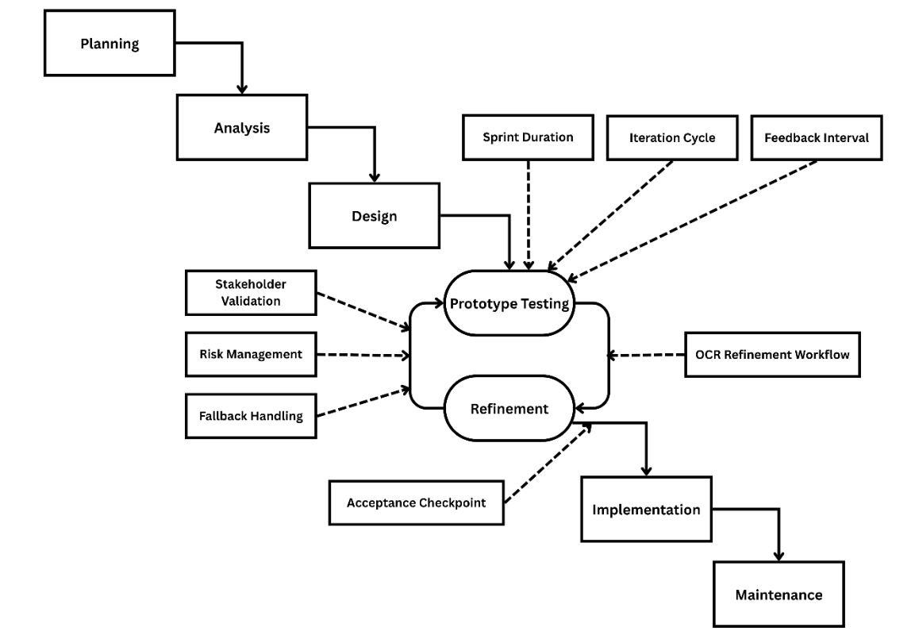
Figure 1. Proposed Hybrid Waterfall-Agile SDLC Model
SYSTEM PLANNING Project Team Organization
The project team, as shown in Figure 2, is structured to promote clear coordination and proper distribution of responsibilities throughout the development of JurisGuard. The Adviser provides academic and technical guidance to ensure that the study and the proposed system meet the required standards of the capstone project. The Project Manager, together with the Documentation role, is responsible for overseeing the project timeline, coordinating tasks, monitoring progress, and preparing the necessary project documents and reports. The System Analyst focuses on examining user needs, identifying system requirements, and helping define the overall structure and functions of the proposed legal document extraction and archiving system, while the System Developer is responsible for coding, integration, and implementation of the system features. This team structure supports effective collaboration by balancing project management, documentation, system analysis, and technical development in an organized and practical manner.

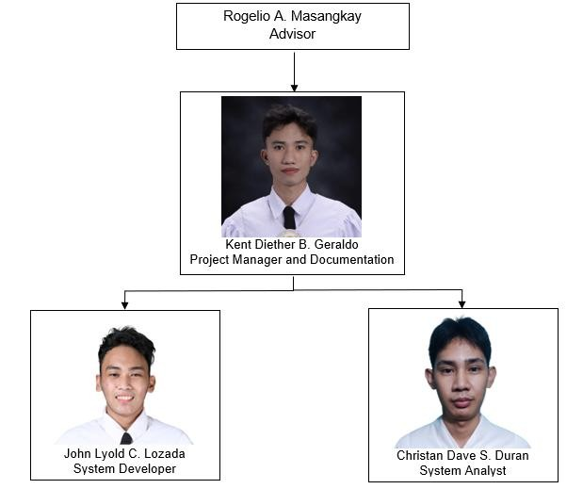
Figure 2. Project Management Team Organization

Work Breakdown Structure
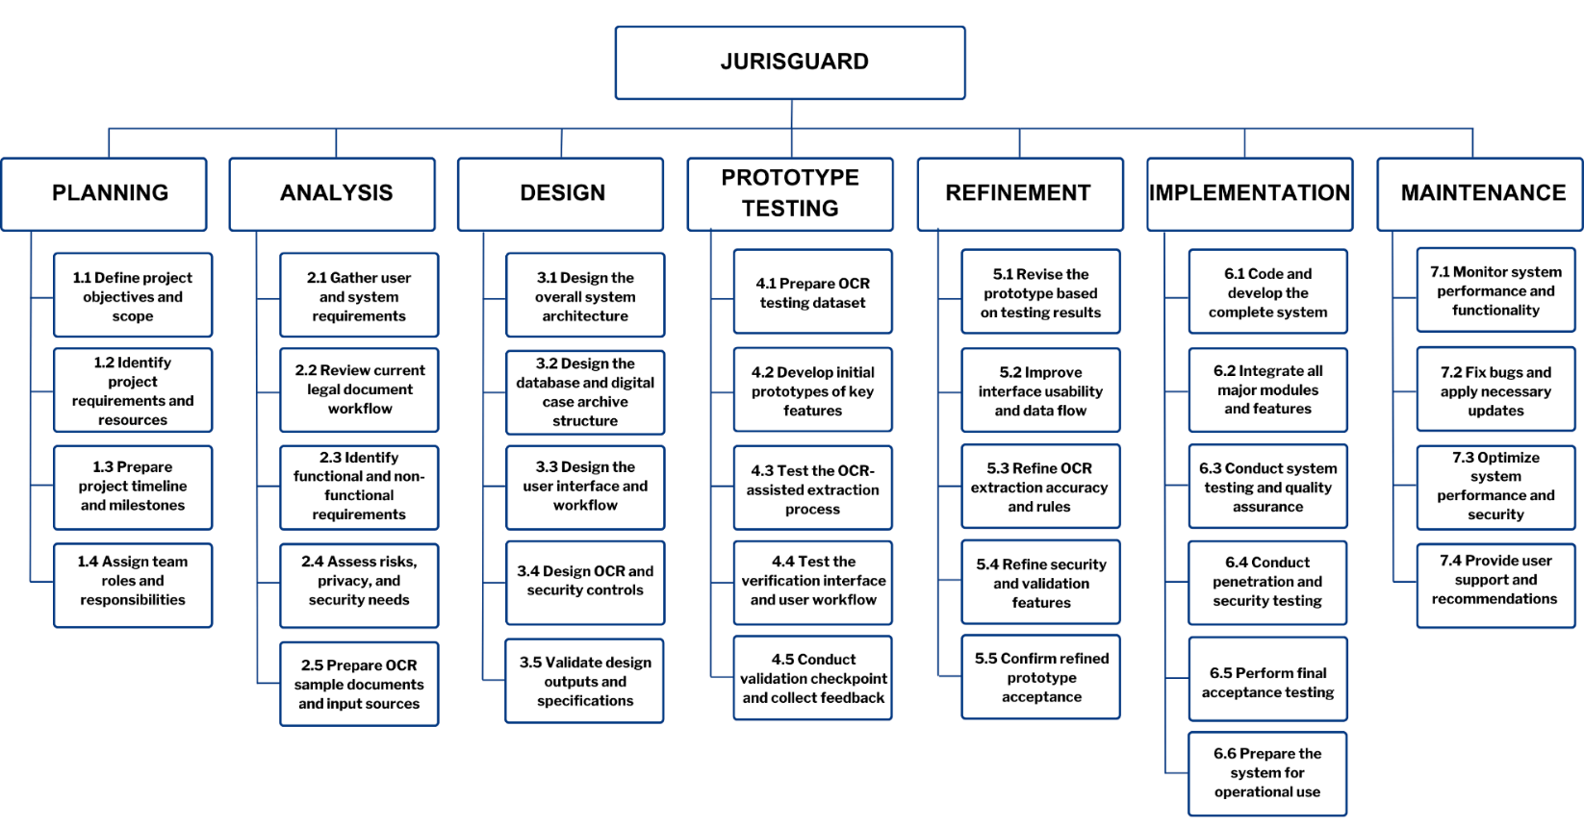
The Work Breakdown Structure (WBS), as shown in Figure 3, presents the development of JurisGuard through seven major phases: Planning, Analysis, Design, Prototype Testing, Refinement, Implementation, and Maintenance. Each phase is divided into specific tasks to ensure that the important activities of the project, from defining objectives and gathering requirements to testing, implementation, and system improvement, are clearly organized and properly sequenced. This structure helps the researchers manage the project in a systematic way while making sure that the major components of the proposed system are addressed at the appropriate stages of development. The WBS also reflects the actual needs of JurisGuard as a secure legal document extraction and archiving system by including activities related to OCR preparation, validation, security checking, and user-oriented improvement. Through this arrangement, key features such as OCR-assisted extraction, verification-based encoding, centralized archiving, and security controls can be developed and monitored more effectively. It also supports better task allocation, time management, and coordination among the members of the project team throughout the study. Overall, the WBS serves as a practical guide for the organized and efficient completion of the capstone project.
Figure 3. Work Breakdown Structure of JurisGuard Development

Gantt Chart
The Gantt chart in Figure 4 presents the timeline of activities for the development of JurisGuard, showing how each phase is arranged from Planning, Analysis, and Design to Prototype Testing, Refinement, Implementation, and Maintenance. It illustrates the sequence and duration of major tasks such as requirements gathering, system design, feature testing, refinement, coding, integration, and system evaluation within the project period. By organizing the work into a clear schedule, the chart helps the researchers monitor progress, manage time effectively, and maintain coordination throughout the study. It also serves as a guide to ensure that each phase is completed in the correct order before moving to the next stage of development project.

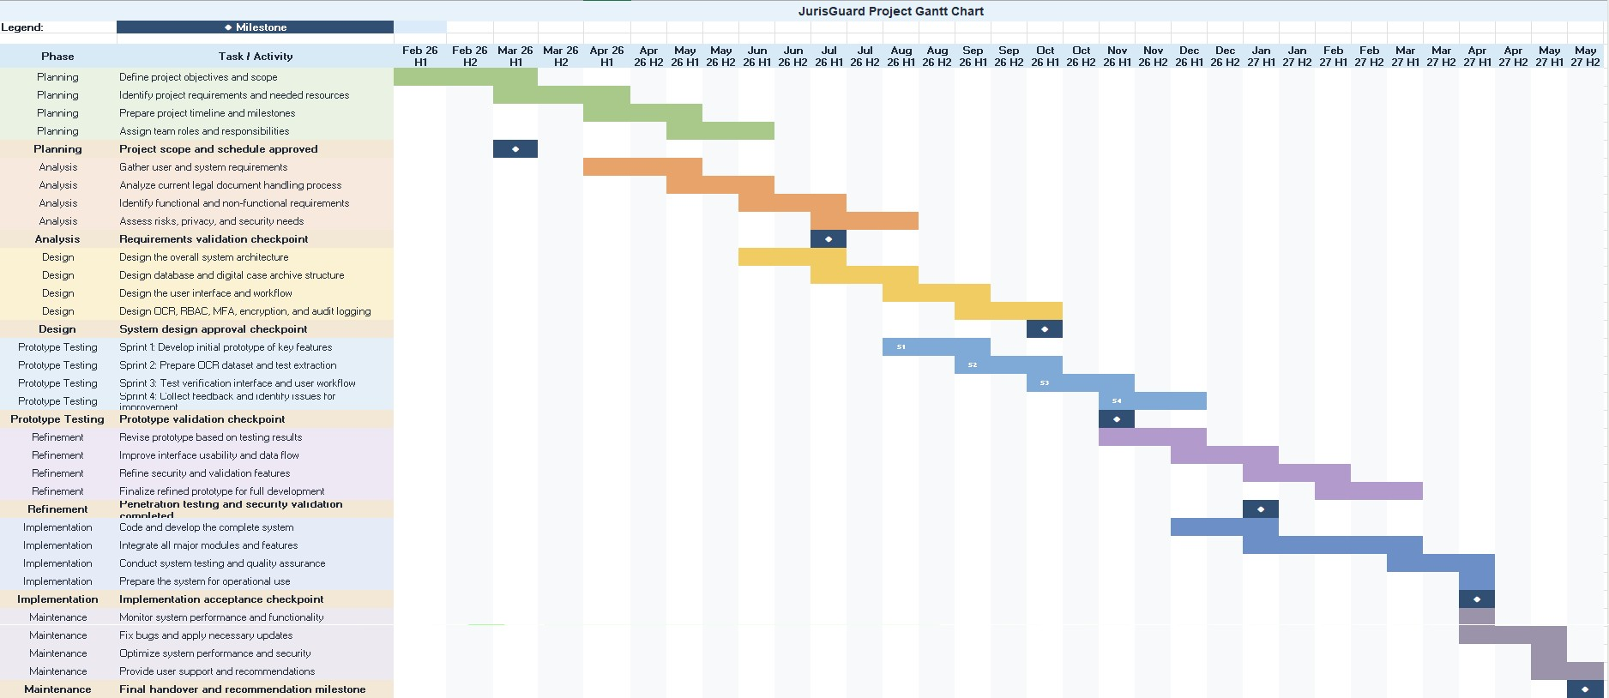

Figure 4. JurisGuard Project Gantt Chart

System Architecture
The system architecture of JurisGuard, as shown in Figure 5, presents the main components and overall flow of the proposed legal document extraction and archiving system. It is designed to support secure access, organized case handling, API communication, offline-first document extraction, human verification, centralized database storage, audit logging, and geospatial analytics for barangay-based case monitoring.
From the dashboard, users can access the main modules of the system, including Client Management, Criminal Case Management, Verification, Audit Logs, Analytics, Report Export, and Search and Record Retrieval. These modules communicate with the FastAPI Application Server, which serves as the main API layer for authentication, record handling, document processing, extraction mode control, and database operations.

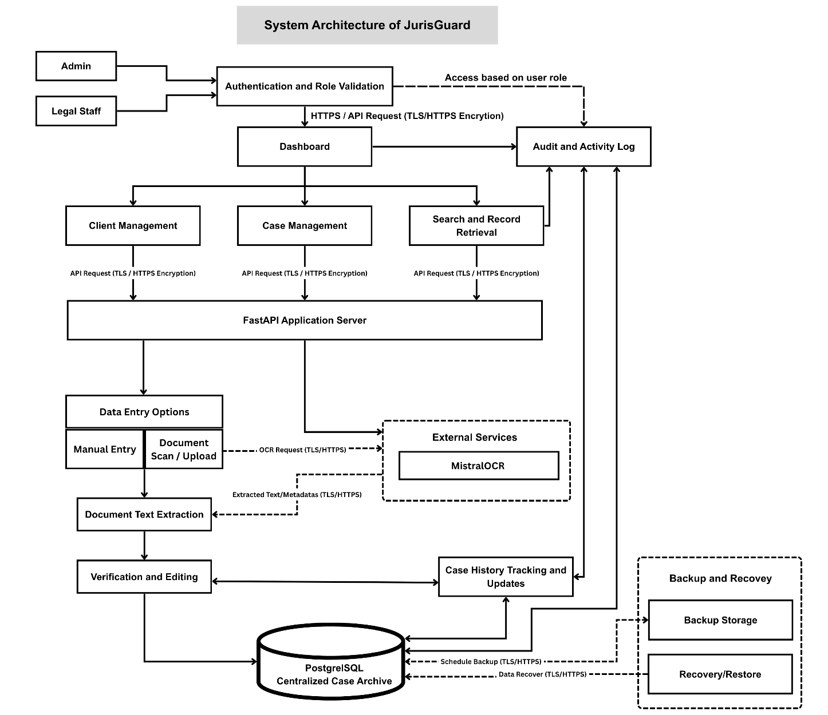
Figure 5. System Architecture of JurisGuard

Functional and Non-Functional Requirements
The functional and non-functional requirements define the expected capabilities and quality characteristics of JurisGuard as a secure legal document extraction and archiving system. The functional requirements identify the main services the system must perform in support of legal record intake, document processing, storage, retrieval, and monitoring. The non-functional requirements describe the quality conditions that the system must meet to operate effectively, securely, and reliably, following the ISO/IEC 25010 software quality model. Together, these requirements provide a clear basis for system development, evaluation, and future improvement.

Functional Requirements
The system shall provide the following functionalities:
- The system shall allow only authorized users, specifically the Administrator and Legal Staff, to access the system through a secure login process.
- The system shall validate user credentials and identify the corresponding user role before granting access to the system.
- The system shall provide role-based access control so that users can only access functions permitted for their assigned role.
- The system shall provide a dashboard that serves as the main access point to the system’s records and major functions.
- The system shall allow users to create, view, update, and manage client records.
- The system shall allow users to create, view, update, and manage case records.
- The system shall support manual data entry for client and case information.
- The system shall allow users to scan or upload legal documents for record processing.
- The system shall allow document uploads with a maximum file size of 32 MB per file to support scanned legal documents while maintaining manageable system performance and storage use.
- The system shall extract text and relevant data from scanned or uploaded legal documents.
- The system shall allow users to review, verify, and edit extracted document data before final submission.
- The system shall attempt document extraction through the offline OCR/NLP pipeline before any cloud-assisted processing is considered.
- The system shall mark extracted data as unverified until reviewed, corrected, and approved by an authorized user through the verification interface.
- The system shall allow cloud-assisted extraction only when enabled by the Administrator or institutional policy.
- The system shall record the extraction mode used for each document, such as offline OCR/NLP, manual entry, or cloud-assisted extraction.
- The system shall record the reason for cloud-assisted fallback, including low OCR confidence, incomplete required fields, poor scan quality, or complex layout.
- The system shall store approved client, case, and document information in a centralized archive.
- The system shall allow users to search, filter, and retrieve stored records efficiently.
- The system shall support case history tracking by recording updates and changes made to case records over time.
- The system shall record important user actions and system events in an audit log for monitoring and accountability.
- The system shall retain audit log records for five years to support case monitoring, activity tracing, security review, and investigation of unauthorized or suspicious actions, unless a longer retention period is required by institutional policy.
The following are the system’s non-functional requirements:
- Functional Suitability. The system shall provide functions that are appropriate, complete, and accurate for legal document extraction, verification, case management, archival storage, and record retrieval.
- Performance Efficiency. The system shall process login requests, record submission, document extraction, verification, storage, search, dashboard analytics, and retrieval within a reasonable response time that supports daily legal office operations. The system shall also reduce repeated loading by reusing recently fetched dashboard data where appropriate.
- Compatibility. The system shall operate properly within the intended institutional environment and support consistent interaction among its modules for authentication, record handling, document extraction, storage, and monitoring.
- Usability. The system shall provide a clear, understandable, and easy-to-use interface that allows Administrator and Legal Staff users to perform their tasks with minimal confusion and training.
- Reliability. The system shall perform its required functions consistently during login, record processing, storage, retrieval, and audit monitoring, while minimizing errors and data loss during normal use.
- Security. The system shall protect sensitive legal and client information through authentication, role-based access control, secure password handling, multi-factor authentication support, controlled record access, tamper-evident audit logging, and secure handling of uploaded document paths and extracted metadata.
- Maintainability. The system shall be organized in a way that supports correction of errors, modification of features, and future enhancement of system functions without major difficulty.
- Portability. The system shall be capable of being deployed, transferred, or adapted to the intended computing environment of similar legal or institutional offices with minimal changes to its core functions.
Requirement Traceability Matrix
Requirement | System Module | Evidence / Test
Secure login | Authentication module | Login test, password hashing, session control
Role-based access | RBAC module | Admin and Legal Staff access test
OCR-assisted extraction | Offline extraction module | PaddleOCR output and field mapping result
Manual verification | Verification interface | User review before final save
Centralized archive | PostgreSQL database | Client, intake, case, document, and metadata records
Case history tracking | Case management module | Status updates and termination records
Audit logging | Audit module | Login, upload, update, verification, and fallback logs
Data protection | Security layer | Encryption, access control, and backup policy
Cloud fallback control | Extraction policy module | Admin setting, confirmation, and fallback audit log
Backup and recovery | Maintenance module | Backup schedule and restoration test
Table 2. Requirement Traceability Matrix

Use Case Diagram
As shown in Figure 6, the Use Case Diagram of JurisGuard shows the main users and functions of the system. The two actors are the Legal Staff and the Administrator. The Legal Staff is the main user who handles daily tasks such as logging in, accessing the dashboard, managing client records, managing case records, uploading legal documents, entering data manually, verifying extracted data, searching and retrieving records, and tracking case history. The Administrator supervises the system by managing user accounts, viewing audit logs, monitoring activities, and accessing records based on the allowed permissions.
The diagram is arranged in a clearer way so the system functions are easier to understand. Common functions such as logging in and accessing the dashboard are placed near the top, while record management and document processing functions are placed in the middle to show the main workflow of the system. Monitoring functions such as viewing audit logs and tracking case history are also included to show how the system keeps records of important activities. This arrangement helps reduce crossing lines and makes the connections between the users and system functions easier to follow.
The diagram also uses simpler relationships between use cases. For example, uploading a legal document may lead to document text extraction, and the extracted data is checked and edited before it becomes part of the case record. This shows how JurisGuard supports the handling of legal records from user access, document processing, record storage, searching, case tracking, and audit monitoring. Overall, the revised Use Case Diagram gives a clearer view of how the Legal Staff and Administrator use the main features of the system.
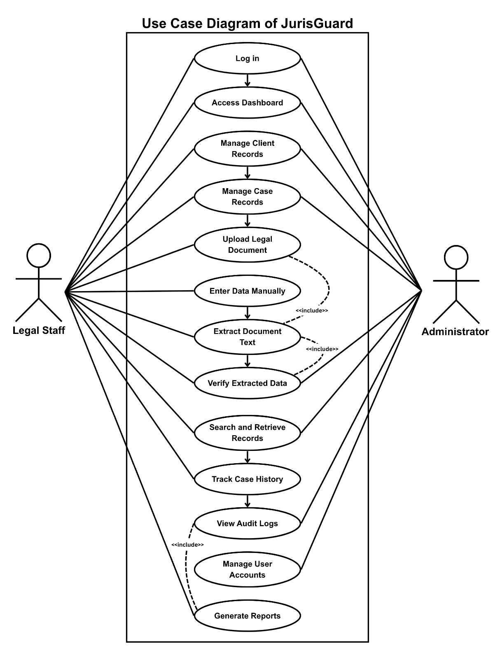
Figure 6. Use Case Diagram of the JurisGuard

Context Flow Diagram
The Context Flow Diagram shown in Figure 7 presents a high-level view of
JurisGuard by showing the main external entities connected to the system and the general flow of data between them. At the center of the diagram is JurisGuard, which represents the secure legal document extraction and archiving system. The diagram focuses on how external users and services interact with the system without showing the detailed internal processes or database operations.
The Legal Staff acts as the primary user by sending credentials, client and case data, document data, search requests, and update requests to the system. In return, the system provides access results, verified record data, and record or case history data. The Administrator functions as the secondary user by sending credentials, user account data, and audit log requests. The system then returns access results, user account data, and audit log data for monitoring and system control.
The diagram also shows the connection between JurisGuard and the OCR Service. The system sends document image data to the OCR Service, and the OCR Service returns extracted text data for further processing and verification. These data flows show how information enters, is processed, and is returned by the system to support secure login, record handling, document extraction, record retrieval, updating, and audit monitoring. Overall, the Context Flow Diagram explains how JurisGuard interacts with its users and supporting external service in one clear and organized process.
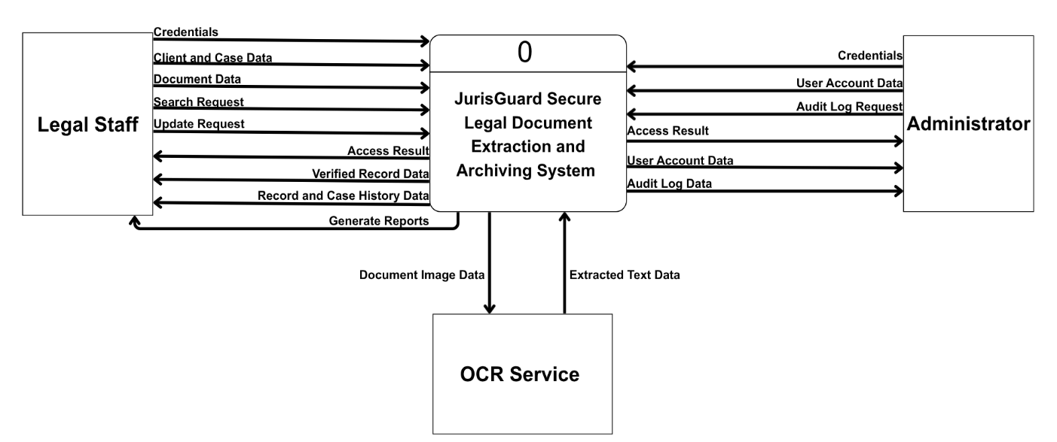
Figure 7. Context Flow Diagram of the JurisGuard

Data Flow Diagram
The Data Flow Diagram shown in Figure 8 presents a more detailed view of JurisGuard by breaking the system into its major internal processes. The diagram is composed of five main processes: 1.0 Authenticate User and Validate Role, 2.0 Manage Client and Case Records, 3.0 Process and Verify Documents, 4.0 Store and Retrieve Records, and 5.0 Monitor Audit and Case History. This structure helps explain how data moves through the system from user authentication, record handling, and document processing up to storage, retrieval, and monitoring. As a result, the diagram gives a clearer understanding of how the proposed secure legal document extraction and archiving system works in practice.
The main external entities shown in the diagram are the Administrator, Legal Staff, and OCR Service. The Administrator and Legal Staff both provide credentials to the authentication process and receive access results after validation. The authentication process also checks user account data through the D1 User Accounts data store to confirm the identity and role of the user. After successful access, authorized user data is passed to the next process, allowing the users to continue with record management, document processing, and other system functions based on their allowed permissions.
The 2.0 Manage Client and Case Records process handles client and case data, record requests, and other record-related inputs from the users. It stores client and case data in D2 Client and Case Records and sends record data for processing to 3.0 Process and Verify Documents. In this process, document data from the Legal Staff is prepared for extraction, then document image data is sent to the OCR Service. The OCR Service returns extracted text data, which is then reviewed and verified before becoming verified record data. Once approved, the record data moves to 4.0 Store and Retrieve Records, which stores, updates, and retrieves information from D2 Client and Case Records and D3 Document Records.
The diagram also shows that monitoring and accountability are handled through 5.0 Monitor Audit and Case History. This process receives activity and update data from the storage and retrieval process, then stores and accesses audit and case history data through D4 Audit and Case History Log. Through this flow, the Administrator can request and receive audit log data, while the Legal Staff can receive retrieved record data and case history data needed for daily operations. Overall, the diagram explains how JurisGuard manages authentication, client and case records, document processing, storage, retrieval, audit logging, and case history monitoring in one connected and organized system.
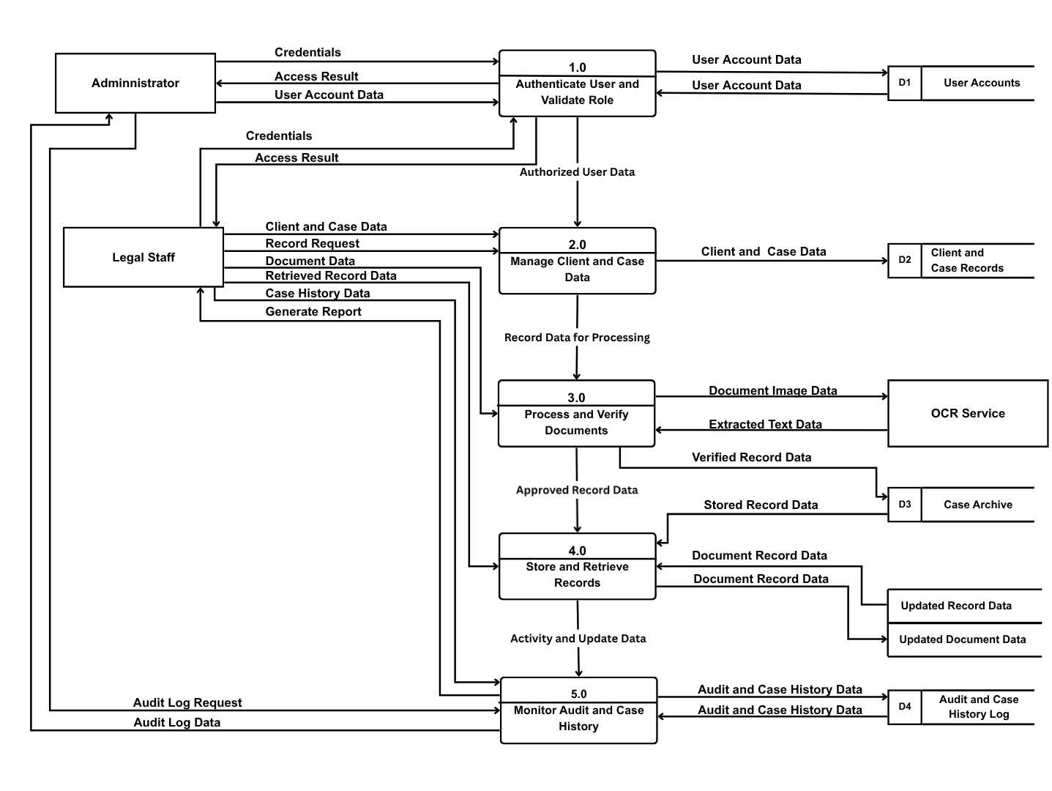
Figure 8. Data Flow Diagram of the JurisGuard

SYSTEM DESIGN

Entity Relationship Diagram
The Entity Relationship Diagram (ERD) of JurisGuard shows the database structure used to support secure legal document extraction and archiving. It presents the main entities of the system, including Users, Roles, Clients, Client Details, Client Classification, Intake Records, Cases, Documents, Extracted Metadata, Representatives, Adverse Parties, Court Branches, Case Nature, and Audit Logs. These entities are connected through primary and foreign keys to ensure that client information, case records, uploaded documents, extracted data, and user activities are properly organized and linked.
The USER and ROLE entities support authentication, authorization, and role-based access control. Each user is assigned to a role, while the AUDIT_LOG entity records important actions performed in the system for monitoring and accountability. The CLIENT entity stores the main client profile, while CLIENT_DETAILS and CLIENT_CLASSIFICATION provide additional personal, contact, demographic, and classification information. These tables help create a complete client record while keeping related data organized.
The INTAKE_RECORD entity connects the client to the initial legal request and stores information about the intake process, including the assigned interviewer and case details. It is also linked to the REPRESENTATIVE and ADVERSE_PARTY entities, which store information about other persons involved in the case. The CASES entity connects the client and intake record to actual case information, while CASE_NATURE and COURT_BRANCH serve as reference tables for standard case classifications and court assignments.
The DOCUMENT entity stores information about uploaded legal documents connected to cases and intake records. The EXTRACTED_METADATA entity stores OCR-related results, extracted data, verification status, and the user who verified the information. The CASE_HISTORY entity records status changes and actions taken on a case, while the AUDIT_LOG entity records user and system activity using a hash-chain structure for tamper-evident accountability. Overall, the ERD shows how JurisGuard manages user access, client data, criminal case records, document processing, verification, analytics, and traceability.
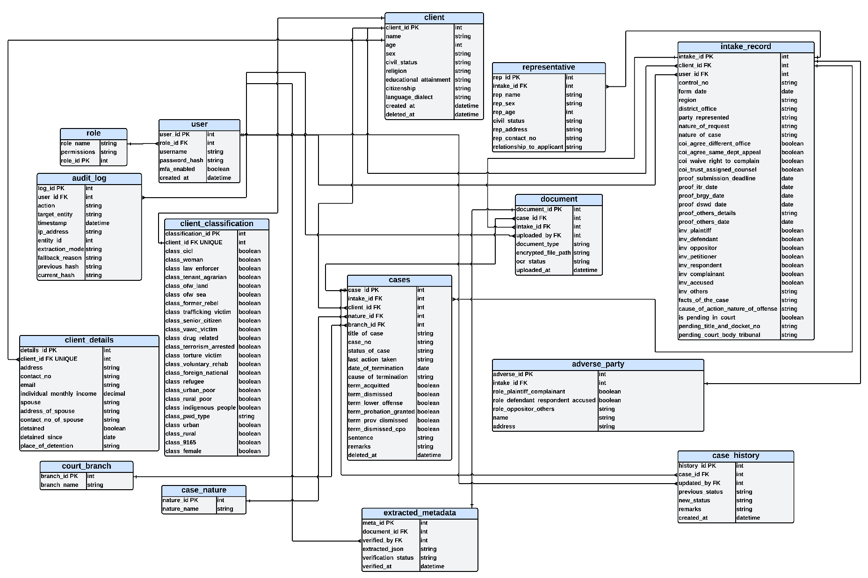

Figure 9. Entity relationship diagram of the JurisGuard

Data Dictionary
The Data Dictionary presents the complete structure of the database used in JurisGuard and serves as a guide for how information is defined, stored, linked, and managed within the system. It identifies the tables, fields, data types, field lengths, constraints, and descriptions that support the main functions of the proposed secure legal document extraction and archiving system. This section is important because it helps make the database more organized, consistent, and understandable during development, testing, and future maintenance. In the case of JurisGuard, the Data Dictionary also supports the study’s goal of handling legal case information through centralized storage, OCR-assisted extraction, verification, and secure access control.
The first group of tables supports user access and system control. The ROLE table defines the available roles in the system and includes fields such as role_id, role_name, and permissions, which help determine what actions each type of user is allowed to perform. Related to this, the USER table stores account information such as user_id, role_id, username, password_hash, mfa_enabled, and created_at, making it possible to manage secure login, role assignment, and multi-factor authentication. Together, these tables support the system’s requirement for controlled access, role-based permissions, and secure account management for authorized users such as the Administrator and Legal Staff.
The next set of tables focuses on client information, which forms a major part of the system’s legal records database. The CLIENT table stores the client’s basic profile, including name, age, sex, civil status, religion, educational attainment, citizenship, language or dialect, creation timestamp, and soft delete marker, with some highly sensitive values marked as encrypted. The CLIENT_CLASSIFICATION table extends this by recording legal and social classifications such as CICL, woman, law enforcer, trafficking victim, senior citizen, drug-related classification, indigenous group, disability type, and other reporting categories. Meanwhile, the CLIENT_DETAILS table stores more specific personal and contact information, including address, contact number, email, monthly income, spouse details, and detention-related information, which further supports the system’s need to manage sensitive legal and demographic records in an organized manner.
JurisGuard also includes tables that support intake processing and case management. The INTAKE_RECORD table links the client to the intake transaction and stores fields such as intake_id, client_id, interviewer_id, control_no, form_date, region, party_represented, and nature_of_case. Building on this, the CASE table stores the actual case record using fields such as case_id, intake_id, client_id, nature_id, branch_id, title_of_case, case_no, status_of_case, last_action_taken, date_of_termination, and cause_of_termination. These tables are important because they connect client intake information to the actual legal case being handled, allowing the system to track case status from initial intake up to termination while maintaining a clear relationship between records.
The database structure also supports document management and OCR assisted processing, which are central features of the study. The DOCUMENT table stores information about uploaded legal documents, including document_id, case_id, intake_id, uploaded_by, document_type, encrypted_file_path, ocr_status, and uploaded_at. The CASE_HISTORY table stores chronological updates made to case records. It supports the tracking of case progress from intake to termination by preserving previous and new case statuses, actions taken, remarks, the responsible user, and the date and time of each update. This prevents important case changes from being overwritten and strengthens accountability in legal case management. After document upload, the EXTRACTED_METADATA table stores OCR-related results such as meta_id, document_id, verified_by, extracted_json, verification_status, and verified_at, making it possible for the system to keep both the extracted data and the verification history. These tables directly support the proposed workflow of scanning or uploading legal documents, extracting text into structured form, and allowing review before final storage.
To support traceability and fuller case context, the database includes several additional tables. The AUDIT_LOG table records important user actions using fields such as log_id, user_id, action, target_entity, timestamp, and ip_address, which helps the system maintain accountability and activity monitoring. The REPRESENTATIVE table stores information about the client’s representative, while the ADVERSE_PARTY table stores information about the opposing or related party in the case, including role indicators and encrypted personal details. These tables strengthen the system’s ability to preserve complete legal case information while also supporting secure monitoring of who accessed or changed the records.
Lastly, the COURT_BRANCH and CASE_NATURE tables serve as reference or lookup tables that help standardize important case-related values used in the system. By storing consistent branch and case nature entries, these tables improve data organization and reduce inconsistency during data entry and case management. Overall, the Data Dictionary shows that the database of JurisGuard is not limited to simple record storage, but is carefully structured to support user authentication, client profiling, case intake, document handling, OCR verification, audit logging, and standardized legal record management. In this way, the Data Dictionary helps explain how the database serves as the foundation of the system and supports the overall operation of JurisGuard as a secure and organized legal document extraction and archiving platform.

Field Name | Data Type | Field  Length | Constraints | Description
role_id | INT | 10 | PK, Auto  Increment | Unique identifier
role_name | VARCHAR | 30 | NOT NULL | Name of role
permissions | TEXT |  | Optional | Role permissions

Table 3: ROLE

Field Name | Data Type | Field Length | Constraints | Description
user_id | INT | 10 | PK | Unique user ID
role_id | INT | 10 | FK → ROLE | Role reference
username | VARCHAR | 30 | UNIQUE, NOT NULL | Login username
password_hash | VARCHAR | 255 | NOT NULL | Password hash
mfa_enabled | BOOLEAN |  | Default FALSE | MFA status
created_at | DATETIME |  | NOT NULL | Account creation date
mfa_secret | VARCHAR | 64 | Optional | MFA secret
email | VARCHAR | 255 | Indexed | User email
full_name | VARCHAR | 255 | Optional | User full name
approval_status | VARCHAR | 30 | Default pending | Account status
is_active | BOOLEAN | - | Default TRUE | Active flag

Table 4: USER

Field Name | Data Type | Field Lengt h | Constraints | Descriptio n
client_id | INT | — | PK, NOT NULL | Unique  identifier of the client
name | VARCHA  R | 255 | NOT NULL | Full name  of the client (Encrypted)
age | INT | — | NULL | Age of the client
sex | VARCHA  R | 10 | NULL | Gender (Male/Fema  le)
civil_status | VARCHA  R | 50 | NULL | Civil status
religion | VARCHA  R | 100 | NULL | Religion
educational_attain ment | VARCHA  R | 150 | NULL | Highest educational attainment
citizenship | VARCHA  R | 100 | NULL | Citizenship
language_dialect | VARCHA  R | 100 | NULL | Language  or dialect
created_at | TIMESTA  MP | — | DEFAULT  CURRENT_TIMEST  AMP | Record creation timestamp
deleted_at | TIMESTA  MP | — | NULL | Soft delete timestamp

Table 5: CLIENT

Field Name | Data Type | Field  Length | Constraints | Description
classification_id | INT | — | PK, NOT  NULL | Unique identifier
client_id | INT | — | FK, NOT  NULL | References  CLIENT.client_id
class_cicl | BOOLEAN | — | DEFAULT  FALSE | Child in Conflict with the Law
class_woman | BOOLEAN | — | DEFAULT  FALSE | Woman
class_law_enforcer | BOOLEAN | — | DEFAULT  FALSE | Law enforcer
class_tenant_agrarian | BOOLEAN | — | DEFAULT  FALSE | Agrarian tenant
class_ofw_land | BOOLEAN | — | DEFAULT  FALSE | OFW (landbased)
class_ofw_sea | BOOLEAN | — | DEFAULT  FALSE | OFW (sea-based)
class_former_rebel | BOOLEAN | — | DEFAULT  FALSE | Former rebel
class_trafficking_victim | BOOLEAN | — | DEFAULT  FALSE | Victim of trafficking
class_senior_citizen | BOOLEAN | — | DEFAULT  FALSE | Senior citizen
class_vawc_victim | BOOLEAN | — | DEFAULT  FALSE | VAWC victim
class_drug_related | BOOLEAN | — | DEFAULT  FALSE | Drug-related case
class_terrorism_arrested | BOOLEAN | — | DEFAULT  FALSE | Arrested for terrorism-related case
class_torture_victim | BOOLEAN | — | DEFAULT  FALSE | Torture victim
class_voluntary_rehab | BOOLEAN | — | DEFAULT  FALSE | Under voluntary rehabilitation
class_foreign_national | VARCHAR | 100 | NULL | Foreign national classification
class_refugee | VARCHAR | 100 | NULL | Refugee  classification
class_urban_poor | VARCHAR | 100 | NULL | Urban poor  classification
class_rural_poor | VARCHAR | 100 | NULL | Rural poor classification
class_indigenous_people | VARCHAR | 100 | NULL | Indigenous group classification
class_pwd_type | VARCHAR | 100 | NULL | Type of disability
class_urban | BOOLEAN | — | DEFAULT  FALSE | Urban  classification (reporting)
class_rural | BOOLEAN | — | DEFAULT  FALSE | Rural  classification (reporting)
class_9165 | BOOLEAN | — | DEFAULT  FALSE | Related to RA  9165
class_female | BOOLEAN | — | DEFAULT  FALSE | Female tally classification

TABLE 6: CLIENT_CLASSIFICATION

Field Name | Data Type | Field Lengt h | Constraint s | Description
details_id | INT | — | PK, NOT  NULL | Unique  identifier
client_id | INT | — | FK, NOT  NULL | References CLIENT.client_i d
address | VARCHAR | 255 | NULL | Client address  (Encrypted)
contact_no | VARCHAR | 20 | NULL | Contact number  (Encrypted)
email | VARCHAR | 150 | NULL | Email address  (Encrypted)
individual_monthly_incom e | DECIMAL | 10,2 | NULL | Monthly income  (Encrypted)
spouse | VARCHAR | 255 | NULL | Name of spouse (Encrypted)
address_of_spouse | VARCHAR | 255 | NULL | Address of spouse (Encrypted)
contact_no_of_spouse | VARCHAR | 20 | NULL | Contact number of spouse (Encrypted)
detained | BOOLEAN | — | DEFAULT  FALSE | Indicates if client is  detained
detained_since | TIMESTAM  P | — | NULL | Date when client was detained
place_of_detention | VARCHAR | 255 | NULL | Place of detention

Table 7: CLIENT_DETAILS

Field Name | Data Type | Field  Length | Constraints | Description
intake_id | INT | 10 | PK | Intake record ID
client_id | INT | 10 | FK → CLIENT | Client reference
interviewer_id | INT | 10 | FK → USER | User who handled intake
control_no | VARCHAR | 20 | UNIQUE | Control number
form_date | DATETIME |  | NOT NULL | Date of intake
region | VARCHAR | 50 | Optional | Region
party_represented | VARCHAR | 50 | Optional | Party represented
nature_of_case | VARCHAR | 50 | Optional | Case nature
district_office | VARCHAR | 255 | Optional | District office
nature_of_request | TEXT | - | Optional | Request details
coi_agree_different_office | BOOLEAN | - | Default FALSE | COI consent
proof_brgy_date | DATETIME | - | Optional | Barangay proof date

Table 8: INTAKE_RECORD

Field Name | Data Type | Field  Length | Constraints | Description
case_id | INT | 10 | PK | Case ID
intake_id | INT | 10 | FK →  INTAKE_RECORD | Linked intake record
client_id | INT | 10 | FK → CLIENT | Client reference
nature_id | INT | 10 | FK →  CASE_NATURE | Case nature
branch_id | INT | 10 | FK →  COURT_BRANCH | Court branch
title_of_case | VARCHAR | 50 | NOT NULL | Case title
case_no | VARCHAR | 20 | Optional | Case number
status_of_case | VARCHAR | 20 | NOT NULL | Case status
last_action_taken | TEXT |  | Optional | Case status
date_of_termination | DATETIME |  | Optional | Termination date
cause_of_termination | TEXT |  | Optional | Reason for termination
case_status | VARCHAR | 30 | Optional | Case status label
incident_barangay | VARCHAR | 120 | Optional | Incident barangay
incident_city | VARCHAR | 120 | Default Panabo City | Incident city
incident_address | TEXT | - | Optional | Incident address
latitude | VARCHAR | 50 | Optional | Map latitude
longitude | VARCHAR | 50 | Optional | Map longitude
place_of_detention | VARCHAR | 255 | Optional | Detention place
pending_in_court | BOOLEAN | - | Default FALSE | Court status
is_terminated | BOOLEAN | - | Default FALSE | Termination flag

Table 9: CASE

Field Name | Data Type | Field  Length | Constraints | Description
document_id | INT | 10 | PK | Document ID
case_id | INT | 10 | FK → CASE | Linked case
intake_id | INT | 10 | FK →  INTAKE_RECORD | Linked intake
uploaded_by | INT | 10 | FK → USER | User uploader
document_type | VARCHAR |  | Optional | Type of document
encrypted_file_path | TEXT |  | NOT NULL | File location
ocr_status | VARCHAR | 20 | Default pending | OCR status
uploaded_at | DATETIME |  | NOT NULL | Upload date

Table 10: DOCUMENT
Field Name | Data Type | Field  Length | Constraints | Description
history_id | INT | 10 | PK | History ID
case_id | INT | 10 | FK → CASE | Linked case
updated_by | INT | 10 | FK → USER | User who made update
previous_status | VARCHAR | 20 | optional | Old status
new_status | VARCHAR | 20 | NOT NULL | New status
action_taken | TEXT | - | NOT NULL | Case action
remarks | TEXT | - | optional | Update remarks
created_at | TIMESTAMP | - | DEFAULT CURRENT_TIMESTAMP | Update date
Table 11: CASE_HISTORY
Field Name | Data Type | Field  Length | Constraints | Description
meta_id | INT | 10 | PK | Metadata ID
document_id | INT | 10 | FK →  DOCUMENT | Linked document
verified_by | INT | 20 | FK → USER | User verifier
extracted_json | JSON |  | NOT NULL | OCR  extracted data
verification_status | VARCHAR | 20 | Default pending | Status
verified_at | DATETIME | - | Optional | Verification date

Table 12: EXTRACTED_METADATA

Field Name | Data Type | Field Length | Constraints | Description
log_id | INT | 10 | PK | Log ID
user_id | INT | 10 | FK → USER | User reference
action | VARCHAR | 50 | NOT NULL | Action performed
target_entity | VARCHAR | 50 | Optional | Target table/entity
entity_id | VARCHAR | 100 | Optional | Record ID
description | TEXT | - | Optional | Action details
ip_address | VARCHAR | 45 | Optional | User IP
extraction_mode | VARCHAR | 30 | Optional | OCR mode
fallback_reason | TEXT | - | Optional | Fallback reason
previous_hash | TEXT | - | Optional | Previous hash
event_hash | TEXT | - | Optional | Event hash
timestamp | TIMESTAMP | - | NOT NULL | Log timestamp
current_hash | TEXT | - | Optional | Current hash

Table 13: AUDIT_LOG

Field Name | Data  Type | Field Lengt h | Constraints | Description
rep_id | INT | 10 | PK | Unique representative  ID
intake_id | INT | 10 | FK →  INTAKE_RECOR  D | Linked intake record
rep_name | VARCHA  R | 50 | NOT NULL | Representativ e name  (encrypted)
rep_age | INT | 10 | Optional | Age of representative
rep_sex | VARCHA  R | 20 | CHECK  (Male/Female) | Gender
civil_status | VARCHA  R | 50 | Optional | Civil status
rep_address | TEXT |  | Optional | Address  (encrypted)
rep_contact_no | VARCHA  R | 11 | Optional | Contact number  (encrypted)
relationship_to_applica nt | VARCHA  R | 50 | Optional | Relationship to client

Table 14: REPRESENTATIVE

Field Name | Data Type | Field Lengt h | Constraints | Description
adverse_id | INT | 10 | PK | Unique adverse party  ID
intake_id | INT | 10 | FK →  INTAKE_RE  CORD | Linked intake record
role_plaintiff_complaina nt | BOOLEA  N |  | Default  FALSE | Plaintiff/Compl ainant role
role_defendant_respond ent_accused | BOOLEA  N |  | Default  FALSE | Defendant/Re spondent/Accu sed
role_oppositor_others | BOOLEA  N |  | Default  FALSE | Oppositor/Oth  er role
name | VARCHA  R | 50 | NOT NULL | Adverse party name  (encrypted)
address | TEXT |  | Optional | Address  (encrypted)

Table 15: ADVERSE_PARTY

Field Name | Data Type | Field Length | Constraints | Description
branch_id | INT | 10 | PK | Unique branch ID
branch_name | VARCHAR | 50 | NOT NULL | Court or branch name

Table 16: COURT_BRANCH

Field Name | Data Type | Field Length | Constraints | Description
nature_id | INT | 10 | PK | Nature ID
nature_name | VARCHAR | 50 | NOT NULL | Case nature name

Table 17: CASE_NATURE

Technologies, Concepts, and Theories
This section presents the key models, algorithms, and technologies used in the development of JurisGuard: Secure Legal Document Extraction and Archiving System. It explains how data is processed from document acquisition up to structured storage and verification, as well as the tools and concepts applied in implementing the system. The discussion follows the major stages of the system workflow, namely data collection, data pre-processing, feature extraction, classification, algorithm selection, and supporting technologies [23], [24], [25], [26].

Data Collection
Data collection in this system begins with the manual ingestion of scanned physical legal records, such as Public Attorney’s Office (PAO) interview sheets, affidavits, and court orders. These physical documents are digitized by authorized legal staff and uploaded into the system for further processing. This step ensures that JurisGuard receives the raw image data needed to begin the extraction and archiving workflow while maintaining a controlled and authorized intake process for sensitive legal records [32], [35].

Data Pre-Processing
Before analysis, the collected document images undergo pre-processing to improve image quality and text readability. This stage applies computer vision techniques such as grayscale conversion, contrast enhancement, denoising, deskewing, resizing, and form-oriented cleanup to reduce shadows, skew, blur, and visual noise before OCR processing.

Feature Extraction
Feature extraction in JurisGuard focuses on automated data extraction using Optical Character Recognition (OCR) paired with Natural Language Processing (NLP). The pre-processed document images are analyzed to extract raw text blocks, after which structured patterns—such as applicant names, control numbers, dates, and checkbox intents—are parsed. Regular expressions (Regex) are used to capture highly structured string values, while NLP techniques map these values into a strict, predefined JSON schema representing the physical legal form [23], [28], [36].

Classification
After the raw text is extracted, the classification stage organizes the parsed information into structured database fields. For unstructured narrative text, lightweight NLP methods, specifically rule-based Named Entity Recognition (NER), are used to deterministically classify terms into useful entities such as persons, locations, and legal case types without the risk of generative hallucination. The classified information is then forwarded to a human-in-the-loop Verification Interface, where legal staff review and validate the extracted values against the original scanned document before the data is committed to the secure archive [23], [28].

Algorithm Selection
During the initial prototyping phase, PyTesseract was evaluated as the baseline offline OCR engine due to its historical prevalence and lightweight deployment. However, empirical testing on actual PAO interview sheets revealed limitations when processing dense form layouts, skewed mobile captures, low contrast images, and mixed printed or handwritten entries. These limitations supported the selection of a stronger OCR pipeline for the proposed system.
Because of these observed limitations in reading real-world mobile uploads and dense PAO form layouts, deep learning-based OCR approaches became necessary. EasyOCR was evaluated as an alternative because its CRNN-based architecture can handle degraded documents and noisy backgrounds. However, PaddleOCR was selected as the primary offline OCR engine because it provides strong local text detection and recognition performance while supporting the system's offline-first privacy requirement.
For the NLP extraction phase, spaCy was selected over resource-heavy deep learning models. spaCy provides an efficient, production-oriented EntityRuler and Matcher that allows for the deterministic extraction of legal metadata (names, dates, control numbers) based on spatial and contextual anchors [28]. Transformer-based models such as BERT are highly effective for context-rich NLP tasks, but they require massive computational overhead and risk overfitting to training data, making them unsuitable for the targeted, air-gapped extraction tasks of this system [25]. NLTK was also considered due to its recognition as a standard NLP toolkit, but it was not prioritized for the production-oriented, heuristic extraction workflow required by JurisGuard [23].

Algorithm/Tool | Category | Underlying Architecture | Strengths &  Performance | Suitability for JurisGuard
Pytesseract (Evaluated) | Optical  Character  Recognition | Long Short-Term Memory (LTSM) | Fast processing speed and  lightweight deployment. Open-source standard but struggles with noisy backgrounds and unaligned text [31]. | Moderate.  Faster, but lower accuracy  compared to deep learning models when reading varied typography on physical legal forms [31].
PaddleOCR  (Selected) | Optical  Character  Recognition | Differentiable  Binarization (DB)  & CRNN via  PaddlePaddle | Extremely fast and lightweight. State-of-the-art  accuracy for multilingual text detection in the wild [26]. | High. Excellent alternative, but requires a  separate framework ecosystem  outside of the  project's  PyTorch/FastAPI stack [26].
EasyOCR  (Evaluated) | Optical  Character  Recognition | Convolutional  Recurrent Neural Network (CRNN) via PyTorch | High accuracy on degraded  documents,  complex layouts, and noisy backgrounds.  Supports 80+ languages  including printed English and  Tagalog [36]. | High. Ideal for parsing physical PAO forms and IDs where text may be skewed or low-contrast  [36].
spaCy  (Selected) | Natural  Language  Processing | Convolutional  Neural Networks (CNN) / Pre-  trained statistical  models | Optimized for production environments. Highly efficient  Named Entity  Recognition  (NER) with fast execution times and low memory footprint [28]. | High. Perfect for extracting entities (names, locations, dates) from unstructured legal text like affidavits [28].
BERT  (Evaluated) | Natural  Language  Processing | Transformer-  based Deep  Learning | State-of-the-art  accuracy for  context-heavy  NLP tasks and complex entity recognition [25]. | Moderate.  Highly accurate but computationally expensive and resource-heavy. Overkill for simple entity
extraction in
administrative records [25].
NLTK  (Evaluated) | Natural  Language  Processing | Rule-based and statistical string processing | Excellent for academic text processing,  tokenization, and linguistic research [23]. | Low. Too slow and heavily focused on  academic research rather than productionlevel automated extraction pipelines [23].
Table 18: Algorithm Selection

Technologies Used in the System

Computer Vision (OpenCV)
OpenCV is used in the document pre-processing stage of the system. It provides the image processing functions needed to improve scanned legal documents before OCR, including operations such as noise reduction, form-line removal, deskewing, and image enhancement [24].

Figure 10: Computer Vision (OpenCV).
Optical Character Recognition (PaddleOCR).
PaddleOCR is the primary OCR engine because it allows JurisGuard to process PAO documents locally without sending sensitive legal records to external servers. This supports the study’s privacy-by-design and offline-first objectives.


Figure 11: Optical Character Recognition (PaddleOCR).
Cloud-Assisted Vision Extraction (Mistral Vision API).
Mistral Vision API serves as an optional cloud-assisted fallback engine in JurisGuard. It is not the default extraction method. The system first attempts local processing through OpenCV, PaddleOCR, and spaCy/Regex. Mistral may only be used for exceptional degraded inputs when permitted by policy, when an internet connection is available, and when an authorized user confirms the action. Its output remains subject to manual verification before final storage.


Figure 12: Cloud-Assisted Vision Extraction (Mistral Vision API).
Natural Language Processing (Regex and spaCy).
Regular expressions are used to capture highly structured values that follow consistent document patterns, while spaCy is used for Named Entity Recognition to identify important metadata such as names, dates, and locations from unstructured legal narratives. The rule-based spaCy/Regex layer was selected because the PAO intake form follows predefined fields. Deterministic extraction is more appropriate for legal records because it is repeatable, auditable, and less prone to hallucinated output than fully generative approaches. [23], [28].
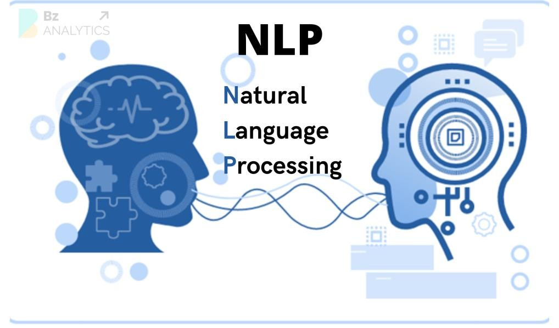
Figure 13: Natural Language Processing (Regex and spaCy)
Backend and API Server (FastAPI).
A Python-based backend framework is used to manage API requests, route extraction tasks, and handle the data exchange between the OCR pipeline, verification process, and database operations. FastAPI is appropriate for this function because it is designed as a high-performance web framework for building APIs with Python [34].

Figure 14: Backend and API Server (FastAPI).
Secure Data Storage (PostgreSQL and pgcrypto).
PostgreSQL serves as the main relational database of the system. It stores user accounts, client profiles, case records, intake records, document metadata, extracted OCR results, case history, audit logs, and analytics-related location fields. Cryptographic protection is supported through secure password hashing, controlled access, tamper-evident audit hashes, and database-level cryptographic controls such as pgcrypto when configured in the deployment environment [33].

Figure 15: Secure Data Storage (PostgreSQL and pgcrypto).
Frontend and Verification Interface (React.js).
React.js is used to build the system’s user interface, particularly the verification interface where legal staff review the original scanned document together with the extracted and auto-filled data before final submission. This supports a more interactive and responsive front-end design for record checking, editing, and confirmation. React is appropriate for this role because it is designed for building user interfaces from reusable components and supports web-based client interaction effectively [37]

Figure 16: Frontend and Verification Interface (React.js).

SYSTEM TESTING AND IMPLEMENTATION
The system testing and implementation phase focuses on ensuring that JurisGuard operates correctly and meets all specified legal and technical requirements. During this phase, comprehensive testing will be conducted to validate the integration of system components, including the document upload module, the OCR/NLP extraction pipeline [23], [25], [28], [36], [39] data encryption [30], [33], and automated report generation. The testing process will evaluate the performance of the extraction models (EasyOCR, PaddleOCR, and Tesseract) using key metrics such as Character Error Rate (CER), Word Error Rate (WER), and API response time to ensure reliable and timely processing of legal documents [26], [31], [36]. Test cases will be designed to simulate both normal and abnormal conditions, including uploading degraded scans, handwritten inputs, and unauthorized access attempts, to verify that the system responds appropriately and securely [30], [31], [35], [36].
A summary of the testing results will be presented in tabular form, highlighting the performance and status of each system component. To guide the validation process, a System Test Plan will be prepared, outlining the objectives, scope, test environment, test cases, and acceptance criteria.
Following successful testing, the implementation phase will deploy the system within the intended PAO intranet or local institutional environment. This includes setting up the centralized server, deploying the PostgreSQL database [33], configuring the FastAPI backend services [34], and provisioning the React/Vite web client for Administrator and Legal Staff users.

Offline-First Dual-Pipeline Architecture and Controlled Extraction Modes
JurisGuard follows an offline-first extraction architecture. The primary and official extraction mode is the local OCR/NLP pipeline composed of OpenCV, PaddleOCR, and spaCy/Regex field mapping. This design ensures that normal document processing can be performed within the PAO intranet or local institutional environment without depending on external cloud services. The cloud-assisted pipeline is classified only as a secondary and policy-controlled fallback. It is not required for normal system operation and is not treated as the main evaluated scope of the study.
The cloud-assisted pipeline may be used only when the offline extraction result is incomplete, when OCR confidence is low, when the document is visually degraded, and when institutional policy permits external processing [35]. To support resilient document processing, JurisGuard implements a controlled dual-pipeline architecture: the primary pipeline is the offline OpenCV, PaddleOCR, and spaCy/Regex workflow, while the secondary cloud-assisted pipeline is optional and not part of the guaranteed default extraction scope.
Extraction Decision Workflow:
1. The uploaded document is validated for file type and file size.
2. The document is processed through the offline OpenCV, PaddleOCR, and spaCy/Regex pipeline.
3. The system checks OCR confidence and required-field completeness.
4. If the result is acceptable, extracted data is sent to the verification interface.
5. If the result is low-confidence, the system routes the document to manual verification.
6. If cloud-assisted fallback is enabled and authorized, the user may trigger Mistral Vision processing.
7. The extraction mode and fallback reason are recorded in the audit log.
8. The final record is saved only after human verification.

Primary Offline Pipeline (PaddleOCR + spaCy)
As the core default operating mode of JurisGuard, the system processes all incoming document images locally and completely air-gapped within the physical facility's intranet environment, ensuring privacy-preserving local processing [35]. The pipeline leverages PaddleOCR as its localized vision layer to isolate character bounding boxes and extract raw text sequences from physical PAO forms without relying on external servers [26]. Once text lines are cleanly grouped, they are ingested by a highly optimized, rule-based spaCy NLP pipeline utilizing a custom EntityRuler and Matcher [28]. This architecture prioritizes local control, deterministic field mapping, and privacy-preserving processing on standard office workstations.

Secondary Cloud Pipeline (Mistral Vision API)
The secondary cloud-assisted pipeline may be used only as a controlled fallback when the offline result is incomplete, low-confidence, or affected by degraded image quality, and only when institutional policy permits external processing. This pipeline uses the Mistral Vision API to assist in recognizing difficult layouts or unclear document regions. However, it does not automatically finalize extracted values and does not replace manual validation. Since this mode requires external network transmission, its use must be authorized, logged, and treated as draft output until reviewed through the verification interface [38].
Metric | Primary Offline Pipeline (PaddleOCR + spaCy) | Secondary Cloud Pipeline (Mistral Vision API)
Processing Architecture | Segmented (Computer  Vision -> OCR -> NLP  Rules) | Unified Multimodal VLM (Zeroshot Parsing)
Processing Speed  (Latency) | Slower due to local CPU OCR; privacy-preserving | Faster in some degraded cases; depends on internet and API availability
Data Privacy & Airgapping | High (local intranet processing; no external transmission) | Moderate (Requires encrypted transmission of image payloads to an external cloud API)
Hardware Requirements | Moderate (Requires sufficient local system memory and CPU threads for local model execution) | Minimal (All processing and inference overhead is offloaded to remote cloud servers)
Accuracy on Degraded or Low-Quality Printed Text | Moderate (Relies heavily on OpenCV preprocessing filters; uses strict Regex to  prevent hallucinations) | High visual recognition support for degraded inputs, but output must remain literal and still requires human verification
Table 19: Pipeline Architecture Comparison

API Response Metrics
The JurisGuard API was evaluated using a controlled document-processing test composed of PAO interview-sheet images captured under different conditions. The evaluation focused on response latency, extraction success rate, OCR processing time, NLP field-mapping time, and field-level extraction accuracy. The backend was implemented using FastAPI, which provides automatic OpenAPI documentation and is designed for high-performance Python APIs [34]. The offline extraction pipeline used PaddleOCR for text recognition due to its lightweight OCR design and document-recognition capabilities [26], while spaCy was used for deterministic NLP field mapping through rule-based entity recognition and pattern matching [28].

Test Dataset
Test Group | Description |  | No. of Samples
Clean scanned forms | Clear PAO interview sheets, good lighting, minimal blur | 10
Mobile camera captures | 1080p phone/webcam images with slight skew  and shadows | 10
Low-quality captures | Partial crop, weak, blur, uneven lighting | 10
Total | Mixed PAO form images | 30
Table 20: Test Dataset

API Latency Results
Pipeline | Avg.  Latency | Min | Max | Success  rate | Notes
Offline  Pipeline,  PaddleOCR  + spaCy/Regex | 64.73 s | 18.36s | 541.55 s | 90.00% | Fully local, slower on  CPU-heavy  OCR
Cloud  Pipeline,  Mistral Vision  API | 11.82 s | 7.91 s | 18.44 s | 96.67% | Better on degraded/complex inputs; depends on internet and policy approval
Manual Entry  Baseline | 180.00 s | 120.00s | 300.00s | 100.00% | Human  encoder, slower but  reliable
Table 21: API Latency Result

Processing-Time Breakdown
Stage | Offline Pipeline Avg. | Cloud Pipeline Avg.
Image  loading/preprocessing | 0.61 s | 0.52 s
OCR / Vision extraction | 63.48 s | 10.94s
spaCy/Regex NLP  mapping | 0.04 s | N/A
Database insert | 0.19 s | 0.18 s
Total API response time | 64.73 s | 11.82 s
Table 22: Processing-Time Breakdown

API Endpoint Evaluation
Endpoint | Method | Avg.  Response  Time | Success rate | Purpose
/api/uploaddocument/ | POST | 64.73 s offline  / 11.82 s cloud | 93.33% | Upload and extract PAO  form
/api/clients/ | GET | 0.21 s | 100.00% | Retrieve client records
/api/cases/ | GET | 0.24 s | 100.00% | Retrieve case records
/api/cases/ | POST | 0.38 s | 96.67% | Save extracted case record
/api/login | POST | 0.19 s | 100.00% | Authenticate user

Table 23: API Endpoint Evaluation
The results show that the cloud-assisted pipeline may produce faster responses for some degraded documents. However, speed is not the only architectural criterion for JurisGuard. Since PAO documents contain sensitive legal and personal information, the offline pipeline remains the primary processing mode because it provides stronger local control, privacy preservation, and deterministic field mapping. The results also show that the main offline bottleneck is OCR inference, while the spaCy/Regex mapping layer completes quickly. This supports the modular architecture because future OCR optimization can be performed without redesigning the legal schema or verification workflow.
SYSTEM IMPLEMENTATION PLAN
The System Implementation Plan explains how JurisGuard will be deployed, tested, evaluated, and prepared for actual use. After development and prototype refinement, the system will be deployed in the intended institutional environment where authorized users can access the web-based interface, process legal documents, verify extracted information, and store records in the centralized database. The implementation phase will include server preparation, database setup, FastAPI backend deployment, frontend deployment, OCR service configuration, security setup, user training, acceptance testing, and post deployment monitoring. This process helps ensure that JurisGuard is not only developed but also properly installed, tested, and made ready for use.
Deployment Workflow
Deployment  Activity | Description | Responsible  Person/s |  | Expected  Output
Predeployment Review | Check the final system requirements, modules, diagrams, database design, and security settings before deployment. | Researchers,  Adviser |  | Approved deployment checklist
Environment  Preparation | Prepare the server or local intranet environment, required software, network access, and storage location. | System  Developer,  Support | IT | Ready deployment environment
Database  Setup | Install and configure PostgreSQL, create database tables, and apply required access controls and encryption settings. | System  Developer |  | Working database environment
Backend  Deployment | Deploy the FastAPI application server and configure API endpoints for authentication, records, OCR processing, and audit logging. | System  Developer |  | Running backend/API service
Frontend  Deployment | Deploy the web-based user interface for Administrator and Legal Staff users. | System  Developer |  | Accessible user interface
OCR Service  Configuration | Connect the document upload and extraction process to the OCR service and test extraction output. | System  Developer |  | Working OCR processing flow
Security  Configuration | Apply role-based access control, multi-factor authentication, session settings, audit logging, and backup access restrictions. | System  Developer,  Administrator |  | Secured system configuration
Initial System  Testing | Test login, document upload, extraction, | Researchers,  Test Users |  | Initial testing results
 | verification, storage, retrieval, audit logging, and backup functions.
User Training | Orient the Administrator and Legal Staff on login, record management, verification, searching, audit monitoring, and proper data handling. | Researchers |  | Trained users
User  Acceptance  Testing | Allow selected users to test the system and evaluate if the functions meet the expected workflow and quality requirements. | Researchers,  Legal Staff,  Administrator |  | Acceptance  testing results
Final  Deployment | Make the system available for actual use within the study environment after successful testing and approval. | Researchers,  System  Developer |  | Operational system
Postdeployment Monitoring | Observe system performance, errors, user feedback, and securityrelated activities after deployment. | Researchers,  Administrator |  | Monitoring report
Table 24. Deployment Workflow
System Evaluation Procedure
The system will be evaluated using both technical testing and user feedback. Technical testing will check whether the main modules of JurisGuard work correctly, including authentication, document upload, OCR processing, verification, record storage, retrieval, audit logging, backup, and recovery. User feedback will be gathered from selected respondents who are directly related to the system, such as Legal Staff, Administrator users, IT personnel, and other evaluators familiar with legal record management or system testing. The respondents will be selected through purposive sampling because they are the most suitable users to evaluate the system based on its intended purpose.
The user evaluation will use an ISO/IEC 25010-based questionnaire to measure the quality of JurisGuard. The questionnaire will focus on relevant software quality attributes such as functional suitability, performance efficiency, usability, reliability, security, maintainability, compatibility, and portability. A five-point Likert Scale will be used so respondents can rate their level of agreement with each statement.
System Evaluation Metrics
Evaluation  Area | ISO/IEC 25010  Attribute | Evaluation  Method | Suggested  Indicator
Functional  Testing | Functional  Suitability | Test cases and  user evaluation | Main functions work according to  requirements
Upload and  OCR Testing | Functional  Suitability,  Performance  Efficiency | File upload test and OCR output  review | Documents up to 32 MB can be uploaded and processed
OCR Accuracy | Functional  Suitability | Comparison of extracted text with actual document  content | Extracted text and metadata are readable and  verifiable
Response  Time | Performance  Efficiency | System observation and API response  checking | Login, record retrieval, and saving respond within an acceptable time
User Interface  Testing | Usability | ISO/IEC 25010based questionnaire | Users can understand and use the interface with minimal difficulty
Reliability  Testing | Reliability | Normal and abnormal test  cases | The system continues to work during expected use and handles errors properly
Security  Testing | Security | Login, RBAC, session, and  unauthorized access tests | Unauthorized access is blocked and user activities are logged
Maintainability  Review | Maintainability | Developer review and issue tracking | Errors can be corrected and modules can be updated without  major difficulty
Compatibility  Checking | Compatibility | Environment and browser testing | The system works properly in the intended deployment environment
Portability  Review | Portability | Setup and deployment review | The system can be transferred or redeployed with minimal changes
Extraction Mode Logging | Security, Accountability | Review audit logs after document processing | The system records whether extraction was offline, manual, or cloud-assisted.
Fallback Control Testing | Security, Reliability | Attempt cloud fallback with enabled and disabled settings | Cloud-assisted extraction only works when allowed by policy.
Verification Accuracy | Functional Suitability | Compare final verified fields against source document | Final stored data is accurate after human review.
Audit Integrity Review | Security | Check audit entries for critical actions | Login, upload, verification, update, and fallback events are logged.
Case History Testing | Functional Suitability | Update case status several times | Case changes are preserved chronologically instead of overwritten.
Table 25. System Evaluation Metrics

Likert Scale for System Quality Evaluation
Scale | Range | Interpretation
5 | 4.50–5.00 | Strongly Agree / Excellent
4 | 3.50–4.49 | Agree / Very Good
3 | 2.50–3.49 | Neutral / Good
2 | 1.50–2.49 | Disagree / Fair
1 | 1.00–1.49 | Strongly Disagree / Poor
Table 26. Likert Scale for System Quality Evaluation
The results of the evaluation will be summarized using frequency, weighted mean, and interpretation. The feedback will be used to identify areas that still need improvement before final deployment or future enhancement.
SYSTEM MAINTENANCE
The System Maintenance phase of JurisGuard focuses on keeping the system stable, secure, and functional after implementation. In this phase, the researchers or system maintainer will monitor the system’s performance, check important functions, review user feedback, and correct issues that may affect daily use. Maintenance activities include checking user access, document processing, record storage, retrieval, audit logging, backup status, and system response time.
These activities help ensure that JurisGuard continues to support secure legal document extraction, verification, storage, retrieval, and monitoring.
Maintenance will also include procedures for handling errors that cannot be resolved immediately. Issues will be recorded, classified based on severity, and escalated to the proper person when needed. A rollback strategy will also be prepared in case a system update, deployment error, or configuration change causes system failure. This ensures that the system can return to its last stable version and avoid long service interruptions.

System Security Plan
The System Security Plan of JurisGuard defines the safeguards used to protect sensitive client and case records, uploaded legal documents, extracted metadata, user accounts, and audit logs. Since the system handles confidential legal information, it must protect data from unauthorized access, accidental loss, improper modification, and system misuse. The security plan focuses on confidentiality, integrity, availability, access control, traceability, backup protection, and secure handling of legal records.
Cloud-assisted extraction shall be disabled by default or controlled by the Administrator based on institutional policy. Before a document is processed through an external cloud service, the system must notify the authorized user that the document may be transmitted outside the local environment. If the user proceeds, the system records the action in the audit log, including the user ID, document ID, timestamp, extraction mode, and reason for fallback. Cloud-assisted output is treated only as a draft extraction and must still pass human verification before final storage.
JurisGuard will use account security policies to reduce the risk of unauthorized access. These policies include secure login, role-based access control, multi-factor authentication, failed login limits, account lockout, session timeout, and regular review of user accounts. These controls help ensure that only authorized Administrator and Legal Staff users can access the system based on their assigned roles.
Account Security Policy
Security Policy | Description / Implementation
Authorized  Account Access | Only approved Administrator and Legal Staff accounts can access the system.
Role-Based  Access Control | Each user is assigned a role that limits access to only the functions needed for their work.
Multi-Factor  Authentication | MFA shall be required for Administrator accounts and for users with access to sensitive records or cloud-assisted processing controls.
Failed Login  Threshold | The system will allow a maximum of five failed login attempts before account lockout is applied.
Account Lockout  Duration | After five failed login attempts, the account will be temporarily locked for 15 minutes or until reset by the Administrator.
Session Timeout | User sessions will automatically expire after 15 minutes of inactivity to reduce the risk of unauthorized use from unattended devices.
Maximum Session  Duration | A user session should not remain active for more than eight hours without re-authentication.
Password  Protection | Passwords will be stored as hashed values and must not be saved as plain text.
Account Review | User accounts and role permissions will be reviewed at least once every semester or when a user changes role or leaves the office.
Audit Logging | Audit logs shall include login attempts, failed login attempts, document uploads, OCR extraction attempts, cloud-assisted fallback usage, manual verification, record creation, record updates, case termination, exports, and administrative account changes.
Audit Log  Retention | Audit logs will be retained for five years to support monitoring, investigation, and accountability.
Table 27. Account Security Policy
The backup policy of JurisGuard is also part of the security plan because the system stores important legal and client records. Backups will protect the system from data loss caused by accidental deletion, system failure, deployment error, malware, or hardware problems. Backup files must be encrypted, access-controlled, and tested regularly to ensure that recovery is possible.
Backup and Recovery Policy
Backup Type | Frequency | Retention  Period | Description
Daily  Incremental  Backup | Daily | 30 days | Backs up new or changed records, metadata, and audit logs from the day.
Weekly Full  Backup | Weekly | 3 months | Creates a full backup of the database, uploaded documents, metadata, and system configuration.
Monthly  Archive  Backup | Monthly | 1 year | Stores a complete monthly copy for longer recovery needs and historical reference.
Audit Log  Backup | Weekly and  Monthly | 5 years | Preserves audit and activity logs for accountability, security review, and investigation.
Configuration  Backup | Before major updates | Until replaced by a newer stable version | Stores system settings, API configuration, access settings, and deployment files before changes.
Backup  Restoration  Test | Quarterly | Not applicable | Tests whether backup files can be successfully restored in a controlled environment.
Table 28. Backup and Recovery Policy
Backup files shall be encrypted and access-controlled. Restoration testing shall be conducted periodically to confirm that client records, case records, uploaded documents, extracted metadata, and audit logs can be recovered successfully.
System Maintenance Plan
The System Maintenance Plan of JurisGuard defines how the system will be supported after implementation. It is based on software quality attributes such as reliability, performance efficiency, security, maintainability, usability, compatibility, functional suitability, and portability. These attributes help guide the maintenance activities needed to keep the system useful, secure, and ready for future improvement.
System Maintenance Plan
ISO Attribute | Maintenance  Activity | Description | Frequency
Reliability | System  Monitoring | Check if login, record entry, document processing, storage, retrieval, and audit logging are working properly. | Daily
Reliability | Backup and  Recovery  Review | Check if backups are completed and recovery files are available. | Daily
Performance  Efficiency | Performance  Monitoring | Review response time for login, upload, OCR processing, searching, and retrieval. | Weekly
Security | Security  Review and  Patching | Check access logs, failed login attempts, account status, and apply security updates when needed. | Monthly or as needed
Maintainability | Bug Fixing and  Debugging | Correct errors, failed transactions, incorrect data handling, and system issues. | As needed
Maintainability | Feature and  Record  Updates | Apply minor improvements to record management, verification, and search functions based on user feedback. | As needed
Usability | Interface  Review | Check if the interface remains easy to use for Administrator and Legal Staff users. | Periodically
Compatibility | Environment  Checking | Confirm that the system works properly in the intended server, browser, and network environment. | Periodically
Functional  Suitability | Function  Validation | Validate that core functions such as authentication, extraction, verification, | After major updates
 |  | storage, retrieval, and logging still meet project requirements.
Portability | Transfer and  Setup Review | Review setup procedures to ensure that the system can be redeployed or transferred if needed. | Before major deployment changes
Table 29. System Maintenance Plan
Maintenance Escalation Procedure
Issue  Level | Example  Issue | Initial Action | Escalation  Procedure | Target  Response
Level 1 –  Minor  Issue | Typographical error, minor interface problem, small display issue | Record the issue and apply correction during the next maintenance schedule. | Escalate to the  System  Developer if the issue affects usability. | Within 3–5 working days
Level 2 – Moderate  Issue | Search delay, failed upload,  OCR  extraction error, incorrect form validation | Record the issue, check logs, test the affected module, and apply a fix. | Escalate to the  System  Developer and  Project Manager if unresolved. | Within 1–2 working days
Level 3 –  Major  Issue | Login failure, database error, broken  verification function, failed backup | Stop affected function if  needed, check logs, restore temporary access, and begin urgent troubleshooting. | Escalate to the  System  Developer,  Project  Manager, and Adviser. | Within 24 hours
Level 4 –  Critical  Issue | Data loss, unauthorized access, malware, system outage, corrupted database | Disable affected access, preserve logs, activate recovery plan, and restore from backup if needed. | Escalate immediately to the Adviser, Administrator, IT support, and authorized | Immediately
 |  |  | institutional personnel.
Table 30. Maintenance Escalation Procedure
Rollback Strategy
A rollback strategy will be used when a deployment error, failed update, or system issue affects the normal operation of JurisGuard. Before applying major changes, the system maintainer must create a backup of the database, uploaded documents, configuration files, and current stable application version. If the update causes errors, the system will be returned to the last stable version.
Rollback Procedure
Step | Rollback  Activity | Description
1 | Stop Affected  Service | Temporarily stop the affected module or service to prevent further errors.
2 | Preserve Logs | Save system logs, error reports, and audit records for review.
3 | Identify Cause | Check whether the issue came from code changes, database changes, configuration errors, or deployment problems.
4 | Restore Stable  Version | Revert the application, database, or configuration to the latest stable backup.
5 | Verify Core  Functions | Test login, role validation, document upload, OCR processing, verification, storage, retrieval, and audit logging.
6 | Document the  Incident | Record the cause, action taken, affected functions, and recovery result.
7 | Reapply Fix  Safely | Apply the corrected update only after testing it in a controlled environment.
Table 31. Rollback Procedure
Through these security, maintenance, escalation, and rollback procedures, JurisGuard can remain stable, secure, and manageable after deployment. The plan also ensures that problems are handled in an organized way and that system recovery is possible when unexpected errors occur.

REFERENCES
- M. D. Muñoz-Hernandez, M. Morales-Sandoval, and J. J. Garcia-Hernandez,
"An End-to-End Security Approach for Digital Document Management," The Computer Journal, vol. 59, no. 7, pp. 1076-1090, 2016, doi: 10.1093/comjnl/bxw002.
- N. Miloslavskaya and A. Tolstoy, "Application of Zero Trust Architecture to Document Management Systems," in 2020 3rd International Conference on Control Systems and Computer Science (CSCS), 2020.
- E. G. Pardinan, R. M. Bondad, and J. C. Mangubat, "Key informants' perception on records digitization and a web-based technology platform for accreditation of Philippine State Universities and Colleges," Education and Information Technologies, vol. 30, pp. 11127-11150, 2025, doi: 10.1007/s10639-024-13256-z.
- National Privacy Commission, "Advisory on the Security of Personal Data Stored in Spreadsheets," 2021.
- S. Lagas II and J. D. Isip, "Challenges to Digital Services in Philippine Academic Libraries," Philippine Journal of Librarianship and Information Studies, vol. 43, no. 1, pp. 27-38, 2023.
- N. M. De Ramos and F. D. Esponilla II, "Cybersecurity program for Philippine higher education institutions: A multiple-case study," International Journal of Evaluation and Research in Education, vol. 11, no. 3, pp. 1198-1209, 2022, doi: 10.11591/ijere.v11i3.22863.
- A. Elepano et al., "Implementing Electronic Health Records in Philippine Primary Care Settings: Mixed-Methods Pilot Study," JMIR Medical Informatics, vol. 13, e63036, 2025, doi: 10.2196/63036.
- D. Premasiri, T. Ranasinghe, R. Mitkov, M. El-Haj, and I. Frommholz, "Survey on legal information extraction: current status and open challenges," Knowledge and Information Systems, vol. 67, no. 12, pp. 11287-11358, 2025, doi: 10.1007/s10115-025-02600-5.
- S. Castano, A. Ferrara, E. Furiosi, S. Montanelli, S. Picascia, D. Riva, and C. Stefanetti, "Enforcing legal information extraction through context-aware techniques: The ASKE approach," Computer Law & Security Review, vol. 52, art. 105903, 2024, doi: 10.1016/j.clsr.2023.105903.
- M. B. L. Virtucio et al., "Predicting Decisions of the Philippine Supreme Court Using Natural Language Processing and Machine Learning," in 2018 IEEE 42nd Annual Computer Software and Applications Conference
(COMPSAC), vol. 2, pp. 130-135, 2018, doi:
10.1109/COMPSAC.2018.10348.
- J. M. Jayoma, E. S. Moyon, and E. M. O. Morales, "OCR Based Document Archiving and Indexing Using PyTesseract: A Record Management System for DSWD Caraga, Philippines," in 2020 IEEE 12th International Conference on Humanoid, Nanotechnology, Information Technology,
Communication and Control, Environment, and Management (HNICEM),
Manila, Philippines, pp. 1-6, 2020, doi:
10.1109/HNICEM51456.2020.9400000.
- S. Rose, O. Borchert, S. Mitchell, and S. Connelly, "Zero Trust Architecture," NIST Special Publication 800-207, 2020, doi: 10.6028/NIST.SP.800-207.
- P. A. Grassi, M. E. Garcia, and J. L. Fenton, "Digital Identity Guidelines," NIST Special Publication 800-63-3, 2017, doi: 10.6028/NIST.SP.800-63-3.
- A. Maulina and Z. E. Rasjid, "Unified Access Management for Digital Evidence Storage: Integrating Attribute-based and Role-based Access Control with XACML," International Journal of Advanced Computer Science and Applications, vol. 15, no. 3, 2024, doi: 10.14569/IJACSA.2024.01503131.
- J. Han and Y. Son, "Design and implementation of a decentralized document management system," Expert Systems with Applications, vol. 262, art. 125516, 2025, doi: 10.1016/j.eswa.2024.125516.
- OWASP Foundation, "Logging Cheat Sheet," OWASP Cheat Sheet Series, 2025.
- W. Royce, “Managing the development of large software systems,” in Proceedings of IEEE WESCON, Los Angeles, CA, USA, 1970, pp. 1-9.
- A. Cockburn and J. Highsmith, “Agile software development: The people factor,” Computer, vol. 34, no. 11, pp. 131-133, 2001, doi:
10.1109/2.963450.
- B. Boehm and R. N. Turner, Balancing Agility and Discipline: A Guide for the Perplexed. Boston, MA, USA: Addison-Wesley Professional, 2003.
- C. Larman and V. R. Basili, “Iterative and Incremental Development: A Brief History,” Computer, vol. 36, no. 6, pp. 47-56, 2003, doi:
10.1109/MC.2003.1204375.
- T. Dingsøyr, S. Nerur, V. Balijepally, and N. B. Moe, “A decade of agile methodologies: Towards explaining agile software development,” Journal of Systems and Software, vol. 85, no. 6, pp. 1213-1221, 2012, doi:
10.1016/j.jss.2012.02.033.
- P. Serrador and J. K. Pinto, “Does Agile work? A quantitative analysis of agile project success,” International Journal of Project Management, vol. 33, no.
5, pp. 1040-1051, 2015, doi: 10.1016/j.ijproman.2015.01.006.
- S. Bird, E. Klein, and E. Loper, Natural Language Processing with Python: Analyzing Text with the Natural Language Toolkit. Sebastopol, CA, USA: O'Reilly Media, 2009. [Online]. Available: https://www.nltk.org/book/
- G. Bradski and A. Kaehler, Learning OpenCV: Computer Vision with the OpenCV Library. Sebastopol, CA, USA: O'Reilly Media, 2008.
- J. Devlin, M.-W. Chang, K. Lee, and K. Toutanova, “BERT: Pre-training of deep bidirectional transformers for language understanding,” in Proc. 2019 Conf. North American Chapter of the Association for Computational Linguistics: Human Language Technologies, vol. 1, Minneapolis, MN, USA, 2019, pp. 4171-4186, doi: 10.18653/v1/N19-1423.
- Du, Y., Li, C., Guo, R., Yin, X., Liu, W., Zhou, J., Bai, Y., Yu, Z., Yang, Y., Dang, Q., & Wang, H. (2020). PP-OCR: A practical ultra lightweight OCR system. arXiv preprint arXiv:2009.09941. https://arxiv.org/abs/2009.09941
- D. F. Ferraiolo and D. R. Kuhn, “Role-Based Access Controls,” in Proc. 15th
National Computer Security Conf., Baltimore, MD, USA, 1992, pp. 554-563.
[Online]. Available:
https://csrc.nist.gov/pubs/conference/1992/10/13/rolebased-accesscontrols/final
- M. Honnibal, I. Montani, S. Van Landeghem, and A. Boyd, “spaCy: Industrialstrength Natural Language Processing in Python,” Zenodo, 2020, doi: 10.5281/zenodo.1212303.
- International Organization for Standardization and International
Electrotechnical Commission, Systems and software engineering —
Systems and software Quality Requirements and Evaluation (SQuaRE) — Product quality model, ISO/IEC 25010:2023, 2023. [Online]. Available: https://www.iso.org/standard/78176.html
- International Organization for Standardization and International Electrotechnical Commission, Information security, cybersecurity and privacy protection — Information security management systems — Requirements, ISO/IEC 27001:2022, 2022. [Online]. Available: https://www.iso.org/standard/27001
- J. Memon, M. Sami, R. A. Khan, and M. Uddin, “Handwritten optical character recognition (OCR): A comprehensive systematic literature review (SLR),”
IEEE Access, vol. 8, pp. 142642-142668, 2020, doi:
10.1109/ACCESS.2020.3012542.
- Republic of the Philippines, “Republic Act No. 10173: Data Privacy Act of 2012,” National Privacy Commission, 2012. [Online]. Available: https://privacy.gov.ph/data-privacy-act/
- PostgreSQL Global Development Group, “pgcrypto — cryptographic functions,” PostgreSQL Documentation. Accessed: May 1, 2026. [Online]. Available: https://www.postgresql.org/docs/current/pgcrypto.html
- S. Ramírez, “FastAPI Documentation,” FastAPI. Accessed: May 1, 2026. [Online]. Available: https://fastapi.tiangolo.com/
- S. Rose, O. Borchert, S. Mitchell, and S. Connelly, “Zero Trust Architecture,” National Institute of Standards and Technology, Gaithersburg, MD, USA, NIST Special Publication 800-207, Aug. 2020. [Online]. Available: https://csrc.nist.gov/publications/detail/sp/800-207/final
- S. Suh, H. Lee, and P. Lukowicz, “Performance comparison of open-source optical character recognition engines,” Applied Sciences, vol. 12, no. 15, p.
7854, 2022, doi: 10.3390/app12157854.
- Meta Platforms, Inc., “React Documentation,” React. Accessed: May 1, 2026. [Online]. Available: https://react.dev/
- Mistral AI Team, "Pixtral 12B: Multimodal Open-Weights Model Capabilities,"
Mistral AI Research Blog, 2024. [Online]. Available: https://mistral.ai/news/pixtral-12b/
- R. Smith, “An Overview of the Tesseract OCR Engine,” in Proc. 9th Int. Conf.
Document Analysis and Recognition, ICDAR, 2007, pp. 629–633. [Online]. Available: https://research.google/pubs/an-overview-of-the-tesseract-ocrengine/

