Imperial College Business School
Autumn 2025 Financial Econometrics
Group coursework
Forecasting next month's WTI return
What month-end data can, and cannot, tell an oil desk
Group members: [add names]

Abstract
The question is whether month-end public data justify a view on next month's return on front-month WTI. The target is the monthly log return on CL1, not the price. A regression on five lagged predictors — the futures basis, inventory growth, the dollar, industrial-production growth and Baltic Dry growth — is compared with a forecast of zero, the historical mean, ARIMA, ARIMAX, LASSO and ridge. From February 2005 to June 2024 the regression is less accurate than predicting zero: the root-mean-squared error is 12.3 percentage points, against 11.3. LASSO drops every predictor. A long/short rule based on the sign of the regression loses 94 per cent of its capital, mostly in the spring of 2020. The desk should treat next month's expected return as zero.

1. Introduction
At each month-end the question is whether the curve, inventories, the dollar and a couple of activity indicators justify a position in front-month WTI. Most of a monthly oil move is news, and last month's public data do not contain next month's news. The useful output is a stated target, a model the desk can audit, diagnostics, and a comparison with the forecast a trader already has: that the expected return is about zero.
The target is the log return on CL1. The price level is non-stationary, so a forecast of the level stays close to the last price and does not say whether to be long or short. The CL2–CL1 spread is a roll trade rather than a directional view. It enters the model as a predictor of the return.

2. Data and frequency
The file covers December 1994 to June 2024. Futures prices, inventories, production, the rig count and positioning are on the monthly industry sheet. CPI inflation, Treasury yields, industrial production, equities, the dollar-index return and the VIX are monthly. A daily or weekly model would have to carry those monthly releases forward unchanged, so every series used here is monthly and nothing is interpolated.
CL1 is matched to the macro data by calendar month. After the return and a one-month lag are formed, the regression sample is February 1995 to June 2024, 353 months. CL1 rises from $17.76 at the end of 1994 to $81.54 in June 2024. The lowest month-end price is $11.22, so the log return is defined throughout. The negative WTI print of 20 April 2020 was an expiry-day event; the month-end price in this file is $18.84.
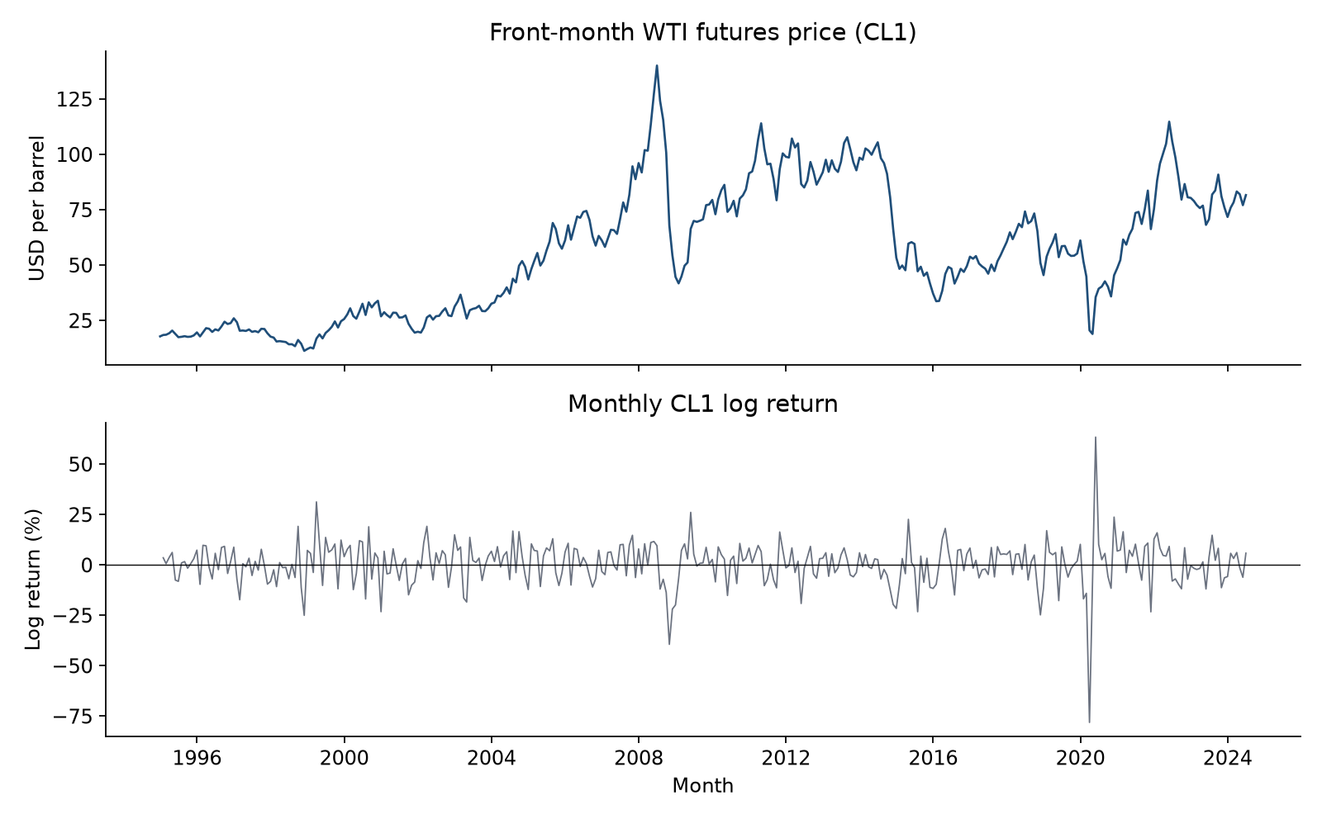
Figure 1. Front-month WTI price and its monthly log return, December 1994 to June 2024. Source: Oil Data.xlsx.
The change in the published CL1 series only approximates the return on a rolled futures position, because the front contract is not the same instrument at every month-end. The wealth curve later in the report is not a live profit and loss net of roll slippage, margin or market impact. The return in month t is predicted only with information dated t−1. The monthly log return averages 0.42 per cent, with a standard deviation of 10.7 per cent.

3. Methodology
The five predictors were chosen from standard market stories, and the out-of-sample scores were not used to add or remove them. The basis is (CL1 − CL2) / CL1, positive when the curve is backwardated. The theory of storage links backwardation to scarce inventories and higher subsequent commodity returns, so the expected sign was positive. Inventory growth, the monthly log change in US crude stocks, was expected to enter with a negative sign. The dollar-index return was expected to be negative for oil. Industrial-production growth and Baltic Dry Index growth, as proxies for activity and bulk freight, were expected to be positive. The predictors are growth rates or a spread, not persistent macro levels.
LASSO and ridge use sixteen variables: the five above, plus the lagged oil return, rig and production growth, the crack, the Treasury slope, the VIX, the S&P 500, CPI inflation, commercial positioning, gasoline and the oil-equity index.
The main model is ordinary least squares on a constant and the five lagged predictors. Standard errors are Newey–West with four lags. Forecasts are re-estimated every month. Benchmarks are a forecast of zero and the historical mean return. An ARIMA order is chosen by AIC on the first 120 months and then frozen, which selects an ARIMA(2, 0, 2). ARIMAX adds the five predictors to that order. LASSO and ridge standardise the wide set inside each window and pick the penalty by time-series cross-validation. The estimates are produced by oil_forecast.py.
Evaluation starts in February 2005, after 120 months, and runs for 233 one-step forecasts through June 2024. Accuracy is RMSE, MAE and the out-of-sample R-squared. Because the regression nests the mean, Clark–West adjusts for the noise from extra slopes, and Diebold–Mariano is reported on the raw gap. In this window 55.4 per cent of months are up and the historical-mean forecast is always positive, so its hit rate is the hit rate of a standing long.

4. Diagnostics
An augmented Dickey–Fuller test does not reject a unit root in the CL1 price (p = 0.14), and a KPSS test rejects stationarity (p < 0.01). The log return is stationary on both tests. The five predictors are stationary at the 5 per cent level; the basis is the closest case, with a KPSS p-value of 0.06.
The full-sample regression is for interpretation and specification tests, not for the forecast scores. On 353 months the R-squared is 3.9 per cent and the adjusted R-squared is 2.6 per cent. All variance-inflation factors are below 1.4. The strongest correlation among the five predictors is 0.45, between the basis and industrial-production growth.
Predictor (lagged one month) | Coefficient | Newey–West s.e. | p-value
Constant | 0.004 | 0.006 | 0.557
Futures basis, (CL1−CL2)/CL1 | −0.648 | 0.329 | 0.049
Crude inventory growth | 0.050 | 0.435 | 0.908
US dollar index return | −0.062 | 0.239 | 0.795
US industrial production growth | −0.686 | 1.433 | 0.632
Baltic Dry Index growth | 0.037 | 0.031 | 0.222

Table 1. Full-sample OLS, February 1995 to June 2024 (353 months). Newey–West standard errors use four lags. R-squared is 0.039.
The signs do not match the stories that motivated the variables. The basis coefficient is −0.65, with a Newey–West standard error of 0.33 and a p-value of 0.049. Backwardation in this sample lines up with lower subsequent returns, the opposite of the convenience-yield prediction. A one-standard-deviation move in the basis is 2.2 percentage points of the curve and corresponds to about 1.5 percentage points of return, set against monthly volatility of 10.7 percentage points. Across five slopes, a p-value of 0.049 would not survive a Bonferroni threshold of 0.01. Inventory growth has a p-value of 0.91 and the wrong sign for a supply surprise. The dollar has the expected negative sign and a p-value of 0.80. Industrial production and the Baltic index are similarly uninformative in the full sample. The intercept is 0.37 percentage points a month (p = 0.56).
The residuals are why the standard errors are robust. A Breusch–Godfrey test rejects no serial correlation at six lags (p = 0.009), and a Ljung–Box test agrees at six lags (p = 0.035). A Breusch–Pagan test rejects homoskedasticity (p = 0.0007; Durbin–Watson 1.71). Skewness is −1.3 and Pearson kurtosis is 12.3, against 3 for a normal distribution, so a Jarque–Bera test rejects normality. A normal prediction interval would be far too narrow around a crash.
A CUSUM test on the residuals does not reject constant parameters (p = 0.28), but the test has limited power against a shift in slopes. Chow tests at the end of September 2008, July 2014 and March 2020 — dates set as market events, not as the dates that maximise a break statistic — give p-values of 0.11, 0.003 and 0.004. The recursive coefficients locate the break. The basis slope stays near −0.5 throughout. The industrial-production slope is about +2.6 in April 2020 and −1.1 by June 2020, and it finishes near −0.7. The full-sample production coefficient of −0.69 averages two regimes and describes neither.
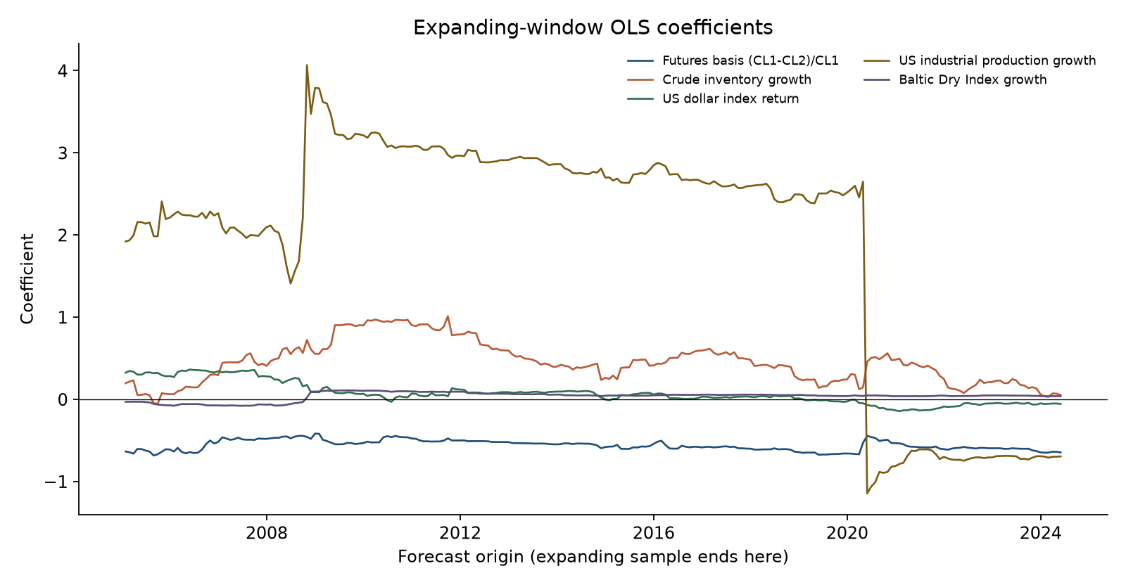
Figure 2. Expanding-window OLS coefficients. The date is the last month used in that estimate. The industrial-production slope changes sign in spring 2020.

5. Out-of-sample performance
On the first 120 months the R-squared is 4.0 per cent. Out of sample the extra slopes make the forecasts worse. Predicting zero slightly beats the historical mean, because the drift is small and the estimated mean adds noise.
Model | RMSE | MAE | Hit rate | R² vs zero | R² vs mean
Forecast of zero | 11.34 | 7.90 | — | 0 | +0.5%
Historical mean | 11.36 | 7.87 | 55.4% | −0.5% | 0
ARIMA(2,0,2) | 11.31 | 7.88 | 52.4% | +0.4% | +0.9%
OLS, five predictors | 12.29 | 8.08 | 53.6% | −17.5% | −16.9%
ARIMAX | 12.24 | 8.06 | 51.5% | −16.6% | −16.1%
LASSO, sixteen predictors | 11.36 | 7.87 | 55.4% | −0.5% | 0
Ridge, sixteen predictors | 12.19 | 8.12 | 55.8% | −15.6% | −15.1%

Table 2. One-step accuracy, February 2005 to June 2024 (233 months). RMSE and MAE are in percentage points of the monthly log return. Each forecast uses only data available at the previous month-end.
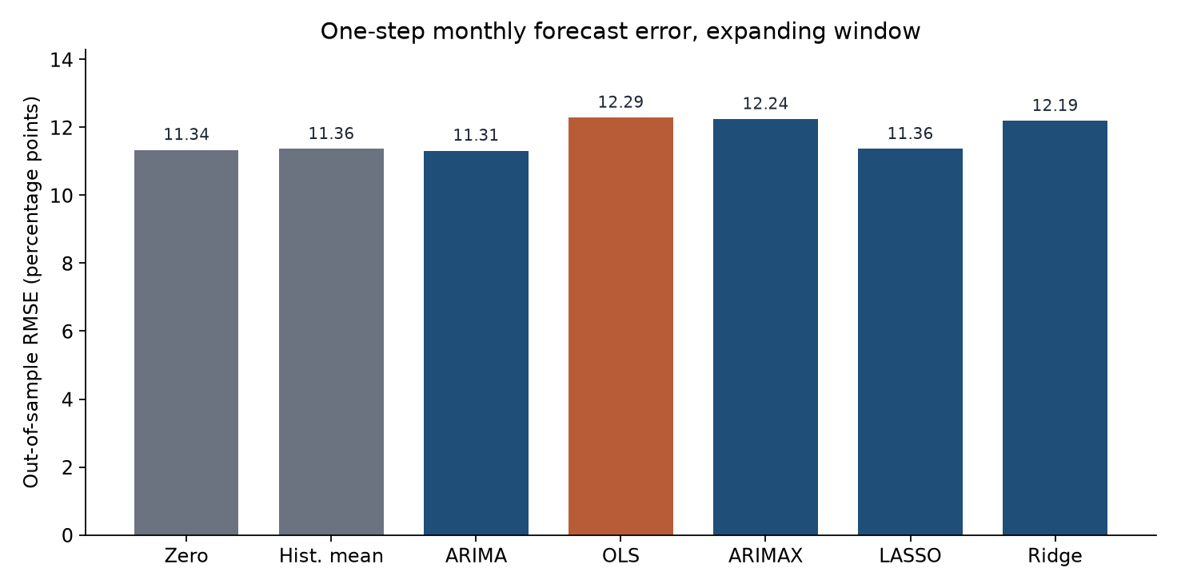
Figure 3. Out-of-sample root-mean-squared error. The axis starts at zero.
ARIMA(2, 0, 2) is the only model with a smaller squared error than both benchmarks, and the gain against zero is 0.03 percentage points of RMSE. Diebold–Mariano does not reject equal accuracy against the mean (p = 0.64). Clark–West, the more generous nested-model test, has a one-sided p-value of 0.09. Its hit rate is 52.4 per cent, worse than always being long.
The economic regression has a root-mean-squared error of 12.29, against 11.34 for a forecast of zero, so its squared errors are about 17 per cent larger. The Clark–West statistic is negative (one-sided p = 0.77). Diebold–Mariano against the mean has p = 0.26, so there is no evidence of an improvement. ARIMAX and ridge fall in the same place. Adding the five predictors to the time-series model, or shrinking sixteen predictors with ridge, imports noise.
LASSO reaches the same conclusion by another route. Time-series cross-validation chooses a penalty at which every standardised slope is zero, on the full sample and at every forecast origin. The forecast collapses to the historical mean, which is why those two rows of the table match. Asked which variables to keep, the procedure keeps none.
A Mincer–Zarnowitz regression of the realised return on the out-of-sample OLS forecast rejects a zero intercept and a unit slope (Wald p = 0.029). The slope on the forecast is −0.67 (p = 0.29).
May 2020 shows how a linear model behaves in a regime change, and it does not rescue the specification. Using April's data, the regression forecast a log return of −29 per cent. Industrial production had fallen 14 per cent, and the production coefficient then available was about +2.6. The front-month price rose 88 per cent. That month is 24 per cent of the regression's out-of-sample sum of squared errors. Dropping it, only as a sensitivity, cuts the regression RMSE from 12.3 to 10.7 percentage points, against 10.6 for the historical mean on the same months. The regression still loses.

6. Implications for trading
The trading rule is the forecast judged as a position. At each month-end the regression is refitted. A positive forecast is a long position in the front contract. A negative forecast is a short in the long/short rule and a flat position in the long/flat rule. Active rules pay 10 basis points of notional per unit of turnover. Buy-and-hold pays none. The cost leaves out the roll and any limit on the May 2020 short.
Rule | Ann. return | Ann. vol. | Sharpe | Total return | Max drawdown
Buy and hold | 10.8% | 39.3% | 0.26 | +69% | −87%
Long / flat | 4.5% | 27.0% | 0.16 | +6% | −76%
Long / short | −1.4% | 39.5% | −0.04 | −94% | −99%

Table 3. Illustrative P&L on the spliced CL1 simple return, February 2005 to June 2024. Active rules pay 10 basis points per unit of turnover. Buy-and-hold does not trade.
The Sharpe ratios in the table use the futures return, not an excess return over cash. One dollar in buy-and-hold grows to about $1.69: 10.8 per cent annualised, 39 per cent volatility, a Sharpe ratio of 0.26 on the futures return, and a maximum drawdown of 87 per cent. Long/flat grows to $1.06, with a Sharpe ratio of 0.16 and a 76 per cent drawdown. Long/short finishes near six cents on the dollar, with a Sharpe ratio of −0.04 and a 99 per cent drawdown.
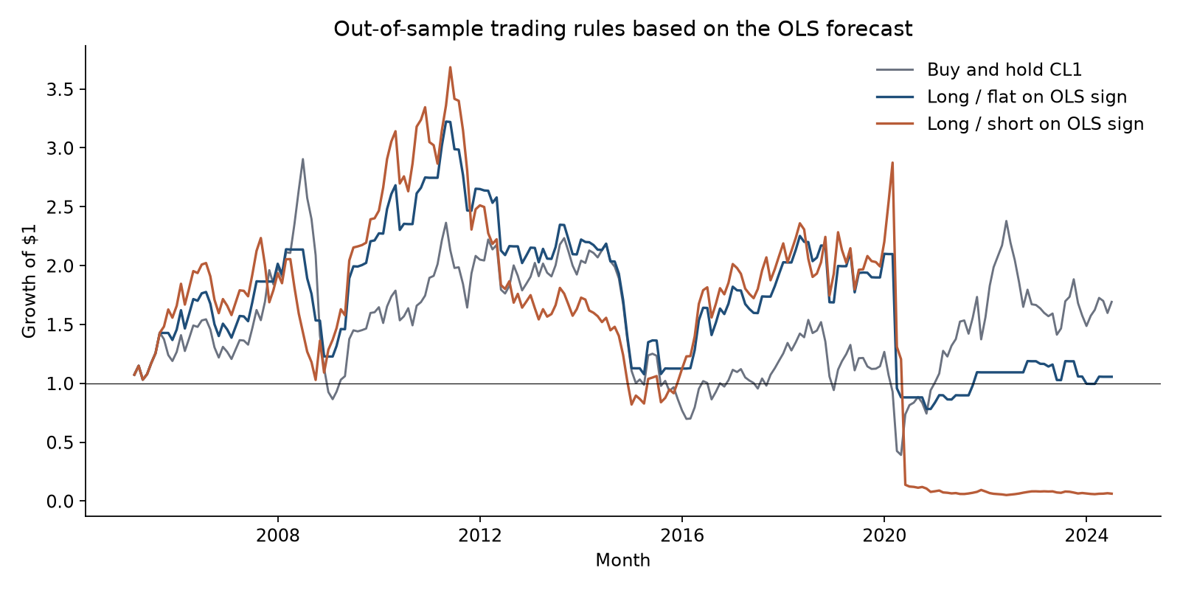
Figure 4. Growth of one dollar. The long/short path breaks in the spring of 2020.
The path matters more than those averages. The long/short book is intact through 2019. In January and February 2020 it is short while oil falls, so the short makes money. In March the forecast turns positive and the rule is long a month with a simple return of −54 per cent. In May the forecast is −29 per cent, the rule is short, and the simple return is +88 per cent. Those two months, not the 10-basis-point cost, wipe the strategy out.
The signal should not size a position. A cap would have limited the May loss without creating an edge, and no cap or new predictor list is searched after seeing this path. Month-end macro and inventory data do not improve on having no view. The basis slope is stable, small, and opposite in sign to the scarcity story. The production slope does not survive 2020.

7. Conclusion
The price is the wrong dependent variable and the monthly return is the right one. The five predictors do not earn a place in the forecast. Out of sample they lose to a prediction of zero, a penalised search keeps none of a wider set, and a rule that trades the sign loses to holding the contract, with the damage concentrated in the spring of 2020. Next month's expected WTI return should be treated as zero unless a different information set beats that forecast on a window it was not fitted to.

References
Campbell, J.Y. and Thompson, S.B. (2008). Predicting excess stock returns out of sample: Can anything beat the historical average? Review of Financial Studies, 21(4), 1509–1531.
Clark, T.E. and West, K.D. (2007). Approximately normal tests for equal predictive accuracy in nested models. Journal of Econometrics, 138(1), 291–311.
Diebold, F.X. and Mariano, R.S. (1995). Comparing predictive accuracy. Journal of Business and Economic Statistics, 13(3), 253–263.
Gorton, G.B., Hayashi, F. and Rouwenhorst, K.G. (2013). The fundamentals of commodity futures returns. Review of Finance, 17(1), 35–105.
Newey, W.K. and West, K.D. (1987). A simple, positive semi-definite, heteroskedasticity and autocorrelation consistent covariance matrix. Econometrica, 55(3), 703–708.
Working, H. (1949). The theory of price of storage. American Economic Review, 39(6), 1254–1262.
Word count: 2003 (abstract through conclusion, including headings; excluding tables, figures, captions and references). Forecasts are produced by oil_forecast.py.

