Derrick A., Jared W., Colin M.

Abstract

A remotely controllable set of air-duct dampers as IoT devices that enable temperature customization for each room/zone of an HVAC system.

TEAM E-PROJECT #2

iFlow

**Project Step 2 -**

1. **Organization**

In our second team meeting we discussed the best way to go about interviewing current HVAC users, developing a Work Activity Affinity Diagram, and then creating an initial Flow Model. We formulated five key questions that we felt best suited both homeowners and business complexes. After conducting our interviews, we summarized the feedback and data, built a WAAD, and created a Flow Model that we thought best captured our overall concept. These steps helped us gain a better understanding of the needs and design of an effective HVAC control app.

2. **People who we Interviewed / Job Title / Team Member assigned to Interview**

Sophia Mitchell – Marketing Coordinator / Derrick

Benjamin Foster – Finical Analyst / Derrick

Olivia Anderson – Software Engineer / Derrick

Kyle Adamson – HVAC Tech / Jared

Ethan Robbins – HVAC Tech / Jared

Blake Richards – HVAC Tech / Jared

Eric Rothwell – Vice Principal / Colin

Michelle Gunther – CFO QCBB / Colin

Tony Hatch – Data Analyst / Colin

3. **Initial Questions**

1. Do you use manually operated air-duct dampers to limit airflow to areas of your home?
2. How often and for what have you used manually operated air-duct dampers at home?
3. What do you like the least about your home's manually operated air-duct dampers?
4. If there was a Wi-Fi-controlled air-duct damper for your home that did this, would you use it?
5. What features would you like to see in a Wi-Fi-controlled air-duct damper?

4. **Interviews**

After analyzing the collected interview responses, we observed a consistent pattern in our feedback. Users consistently expressed frustration with manual air-ducts, and the inconvenience of adjusting them. Their desire and strong demand for a Wi-Fi controlled air-duct damper control app was unmistakable. The users emphasized several key features and attributes that they would like to see in the app including a user-friendly interface, scheduling capabilities, and an seamless integration into their daily lives. Homeowners particularly highlighted the importance of energy and saving costs. While security measures and the ability to support multiple units and buildings was mentioned frequently when focused more on businesses and complexes. By considering these user prospectives, it became apparent that a Wi-Fi controlled air-duct control app that is easy to use and while saving time and money is highly valued by both homeowners and business owners.

5. **Data**

When developing our app, we now have needs and expectations for what our finale product should look like. Design features, app capabilities, and ensuring quality of life is at the top of our list. Ensuring that our Wi-Fi controlled control app addresses the proper issues and offers a compelling solution to the market.

6. **WAAD**

When creating the WAAD, we tried thinking of the 5 key elements that go into the design process of iFlow. What are users want, how our users interact with the software, the concerns our users have, automation, and what issues our software is fixing. From there, we begin putting ideas under those five factors, taking into consideration what we learned from our interviews.

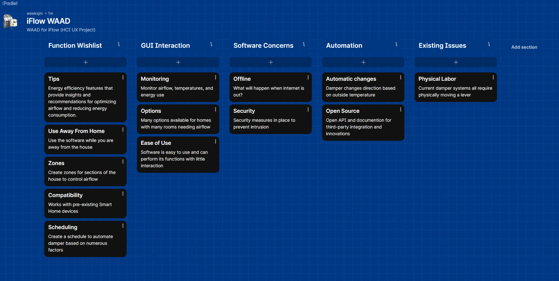

7. **Initial Flow Model**

Our initial flow model will help our team create a visual representation of how the system fits into the workflow of our project.

