Derrick A., Jared W., Colin M.

Abstract

A remotely controllable set of air-duct dampers as IoT devices that enable temperature customization for each room/zone of an HVAC system.

TEAM E-PROJECT #3

iFlow

**Project Step 3 -**

**1**. **Planning**

During our third meeting, we began to examine the scope of our project, considering the entire process moving forward. With the objective of creating a user-friendly HVAC control app, we diligently made decisions that followed our personal project goals and predetermined the outline of the project. When it came to deciding the specific design requirements, we used a combination of our requirements from early in class, along with additional requirements we came up with together. After we had a good understanding of the needs and wants of the app, we were able to design accurate models that demonstrated both usability and efficiency.

**Models:**

Jared – Users Classes

Jared – Usage Scenario

Jared – Work Roles

Derrick – Workflow

Derrick – HTI

Colin – Step by Step Task Interaction

Colin – Essential Use Case Task Interaction

Colin – Information Object

**2**. **Integration Design Requirements**

**1. Battery Options**

|  |
| --- |
| **Level 1: Battery Options** |
| **Level 2: Operate device with batteries** |
| **Requirement: Provide users with ability to use batteries over electricity** |
| **Note:** |

**2. Ease of Use**

|  |
| --- |
| **Level 1: Ease of Use** |
| **Level 2: GUI is simple to use** |
| **Requirement: Software is easy to use and can perform its functions with little interaction** |
| **Note: Easy to use, but offers depth in customization options** |

**3.**  **Security**

|  |
| --- |
| **Level 1: Security** |
| **Level 2: Protect iFlow and other devices on user’s network** |
| **Requirement: Security measures in place to prevent intrusion** |
| **Note: In design, consider safety features (2FA, etc.)** |

**4.** **Number of Units**

|  |
| --- |
| **Level 1: Number of Units** |
| **Level 2: Control multiple units with the same software** |
| **Requirement: Create zones for sections of the house to control airflow** |
| **Note: Will have to consider the feasibility of multiple buildings and balance security concerns.** |

**5. Offline Use**

|  |
| --- |
| **Level 1: Offline Use** |
| **Level 2: What happens when the internet goes down?** |
| **Requirement: Provide options if users are unable to connect to the internet to operate software.** |
| **Note: Even though this is an IoT device, a physical lever will still operate units as fail-safe.** |

**6. Energy Consumption**

|  |
| --- |
| **Level 1: Energy Consumption** |
| **Level 2: Tips** |
| **Requirement: Energy efficiency features that provide insights and recommendations for optimizing airflow and reducing energy consumption.** |
| **Note: Can this save the user’s money? Marketing point potential.** |

**7.**  **Open-Source**

|  |
| --- |
| **Level 1: Open-Source** |
| **Level 2: Open-Source Development** |
| **Requirement: Open API and documentation for third-party integration and innovations** |
| **Note: If project takes off, consider other advancements in field (collaboration, new industry)** |

**8. Customization**

|  |
| --- |
| **Level 1: Customization** |
| **Level 2: Changes aspects of the app to the users liking** |
| **Requirement: Providing app customization and adaptable design features will give any users the option to change their app to specific wants and needs.** |
| **Note:**  Will this help with sales and customer satisfaction |

**9. Reminders**

|  |
| --- |
| **Level 1: Reminders** |
| **Level 2: Alerts and notifications to the user** |
| **Requirement: The ability to send out notifications and alerts to the user letting them know when dampers need to be replaced, when a specific room reaches a desired temperature, or if the air quality is bad.** |
| **Note:** |

**10. Unit Scheduling**

|  |
| --- |
| **Level 1: Unit Scheduling** |
| **Level 2: Customizable schedules for different areas in the house and times of day.** |
| **Requirement: Users want the ability to set personalized schedules for their air-ducts dampers to optimize comfort and energy efficiency.** |
| **Note: Develop a robust scheduling feature that can be personalized to each user.** |

**11. Real Time Monitoring**

|  |
| --- |
| **Level 1: Real Time Monitoring** |
| **Level 2: Airflow and temperature data visualization and monitoring** |
| **Requirement: The ability to monitor airflow and room temperature in different zones and building complexes at any time. Providing users, a clear visual representation of this data will ensure users optimize comfort and savings.** |
| **Note: Implement a real-time monitor feature that present airflow and temperature data visually.** |

**12. Bluetooth Support**

|  |
| --- |
| **Level 1: Bluetooth Support** |
| **Level 2: Smartphone Bluetooth connection** |
| **Requirement: Having the option to switch to Bluetooth connection instead of having the internet connection.** |
| **Note:** |

**13. AI**

|  |
| --- |
| **Level 1: AI** |
| **Level 2: Business Issues and Decisions** |
| **Requirement: Integration of AI model for detecting usage patterns and predicting/automating future use** |
| **Note:** |

**14. Integration**

|  |
| --- |
| **Level 1: Integration** |
| **Level 2: Smart Home Integration** |
| **Requirement: Voice activation integration with smart home devices such as Alexa and Google Home** |
| **Note: “Hey google, set airflow in kitchen to fifty percent”** |

**15. Zoning Section**

|  |
| --- |
| **Level 1: Zoning Section** |
| **Level 2: Sectioning areas of the house** |
| **Requirement: The ability to zone each room in the house and set them to which ever temperature you want them to be.** |
| **Note: Room by Room integration** |

**3. Models**

**1. Usage Scenario – Jared**

Sophia Mitchell is a marketing coordinator for a Fortune 500 company. She lives in a larger home consisting of 4 bedrooms and 3 bathrooms. Her job keeps her away from home often as she tends to work 50–55-hour weeks. Her husband works for the city and works busy shifts. They have two teenagers who come home from school around 3PM, they are in the house more than their parents. While their kids are home and they are still at work, iFlow lets them readjust the angle of their new damper to direct more airflow to the children’s room with only a few buttons presses on their phone. And as the summer season warms up, Sophia can help with her children’s frequent complaints about the heat. Thanks to iFlow’s wi-fi connectivity features, Sophia and her husband can control their new damper system while they are out and about so they can come back to a nice, cool home.

**2. User Classes – Jared**

Class: Homeowners

Class: HVAC Technicians

Class: Property Managers

Class: Residents who live in a home or apartment that do not have direct access to HVAC

**3. Work Roles – Derrick**

iFlow – Work Roles

|  |  |
| --- | --- |
| iFlow buyer | Who interacts with the iFlow seller to learn about and buy the product |
| iFlow seller | Who sells iFlow system to iFlow buyers |
| iFlow installer | Who installs iFlow system for iFlow buyer at their home/office/building |
| iFlow manufacturer | Who manufactures and assembles iFlow system |
| iFlow distributer | Who distributes manufactured iFlow systems to iFlow buyers |

**4. Workflow - Derrick**

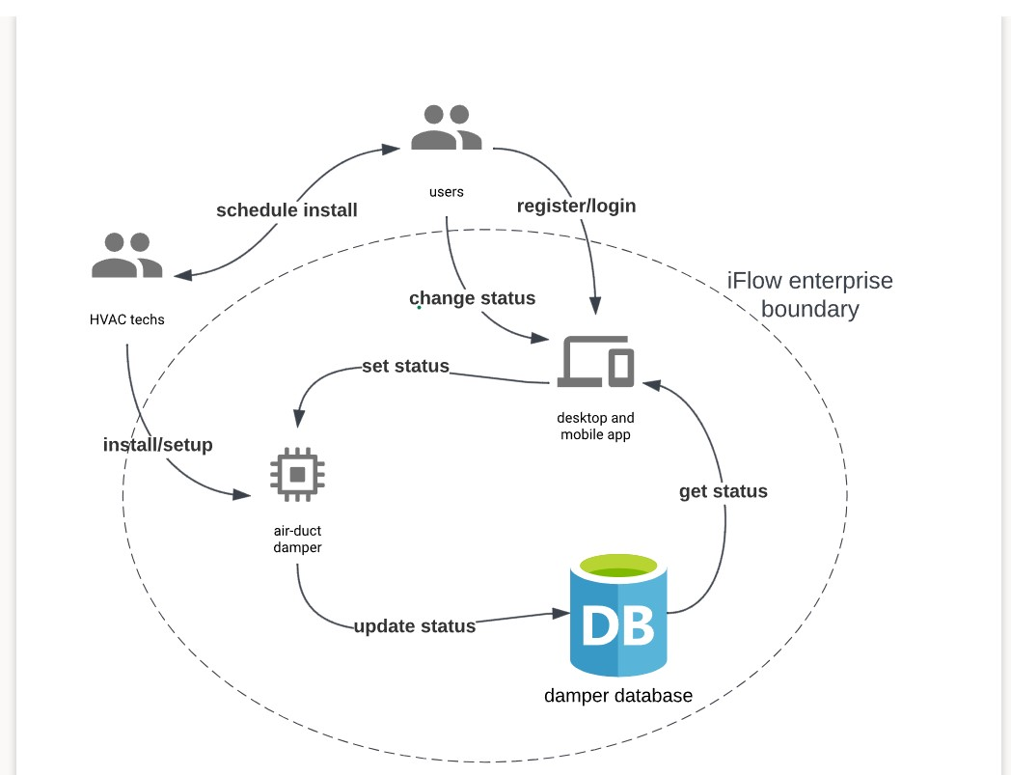

**5. HTI – Derrick**

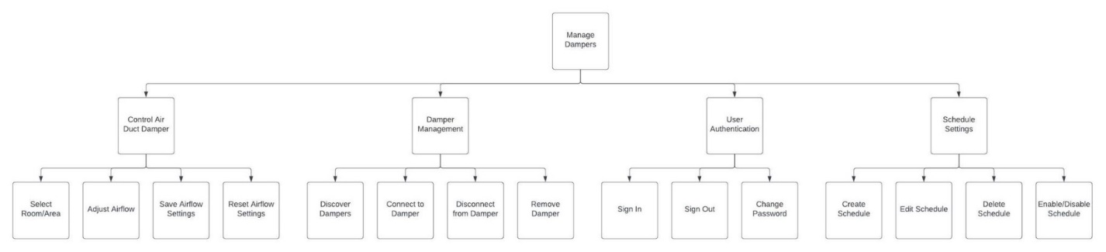

**6. Step by Step – Colin**

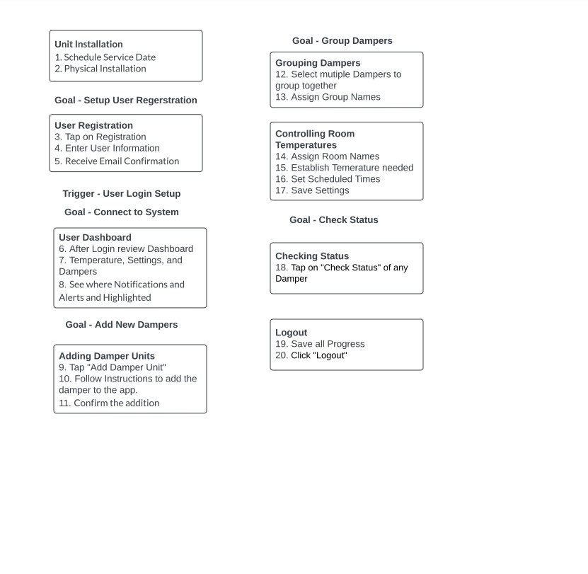

**7. Essential Use Case – Colin**

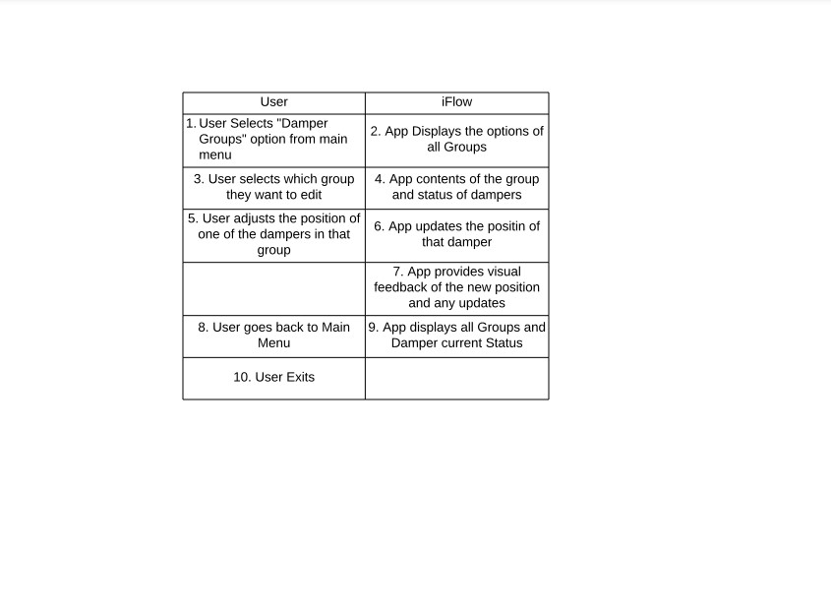

**8. Information Object – Colin**

