Cutdown Base/GPS Notes

4/23/14 - Clear Day
Best feedback from GPS when separated from the payload by at least 6 inches, or when left on top of the mini maglite black box inside the payload or at least separated from the cut-down arduino.
Insulation on top of the payload did not appear have any effect on GPS when left separate from the arduino. Results were less consistent when GPS placed on top of the payload cover.
When outside and on top of the payload, best results were on the corners that were furthest from the cut-down arduino.
Also, results seemed to vary depending on which side of the payload the wire protrudes from when GPS is placed on top.
Possible factors for varying results: smaller number of satellites in range (however we have no way of knowing when this is the case, as we do not have a display for that variable) Also the material of the foam insulation of the payload could affect/disturb the RF performance of the device. I will continue tests tomorrow, so as to make sure the results of today are not anomalous.
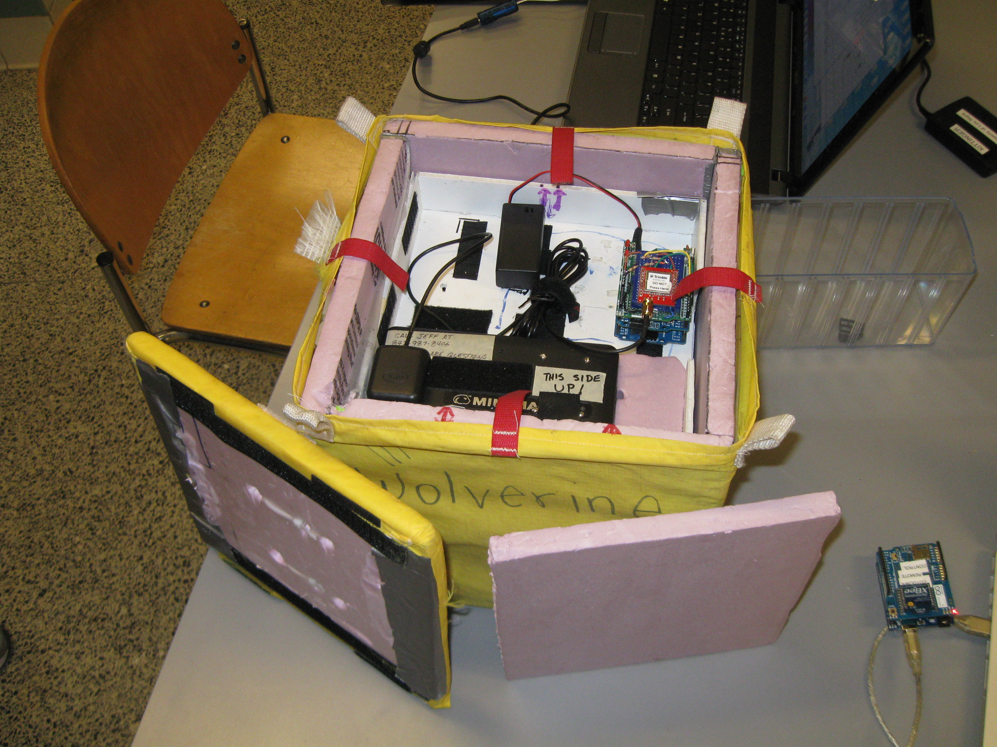Illustration 1: Payload with top removed

4/24/14 - Overcast Day

Very poor feedback from GPS when placed anywhere on or in the box.
Best results when GPS receiver placed off of the payload all together, but even then the results are not 100%. May go for a couple of seconds or more before it picks the signal back up.
Tried using just the top of payload and took out extra layer of insulation, seemed to work for a few seconds, then nothing regardless of the corner it was on.

4/29/14 - Mostly Overcast Day

Worked fine with spacer and lid with antenna mounted near corner on maglite case. Also worked at other side of case. Box set on south part of elevator platform with antenna facing antenna doors.
Turned maglite GPS on with spacer removed at 16:28.
Replaced spacer at about 16:31.
Lost data from CutDownBase at 16:34:11 UTC. Not sure if battery died, or just stopped getting fixes.

NOTE: According to the log, the Maglite GPS got no fixes until 10 seconds after CutDownBase GPS stopped getting fixes.

