The Circuit Layout

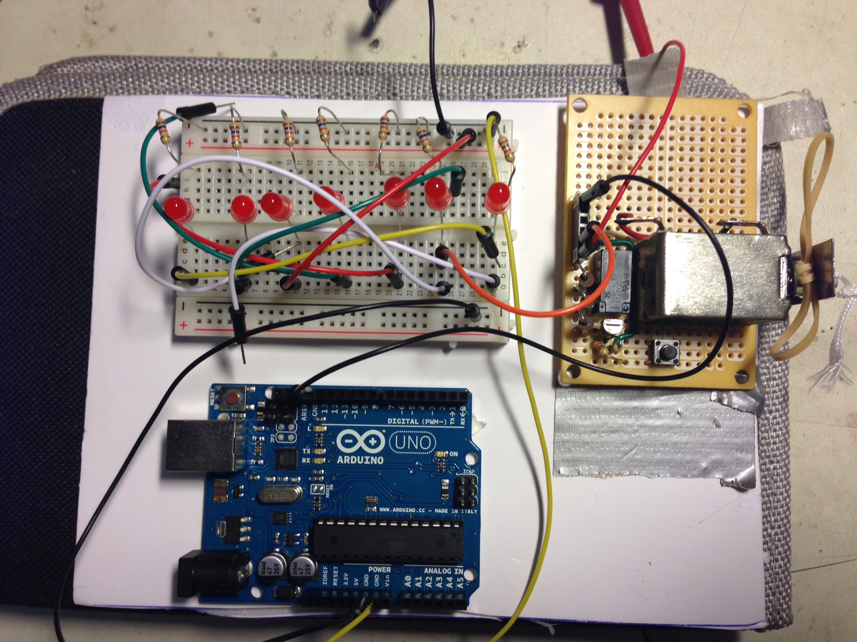

Some distance displacement for spring in order to get the maximum Force.

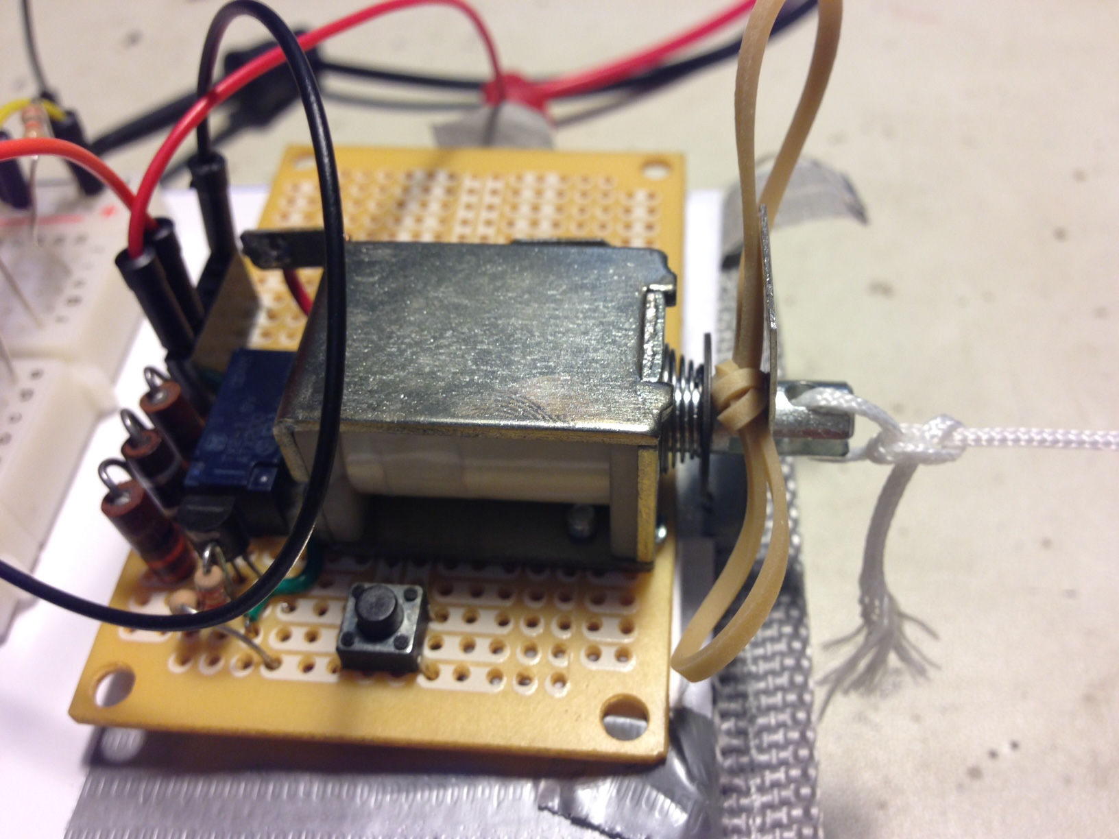

Experiment Set Up

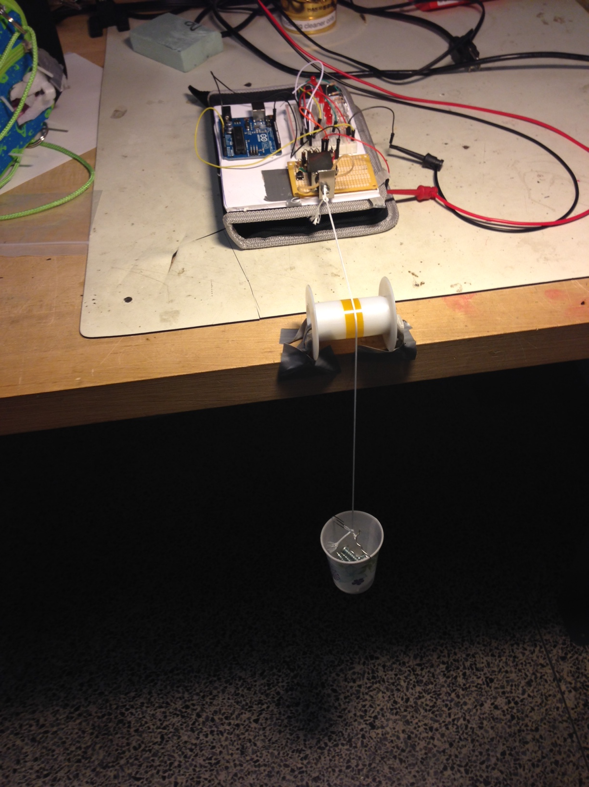

***February 21st, 2015***

Today, I have tried to verify experimentally if properties of solenoids F0411A and G0403A correspond to their properties from Data Sheet.

In order to find these properties, I attached weights to the solenoids’ shafts and tested if they could hold the weight. The weights were attached vertically down from the solenoids’ shafts.

The shat itself weights = *8 grams*

***F0411A – Pontiac Coil (PL012DC) Continuous***

This solenoid has a continuous pull. According to the data sheet, it should have a sealed force of *41 oz.*, which is *1162 grams*.

Experimentally Tested:

*1158 g* (weight) + *8 g* (shaft)= *1166 g* ***did hold***

*1174 g* (weight) + *8 g* (shaft)= *1182 g* ***did not hold***

As a result, experimentally results are very close to those from data sheet specifications.

***G0403A – Pontiac Coil Pulse***

According to the data sheet, this solenoid should have a latched force of *37 oz*., which is *1049 grams*.

Experimentally Tested:

*1628 g* (weight) +*8 g* (shaft) = *1636 g* **held for 20 seconds and it could more**

*1702 g* (weight) +*8 g* (shaft) = *1710 g* **held for 20 seconds and it could more**

*1769 g* (weight) +*8 g* (shaft) = *1777 g*  **held for 18 seconds and it fell down**

As a result, the tested results are higher than those from data sheet. Therefore, we might use this solenoid for our upcoming experiment.