Parawing Assembly Instructions
1. Make sure the linear actuators are attached to the parawing, and the strings have been fed through the correct tubes.

2.Slide the IMU into the right side of the sensor compartment, making sure that the board is aligned correctly and the board is underneath the orange line.

3.Slide the sensor module into the left side of the sensor compartment. Make sure the "this side up" label is facing up ane the "up towards door" label is facing towards the door.

4.Velcro the 9V battery pack for the sensors horizontally in front of the IMU.

5. Put the Arduino/battery holder into place on the left wall, the arduino above the battery box.
6. Place the big pink foam block into the main compartment so that the two arrows are visible and pointing upwards.

7. String the cutdown system, and feed the strings into the tubes before continuing.
**IF this is an actual flight, turn the cutdown on**

8. Thread the antenna of the big red bee through the small tube facing downwards. Push the BRB into place on top of the cutdown system, battery side down.
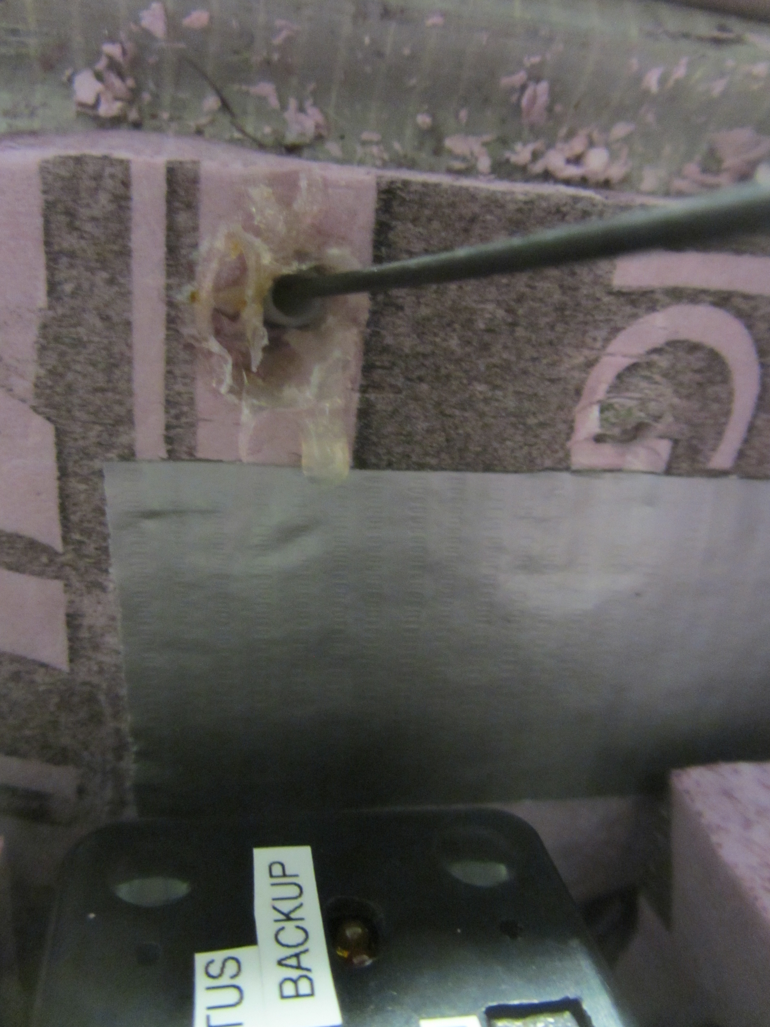

9. Put foam spacers on either side of the tracker, left and right

