🌱
lookmeup.online
Product: LookMeUp.Online — Family Tree Web Application
Project Master Requirements Document
Version 0.4 | Draft | Confidential
Development Domain: crunod.com | Production Domain: lookmeup.online

1. Company & Product Identity
Company Name | lookmeup.online
Product Name | LookMeUp.Online
Product Tagline | Grow your family, one branch at a time
Production Domain | lookmeup.online
Development Domain | crunod.com — all dev, demo, and QA work lives here
Target Market | Global — multi-country, multi-language families
Business Model | SaaS subscription — $1/profile/month billed annually ($12/year per profile)
Privacy Commitment | No exact birth dates, no SSNs, no government IDs, no data usable for identity theft

2. Project Overview
LookMeUp.Online is a private, invite-only family tree web application designed to help families across multiple countries and generations document, connect, and preserve their history. One person starts a sapling — a small household tree — and grows it organically by inviting others who each manage and pay for their own profiles.

- Every tree is private — no public directory, no searchable data
- Growth is organic and invite-driven — no paid advertising required at launch
- The creator of each profile pays for it — distributed billing across the family network
- One canonical profile per real person — no duplicate billing across households
- No identity-theft-vulnerable data is ever collected (no exact DOB, no SSN, no government IDs)
- Built on a CMS framework from day one — no static HTML pages

3. Domain & Environment Strategy

3.1 Two-Domain Architecture
All development, demo, and beta testing runs under crunod.com. The production launch transitions to lookmeup.online. The entire codebase and infrastructure must be transferable between domains with configuration-only changes — no hardcoded domain references anywhere in code.

Development / Demo | crunod.com — free tier tools, dev databases, test Stripe keys, beta users
Production | lookmeup.online — paid tools, production database, live Stripe keys, real users
Transition Method | Environment variables control all domain, API key, and service endpoint references
DNS / SSL | Vercel handles SSL automatically for both domains

3.2 Environment Variables Strategy
Every external service endpoint, domain name, API key, and database URL must be stored in environment variables — never hardcoded. This is what makes the free-to-paid tool transition seamless.

- NEXT_PUBLIC_SITE_URL — switches between crunod.com and lookmeup.online
- DATABASE_URL — switches between free Supabase and paid database
- STRIPE_SECRET_KEY — switches between test and live keys
- EMAIL_PROVIDER_KEY — switches between Resend free and paid email provider
- STORAGE_BUCKET_URL — switches between Supabase Storage and Cloudflare R2 or S3
- CLAUDE_API_KEY — AI support chatbot key

3.3 Free-to-Paid Tool Migration Path
Layer | Free (Dev — crunod.com) | Paid (Production — lookmeup.online)
Database | Supabase Free Tier (PostgreSQL) | Supabase Pro or dedicated PostgreSQL (Railway / Neon)
Auth | Supabase Auth | Supabase Auth (scales with plan) or Auth0
File Storage | Supabase Storage (1GB free) | Cloudflare R2 or AWS S3
Hosting | Vercel Hobby (free) | Vercel Pro or dedicated server
Email | Resend (3k/mo free) | Resend Pro or Postmark
Payments | Stripe Test Mode | Stripe Live Mode (same code, different keys)
CMS | Custom CMS (built in-house, free) | Same custom CMS or migrate to Payload CMS / Sanity
AI Support | Claude API (pay per use) | Claude API (same, scales with volume)
Monitoring | Vercel Analytics (free) | Datadog or Sentry (paid)

4. Content Management System (CMS) Framework

4.1 Philosophy — CMS First, Always
The site will be built on a CMS framework from day one. There are no static HTML pages in this application. Every piece of content — FAQ entries, policy text, terms, page copy, help articles, announcements — is stored in the database and managed through the admin portal. This means:

- Content can be updated without a code deployment
- Non-technical team members can manage content as the company grows
- The same CMS powers the AI support chatbot knowledge base
- All legal/compliance pages (Terms, Privacy Policy, Cookie Policy) are CMS-managed and version-controlled
- The transition from crunod.com to lookmeup.online requires zero content re-entry

4.2 CMS Content Types
cms-pages | All navigable pages — FAQ, About, Pricing, Help, Compliance
cms-policies | Terms of Service, Privacy Policy, Cookie Policy, GDPR Compliance — versioned
cms-faq | FAQ entries — categorized, searchable, fed to AI chatbot context
cms-announcements | System-wide notices and product update banners
cms-help-articles | Inline help content displayed in tooltips and support widget
cms-emails | Email templates — all transactional and notification emails managed here

4.3 CMS Build Schedule
CMS pages are built progressively as features are developed — not at the end. The following pages are built in tandem with the feature they support:

- FAQ — starts Phase 1, grows with every feature added
- Privacy Policy — written Phase 1, reviewed before beta launch
- Terms of Service — written Phase 1, reviewed before beta launch
- Cookie Policy — written Phase 1
- GDPR / Data Compliance — written Phase 2, updated as data fields are added
- Help Articles — written in parallel with each feature phase
- Pricing Page — written Phase 6 when billing is built

5. Database Naming Conventions & Standards

5.1 Core Principle
All database schema names, table names, and column names follow a standardized naming convention anchored by the PURPOSE of the data. This makes the schema self-documenting, easy to navigate as the application grows, and immediately identifiable when new services are added.

5.2 Schema Naming Convention
Each schema is named after the functional domain it serves, using a lowercase hyphenated prefix:

profiles- | All data related to user profiles and family members
trees- | Family tree structure, membership, descriptions, roles
relationships- | Person-to-person relationship links
messages- | In-app messaging, notifications, announcements
invitations- | Invite tokens, status, sender/recipient tracking
billing- | Stripe customer data, subscription state, profile counts
auth- | User accounts, sessions, permissions (managed by Supabase Auth)
cms- | All CMS content — pages, policies, FAQ, emails, help articles
admin- | Admin portal data — reports, audit logs, system settings
qa- | QA test cases, bug reports, tester assignments, test run logs
company- | Company-level settings, branding, feature flags
support- | Customer support tickets, AI chat logs (anonymized), escalations

5.3 Table Naming Convention
Tables inherit their schema prefix, followed by a descriptive noun. All lowercase, hyphen-separated:

profiles-members | Individual family member profile records
profiles-photos | Photo storage references per profile
trees-index | Master list of all family trees
trees-descriptions | Collaborative tree descriptions
trees-members | Tree membership and role assignments
relationships-links | Person A to Person B relationship records
messages-direct | Direct messages between tree members
messages-profile-comments | Comments left on individual profiles
messages-announcements | Moderator tree-wide broadcasts
invitations-sent | Outbound invite records and tokens
billing-customers | Stripe customer ID per user
billing-subscriptions | Active subscription state per user
billing-profile-counts | Profile count history for billing reconciliation
cms-pages | Page content records
cms-faq | FAQ entries
cms-policies | Legal/compliance documents — versioned
admin-reports | Saved report configurations
admin-audit-log | All admin actions timestamped
qa-test-cases | QA test case definitions
qa-test-runs | Individual QA test execution records
support-tickets | Customer support requests
support-chat-logs | AI chatbot session logs (anonymized)

5.4 Column Naming Rules
- All column names lowercase with underscores: first_name not firstName
- Primary keys always named: [table_singular]_id (e.g. profile_id, tree_id)
- Foreign keys always named: [referenced_table_singular]_id (e.g. owner_user_id, tree_id)
- Boolean fields prefixed with is_ or has_: is_deceased, is_active, has_photo
- Timestamp fields suffixed with _at: created_at, updated_at, deleted_at
- Status fields always use defined ENUM strings, never integers (active / archived / pending)
- No abbreviations unless universally understood (url, id, cms are fine — usr is not)

6. User Roles & Access Control

6.1 System-Level Roles (Platform Wide)
Role | Who | Access Level
SuperUser | Founder / core team — full platform access | Unrestricted — all data, all admin, all portals, billing override
Collaborator | Trusted team members, designers, consultants | Admin portal, CMS, QA portal — no billing or user deletion
Tester | QA testers — internal and invited beta users | QA portal, full app features, test data only — no admin access
Subscriber | Paying end users | Own tree(s), own profiles, messaging — no admin access

6.2 Tree-Level Roles (Per Family Tree)
Role | Assigned By | Capabilities
Owner | System on tree creation | Full control of tree — delete, assign moderators, all edits, billing owner
Moderator | Owner only | Edit any profile in tree, approve members, resolve duplicates, announcements
Contributor | Invitation acceptance | Create and edit own profiles, link relationships, message members
Viewer | Invitation (read-only invite) | Browse tree, view profiles — cannot edit or add anything

7. Admin Portal

7.1 Purpose
The admin portal is built from Phase 1 of development and grows in capability as the application grows. It is the operational control center for SuperUsers and Collaborators. It is never public-facing and is accessible only to system-level privileged users.

7.2 Admin Portal Modules
User Management | View all accounts, roles, status — suspend, delete, reset password, impersonate (SuperUser only)
Tree Management | View all trees — member count, profile count, activity, flag for review
Billing Dashboard | Profile counts, subscription status, revenue summary, overdue accounts — read-only Stripe mirror
Invitation Monitor | All pending / accepted / expired invites — resend or revoke
Reports | Configurable reports: user growth, profile count, tree depth, revenue, churn (see 7.3)
CMS Manager | Edit all CMS content — pages, FAQ, policies, email templates, help articles
Support Queue | View open support tickets, AI chat escalations, send responses
Audit Log | Immutable log of all admin actions with timestamp and actor ID
Feature Flags | Toggle features on/off per environment or user segment without code deploy
System Health | API response times, error rates, database status, storage usage

7.3 Built-In Reports (Phase 1 Baseline)
Reports are built progressively. These are available from the first admin portal build:

- User signups over time — daily / weekly / monthly
- Profile count per user — identify power users and billing tier
- Tree size distribution — how many profiles per tree on average
- Invitation funnel — sent vs accepted vs expired conversion rate
- Active vs inactive users — last login within 30 / 60 / 90 days
- Support ticket volume — open / resolved / escalated per week

8. QA Tester Portal

8.1 Philosophy — QA Built in Parallel
The QA portal is not a post-build addition. It is built starting Phase 1 and updated with every new feature as it is developed. Each feature ships with its own test cases already entered into the QA portal before or alongside the feature build.

8.2 QA Portal Capabilities
- Test case library — categorized by feature area (profiles, trees, billing, messaging, etc.)
- Test run execution — tester marks each case pass / fail / blocked with notes
- Bug report submission — linked directly to the failing test case
- Bug status tracking — open / in progress / resolved / closed — visible to testers and admin
- Tester assignment — SuperUser assigns test runs to specific Tester accounts
- Test coverage dashboard — shows which features have test cases and latest pass rate
- Regression suite — flagged test cases that must pass before any release
- Environment selector — tester specifies which environment the run was executed on

8.3 QA Test Case Structure
qa_test_case_id | Unique identifier
feature_area | profiles / trees / billing / messaging / invitations / admin / cms / support
title | Short description of what is being tested
preconditions | What must be true before test can run
steps | Numbered step-by-step actions
expected_result | What should happen if the feature works correctly
priority | critical / high / medium / low
phase_added | Which development phase introduced this test

9. Data Privacy & Security

9.1 No Identity-Theft-Vulnerable Data — Ever
LookMeUp.Online never collects, stores, or transmits information that could be used for identity theft. This is a core product principle and must be respected in every future feature decision.

⚠️ The following data fields are permanently prohibited on this platform:

- Exact full birth dates (day + month + year combined) — year only is permitted
- Social Security Numbers or National ID numbers of any country
- Passport numbers or driver's license numbers
- Full home addresses (country and city of birth are permitted — not current address)
- Financial account numbers or payment card details (Stripe handles all payment data)
- Biometric identifiers
⚠️ Year of birth alone is considered safe and is the only date-related field collected.

9.2 General Privacy Architecture
- All trees private by default — no public directory, no external search indexing
- Access via invite token only — no discoverable profile links
- Row Level Security (RLS) enforced at database level in PostgreSQL
- Photos stored in object storage — not in the database
- GDPR account deletion: owned profiles flagged, moderator notified to reassign
- AI support chat logs stored anonymized — no PII in support-chat-logs table
- Audit log is immutable — no admin can delete their own action records

10. Technology Stack

10.1 Development Stack (crunod.com — Free)
Frontend | Next.js (React) — App Router, Server Components
Backend / DB | Supabase — PostgreSQL, Auth, Storage, Realtime
Hosting | Vercel — Hobby tier (free)
File Storage | Supabase Storage (1GB free)
Payments | Stripe — Test Mode (free during development)
Email | Resend — 3,000 emails/month free
Tree Rendering | D3.js — open source, SVG export
Print / Export | Puppeteer — headless Chrome server rendering
In-App Messaging | Supabase Realtime — included in free tier
AI Support | Claude API (Anthropic) — pay per use
Version Control | GitHub — free
Total Dev Cost | $0 until production launch

10.2 Production Stack (lookmeup.online — Paid)
Identical codebase — only environment variables change. No code modifications required for the transition.
Database | Supabase Pro or Railway / Neon PostgreSQL
Hosting | Vercel Pro or dedicated VPS
File Storage | Cloudflare R2 or AWS S3
Email | Resend Pro or Postmark
Payments | Stripe Live Mode
Monitoring | Sentry (errors) + Datadog or Vercel Analytics Pro
CMS | Custom CMS (built in-house) — optional future migration to Payload CMS or Sanity

11. Database Architecture

11.1 Profile Fields
⚠️ Year of birth is collected as an integer only. No full birth dates. No government identifiers.

profile_id | UUID — primary key
tree_id | FK → trees-index
owner_user_id | FK → auth — who pays for this profile
tree_identifier | System generated: '1942-JM' or '1942-JM-2' for collisions
first_name | Text — optional for unknown ancestors
last_name | Text — optional
country_of_birth | Text — country name or code
city_of_birth | Text — optional
year_of_birth | Integer — year only. NULL if unknown.
year_of_birth_confidence | exact / approximate / estimated
year_of_passing | Integer — year only. NULL if living.
is_deceased | Boolean
biography | Long text
social_links | JSONB — flexible key/value pairs
profile_emoji | Text — emoji placeholder when name/photo unknown
photo_1_url | Storage URL
photo_2_url | Storage URL
photo_3_url | Storage URL
created_at | Timestamp
updated_at | Timestamp

11.2 Relationship Types
Stored in relationships-links. All relationship data is directional rows — no fixed columns for family members.

- parent / child / sibling / half-sibling
- spouse / ex-spouse
- adopted-parent / adopted-child
- Unlimited entries per profile — a person with 10 siblings = 10 rows

11.3 Tree Identifier Logic
Format: {YYYY}-{F}{L} where F = first initial of first name, L = first initial of last name.

- Unknown year → ???? prefix: ????-JM
- Approximate year → tilde prefix: ~1923-JM
- Single name / no last name → emoji fills the gap: 1942-J🌿
- Collision → append sequential suffix: 1942-JM, 1942-JM-2, 1942-JM-3

12. Tree Visualization & Export
- Interactive browser tree via D3.js — zoomable, pannable, clickable nodes
- Each node: thumbnail photo or emoji, display name, birth–passing years, tree identifier
- Spouses rendered side-by-side; adopted relationships shown with dashed lines
- Top-down default layout; toggle to left-right for wide trees
- Server-side export via Puppeteer — PNG and PDF output
- Print sizes: Letter, A4, A3, A2, Poster (reunion use case)
- 60–80 node trees render in under 5 seconds

13. Billing & Subscription
Price | $12 per profile per year (billed annually upfront)
Who Pays | The user who creates the profile
Invitations | Free to send — recipient pays for their own profiles
Processor | Stripe Billing — quantity-based annual subscriptions
Profile Counting | Stripe quantity increments when profile added, decrements when deleted
Renewals | Billed at profile count on renewal date — prorated for mid-year changes
No Duplication | One canonical profile per real person — new members link, not recreate

14. Customer Support — AI-First Strategy
Live Support Threshold | No human support agents until registered user count exceeds 30,000
AI Engine | Claude API (Anthropic) — embedded chat widget in-app
Knowledge Base | CMS-managed FAQ and help articles fed into Claude context window
Escalation Path | AI flags unresolved queries → email ticket → founder review in batches
Chat Log Storage | Stored anonymized in support-chat-logs — no PII retained
Email Support | help@lookmeup.online — AI-drafted responses, founder reviews and sends
Response Target | 48–72 hours pre-30k users

User Count | Support Model | Tooling
0 – 30,000 | AI chatbot only + async email | Claude API + Resend
30k – 100k | AI chatbot + 1–2 part-time human agents | Claude API + help desk (Crisp or Intercom)
100k+ | Dedicated team + AI triage layer | Full help desk platform

15. In-App Messaging
- Direct messages between tree members — Supabase Realtime
- Profile comments — notes left on individual profiles
- Tree announcements — moderator broadcasts to all tree members
- Notification bell — new message, new profile added, new relationship linked
- All messages scoped to tree membership — no cross-tree visibility

16. Revenue Streams — Overview
LookMeUp.Online is designed with layered revenue from launch. The core subscription is the foundation. Each additional revenue stream is triggered by natural user behavior already occurring inside the platform — no forced upsells. Detailed users and business processes for each external stream are documented in Sections 17 through 22.

Revenue Stream | Type | Est. Revenue Per Event
Core Profile Subscriptions | Recurring SaaS | $12/profile/year
Premium Profile Upgrade | Recurring Add-on | $3/profile/year upgrade
Print Products | One-time transactional | $35–$120 per order
DNA & Records Affiliate | Affiliate commission | $15–$60 per referral
Family Reunion Tools | One-time event fee | $15–$25 per event
Institutional / B2B Licensing | Recurring SaaS (B2B) | $200–$500/month per org
Translation Add-on | Recurring Add-on | $2–$5/profile/year

17. Revenue Stream 1 — Premium Profile Upgrade

17.1 Description
A per-profile annual upgrade that unlocks enhanced media and document capabilities. Charged in addition to the base $12/profile/year subscription. The upgrade is applied per profile — a user can upgrade selected profiles and leave others at the standard tier.

17.2 Users Involved
User | Role in This Stream | Action
Profile Owner (Subscriber) | Primary actor — pays for the upgrade | Purchases premium upgrade for one or more of their owned profiles
Profile Subject | Beneficiary — richer profile representation | Has more photos, audio, video, documents attached to their record
Tree Members (Viewers) | Secondary beneficiaries | See richer profile content when browsing the tree
SuperUser / Admin | Monitor and report | Views premium profile counts and upgrade revenue in admin dashboard

17.3 Business Process
Trigger
User attempts to upload a 4th photo, attach a document, or add a video link to a standard profile. System intercepts and displays upgrade prompt.
Upgrade Flow
- User clicks 'Upgrade this profile to Premium' from the profile edit screen
- Modal displays: what's included, price ($3/profile/year), billed with next annual renewal
- User confirms — Stripe subscription quantity for premium tier increments by 1
- Profile is immediately unlocked — user continues their upload
- Confirmation email sent via Resend
What Premium Unlocks
- Up to 10 photos (standard: 3)
- Video embed — YouTube or Vimeo link displayed on profile
- Document attachments — scanned letters, birth certificates, newspaper clippings (PDF/image)
- Audio recording — voice memo or oral history clip (MP3/M4A, max 10 minutes)
Billing Logic
- Prorated at time of upgrade — partial year billed immediately via Stripe
- Full $3/year included in next annual renewal alongside base subscription
- Downgrade: user can revert to standard at renewal — excess media flagged but not deleted for 90 days
Database Tables Affected
- billing-subscriptions — premium_profile_count field increments
- profiles-members — has_premium flag set to true
- profiles-photos, profiles-documents, profiles-audio — new tables activated for premium profiles

18. Revenue Stream 2 — Print Products

18.1 Description
Physical printed products generated from the family tree data and ordered on-demand through a print partner (Printful or Gelato). Zero inventory — products are printed and shipped directly to the customer by the partner. LookMeUp.Online earns the margin between the retail price charged to the user and the wholesale cost charged by the print partner.

18.2 Product Catalog
Product | Retail Price | Est. Wholesale Cost
Family Tree Poster (A2) | $45 | ~$12
Family Tree Poster (A1 — large) | $75 | ~$20
Framed Family Tree Portrait | $90 | ~$35
Hardcover Family History Book | $95 | ~$40
Softcover Family History Book | $60 | ~$25
Family Photo Collage Print | $45 | ~$15

18.3 Users Involved
User | Role in This Stream | Action
Tree Owner / Contributor | Primary actor — initiates and pays for print order | Selects product, customizes, places order
Tree Members | Potential co-purchasers | Receive sharing link to order their own copy of same design
Print Partner (Printful / Gelato) | Fulfillment partner | Receives order via API, prints, ships directly to customer
SuperUser / Admin | Monitor | Views print order revenue, fulfillment status in admin dashboard

18.4 Business Process
Trigger
User views their rendered family tree and clicks 'Order a Print' or 'Export & Print'. Also surfaced after a tree reaches 10+ profiles as a milestone prompt: 'Your tree is growing — preserve it in print.'
Order Flow
- User selects product type and size from print catalog
- System renders a high-resolution preview using the Puppeteer export engine
- User can optionally customize: title text, date range, color scheme
- User reviews preview, selects quantity, enters shipping address
- Stripe processes payment — retail price charged to user
- Order payload sent to Printful or Gelato API — wholesale cost deducted automatically
- Print partner confirms order and provides fulfillment tracking number
- User receives order confirmation and tracking link via email (Resend)
- LookMeUp.Online retains margin — no manual fulfillment required
Book Generation Process (Hardcover / Softcover)
- System auto-generates chapter per tree branch — one page per profile
- Each profile page includes: photo, name, dates, biography, relationships listed
- Cover page: tree name, date range, contributor list
- Table of contents auto-generated by generation and branch
- PDF sent to print partner in press-ready format
Sharing Logic
- After order placed, user sees: 'Share this design with your family'
- Shareable link generated — other tree members can order their own copy at same retail price
- Each order is independent — no group order complexity
Database Tables Affected
- billing-print-orders — new table: order_id, user_id, tree_id, product_type, status, partner_order_id, retail_price, wholesale_cost, margin, shipped_at
- admin-reports — print revenue report updated

19. Revenue Stream 3 — DNA & Genealogy Records Affiliate

19.1 Description
When users encounter unknown ancestors, approximate dates, or dead ends in their tree, LookMeUp.Online surfaces contextual affiliate links to partner genealogy and DNA services. LookMeUp.Online earns a referral commission for each user who clicks through and completes a qualifying action (purchase, subscription, or kit order) on the partner site. No data is shared with partners without explicit user consent.

19.2 Affiliate Partners
Partner | Product | Commission Model
AncestryDNA | DNA kit + family matching | ~$20–$40 per kit sold
23andMe | DNA kit + health + ancestry reports | ~$20–$50 per kit sold
MyHeritage | DNA kit + historical record matching | ~$15–$30 per subscription
Findmypast | Historical records (strong UK/Ireland/Commonwealth coverage) | ~$10–$20 per subscription
FamilySearch | Free LDS-sponsored records (no commission — goodwill placement) | None — trust building

19.3 Users Involved
User | Role in This Stream | Action
Subscriber (any role) | Primary actor — clicks affiliate link | Follows link to partner site and completes purchase
Tree Moderator / Owner | Indirect trigger | Their tree has profiles with unknown data — prompts surfacing
Affiliate Partner | External revenue source | Tracks clicks, conversions, pays LookMeUp.Online commission monthly
SuperUser / Admin | Monitor | Views affiliate click-through and conversion rates in admin

19.4 Business Process
Trigger Points — Where Affiliate Links Are Surfaced
- Profile has year_of_birth_confidence = 'estimated' or year_of_birth is NULL → 'Discover more about [Name] — search historical records'
- Profile has no photo and is more than 2 generations back → 'Find photos and records for ancestors like [Name]'
- Tree reaches a dead end (profile with no parents linked) → 'Trace this branch further — search DNA matches'
- User manually clicks 'Research this person' button on any profile
- Tree hits 3+ generations → milestone banner: 'Ready to go deeper? Connect your DNA'
Placement Rules
- Affiliate links are always labeled: 'Powered by [Partner]' — never disguised as LookMeUp.Online features
- Maximum one affiliate prompt per session — not shown on every page view
- User can dismiss and suppress for 30 days
- Links always open in a new tab — user never leaves LookMeUp.Online
Tracking & Commission Flow
- Each affiliate link includes LookMeUp.Online's unique referral tracking code
- Partner tracks clicks and conversions on their side
- Monthly commission report reconciled against partner dashboard
- Commission deposited to LookMeUp.Online bank account monthly by each partner
Privacy Rule
No user data, profile data, or tree data is ever transmitted to affiliate partners. The referral link contains only LookMeUp.Online's partner ID — not the user's name, email, or any profile content.
Database Tables Affected
- billing-affiliate-clicks — new table: click_id, user_id, partner_name, profile_id (optional context), clicked_at, session_id
- billing-affiliate-commissions — partner, month, clicks, conversions, commission_amount, paid_at

20. Revenue Stream 4 — Family Reunion Tools

20.1 Description
A one-time fee feature that generates a shareable family reunion package from the existing tree data. Families use this for annual gatherings, milestone birthdays, memorial events, and cultural heritage celebrations. The product requires no new data entry — it is assembled entirely from profiles already in the tree.

20.2 Reunion Package Contents
- Printed or digital reunion booklet (PDF) — auto-generated, professionally formatted
- Family tree poster export at reunion print size
- RSVP page — simple event page hosted on LookMeUp.Online where tree members can confirm attendance
- Guest list — drawn from tree members who RSVP
- Memory wall — members can upload a photo and a short message before the event
- Event details page — date, location (no exact address required — city/venue name only), organizer contact

20.3 Users Involved
User | Role in This Stream | Action
Tree Owner / Moderator | Event organizer — pays the one-time fee | Creates reunion event, customizes booklet, shares RSVP link
Tree Members (all roles) | RSVPs and memory wall contributors | Receive invite, RSVP, optionally add photo and message
Viewers (read-only) | Invited attendees outside the tree | Can RSVP via public event link — no LookMeUp.Online account required
SuperUser / Admin | Monitor | Views reunion event count and one-time fee revenue in admin

20.4 Business Process
Trigger
Tree moderator or owner clicks 'Plan a Family Reunion' from the tree dashboard. Also surfaced as a prompt when a tree reaches 5+ branches or 20+ profiles.
Setup Flow
- Organizer enters event name, approximate date (month + year — no exact date required), city/venue name
- System generates a preview of the reunion booklet from current tree data
- Organizer reviews and optionally customizes: cover title, which branches to include, whether to show all profiles or living only
- One-time fee ($15–$25) charged via Stripe
- Event page goes live — unique URL generated (hosted on lookmeup.online/reunion/[event-code])
- Organizer shares event URL with tree members and extended family via in-app messaging and/or email
RSVP Flow
- Recipients open event URL — see tree poster, event details, memory wall
- Click RSVP — existing LookMeUp.Online members log in, external guests enter name only (no account required)
- Organizer sees live RSVP count in their event dashboard
- Memory wall: members upload one photo and one short message (50 words max) before the event
Booklet Generation
- PDF booklet auto-generated by Puppeteer — one chapter per family branch
- Includes: family tree diagram, per-profile pages (photo, name, years, biography excerpt), memory wall submissions, RSVP guest list
- Organizer downloads print-ready PDF — can send to local printer or order via print product integration
Database Tables Affected
- cms-reunion-events — event_id, tree_id, organizer_user_id, event_name, event_month, event_year, event_city, status, fee_paid_at
- cms-reunion-rsvps — rsvp_id, event_id, user_id (nullable), guest_name, attending, responded_at
- cms-reunion-memories — memory_id, event_id, user_id, photo_url, message, submitted_at

21. Revenue Stream 5 — Institutional & B2B Licensing

21.1 Description
A white-labeled or co-branded version of the LookMeUp.Online platform licensed to organizations that serve communities with shared heritage. This is a B2B subscription sold to the organization — end users within the organization's community use the platform for free or at a heavily subsidized rate set by the organization.

21.2 Target Organizations
- Genealogical and historical societies (e.g. national or regional family history organizations)
- Cultural heritage nonprofits — diaspora communities, indigenous heritage organizations, immigrant community groups
- Religious institutions — churches, mosques, synagogues, temples maintaining community lineage records
- Universities and libraries — academic genealogy programs, special collections departments
- Government heritage departments — national archives, cultural ministries (international)

21.3 Users Involved
User | Role in This Stream | Action
Organization Administrator | B2B client — signs contract, pays subscription | Manages org account, invites community members, configures branding
Community Members | End users within the org | Use LookMeUp.Online to build trees — may pay reduced or zero individual cost
SuperUser (LookMeUp.Online) | Account manager | Onboards org, configures white-label settings, monitors usage
Collaborator (LookMeUp.Online) | Support contact for org admin | Handles org-level support queries and feature requests

21.4 Institutional Plan Tiers
Plan | Monthly Fee | Includes
Community | $200/month | Up to 500 profiles, LookMeUp.Online branding, standard support, basic admin reports
Heritage | $350/month | Up to 2,000 profiles, co-branded (org logo + LookMeUp.Online), priority support, full reports
Enterprise | $500+/month | Unlimited profiles, white-labeled (org brand only), dedicated contact, custom features roadmap

21.5 Business Process
Outreach & Qualification
- Inbound: organization contacts via help@lookmeup.online — flagged as B2B inquiry in support queue
- Outbound (post-30k users): SuperUser identifies candidate organizations from user signup patterns — clusters of users from same organization type
- Initial discovery call — SuperUser conducts via video call to qualify need, size, budget
Onboarding Flow
- SuperUser creates institutional account in admin portal — assigns Organization Administrator role
- Admin portal: org name, logo upload, custom color scheme (Heritage and Enterprise plans)
- Subdomain or path configured: e.g. LookMeUp.Online.com/org/[orgcode] or org.LookMeUp.Online.com (Enterprise)
- Stripe invoice created — monthly recurring, billed to organization's payment method
- Organization Administrator receives onboarding email with setup guide and admin credentials
- LookMeUp.Online SuperUser monitors first 30 days — checks in at day 7 and day 30
Community Member Onboarding (via Org Admin)
- Org Admin uses bulk invite tool — uploads CSV of member email addresses
- System sends branded invite emails to all addresses
- Members join and build trees within the organization's space
- Profile costs at Community/Heritage plans: absorbed by org subscription — members pay $0 for base profiles
- Enterprise plan: org sets member pricing — can pass cost through or subsidize fully
Database Tables Affected
- company-institutions — institution_id, name, plan_tier, stripe_customer_id, admin_user_id, logo_url, color_scheme, subdomain, status, created_at
- company-institution-members — institution_id, user_id, joined_at, invited_by
- billing-institutional-subscriptions — institution_id, plan_tier, monthly_fee, profile_count, billing_cycle_start, stripe_invoice_id

22. Revenue Stream 6 — Translation & Localization Add-on

22.1 Description
An AI-powered translation add-on that enables profiles to be displayed in multiple languages and supports non-Latin names and scripts. Given LookMeUp.Online's globally distributed user base across multiple countries, many families include members who speak different languages. This add-on makes those trees accessible to all branches regardless of language.

22.2 What the Add-on Does
- Translates biography text into up to 5 languages per profile — powered by Claude API or a translation API (DeepL / Google Translate)
- Displays profile in viewer's preferred language — auto-detected from browser, overridable in settings
- Supports non-Latin name display — Arabic, Chinese, Cyrillic, Korean, Hindi scripts rendered correctly alongside Latin transliteration
- Country and city of birth displayed in viewer's local language
- Tree-wide toggle: moderator can enable translation for entire tree as a shared feature

22.3 Pricing Model
Per-Profile Translation | $2/profile/year — applied to individual profiles, paid by profile owner
Tree-Wide Translation | $5/profile/year — moderator pays for all profiles in tree to be translatable
Institutional Translation | Included in Heritage and Enterprise B2B plans

22.4 Users Involved
User | Role in This Stream | Action
Profile Owner | Pays for per-profile translation | Enables translation on their owned profiles
Tree Moderator / Owner | Pays for tree-wide translation | Enables translation for all profiles in tree — billed per profile count
All Tree Members | Beneficiaries | View profiles in their preferred language
SuperUser / Admin | Monitor | Tracks translation add-on uptake and revenue in admin dashboard

22.5 Business Process
Trigger
User views a profile written in a different language. System detects language mismatch between profile biography and viewer's browser language. Displays: 'This profile is written in [Language]. Enable translation to read it in [Your Language].'
Activation Flow
- User clicks 'Enable Translation' — presented with per-profile or tree-wide option
- Pricing displayed — user selects and confirms
- Stripe increments translation add-on quantity in subscription
- Translation job queued — biography sent to translation API
- Translated text stored in profiles-translations table (not overwriting original)
- Profile now displays language toggle — viewer can switch between original and translated versions
Non-Latin Name Handling
- Name entry form accepts non-Latin characters natively
- System stores both original script and Latin transliteration
- Tree identifier uses Latin transliteration for the initials — e.g. Mohammed Al-Rashid → 1965-MA
- Profile display shows original script name prominently, transliteration in smaller text below
Database Tables Affected
- profiles-translations — translation_id, profile_id, language_code, field_name (biography / city_of_birth etc.), translated_text, translated_at, translation_engine
- profiles-members — has_translation (boolean), translation_languages (JSONB array of enabled language codes)
- billing-subscriptions — translation_profile_count field for billing reconciliation

23. Revenue Stream Rollout Timeline
Revenue streams are introduced progressively — not all at launch. Each stream is added when the platform has sufficient user base and infrastructure to support it.

Phase | Revenue Stream | Rationale
Launch (Phase 6) | Core Subscriptions ($12/profile/year) | Platform foundation — required from day one
Launch + 1 month | Premium Profile Upgrade | Immediately valuable — users will hit photo limits early
Month 3–6 | Print Products | Requires Puppeteer export (Phase 8) to be complete
Month 3–6 | DNA & Records Affiliate | Low effort — just affiliate links in existing UI; high intent moments
Month 6–9 | Family Reunion Tools | Requires event infrastructure — built as mini-feature on top of existing tree
Month 9–12 | Translation Add-on | Requires multi-language user base to have natural demand
Year 2+ | Institutional / B2B Licensing | Requires proven product, case studies, and sales process maturity

23.1 Revenue Stream Database Summary
New tables introduced by external revenue streams — following the established naming convention:

profiles-documents | Attached documents per premium profile (PDFs, scans)
profiles-audio | Audio recording references per premium profile
profiles-translations | Translated text per profile per language
billing-print-orders | Print product orders, partner fulfillment tracking, margin tracking
billing-affiliate-clicks | Affiliate link click events — anonymized, no PII
billing-affiliate-commissions | Monthly commission reconciliation per partner
billing-institutional-subscriptions | B2B org subscription billing records
cms-reunion-events | Reunion event records per tree
cms-reunion-rsvps | RSVP responses per event
cms-reunion-memories | Memory wall submissions per event
company-institutions | Institutional/B2B account records
company-institution-members | Members belonging to each institutional account

24. Development Plan

17.1 Team & Approach
Solo development with Claude (Anthropic AI) as primary coding assistant. Developer provides all product direction and decisions. Claude generates code, architecture, migrations, and debugging support. Estimated pace: 6 hours per week in focused 2–3 hour sessions.

17.2 Phase Roadmap
Phase | What Gets Built | Est. Duration
Phase 1 — Foundation | GitHub, Supabase, Vercel setup. Auth. Base DB schema. Admin portal shell. CMS framework. QA portal shell. Privacy/Terms pages started. | 4–6 weeks
Phase 2 — Profiles | Profile create/edit. Photo upload. Tree identifier generation. CMS help articles for profiles. QA test cases for profiles. | 5–7 weeks
Phase 3 — Relationships | Parent/child/sibling/spouse linking. Relationship table logic. QA test cases. | 4–6 weeks
Phase 4 — Trees & Invites | Tree creation. Invite system. Roles. Moderator logic. QA test cases. | 4–6 weeks
Phase 5 — Tree Rendering | D3.js visual tree. Zoom/pan. Node display. QA test cases. | 6–8 weeks
Phase 6 — Billing | Stripe integration. Profile counting. Annual billing. Pricing CMS page. QA test cases. | 3–4 weeks
Phase 7 — Messaging | In-tree messaging. Notifications. Announcements. QA test cases. | 3–4 weeks
Phase 8 — Export/Print | PNG/PDF tree generation. Puppeteer. Size options. QA test cases. | 3–4 weeks
Phase 9 — AI Support | Claude API chatbot. Help docs in CMS. Ticket flow. QA test cases. | 2–3 weeks
Phase 10 — Beta Polish | Bug fixes. Mobile responsiveness. Onboarding flow. Full regression QA run. | 4–6 weeks

Total Estimated | 9–13 months at 6 hours/week
Beta Testing | Developer's own family network spanning multiple countries
Domain at Beta | crunod.com
Domain at Launch | lookmeup.online

17.3 First Week Sprint
- Session 1 (2hrs): Create GitHub repo, Supabase project, Vercel project — connect all three under crunod.com
- Session 2 (2hrs): Build auth — sign up, login, logout, protected routes, SuperUser/Collaborator/Tester roles
- Session 3 (2hrs): Create base database schema following naming convention. Scaffold admin portal shell.

25. Open Questions & Decisions Needed
- Final confirmation: is lookmeup.online registered and pointed to Vercel?
- Is crunod.com already owned and available for dev use?
- Emoji placeholder set — needs a curated design pass (20–30 options)
- Unknown year display — confirm preferred format: ???? vs ~ vs circa
- Cap on collaborative tree descriptions — 3, 5, or 10 entries?
- Moderator nomination — owner-only or can moderators nominate?
- Memorial public mode for deceased profiles — at launch or post-launch?
- Support ticket batch review cadence — daily, every 2 days, or on-demand?
- Print product partner — Printful vs Gelato vs evaluate at Phase 8?
- Paid CMS decision point — custom CMS only or evaluate Payload / Sanity at Phase 4?

Appendix A — Visual Reference Diagrams
The following 10 diagrams summarize the key concepts, architecture, and business model of the LookMeUp.Online platform. Each diagram is designed to stand alone and can be extracted individually for presentations, developer onboarding, or investor conversations.

Diagram 1: Sitemap — All Pages & Navigation
Every page in the application organized by section: Public, App, and Portals. All pages are CMS-managed.
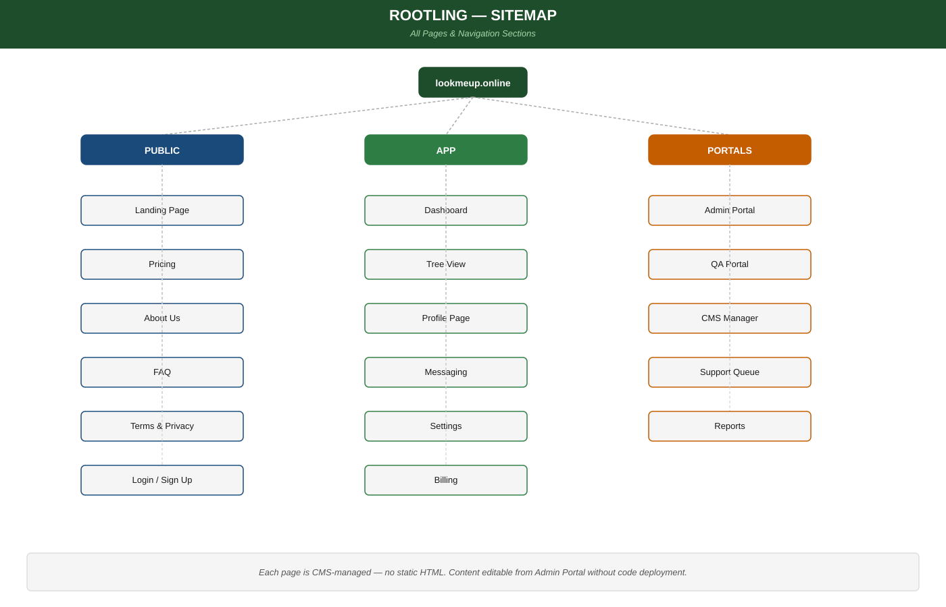

Diagram 2: The Invite Ripple — Viral Growth Model
How one household starting a tree organically becomes dozens of paying users across multiple family branches.
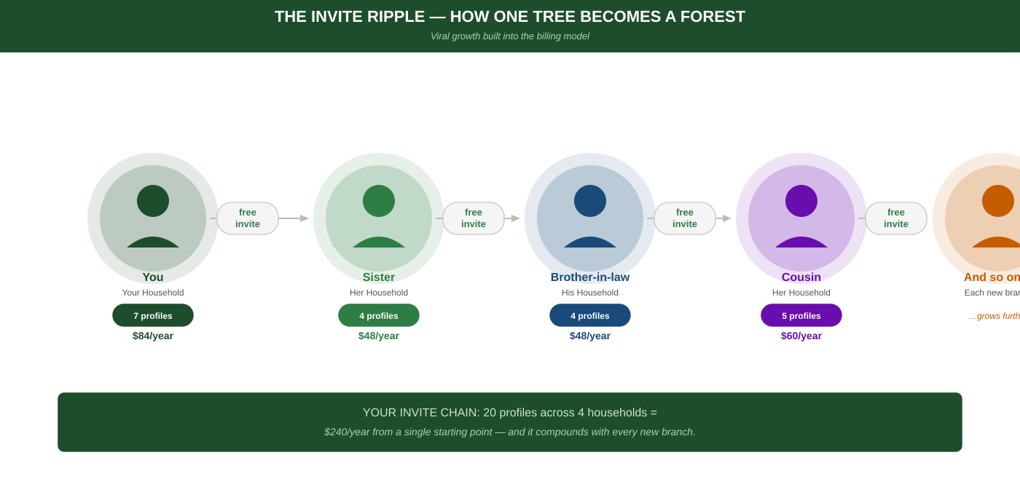

Diagram 3: Billing Flow — How Money Moves
Profile creation to Stripe charge, plus the distributed billing model and invite-to-independent-account flow.
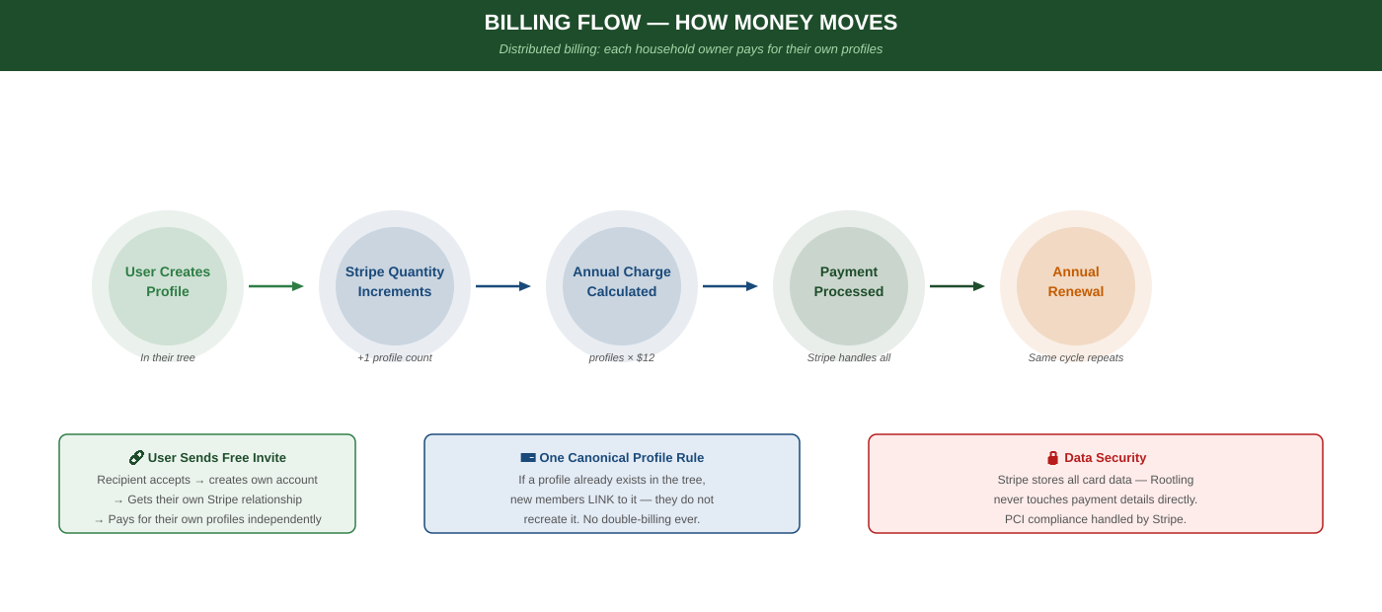

Diagram 4: System Architecture — Free to Paid Path
Full tech stack showing dev tools (crunod.com) vs production (lookmeup.online). Same codebase — environment variables swap everything.
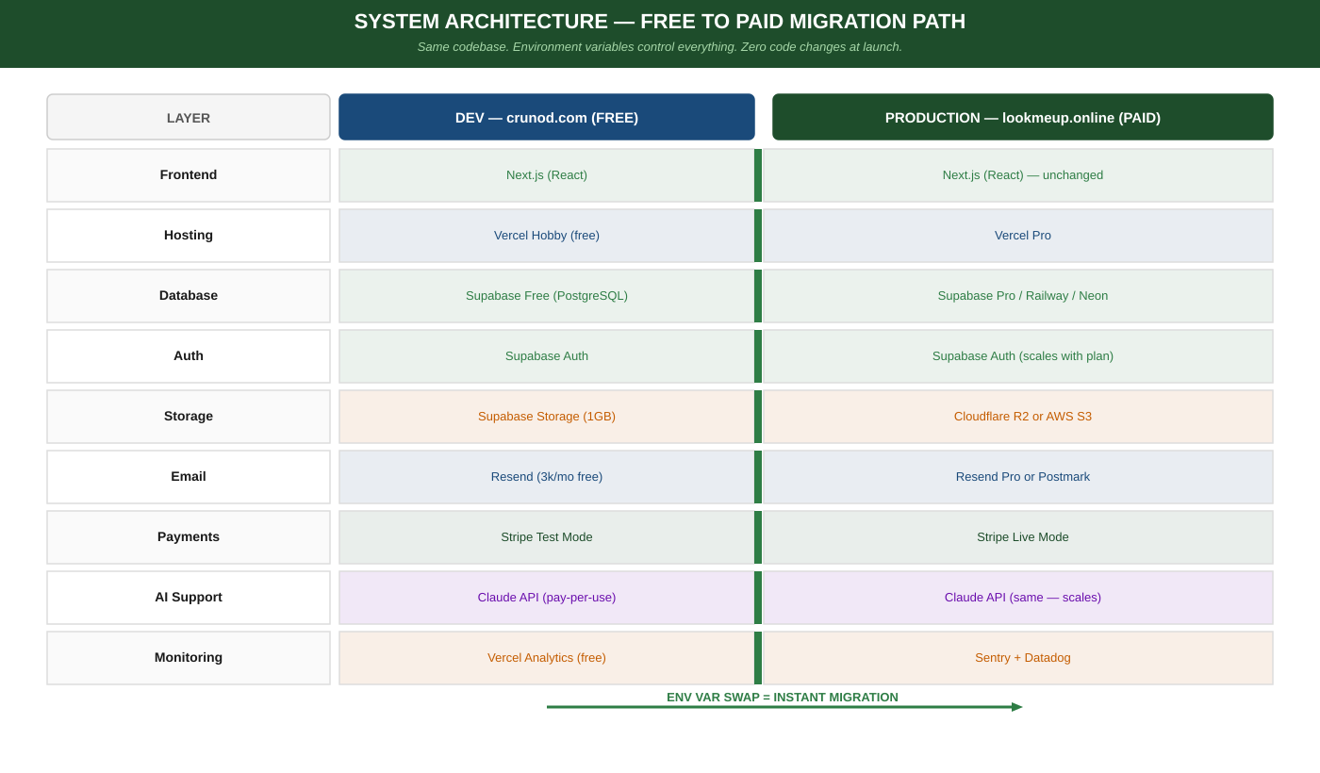

Diagram 5: Simplified Entity Relationship Diagram
Core data entities: User, Profile, Tree, Relationship, Invitation, Billing, and CMS — and how they connect.
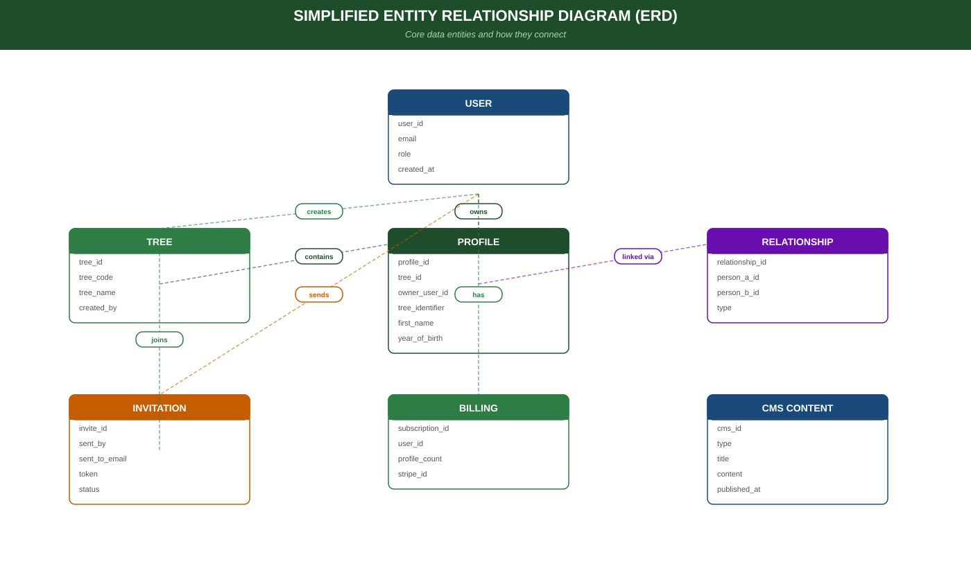

Diagram 6: User Roles & Permissions Matrix
What every role from SuperUser to Viewer can and cannot do across all key platform actions.
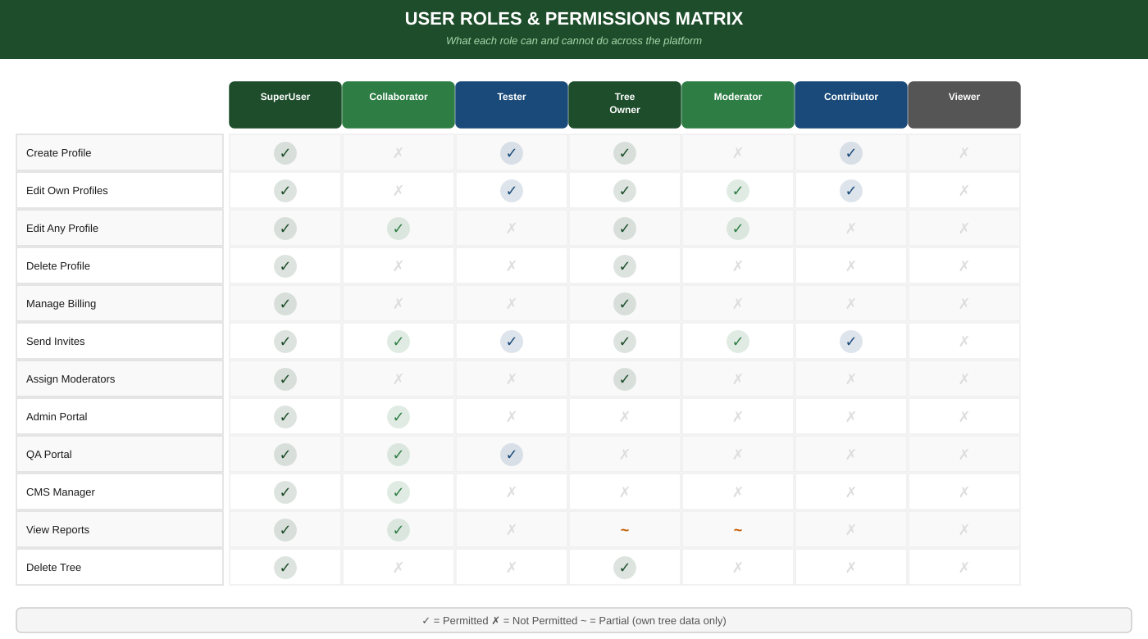

Diagram 7: Revenue Ecosystem Map
All six revenue streams radiating from the core platform. Each triggered by natural user behaviour — no forced upsells.
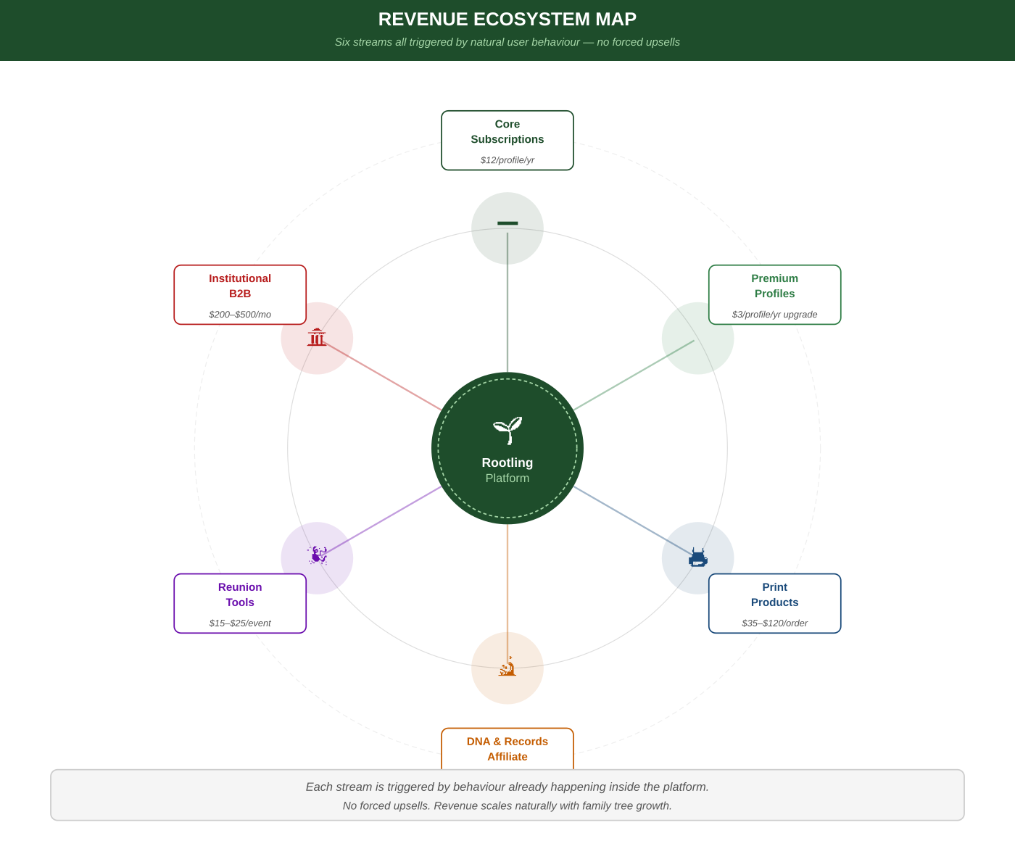

Diagram 8: Development Timeline — Gantt Chart
All 10 development phases across 13 months at 6 hours/week. Key milestones: beta, billing live, public launch.
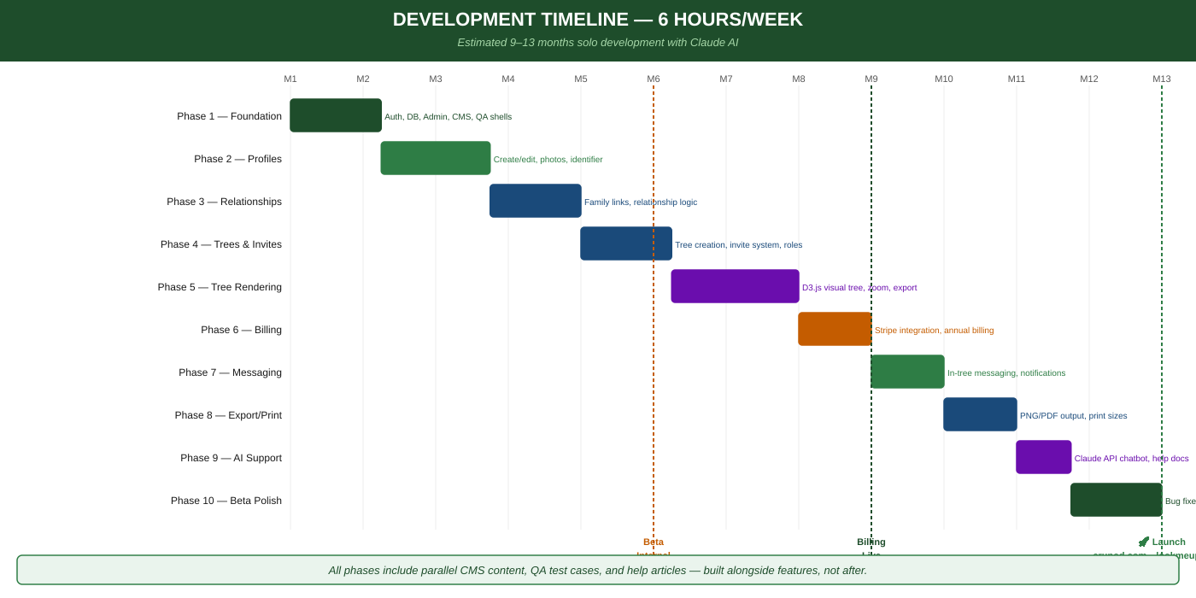

Diagram 9: Privacy Promise — What We Store vs. Never Store
Two-column comparison of permitted vs permanently prohibited data. No exact birth dates, no government IDs, no identity-theft risk.
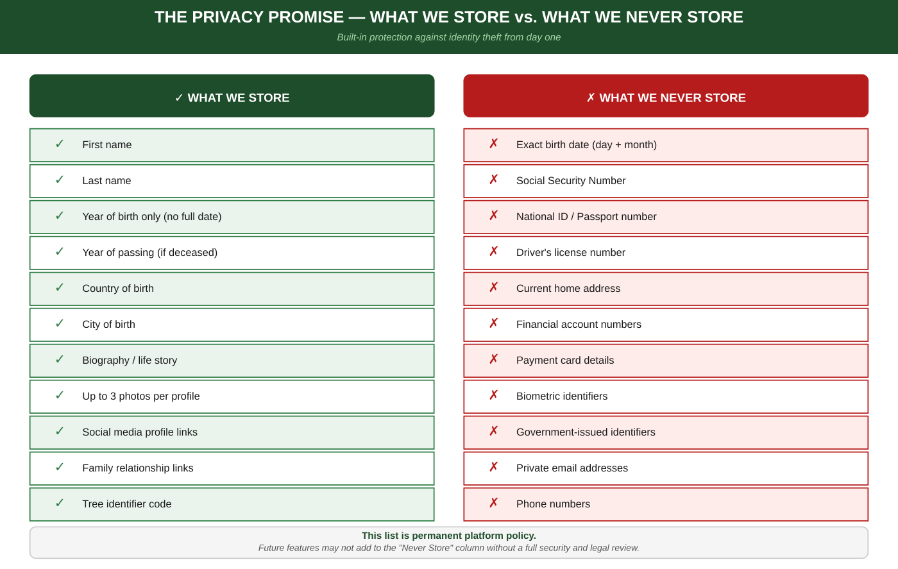

Diagram 10: The Forest Concept — Scale Metaphor
From Sapling (one household) to Grove to Forest to Ecosystem (institutional). Privacy holds constant at every stage of growth.
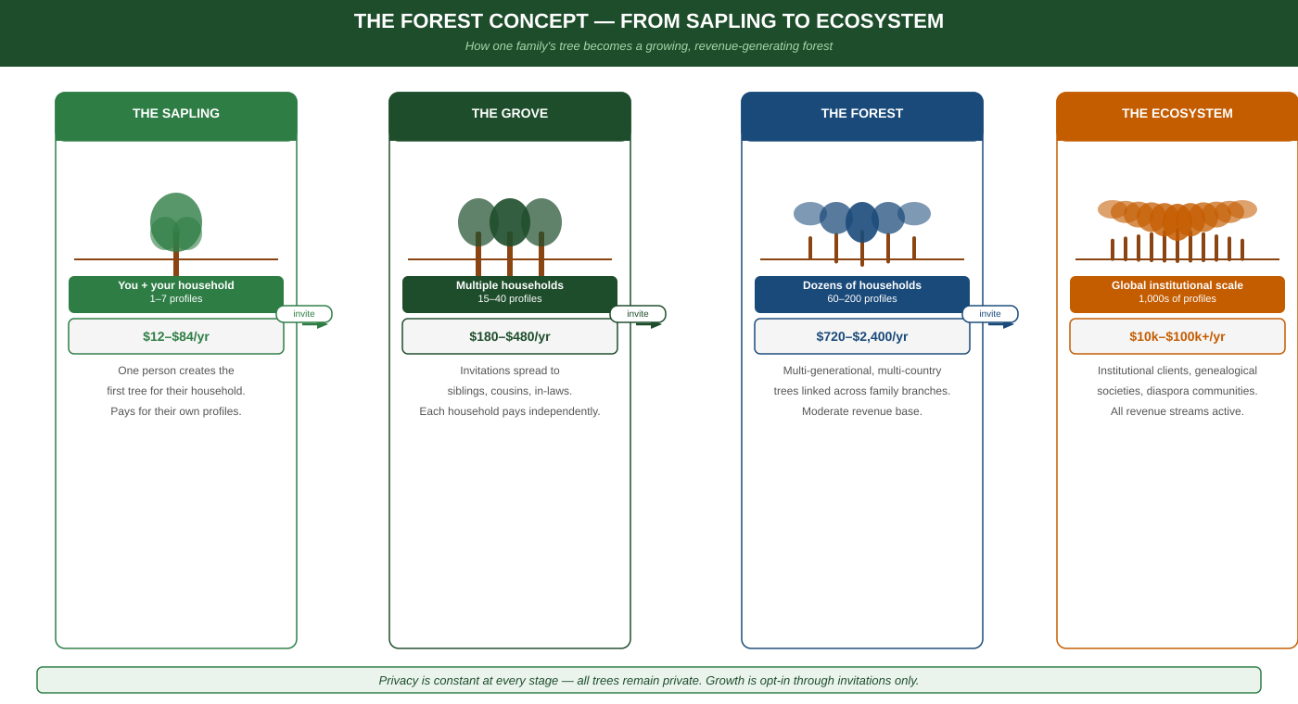

lookmeup.online | Product: LookMeUp.Online | Project Master Requirements v0.4
Private & Confidential — All rights reserved

