
EternalCurrent.Online
Product: EternalCurrent.Online — Family Tree Web Application
Appendix: Visual Reference Diagrams
Version 0.4 | Draft | Confidential
This appendix supplements PRD v0.3 — all 10 reference diagrams in one standalone document.

Diagram Index
The following diagrams are designed to be pulled out individually for presentations, conversations, and developer onboarding. Each diagram stands alone with its own title and description.

- Diagram 1: Sitemap — All Pages & Navigation
- Diagram 2: The Invite Ripple — Viral Growth Model
- Diagram 3: Billing Flow — How Money Moves
- Diagram 4: System Architecture — Free to Paid Path
- Diagram 5: Simplified Entity Relationship Diagram
- Diagram 6: User Roles & Permissions Matrix
- Diagram 7: Revenue Ecosystem Map
- Diagram 8: Development Timeline — Gantt Chart
- Diagram 9: Privacy Promise — What We Store vs. Never Store
- Diagram 10: The Forest Concept — Scale Metaphor

How to use: Each diagram begins on its own page. Extract individual pages from this PDF/document as needed for investor decks, developer briefs, or team conversations.

Diagram 1: Sitemap — All Pages & Navigation
Every page in the application organized by section: Public, App, and Portals. All pages are CMS-managed.
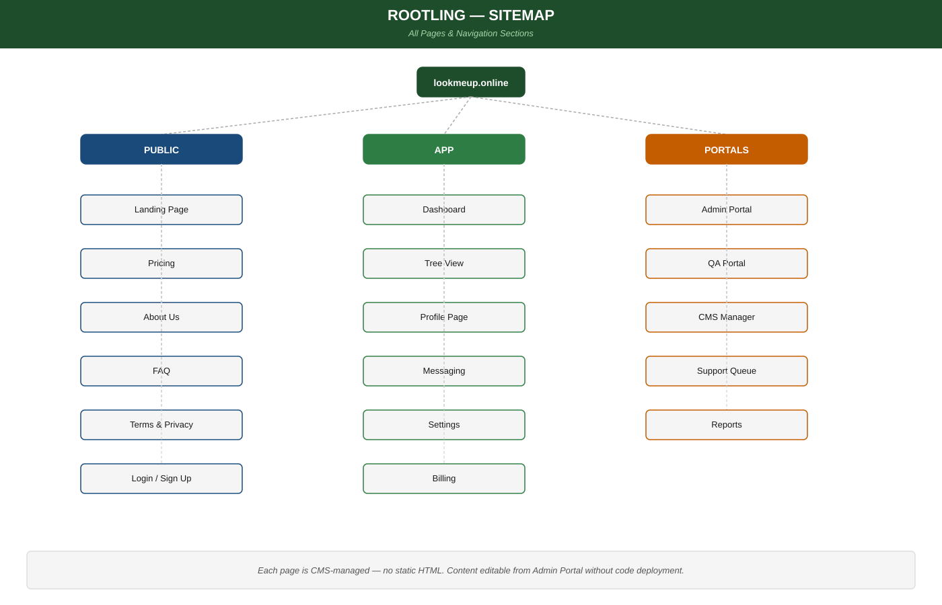

Diagram 2: The Invite Ripple — Viral Growth Model
How one household starting a tree organically becomes dozens of paying users across multiple family branches.
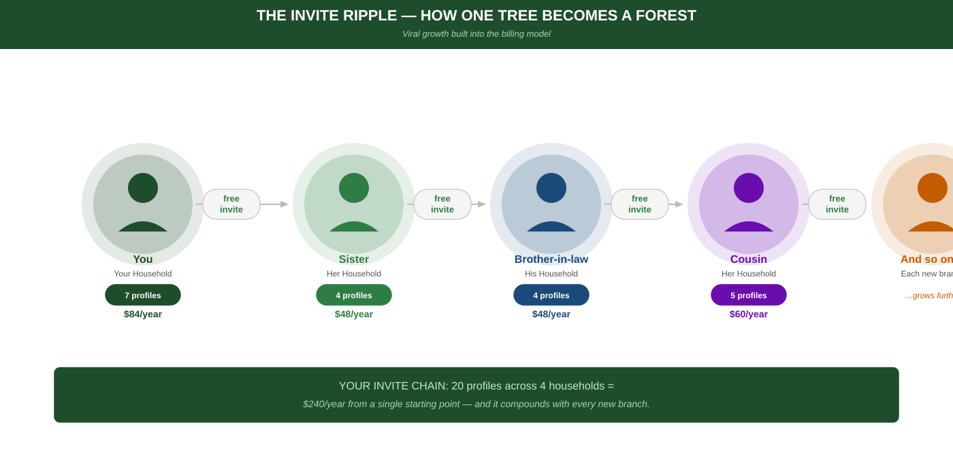

Diagram 3: Billing Flow — How Money Moves
The complete billing process: profile creation to Stripe charge, plus the distributed billing model and invite-to-independent-account flow.
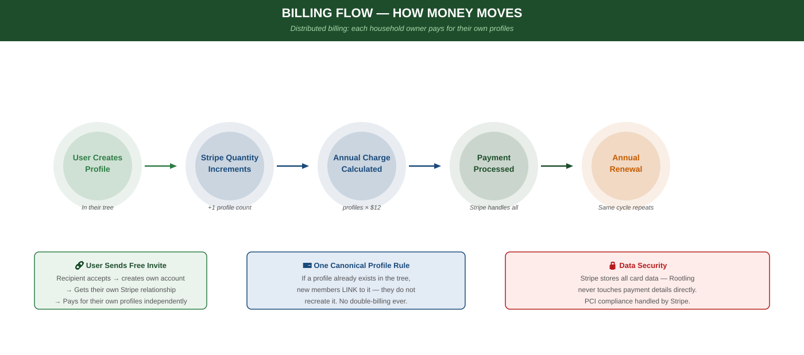

Diagram 4: System Architecture — Free to Paid Path
The full technology stack showing dev tools (crunod.com) vs production tools (EternalCurrent.online). Same codebase — environment variables swap everything.
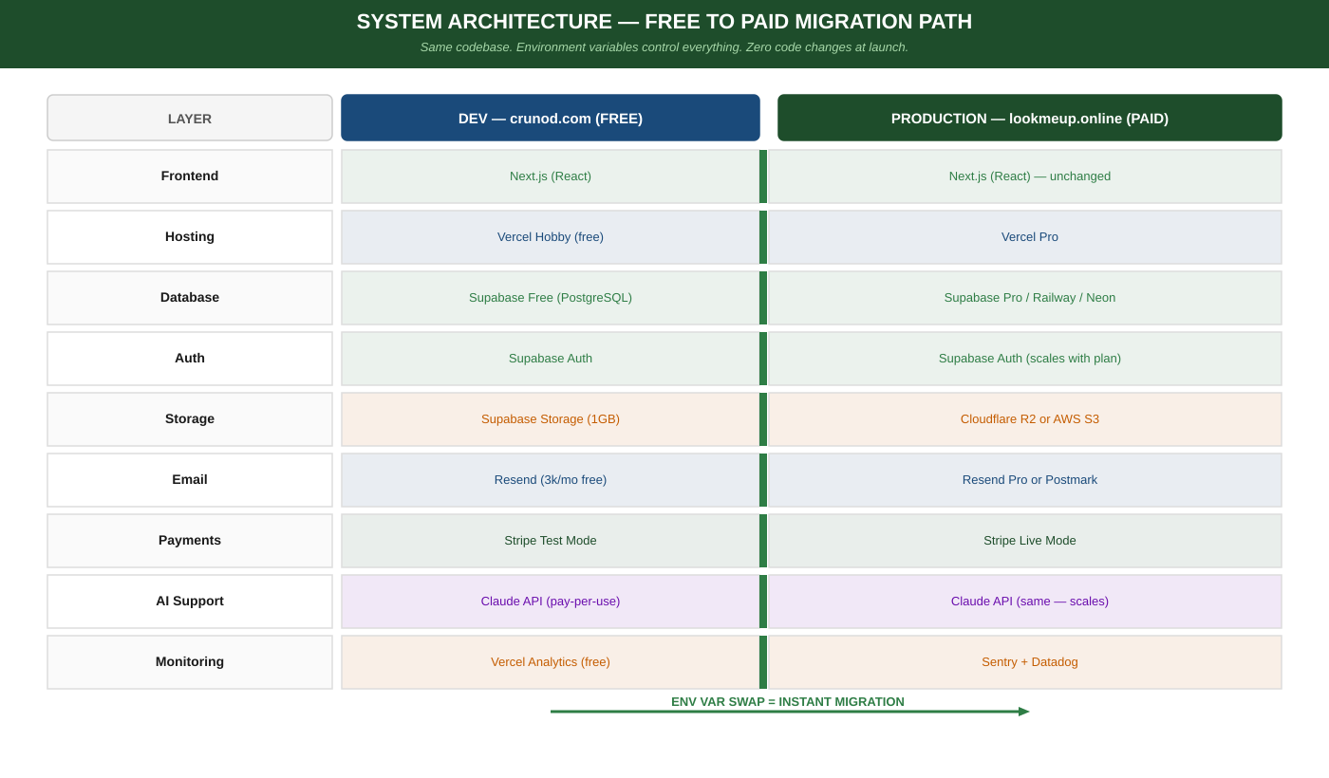

Diagram 5: Simplified Entity Relationship Diagram
Core data entities and how they connect: User, Profile, Tree, Relationship, Invitation, Billing, and CMS.
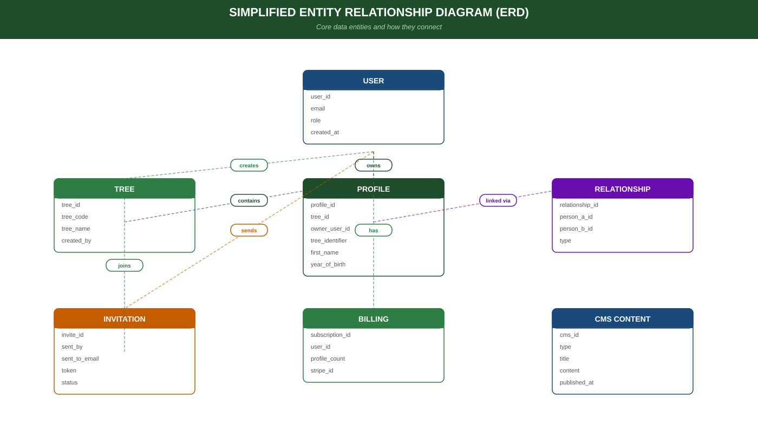

Diagram 6: User Roles & Permissions Matrix
What every role (SuperUser through Viewer) can and cannot do across all key actions on the platform.
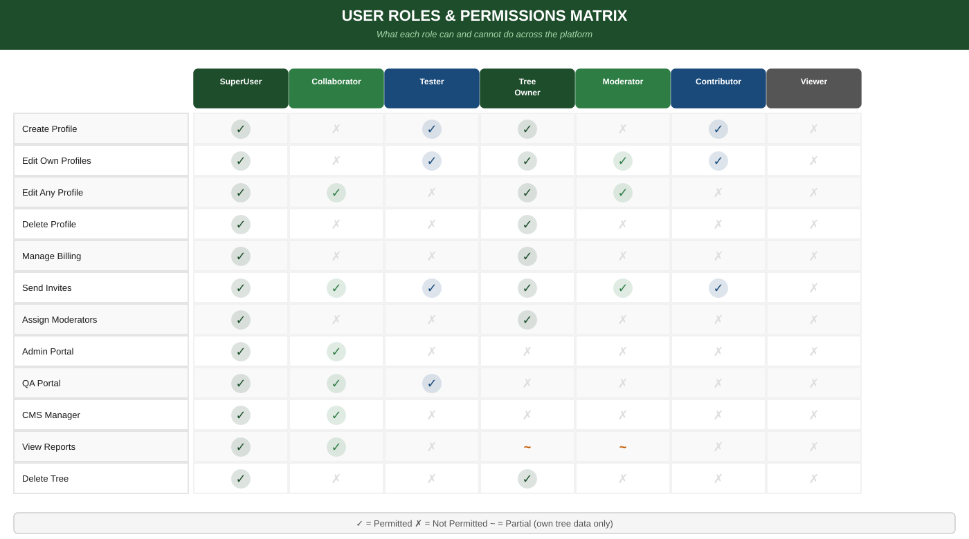

Diagram 7: Revenue Ecosystem Map
All six revenue streams radiating from the core platform. Each is triggered by natural user behaviour — no forced upsells.
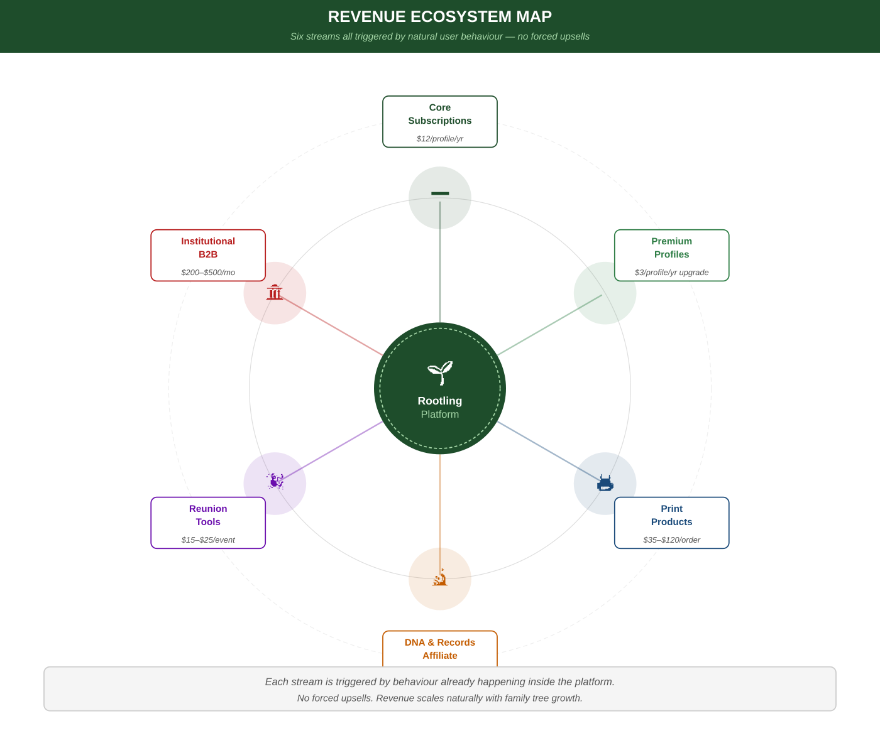

Diagram 8: Development Timeline — Gantt Chart
All 10 development phases mapped across 13 months at 6 hours/week. Key milestones: internal beta, billing live, and public launch.
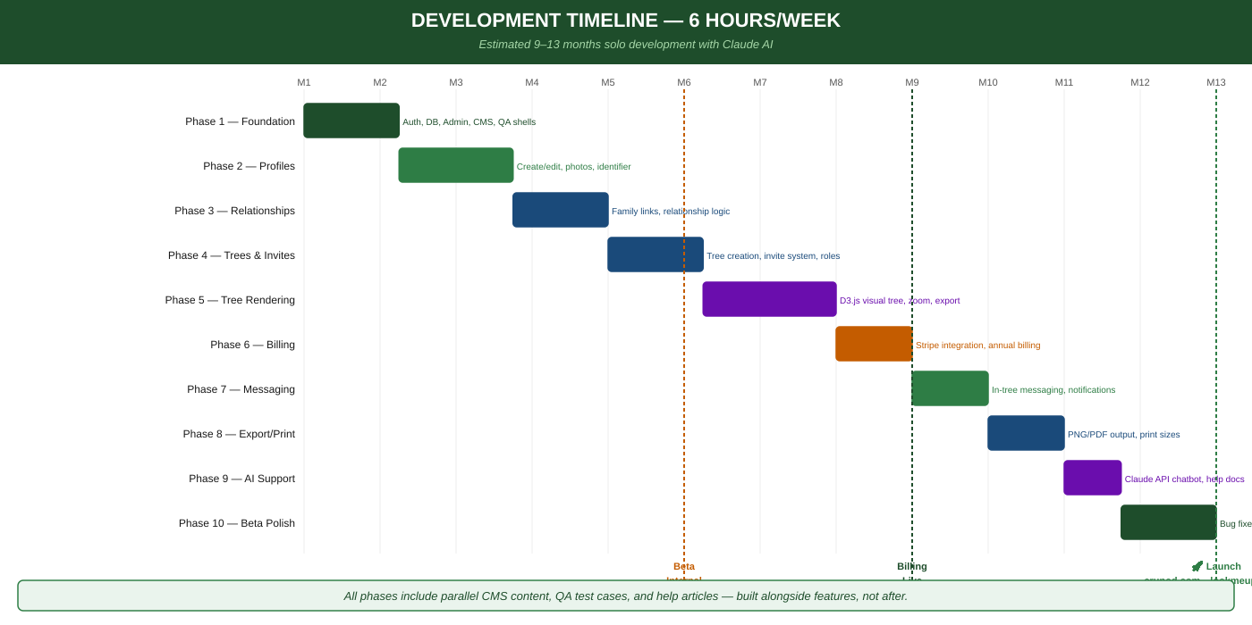

Diagram 9: Privacy Promise — What We Store vs. Never Store
A clear two-column comparison of permitted vs permanently prohibited data. No exact birth dates, no government IDs, no identity-theft risk.
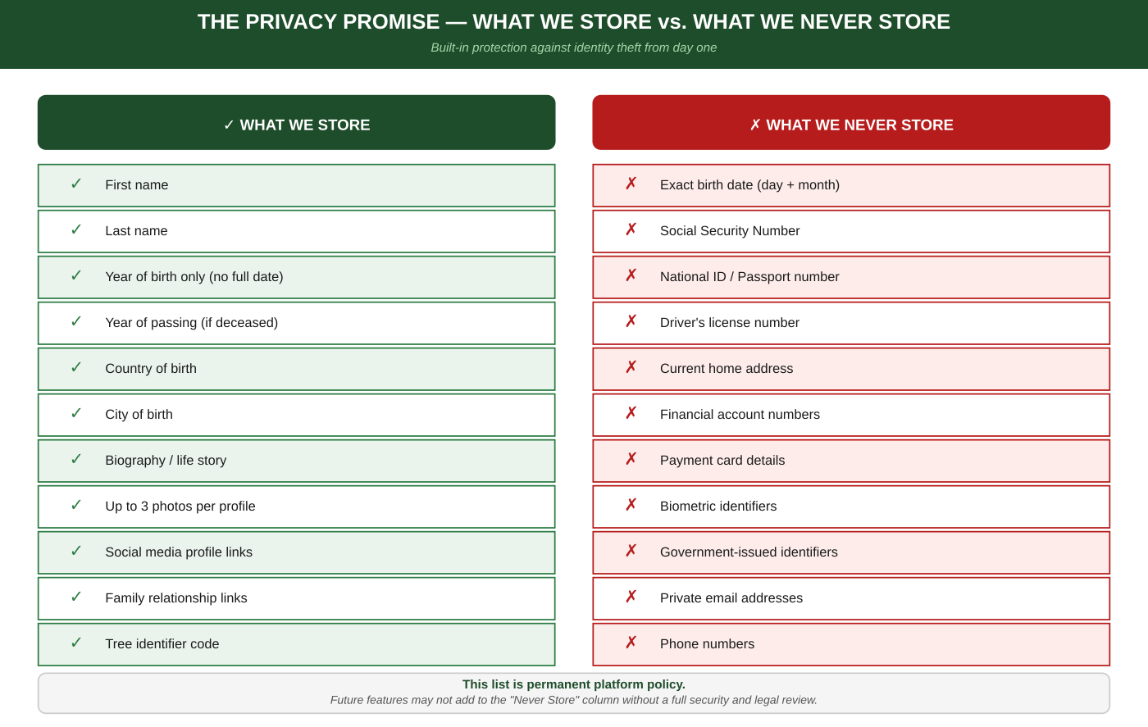

Diagram 10: The Forest Concept — Scale Metaphor
From Sapling (one household) to Grove (multiple households) to Forest (multi-country) to Ecosystem (institutional scale). Privacy holds at every stage.
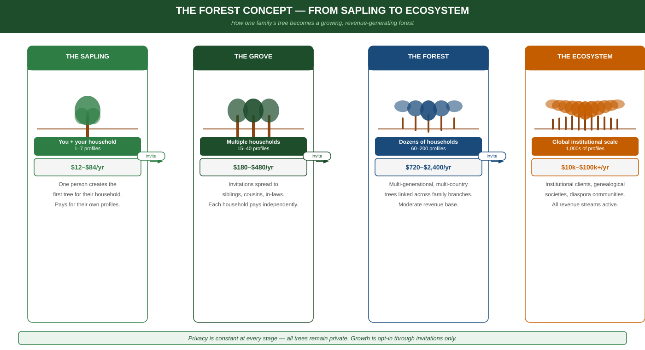

EternalCurrent.online | EternalCurrent.Online | Visual Reference Diagrams v0.4
Private & Confidential — All rights reserved

