

<TITLE OF THE GRADUATION PROJECT>

**Graduation Project**

**<TITLE OF THE GRADUATION PROJECT>**

**Submitted By**

**<Name LastName> <Student ID Number>**

**<Name LastName> <Student ID Number>**

Project Advisor

<Title> <Name> <LastName>

Department of Computer Engineering

İstanbul Kültür University

<Year><Term>

<Month> <Year>



**Graduation Project**

**<TITLE OF THE GRADUATION PROJECT>**

**Submitted By**

**<Name LastName> <Student ID Number>**

**<Name LastName> <Student ID Number>**

Advisor

<Title, Name LastName>

THE EXAMINATION COMMITTEE

Jury Member Signature

1. ………………………….. ………………………..

2. ………………………….. ………………………..

3. ………………………….. ………………………..

# ABSTRACT

A brief description of the project.

# ÖZET

Yapılan çalışmanın kısa bir Türkçe sunumu. Abstract bölümünün birebir Türkçe karşılığı yazılmalıdır.

# ACKNOWLEDGEMENTS

Thank to the people who extensively contributed to your study.

# TABLE OF CONTENTS

ABSTRACT I

ÖZET II

ACKNOWLEDGEMENTS III

TABLE OF CONTENTS IV

LIST OF TABLES VI

LIST OF FIGURES VII

SYMBOLS & ABBREVIATIONS VIII

1. INTRODUCTION 1

1.1. Problem Statement 1

1.2. Project Purpose 1

1.3. Project Scope 1

1.4. Objectives and Success Criteria of the Project 1

1.5. Report Outline 1

2. RELATED WORK 2

2.1. Existing Systems 2

2.2. Overall Problems of Existing Systems 2

2.3. Comparison Between Existing and Proposed Method 2

3. METHODOLOGY 3

3.1. Requirement Analysis 3

3.2. Design 3

3.3. Implementation 3

3.4. Testing 3

3.1. Overview of the Dataset/Model 3

3.2. Tools and Technology 3

3.3. Proposed Approach 3

3.1. Design Overview 4

3.2. System Architecture 4

3.2.1. Module A 4

3.2.2. Module B (and more, if necessary) 4

3.3. System Software 4

4. EXPERIMENTAL RESULTS 5

5. DISCUSSION 6

6. CONCLUSIONS 7

REFERENCES 8

APPENDIX 9

# LIST OF TABLES

Table 2.1: Comparison of methods 2

# LIST OF FIGURES

Figure 4.1: Comparison with the current best algorithm and our algorithm 4

# SYMBOLS & ABBREVIATIONS

ACM: Association for Computing Machinery

APA: American Psychological Association

IEEE: Institute of Electrical and Electronics Engineers

# INTRODUCTION

## Problem Statement

Give the definition of the project stated by the instructor (the project descriptions posted at the beginning of the semester).

## Project Purpose

Introduces the motivation of the project to the reader. Remember that the reader may be from a different branch of the discipline, and will require some orientation to the subject of your report.

## Project Scope

State clearlythe coverage of your work e.g. survey and analyze the problem area; design a system; implement a system; etc.

## Objectives and Success Criteria of the Project

State clearly the measurable terms of what should be the outcome of the project that is acceptable to the examination committee.

## Report Outline

Outline the rest of the sections of your graduation report.

# RELATED WORK

Provide a survey of similar work, projects or products that you used as a starting point. A short summary of what you can include (but not limited to) in the Related Works section:

* Work that proposes a different method to solve the same problem.
* Work that uses the same proposed method to solve a different problem.
* A method that is similar to your method that solves a relatively similar problem.
* A discussion of a set of related problems that covers your problem domain.

It is highly recommended to use electronic databases such as [IEEE](https://ieeexplore.ieee.org/), [ACM](https://dl.acm.org/), [Springer](https://link.springer.com/), etc. in finding relevant publications.

## Existing Systems

## Overall Problems of Existing Systems

## Comparison Between Existing and Proposed Method

Table 2.1: Comparison of methods

| Method A | Method B | Method C | Method D | Our Method |
| --- | --- | --- | --- | --- |
|  |  |  |  |  |
|  |  |  |  |  |
|  |  |  |  |  |

Note that, Table and Figure numbers start with the Section number and continue with the unique float identifier. All floats (Figures, Tables, Pseudocodes, Code Listings, etc.) should be referred in the text and if the float came from a different resource, you must provide a complete citation (e.g. Reprinted from [3]).

# METHODOLOGY

This section tells how you conducted your project. It should be detailed enough to guide someone who wants to reproduce your study.

Consult your supervisor to choose only one of the sub-section groups to implement your report!

- For Software Intensive Projects;

## 3.1. Requirement Analysis

3.1.1. Textual Requirements / Use Case Diagram

3.1.2. Use Case Scenarios

## 3.2. Design

3.2.1. Activity Diagram

3.2.2. Class Diagram

3.2.3. Deployment Diagram (and other UML diagrams if necessary)

## 3.3. Implementation

## 3.4. Testing

- For Data/Model-driven Research Projects;

## 3.1. Overview of the Dataset/Model

## 3.2. Tools and Technology

## 3.3. Proposed Approach

- For System Design Projects;

## 3.1. Design Overview

## 3.2. System Architecture

## 3.2.1. Module A

## 3.2.2. Module B (and more, if necessary)

## 3.3. System Software

# EXPERIMENTAL RESULTS

The following points should be considered when presenting your findings:

* Present your findings in a clear and easy-to-understand manner.
* Consider your readers; make it easy for them to understand the data.
* Include only the particularly important findings in the body of the graduate report. Do not distract the reader with very detailed data. If you have very detailed information that you would like the reader to refer to, consider including it in an appendix. Remember to refer the reader to the appendix.
* Consider the most effective presentation style for your results. Normally a combination of text and tables/figures is the preferred style. Tables and figures provide data in numeric or pictorial terms in a more visual manner than straight text. The straight text, however, enables you to explain the significance of the data. The straight text also enhances the fluency of the chapter and helps the reader to focus on the most important aspects of the data.
* Ensure that your tables and figures add more information than that given in the text. Do not just display visually what has already been described.

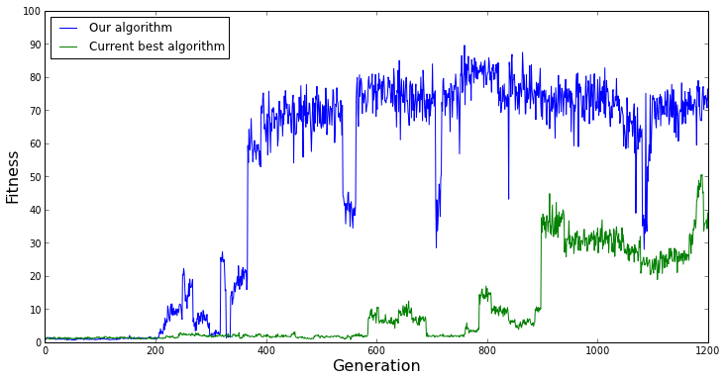

Figure .: Comparison with the current best algorithm and our algorithm

# DISCUSSION

In this section, you should restate the problem to address, and summarize how the results have addressed it. Students should discuss the significance of all the results, and interpret their meaning. Potential sources of error should be discussed, and anomalies analyzed. Finally, you should tie your conclusions into the “big picture” by suggesting the impact and applications this research might have. This can be accomplished by discussing how the results of this project will affect the project’s domain, what future experiments could be carried out based on this research, or what affect the conclusions could have on the industry.

# CONCLUSIONS

State a brief summary of your interpretations and conclusions regarding the project’s topic. Recommended structure moves from Specific to General;

* Begins with a reiteration of the project topic (tone is emphatic),
* May summarize main points and findings,
* Brings the topic back to some general significance or relevance,
* Finally, provides future directions to this study.

# REFERENCES

Every citation made in the body of the project report must appear in the References. Similarly, every item listed in the References must be cited in the body of the report. Follow the APA standard method for citing and listing both the print references and online references. Examples;

1. Zadeh, L. A. (1978). Fuzzy sets as a basis for a theory of possibility. Fuzzy sets and systems, 1(1), 3-28.
2. Mitchell, J.A., Thomson, M., & Coyne, R.P. (2017). A guide to citation. London, England: My Publisher
3. Troy, B.N. (2015). APA citation rules. In S.T, Williams (Ed.). A guide to citation rules (2nd ed., pp. 50-95). New York, NY: Publishers.
4. Rosten, E., & Drummond, T. (2006, May). Machine learning for high-speed corner detection. In European conference on computer vision (pp. 430-443). Springer, Berlin, Heidelberg.
5. Fowler, M., & Lewis, J. (2014). Microservices a definition of this new architectural term. URL: <http://martinfowler.com/articles/microservices.html>

!Hint: You may use [Google Scholar](https://scholar.google.com/) to create APA style references in an easy way.

# APPENDIX

Include additional content (raw data, code listing, etc.) as necessary to provide a detailed explanation that is not essential in the body of the report but that would be of interest of readers. If this section is not used, remove it from the project template. In case of having multiple appendix sections, informatively title and label as Appendix A, Appendix B, etc., according to the order in which they are mentioned in the text.