GearboxAddon

Author: Mogli  
Version: 1.2  
For: Farming Simulator 2015 Patch 1.2

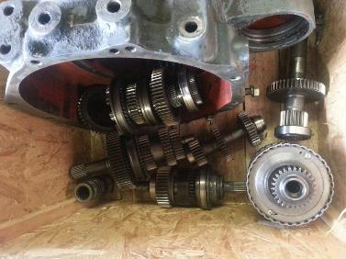

Table of Contents

Description 3

Keyboard Layout 3

Simple Keys 4

With the right Shift key 4

More unassigned keys 5

Cruise Control 5

Hired Worker and Courseplay 6

Configured Vehicles 6

Version 0.9 6

Deutz Agrostar 6.61 6

New in Version 1.0 8

New in Version 1.1 10

Continuously variable transmissions in Version 1.1 12

Own configurations 13

The main XML tags and attributes 13

gearboxMogliGlobals 13

gearboxMogli 14

gears 14

ranges 15

reverse 15

hydrostatic 16

realEngine 16

blowOffVentilSound 16

For Modders 16

Option 1: The transmission as a separate mod 16

Option 2: The transmission as a specialization in Mod 17

API methods in GearboxAddon 17

Multiple configuration for the same mod 19

Mutliplayer 19

Changes and Corrections 19

Version 1.1 19

Version 1.2 20

# Description

This is the continuation of the mod MoreRealistic GearboxAddon for FS13. In FS15 it works even without MoreRealistic.

Not every tractor has a continuously variable transmission. And even the continuously variable transmissions are not as simple in construction as the standard one in FS15. This mod adds on the basis of the file zzzMrGearboxAddonConfig.xml a gearbox to all configured tractors. Many various transmission kinds can be simulated. There are classic gearboxes with gears, one or two groups and reverse gears or groups. Shorting the response time to zero will result into a power shift transmission. In modern tractors power shift transmissions are often combined with automatic gear shifting.

New in version 1.1 is now also the support of continuously variable transmissions. There are models with one or two gears like the Fendt Vario. Other models combine four automatically switched mechanical gears with a continuously variable hydrostatic drive. All of these continuously variable transmission have one thing in common. The efficiency varies quite strongly depending on the gear ratio.

# Keyboard Layout

If you look at the arm rest of a modern tractor you can find many buttons. Not every buttons operates a function of the transmission of cruise control. But it quickly becomes clear that you will not get along with one or two buttons.

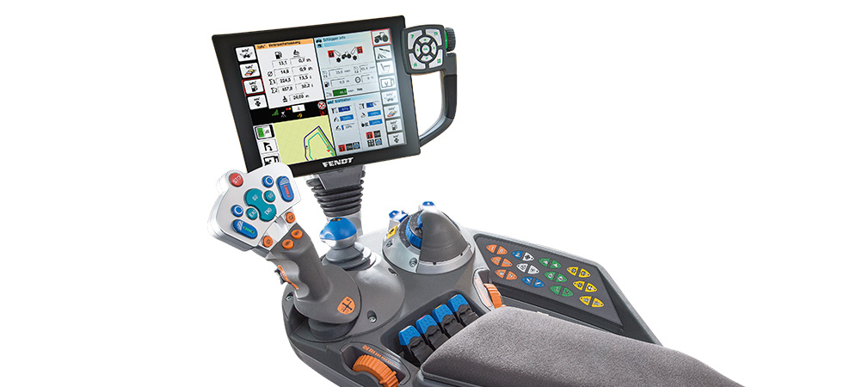

Source: fendt.com

I myself usually drive only with keyboard and without numeric keypad. The left hand operates the keys A, D, W and S. The transmission therefore so must be controllable in essential with the right hand.

Anyone can easily change the key assignments in the options menu within farming simulator 2015. Here are the default settings. Most functions are preset for the keyboard. If you want to play with a steering wheel or a joystick you might have to adjust it.

## Simple Keys

These are the settings without pressing any control or shift key.   
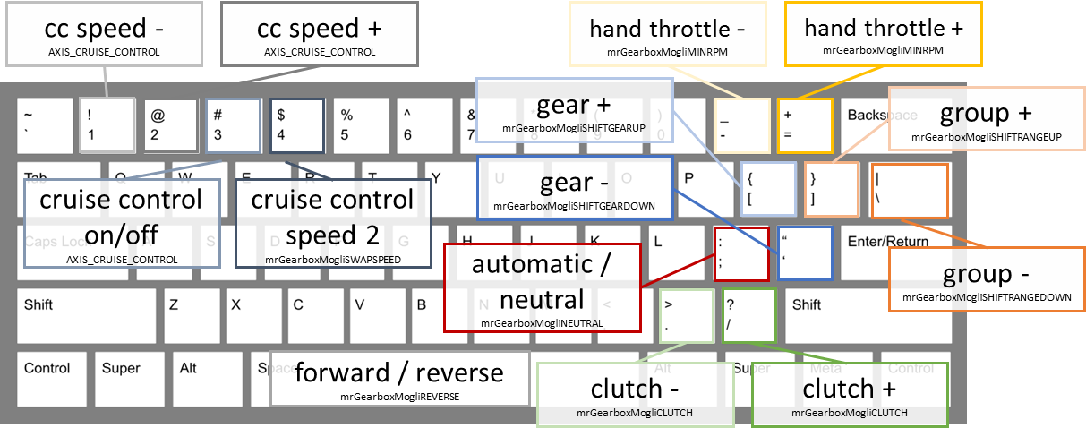

* You change gears with the keys [ and ‘
* You change the levels in group one with ] and \.
* Use the spacebar to switch between forward and reverse.
* You can override the automatic clutch for about 5. This can be useful when starting on a hill. This is defined as axis with keyboard mapping / and .
* Button ; switches the transmission between automatic and manual mode. A purely manual gearbox is switched to neutral here.
* The normal cruise control is controlled via the keys 1, 2 and 3.
* In addition, you can change the button 4 to a second cruise control speed. The default speed is 10 km / h.
* This gearbox also has hand throttle. This in turn is also an axis, which you can assign the joystick or steering wheel itself. On the keyboard to adjust hand throttle with the keys = and -

## With the right Shift key

Other features are offered in holding down the right shift key.   
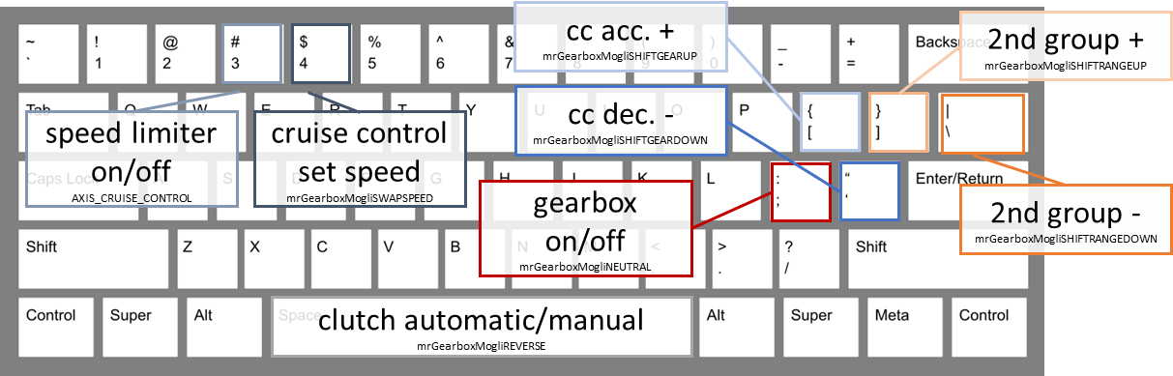

* Switching within the second group is done with ] and \. Not every tractor has two groups.
* If you press the shift key together with the spacebar, then you switch between automatic and manual clutch. This is really only useful if you have a separate clutch pedal as an input device. When you save the game with this setting is saved.
* The 3 key together with the shift key (de-) activated the speed limiter. You must continue press the throttle, but you cannot drive faster than a certain speed. The speed changes with the keys 1 and 2 without Shift.
* The key 4 in combination with the right shift key sets the current speed as cruise control speed. If cruise control is not on the limiter is activated automatically.
* You can also turn off the transmission. Then you have again the simple transmission of Giants along with the regular motor data. When you save the game with this setting is saved.

## More unassigned keys

There are other keys not yet assigned.

* 1st gear: BUTTON_9 (mrGearboxMogliGEAR1)
* 2nd gear: BUTTON_10 (mrGearboxMogliGEAR2)
* 3rd gear: BUTTON_11 (mrGearboxMogliGEAR3)
* 4th gear: BUTTON_12 (mrGearboxMogliGEAR4)
* 5th gear: BUTTON_13 (mrGearboxMogliGEAR5)
* 6th gear: BUTTON_14 (mrGearboxMogliGEAR6)
* 1st reverse gear: BUTTON_15 (mrGearboxMogliGEARR)
* Forward (mrGearboxMogliGEARFWD)
* Reverse (mrGearboxMogliGEARBACK)

# Cruise Control

If you look at videos on the operation of modern tractors, then the speed is often controlled by a cruise control. The setting of the respective velocity in Farming Simulator 2015 have certainly become easier than in the previous version. Unfortunately the switching between different speeds disappeared.

As a solution, the GearboxAddon introduces the key 4 to switch to a second cruise control speed. So you can set the cruise control at the right speed to work. In most cases the maximum speed fits because the farming simulator automatically adjusts the speed with the work unit. But when turning at the end of the field this does not fit anymore. When you lift the implement the tractor will immediately accelerate to maximum speed. The expectation is that when turning it should go slower and not faster! Therefore, the second cruise control speed is set by default to 10 km/h. You can set the current cruise control speed as before with the 1 and 2 keys.

In addition, it bothered me that the tractor when turning on the cruise control or when changing the speed accelerates always at full power. Therefore, you can limit the positive and negative acceleration. The acceleration is limited in cruise control mode only. The tractor still has the full power.

The GearboxAddon stores the second cruise speed of the vehicle during save.

# Hired Worker and Courseplay

If the tractor has a fully automatic or continuously variable transmission, it usually works in conjunction with the hired worker and Play Course. All other gear boxes are switched off automatically as soon as the hired worker or Courseplay is activated. When disabling the helper or Course Play the gearbox automatically switch on again. For a small number of vehicles, such as MAN, it is recommended on hilly maps to deactivate the transmission manually before the starting Courseplay. The long switching times do not work on steep mountains.

# Configured Vehicles

For most tractors in farming simulator there is already a configuration and changed engine data. The modified engine data, however, are effective only when the transmission. In addition, the GearboxAddon already contains configurations for some mods. Currently these tractors are already configured:

## Version 0.9

### Deutz Agrostar 6.61

Source:

* Farming Simulator 2015
* [Deutz Agrostart 6.31 / 6.61 in Modhoster](https://translate.google.com/translate?hl=de&prev=_t&sl=de&tl=en&u=http://www.modhoster.de/mods/deutz-agrostar-6-31-6-61)

48 forward and 12 reverse speeds

* 6 courses
* 2 powershift speeds in group 1
* 4 steps and 1 reverse gear in Group 2

#### Same Fortis 190

Source:

* Farming Simulator 2015
* [With front loader at Modhoster](https://translate.google.com/translate?hl=de&prev=_t&sl=de&tl=en&u=http://www.modhoster.de/mods/same-fortis-190--2)
* [With Pflegebereifung replaceable tires at Modhoster](https://translate.google.com/translate?hl=de&prev=_t&sl=de&tl=en&u=http://www.modhoster.de/mods/same-fortis-190-mit-wechselbare-pflegebereifung)

24 forward and 24 reverse speeds

* 6 courses
* 4 power shift speeds with automatic
* Reverse Gear

#### Lindner Geotrac 94

Source: Farming Simulator 2015

16 forward and 8 reverse speeds

* 4 courses
* 2 Load scarf levels with automatic (speed matching)
* 2 groups + 1 reverse

#### Buhrer 6135A

Source: Farming Simulator 2015

15 forward and 3 reverse gears

* 5 courses
* 3 groups
* Extended final drive ratio to 42 km / h

#### MAN TGS 18.440

Source:

* Farming Simulator 2015
* [As a tipper at Modhoster](https://translate.google.com/translate?hl=de&prev=_t&sl=de&tl=en&u=http://www.modhoster.de/mods/man-tgs-18440-kipper--2)
* [Agricultural version with Modhoster incl. 18.540 6x6](https://translate.google.com/translate?hl=de&prev=_t&sl=de&tl=en&u=http://www.modhoster.de/mods/man-agrar-3er-pack)

12 forward and 2 reverse gears

* 6 gears and 1 reverse gear
* 2 groups
* Fully automated

#### Case IH Quadtrac 620

Source: Farming Simulator 2015

16 forward and 2 reverse gears

* Full-shiftable
* Automatic

#### Steyr 4115

Source: Farming Simulator 2015

32 forward and reverse gears

* 4 courses
* 4 power shift speeds
* 2 groups (arable and street)
* Reverse Gear

#### piQup

Source: Farming Simulator 2015

4-speed automatic transmission

* No speed limiter

#### Schlüter 2500 VL

Source: [Schlüter 2500 VL](https://translate.google.com/translate?hl=de&prev=_t&sl=de&tl=en&u=http://www.modhoster.de/mods/2500vl--2)

18 forward and 6 reverse gears

#### Schlüter 1500 TVL

Source: [Schlüter 1500 TVL](https://translate.google.com/translate?hl=de&prev=_t&sl=de&tl=en&u=http://www.modhoster.de/mods/schluter-1500-tvl--8)

24 forward and 12 reverse speeds

#### John Deere 6810

Source: [John Deere 6810](https://translate.google.com/translate?hl=de&prev=_t&sl=de&tl=en&u=http://www.modhoster.de/mods/john-deere-6810--7)

Auto Quad II transmission with 20 forward and reverse gears

* 6 courses
* 4 power shift speeds with automatic
* Reverser

#### Hürlimann H488 and Eicher 2090

Source:

* Farming Simulator 2015
* [Eicher 2090 at Modhoster](https://translate.google.com/translate?hl=de&prev=_t&sl=de&tl=en&u=http://www.modhoster.de/mods/eicher-2090-turbo)

10 forward and 5 reverse gears

#### Mercedes Zetros

Source: [Mercedes Zetros](https://translate.google.com/translate?hl=de&prev=_t&sl=de&tl=en&u=http://www.modhoster.de/mods/mercedes-zetros-sattelzug)

12 Advantages and 2Rückwärtsgänge with automatic

### New in Version 1.0

#### Unimog U 400

Source: [Unimog U 400](https://translate.google.com/translate?hl=de&prev=_t&sl=de&tl=en&u=http://www.modhoster.de/mods/unimog-u400-wb)

#### VW Transporter T2

Source: [VW Transporter T2](https://translate.google.com/translate?hl=de&prev=_t&sl=de&tl=en&u=http://www.modhoster.de/mods/volkswagen-transporter-t2b-pritsche-plane-1972)

4 forward and 1 reverse gears

#### VW Beetle

Source: [VW Beetle](https://translate.google.com/translate?hl=de&prev=_t&sl=de&tl=en&u=http://www.modhoster.de/mods/volkswagen-kaefer-1966)

4 forward and 1 reverse gears

#### Mercedes Benz 200D

Source: [Mercedes Benz 200D](https://translate.google.com/translate?hl=de&prev=_t&sl=de&tl=en&u=http://www.modhoster.de/mods/mercedes-benz-200d-1973)

4 forward and 1 reverse gears

#### Chevy C10

Source: [Chevy C10](https://translate.google.com/translate?hl=de&prev=_t&sl=de&tl=en&u=http://www.modhoster.de/mods/chevrolet-c-10-fleetside-lwb-1966)

2-speed automatic (Powerglide)

#### Schlüter 1250 TVL compact

Source: [Schlüter 1250 TVL compact](https://translate.google.com/translate?hl=de&prev=_t&sl=de&tl=en&u=http://www.modhoster.de/mods/schluter-tvl-1250-compact)

36 forward and 18 reverse speeds

* 6 gears, these are the top 3 reverse locked
* 3 power shift speeds in group 1
* 2 levels in Group 2
* Gearbox, 1.75 times faster than forward

#### Same Argon 3 75

Source: [Same Argon 3 75](https://translate.google.com/translate?hl=de&prev=_t&sl=de&tl=en&u=http://www.modhoster.de/mods/same-argon-3-75%252D%252D2)

#### IHC 1445A

Source: [IHC 1445A](https://translate.google.com/translate?hl=de&prev=_t&sl=de&tl=en&u=http://www.modhoster.de/mods/ihc-1455a)

I have taken the configuration of the Cretan Iceland from some details

12 forward and reverse gears

* 6 courses
* 2 levels in group 1 (arable and street)
* Reverser

#### Fahr M66

Source: [Fahr M66](https://translate.google.com/translate?hl=de&prev=_t&sl=de&tl=en&u=http://www.modhoster.de/mods/fahr-m66)

The GearboxAddon also supports combine harvesters!

4 forward and 1 reverse gears

### New in Version 1.1

#### Deutz Fahr 120 MK3

Source: [Facebook](https://translate.google.com/translate?hl=de&prev=_t&sl=de&tl=en&u=https://www.facebook.com/ModdinggemeinschaftLs13) , [Link](https://translate.google.com/translate?hl=de&prev=_t&sl=de&tl=en&u=http://uploaded.net/file/e9vdghz1)

12 forward and reverse gears

* 6 courses
* 4 power shift speeds
* Reverser

#### Fendt Farmer 310 LSA

Source: [Fendt Farmer 310 LSA at Modhoster](https://translate.google.com/translate?hl=de&prev=_t&sl=de&tl=en&u=http://www.modhoster.de/mods/fendt-farmer-310-lsa%252D%252D6)

21 forward and 6 reverse gears

* Gearbox with 3 forward gears and one reverse gear
* A group of 6 levels plus overdrive

#### Steyr8080aTurbo_SK1

Source: [Steyr8080aTurbo_SK1](https://translate.google.com/translate?hl=de&prev=_t&sl=de&tl=en&u=http://www.modhoster.de/mods/steyr-8080a-turbo-sk1)

16 forward and 8 reverse speeds

* 4 courses
* Group 1 with 2 forward gears and one reverse gear
* Group 2 with 2 levels (low and high)

#### Case IH Magnum 340

Source: Farming Simulator 2015

19.4 full powershift

* 19 forward and 4 reverse gears
* Full-shiftable
* Automatic

#### New Holland T4.75

Source: Farming Simulator 2015

24 forward and reverse gears

* 4 courses
* 2 power shift speeds in group 1
* 3 levels in Group 2
* Reverse Gear

#### New Holland T6.160

Source: Farming Simulator 2015

* 17 forward and 16 reverse speeds
* Full-shiftable
* Automatic

#### New Holland T8.320

Source: Farming Simulator 2015

19.4 full powershift

* 19 forward and 4 reverse gears
* Full-shiftable
* Automatic

#### Deutz 5110 without TTV

Source: [Deutz Series 5 TTV](https://translate.google.com/translate?hl=de&prev=_t&sl=de&tl=en&u=http://www.modhoster.de/mods/deutz-serie-5-ttv)

30 forward and reverse gears

* 5 courses
* 3 power shift speeds in Group 1 with automatic
* 2 levels in Group 2
* Reverse Gear

#### Peterbilt 379

Source:

* [American Eagles Modding](https://translate.google.com/translate?hl=de&prev=_t&sl=de&tl=en&u=http://americaneaglesmodding.com/index.php%3Faction%3Ddownloads%3Bsa%3Dview%3Bdown%3D1098)
* [Modhoster](https://translate.google.com/translate?hl=de&prev=_t&sl=de&tl=en&u=http://www.modhoster.de/mods/peterbilt-3782D2D2)

Eaton Fuller 13 speed

* 13 forward gears
* 2 reverse
* Automatic, even though it is not realistic

### Continuously variable transmissions in Version 1.1

#### Deutz Fahr 7250 TTV

Source: Farming Simulator 2015

Continuously variable transmission with 4 automatically switched, mechanical stages

*Lamborghini Mach230VRT*

Source: Farming Simulator 2015

Continuously variable transmission with 4 automatically switched, mechanical stages

#### Case IH Puma 160

Source: Farming Simulator 2015

Continuously variable transmission with 4 automatically switched, mechanical stages

#### Case Puma 230 CVX I

Source: [Case Puma 230 cvx front loader red from Timber131](https://translate.google.com/translate?hl=de&prev=_t&sl=de&tl=en&u=http://www.modhoster.de/mods/case-puma-230-cvx-frontlader)

Continuously variable transmission with 4 automatically switched, mechanical stages

#### New Holland T8.435

Source: Farming Simulator 2015

Continuously variable transmission with 4 automatically switched, mechanical stages

#### John Deere 7280r

Source: [John Deere 7280r beta AGO](https://translate.google.com/translate?hl=de&prev=_t&sl=de&tl=en&u=http://www.modhoster.de/mods/john-deere-7280r-beta)

John Deere AutoPowr; continuously variable transmission with 4 automatically switched, mechanical stages

#### Hürlimann XM4Ti

Source: Farming Simulator 2015

Continuously variable transmission with two speed ranges (heavy duty, transportation)

#### Deutz 5130 with TTV

Source: [Deutz Series 5 TTV](https://translate.google.com/translate?hl=de&prev=_t&sl=de&tl=en&u=http://www.modhoster.de/mods/deutz-serie-5-ttv)

Continuously variable transmission with two speed ranges (heavy duty, transportation)

#### Fendt 936 Vario

Source: [Fendt 936 Vario Pack](https://translate.google.com/translate?hl=de&prev=_t&sl=de&tl=en&u=http://www.modhoster.de/mods/fendt-936-vario-pack%252D%252D9)

Continuously variable transmission with two speed ranges (heavy duty, transportation)

#### Fendt Vario 1050

Source: [Facebook](https://translate.google.com/translate?hl=de&prev=_t&sl=de&tl=en&u=https://www.facebook.com/vasilis.caleniuc) , [Link](https://translate.google.com/translate?hl=de&prev=_t&sl=de&tl=en&u=http://uploaded.net/file/krzo5brz)

Continuously variable transmission with two speed ranges (heavy duty, transportation)

# Own configurations

You can create other configurations yourself. Just create the file zzzMrGearboxAddonConfig.xml directly in the mods folder where you find zzzMrGearboxAddon.zip. There is already such file inside the mod that can used as a template. However, it is not necessary to change anything at zzzMrGearboxAddon.zip or other mods. The zzzMrGearboxAddonConfig.xml file also works in multiplayer .

Here is a small example:

<vehicles>  
 <vehicle>

<!-- http://www.modhoster.de/mods/ihc-1455a -->

<configFile modName="IHC_1455_FH" xmlName="IHC_1455A.xml" />

<configFile modName="IHC_1455" xmlName="IHC_1455A.xml" />

<gearboxMogli autoStartStop="false" idlePitchFactor="0.96" runPitchFactor="0.96">

<gears shiftTimeMs="800">

<gear speed="3.9"  name="1" />

<gear speed="6.2"  name="2" />

<gear speed="9.7"  name="3" />

<gear speed="14.7"  name="4" />

<gear speed="23.5"  name="5" />

<gear speed="40.0"  name="6" />

</gears>

<ranges defaultRange="2" gearOffset="1" shiftTimeMs="1200">

<range ratio="0.7825" name="A" />

<range ratio="1.0000" name="S" />

</ranges>

<reverse ratio="0.7475" shiftTimeMs="500" clutchRatio="1" resetRange="false" resetGear="false"/>

</gearboxMogli>

</vehicle>

</vehicles>

## The main XML tags and attributes

### gearboxMogliGlobals

This tag can be used to control some global parameters of the transmission. The tag can be used both in the separate file zzzMrGearboxAddonConfig.xml, as well as in the XML file of the vehicles as described in section The transmission as a specialization in Mod: Option 2.

<gearboxMogliGlobals>  
 <torqueFactor value="**1.1182033096926713947990543735225** " type="**float**"/>  
 <blowOffVentilVol value="**0.14**" type="**float**"/>  
 <drawTargetRpm value="**false**" type="**bool**"/>  
 <drawReqPower value="**false**" type="**bool**"/>  
 <defaultOn value="**true**" type="**bool**"/>  
 <disableManual value="**false**" type="**bool**"/>  
 <blowOffVentilRpmRatio value="**0.6**" type="**float**"/>  
 <minTimeToShift value="**0**" type="**float**"/>  
 <maxTimeToSkipGear value="**251**" type="**float**"/>  
 <shiftEffectTime value="**251**" type="**float**"/>  
 <modifySound value="**true**" type="**bool**"/>  
 <modifyVolume value="**true**" type="**bool**"/>  
 <modifyTransVol value="**true**" type="**bool**"/>  
 <playGrindingSound value="**true**" type=" **bool** "/>  
</gearboxMogliGlobals>

### gearboxMogli

This is the transmission. The XML tags <gears>, <ranges>, <reverse>, <real engine> and <hydrostatic> are optional sub-tags. In addition, there are the following XML attributes:

* defaultOn: Boolean (true) / the transmission is immediately turned on
* showHud: boolean (true) / show the HUD with information about the transmission
* swapGearRangeKeys: boolean (false) / obsolete, replaced the gears with the first group
* transmissionEfficiency: float (0.94) / efficiency of the transmission
* ptoRpm: integer / speed with active PTO
* clutchOpenRpm: integer (0) / speed below which the clutch will start automatically; so you can simulate a converter clutch
* clutchCloseRpm: integer (~ 1200) / speed above which the clutch is engaged; this like a lock-up clutch
* speed limiter: boolean / drive by limiting the maximum speed
* maxForwardSpeed: float / here you can override the maximum speed of the tractor
* maxBackwardSpeed: float / ditto for reverse
* doubleClutch: boolean (false) / the complete gearbox is not synchronized => domes with intermediate gas
* minClutchRatio: float (0.002) / smallest value for clutch
* maxClutchRatio: float (1) / greatest value for clutch
* global ratio factor: float (1,025) / total ratio
* revUpMs: integer (2000) / time in milliseconds it takes for the engine from idle to maximum speed
* revDownMs: integer (1000) / ditto for the other direction
* hide (false) / manual mode: disableManual

### gears

Here the aisles with the sub-tag be defined gear. The following attributes:

* shiftTimeMs: integer (800) / time for switching in ms; 0 for a power shift; -1 for automatic gears in continuously variable transmission
* clutchRatio: float (0.5) / minimum clutch after the shift
* manualClutch: boolean / clutch must be operated in manual mode
* doubleClutch: boolean (false) / hallways are not synchronized => domes with intermediate gas
* reverse reset: boolean (false) / adjustment of gears when switching between forward and backward: remember and reset
* defaultGear: integer (1) / gear at the start
* automatic: boolean (false) / automatic

#### gear

That is the definition of a single passage. The following attributes:

* speed: float / speed at rated speed
* name: string / text for the gear indicator
* reverse only: boolean (false) / locks the gear for forward travel
* forward only: boolean (false) / disables the course of reversing

### ranges

Here are the stages of a group are defined with the Under-day range. This XML tag can appear zero or twice in a transmission. The following attributes:

* shiftTimeMs: integer (1000, 1200) / time for switching in ms
* clutchRatio: float (0.5) / minimum clutch after the shift
* manualClutch: boolean / clutch must be operated in manual mode
* doubleClutch: boolean (false) / group is not synchronized => domes with intermediate gas
* reverse reset: boolean (false) / transition when switching between forward and backward remember and reset
* default range: integer / stage at the start
* automatic: boolean (false) / automatic, but only in group 1 possible

#### range

That is the definition of a single group. There are the following attributes:

* ratio: float / or step-down one step; Normally, the highest group has the value "1" and all other groups are smaller than 1
* name: string / text for the gear indicator
* reverse only: boolean (false) / locks the gear for forward travel
* forward only: boolean (false) / disables the course of reversing

### reverse

Here you can configure the reverse gear or reversing. There are the following attributes:

* shiftTimeMs: integer (800) / time for switching in ms
* clutchRatio: float (0.5) / minimum clutch after the shift
* manualClutch: boolean / clutch must be operated in manual mode
* doubleClutch: boolean (false) / group is not synchronized => domes with intermediate gas
* ratio: float (1) / transmission or reduction of reverse gears

### hydrostatic

The continuously variable transmission has mechanical gears changed by an additional hydrostatic transmission. You can define the ratio and efficiency.

#### efficiency

This XML tag has the following attributes:

* ratio: float / must be defined in ascending order
* factor: float / efficiency

### realEngine

This XML tag, one can define an alternative torque curve. Most tractors use unfortunately the standard curve of Giants, which I personally think is insufficient. The individual values ​​are specified in sub-tag torque. There are the following attributes:

* idleRpm: integer / idle speed in rev / min
* ratedRpm: integer / rated speed in rev / min

#### torque

This XML tag has the following attributes:

* rpm: integer / speed in rev / min
* motor torque: float / torque in Nm
* ptoTorque: float / alternative to motor torque; Torque in Nm PTO

### blowOffVentilSound

There are two settings for blow off ventil sound.

* file: string / This is only available if the configuration is stored inside the tractor/vehicle. Here you specify the sound file
* volume: float / volume of the blow off ventil sound

# For Modders

You can already install the gearbox in two different ways in your mod. In both cases, the necessary entries are in the XML file of your vehicle.

## Option 1: The transmission as a separate mod

Option 1 is to add just the configuration in the mod. The GearboxAddon must still be installed as a separate mod. As example I have created the sampleMod1.zip. It is based on the sampleMod from the farming simulator SDK.

## Option 2: The transmission as a specialization in Mod

You can install the transmission in a mod. The advantage is that the transmission always works and not only when the GearboxAddon is available. As an example, I have created the sampleMod2.zip. In addition to the configuration you have quite a few entries in the modDesc.xml. Missing key assignments, however, not result in an error. The function is then simply not there.

With version 1.2 two of the cruise control function are now in a separate specialization. You can use them even without the GearboxAddon. Here are both specializations:

<specialization filename="**scripts/mrGearboxMogli.lua**" className="**mrGearboxMogli**" name="**gearboxMogli**"/>

<specialization filename="**scripts/tempomatMogli.lua**" className="**tempomatMogli**" name="**tempomatMogli**"/>

## API methods in GearboxAddon

In order to control the transmission in the mod itself, there are a set of functions for setting and getting values. If you add the gearbox with option 1 you should better make sure that the corresponding element of self is not nil before calling the function.

* self:mrGbMGetClutchPercent()   
  No parameters, return values ​​is a number   
  Current value of the coupling range of 0..1
* self:mrGbMGetTargetRPM()   
  No parameters, return values ​​is a number   
  Current target speed in rounds per minute. The method works only if value in <gearboxMogliGlobals> the value of <drawTargetRpm> is "true"
* self:mrGbMGetMotorLoad()   
  No parameters, return values ​​is a number   
  Current motor load, i.e. the quotient of torque used to maximum torque at the current rpm
* self:mrGbMGetUsedPower()   
  No parameters, return values ​​is a number   
  Power currently used in HP. The method works only if value in <gearboxMogliGlobals> the value of <drawReqPower> is "true"
* self:mrGbMGetModeText()   
  No parameters, return value is a string   
  This will display the description of the transmission mode; for example, "manual" "automatic", ...
* self:mrGbMGetGearText()   
  No parameters, return value is a string   
  This function returns the text to the current gear, group, etc.
* self:mrGbMGetIsOn()   
  No parameters, return value is a Boolean   
  Returns a true if the gearbox is turned on.
* self:mrGbMSetIsOnOff(boolean) / self:mrGbMGetIsOnOff()  
  Boolean parameter   
  Turns the transmission on or off
* self:mrGbMSetCurrentGear(integer) / self:mrGbMGetCurrentGear()   
  Parameter of type Integer  
  Sets the current gear
* self:mrGbMGetCurrentRange(integer) / self:mrGbMGetCurrentRange()   
  Parameter of type Integer   
  Sets the current stage in group 1
* self:mrGbMGetCurrentRange2(integer) / self: mrGbMGetCurrentRange2()   
  Parameter of type Integer   
  Sets the current stage in Group 2
* self:mrGbMSetAutomatic(boolean) / self:mrGbMGetAutomatic()  
  Boolean parameter   
  Turns the automatic mode on or off
* self:mrGbMSetNeutralActive(boolean) / self:mrGbMGetNeutralActive()   
  Boolean parameter   
  Turns the neutral mode on or off
* self:mrGbMSetReverseActive(boolean) / self: mrGbMGetReverseActive()  
  Boolean parameter   
  Turns the reverse mode on or off
* self:mrGbMSetSpeedLimiter(boolean) / self:mrGbMGetSpeedLimiter()  
  Boolean parameter   
  Turns the automatic mode on or off
* self:mrGbMSetHandThrottle(integer) / self: mrGbMGetHandThrottle()   
  Parameter of type number, value range 0..1   
  Sets Hand Throttle
* self:mrGbMSetAutoClutch(boolean) / self:mrGbMGetAutoClutch()   
  Boolean parameter   
  Turns the automatic clutch on or off
* self:mrGbMSetManualClutch(boolean) / self: mrGbMGetManualClutch()   
  Parameter of type number, value range 0..1   
  Sets the value of the coupling. This is actually only useful in combination with self:mrGbMGetAutoClutch(false)

The following functions are now part of tempomatMogli.lua:

* self:tempomatMogliSetSpeedLimit()  
  No parameters  
  Sets the actual speed as new cruise control speed
* self:tempomatMogliGetSpeedLimit ()  
  No parameters  
  Returns the actual cruise control speed
* self:tempomatMogliGetSpeedLimit2()  
  No parameters  
  Returns the secondary cruise control speed
* self:tempomatMogliSwapSpeedLimit ()  
  No parameters  
  Swaps the cruise control speed with the second speed

In addition, the normal specialization has still driveable following interesting things:

* self.motor.minRpm, self.motor.maxRpm, self.motor.lastMotorRpm   
  Minimum, maximum and current speed in rev / min   
  These values ​​should also be available in the MP on both client and server
* self.lastSpeedReal   
  Current speed in km / s. To come km / h, set the value so even with multiply 3600, and by 1000 for m / s
* self:setCruiseControlState(integer)   
  This function is used to turn the cruise control on and off. The parameter can have the following values:
  + Drivable.CRUISECONTROL_STATE_OFF = 0,
  + Drivable.CRUISECONTROL_STATE_ACTIVE = 1
  + Drivable.CRUISECONTROL_STATE_FULL = 2
* self:setCruiseControlMaxSpeed​​(integer)   
  This is given to the cruise control speed. The value must be in km / h and not in m / s are given. So you have may still be multiplied by 3.6

# Multiple configuration for the same mod

There are 3 ways where you can store the configuration for the GearboxAddon. There are configurations in the GearboxAddon itself, modders can in their vehicle already deposited configurations and you can also create itself and what to put in the zzzMrGearboxAddonConfig.xml file. Which configuration is then used in the end?

1. A configuration file in the zzzMrGearboxAddonConfig.xml is a top priority. Finally, it was indeed created especially for this purpose. However, there is a limitation. If a mod myself already have a gearbox fitted as specialization, we do not even have the GearboxAddon in this mod and therefore will not be overwritten
2. Subsequently, the configuration has the mod itself precedence, if there is one.
3. 2. If a configuration was not found in either the 1st, then GearboxAddon will still look after its own configuration.

# Mutliplayer

The GearboxAddon works from version 1.1 in MultiPlayer mode. A separate configuration can and must be deposited only in the server. The XML file zzzMrGearboxAddonConfig.xml stands still in the mods folder, ie in the same directory as zzzMrGearboxAddon.zip. Therefore, it is not necessary to modify the GearboxAddon itself.

# Changes and Corrections

## Version 1.1

* Continuously variable transmission
* MultiPlayer support rewritten in large parts
* Support for G27
* Turbosound
* Second speed in cruise control

## Version 1.2

* Assistants and Course play drive with fully automatic and continuously variable transmissions
* In all other cases, Course Play turns off the Gear type
* Improved gear change; it is less decelerated
* Corrected torque at PTO
* Correction manual clutch in MultiPlayer
* No warning when changing gear and manual clutch; instead GrindingSound
* Advanced Cruise Control functions