**MATHS-X (SA-II)**

**[Time Allowed: 3 Hours] [Maximum Marks: 90]**

**General Instructions:**

**(i) All questions are compulsory.**

**(ii) The question paper consists of 31 questions divided into four sections A,B,C and D .Section A**

**comprises of 4 questions of 1 mark each. Section B comprises of 6 questions of 2 marks each,**

**section C comprises of 10 questions of 3 marks each and Section D comprises of 11 questions of**

**4 marks each.**

**(iii) There is no overall choice.**

**(iv) Use of calculators is not permitted.**

**(v) An additional 15 minutes time has been allotted to read this question paper only.**

**Section -‘A’**

1. The common difference of the A.P.

(a) -1 (b) 1 (c) q (d) 2q

2. In figure, DE and De are tangents from an external point D to a circle with centre A.If DE =5cm and

, then the radius of the circle is

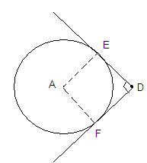

(a) 3cm (b) 5cm (c) 4 cm (d) 6 cm

3. In figure, a circle I inscribed in a quadrilateral ABCD touching its sides AB, BC CD and AD at P, Q, R and

S respectively. If the radius of the circle is 10 cm, BC =38cm, PB=27 m and , then the length of CD is

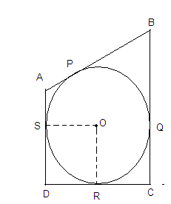

4. A die is thrown once. The probability of getting a prime number is:

(a)  (b)  (c)  (d) 

5. A ladder 15 m long just reaches the top of a vertical wall. If the ladder makes an angle of 600 with the

wall, then the height of the wall is

(a)  (b)  (c)  (d) 15 m

6. A box contains cards numbered 6 to 50 .A card is drawn at random from the box. The probability that

the drawn card has a number which is a perfect square, is

(a)  (b)  (c)  (d) 

7. The point on the x-axis which is equidistant from points (-1,0) and (5,0) is

(a)(0,2) (b)(2,0) (c)(3,0) (d) (0,3)

8. If is taken as  , the distance (in metres) covered by a wheel of diameter 35 cm, in one

revolution, is

(a) 2.2 (b) 1.1 (c) 9.625 (d) 96.25

**Section -‘B’**

9. Solve the following for x:



10. Find the number of all three-digit natural numbers which are divisible by 9.

11.In figure ,two circles touch each other at the point C.Prove that the common tangent to the circles at

C, bisects the common tangent at P and Q.

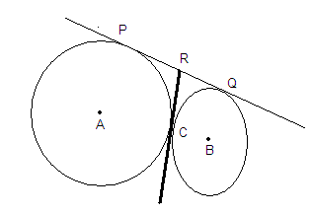

12.Infigure ,a quadrilateral ABCD is drawn to circumscribe a circle .Prove that AB + CD = AD + BC.

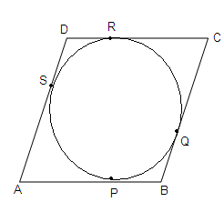

13.Two coins are tossed simutancously.Find the probability of getting at least one head.

14.The length of the minute hand of a clock is 14 cm .Find the area swept by the minute hand in 5

minutes.

**Section -‘C’**

15. For what values of k, are roots of the quadratic equation (k + 4) x 2 +(k + 1) x + 1 = 0 equal?

16.The 19 the term of an A.P .is equal to three times its sixth term. If its 9 the term is 19, find the A.P.

17.Draw a pair of tangents to a circle of radius 4 cm .which are inclined to each other at an angle of600.

18.As observed from the top of a 60 m high lighthouse from the sea-level, the angles of depression of

two ships are 300 and 450.If one ship is exactly behind the other on the same side of

The lighthouse, find the distance between the two ships.

19.Prove that the points A(2,3),B(-2,2),C(-1,-2)and D(3,-1) are the vertices of a square ABCD.

20. Find the ratio in which point P (-1,y)lying on the segment joining points A(-3,10) and B)6,-8)divides

it.Also find the value of y.

21. In figure, a square OABC is inscribed in a quadrant OPBQ of a circle .If OA=21 cm find the area of the

shaded region.

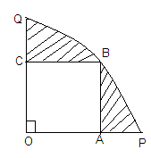

22.A toy is in the form of a cone mounted on a hemisphere of same radius 7cm .If the total height of the

toy is 31 cm. find its total surface area.

23.A solid cone of base radius 10 cm is cut into two parts through the mid –point of its height ,by a plane

parallel to its base .Find the ratio in the volumes of the two parts of the cone.

24.A solid metallic sphere of diameter 8 cm is melted and drawn into cylindrical wire of uniform width

.If the length of the wire is 12 m, find its width.

**Section -‘D’**

25.Solve for x:



26.A box contains cards numbered 3,5,7,9,….35,37.A card is drawn at random from the box. Find the

probability that the number on the drawn card is a prime number.

27.The sum of first n terms of an A.P.is 5n2+3n.If its m the term is 168,find the value of m .Also find the 20th term of this A.P.

28. Prove that the lengths of tangents drawn from an external point to a circle are equal.

29.In figure ,the sides AB,BC and CA of triangle ABC touch a circle with centre O and radius r at P,Q and

R respectively .

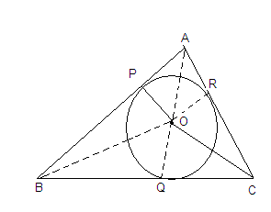

30.The ngle of elevation of the top of a building from the foot of a tower is 300.The angle of elevation of

the top of the tower from the foot of the building is 600.If the tower is 60 m high, find the height of

the building.

31.If the points A(1,-2),B(2,3),C(-3,2) and D(-4,-3) re the vertices of parallelogram ABCD ,then taking AB

as the base ,find the height of this parallelogram.

32.Water running in a cylindrical pipe of inner diameter 7cm,is collected in a container of the rate of

192.5 liters per minute .Find the rate of flow of water in the pipe in km/h.

33.While boarding an aeroplane ,a passenger got hurt .The pilot ,showing promptness and concern

,made arrangements to hospitalize the injured and so the plane started late by 30 minutes .To reach

the destination ,1500 km away ,in time ,the pilot increased the speed by 100 km/hour .Find the

original speed /hour of the plane .Do you appreciate the values shown by the pilot, namely

,promptness in providing help to the injured and his efforts to reach in time?