Q1. Grade Checker

Take a score as input and print the grade based on the following:

90+ : "A"

80-89 : "B"

70-79 : "C"

60-69 : "D"

Below 60 : "F"

here we used a basic if else statement to carry out marks and all.

Answer:

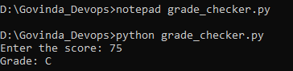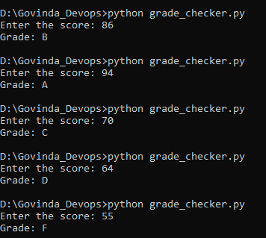

This program takes a numerical score as input and uses **if-else conditions** to decide which grade the student gets.

* If the score is 90 or above, the grade is **A**.
* If the score is between 80–89, the grade is **B**.
* If the score is between 70–79, the grade is **C**.
* If the score is between 60–69, the grade is **D**.
* If the score is below 60, the grade is **F**.

This demonstrates **basic conditional statements in Python**.

Q2. Student Grades

Create a dictionary where the keys are student names and the values are their grades. Allow the user to:

Add a new student and grade.

Update an existing student’s grade.

Print all student grades.

Used dictionary and basic operations. Using if else:

Answer:

 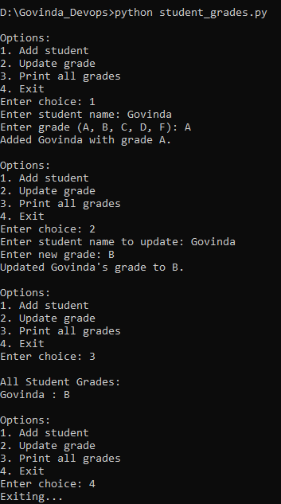

This program uses a **dictionary** to store student names and their grades. It provides a simple **menu system** to:

1. **Add** a new student and grade.
2. **Update** an existing student’s grade.
3. **Print** all student grades.
4. **Exit** the program.

This demonstrates how to work with **dictionaries and user input** using if-else statements.

Q3.Write to a File

Write a program to create a text file and write some content to it.

Using file functions like write and open.

Answer:

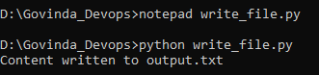

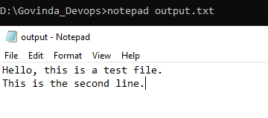

This program creates a new text file (output.txt) and writes some lines into it using Python’s open() function in **write ("w") mode**.

* If the file does not exist, it will be created.
* If it already exists, the previous content will be **overwritten**.

This demonstrates **file handling** with the write() method.

Q4. Read from a File

We used open in read mode and file.read to read and print to display.

Answer:

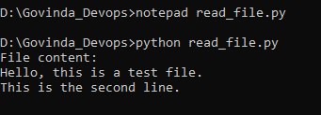

This program opens the previously created output.txt file in **read ("r") mode** and prints its contents to the screen.

* It uses the read() function to load the entire content of the file.

This demonstrates **reading data from files** in Python.