**METHODS USED 🡪**

LAUNCH Method:-

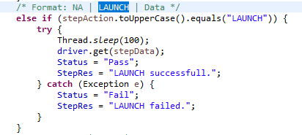

WAIT Method:-

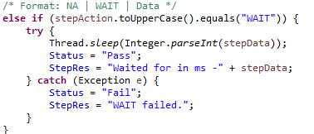

CLICK Method:-

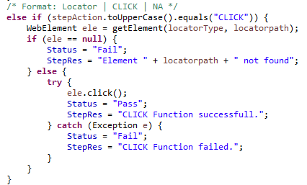

INPUT Method:-

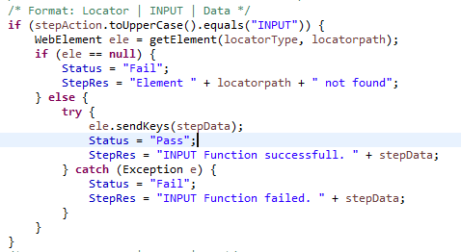

VERIFYTEXT Method:-

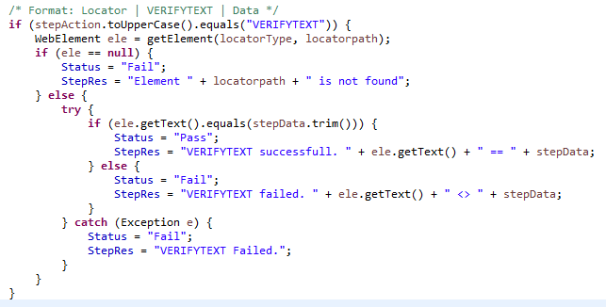

VERIFYTITLE Method:-

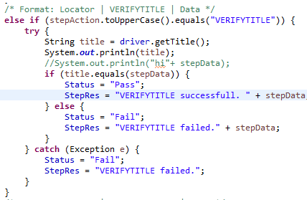

VERIFYELEMENTISENABLED Method:-

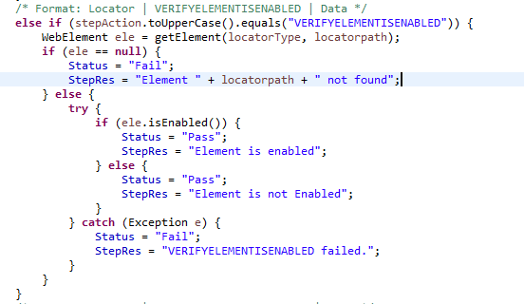

CAPTURESCREENSHOT Method:-

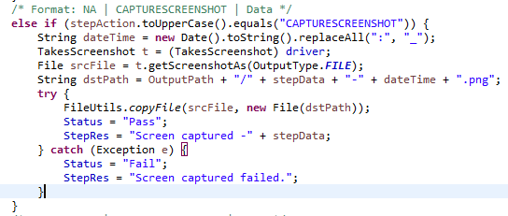

SCROLLUSINGPIXELX Method:-

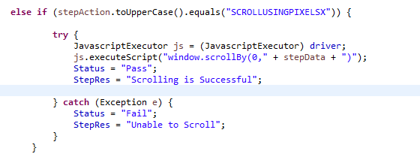

SCROLLUSINGPIXELY Method:-

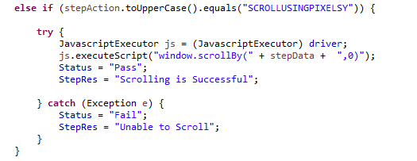

SELECTBYVALUE Method:-

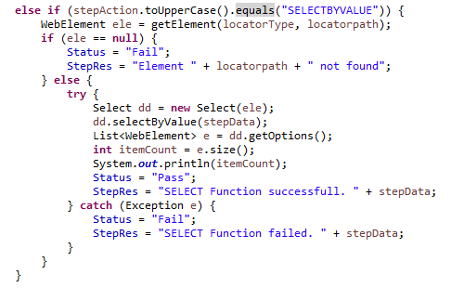

SELECTBYINDEX Method:-

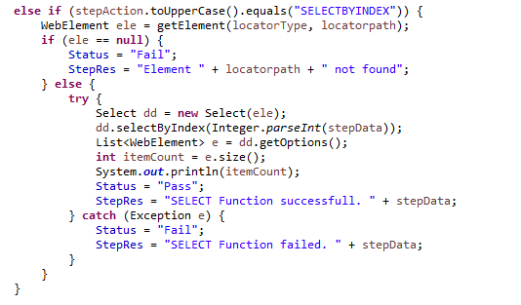

SELECTBYVISIBLETEXT Method:-

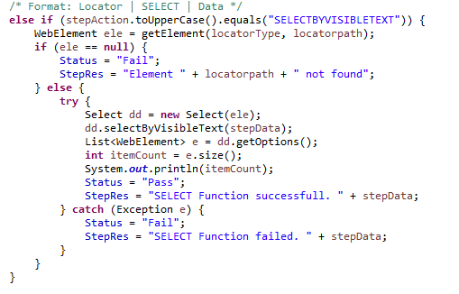

VERIFYELEMENTISDISPLAYED Method:-

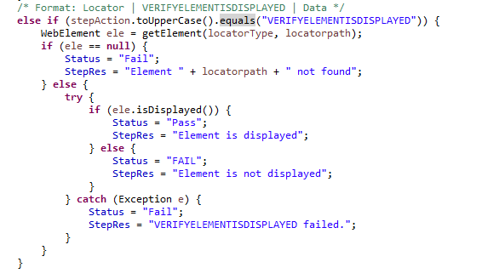

VERIFYELEMENTISSELECTED Method:-

