<https://sqlserverwarrior.wordpress.com/2019/11/01/install-powershell-module-offline-without-internet-access/>

1. Download Package from powershell gallary
2. Rename to .zip
3. Delete the following

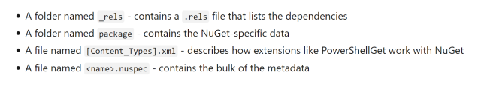

1. Find installation folder for modules by entering

****$env:PSModulePath -split ‘;’****

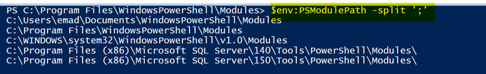

1. The cd to directory “C:\Program Files\WindowsPowerShell\Modules ”
2. Copy the extracted folder there
3. Rename it and remove the point version

Eg. from ****sqlserver.21.1.18179**** to ****sqlserver****

1. Then write commands
   1. ****Import-Module sqlserver****
   2. ****Get-Module sqlserver****

****done****