**Documentation – GUI Architecture**

Our GUI will have two possible logins; one for a candidate and one for an admin. If a candidate signs in they will be asked to complete a digital literacy test, if they fail then they will not be added to the potential employee database and their test will be terminated. If they are successful and answer four out of five questions correctly then they will be added to the potential employee database and advance to the next stage of the recruitment process.

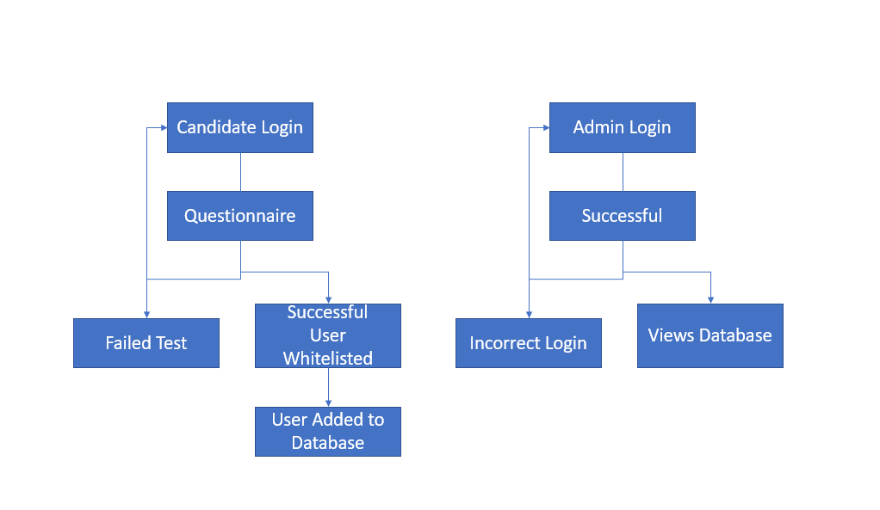The admin login will show an error message for an incorrect login. If the login is successful it will allow the admin to access the database and make amendments where necessary.