  - The .NET Compiler Platform (“Roslyn”)

Getting Started: Syntax Analysis
  - March 2014

Prerequisites
- Visual Studio 2013
- “Roslyn” End User Preview
- “Roslyn” SDK Project Templates
- “Roslyn” Syntax Visualizer

Introduction
Today, the Visual Basic and C# compilers are black boxes – text goes in and bytes come out – with no transparency into the intermediate phases of the compilation pipeline. With the .NET Compiler Platform (formerly known as “Roslyn”), tools and developers can leverage the exact same data structures and algorithms the compiler uses to analyze and understand code with confidence that that information is accurate and complete.
In this walkthrough we’ll explore the Syntax API. The Syntax API exposes the parsers, the syntax trees themselves, and utilities for reasoning about and constructing them.

Understanding Syntax Trees
The Syntax API exposes the syntax trees the compilers use to understand Visual Basic and C# programs. They are produced by the same parser that runs when a project is built or a developer hits F5. The syntax trees have full-fidelity with the language; every bit of information in a code file is represented in the tree, including things like comments or whitespace. Writing a syntax tree to text will reproduce the exact original text that was parsed. The syntax trees are also immutable; once created a syntax tree can never be changed. This means consumers of the trees can analyze the trees on multiple threads, without locks or other concurrency measures, with the security that the data will never change under.
The four primary building blocks of syntax trees are:
- The SyntaxTree class, an instance of which represents an entire parse tree. SyntaxTree is an abstract class which has language-specific derivatives. To parse syntax in a particular language you will need to use the parse methods on the VisualBasicSyntaxTree (or CSharpSyntaxTree) class.
- The SyntaxNode class, instances of which represent syntactic constructs such as declarations, statements, clauses, and expressions.
- The SyntaxToken structure, which represents an individual keyword, identifier, operator, or punctuation.
- And lastly the SyntaxTrivia structure, which represents syntactically insignificant bits of information such as the whitespace between tokens, preprocessor directives, and comments.
SyntaxNodes are composed hierarchically to form a tree that completely represents everything in a fragment of Visual Basic or C# code. For example, were you to examine the following Visual Basic source file using the “Roslyn” Syntax Visualizer (In Visual Studio, choose View -> Other Windows -> Roslyn Syntax Visualizer) it tree view would look like this:
SyntaxNode: Blue
SyntaxToken: Green
SyntaxTrivia: Red
Visual Basic Code File
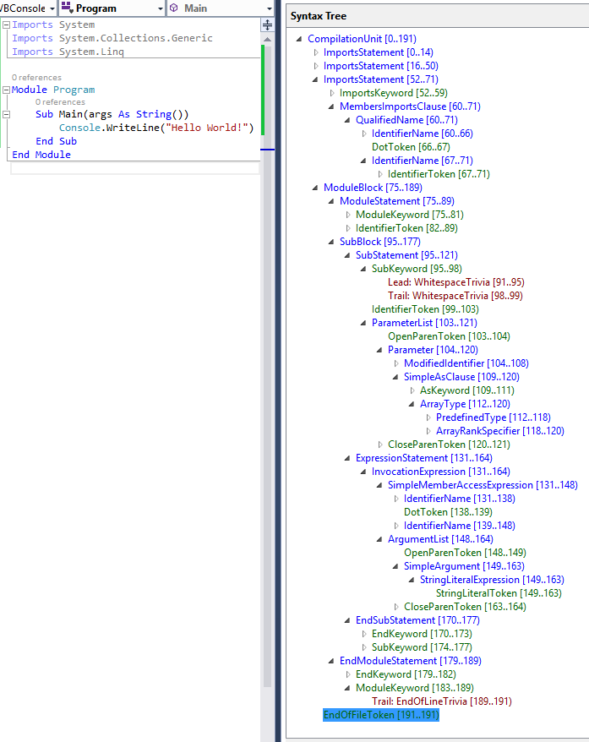

By navigating this tree structure you can find any statement, expression, token, or bit of whitespace in a code file!

Traversing Trees

Manual Traversal
The following steps use Edit and Continue to demonstrate how to parse VB source text and find a parameter declaration contained in the source.

Example – Manually traversing the tree
- Create a new VB Roslyn Console Application project.
  - In Visual Studio, choose File -> New -> Project… to display the New Project dialog.
  - Under Visual Basic -> Roslyn, choose “Console Application”.
  - Name your project “GettingStartedVB” and click OK.
- Enter the following line at the top of your Module1.vb file:
Option Strict Off
  - Some readers may run with Option Strict turned On by default at the project level. Turning Option Strict Off in this walkthrough simplifies many of the examples by removing much of the casting required.
- Enter the following code into your Main method:
Dim tree As SyntaxTree = VisualBasicSyntaxTree.ParseText(
"Imports System
Imports System.Collections
Imports System.Linq
Imports System.Text
Namespace HelloWorld
Module Program
Sub Main(args As String())
Console.WriteLine(""Hello, World!"")
End Sub
End Module
End Namespace")
Dim root As CompilationUnitSyntax = tree.GetRoot()
- Move your cursor to the line containing the End Sub of your Main method and set a breakpoint there.
  - In Visual Studio, choose Debug -> Toggle Breakpoint.
- Run the program.
  - In Visual Studio, choose Debug -> Start Debugging.
- Inspect the root variable in the debugger by hovering over it and expanding the datatip.
  - Note that its Imports property is a collection with four elements; one for each Import statement in the parsed text.
  - Note that the Kind of the root node is SyntaxKind.CompilationUnit.
  - Note that the Members collection of the CompilationUnitSyntax node has one element.
- Insert the following statement at the end of the Main method to store the first member of the root CompilationUnitSyntax variable into a new variable:
Dim firstMember = root.Members(0)
- Set this statement as the next statement to be executed and execute it.
  - Right-click this line and choose Set Next Statement.
  - In Visual Studio, choose Debug -> Step Over, to execute this statement and initialize the new variable.
  - You will need to repeat this process for each of the following steps as we introduce new variables and inspect them with the debugger.
- Hover over the firstMember variable and expand the datatips to inspect it.
  - Note that its Kind is SyntaxKind.NamespaceBlock.
  - Note that its run-time type is actually NamespaceBlockSyntax.
- Cast this node to NamespaceBlockSyntax and store it in a new variable:
Dim helloWorldDeclaration As NamespaceBlockSyntax = firstMember
- Execute this statement and examine the helloWorldDeclaration variable.
  - Note that like the CompilationUnitSyntax, NamespaceBlockSyntax also has a Members collection.
- Examine the Members collection.
  - Note that it contains a single member. Examine it.
    - Note that its Kind is SyntaxKind.ModuleBlock.
    - Note that its run-time type is ModuleBlockSyntax.
- Cast this node to ModuleBlockSyntax and store it in a new variable:
Dim programDeclaration As ModuleBlockSyntax =
helloWorldDeclaration.Members(0)
- Execute this statement.
- Locate the Main declaration in the programDeclaration.Members collection and store it in a new variable:
Dim mainDeclaration As MethodBlockSyntax = programDeclaration.Members(0)
- Execute this statement and examine the members of the MethodBlockSyntax object.
  - Examine the Begin property.
    - Note the AsClause, and Identifier properties.
    - Note the ParameterList property; examine it.
      - Note that it contains both the open and close parentheses of the parameter list in addition to the list of parameters themselves.
      - Note that the parameters are stored as a SeparatedSyntaxList(Of ParameterSyntax).
  - Note the Statements property.
- Store the first parameter of the Main declaration in a variable.
Dim argsParameter As ParameterSyntax =
mainDeclaration.Begin.ParameterList.Parameters(0)
- Execute this statement and examine the argsParameter variable.
  - Examine the Identifier property; note that it is of type ModifiedIdentifierSyntax. This type represents a normal identifier with an optional nullable modifier (x?) and/or array rank specifier (arr(,)).
  - Note that a ModifiedIdentifierSyntax has an Identifier property of the structure type SyntaxToken.
  - Examine the properties of the Identifier SyntaxToken; note that the text of the identifier can be found in the ValueText property.
- Stop the program.
  - In Visual Studio, choose Debug -> Stop debugging.
- Your program should look like this now:
Option Strict Off
Module Module1
Sub Main()
Dim tree As SyntaxTree = VisualBasicSyntaxTree.ParseText(
"Imports System
Imports System.Collections
Imports System.Linq
Imports System.Text
Namespace HelloWorld
Module Program
Sub Main(args As String())
Console.WriteLine(""Hello, World!"")
End Sub
End Module
End Namespace")
Dim root As CompilationUnitSyntax = tree.GetRoot()
Dim firstMember = root.Members(0)
Dim helloWorldDeclaration As NamespaceBlockSyntax = firstMember
Dim programDeclaration As ModuleBlockSyntax =
helloWorldDeclaration.Members(0)
Dim mainDeclaration As MethodBlockSyntax = programDeclaration.Members(0)
Dim argsParameter As ParameterSyntax =
mainDeclaration.Begin.ParameterList.Parameters(0)
End Sub
End Module

Query Methods
In addition to traversing trees using the properties of the SyntaxNode derived classes you can also explore the syntax tree using the query methods defined on SyntaxNode. These methods should be immediately familiar to anyone familiar with XPath. You can use these methods with LINQ to quickly find things in a tree.

Example - Using query methods
- Using IntelliSense, examine the members of the SyntaxNode class through the root variable.
  - Note query methods such as DescendantNodes, AncestorsAndSelf, and ChildNodes.
- Add the following statements to the end of the Main method. The first statement uses a LINQ expression and the DescendantNodes method to locate the same parameter as in the previous example:
Dim firstParameters = From methodStatement In root.DescendantNodes().
OfType(Of MethodStatementSyntax)()
Where methodStatement.Identifier.ValueText = "Main"
Select methodStatement.ParameterList.Parameters.First()
Dim argsParameter2 = firstParameters.First()
- Start debugging the program.
- Open the Immediate Window.
  - In Visual Studio, choose Debug -> Windows -> Immediate.
- Using the Immediate window, type the expression ? argsParameter Is argsParameter2 and press enter to evaluate it.
  - Note that the LINQ expression found the same parameter as manually navigating the tree.
- Stop the program.

SyntaxWalkers
Often you’ll want to find all nodes of a specific type in a syntax tree, for example, every property declaration in a file. By extending the VisualBasicSyntaxWalker class and overriding the VisitPropertyStatement method, you can process every property declaration in a syntax tree without knowing its structure beforehand. VisualBasicSyntaxWalker is a specific kind of SyntaxVisitor which recursively visits a node and each of its children.

Example - Implementing a VisualBasicSyntaxWalker
This example shows how to implement a VisualBasicSyntaxWalker which examines an entire syntax tree and collects any Imports statements it finds which aren’t importing a System namespace.
- Create a new VB Roslyn Console Application project; name it “ImportsCollectorVB”.
- Enter the following line at the top of your Module1.vb file:
Option Strict Off
- Enter the following code into your Main method:
Dim tree As SyntaxTree = VisualBasicSyntaxTree.ParseText(
"Imports Microsoft.VisualBasic
Imports System
Imports System.Collections
Imports Microsoft.Win32
Imports System.Linq
Imports System.Text
Imports Microsoft.CodeAnalysis
Imports System.ComponentModel
Imports System.Runtime.CompilerServices
Imports Microsoft.CodeAnalysis.VisualBasic
Namespace HelloWorld
Module Program
Sub Main(args As String())
Console.WriteLine(""Hello, World!"")
End Sub
End Module
End Namespace")
Dim root As CompilationUnitSyntax = tree.GetRoot()
- Note that this source text contains a long list of Imports statements.
- Add a new class file to the project.
  - In Visual Studio, choose Project -> Add Class…
  - In the "Add New Item" dialog type ImportsCollector.vb as the filename.
- Enter the following line at the top of your ImportsCollector.vb file:
Option Strict Off
- Make the new ImportsCollector class in this file extend the VisualBasicSyntaxWalker class:
Public Class ImportsCollector
Inherits VisualBasicSyntaxWalker
- Declare a public read-only field in the ImportsCollector class; we’ll use this variable to store the ImportsStatementSyntax nodes we find:
Public ReadOnly [Imports] As New List(Of ImportsStatementSyntax)()
- Override the VisitMembersImportsClause method:
Public Overrides Sub VisitMembersImportsClause(
node As MembersImportsClauseSyntax
)
End Sub
- Using IntelliSense, examine the MembersImportsClauseSyntax class through the node parameter of this method.
  - Note the Name property of type NameSyntax; this stores the name of the namespace being imported.
- Replace the code in the VisitMembersImportsClause method with the following to conditionally add the found node to the [Imports] collection if Name doesn’t refer to the System namespace or any of its descendant namespaces:
If node.Name.ToString() = "System" OrElse
node.Name.ToString().StartsWith("System.") Then Return
[Imports].Add(node.Parent)
- The ImportsCollector.vb file should now look like this:
Option Strict Off
Public Class ImportsCollector
Inherits VisualBasicSyntaxWalker
Public ReadOnly [Imports] As New List(Of ImportsStatementSyntax)()
Public Overrides Sub VisitMembersImportsClause(
node As MembersImportsClauseSyntax
)
If node.Name.ToString() = "System" OrElse
node.Name.ToString().StartsWith("System.") Then Return
[Imports].Add(node.Parent)
End Sub
End Class
- Return to the Module1.vb file.
- Add the following code to the end of the Main method to create an instance of the ImportsCollector, use that instance to visit the root of the parsed tree, and iterate over the ImportsStatementSyntax nodes collected and print their names to the Console:
Dim visitor As New ImportsCollector()
visitor.Visit(root)
For Each statement In visitor.Imports
Console.WriteLine(statement)
Next
- Your Module1.vb file should now look like this:
Option Strict Off
Module Module1
Sub Main()
Dim tree As SyntaxTree = VisualBasicSyntaxTree.ParseText(
"Imports Microsoft.VisualBasic
Imports System
Imports System.Collections
Imports Microsoft.Win32
Imports System.Linq
Imports System.Text
Imports Microsoft.CodeAnalysis
Imports System.ComponentModel
Imports System.Runtime.CompilerServices
Imports Microsoft.CodeAnalysis.VisualBasic
Namespace HelloWorld
Module Program
Sub Main(args As String())
Console.WriteLine(""Hello, World!"")
End Sub
End Module
End Namespace")
Dim root As CompilationUnitSyntax = tree.GetRoot()
Dim visitor As New ImportsCollector()
visitor.Visit(root)
For Each statement In visitor.Imports
Console.WriteLine(statement)
Next
End Sub
End Module
- Press Ctrl+F5 to run the program without debugging it. You should see the following output:
Imports Microsoft.VisualBasic
Imports Microsoft.Win32
Imports Microsoft.CodeAnalysis
Imports Microsoft.CodeAnalysis.VisualBasic
Press any key to continue . . .
- Observe that the walker has located all four non-System namespace Imports statements.
- Congratulations! You’ve just used the Syntax API to locate specific kinds of VB statements and declarations in VB source code.

