Contents
Contents 1
Introduction 2
1.1 Main contribution of the research 3
1.2 Literature review 4
1.3 Research gap 5
1.4 Methods and experiments 6
1.4.1 Methods and experiments 6
1.4.2 Dot production attention 6
1.4.3 System model 6
1.4.4 Query key value 7
1.4.5 Architecture and algorithm 7

Introduction
As 6G networks process toward edge deployment, huge machine type communication, and network slicing, the web attacks surface for web-oriented threats increases rapidly. Edge nodes process latency with limited security instrumentation where data are increasingly served at the network edge rather than centralized data centers. Safeguarding from web-based attacks such as brute force, SQL injection and shell script exploitation with this setting requires a good architecture that is accurate, lightweight enough for edge hardware and validate the ability to generalize across traffic domains.
The increase in use of mobile devices have led to the rise of dependency on mobile networks and in as a result escalated web-based attack. With the emergence of next generation 6G networks and the growth of edge-based content sharing, security challenges are amplified. According to the report of Edge-scan, mobile network-based vulnerabilities and web attacks have surged drastically since the year 2023. Among the most well-known web attacks are brute force, shell script, and SQL injection. As mobile traffic continues to dominate the internet usage globally [1], protecting these networks, especially in the context of 6G edge deployments, has become very important. The mobile environment not only have increased the attack surface in traditional web attacks [2] but also have opened new security challenges related to distributed edge computing [3]. Deep learning (DL) techniques are being applied across various cybersecurity areas like infrastructure threats and attacks, software attacks, and privacy preservation [4].

Main contribution of the research
The goal of this research work is:
- This research introduces a novel intellectual security architecture (ISA) that combines a lightweight Bi-LSTM temporal encoder with a transformer-based MHA model, specifically designed for detecting web attacks.
- To conduct a controlled ablation study separating the accuracy contribution of each component like Bi-LSTM only, MHA only, and hybrid model quantifying the benefit of combing them in attack detection.
- To provide a system level characterization such as parameter count, disk footprint, inference latency, and throughput for edge deployment feasibility;
- To perform exhaustive evaluation using a diverse dataset on trained model zero shot on an independent edge IIoT dataset reporting its strength as preserved AUC and limitation reduced accuracy on domain shift.

Literature review
In recent years, the detection of web attacks in mobile networks is attracting the attention of the researchers. To enhance security in mobile networks, and specifically in the context of edge-based content sharing in next generation 6G networks, numerous ML and DL approaches have been proposed in the literature.
Tian et al. [9] proposed a hybrid model which combines long short-term memory (LSTM) and convolutional neural networks (CNNs) for web attack detection. To identify the malicious patterns, they processed HTTP request as character sequences and then extracted both the temporal and spatial features. Their approach demonstrated 98.2% accuracy with a false positive rate of 0.76% that was tested against five types of web attacks. Although while dealing with unknown attack types like zero-day attack, their accuracy reduced to 12% which shows the limitation of the model while dealing with the dynamic mobile environment.
Zhang et al. [10] introduced a network intrusion detection system (NIDS) combining Bi-LSTM and multihead attention mechanism. An embedding layer was used to convert input features into dense vector and then the multi-head attention assigned different weights to various parts of the input sequence in a way enhancing the focus of the model on critical features. They evaluated their model on datasets namely KDDCUP99, NSLKDD, and CICIDS2017 that recorded accuracies of 98.29%, 95.19%, and 99.08%, respectively. Due to the inherent properties of mobile environments, particularly resource constraint and real-time processing capabilities (critical in edge deployments), the proposed model’s applicability to mobile networks remains unexplored.

Research gap
The above-mentioned literature classifies the following methodological gaps, which are particularly pronounced in next generation 6G and edge-based content sharing environments:
- Many traditional models of web attack detection are based on heavy and deeper architecture models, which are not suitable for edge devices and resource-constrained computing environments.
- Current deep learning models are slow in detecting real-time web attacks and provide overfitting results with high classification accuracy on imbalanced multiclass attack datasets, making them unsuitable for the high-speed, dynamic nature of 6G traffic.
- Most models are black boxes that do not consider important data such as HTTP requests and URL mapping. This results in poor interpretability of the predicted outcomes, which is vital for forensic analysis within an Intellectual Security Architecture (ISA).

Methods and experiments
The proposed research is to predict the different types of web attacks in next generation 6G mobile communication networks, which may stall the efficiency of mobile networks with coverage issues and low bandwidth in metropolitan areas, especially affecting edge-based content sharing.

Methods and experiments
Features | Testing data
Traffic data | Source and destination IP
Headers | HTTP, URL
Payload | Content, query, token
Network info | Port, packet size, duration
Training and validation set | 70:30
Label | Bots, DDoS, DOS, Port scanning,  Web attacks-Brute force, SQL injection
Table 1 Dataset parameters

Dot production attention
After using the attention function as the first step to change the dimensions of each head from the initial layer to capture long-range dependencies, create a foundation for dot product attention, shown in (1):
$$Attention\left(Q, K, V\right)=Softmax\left(\frac{QK^{T}}{\sqrt{d^{k}}}\right)V,$$ | (1)
where $d_{k}$ – are the dimensions of key vectors inside the attention layer with activation function.

System model
The next process after normalization is the pooling function, which reduces the length of each sequence, like link address, HTTP request, and duration, to a fixed length. This is important for creating compact feature vectors for the final classification layer within the intellectual security architecture (ISA) [44]. The average pooling function removes the dimension of time to make each sequence feature to enter the next dense layer as a fixed-size feature vector. The equation of average pooling is expressed in (2)

$$RC_{1}=ReLU(W_{1}RC_{avg}+b_{1}).$$ | (2)

Query key value
Finally, binary cross-entropy loss is used to train the model in an effective way to handle model loss and prevent overfitting. The main advantage of this loss function is its ability to minimize classification errors related to web attacks or normal operations within the mobile communication network, which is essential for the reliability of the intellectual security architecture (ISA) in 6G edge nodes. [46] The final layer applies a SoftMax activation over seven output classes such as normal traffic, bots, brute force, DDoS, DoS, Port scanning, and web attacks process a variable distribution over attack types expressed in (3):
$$y=Softmax\left(W_{2}RC_{avg}+b_{2}\right).$$ | (3)
Given the severe class imbalance across the seven categories, the model is trained with class weighted sparse categorical cross-entropy expressed in (4):
$$Loss=-\sum_{c=1}^{7}{w_{c}}y_{c}\log{(\hat{y_{c}})},$$ | (4)
where $w_{c}$ – is the weight applied to class c.

Architecture and algorithm
The process is to separate the class of each attack that is performed inside the mobile communication network and this is most useful in imbalanced dataset. Figure 1 Receiver operating characteristic (ROC) and area under curve (AUC) analysis for multiclass attack detection. displays the AUC curve of the proposed work.
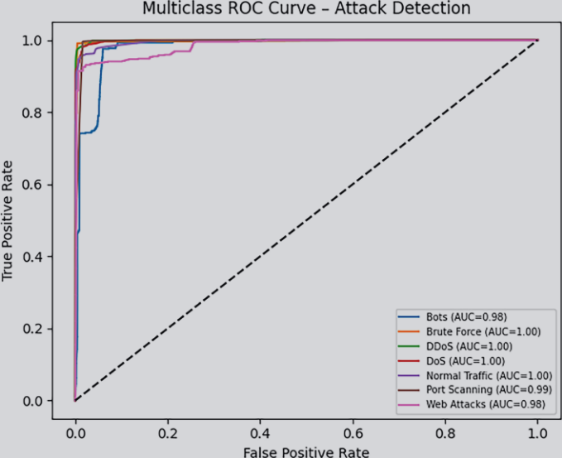
Figure 1 Receiver operating characteristic (ROC) and area under curve (AUC) analysis for multiclass attack detection.

