Conveyor program

# Problem: inner arcs are not drawn at the proper positions

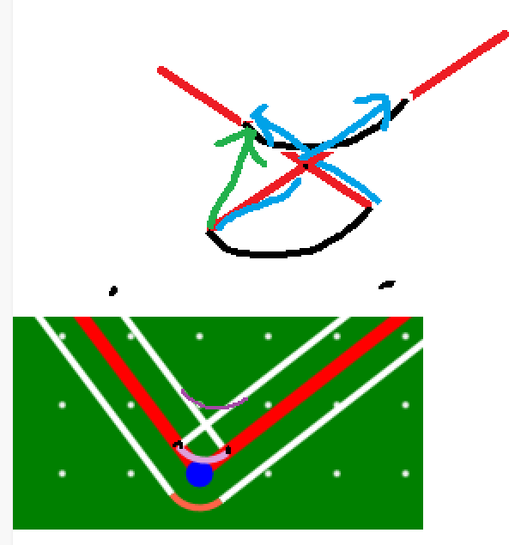

# Deducing the necessary formulae to calculate the crossing point:

# Solving the equations:

// what happens if is 0?

# Implementation

Ein Bild, das Text enthält.
