**Assignment : Day 4**

**Q.1**

A) ibm.com

Windows🡪Run🡪cmd🡪nslookup🡪set type=mx🡪www.ibm.com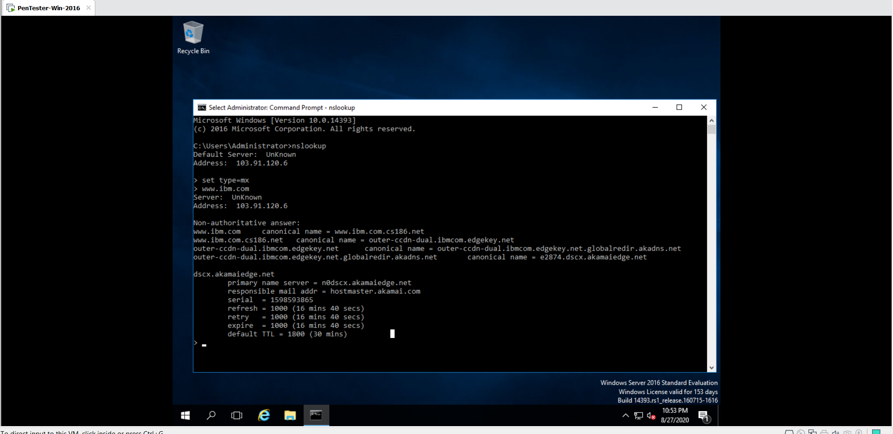

B) wipro.com

Windows🡪Run🡪cmd🡪nslookup🡪set type=mx🡪www.wipro.com

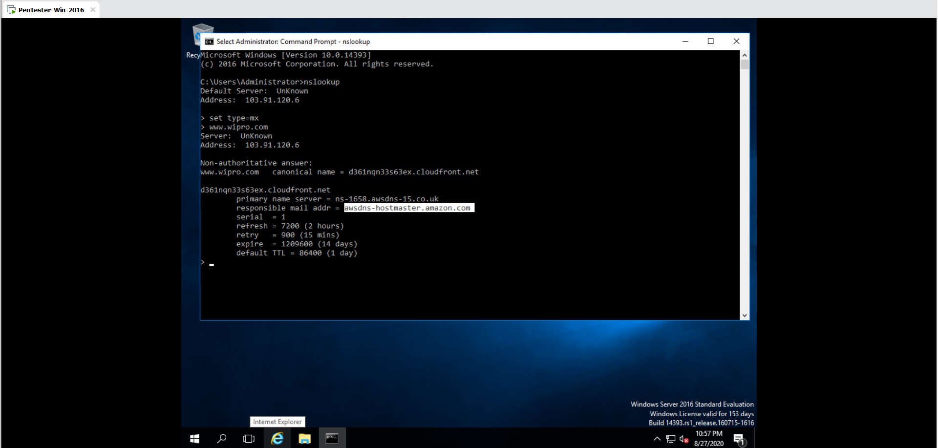

**Q.2**

A) ibm.com

Windows🡪Run🡪cmd🡪nslookup🡪set type=mx🡪ibm.com

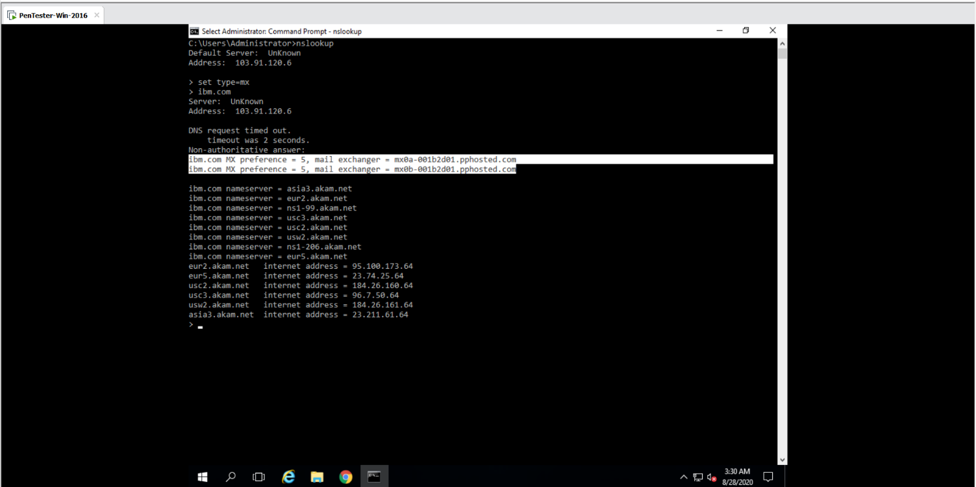

Address 1 :- mx0a-001b2d01.pphosted.com

Then Go to this URL :- <https://tools.keycdn.com/geo?host=mx0a-001b2d01.pphosted.com>

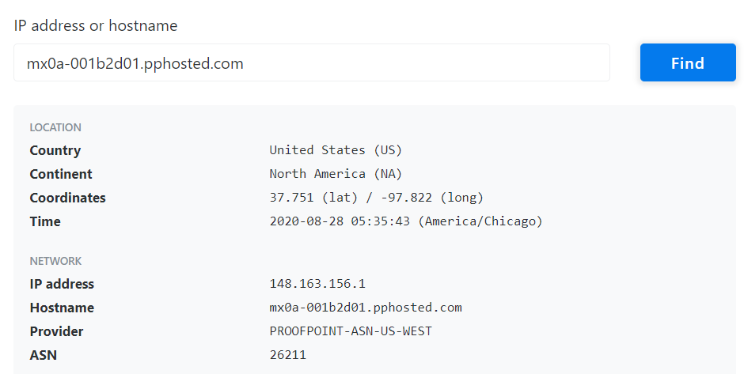

Address 2: mx0b-001b2d01.pphosted.com

Then Go to this URL :- <https://tools.keycdn.com/geo?host=mx0b-001b2d01.pphosted.com>

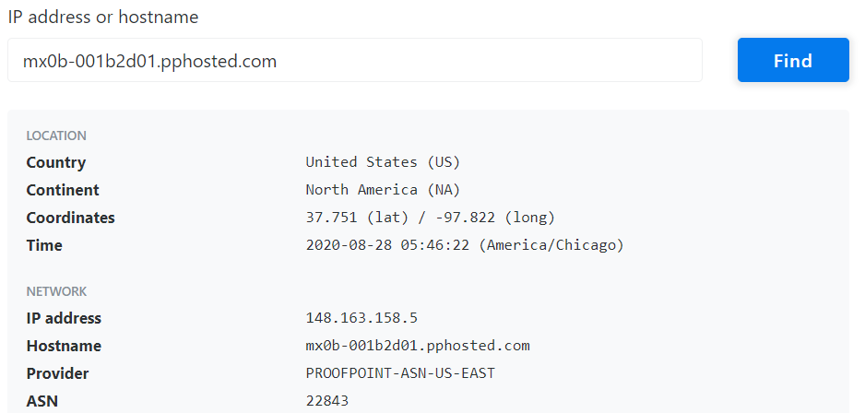

B) wipro.com

Windows🡪Run🡪cmd🡪nslookup🡪set type=mx🡪wipro.com

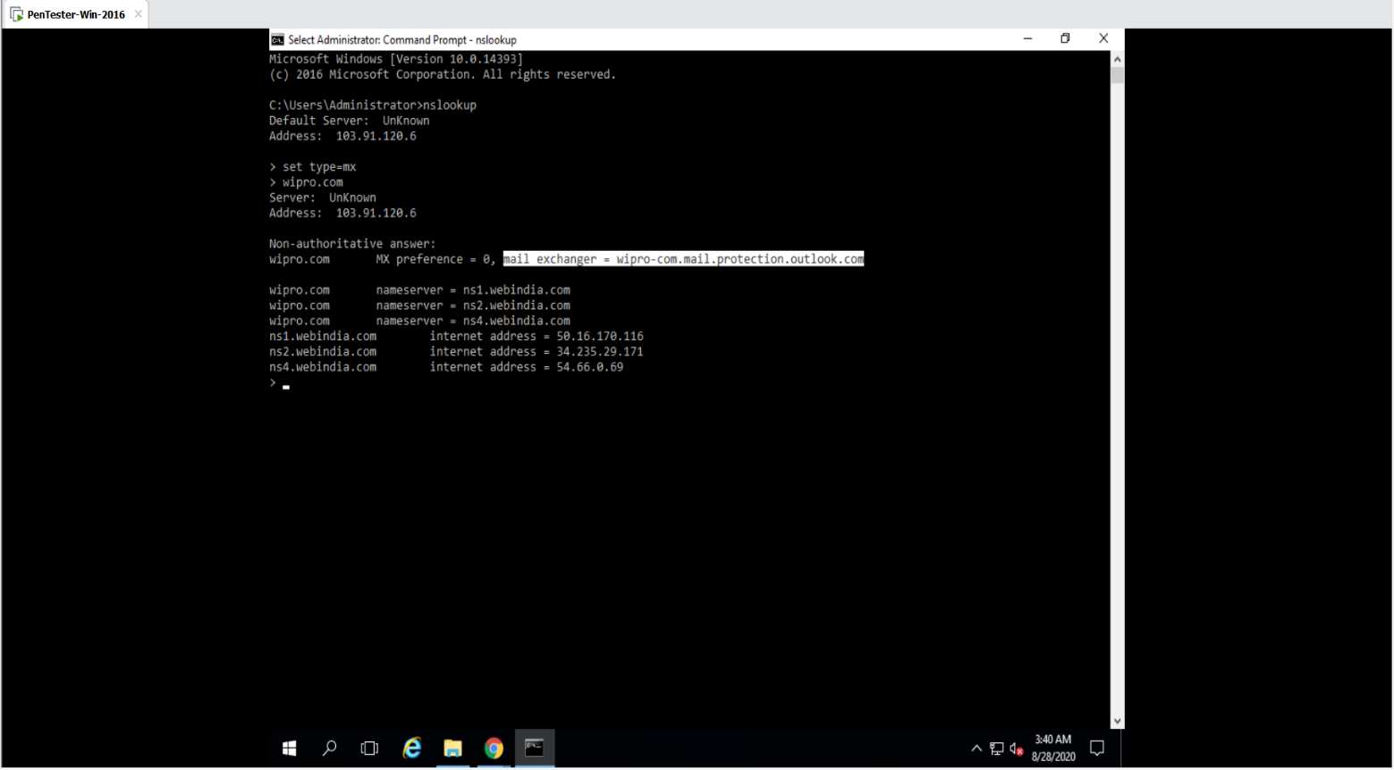

Address : wipro-com.mail.protection.outlook.com

Then Go to this URL :- <https://tools.keycdn.com/geo?host=wipro-com.mail.protection.outlook.com>

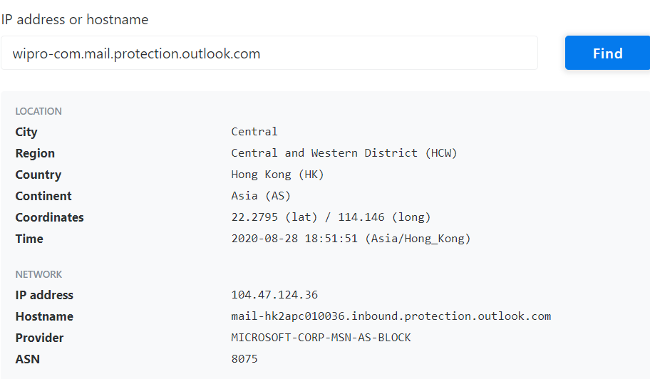

**Q.3**

Vm🡪KALI Linux🡪Terminal🡪sudo su – (now enter password )🡪 nmap 203.163.246.23

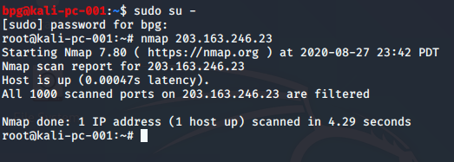

For More Scans :- *nmap -v -A 203.163.246.23*

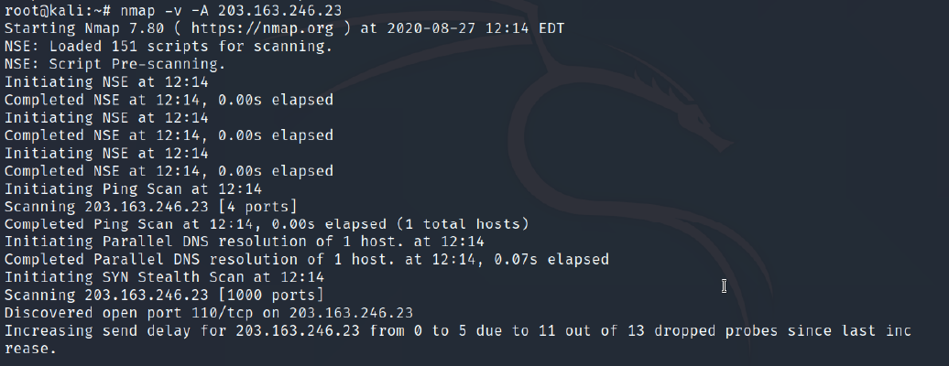

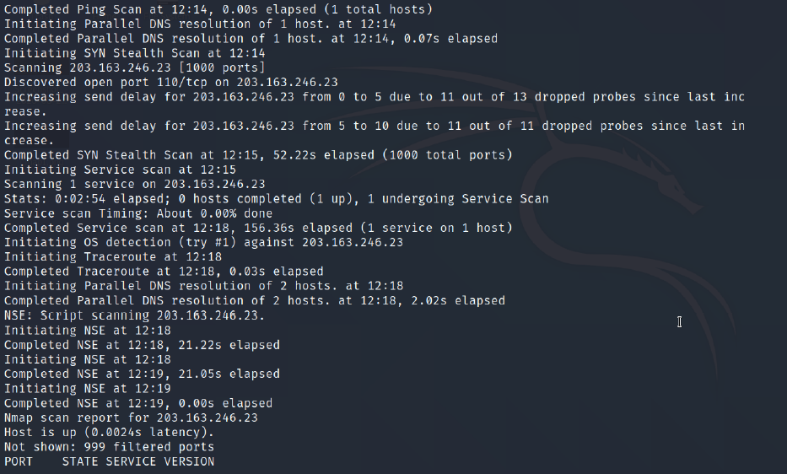

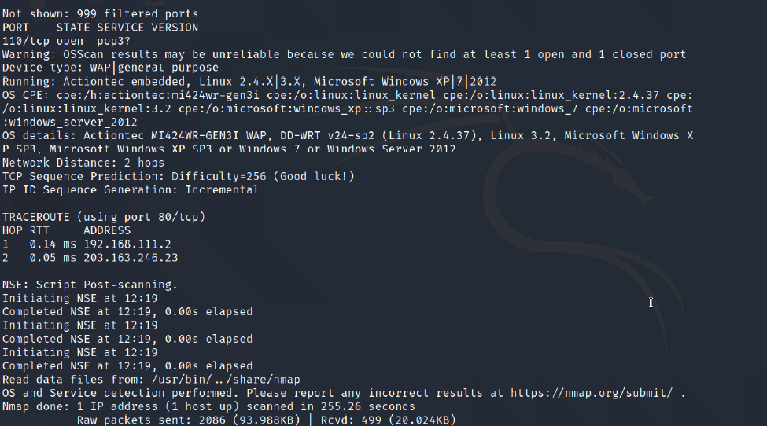

**Q.4**

Open Pentester - Windows 2016 VM and install Nessus and open it in browser.

Create New Scan 🡪 Advance Settings 🡪 Launch the Scan

