Accident Prevention on Blind Spots/Turns of Mountainous Roads



*By*

Adnan Khan

CUI/FA16-BCE-030/ATD

Ahmad

CUI/FA16-BCE-025/ATD

Osama Shah

CUI/FA16-BCE-021/ATD

BS Thesis

In

Electrical (Computer) Engineering

COMSATS University Islamabad

Abbottabad Campus-Pakistan

Spring 2020



**COMSATS University Islamabad-Abbottabad Campus**

Accident Prevention on Blind Spots/Turns of Mountainous Roads

A Thesis Presented to

COMSATS University Islamabad- Abbottabad Campus

In partial fulfillment

of the requirement for the degree of

BS Electrical (Computer) Engineering

By

Adnan Khan

CUI/FA16-BCE-030/ATD

Ahmad

CUI/FA16-BCE-025/ATD

Osama Shah

CUI/FA16-BCE-021/ATD

Spring 2020

Accident Prevention on Blind Spots/Turns of Mountainous Roads

An Undergraduate Thesis submitted to the Electrical and Computer Engineering Department as partial fulfillment of the requirement for the award of Degree of Bachelor of Science in Electrical (Computer) Engineering.

|  |  |
| --- | --- |
| Name | Registration Number |
| Adnan Khan | CUI/FA16-BCE-030/ATD |
| Ahmad | CUI/FA16-BCE-025/ATD |
| Osama Shah | CUI/FA16-BCE-021/ATD |

**Supervisor**

Engr. Muhammad Naveed Shaikh

Lecturer, Electrical and Computer Engineering

Abbottabad Campus

COMSATS University Islamabad (CUI)

Abbottabad Campus

July 2020

Final Approval

This thesis titled

Accident Prevention on Blind Spots/Turns of Mountainous Roads

By

*Adnan Khan*

*CUI/FA16-BCE-030/ATD*

*Ahmad*

*CUI/FA16-BCE-025/ATD*

*Osama Shah*

*CUI/FA16-BCE-021/ATD*

Has been approved

For the COMSATS University Islamabad, Abbottabad Campus

Supervisor: ______________________________________________

Engr. Muhammad Naveed Shaikh, Lecturer

Department of Electrical and Computer Engineering Engineering/CUI, Abbottabad Campus

HOD: ______________________________________________

Dr. Imdad Khan, Associate Professor

Department of Electrical and Computer Engineering, CUI, Abbottabad Campus

**Declaration**

I Adnan Khan CUI/FA16-BCE-030/ATD along with my group mates hereby declare that we have produced the work presented in this thesis, during the scheduled period of study. We also declare that we have not taken any material from any source except referred to wherever due to that amount of plagiarism is within an acceptable range. If a violation of HEC rules on research has occurred in this thesis, we shall be liable to punishable action under the plagiarism rules of the HEC.

Date: _________________ Signature of the student:

Adnan Khan

CUI/FA16-BCE-030/ATD

Ahmad

CUI/FA16-BCE-025/ATD

Osama Shah

CUI/FA16-BCE-021/ATD

**Certificate**

It is certified that Adnan Khan CUI/FA16-BCE-030/ATD, Ahmad CUI/FA16-BCE-025/ATD and Osama Shah CUI/FA16-BCE-21/ATD has carried out all the work related to this report under my supervision at the Department of Electrical and Computer engineering, COMSATS University Islamabad, Abbottabad Campus, and the work fulfills the requirement for the award of BS degree.

Date: _________________

Supervisor:

Mr. Muhammad Naveed Shaikh

Department of Electrical and Computer Engineering

Head of Department:

Dr. Imdad Khan

Department of Electrical and Computer Engineering

**DEDICATION**

This study is wholeheartedly dedicated to our beloved parents and teachers, who have been our source of inspiration and gave us strength when we thought of giving up, who continually provide their moral, spiritual, emotional, and financial support.

To our brothers, sisters, relatives, mentor, friends, and classmates who shared their words of advice and encouragement to finish this study.

And lastly, we dedicated this study to the Almighty Allah, thank you for the guidance, strength, power of mind, protection and skills and for giving us a healthy life. All of these we offer to you.

**ACKNOWLEDGEMENTS**

We would like to acknowledge everyone who played a role in our academic accomplishments. First of all, our parents, who supported us with love and understanding. Without you, we could never have reached this current level of success.

Secondly, our supervisor and co-supervisor, each of whom has provided patient advice and guidance throughout the project. Thank you all for your unwavering support.

**Adnan Khan FA16-BCE-030**

**Ahmad FA16-BCE-025**

**Osama Shah FA16-BCE-021**

**ABSTRACT**

Accident Prevention on Blind Spots/Turns of Mountainous Roads

In the developing nations, road accidents are the significant reasons for death. For instance, if we look at the main 10 risky roads in the world, we can see that every one of them is a mountainous road. In the mountain roads, there will be tight bends and the roads will be restricted. In these sorts of circumstances, the driver of a vehicle cannot see vehicles approaching from the inverse side. A great many individuals lose their lives every year due to this issue. Since we are discussing mountain roads, here the opposite side may lead to a precipice. The answer to this issue is cautioning the driver about the vehicle originating from the inverse side. This objective is achieved by building a module that will detect vehicle position and speed and aware of the driver in the vehicle of the incoming cars. These goals are achieved using fast and reliable V2V (Vehicle to Vehicle) communication. The modules in each respective car will exchange the data which will help to prevent mishaps, especially in mountainous curves.

Table of Contents

Chapter 1……………………………………………………………………………………………………………………………………………………………………………………………………..…… 1

1 Introduction 1

1.1 Introduction 1

1.1.1 Top 10 Dangerous Roads in World 1

1.1.2 Deaths Caused by Accidents in Pakistan 1

1.2 Motivation 2

1.3 Objectives 2

1.3.1 Fast V2V communication 2

1.3.2 Cost-Effective System Design 2

1.3.3 Desired Prevention System Independent of Internet 2

Chapter 2 4

2 Literature Review 4

2.1 Introduction 4

2.2 Sensor Based Accident Prevention System 4

2.2.1 Limitations 4

2.3 Speed Detection Using Electro Strips 4

2.3.1 Limitations 4

Chapter 3 5

3 Components and Technical Specification 5

3.1 Arduino Mega 2560 6

3.1.1 Product Description 6

3.1.2 Input and Output Pins 6

3.1.3 Summary 7

3.2 HC-12 Transceiver as Communication Module 7

3.2.1 Product Description 7

3.2.2 Definition of Pins 8

3.3 NEO-6M GPS 9

3.3.1 Product Description 9

3.3.2 Wiring with Arduino UNO 9

3.3.3 Schematic 10

3.4 Arduino 2.4” TFT Shield Screen 10

3.4.1 Product Description 10

3.4.2 Display Parameters 10

3.5 Circuit Diagram 11

Chapter 4 13

4 Results 13

4.1 Project Testing 13

4.1.1 Desired Outcomes 13

4.1.2 Testing site 13

4.2 Milestone: V2V communication 14

4.3 Milestone: No dependency on Internet 14

4.4 Milestone: Cost Effective 14

Chapter 5 16

5 Discussion 16

5.1 Key Findings 16

5.2 Implications of Results 16

5.3 Limitations 16

5.4 Maximum Performance Area 16

5.5 Future Motivation 16

5.5.1 Finding Curve Distance 17

6 Bibliography 19

**LIST OF FIGURES**

Figure 1:Schematic of Arduino and Neo-6M GPS interfacing 9

Figure 2: Circuit Diagram 11

Figure 3:Google Earth Satellite View of the Testing Site 13

Figure 4:Prototype of Modules 15

Figure 5: Arc Distance 17

Figure 6: Change in Vertical vs Horizontal Distance 18

**LIST OF TABLES**

Table 1 :Techincal Specifications of Arduino Mega 2560 6

Table 2: Definitions of HC-12 pins 8

Table 3:NEO-6M Wiring with Arduino UNO 9

Table 4:Display Parameter of 2.4” TFT shield screen 10

Table 5:Cost Analysis 13

**Glossary**

V2V Vehicle to Vehicle

WHO World Health Organization

LED Light Emitting Diode

DC Direct Current

PWM Pulse Width Modulation

UART Universal Asynchronous Receiver-Transmitter

SPI Serial Peripheral Interface

ICSP In-Circuit Serial Programming

SRAM Static Random Access Memory

EPROM Erasabale Programmable Read-Only Memory

**Chapter 1**

# Introduction

## Introduction

There are numerous hazardous roads in the world like mountain roads, T roads, and slender bend roads. In these, some mountain roads will be tight and they contain such huge numbers of bends. For example, Karakoram highway, fairy Meadows track, and Babusar Pass in Pakistan. In a portion of narrow roads, the opposite finish of the narrow road cannot be seen by the driver in view of the hindrances like trees or rocks, etc. present in the middle of the road. In such types of mountainous blind spots/turns, thousands of people lose their lives because of less care or the presence of unexpected obstacles. The problem gets severe when there are bad weather conditions such as foggy weather, over-speeding vehicles, and so on.

### Top 10 Dangerous Roads in World

If we gaze around the top ten dangerous roads in the whole world they are all mountainous roads. At the top of them is Fairy Meadows road in Pakistan followed by North Yungas road (The Road of Death) in Bolivia. After that are Zoji La in India, Guoliang Tunnel Road in China, Taroko Gorge Road in Taiwan, Svalvogur Road in Iceland.

### Deaths Caused by Accidents in Pakistan

According to the World Health Organization (WHO) report, about 2.69 percent of total Pakistanis die due to road accidents. Road traffic injuries are predicted to become the fifth leading cause of deaths by 2030 (WHO, 2013). 67% of accidents could be attributed to human errors. A total of 11121 accidents are recorded in the year 2017-2018 only in Pakistan due to road accidents, in which 5948 people have lost their lives while 14489 were badly injured involving 13134 vehicles (Pakistan Bureau of Statistics, Government of Pakistan, 2017-18).

## Motivation

Pakistan has made great progress in highways construction in recent years. Different cities are being interconnected now by the optimal routes. At the same time, Pakistan is facing challenges to overcome the accidents happening in mountainous roads. Thus, to ensure safety in mountainous curves is one of the important topics of research and engineering today. The motivation of this project is mainly to give a cost-effective solution to accident reduction in mountainous curves using the modern technology present today.

## Objectives

Some of the main objectives of carrying out this project are:

### Fast V2V communication

Reliable V2V communication is highly required to prevent accidents in the narrow mountainous curves. The goal is to achieve communication between the two vehicles approaching the blind turn in that is when they are in non-line of Sight. Based on V2V communication, it can be understood that how far is the approaching vehicle and with what speed the vehicles are approaching each other.

### Cost-Effective System Design

Reducing manufacturing costs is one of the important aspects to consider. The module along with reliability must be easy to avail. Special attention towards mitigating the manufacturing cost helps in generating an optimal solution to a problem.

### Desired Prevention System Independent of Internet

The availability of the internet in the mountainous area is not ensured. The desired system is required to operate even offline. One of the major goals is to have a working device ensuring safety in areas where the internet is limited. The elimination of dependency on the internet for fetching coordinates of specific areas from satellite is one of the objectives.

# Chapter 2

# Literature Review

## Introduction

The problem of accidents on mountainous curves is addressed by many people in different ways in the past. Multiple methodologies have been developed in the past to prevent the accidents in mountainous curves. By examining the methodologies earlier there is a big trade-off in cost and efficiency of the system. As transportation increases day by day, the objective to achieve an optimized solution to this problem has become essential.

## Sensor Based Accident Prevention System

Students of Control System Engineering dept. Sahyadri College of Engineering and Management, Mangalore, India devised a solution to mountainous roads accidents. Their system design included ultrasonic sensors supplied by +5V DC supply, a microcontroller and LED. The Ultrasonic sensor was used to send the signal to microcontroller in the form of pulses whenever the incoming car is detected. The microcontroller was in turn used to process the data and connected to LED. The LED glows whenever the object is detected and otherwise not (Mahapatra, 2008).

### Limitations

The range of ultrasonic sensors used to detect an object is just 2 cm to 100 cm. In order to cover a large curve, more sensors are needed to be placed on road which results in more cost. In addition, the LEDs placed on either side of the road cannot be seen easily especially in the foggy weather. There is also no speed calculation of incoming car to aware the driver on opposite side of the incoming car speed.

## Speed Detection Using Electro Strips

This setup devised by the group of undergraduate students from the Faculty of Mechanical Engineering, Universiti Teknologi MARA (UiTM) used installing electro strips that emits warning lights when a vehicle is detected from the opposite side of the road corner. The design consists of two separate subsystems combined to one main system. One subsystem which includes, electro strips that emits warning lights, by sensing vibrations when a car passes through rumble strips on which the vibration sensors are installed. Parallel to this, second subsystem consisting of two ultrasonic sensors are used to measure speed of passing vehicles, thus sending data to be displayed on LED screen installed at the end of blind corner (Mustafa, 2017).

### Limitations

The system installed in this scheme provides safety at one side of the road, and in order to provide the safety for another side, the whole system needs to be replicated and hence increasing the cost. In addition, the hardware of system is not in vehicle and protection of system in open environment makes it less secure.

# Chapter 3

# Components and Technical Specification

In order to carry out our project, a requirement analysis procedure was carried out. The components we selected were after having a vast study on its performance and cost factor. To achieve the optimal solution with in less cost we selected the following components.

## Arduino Mega 2560

### Product Description

The Mega 2560 is a microcontroller board dependent on the ATmega2560. It has 54 advanced in/out pins (of which 15 can be utilized as PWM yields), 16 simple sources of info, 4 UARTs , a 16 MHz crystal oscillator, a USB association, a power jack, an ICSP header, and a reset button. It contains everything expected to help the microcontroller; essentially interface it to a PC with a USB link or force it with an AC-to-DC connector or battery to begin.

### Input and Output Pins

Every one of the 54 computerized pins on the Mega can be utilized as an input or output, utilizing pinMode() , digitalWrite(), and digitalRead() capacities. They work at 5 volts. Each pin can give or get a limit of 40 mA and has an inner draw up resistor (discon-nected of course) of 20-50 kOhms. Likewise, a few pins have specific capacities:

● Serial: 0 (RX) and 1 (TX); Serial 1: 19 (RX) and 18 (TX); Serial 2: 17 (RX) and 16 (TX); Serial 3: 15 (RX) and 14 (TX)

These pins used to receive (RX) and transmit (TX) TTL serial data. Pins 0 and 1 are also connected to the corresponding pins of the ATmega8U2 USB-to-TTL Serial chip.

● External Interrupts: 2 (interfere with 0), 3 (intrude on 1), 18 (interfere with 5), 19 (interfere with 4), 20 (intrude on 3), and 21 (interfere with 2).

These pins can be designed to trigger a hinder on a low worth, a rising or falling edge, or an adjustment in value.

**●** PWM: 0 to 13

Furnish 8-piece PWM yield with the analogWrite() work.

**●** SPI: 50 (MISO), 51 (MOSI), 52 (SCK), 53 (SS)

These pins support SPI correspondence utilizing the SPI library. The SPI pins are additionally broken out on the ICSP header, which is truly good with the Uno, Duemilanove and Diecimila.

**●** LED: 13

There is a worked in LED associated with advanced pin 13. At the point when the pin is HIGH worth, the LED is on, when the pin is LOW, it's off.

### Summary

|  |  |
| --- | --- |
| Microcontroller | ATmega2560 |
| Operating Voltage | 5V |
| Input Voltage (recommended) | 7-12V |
| Input Voltage (Limits) | 6-20V |
| Digital I/O Pins | 54 (of which 14 provide PWM output) |
| Analog Input Pins | 16 |
| DC current per I/O Pin | 40mA |
| DC current for 3.3V Pin | 50mA |
| Flash Memory | 256KB of which 8KB is used by bootloader |
| SRAM | 8KB |
| EEPROM | 4KB |
| Clock Speed | 16 MHz |

Table 1 :Techincal Specifications of Arduino Mega 2560

## HC-12 Transceiver as Communication Module

### Product Description

The HC-12 is a half-duplex 20 dBm (100 mW) transmitter paired with a receiver that has -117 dBm sensitivity at 5000bps. Paired with an external antenna, these transceivers are capable of communicating up to 1 kilometer in the open and are more than adequate for reliable data transmission and receiving. There is a PCB antenna pedestal ANT1 on the module, and user can use external antenna of 433M frequency band through coaxial cable; there is also an antenna solder eye ANT2 in the module, and it is easy for user to weld spring antenna. User could select one of these antennas according to use requirements. The module adopts multiple serial port transparent transmission modes, and user could select them by AT command according to use requirements. The average working current of three modes FU1, FU2 and FU3 in idle state is 80μa, 3.6mA an 16mA respectively, and the maximum working current is 100mA (in transmitting state).

### Definition of Pins

The module totally has nine pins and one RF Antenna pedestal ANT1, and their definitions are as shown in the table below:

|  |  |  |  |
| --- | --- | --- | --- |
| Pin | Definition | I/O Direction | Note |
| 1 | VCC |  | Power supply input,  DC3.2V-5.5V, with  load capacity not  less than 200mA.  (Note: If the module  is working in transmitting state for a long time, it is  suggested that one  1N4007 diode should be connected in series when the power voltage is greater than 4.5V, to avoid heating of built-in LDO of module.) |
| 2 | GND |  | Common ground |
| 3 | RXD | Input, weak pull-up | URAT input port, TTL level; 1k resistance has been connected in series inside |
| 4 | TXD | Output | URAT output port, TTL level; 1k resistance has been connected in series inside |
| 5 | SET | Input, internal 10k pull-up resistance | Parameter setting control pin, valid for low level; 1k resistance has been  connected in series  inside |
| 6 | ANT | Input/output | 433 MHz antenna pin |
| 7 | GND |  | Common ground |
| 8 | GND |  | Common ground |
| 9 | NC |  | No connection, used in fixing, compatible with HC-11 module pin position |
| ANT1 | ANT | Input/output | IPEX20279-001E-03  antenna socket |
| ANT2 | ANT | Input/output | 433MHz spring antenna solder eye |

Table 2: Definitions of HC-12 pins

So, in order to achieve the reliable V2V communication, in non-line of sight situation, we extrapolated HC-12 transceiver as an optimal option for us.

## NEO-6M GPS

### Product Description

The NEO-6M GPS module comes with an external antenna which is high-gain active antenna. The module is compatible with 3V/5V systems. It has baud rate 9600kbps by default which can be adjusted. It is also provided with rechargeable battery backup, enabling to save ephemeris data on power down (HAREENDRAN, 2014).

### Wiring with Arduino UNO

|  |  |
| --- | --- |
| NEO-6M GPS Module | Wiring to Arduino Module |
| VCC | 5V |
| RX | TX pin defined in the software serial |
| TX | RX pin defined in the software serial |
| GND | GND |

Table 3:NEO-6M Wiring with Arduino UNO

### Schematic

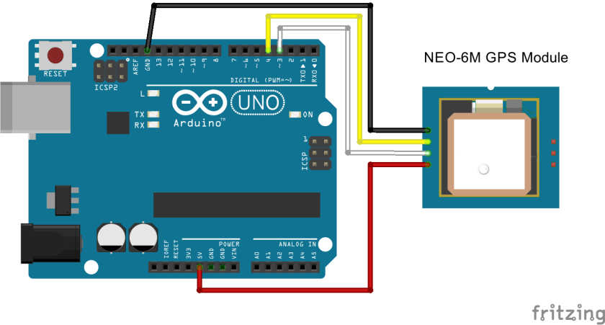

Figure 1:Schematic of Arduino and Neo-6M GPS interfacing

## Arduino 2.4” TFT Shield Screen

### Product Description

The job of screens in electronic undertakings is significant. 2.4" TFT Shield is one of the most generally utilized realistic screens. It has significant highlights. It has capacity to show 262000 distinct hues with 240*320 pixels goals. It has 8-piece equal screen between face. The shield screen needs a voltage gracefully of 5V.

### Display Parameters

|  |  |
| --- | --- |
| Screen size | 2.4 inches |
| Display size | 48.96mm * 36.72mm |
| Dimensions | 72.20mm * 52.7mm |
| Screen resolution | 320*240 pixels |
| Screen Color | RGB, 65K colors |
| Screen Interface | 8-bit parallel interfaces |
| Driver IC | ILI9342 |

Table 4:Display Parameter of 2.4” TFT shield screen

## Circuit Diagram

The devices discussed above are presented in below circuit diagram. All of them make up our single in-vehicle module.

1. Arduino 2.4” TFT Shield Screen
2. Neo 6M GPS
3. HC-12 Transciever
4. Arduino Mega 2560

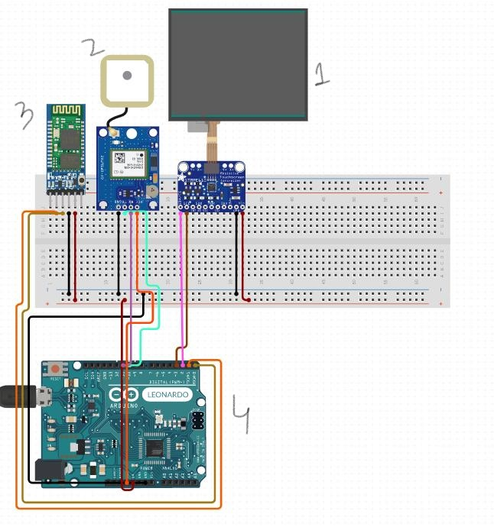

Figure 2: Circuit Diagram

# Chapter 4

# Results

## Project Testing

### Desired Outcomes

Our project was tested for whether it is achieving the desired outcomes which included:

1. The reliable communication of two modules in non-line of sight
2. The working of module in rainy/foggy weather
3. Reduced production costs

### Testing site

The site we chose for project testing was Khoye da Nall Rd. Abbottabad Heights, Abbottabad, Pakistan which is about 1500m above the sea level. There are tight curves as we go above the track. There are many curves in which vehicles approaching from either side are in non-line of sight. The area is covered with a lot of tress and mountains. Such spot was good to choose for the project testing.

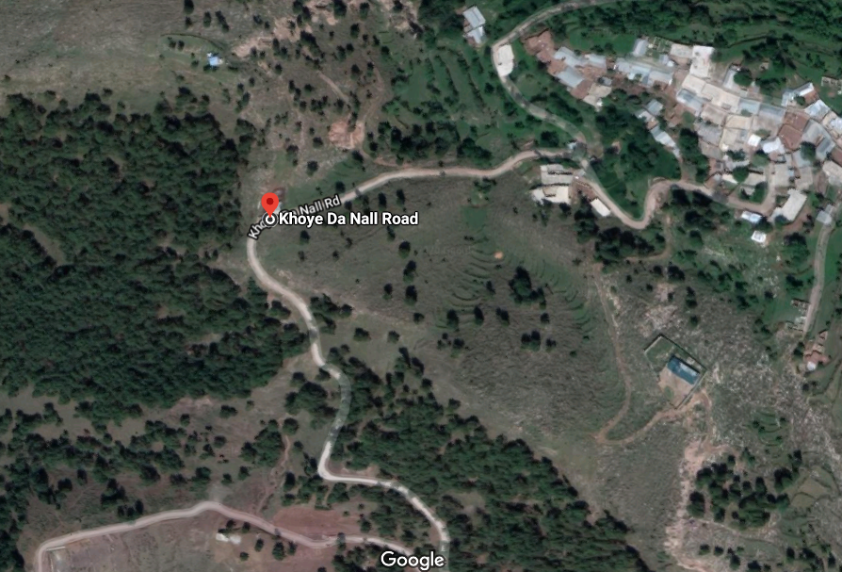

Figure 3:Google Earth Satellite View of the Testing Site

## Milestone: V2V communication

The modules were kept in separate vehicles. Both the vehicles were apart from each other. Each vehicle was on either side of the blind spot. The two modules successfully communicated with each other when they were even 200 m apart without any loss of data packets.

## Milestone: No dependency on Internet

In order to avoid dependency on internet, the coordiantes of the testing site were loaded in to the module. The longitude and latitude coordinates were fetched using Neo 6m GPS and were stored in Arduino to process it in the testing site. The map was loaded succesffuly showing the exact location of the second module present in another vehicle.

## Milestone: Cost Effective

Cost of our two prototypes is Rs. 10 thousand approximately (5k/module). The cost of each module is given in the following table:

|  |  |
| --- | --- |
| **Component** | **Price (1 pc)** |
| Arduino Mega 2560 | Rs: 1450/- |
| HC-12 Transceiver | Rs: 750/- |
| Arduino 2.4’’ tft Shield Screen | Rs: 1200/- |
| Neo 6M GPS | Rs: 1200/- |

Table 5:Cost Analysis

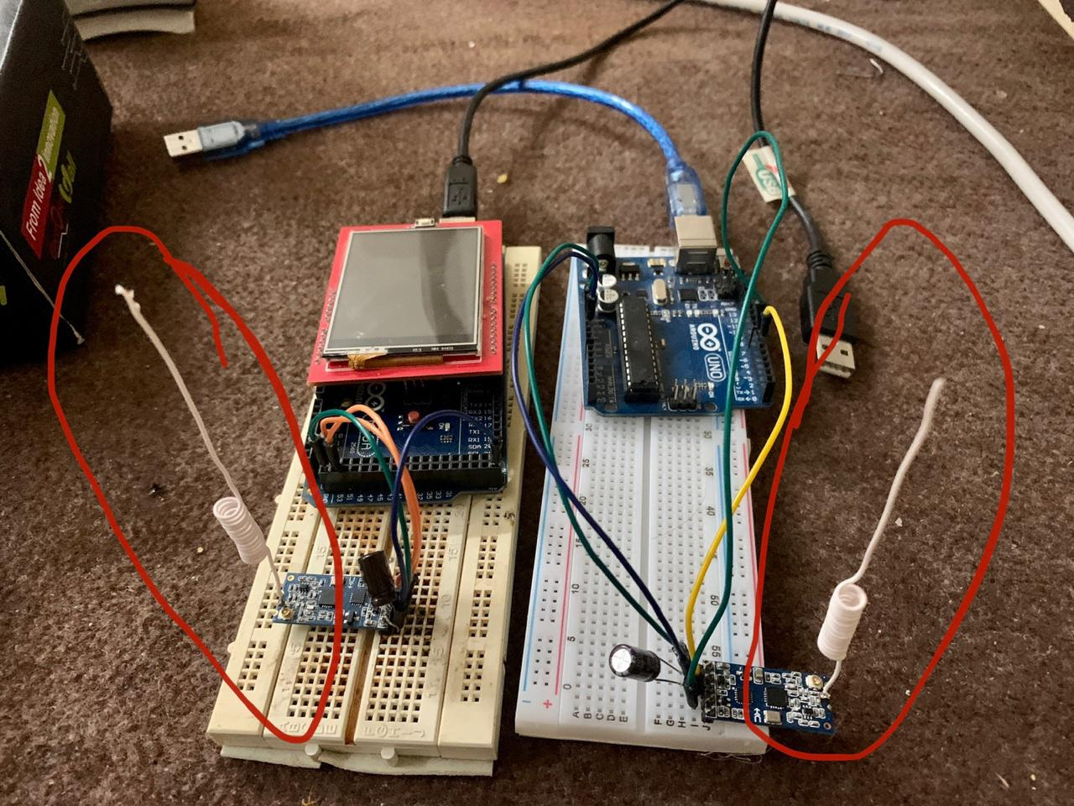

Figure 4:Prototype of Modules

# Chapter 5

# Discussion

## Key Findings

The results indicate that in-vehicles modules communicated successfully with each other with accuracy. There were no loss of coordinates while communication between the modules. The study demonstratres that the problem of accidents can be mitigated significantly in dangerous blind turns by installing the modules in each and every vehicle passing through the turn. The analysis confirms that no internet connection is required and the limition of internet is not necessary at the accident prevention spots. As expected, the results met our goals of overcoming the problem of accidents on mountainous curves.

## Implications of Results

Our results differ in some ways from the approaches adopted by the researchers and engineers who addressed the problem of accident prevention previously. In vehicle module was never designed before for the problem under consideration, which ensures the safety of hardware. Having the whole system in vehicle won’t let animals or humans damage the system.

## Limitations

With all the perks of our module there is also one limitation. In order to ensure safety for all the vehicles, the vehicle *must* have the safety module inside it. If one vehicle on a curve has the module and the vehicle approaching from opposite side lacks it, the system will totally fail and will not be applicable in that situations. For dangerous spots it has to be ensured by the government or highway authorities that every vehicle shoud have the module inside it.

## Maximum Performance Area

For specific dangerous sites, for instance the road from Naran to jhel Saif-ul-Malook in Pakistan which has the same entry and exit points, the road safety can be ensured by our device very efficitely. The vehicles can take the module from entry point and give it back to highway authority while coming back to exit point.

## Future Motivation

Due COVID-19 Outbreak in January 2020, our university soon closed all the educational activities in response to outbreak. As a result our project goals are not completely met since the labs were closed and it was not feasible to continue testing the project prototypes in lockdown situation. Although the prototype is ready about 80 percent but the algorithm of finding the distance between the two vehicles during V2V communication is not integrated.

However we got enough time to conduct a good research on the milestone of calculating the distance along a curve and the project group is intended to test it soon when the pandemic situation is handled.

### Finding Curve Distance

In order to find the distance between the two vehicles in a curve we need to find the arc length of the curve. Mathematically we can achieve it by using the definite integrals. We can think of the arc length as the distance travelled by each vehicle along the curve.

#### Mathematical Formulation

We start by considering arc length defined as function of x, and by repeating the same identical process but in a reversed way we can examine the arc length of y (Herman, 2019).

Let f(x) be a smooth function defined over interval [a,b]. We need to calculate length of curve from (a,f(a)) to (b,f(b)). We use line segments to approximate the length of curve.

For s = 0,1,2,..,n let P = {xs} be a smooth running portion of [a,b], then for s = 1,2,3,..,n make a line segment from (xs-1, f(xs-1)) to (xs,f(xs)). In figure below we have assumed n=5.

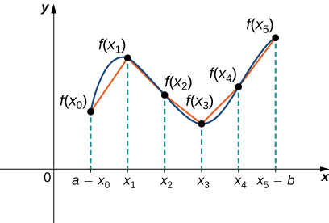

Figure 5: Arc Distance

To calculate length of each line segment we need to track change in vertical distance as well as horizontal distance.

Let change in vertical distance is ys on interval [xs-1,xs]

ys = f(x)-f(xs-1)

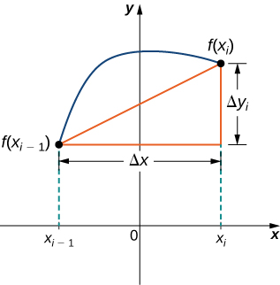

Figure 6: Change in Vertical vs Horizontal Distance

By Pythagorean theorem, the length of line segment is,

√(x)2 +(ys)2

Which can be re-written as

x√ 1+((ys)/(x))2

Now by mean value theorem, point xs* belongs to [xs-1, xs ­­­] such that f’(xs*) =(ys)/(x). Then length of line segment is given by,

x√1+[f’(xs*)]2

Adding up all the lengths gives us the arc length,

Arc Length is approximately equal to ns=1 ­√1+[f’(xs*)]2 x

This is Riemann sum. Taking the limit n approaches ∞

Arc Length = limn🡪∞ s=1 n√1+[f’(xs*)]2 x = ­0∫b √1+f’(x)2dx

# Bibliography

HAREENDRAN, T. (2014). *Neo-6M GPS --An Introduction*. Retrieved from Electro Schematics: https://www.electroschematics.com/neo-6m-gps-module/

Herman, G. S. (2019). Applications of Integration. In G. S. Herman, *Calculus Volume 1.* Pressbooks.

Mahapatra, R. P. (2008). Ultra sonic sensor based blind spot accident prevention system. *International conference on advanced computer theory and engineering,IEEE*, 992-995.

Mustafa, Z. (2017, November 15). *Education*. Retrieved from New Straits Times: https://www.nst.com.my/education/2017/11/303399/electro-strips-prevent-accidents-blind-turns

Pakistan Bureau of Statistics, Government of Pakistan. (2017-18). *Home> Traffic Accidents(Annual)*. Retrieved from Pakistan Bureau of Statistics: http://www.pbs.gov.pk/content/traffic-accidents-annual

WHO. (2013). *Global Health Obsevatory (GHO) data*. Retrieved from Whort Health Organization: https://www.who.int/gho/road_safety/mortality/number_text/en/