PRACTICAL NO 1
Aim: Write a program to implement CRUD operations.
INPUT:
class Student:
next_id = 1
def __init__(self, name, elective):
self.studentId = Student.next_id
self.studentName = name
self.selectedElective = elective
Student.next_id += 1
student_db = []
def add_students(self):
Student.student_db.append(self)
print(f"{self.studentId} | {self.studentName} | {self.selectedElective} is Added in database")

def update_elective(self, new_elective):
for student in Student.student_db:
if student.studentId == self.studentId:
student.selectedElective = new_elective
return "Student updated successfully"
return "Student not found"

def remove_student(self):
for i in range(len(Student.student_db)):
if Student.student_db[i].studentId == self.studentId:
print(f"\n\nRemoving :- {self.studentName}")
Student.student_db.pop(i)
return "Student removed sucessfully"
@classmethod
def display_database(cls):
print("\n\n Current student records ")
for student in Student.student_db:
print(f"ID: {student.studentId} | Name: {student.studentName} | Elective : {student.selectedElective} ")

Nahid = Student("Nahid", "IOT")
Nahid .add_students()
yusuf = Student("Yusuf", "ML")
yusuf.add_students()
ismail = Student("Ismail", "IOT")
ismail.add_students()
fareed = Student("Fareed", "AI")
fareed.add_students()

Student.display_database()
Nahid.update_elective( "AI")
Student.display_database()

print(Nahid.remove_student())
Student.display_database()

OUTPUT:
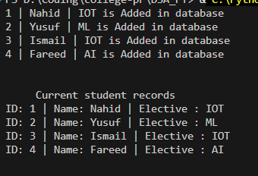

PRACTICAL NO 2
Aim: Write a program to create a to-do list using a singly linked list.
INPUT:
class Node:

def __init__(self, task):
self.task = task
self.next = None

class todoList:
def __init__(self):
self.head = None

def add_task(self, task):
new_node = Node(task)
if self.head is None:
self.head = new_node
else:
temp = self.head
while temp.next:
temp = temp.next
temp.next = new_node

def show_task(self):
if self.head is None:
print("No Tasks yet")
return
temp = self.head
count = 1

while temp:
print(f"{count}. {temp.task}")
temp = temp.next
count += 1

def delete_task(self, task):
temp = self.head

if temp and temp.task == task:
self.head = temp.next
return

prev = None

while temp and temp.task != task:
prev = temp
temp = temp.next

if temp is None:
print("Task not found")
return
prev.next = temp.next
todo = todoList()

while True:
print("\n1. Add Task")
print("2. Show Task")
print("3. Delete Task")
print("4. Exit")

choice = input("Enter your choice(1-4): ")

if choice == "1":
task = input("Enter a Task: ")
todo.add_task(task)

elif choice == "2":
todo.show_task()

elif choice == "3":
task = input("Enter task to delete: ")
todo.delete_task(task)

elif choice == "4":
print("Exit")
break

else:
print("Invalid choice")

OUTPUT:
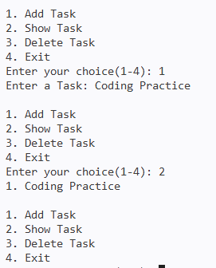

PRACTICAL NO 3
Aim: Write a program to implement a polynomial using a singly linked list.
INPUT:
class polynomial:
def __init__(self, coefficient=None, power=None):
self.coefficient = coefficient
self.power = power
self.head = None
self.next = None

def append(self, coefficient, power):
newNode = polynomial(coefficient, power)

if self.head is None:
self.head = newNode
else:
current = self.head
while current:
if current.next is None:
current.next = newNode
return
current = current.next
def display(self):
current = self.head

while current is not None:
print(f"{current.coefficient} x^ {current.power}", end="")

if current.next is not None:
print(" + ", end="")
current = current.next
print()
# Function to add two polynomials
def addPolynomial(poly1, poly2):
result = polynomial()
first = poly1.head
second = poly2.head
while first is not None and second is not None:
if first.power == second.power:
result.append(first.coefficient + second.coefficient, first.power)
first = first.next
second = second.next
elif first.power > second.power:
result.append(first.coefficient, first.power)
first = first.next
else:
result.append(second.coefficient, second.power)
second = second.next

while first is not None:
result.append(first.coefficient, first.power)
first = first.next

while second is not None:
result.append(second.coefficient, second.power)
second = second.next

return result
p1 = polynomial()

p1.append(5,3)
p1.append(2,1)
p1.append(3,0)

p2 = polynomial()

p2.append(4,2)
p2.append(3,2)
p2.append(2,1)

print("First Polynomial: ")
p1.display()

print("Second Polynomial: ")
p2.display()

result = addPolynomial(p1, p2)
print("\nResultant Polynomial:")
result.display()

OUTPUT:
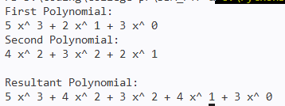

PRACTICAL NO 4
Aim: Write a program to implement a Doubly Linked List.
INPUT:
class DoublyLinkedList:
def __init__(self, data):
self.data = data
self.tail = None
self.next = None
self.head = None

def insertion_at_beginning(self, data):
newNode = DoublyLinkedList(data)
if self.head is None:
self.head = newNode
else:
newNode.next = self.head
self.head.tail = newNode
self.head = newNode

def insertion_at_end(self, data):
newNode = DoublyLinkedList(data)
current = self.head

while current.next is not None:
current = current.next
current.next = newNode
newNode.tail = current

def insertion_at_position(self, data, position):
newNode = DoublyLinkedList(data)
if position == 1:
newNode.next = self.head
self.head.tail = newNode
self.head = newNode
else:
current = self.head
current_position = 1
while current_position < position - 1 and current.next is not None:
current = current.next
current_position += 1
if current.next is None:
current.next = newNode
newNode.tail = current
else:
newNode.next = current.next
newNode.tail = current
current.next.tail = newNode
current.next = newNode

def deletion_at_beginning(self):
self.head = self.head.next
if self.head is not None:
self.head.tail = None

def deletion_at_end(self):
current = self.head

while current.next is not None:
current = current.next
current.tail.next = None

def deletion_at_position(self, position):
if self.head is None:
return
elif position == 1:

self.head = self.head.next
if self.head is not None:
self.head.tail = None
else:
current = self.head
current_position = 1

while current_position < position - 1 and current.next is not None:
current = current.next
current_position += 1
if current.next is None:
return
else:
current.next = current.next.next
if current.next is not None:
current.next.tail = current

def display(self):
newNode = self.head
while newNode is not None:
print(newNode.data, end=" ")
newNode = newNode.next
print()

dll = DoublyLinkedList(10)

dll.insertion_at_beginning(20)
dll.insertion_at_beginning(30)
dll.insertion_at_beginning(40)

dll.insertion_at_end(50)
dll.insertion_at_end(70)
dll.insertion_at_end(80)

dll.insertion_at_position(60, 3)

print("Original List:")
dll.display()

dll.deletion_at_beginning()
dll.deletion_at_end()
dll.deletion_at_position(3)

print("Modified List:")
dll.display()

OUTPUT:
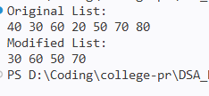

PRACTICAL NO 5
Aim: Write a program to implement Stack ADT.
INPUT:
class Stack:
def __init__(self):
self.stack = []
def push(self, item):
self.stack.append(item)
def pop(self):
if len(self.stack) == 0:
return None
return self.stack.pop()
def peek(self):
return self.stack[-1]
def isEmpty(self):
return len(self.stack) == 0
def display(self):
print(self.stack)

print("------------- Stack Operations -------------")
st = Stack()

st.push(10)
st.push(20)
st.push(40)

print("Stack: ")
st.display()

print("Peek:", st.peek())
st.push(35)
print("Pop:", st.pop())

print("After Pop:")
st.display()
print()

print("---------------- Delimiter Matching ----------------")

s = "{[()()]}
st = Stack()
for ch in s:
if ch in "{[(":
st.push(ch)
else:
if st.isEmpty():
print("Not Balanced")
break
top = st.pop()
if ch == ')' and top != '(':
print("Not Balanced")
break
if ch == '}' and top != '{':
print("Not Balanced")
break
if ch == ']' and top != '[':
print("Not Balanced")
break
else:
if st.isEmpty():
print("Balanced")
else:
print("Not Balanced")

print("------------- Prefix to Postfix -------------")

def isOperator(ch):
return ch in ['+' , '-', '*', '/']
def preToPost(preExp):
st = Stack()
preExp = preExp[::-1]
print(preExp)
for ch in preExp:
if isOperator(ch):
op1 = st.pop()
op2 = st.pop()
st.push(op1 + op2 + ch)
else:
st.push(ch)
return st.pop()
ex = "*+-ABC*/DFG"
print("PreFix Expression: ", ex)
print("PostFix Expression: ", preToPost(ex))

OUTPUT:
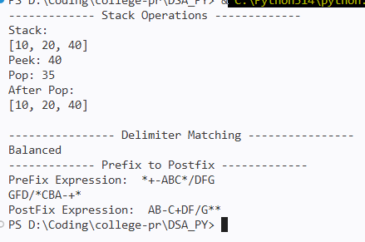

PRACTICAL NO 6
Aim: Write a program to understand Linear Queue and Circular Queue.
Linear Queue:
class Queue():
def __init__(self, k):
self.k = k
self.queue = [None] * k
self.head = self.tail = -1
def enqueue(self, data):
if (self.tail == self.k -1):
print("The queue is full\n")
elif (self.head == -1):
self.head = 0
self.tail = 0
self.queue[self.tail] = data
else:
self.tail = self.tail + 1
self.queue[self.tail] = data
def dequeue(self):
if (self.head == -1):
print("The queue is empty\n")
elif (self.head == self.tail):
temp = self.queue[self.head]
self.head = -1
self.tail = -1
return temp
else:
temp = self.queue[self.head]
self.head = self.head + 1
return temp
def printQueue(self):
if (self.head == -1):
print("No element in the queue")
else:
for i in range(self.head, self.tail + 1):
print(self.queue[i], end=" ")
print()

obj = Queue(5)
obj.enqueue(1)
obj.enqueue(2)
obj.enqueue(3)
obj.enqueue(4)
obj.enqueue(5)
print("Initial Queue")
obj.printQueue()
obj.dequeue()
print("After removing an element from the queue")
obj.printQueue()
OUTPUT:
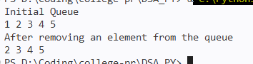
Circular Queue:
class CircularQueue():

def __init__(self, k):
self.k = k
self.queue = [None] * k
self.head = self.tail = -1

def enqueue(self, data):
if ((self.tail + 1) % self.k == self.head):
print("The circular queue is full:- Overflow\n")
elif (self.head == -1):
self.head = 0
self.tail = 0
self.queue[self.tail] = data
else:
self.tail = (self.tail + 1) % self.k
self.queue[self.tail] = data

def dequeue(self):
if (self.head == -1):
print("The circular queue is empty:- Underflow\n")
elif (self.head == self.tail):
temp = self.queue[self.head]
self.head = -1
self.tail = -1
return temp
else:
temp = self.queue[self.head]
self.head = (self.head + 1) % self.k
return temp

def printCQueue(self):
if(self.tail >= self.head):
for i in range(self.head, self.tail + 1):
print(self.queue[i], end=" ")
print()

else:
for i in range(self.head, self.k):
print(self.queue[i], end=" ")
for i in range(0, self.tail +0):
print(self.queue[i], end=" ")
print()

obj = CircularQueue(5)
obj.enqueue(1)
obj.enqueue(9)
obj.enqueue(3)
obj.enqueue(8)
obj.enqueue(7)
print("Initial queue")
obj.printCQueue()

obj.dequeue()
print("After removing an element from the queue")
obj.printCQueue()

OUTPUT:
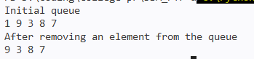

PRACTICAL NO 7
Aim: Write a program to implement Tree Traversal of Binary Search Tree.
INPUT:
class Node:
def __init__(self, data):
self.data = data
self.leftChild = None
self.rightChild = None

# preorder (Root → Left → Right)
def preorder(self):
print(self.data, end=' ')
if self.leftChild:
self.leftChild.preorder()
if self.rightChild:
self.rightChild.preorder()

# inorder (Left → Root → Right)
def inorder(self):
if self.leftChild:
self.leftChild.inorder()
print(self.data, end=' ')
if self.rightChild:
self.rightChild.inorder()

# postorder (Left → Right → Root)
def postorder(self):
if self.leftChild:
self.leftChild.postorder()
if self.rightChild:
self.rightChild.postorder()
print(self.data, end=' ')
def insert(root, data):
# If tree is empty, create a new node
if root is None:
return Node(data)
# Don't insert duplicates
if data == root.data:
return root

if data < root.data:
root.leftChild = insert(root.leftChild, data)
else:
root.rightChild = insert(root.rightChild, data)

return root

# Input numbers
numbers = [10, 89, 77, 54, 98, 11, 12, 15, 90]

# First number becomes root
root = None

for data in numbers:
root = insert(root, data)

print("Preorder:", end=' ')
root.preorder()

print("\nInorder:", end=' ')
root.inorder()

print("\nPostorder:", end=' ')
root.postorder()

OUTPUT:
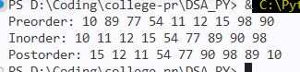

PRACTICAL NO 8
Aim: Write a program to implement Priority AVL Tree.
Balanced AVL Tree:
class Node:
def __init__(self, key):
self.key = key
self.left = None
self.right = None
self.height = 1

class AVLTree:
def get_height(self, node):
if node is None:
return 0
return node.height
def get_balance(self, node):
if node is None:
return 0
return self.get_height(node.left) - self.get_height(node.right)
def right_rotate(self, y):
x = y.left
temp = x.right
x.right = y
y.left = temp
y.height = 1 + max(self.get_height(y.left), self.get_height(y.right))
x.height = 1 + max(self.get_height(x.left), self.get_height(x.right))
return x
def left_rotate(self, x):
y = x.right
temp = y.left
y.left = x
x.right = temp
x.height = 1 + max(self.get_height(x.left), self.get_height(x.right))
y.height = 1 + max(self.get_height(y.left), self.get_height(y.right))
return y

def insert(self, node, key):
if node is None:
return Node(key)
if key < node.key:
node.left = self.insert(node.left, key)
elif key > node.key:
node.right = self.insert(node.right, key)
else:
return node
node.height = 1 + max(self.get_height(node.left), self.get_height(node.right))
balance = self.get_balance(node)
if balance > 1 and key < node.left.key:
return self.right_rotate(node)
if balance < -1 and key > node.right.key:
return self.left_rotate(node)
if balance > 1 and key > node.left.key:
node.left = self.left_rotate(node.left)
return self.right_rotate(node)
if balance < -1 and key < node.right.key:
node.right = self.right_rotate(node.right)
return self.left_rotate(node)
return node

# Inorder Traversal
def inorder(self, node):
if node:
self.inorder(node.left)
print(node.key, end=" ")
self.inorder(node.right)
avl = AVLTree()
root = None

values = [30, 20, 10, 25, 28, 40, 50]

for value in values:
root = avl.insert(root, value)

print("Inorder traversal of AVL Tree:")
avl.inorder(root)

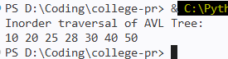

Priority Queue:
class PriorityQueue:
def __init__(self):
self.queue = []

def insert(self, value, priority):
self.queue.append((priority, value))
self.heapify_up(len(self.queue) - 1)

def heapify_up(self, index):
while index > 0:
parent = (index - 1) // 2
if self.queue[parent][0] >= self.queue[index][0]:
break
self.queue[parent], self.queue[index] = \
self.queue[index], self.queue[parent]
index = parent

def remove(self):
if len(self.queue) == 0:
print("Priority Queue is empty")
return None
highest = self.queue[0]
self.queue[0] = self.queue[-1]
self.queue.pop()
if self.queue:
self.heapify_down(0)
return highest

def heapify_down(self, index):
size = len(self.queue)
while True:
largest = index
left = 2 * index + 1
right = 2 * index + 2

if left < size and self.queue[left][0] > self.queue[largest][0]:
largest = left

if right < size and self.queue[right][0] > self.queue[largest][0]:
largest = right

if largest == index:
break
self.queue[index], self.queue[largest] = \
self.queue[largest], self.queue[index]
index = largest

def display(self):
print("Priority Queue:")
for priority, value in self.queue:
print("Value:", value, "Priority:", priority)

pq = PriorityQueue()

pq.insert("Task A", 2)
pq.insert("Task B", 5)
pq.insert("Task C", 1)
pq.insert("Task D", 4)
pq.insert("Task E", 3)

pq.display()

print("\nRemoving elements according to priority:")

while pq.queue:
priority, value = pq.remove()
print(value, "-> Priority:", priority)

OUTPUT:
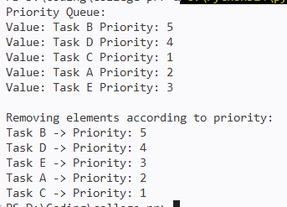

PRACTICAL NO 9
Aim: Write a program to implement BFS and DFS of Binary Search Tree.
INPUT:
def bfs(graph, start):

visited = []
queue = []
visited.append(start)
queue.append(start)
while queue:
vertex = queue.pop(0)
print(vertex, end=" ")
for neighbour in graph[vertex]:
if neighbour not in visited:
visited.append(neighbour)
queue.append(neighbour)
graph = {
0: [1, 2],
1: [2],
2: [3],
3: [1, 2]
}
print("\nBreadth First Traversal:")
bfs(graph, 0)

def dfs(graph, start):
visited = []
stack = []
stack.append(start)
while stack:
vertex = stack.pop()
if vertex not in visited:
visited.append(vertex)
print(vertex, end=" ")
for neighbour in graph[vertex]:
if neighbour not in visited:
stack.append(neighbour)
graph = {
0: [1, 2],
1: [2],
2: [3],
3: [1, 2]
}
print("\nDepth First Traversal:")
dfs(graph, 0)

OUTPUT:
