Practical No: 1
Aim: Write a program to Create a class and Implement or demonstrates the concepts of constructor, this and static.
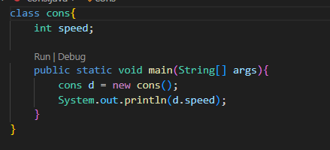
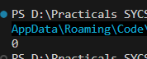
- Default Constructor:
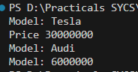
- Parameterised Constructor:
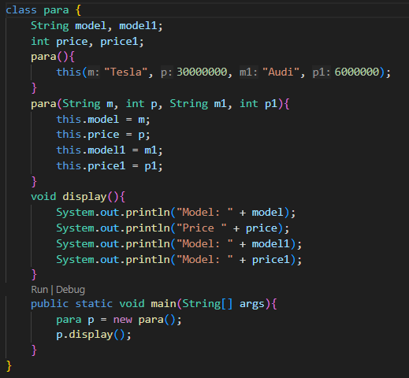

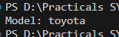
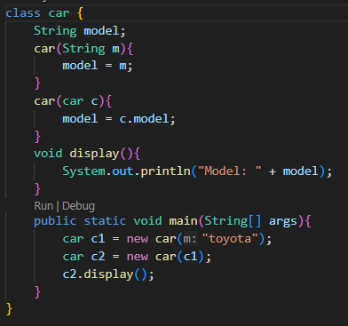
- Copy Constructor:
- Using this keyword:
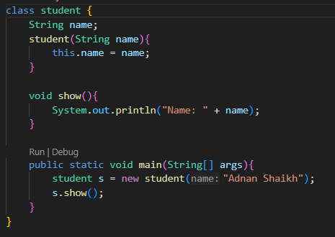
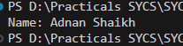

- Static Keyword:
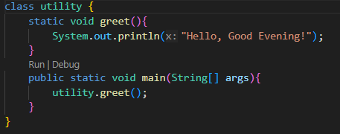
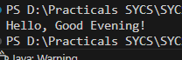
b) Aim: Write a program to implement the concept of inheritance and method overriding.
1. Single Inheritance:
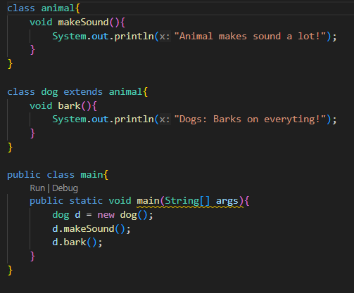
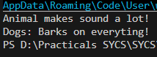

2. Multilevel Inheritance:
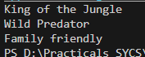
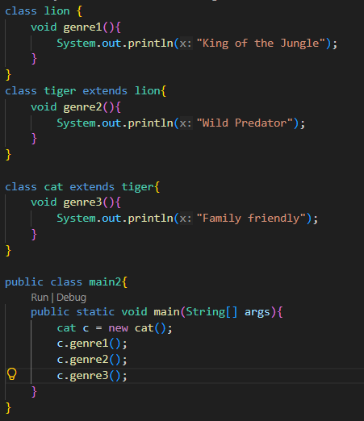
3. Method Overriding:

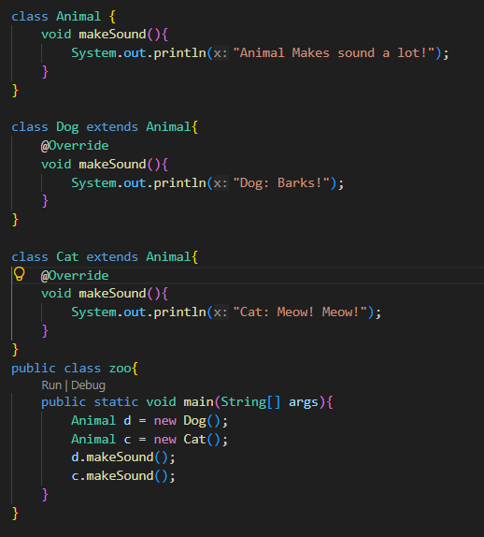

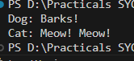

c) Aim: Write a program to demonstrate Polymorphism (Using in Method), Abstraction, and Encapsulation:
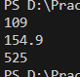
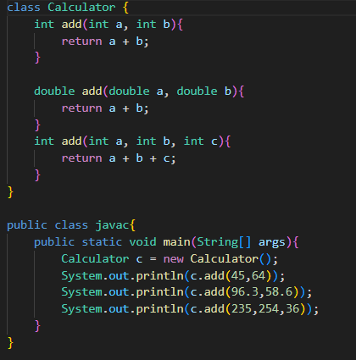
d) Abstraction and Encapsulation:
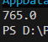
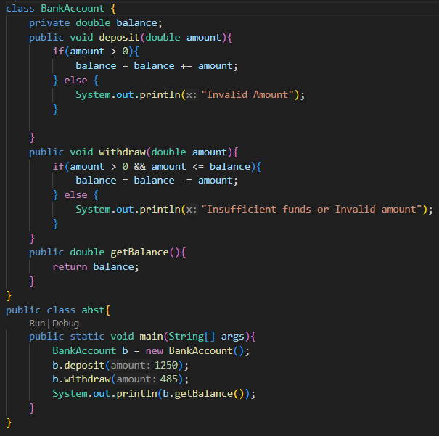
e) Abstract class and Method:
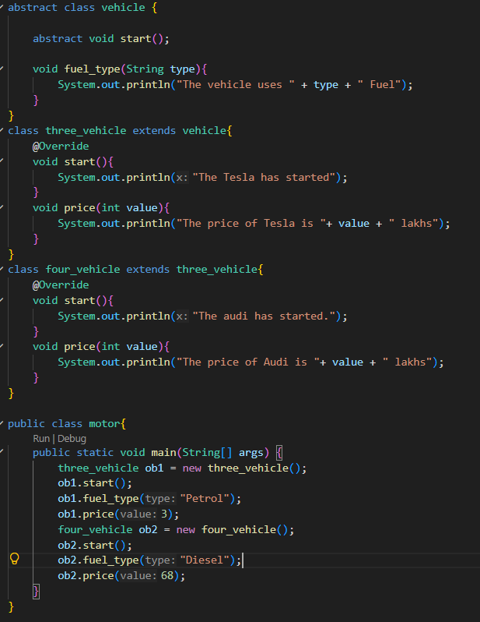
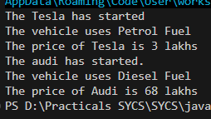

Practical No: 2
- Aim: Write a program to implement predefined packages (java.util, java.io, etc.).
- Using java.util.Scanner for input:-
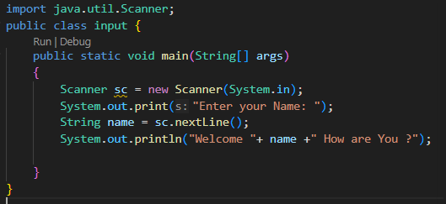
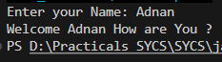
- Using java.lang.Math for Calculation:-
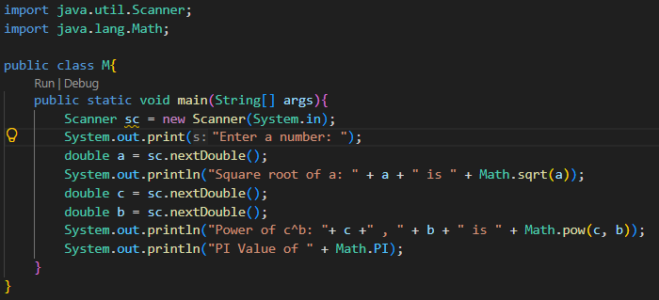
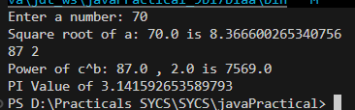
- Using java.time.LocalDate for time:- 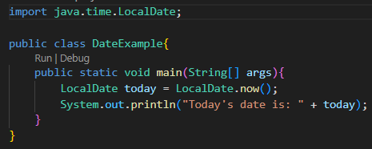
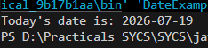
- Using java.io.File:-
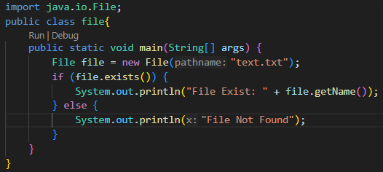
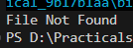
- Using java.net.URL for URL:-
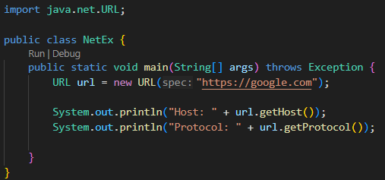
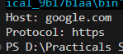

- Using java.security;-
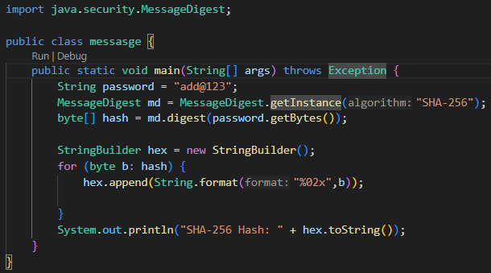
- Write a Program to create and use a user defined packages.
- Create a package src.myapp.utils.Mathutils.java:
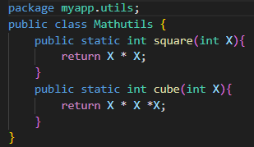
- Create another file to import packages:
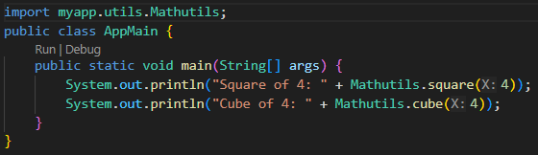
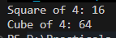

- Aim: Write a program to demonstrate the use of access specifiers (Public, Private, Protected).
- Public Specifier: -
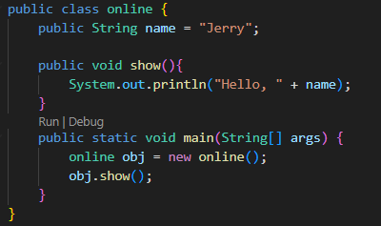
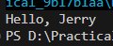
- Private Specifier: -
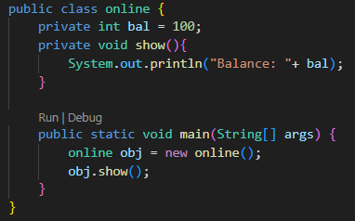
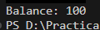0
- Protected Specifier: -
